## Configuration With CI (Travis CI)

The project is integrated with Travis CI continuous integration platform chosen due to popularity, knowledge base, integration with GitHub (ease of) and the fact that it is typically recommended for use cases when you are working on the open-source projects, that should be tested in different environments 🡨and different technology stacks.

Configuration is simple and comprises creation of a single file ‘.travis.yml’ at the root of the project.

## Screenshots

An example of a successful build after committing some changes to GitHub (the latter screenshot illustrates that the tests were executed successfully whilst the first illustrates failed builds):

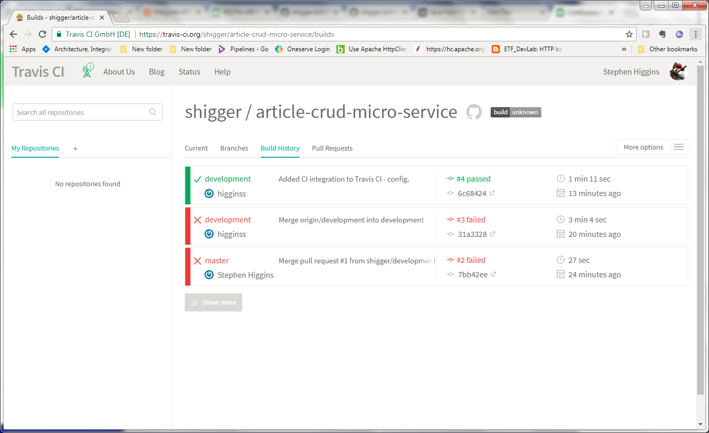

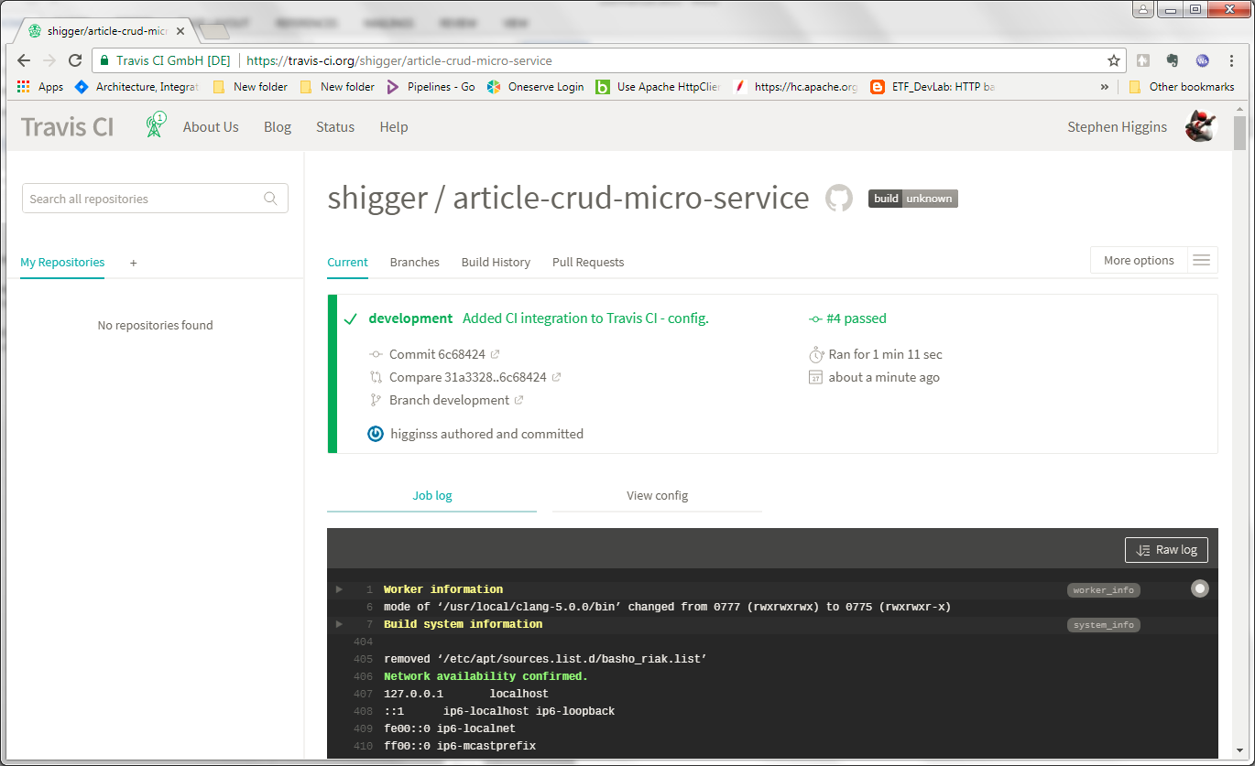

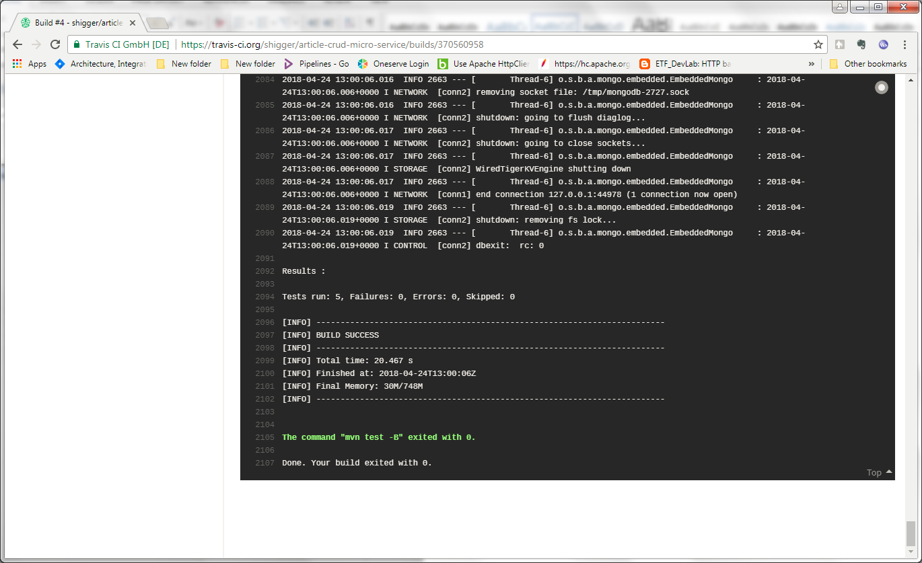

Once branch has been merged (pulled) into the master the build is successful:

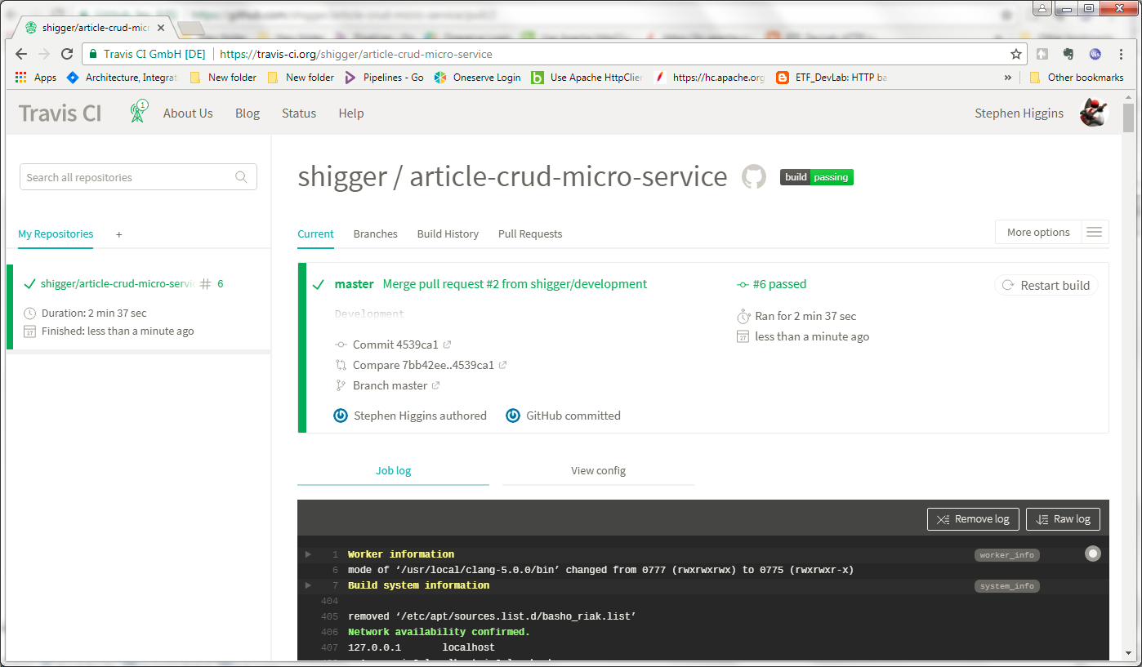

## Code Coverage With JaCoco

Simply add an extra plugin to the Maven pom.xml for code coverage metrics to be captured when tests are executed. This is integrated also into the IDE NetBeans (chosen for this) and further can be integrated into the CI tool (TravisCI).

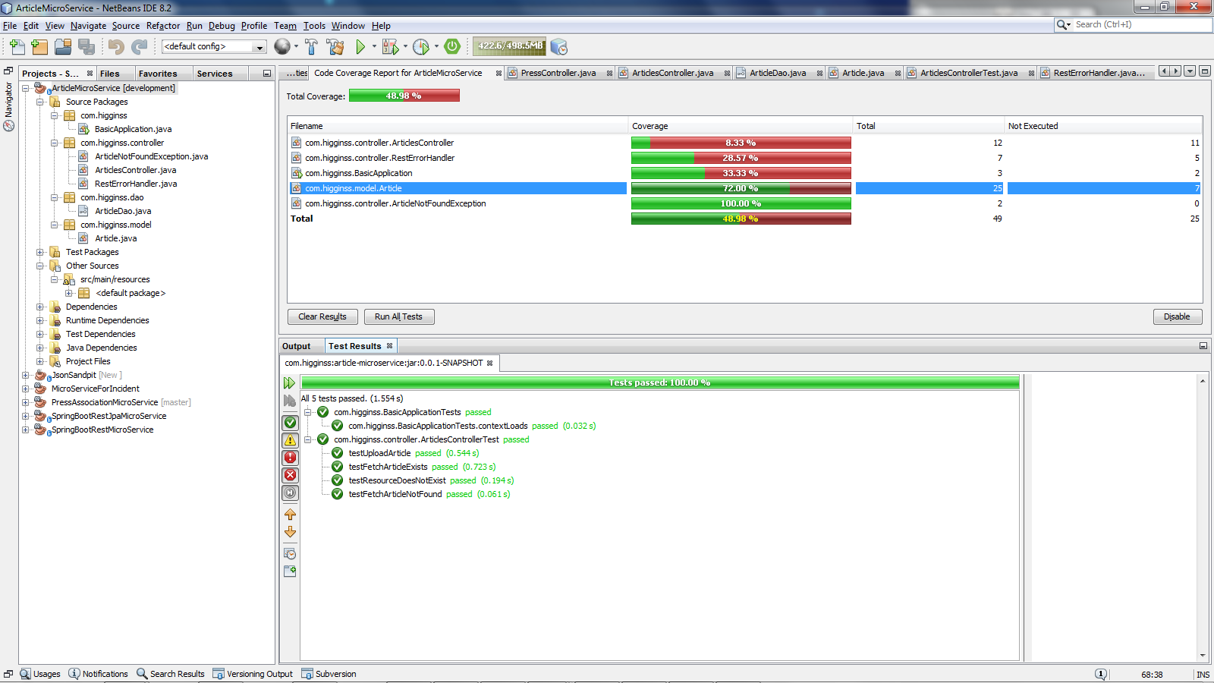

## Code Coverage Integration With CodeCov.IO

Simple integration from TravisCI to codecov.io to view generated metrics re. code coverage by adding a few dependencies to the yaml and pom files.

