Lab Experiment 01: Data Loading

Overview
This notebook introduces fundamental data loading techniques using Pandas, focusing on reading and exporting CSV files, handling file paths, and working with built-in datasets.

Topics Covered
- Loading data from CSV files
- Handling file paths (Windows backslashes vs forward slashes)
- Exporting data to CSV format
- Loading built-in datasets from various sources

Key Concepts

1. Loading CSV Files
Learn to read CSV files using pd.read_csv() with various parameters: -
- Basic file loading
- Setting index columns with index_col parameter
- Handling different file formats (including compressed files)

2. File Path Handling
Understanding Windows file paths in Python: -
- Using double backslashes (\\) for escape characters
- Using forward slashes (/) as alternative
- Using raw strings (prefix with r) for literal paths

3. Data Export
Export DataFrames to CSV format using to_csv() method: -
- Saving with/without index using index=False
- Verifying exported files by reading them back

Dataset
The notebook uses a sample dataset (archive.zip) containing car manufacturer data.

Key Functions Used
- pd.read_csv() - Read CSV files into DataFrame
- df.head() - Display first few rows
- df.to_csv() - Export DataFrame to CSV

Learning Outcomes
After completing this experiment, you will be able to:
- Load data from various file sources into Pandas DataFrames
- Handle file paths correctly in Python on Windows
- Export processed data to CSV format
- Verify data import/export operations
- Work with index columns during data loading

Lab Experiment 02: Data Visualization

Overview
This notebook provides a comprehensive exploration of data visualization techniques using Matplotlib and Seaborn libraries. It covers fundamental to advanced plotting methods for effective data communication and analysis.

Topics Covered
- Line Plots for temporal data
- Scatter Plots for relationship analysis
- Histograms for distribution analysis
- Bar Charts for categorical comparisons
- Heatmaps for matrix visualization
- Advanced Visualizations (Point Plots, Donut Charts, Box Plots, Cat Plots)

Key Concepts

1. Line Plots
Visualizing trends over time using matplotlib.pyplot: -
- Basic line plots with single and multiple series
- Adding labels, titles, and legends
- Using markers to highlight data points
- Styling lines (color, linestyle, linewidth, markers)
- Customizing marker properties (size, edge color)
- Applying Seaborn styles (whitegrid, darkgrid)
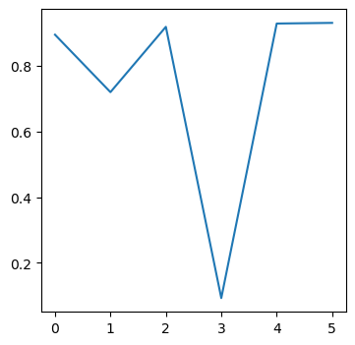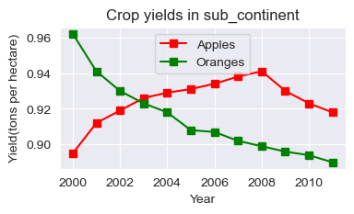

2. Scatter Plots
Understanding relationships between numerical variables: -
- Creating scatter plots with the Iris dataset
- Color-coding by categorical variables using hue
- Adjusting marker size - Combining multiple visualization styles
- Using Seaborn’s scatterplot() function
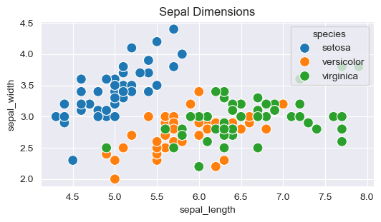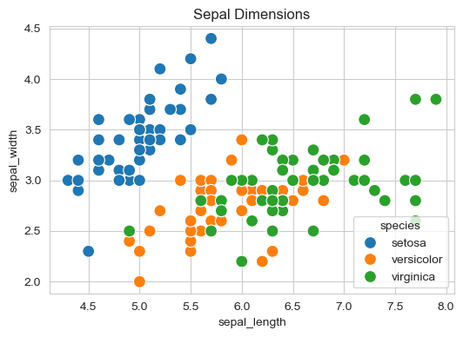

3. Histograms
Analyzing data distributions: -
- Creating basic histograms
- Controlling bin sizes (equal and unequal)
- Multiple histograms with transparency (alpha)
- Stacked histograms for comparing distributions
- Using np.arange() for custom bin ranges
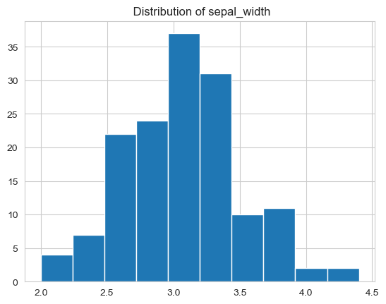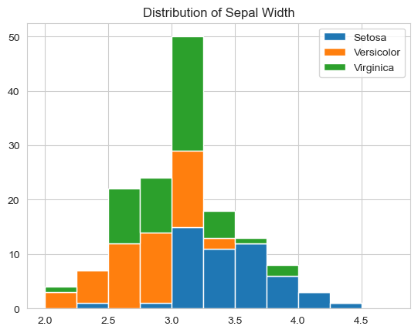

4. Bar Charts
Comparing categorical data: -
- Basic bar charts with plt.bar()
- Stacked bar charts
- Using Seaborn’s barplot() with aggregation functions
- Grouping and aggregating data
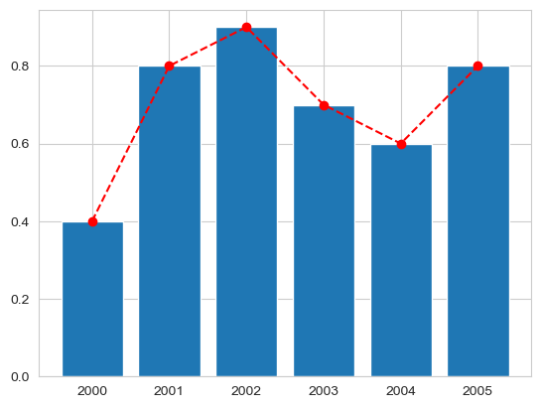

5. Heatmaps
Visualizing matrix data: -
- Creating heatmaps from pivot tables
- Using color maps (cmap)
- Adding annotations with annot=True
- Formatting values with fmt parameter
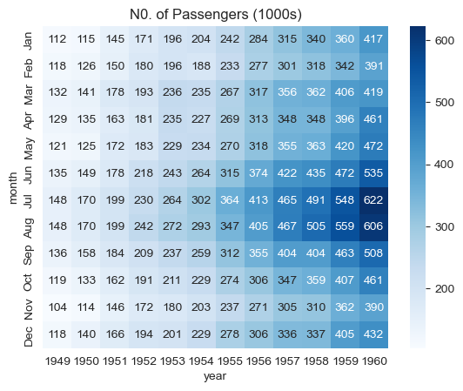

Datasets Used
- Iris Dataset: Flower measurements (sepal/petal length and width)
- Tips Dataset: Restaurant tipping data
- Flights Dataset: Historical airline passenger data

Key Functions Used

Matplotlib
- plt.figure() - Create figure with custom size
- plt.plot() - Create line plots
- plt.scatter() - Create scatter plots
- plt.hist() - Create histograms
- plt.bar() - Create bar charts
- plt.xlabel(), plt.ylabel(), plt.title() - Add labels
- plt.legend() - Add legend

Seaborn
- sns.scatterplot() - Enhanced scatter plots
- sns.barplot() - Statistical bar plots
- sns.heatmap() - Create heatmaps
- sns.pointplot() - Point plots with confidence intervals
- sns.catplot() - Categorical plots
- sns.boxenplot() - Enhanced box plots
- sns.countplot() - Count plots
- sns.set_style() - Set plot style
- sns.load_dataset() - Load built-in datasets

Styling Options

Line/Marker Styling
- c or color - Line color
- ls or linestyle - Line style (‘-’, ‘–’, ‘-.’, ‘:’)
- lw or linewidth - Line width
- ms or markersize - Marker size
- mec or markeredgecolor - Marker edge color
- mew or markeredgewidth - Marker edge width
- alpha - Transparency (0-1)

Seaborn Styles
- whitegrid - White background with grid
- darkgrid - Dark grid background
- Other options: white, dark, ticks

Learning Outcomes
After completing this experiment, you will be able to:
- Create various types of plots for different data types
- Customize plot aesthetics (colors, markers, styles)
- Add informative labels, titles, and legends
- Use both Matplotlib and Seaborn effectively
- Choose appropriate visualizations for different data scenarios
- Create publication-quality figures
- Visualize multivariate relationships
- Handle multiple datasets and compare distributions

Practical Applications
- Time series analysis (stock prices, sensor data)
- Feature relationship exploration in ML
- Distribution analysis for statistical inference
- Categorical data comparison (survey results)
- Correlation analysis
- Presentation and reporting

Lab Experiment 03: Pandas Operations

Overview
This notebook covers advanced Pandas operations for combining, merging, and manipulating DataFrames. These operations are essential for data integration and preparation in real-world data science projects.

Topics Covered
- Creating DataFrames from dictionaries
- Concatenating DataFrames (vertical and horizontal)
- Merging DataFrames (Inner, Outer, Left, Right joins)
- Joining DataFrames on indices
- Applying custom functions to DataFrames
- Data transformation operations

Key Concepts

1. Creating DataFrames
Building DataFrames from dictionary structures: -
- Converting dictionaries to DataFrames using pd.DataFrame()
- Understanding DataFrame structure and indexing
- Working with multiple related DataFrames

2. Concatenation
Combining DataFrames along rows or columns: -
- Vertical Concatenation (axis=0): Stacking DataFrames vertically
- Horizontal Concatenation (axis=1): Combining DataFrames side-by-side
- Using pd.concat() function
- Handling mismatched indices and columns
- Understanding the ignore_index parameter

3. Merging DataFrames
SQL-style joins for combining DataFrames:

Inner Join
- Returns only matching records from both DataFrames
- Syntax: pd.merge(df1, df2, on='key', how='inner')
- Use case: When you need only common records

Outer Join (Full Outer Join)
- Returns all records from both DataFrames
- Fills missing values with NaN
- Syntax: pd.merge(df1, df2, on='key', how='outer')
- Use case: When you need all records regardless of match

Left Join
- Returns all records from left DataFrame and matched records from right
- Syntax: pd.merge(df1, df2, on='key', how='left')
- Use case: Preserving all records from primary dataset

Right Join
- Returns all records from right DataFrame and matched records from left
- Syntax: pd.merge(df1, df2, on='key', how='right')
- Use case: Less common, similar to left join with reversed DataFrames

4. Joining on Indices
Combining DataFrames based on their index: -
- Using df.join() method
- Joining on specific columns vs indices
- Understanding when to use join vs merge

5. Applying Functions
Transforming data using custom functions: -
- Using apply() for row/column-wise operations
- Lambda functions for quick transformations
- Custom function definitions

Sample Data Structure
raw_data_1 = {
"subject_id": ["1", "2", "3", "4", "5"],
"first_name": ["Alex", "Amy", "Allen", "Alice", "Ayoung"],
"last_name": ["Anderson", "Ackerman", "Ali", "Aoni", "Atiches"],
}
raw_data_2 = {
"subject_id": ["4", "5", "6", "7", "8"],
"first_name": ["Billy", "Brian", "Bran", "Bryce", "Betty"],
"last_name": ["Bonder", "Black", "Balwner", "Brice", "Bistan"],
}
raw_data_3 = {
"subject_id": ["1", "2", "3", "4", "5", "6", "7", "8", "9", "10", "11"],
"test_id": [51, 15, 15, 61, 16, 14, 15, 1, 61, 16, 1],
}

Key Functions Used

DataFrame Creation
- pd.DataFrame() - Convert dictionary to DataFrame

Combining DataFrames
- pd.concat([df1, df2], axis=0/1) - Concatenate DataFrames
- pd.merge(df1, df2, on='key', how='inner/outer/left/right') - Merge DataFrames
- df1.join(df2) - Join on indices

Data Selection
- df[['col1', 'col2']] - Select specific columns
- df.head(n) - View first n rows

Other Operations
- df.apply() - Apply function to rows/columns
- df.reset_index() - Reset DataFrame index

Merge Types Comparison
Merge Type | Returns | Use Case
Inner | Only matching records | Default behavior, when you need common data
Outer | All records from both | Complete dataset with all information
Left | All from left, matched from right | Preserving primary dataset
Right | All from right, matched from left | Similar to left but reversed

Learning Outcomes
After completing this experiment, you will be able to:
- Create DataFrames from various data structures
- Concatenate multiple DataFrames vertically and horizontally
- Perform SQL-style joins using merge operations
- Choose appropriate merge types for different scenarios
- Join DataFrames on indices
- Apply custom transformations to DataFrames
- Handle missing data resulting from joins
- Combine data from multiple sources effectively

Practical Applications
- Combining data from multiple CSV files
- Joining customer data with transaction data
- Merging datasets from different sources
- Creating master datasets for analysis
- Data integration in ETL pipelines
- Combining time series from different sensors
- Linking related tables in databases

Lab Experiment 04: Data Preprocessing

Overview
Data preprocessing is a critical step in the machine learning pipeline. This notebook covers essential techniques for transforming raw data into a clean, structured format suitable for machine learning algorithms.

Topics Covered
- Acquiring and importing datasets
- Handling missing values and noise
- Encoding categorical data
- Splitting datasets into training and testing sets
- Feature scaling and normalization
- Data quality assessment

Key Concepts

1. Data Acquisition
- Loading datasets from various sources
- Understanding dataset structure and characteristics
- Initial data inspection

2. Handling Missing Values
Strategies for dealing with incomplete data: -
- Identification: Using isnull(), isna(), info()
- Removal: Dropping rows/columns with dropna()
- Imputation: Filling missing values with: -
  - Mean/median for numerical data
  - Mode for categorical data
  - Forward/backward fill for time series
  - Constant values (e.g., 0, -1, ‘Unknown’)

3. Handling Noisy Data
- Identifying outliers using statistical methods
- Smoothing techniques
- Binning continuous variables
- Data validation and cleaning

4. Encoding Categorical Data
Converting non-numerical data to numerical format:

Label Encoding
- Converts categories to integers (0, 1, 2, …)
- Suitable for ordinal data
- Using LabelEncoder from sklearn

One-Hot Encoding
- Creates binary columns for each category
- Suitable for nominal data
- Using get_dummies() or OneHotEncoder
- Avoids implicit ordering issues

5. Dataset Splitting
Dividing data for training and evaluation: -
- Training Set: Used to train the model (typically 70-80%)
- Testing Set: Used to evaluate model performance (typically 20-30%)
- Using train_test_split() from sklearn
- Importance of random_state for reproducibility
- Stratified splitting for imbalanced datasets

6. Feature Scaling
Normalizing feature ranges for better model performance:

Standardization (Z-score Normalization)
- Transforms data to have mean=0 and std=1
- Formula: (x - mean) / std
- Using StandardScaler
- Suitable when data follows normal distribution

Normalization (Min-Max Scaling)
- Scales data to a fixed range [0, 1] or [-1, 1]
- Formula: (x - min) / (max - min)
- Using MinMaxScaler
- Suitable when data doesn’t follow normal distribution

Data Preprocessing Pipeline
1. Acquire Dataset
↓
2. Import Libraries
↓
3. Load Dataset
↓
4. Identify Missing/Noise Values
↓
5. Handle Missing Values (Drop/Fill)
↓
6. Encode Categorical Data
↓
7. Split Dataset (Train/Test)
↓
8. Feature Scaling
↓
9. Ready for Model Training

Sample Dataset Structure
df = pd.DataFrame({
"Country": ["France", "Spain", "Germany", ...],
"Age": [44, 27, 30, ...],
"Salary": [72000, 48000, 54000, ...],
"Purchased": ["No", "Yes", "No", ...]
})

Key Functions Used

Data Inspection
- df.head(), df.tail() - View data samples
- df.info() - Get dataset information
- df.describe() - Statistical summary
- df.isnull().sum() - Count missing values
- df.shape - Get dimensions

Data Cleaning
- df.dropna() - Remove missing values
- df.fillna() - Fill missing values
- df.drop() - Remove columns/rows

Encoding
- LabelEncoder() - Encode labels to integers
- pd.get_dummies() - Create dummy variables
- encoder.fit_transform() - Fit and transform data

Splitting
- train_test_split(X, y, test_size=0.2, random_state=42) - Split dataset

Scaling
- StandardScaler() - Standardize features
- MinMaxScaler() - Normalize features
- scaler.fit_transform() - Fit and transform training data
- scaler.transform() - Transform test data (using training statistics)

Learning Outcomes
After completing this experiment, you will be able to:
- Identify and handle missing values appropriately
- Detect and handle noisy/outlier data
- Encode categorical variables for machine learning
- Split datasets properly for model evaluation
- Apply appropriate feature scaling techniques
- Understand when to use standardization vs normalization
- Build a complete data preprocessing pipeline
- Prevent data leakage during preprocessing
- Maintain data integrity throughout the pipeline

Practical Applications
- Preparing data for machine learning models
- Cleaning real-world messy datasets
- Feature engineering for better model performance
- Data integration from multiple sources
- Building ETL (Extract, Transform, Load) pipelines
- Data quality improvement projects

When to Use Which Scaling?
Scenario | Scaling Method | Reason
Normal distribution | StandardScaler | Preserves distribution shape
Unknown distribution | MinMaxScaler | Bounded range useful
Outliers present | RobustScaler | Less sensitive to outliers
Neural Networks | StandardScaler or MinMaxScaler | Faster convergence
Tree-based models | Often not needed | Trees are scale-invariant
Distance-based (KNN, SVM) | StandardScaler | Equal feature importance

Lab Experiment 05: Placement Analysis

Overview
This notebook performs comprehensive exploratory data analysis (EDA) on a student placement dataset to understand factors influencing placement outcomes. It demonstrates practical application of data preprocessing, visualization, and statistical analysis techniques.

Topics Covered
- Data loading and initial exploration
- Handling missing values in real datasets
- Categorical and numerical variable analysis
- Correlation analysis
- Advanced data visualization techniques
- Outlier detection and handling
- Feature relationship exploration

Key Concepts

1. Data Loading and Exploration
- Loading placement data from CSV
- Understanding dataset structure with info(), describe(), shape
- Identifying data types and columns
- Initial data quality assessment

2. Missing Value Analysis
- Identifying missing values with isnull().sum()
- Understanding patterns in missing data
- Deciding on appropriate imputation strategies
- Validating data completeness after handling missing values

3. Categorical Variables Analysis
Exploring non-numerical features: -
- Gender distribution
- Board of education (SSC, HSC)
- Stream of education (Commerce, Science, Arts)
- Specialization (MBA, Operations, etc.)
- Placement status
- Using value_counts() for frequency analysis

4. Numerical Variables Analysis
Analyzing continuous features: -
- SSC percentage (10th grade marks)
- HSC percentage (12th grade marks)
- Degree percentage (undergraduate marks)
- MBA percentage
- Employability test scores
- Salary information

5. Correlation Analysis
Understanding relationships between variables: -
- Computing correlation matrices
- Visualizing correlations with heatmaps
- Identifying strongly correlated features
- Understanding multicollinearity
- Feature selection insights
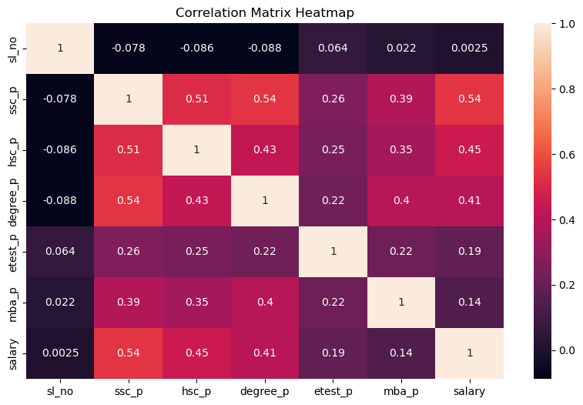

6. Data Visualization Techniques

Scatter Plots
- Visualizing relationships between academic scores
- Identifying patterns and trends
- Color-coding by categorical variables
- Understanding non-linear relationships
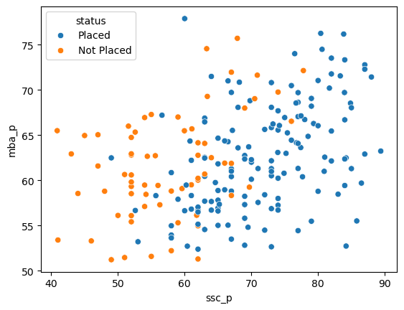

Box Plots
- Detecting outliers in numerical variables
- Comparing distributions across categories
- Understanding quartiles and IQR
- Identifying skewness in data
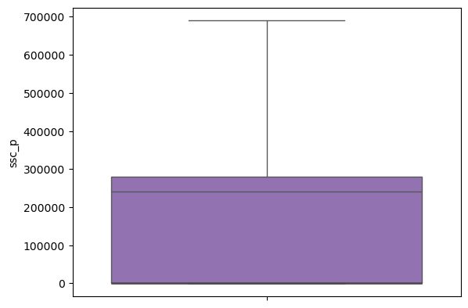

Pair Plots
- Visualizing multiple relationships simultaneously
- Understanding multivariate distributions
- Identifying clusters in data
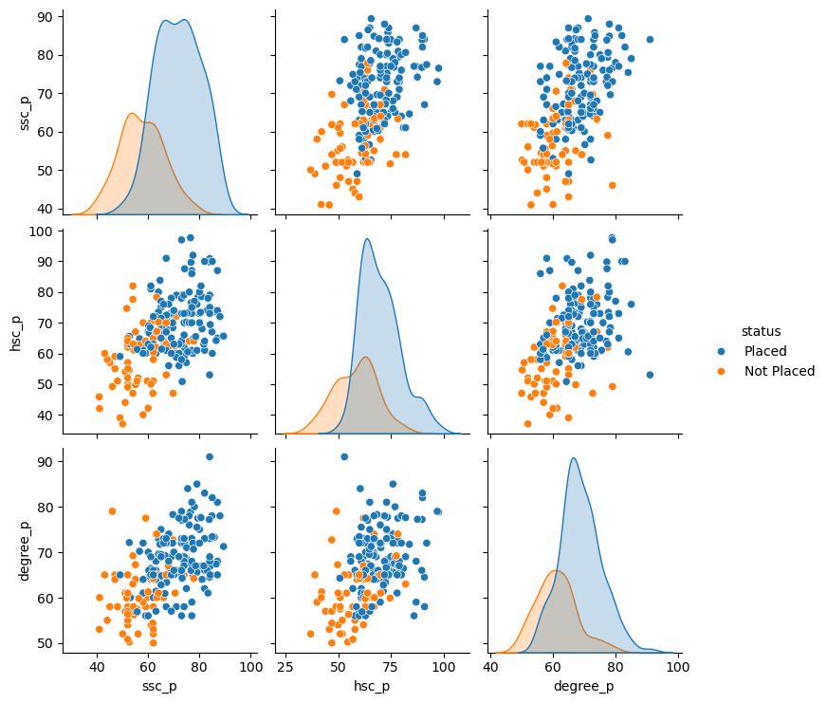

Distribution Plots
- Analyzing feature distributions
- Checking for normality
- Identifying skewness and kurtosis

7. Outlier Detection
Methods for identifying anomalies: -
- IQR Method: Using interquartile range
  - Lower bound: Q1 - 1.5 * IQR
  - Upper bound: Q3 + 1.5 * IQR
- Visual inspection: Box plots, scatter plots
- Z-score method: For normally distributed data
- Deciding whether to remove, cap, or keep outliers

Dataset Description

Features
- sl_no: Serial number (identifier)
- gender: Male (M) / Female (F)
- ssc_p: Secondary Education percentage (10th Grade)
- ssc_b: Board of Education (Central/Others)
- hsc_p: Higher Secondary Education percentage (12th Grade)
- hsc_b: Board of Education (Central/Others)
- hsc_s: Specialization (Commerce/Science/Arts)
- degree_p: Degree percentage
- degree_t: Degree type (Sci&Tech/Comm&Mgmt/Others)
- workex: Work Experience (Yes/No)
- etest_p: Employability test percentage
- specialisation: MBA Specialization
- mba_p: MBA percentage
- status: Placement status (Placed/Not Placed)
- salary: Offered salary (if placed)

Key Functions Used

Data Exploration
- pd.read_csv() - Load dataset
- df.head(), df.tail() - View samples
- df.info() - Dataset information
- df.describe() - Statistical summary
- df.shape - Dimensions
- df.columns - Column names
- df.dtypes - Data types

Missing Values
- df.isnull().sum() - Count missing values
- df.fillna() - Fill missing values
- df.dropna() - Remove missing values

Analysis
- df.value_counts() - Frequency counts
- df.corr() - Correlation matrix
- df.groupby() - Group and aggregate

Visualization
- sns.scatterplot() - Scatter plots
- sns.boxplot() - Box plots
- sns.heatmap() - Correlation heatmap
- sns.pairplot() - Pair plots
- sns.distplot() or sns.histplot() - Distribution plots
- plt.figure() - Create figures
- plt.title(), plt.xlabel(), plt.ylabel() - Labels

Analysis Workflow
1. Load Data
↓
2. Explore Structure (shape, info, describe)
↓
3. Check Missing Values
↓
4. Handle Missing Data
↓
5. Analyze Categorical Variables
↓
6. Analyze Numerical Variables
↓
7. Correlation Analysis
↓
8. Visualize Relationships
↓
9. Detect Outliers
↓
10. Draw Insights

Learning Outcomes
After completing this experiment, you will be able to:
- Perform comprehensive exploratory data analysis
- Handle missing values in real-world datasets
- Analyze both categorical and numerical variables
- Compute and interpret correlation matrices
- Create meaningful visualizations for data exploration
- Detect and handle outliers effectively
- Identify relationships between features
- Draw actionable insights from data
- Prepare data for machine learning modeling
- Communicate findings through visualizations

Key Insights from Placement Data
- Relationship between academic performance and placement
- Impact of work experience on placement outcomes
- Correlation between different education stages
- Gender distribution in placements
- Salary ranges and determinants
- Outliers in academic scores or salary
- Most influential factors for placement success

Practical Applications
- Understanding factors affecting student placements
- Identifying areas for student improvement
- Predicting placement likelihood
- Optimizing recruitment strategies
- Educational policy decisions
- Career counseling insights
- Performance benchmarking

Lab Experiment 06: Linear Regression

Overview
This notebook implements Linear Regression, a fundamental supervised learning algorithm, to predict student salaries based on academic performance and other factors. It demonstrates the complete machine learning workflow from data preparation to model evaluation.

Topics Covered
- Data loading and cleaning for regression tasks
- Exploratory Data Analysis (EDA) for regression
- Feature selection and engineering
- Splitting data for training and testing
- Training Linear Regression models
- Model evaluation using multiple metrics
- Interpreting regression coefficients
- Making predictions on new data

Key Concepts

1. Linear Regression Theory
Understanding the algorithm: -
- Concept: Finding the best-fit line through data points –
- Equation: y = β₀ + β₁x₁ + β₂x₂ + … + βₙxₙ + ε
  - y: Target variable (salary)
  - β₀: Intercept
  - β₁, β₂, …, βₙ: Coefficients (feature weights)
  - x₁, x₂, …, xₙ: Features - ε: Error term
- Goal: Minimize the sum of squared residuals (RSS)
- Assumptions:
  - Linear relationship between features and target
  - Independence of errors
  - Homoscedasticity (constant variance)
  - Normal distribution of errors

2. Data Preparation for Regression
- Loading placement dataset
- Handling missing values (crucial for salary predictions)
- Identifying and separating categorical vs numerical features
- Understanding the target variable (salary)
- Dealing with placement status (not all students have salaries)

3. Feature Engineering
Preparing features for the model: -
- Selecting relevant features (academic scores, test scores, work experience)
- Encoding categorical variables (gender, board, specialization)
- Creating interaction features if needed
- Handling missing salary values (only for placed students)

4. Train-Test Split
- Splitting data into training and testing sets
- Typical ratio: 80-20 or 70-30
- Using train_test_split() with random_state for reproducibility
- Ensuring stratification if needed

5. Model Training
Building the regression model: -
- Creating LinearRegression() instance
- Fitting the model with fit(X_train, y_train)
- Understanding what happens during training
- Learning optimal coefficients

6. Model Evaluation Metrics

R-squared (R²) Score
- Measures proportion of variance explained by the model
- Range: 0 to 1 (higher is better)
- Formula: R² = 1 - (SS_res / SS_tot)
- Interpretation:
  - 0.7-1.0: Strong model
  - 0.4-0.7: Moderate model
  - 0.0-0.4: Weak model

Mean Absolute Error (MAE)
- Average of absolute differences between predictions and actual values
- Same units as the target variable
- Less sensitive to outliers than MSE
- Easier to interpret

Mean Squared Error (MSE)
- Average of squared differences
- Penalizes larger errors more heavily
- Always positive, lower is better

Root Mean Squared Error (RMSE)
- Square root of MSE
- Same units as target variable
- More interpretable than MSE
- Commonly used metric

7. Model Interpretation
- Examining coefficients (feature importance)
- Understanding positive vs negative relationships
- Identifying most influential features
- Assessing model assumptions

8. Making Predictions
- Using predict() on test data
- Comparing predictions with actual values
- Understanding prediction intervals
- Applying model to new, unseen data

Dataset Features

Independent Variables (Features)
- Academic scores: ssc_p, hsc_p, degree_p, mba_p
- Test scores: etest_p
- Categorical: gender, ssc_b, hsc_b, hsc_s, degree_t, workex, specialisation
- Status: placement status

Dependent Variable (Target)
- salary: Offered salary (only available for placed students)

Key Functions Used

Data Preparation
- pd.read_csv() - Load data
- df.isnull().sum() - Check missing values
- df.fillna() - Handle missing values
- df.drop() - Remove unnecessary columns
- LabelEncoder() - Encode categorical variables

Model Building
- train_test_split() - Split dataset
- LinearRegression() - Create model instance
- model.fit(X_train, y_train) - Train model
- model.predict(X_test) - Make predictions

Evaluation
- r2_score(y_true, y_pred) - Calculate R² score
- mean_absolute_error(y_true, y_pred) - Calculate MAE
- mean_squared_error(y_true, y_pred) - Calculate MSE
- np.sqrt(mse) - Calculate RMSE

Analysis
- model.coef_ - Get feature coefficients
- model.intercept_ - Get intercept
- Correlation analysis for feature selection

Model Training Workflow
1. Load and Clean Data
↓
2. Handle Missing Values (especially in salary)
↓
3. Encode Categorical Variables
↓
4. Select Features (X) and Target (y)
↓
5. Split into Train and Test Sets
↓
6. Create Linear Regression Model
↓
7. Train Model on Training Data
↓
8. Make Predictions on Test Data
↓
9. Evaluate Model Performance
↓
10. Interpret Results and Coefficients

Learning Outcomes
After completing this experiment, you will be able to:
- Understand Linear Regression theory and assumptions
- Prepare data specifically for regression tasks
- Handle missing values in target variables
- Encode categorical features appropriately
- Split data for proper model evaluation
- Train a Linear Regression model using scikit-learn
- Evaluate regression models using multiple metrics
- Interpret R² score and error metrics
- Understand feature coefficients and their meaning
- Make predictions on new data
- Identify important features for salary prediction
- Diagnose model performance issues

Practical Applications
- Predicting salaries based on qualifications
- Estimating house prices from features
- Forecasting sales from marketing spend
- Predicting student performance
- Estimating project costs
- Stock price prediction (simple models)
- Budget forecasting
- Resource allocation planning

Common Issues and Solutions
Issue | Possible Cause | Solution
Low R² score | Poor feature selection | Add/remove features, engineer new features
High error on test set | Overfitting | Regularization, more data, simpler model
Large residuals | Outliers present | Remove outliers or use robust regression
Negative R² | Model worse than mean | Check data quality, feature engineering
Coefficients don’t make sense | Multicollinearity | Remove correlated features, use VIF

Interpreting Results
- High R²: Model explains variance well
- Low MAE/RMSE: Predictions are close to actual values
- Positive coefficient: Feature increases with target
- Negative coefficient: Feature decreases with target
- Large coefficient magnitude: Strong feature influence

When to Use Linear Regression
- Linear relationship between features and target
- Continuous target variable
- Minimal multicollinearity
- Need interpretable model
- Fast training required

When NOT to Use Linear Regression
- Non-linear relationships
- Classification problems
- Heavy outliers in data
- Features not independent
- Need complex pattern recognition

Lab Experiment 07: Logistic Regression

Overview
This notebook implements Logistic Regression, a supervised learning algorithm for binary classification, to predict student placement status (Placed/Not Placed). It demonstrates the complete classification workflow including data preparation, model training, and comprehensive evaluation.

Topics Covered
- Binary classification fundamentals
- Data preparation for classification tasks
- Exploratory Data Analysis for classification
- Feature visualization techniques
- Training Logistic Regression models
- Classification evaluation metrics
- Probability prediction and decision thresholds
- Model interpretation for classification

Key Concepts

1. Logistic Regression Theory
Understanding the classification algorithm: -
- Purpose: Binary classification (Yes/No, 0/1, True/False)
- Concept: Predicts probability of an event occurring
- Equation: P(y=1) = 1 / (1 + e^(-(β₀ + β₁x₁ + … + βₙxₙ)))
  - Uses sigmoid/logistic function
  - Outputs probability between 0 and 1
  - Decision boundary typically at 0.5
- Key Difference from Linear Regression: Outputs probabilities, not continuous values
- Applications: Medical diagnosis, spam detection, credit approval, placement prediction

2. Data Preparation for Classification
- Loading placement dataset
- Handling missing values (filling with 0 for salary)
- Binary target variable: status (Placed=1, Not Placed=0)
- Feature engineering for classification

3. Exploratory Data Analysis

Visualization Techniques
- Scatter Plots: Exploring feature relationships colored by class
- Pair Plots: Visualizing multiple feature combinations
- Box Plots: Comparing feature distributions across classes
- Understanding class separation in feature space

Feature Analysis
- Identifying features that discriminate between classes
- Checking for class imbalance
- Correlation with target variable
- Feature distributions for each class

4. Data Encoding and Transformation
- Encoding categorical variables (Label Encoding)
- Handling binary features (gender, work experience)
- Encoding multi-class categories (specialization, degree type)
- Preparing features for model training

5. Model Training
Building the classification model: -
- Creating LogisticRegression() instance
- Fitting model with fit(X_train, y_train)
- Understanding maximum iterations and convergence
- Learning decision boundaries

6. Making Predictions

Binary Predictions
- Using predict() for class labels (0 or 1)
- Applying decision threshold (default 0.5)

Probability Predictions
- Using predict_proba() for probability scores
- Getting probability for each class
- Adjusting threshold for different use cases

7. Model Evaluation Metrics

Accuracy Score
- Proportion of correct predictions
- Formula: (TP + TN) / (TP + TN + FP + FN)
- Range: 0 to 1 (higher is better)
- Limitation: Misleading for imbalanced datasets

Confusion Matrix
A 2x2 table showing prediction results:
Predicted
No Yes
Actual No TN FP
Yes FN TP
- True Positives (TP): Correctly predicted positive class
- True Negatives (TN): Correctly predicted negative class
- False Positives (FP): Incorrectly predicted positive (Type I error)
- False Negatives (FN): Incorrectly predicted negative (Type II error)

Precision
- Accuracy of positive predictions
- Formula: TP / (TP + FP)
- “When it predicts positive, how often is it correct?”
- Important when cost of FP is high

Recall (Sensitivity, True Positive Rate)
- Coverage of actual positive cases
- Formula: TP / (TP + FN)
- “Of all actual positives, how many did we catch?”
- Important when cost of FN is high

F1-Score
- Harmonic mean of precision and recall
- Formula: 2 × (Precision × Recall) / (Precision + Recall)
- Balances precision and recall
- Good for imbalanced datasets

Classification Report
- Comprehensive summary showing precision, recall, F1-score
- Per-class and overall metrics
- Support (number of samples per class)

8. ROC Curve and AUC
- ROC Curve: Plot of True Positive Rate vs False Positive Rate
- AUC: Area Under the ROC Curve (0 to 1)
- Interpretation:
  - AUC = 1.0: Perfect classifier
  - AUC = 0.9-1.0: Excellent
  - AUC = 0.8-0.9: Good
  - AUC = 0.7-0.8: Fair
  - AUC = 0.5: Random guess

Dataset Features

Independent Variables (Features)
- Academic performance: ssc_p, hsc_p, degree_p, mba_p
- Test scores: etest_p
- Categorical: gender, boards, streams, specialization
- Work experience: workex
- Salary information

Dependent Variable (Target)
- status: Placement status (Placed/Not Placed) - Binary classification

Key Functions Used

Data Preparation
- pd.read_csv() - Load data
- df.fillna(0) - Fill missing values
- LabelEncoder() - Encode categorical variables
- df[df['status'] == 'Placed'] - Filter data

Visualization
- plt.scatter() - Scatter plots
- sns.pairplot() - Pair plots
- sns.boxplot() - Box plots
- Color coding by target class

Model Building
- LogisticRegression(max_iter=1000) - Create model
- model.fit(X_train, y_train) - Train model
- model.predict(X_test) - Get class predictions
- model.predict_proba(X_test) - Get probability predictions

Evaluation
- accuracy_score(y_true, y_pred) - Calculate accuracy
- confusion_matrix(y_true, y_pred) - Generate confusion matrix
- classification_report(y_true, y_pred) - Detailed report
- precision_score(), recall_score(), f1_score() - Individual metrics
- roc_auc_score(y_true, y_proba) - Calculate AUC
- roc_curve(y_true, y_proba) - Generate ROC curve data

Model Training Workflow
1. Load Placement Data
↓
2. Handle Missing Values
↓
3. Encode Categorical Features
↓
4. Visualize Feature Relationships by Class
↓
5. Prepare Features (X) and Target (y)
↓
6. Split into Train/Test Sets
↓
7. Create Logistic Regression Model
↓
8. Train Model on Training Data
↓
9. Predict on Test Data
↓
10. Evaluate Using Multiple Metrics
↓
11. Analyze Confusion Matrix
↓
12. Generate Classification Report

Learning Outcomes
After completing this experiment, you will be able to:
- Understand Logistic Regression for binary classification
- Prepare data for classification tasks
- Visualize feature relationships with target classes
- Encode categorical variables for classification
- Train Logistic Regression models
- Make both class and probability predictions
- Evaluate classification models comprehensively
- Interpret confusion matrices
- Understand precision vs recall trade-off
- Calculate and interpret accuracy, precision, recall, F1-score
- Use classification reports effectively
- Understand when to use different evaluation metrics

Practical Applications
- Placement Prediction: Will a student get placed?
- Medical Diagnosis: Does patient have disease?
- Spam Detection: Is email spam or not?
- Credit Approval: Should loan be approved?
- Customer Churn: Will customer leave?
- Fraud Detection: Is transaction fraudulent?
- Quality Control: Is product defective?
- Sentiment Analysis: Positive or negative review?

Understanding the Trade-offs

High Precision, Low Recall
- Conservative classifier
- Few false positives
- Many false negatives
- Example: Only flag very obvious spam

Low Precision, High Recall
- Aggressive classifier
- Few false negatives
- Many false positives
- Example: Flag all potential fraud for review

Balanced F1-Score
- Compromise between precision and recall
- Good for general use cases

Common Issues and Solutions
Issue | Possible Cause | Solution
Low accuracy on test set | Overfitting | Regularization, more data
High accuracy but poor precision | Class imbalance | Use F1-score, adjust threshold
Model not converging | Too few iterations | Increase max_iter parameter
Poor recall | Conservative threshold | Lower decision threshold
Poor precision | Aggressive threshold | Raise decision threshold

When to Use Logistic Regression
- Binary classification problem
- Need probability estimates
- Want interpretable model
- Linear decision boundary sufficient
- Fast training needed
- Limited data available

When NOT to Use Logistic Regression
- Complex non-linear relationships
- Multi-class with many classes (use softmax)
- Need to capture interactions automatically
- Very high-dimensional data
- Strong feature dependencies

Confusion Matrix Interpretation Example
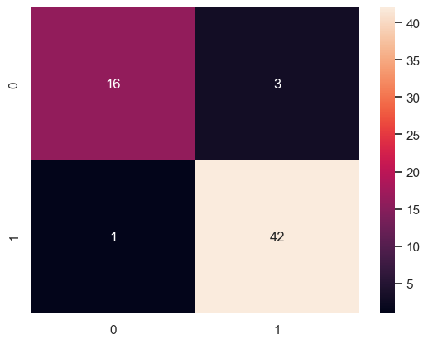

Lab Experiment 08: K-Nearest Neighbors (KNN)

Overview
This notebook implements the K-Nearest Neighbors (KNN) algorithm to classify breast cancer tumors as benign or malignant. KNN is a simple, intuitive, non-parametric machine learning algorithm that demonstrates the power of distance-based classification.

Topics Covered
- Understanding KNN algorithm fundamentals
- Loading and exploring medical datasets
- Handling missing and noisy data
- Feature engineering and selection
- Feature scaling for distance-based algorithms
- Training KNN classifiers
- Comprehensive model evaluation
- Hyperparameter tuning (finding optimal k)
- ROC-AUC analysis

Key Concepts

1. K-Nearest Neighbors Theory

How KNN Works
- Store all training data (lazy learning)
- Calculate distance from test point to all training points
- Identify k nearest neighbors
- Vote among neighbors for classification
- Predict majority class (or weighted vote)

Key Characteristics
- Non-parametric: No assumptions about data distribution
- Lazy learning: No explicit training phase
- Instance-based: Stores all training data
- Distance-based: Relies on similarity metrics

Distance Metrics
- Euclidean Distance (most common): √(Σ(xi - yi)²)
- Manhattan Distance: Σ|xi - yi|
- Minkowski Distance: Generalized distance
- Hamming Distance: For categorical data

Choosing k
- Small k (k=1): More sensitive to noise, complex boundaries
- Large k: Smoother boundaries, more computational cost
- Odd k: Avoids ties in binary classification
- Rule of thumb: k = √n (n = number of samples)

2. Dataset Description

Breast Cancer Wisconsin Dataset
- Source: UCI Machine Learning Repository
- Purpose: Predict tumor type (benign/malignant)
- Samples: ~700 patient records
- Features: 9 attributes describing cell characteristics

Features
- Clump Thickness: 1-10
- Uniformity of Cell Size: 1-10
- Uniformity of Cell Shape: 1-10
- Marginal Adhesion: 1-10
- Single Epithelial Cell Size: 1-10
- Bare Nuclei: 1-10
- Bland Chromatin: 1-10
- Normal Nucleoli: 1-10
- Mitoses: 1-10

Target Variable
- Class: 2 (benign) or 4 (malignant)

3. Data Preprocessing

Handling Missing Values
- Identifying missing values (often marked as ‘?’)
- Converting to NaN
- Imputation strategies:
  - Drop rows with missing values
  - Fill with median/mean
  - Use mode for categorical
  - KNN imputation

Data Type Conversion
- Converting string columns to numeric
- Handling non-numeric entries
- Ensuring proper data types for calculations

Outlier Detection
- Using statistical methods (IQR, Z-score)
- Visual inspection with box plots
- Deciding on outlier treatment

4. Feature Engineering

Feature Scaling (Critical for KNN!)
Why scaling is essential: -
- KNN uses distance calculations
- Features with larger ranges dominate
- Equal feature contribution needed
Methods: -
- StandardScaler: Mean=0, Std=1
- MinMaxScaler: Scale to [0, 1]
- RobustScaler: Resistant to outliers

Feature Selection
- Removing irrelevant features (ID columns)
- Correlation analysis
- Feature importance from preliminary models
- Domain knowledge

5. Model Training and Evaluation

Training Process
from sklearn.neighbors import KNeighborsClassifier
knn = KNeighborsClassifier(n_neighbors=5)
knn.fit(X_train_scaled, y_train)

Evaluation Metrics
All classification metrics from Logistic Regression: -
- Accuracy Score
- Confusion Matrix
- Precision, Recall, F1-Score
- Classification Report
- ROC Curve and AUC

6. Hyperparameter Tuning

Finding Optimal k
Testing different k values:
k_values = range(1, 31)
for k in k_values:
knn = KNeighborsClassifier(n_neighbors=k)
# Train and evaluate

Evaluation Strategies
- Train vs Test Accuracy: Detecting overfitting
- Cross-Validation: More robust evaluation
- Grid Search: Systematic parameter search

Bias-Variance Trade-off
- Low k: High variance, low bias (overfitting)
- High k: Low variance, high bias (underfitting)
- Optimal k: Balances both

7. Model Visualization

Decision Boundaries
- Visualizing how KNN separates classes
- Understanding local vs global patterns
- Comparing different k values

Error Analysis
- Analyzing misclassified samples
- Understanding failure cases
- Identifying challenging regions

Key Functions Used

Data Preprocessing
- pd.read_csv(header=None) - Load data without headers
- df.replace('?', np.nan) - Replace missing value markers
- df.dropna() - Remove missing values
- pd.to_numeric() - Convert to numeric type
- df.drop() - Remove columns

Feature Scaling
- StandardScaler() - Create scaler
- scaler.fit(X_train) - Fit on training data
- scaler.transform(X_train) - Transform training data
- scaler.transform(X_test) - Transform test data (using train stats)

Model Building
- KNeighborsClassifier(n_neighbors=k) - Create KNN model
- model.fit(X_train, y_train) - Train model
- model.predict(X_test) - Make predictions
- model.predict_proba(X_test) - Get probabilities

Evaluation
- All classification metrics functions
- cross_val_score() - Cross-validation
- Grid search functions

Visualization
- plt.plot() - Plot k vs accuracy
- sns.heatmap() - Confusion matrix heatmap
- ROC curve plotting

Model Training Workflow
1. Load Breast Cancer Dataset
↓
2. Explore Data (shape, dtypes, missing values)
↓
3. Handle Missing Values ('?' → NaN → Drop/Fill)
↓
4. Convert Data Types (string → numeric)
↓
5. Visualize Data (distributions, correlations)
↓
6. Remove ID Column and Irrelevant Features
↓
7. Separate Features (X) and Target (y)
↓
8. Split into Train/Test Sets
↓
9. Scale Features (Critical for KNN!)
↓
10. Train KNN Model (start with k=5)
↓
11. Make Predictions
↓
12. Evaluate Model (accuracy, confusion matrix, etc.)
↓
13. Tune k Parameter (test k=1 to k=30)
↓
14. Select Optimal k Based on Validation
↓
15. Final Evaluation with Best k

Learning Outcomes
After completing this experiment, you will be able to:
- Understand KNN algorithm mechanics
- Work with medical datasets responsibly
- Handle missing values in real-world data
- Understand importance of feature scaling for distance-based algorithms
- Implement KNN classification from scratch concepts
- Train KNN models using scikit-learn
- Evaluate classification models comprehensively
- Perform hyperparameter tuning systematically
- Understand bias-variance trade-off
- Choose optimal k value through validation
- Compare KNN with other algorithms
- Interpret distance-based classification results

Practical Applications
- Medical Diagnosis: Cancer detection, disease classification
- Image Recognition: Face recognition, handwriting recognition
- Recommendation Systems: Finding similar users/items
- Anomaly Detection: Detecting outliers
- Pattern Recognition: Fingerprint identification
- Credit Rating: Assessing creditworthiness
- Customer Segmentation: Finding similar customers
- Document Classification: Text categorization

Advantages of KNN
- Simple to understand and implement
- No training phase (fast setup)
- No assumptions about data distribution
- Effective for non-linear decision boundaries
- Naturally handles multi-class classification
- Can be adapted for regression (KNN Regressor)
- New data easily incorporated

Disadvantages of KNN
- Computationally expensive at prediction time
- Requires significant memory (stores all data)
- Sensitive to feature scaling
- Curse of dimensionality (performance degrades in high dimensions)
- Sensitive to noisy data and outliers
- Choosing appropriate k is crucial
- Imbalanced classes can bias predictions

KNN vs Other Algorithms
Aspect | KNN | Logistic Regression | Decision Trees
Training | No explicit training | Learns parameters | Builds tree
Prediction Speed | Slow | Fast | Fast
Decision Boundary | Complex, local | Linear | Rectangular
Interpretability | Low | High | High
Feature Scaling | Required | Recommended | Not needed
Handles Non-linearity | Yes | No | Yes

Choosing Optimal k

Methods
- Elbow Method: Plot k vs accuracy, find “elbow”
- Cross-Validation: Use k-fold CV for each k
- Grid Search: Systematic search with CV
- Odd Numbers: For binary classification (avoid ties)

Indicators
- Overfitting: Training accuracy >> Test accuracy
- Underfitting: Both accuracies low
- Good Fit: Similar train/test accuracies, both high

Feature Scaling Impact

Without Scaling
Feature 1: [0, 1]
Feature 2: [0, 1000]
Distance dominated by Feature 2!

With Scaling (StandardScaler)
Feature 1: [-2, 2] (mean=0, std=1)
Feature 2: [-2, 2] (mean=0, std=1)
Equal contribution to distance!

Handling Imbalanced Classes
- Use weighted KNN (weights='distance')
- Oversample minority class
- Undersample majority class
- Use class-balanced metrics (F1-score)
- Adjust decision threshold

Performance Optimization
- Use KD-trees or Ball-trees for faster search
- Reduce dimensionality (PCA, feature selection)
- Use approximate nearest neighbors for large datasets
- Implement parallel processing
- Consider online KNN for streaming data

Common Pitfalls
- Forgetting to scale features
- Using k=1 (too sensitive to noise)
- Not tuning k parameter
- Including irrelevant features
- Using KNN with high-dimensional data
- Not handling missing values
- Ignoring class imbalance
- Scaling test data independently (use train scaler!)

Lab Experiment 09: K-Means Clustering

Overview
This notebook implements K-Means Clustering, an unsupervised learning algorithm that groups similar data points into clusters. Unlike classification algorithms, K-Means discovers patterns without labeled data, making it ideal for exploratory data analysis and pattern discovery.

Topics Covered
- Understanding unsupervised learning
- K-Means algorithm fundamentals
- Data preparation for clustering
- Determining optimal number of clusters
- Visualizing clusters
- Interpreting cluster characteristics
- Evaluating clustering quality
- Practical applications of clustering

Key Concepts

1. Unsupervised Learning
Understanding the paradigm: -
- No labels: Algorithm finds patterns without target variable
- Goal: Discover hidden structure in data
- Exploratory: Understanding data distribution and groupings
- Types: Clustering, dimensionality reduction, anomaly detection

2. K-Means Algorithm Theory

How K-Means Works
- Initialize: Randomly select k centroids
- Assign: Assign each point to nearest centroid
- Update: Recalculate centroids as mean of assigned points
- Repeat: Steps 2-3 until convergence
- Converge: When centroids no longer move significantly

Key Characteristics
- Partitioning algorithm: Divides data into k non-overlapping clusters
- Distance-based: Uses Euclidean distance (typically)
- Iterative: Refines clusters through iterations
- Converges: Guaranteed to converge (to local optimum)
- Fast: Computationally efficient for large datasets

Algorithm Parameters
- n_clusters (k): Number of clusters to form
- init: Initialization method (‘k-means++’ recommended)
- max_iter: Maximum iterations
- n_init: Number of times algorithm runs with different seeds
- random_state: For reproducibility

3. Determining Optimal k

Elbow Method
- Plot k vs Within-Cluster Sum of Squares (WCSS)
- WCSS = Σ(distance from points to their cluster centroid)²
- Look for “elbow” where WCSS decrease slows
- Trade-off between too few and too many clusters

Silhouette Score
- Measures how similar point is to its cluster vs other clusters
- Range: -1 to +1
  - +1: Point well matched to cluster
  - 0: Point on border between clusters
  - -1: Point assigned to wrong cluster
- Average silhouette score indicates overall quality

Gap Statistic
- Compares WCSS with expected WCSS under null distribution
- Higher gap suggests better clustering

Domain Knowledge
- Consider business requirements
- Interpretability of clusters
- Practical constraints

4. Data Preparation for Clustering

Feature Selection
- Choose relevant features for clustering
- Remove ID columns and target variables (unsupervised!)
- Consider feature importance for grouping

Feature Scaling
Critical for K-Means: -
- Distance-based algorithm
- Features must be on comparable scales
- Use StandardScaler or MinMaxScaler

Handling Missing Values
- Impute before clustering
- Remove rows with missing values
- Use mean/median/mode imputation

Dimensionality Reduction
- Use PCA for high-dimensional data
- Visualize clusters in 2D/3D
- Reduce computational cost

5. Cluster Visualization

2D Scatter Plots
- Plot two features, color by cluster
- Visualize cluster separation
- Identify overlapping regions

3D Scatter Plots
- Show three features simultaneously
- Better understanding of separation

Cluster Centers
- Plot centroids with different markers
- Show cluster representatives
- Understand cluster characteristics

Pair Plots
- Visualize all feature combinations
- See cluster separation across dimensions

6. Cluster Interpretation

Cluster Profiling
- Analyze mean values per cluster
- Identify distinguishing characteristics
- Name clusters based on patterns

Feature Importance
- Which features differentiate clusters most?
- Compare cluster statistics
- Understand cluster meanings

Dataset
Using the Placement dataset for clustering analysis: -
- Academic performance metrics
- Test scores - Background information
- Goal: Find natural groupings of students

Key Functions Used

Data Preparation
- pd.read_csv() - Load data
- df.fillna(0) - Handle missing values
- df.drop() - Remove columns
- StandardScaler() - Scale features

K-Means Clustering
- KMeans(n_clusters=k) - Create model
- kmeans.fit(X) - Fit model to data
- kmeans.predict(X) - Assign clusters
- kmeans.fit_predict(X) - Fit and predict
- kmeans.cluster_centers_ - Get centroids
- kmeans.labels_ - Get cluster assignments
- kmeans.inertia_ - Get WCSS

Evaluation
- silhouette_score(X, labels) - Calculate silhouette score
- Calculate WCSS for elbow method
- Cluster statistics and profiling

Visualization
- plt.scatter() - Scatter plots with cluster colors
- plt.plot() - Elbow curve
- sns.scatterplot() - Enhanced scatter plots
- Centroid visualization

K-Means Workflow
1. Load and Explore Data
↓
2. Handle Missing Values
↓
3. Select Features for Clustering
↓
4. Remove Target Variable (unsupervised!)
↓
5. Scale Features
↓
6. Determine Optimal k (Elbow Method)
↓
7. Train K-Means with Optimal k
↓
8. Assign Cluster Labels
↓
9. Visualize Clusters
↓
10. Interpret Cluster Characteristics
↓
11. Profile Each Cluster
↓
12. Validate and Refine

Learning Outcomes
After completing this experiment, you will be able to:
- Understand unsupervised learning concepts
- Implement K-Means clustering algorithm
- Prepare data appropriately for clustering
- Determine optimal number of clusters
- Use elbow method effectively
- Calculate and interpret silhouette scores
- Visualize clusters in 2D and 3D
- Interpret cluster characteristics
- Profile clusters for business insights
- Evaluate clustering quality
- Compare K-Means with other clustering algorithms
- Apply clustering to real-world problems

Practical Applications

Business Applications
- Customer Segmentation: Group customers by behavior
- Market Segmentation: Identify target markets
- Product Categorization: Group similar products
- Anomaly Detection: Identify outliers as small clusters

Educational Applications
- Student Grouping: Group students by performance
- Learning Patterns: Identify study behavior groups
- Intervention Targeting: Find at-risk student groups

Other Applications
- Image Compression: Color quantization
- Document Clustering: Group similar documents
- Genetics: Identify gene expression patterns
- Network Security: Detect unusual behavior patterns
- Recommendation Systems: Find similar users/items
- Geographic Analysis: Regional patterns

Advantages of K-Means
- Simple and easy to understand
- Fast and efficient (even for large datasets)
- Scalable to large datasets
- Guaranteed to converge
- Works well with spherical clusters
- Easy to implement
- Interpretable results

Disadvantages of K-Means
- Must specify k beforehand
- Sensitive to initialization
- Assumes spherical clusters
- Sensitive to outliers
- Struggles with clusters of different sizes/densities
- Only finds linear cluster boundaries
- Sensitive to feature scaling
- Can converge to local optimum

K-Means vs Other Clustering Algorithms
Aspect | K-Means | Hierarchical | DBSCAN
Cluster Shape | Spherical | Any | Any
Number of Clusters | Must specify | Flexible | Automatic
Outliers | Assigned to clusters | Flexible | Marked as noise
Scalability | Excellent | Poor | Good
Deterministic | No (init dependent) | Yes | Yes
Speed | Fast | Slow | Medium

Interpreting Results

Cluster Statistics Example
Cluster 0 (High Performers):
- Average SSC: 85%
- Average HSC: 82%
- Average MBA: 75%
- Work Experience: 80% Yes
Cluster 1 (Medium Performers):
- Average SSC: 70%
- Average HSC: 68%
- Average MBA: 62%
- Work Experience: 40% Yes
Cluster 2 (Low Performers):
- Average SSC: 55%
- Average HSC: 53%
- Average MBA: 58%
- Work Experience: 20% Yes

Business Insights
- Identify high-potential students
- Targeted intervention strategies
- Understand student profiles
- Optimize placement strategies

Elbow Method Example
WCSS vs k:
k=1: 10000
k=2: 5000 ← Large decrease
k=3: 3000 ← Large decrease
k=4: 2400 ← Smaller decrease (Elbow!)
k=5: 2100 ← Diminishing returns
k=6: 1900

Common Pitfalls
- Forgetting to scale features
- Including ID columns or target variables
- Not handling missing values
- Choosing k arbitrarily
- Ignoring outliers
- Over-interpreting clusters
- Using K-Means for non-spherical clusters
- Not validating results
- Running only once (sensitive to initialization)

Improving K-Means Results

Preprocessing
- Robust scaling for outliers
- PCA for dimensionality reduction
- Feature engineering for better separation

Algorithm Tuning
- Try different k values
- Use k-means++ initialization
- Increase n_init for stability
- Consider mini-batch K-Means for large data

Alternative Approaches
- Use Gaussian Mixture Models for overlapping clusters
- Try DBSCAN for arbitrary shapes
- Use Hierarchical clustering for nested structures
- Combine with other techniques (semi-supervised)

When to Use K-Means
- Spherical, well-separated clusters expected
- Large datasets (efficiency needed)
- Number of clusters can be estimated
- Features are continuous
- Quick exploratory analysis needed

When NOT to Use K-Means
- Clusters have arbitrary shapes
- Clusters have very different sizes
- Many outliers present
- Unknown number of clusters
- Overlapping clusters
- Hierarchical structure needed

Lab Experiment 10: Penguins Dataset Analysis

Overview
This notebook provides a comprehensive demonstration of Pandas operations using the Penguins dataset from Seaborn. It covers essential data manipulation, analysis, and aggregation techniques that are fundamental for data science workflows.

Topics Covered
- Data inspection and exploration
- Data selection and filtering
- Statistical summaries
- Grouping and aggregation
- Data transformation
- Handling categorical variables
- Missing value analysis
- Practical Pandas operations

Key Concepts

1. Data Inspection
Understanding your dataset structure: -
- head(n): View first n rows
- tail(n): View last n rows
- shape: Get dimensions (rows, columns)
- columns: List all column names
- dtypes: Check data types
- info(): Comprehensive dataset overview
- describe(): Statistical summary

2. Data Selection

Column Selection
- Single column: df['column'] or df.column
- Multiple columns: df[['col1', 'col2']]
- Column slicing: df.iloc[:, start:end]

Row Selection
- By position: df.iloc[index]
- By label: df.loc[label]
- First/last rows: head(), tail()
- Random sample: sample(n)

Conditional Selection
- Boolean indexing: df[df['column'] > value]
- Multiple conditions: df[(condition1) & (condition2)]
- isin() method: df[df['column'].isin([val1, val2])]

3. Data Filtering
Extracting relevant subsets: - Filter by single condition - Filter by multiple conditions (AND, OR, NOT) - Filter by text patterns (string methods) - Filter by value ranges - Filter null/non-null values

4. Statistical Operations

Descriptive Statistics
- mean(): Average value
- median(): Middle value
- mode(): Most frequent value
- std(): Standard deviation
- var(): Variance
- min(), max(): Minimum and maximum
- quantile(): Percentiles
- count(): Non-null count

Summary Functions
- describe(): Comprehensive statistics
- value_counts(): Frequency distribution
- nunique(): Count unique values
- unique(): List unique values

5. Grouping and Aggregation

GroupBy Operations
The split-apply-combine paradigm:
- Split: Group data by categorical variable
- Apply: Compute function on each group
- Combine: Aggregate results
df.groupby('category')['numeric_column'].mean()

Aggregation Functions
- sum(): Total
- mean(): Average
- count(): Count of values
- min(), max(): Extremes
- std(), var(): Dispersion
- agg(): Multiple aggregations

Multiple Aggregations
df.groupby('category').agg({
'column1': 'mean',
'column2': ['sum', 'count'],
'column3': 'max'
})

6. Data Transformation

Creating New Columns
- Arithmetic operations: df['new'] = df['col1'] + df['col2']
- Conditional logic: Using np.where() or apply()
- Binning: pd.cut(), pd.qcut()
- Ranking: rank()

Modifying Existing Columns
- In-place modification
- Type conversion: astype()
- String operations: str. methods
- DateTime operations: dt. methods

7. Handling Missing Values

Detection
- isnull(), isna(): Identify missing values
- isnull().sum(): Count missing per column
- isnull().any(): Check if any missing

Handling Strategies
- Drop: dropna()
- Fill: fillna()
- Forward/backward fill: ffill(), bfill()
- Interpolate: interpolate()

8. Working with Categorical Data

Understanding Categories
- Unique values: unique()
- Value counts: value_counts()
- Category proportions

Encoding
- Label encoding: Convert to integers
- One-hot encoding: get_dummies()
- Custom mapping: map(), replace()

Penguins Dataset Description

About the Dataset
- Source: Palmer Archipelago (Antarctica) penguin data
- Collected by: Dr. Kristen Gorman and Palmer Station
- Purpose: Study penguin species and their characteristics

Features
- species: Penguin species (Adelie, Chinstrap, Gentoo)
- island: Island in Palmer Archipelago (Biscoe, Dream, Torgersen)
- bill_length_mm: Bill length (millimeters)
- bill_depth_mm: Bill depth (millimeters)
- flipper_length_mm: Flipper length (millimeters)
- body_mass_g: Body mass (grams)
- sex: Penguin sex (Male, Female)

Dataset Characteristics
- Size: 344 penguins
- Species: 3 (Adelie, Chinstrap, Gentoo)
- Islands: 3 (Biscoe, Dream, Torgersen)
- Missing Values: Some (realistic dataset)
- Purpose: Ideal for learning data analysis

Key Functions Used

Data Inspection
- df.head(n) - First n rows
- df.tail(n) - Last n rows
- df.shape - Dimensions
- df.columns - Column names
- df.dtypes - Data types
- df.info() - Dataset information
- df.describe() - Statistical summary

Data Selection
- df['column'] - Single column
- df[['col1', 'col2']] - Multiple columns
- df.iloc[rows, cols] - Position-based selection
- df.loc[rows, cols] - Label-based selection
- df[df['column'] > value] - Conditional selection

Statistical Operations
- df['column'].mean() - Mean
- df['column'].median() - Median
- df['column'].std() - Standard deviation
- df['column'].min(), df['column'].max() - Min/Max
- df['column'].value_counts() - Frequency counts
- df['column'].nunique() - Count unique values

Grouping and Aggregation
- df.groupby('column') - Group by category
- df.groupby('col').mean() - Group and aggregate
- df.groupby('col').agg(['mean', 'sum']) - Multiple aggregations
- df.groupby(['col1', 'col2']) - Multiple grouping columns

Data Transformation
- df['new_col'] = expression - Create column
- df.drop(columns=['col']) - Remove columns
- df.rename(columns={'old': 'new'}) - Rename columns
- df.sort_values('column') - Sort data
- df.reset_index() - Reset index

Missing Values
- df.isnull() - Detect missing values
- df.dropna() - Remove missing values
- df.fillna(value) - Fill missing values

Common Analysis Tasks

Task 1: Basic Exploration
# Load data
df = sns.load_dataset('penguins')
# Basic info
print(df.shape)
print(df.head())
print(df.info())
print(df.describe())

Task 2: Filtering Data
# Adelie penguins only
adelie = df[df['species'] == 'Adelie']
# Heavy penguins (> 4000g)
heavy = df[df['body_mass_g'] > 4000]
# Multiple conditions
large_male = df[(df['sex'] == 'Male') & (df['body_mass_g'] > 4500)]

Task 3: Grouping Analysis
# Average body mass by species
df.groupby('species')['body_mass_g'].mean()
# Multiple statistics
df.groupby('species')['flipper_length_mm'].agg(['mean', 'min', 'max'])
# Group by multiple columns
df.groupby(['species', 'island'])['body_mass_g'].mean()

Task 4: Counting and Frequencies
# Species distribution
df['species'].value_counts()
# Island distribution by species
df.groupby('species')['island'].value_counts()
# Gender distribution
df['sex'].value_counts()

Task 5: Missing Value Analysis
# Check missing values
df.isnull().sum()
# Percentage missing
(df.isnull().sum() / len(df)) * 100
# Remove rows with missing values
df_clean = df.dropna()

Learning Outcomes
After completing this experiment, you will be able to:
- Load and inspect datasets efficiently
- Select specific rows and columns
- Filter data based on condition
- Calculate descriptive statistics
- Group data by categories
- Perform aggregations on grouped data
- Create and transform columns
- Handle missing values appropriately
- Analyze categorical variables
- Use Pandas efficiently for data analysis
- Extract meaningful insights from data
- Prepare data for visualization and modeling

Practical Applications

Data Analysis Workflows
- Exploratory Data Analysis (EDA)
- Data quality assessment
- Statistical reporting
- Feature engineering
- Data cleaning pipelines

Business Analytics
- Customer segmentation analysis
- Sales performance by region/category
- Product analysis and comparison
- Trend identification
- Cohort analysis

Scientific Research
- Experimental data analysis
- Species comparison studies
- Environmental monitoring
- Population studies
- Statistical hypothesis testing

Example Analyses

Species Comparison
# Average measurements by species
species_stats = df.groupby('species').agg({
'bill_length_mm': 'mean',
'bill_depth_mm': 'mean',
'flipper_length_mm': 'mean',
'body_mass_g': 'mean'
})

Gender Analysis
# Body mass difference between sexes
gender_mass = df.groupby('sex')['body_mass_g'].mean()
# Count by sex and species
sex_species = df.groupby(['species', 'sex']).size()

Island Distribution
# Species distribution across islands
island_species = pd.crosstab(df['island'], df['species'])
# Percentage distribution
island_species_pct = pd.crosstab(
df['island'],
df['species'],
normalize='index'
) * 100

Conclusion
This experiment provides a solid foundation in Pandas operations using a real-world dataset. The skills learned here are directly applicable to any data analysis project and form the basis for more advanced data science techniques.

