212.464.7989 • shigimcp@yahoo.com

Shigeru McPherson  digital designer / art director / front-end developer

<https://www.shigimcp.com> • <https://www.shigimcp.com/shigimcp2020-react>

LinkedIn Profile: <https://www.linkedin.com/in/shigeru-mcpherson-8a19a44>

A Quick Summary…

* Accomplished, energetic and goal-driven with over 25 years of experience in the fast-paced environments   
  of entertainment, fashion, beauty, pharmaceutical and B2B fields.
* Excellent technical skills in digital design, high-end retouching and typography that allow for scalability   
  across all media.
* A clear communicator and active team player, I am highly effective at collaborating with artistic, project   
  and production leadership to oversee projects from concept to final delivery according to budget   
  and schedule goals.
* Strong organizational and multitasking skills that allow me to work with minimal supervision if needed.

Experience

Ichiban Yofuku

Digital Designer / Front-End Developer

02.19 – 11.19

* E-commerce website design and development

Software: Adobe CC Photoshop, Illustrator, After Effects, Media Encoder

Languages: HTML5, JavaScript/jQuery, GSAP, CSS3/SCSS/SASS

MiMi

Digital Designer / Front-End Developer

10.18 – 04.19

* Logo / Brand ideation and design
* E-commerce website design and development

Software: Adobe CC Photoshop, Illustrator, After Effects, Media Encoder, Lightroom, XD, Sketch, InVision, Figma

Languages: HTML5, JavaScript/jQuery, GSAP, CSS3/SCSS/SASS

Elizabeth Arden

Freelance Digital Designer

07.12 - 10.17

* Website, banner and email design and development
* Facebook page design and development using Buddy Media
* Web app design & development (HTML5, CSS3, JavaScript)
* Animation & video editing

Software: Adobe CS Photoshop, Illustrator, After Effects, Media Encoder, Animate, Dreamweaver, DoubleClick

Languages: HTML5, JavaScript/jQuery, GSAP, CSS3, AS3

Armani Exchange

Freelance Digital Designer

12.10 - 07.12

* Microsite design and development
* Banner and email design and development
* Mobile site design and development from concept to completion

Distinction: AOL/KBS Project Devil Competition Winner (in conjunction with Media Kitchen)

Software: Adobe CS Photoshop, Illustrator, After Effects, Media Encoder, Animate, Dreamweaver, DoubleClick

Languages: HTML5, JavaScript/jQuery, GSAP, CSS3, AS3

Hearst Digital Media

Designer / Front-End Developer

04.08 - 01.09

* Promo player & evite design
* ActionScript design and development from concept to completion
* In-house promotion

Publications include: Seventeen, Cosmopolitan, CosmoGirl, Town & Country, Harper’s Bazaar

Software: Adobe CS Photoshop, Illustrator, Flash, Dreamweaver, After Effects

Languages: AS2, AS3

DDB Studio 8 (DDB Worldwide)

Multimedia Specialist

09.07 - 12.07

* Website design and development from concept to completion
* In-house promotion

Software: Adobe CS Photoshop, Illustrator, Dreamweaver

Languages: AS2, AS3

MRM Partners (McCann Worldgroup)

Art Director

08.05 - 05.06

* Worked closely with the copywriter to generate creative ideas and executions
* Very hands-on work including design and ActionScript development
* Produced sketches and storyboards to communicate ideas to clients
* Ensured deadlines were met and worked effectively under pressure
* Worked in industry-standard editing suites to oversee the finished product

Clients include: GM, Intel, Wendy’s

Software: Adobe CS Photoshop, Illustrator, Flash, Dreamweaver

Languages: HTML, CSS, AS2

Heeb Magazine

Designer / Design Director

04.04 - 05.05  
(issues: 06 - 08)

* Page design / layout
* Logo & type treatment
* Retouching
* Pre-press prep
* Asset trafficking

Pages include: "Battle of the Schwartzes", "Out from Under", photo & fiction features, products, parody ads

Software: Adobe CS Photoshop, Illustrator, QuarkXPress, Alias Maya (3D)

Harper’s Bazaar

Designer

11.01 - 08.03  
(Issues: 02.02 - 11.03)

* Heavy page layout, logo/type treatment
* Moderate (p)retouching
* Moderate pre-press preparation
* Light art trafficking

Pages include: cover(s), center of book photo features, "Letter From the Editor", "What to Wear", parties, reviews, horoscopes and product pages

Software: QuarkXPress, Adobe Photoshop, Illustrator, Infini-D, Strata StudioPro, Alias Maya (3D), Fontographer, various word processing applications

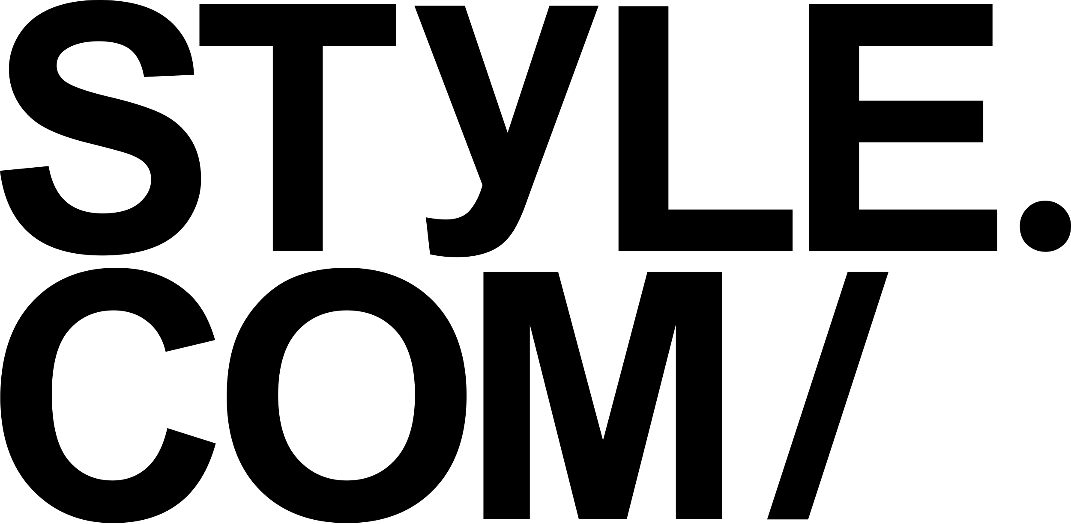Style.com

Freelance Production Designer

06.01 - 09.01

* E-commerce website asset creation
* Retouching
* Batch processing

Software: Adobe Photoshop

Luminant Worldwide Corporation (née Interactive8)

Art Director

11.99 - 11.00

* Website design and art direction
* Moderate HTML and light JavaScript
* Moderate Flash work
* Light 3d modeling & rendering

Clients include: A&E Television Networks, DeBeers, Gazelle.com (formerly MyLegs.com), M&M/Mars,   
Maybelline, RJ Reynolds, StarBand

Software: QuarkXPress, Adobe Illustrator, Photoshop, Premiere, ImageReady, Dimensions, Streamline, After Effects, Infini-D, Strata StudioPro, MacroMedia Director, Flash, AfterShock, Fireworks, SoundEdit 16 Plus Deck II, Fontographer, various word processing applications

Languages: HTML, CSS, AS2

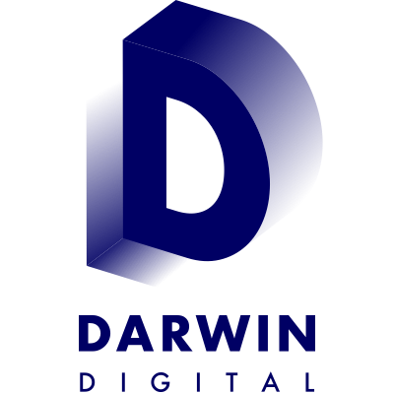Darwin Digital, A Saatchi & Saatchi Vision Company

Designer

12.97 - 11.99

* Website design
* Moderate programming, including html and light Javascript
* Moderate Flash work
* Light 3d modeling & rendering

Clients include: Albertsons, Allied Domecq, Darwin Digital, Enterprise, General Mills, GeoCities,   
Hewlett-Packard, Procter & Gamble, Reynolds Metals, Smarterkids, TeaQ, Tel-Save, Time Inc. New Media

Software: QuarkXPress, Adobe Illustrator, Photoshop, ImageReady, Streamline, After Effects, Infini-D,   
Strata StudioPro, MacroMedia Director, Flash, AfterShock, Fireworks, SoundEdit 16 Plus Deck II,   
Fontographer, various word processing applications

Languages: HTML, light DHTML, JavaScript, CSS

dELiA*s

Designer

02.99 - 03.99

* Prospectus cover design from concept to completion
* Website design from concept to completion

Software: QuarkXPress, Adobe Illustrator, Photoshop, ImageReady, Flash, Fireworks, Fontographer, various word processing applications

Languages: HTML, JavaScript, CSS

Media Circus

Production Designer

09.97 - 12.97

* Website asset creation for MTV and Gateway
* Interactive television screen design for Cablevision
* Also acted as Producer for this project

Software: Adobe Illustrator, Photoshop, Premiere

Sunshine Interactive Network

Designer

12.96 - 07.97

* Website and CD-Rom asset creation
* Moderate interface design
* Heavy 2D animation
* Manipulation of scanned artwork including retouching, coloring and batch processing
* Digital asset management
* Very light HTML programming

Titles include: Scholastic’s Mathshop Deluxe, New Line Cinema’s First Strike, The Mask, Austin Powers

Software: QuarkXPress, Adobe Illustrator, Photoshop, ImageReady, MacroMedia Director, FutureSplash (Flash), various word processing applications

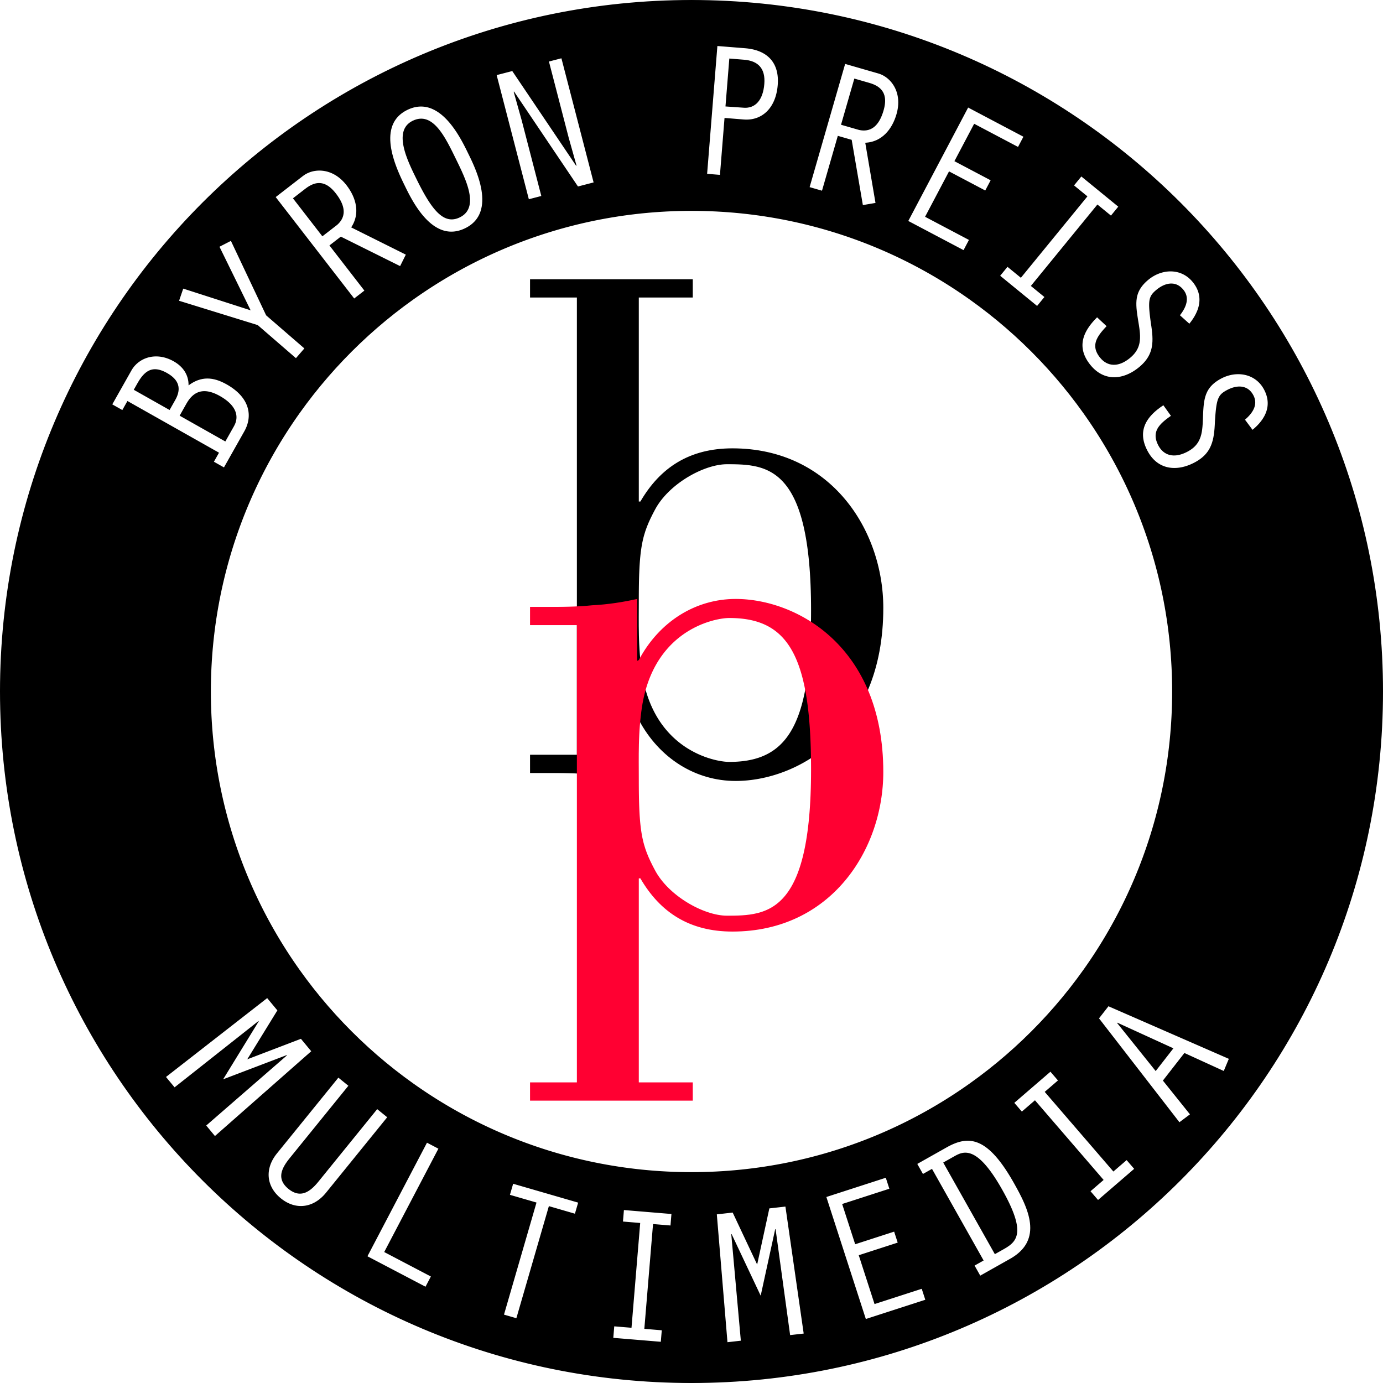Byron Preiss Multimedia Co., Inc.

Production Artist

11.95 - 12.96

* CD_Rom asset creation and interface design
* Heavy Quicktime movie creation including audio and video capture, 2D animation and editing
* 2D manipulation of scanned artwork including retouching, colorization of b/w photos   
  and batch processing
* 3D animation (design, modeling and rendering)
* Digital asset management
* Light Macromedia Director work including some Lingo script

Titles include: Scientific American's From Quarks to Cosmos and Simon & Schuster Interactive's Philip Marlowe, Private Eye

Software: QuarkXPress, Adobe Illustrator, Photoshop, Premiere, ImageReady, Streamline, After Effects,   
Infini-D, MacroMedia Director, various word processing applications

@radical.media / Tape House Interactive / RGA

Scan Retoucher / Colorist / Computer Animator

10.95

* Cel-by-cel production of 90-second animated spot for Nike's “All NYC” campaign   
  for viewing in theaters
* Digital scanning of original art in PC environment
* Scan clean-up in Adobe Photoshop, Streamline and Illustrator in PC and Mac environment
* Retouch and color in Adobe Photoshop in PC and Mac environments

Title: Nike All NYC

Software: Adobe Illustrator, Photoshop, Premiere, Streamline, After Effects, various word processing applications

MIX Film/Video Festival

Designer

09.95

* Design and layout from concept to completion of MIX 95 poster and catalogue
* Extensive scanning and page layout for 2-color output
* Light advertisement layout

Software: QuarkXPress, Adobe Illustrator, Photoshop, Premiere, ImageReady, Streamline, After Effects, Infini-D, various word processing applications

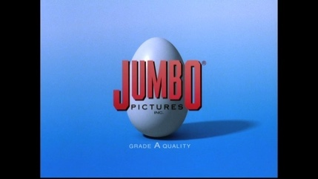Jumbo Pictures

Computer Animator

03.95 - 07.95

* Produce animatics from storyboard images using Adobe Premiere
* Shoot images from video camera directly to computer
* Record audio directly to computer
* Record complete animatic to half-inch or three quarter-inch videotape
* Consult on hardware/software purchases, storage systems and future options   
  for computer video production
* Help maintain and troubleshoot all in-house computers

Title: SportsBenders

Software: Adobe Illustrator, Photoshop, Premiere, After Effects, various word processing applications

ITVS/AIDSFilms

Production Assistant

09.94 - 07.95

* Sound recording
* Production photography
* Tech runner
* Administrative assistance

Title: Positive: Life With HIV

Software: Microsoft Office

MRY - various clients

Partner / Computer Graphics Specialist

04.94 - 12.96

* Design and layout from concept to completion for style guides, textboooks, brochures   
  and advertisements
* Scan retouching and/or compositing in Adobe Photoshop
* Computer illustration and fabric design in Adobe Illustrator and Photoshop
* 3D modeling and rendering using form•Z and Strata StudioPro

Software: QuarkXPress, Adobe Illustrator, Photoshop, form•Z, Infini-D, Strata StudioPro, Electric Image, various word processing applications

Oasis Creative Resources

Computer Graphics Specialist

08.93 - 04.94

* High resolution scan retouching
* Computer illustration including 3D rendering in Adobe Dimensions and Illustrator
* Brochure, ad and magazine layout

Software: QuarkXPress, Adobe Illustrator, Photoshop, various word processing applications

Education

Columbia University

School of Engineering and Applied Science

BS Mechanical Engineering

Skills

discipline

|  |  |
| --- | --- |
| Art Director Experience | 15+ years |
| Branding Experience | 15+ years |
| Conceive, create and produce original graphic design and assets for all marketing creative demands | 15+ years |
| Graphics Design Experience | 15+ years |
| Motion / Animation | 15+ years |
| Print | 15+ years |
| Web / UI / UX | 15+ years |
| Video Editing Experience | 5 years |

software

|  |  |
| --- | --- |
| Adobe Creative Suite | 15+ years |
| Illustrator | 15+ years |
| Photoshop | 15+ years |
| QuarkXPress | 15+ years |
| Premiere Pro / After Effects | 5 years |
| InDesign | 3 years |
| Sketch, XD, Figma, InVision | 1.5 years |

dev

|  |  |
| --- | --- |
| HTML[5], CSS[3] | 15+ years |
| Javascript / JQuery | 15+ years |
| GSAP | 11 years |
| SCSS / SASS | 2 years |
| NodeJS / npm | 1.5 years |
| React | 1.5 years |
| Angular 6 / 7 | 0.5 years |

3d

|  |  |
| --- | --- |
| Maya | 2 years |
| Unity | 2 years |