Shigeru McPherson

Digital Designer / Art Director / Front-End Developer

212.464.7989

shigimcp@yahoo.com

http://www.shigimcp.com

https://www.shigimcp.com/shigimcp2020-react

LinkedIn Profile: https://www.linkedin.com/in/shigeru-mcpherson-8a19a44

A quick summary:

- I am an accomplished, energetic and goal-driven with over 25 years' of experience in the fast-paced environments of entertainment, fashion, beauty, pharmaceutical and B2B fields.

- I possess the technical skills in digital design, high-end retouching and typography that allow for scalability across all media.

- A clear communicator and active team player, I am highly effective at collaborating with artistic, project, production leadership to oversee projects from concept to final delivery according to budget and schedule goals.

- I possess the strong organizational and multitasking skills that allow me to work with minimal supervision if needed.

Ichiban Yofuku

Digital Designer / Front-End Developer

02.19 - 11.19

- ecommerce website design and development (in-progress)

- languages: HTML5, Javascript/JQuery, GSAP, CSS3

MiMi

Digital Designer / Front-End Developer

10.18 - 04.19

- logo / brand ideation and design

- ecommerce website design and development (in-progress)

- languages: HTML5, Javascript/JQuery, GSAP, CSS3

Elizabeth Arden

Freelance Digital Designer

07.12 – 10.17

- website, banner and email design & development

- Facebook page design & development using Buddy Media

- web app design & development (HTML5, CSS3, Javascript)

- animation & video editing

- languages: HTML5, Javascript/JQuery, GSAP, CSS3, AS3

Armani Exchange

Freelance Digital Designer

12.10 – 07.12

- microsite design & development

- banner and email design & development

- mobile site design & development from concept to completion

- languages: HTML5, Javascript/JQuery, GSAP, CSS3, AS3

- distinction: AOL/KBS Project Devil Competition Winner (in conjunction with MediaKitchen)

Hearst Digital Media

Digital Designer / Front-End Developer

04.08 – 01.09

- promo player & evite design

- actionscript design & development from concept to completion

- in-house promotion

- languages: AS2, AS3

- publications include: Seventeen, Cosmopolitan, CosmoGirl, Town & Country, Harper’s Bazaar

DDB Studio 8 (DDB Worldwide)

Multimedia Specialist (design & development)

09.07 – 12.07

- website design & development from concept to completion

- in-house promotion

- languages: AS2

MRM Partners (McCann Worldgroup)

Art Director

08.05 – 05.06

- worked closely with the copywriter to generate creative ideas and executions

- very hands-on work including design and actionscript development

- produced sketches and storyboards to communicate ideas to clients

- ensured deadlines were met and worked effectively under pressure

- worked in industry-standard editing suites to oversee the finished product

- language: AS2

- clients include: GM, Intel, Wendy’s

Heeb Magazine

Designer / Design Director

04.04 – 05.05

(issues: 06 – 08)

- page design / layout

- logo & type treatment

- retouching

- pre-press prep

- asset trafficking

- pages include: Battle of the Schwartzes, Out from Under, photo features, fiction features, products, parody ads

Harper’s Bazaar

Designer

11.01 – 08.03

(issues: 02.02 – 11.03)

- heavy logo and type treatment

- heavy page layout

- moderate (p)retouching

- moderate pre-press preparation

- light art trafficking

- heavy scanning

- pages include: Cover(s), Center of Book photo features, Letter from the Editor, What to Wear, parties, reviews, horoscopes and product pages

Luminant Worldwide Corporation

Art Director

11.99 – 11.00

- website design and art direction

- moderate html and light Javascript

- moderate flash work

- light 3d modeling & rendering

- clients include: A&E Television Networks, DeBeers, gazelle.com (formerly mylegs.com), M&M/Mars, Maybelline, RJ Reynolds, Starband

Darwin Digital - A Saatchi & Saatchi Vision Company

Designer

12.97 – 11.99

- website design

- moderate programming, including html and light Javascript

- moderate flash work

- light 3d modeling & rendering

- clients include: Albertsons, Allied Domecq, Darwin Digital, Enterprise, General Mills, Geocities, Hewlett-Packard, Procter & Gamble, Reynolds Metals, Smarterkids, TeaQ, Tel-Save, Time Inc. New Med

­Education

Columbia University, School of Engineering and Applied Science

Degree: Bachelor of Science

Major: Mechanical Engineering

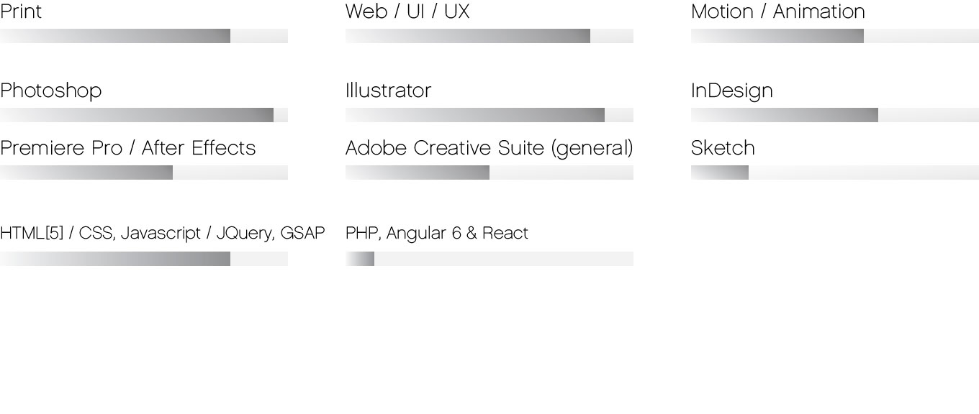Skills