 **Shigeru McPherson  digital designer / art director / (incidental) jr. developer**

I am an accomplished, energetic and goal-driven digital designer / art director   
/ (incidental) jr. developer, bringing over 15 years' experience in the fast-paced environments of entertainment, fashion, beauty, pharmaceutical and B2B fields..

PERSONAL INFO

212.464.7989

shigimcp@yahoo.com

http://www.shigimcp.com

SKILLS

Print  


Web  


SOFTWARE

Photoshop  


Illustrator  


InDesign  


Premiere Pro  


After Effects  


Microsoft Office  


DEVELOPMENT

UI / UX  


HTML[5] / CSS  


Javascript / JQuery  


GSAP  


PHP  


Angular 6 & React  


I possess a keen interest in the arts and a love for the maths and sciences, and I use my creative abilities and technical skills to forge innovative approaches to brand messaging, strategizing and producing ad campaigns and an online presence that inform and engage customers.

A clear communicator and active team player, I am highly effective at collaborating with artistic, project, production leadership to oversee projects from concept to final delivery according to budget and schedule goals. I also possess the strong organizational and multitasking skills that allow me to work with minimal supervision if needed.

All of these qualities have helped me find a rich and rewarding career that allows a free flow of creativity and critical thinking to make projects come to life. I bring that spirit to the table every time, and my hope is to bring that same spirit to *your* table.

EXPERIENCE



MiMi • digital designer / front-end developer 10.18 – 04.19

* logo / brand ideation and design
* ecommerce website design and development (in-progress)
* languages: html5, javascript/jquery, gsap, css3

Elizabeth Arden • freelance digital designer 07.12 - 10.17

* website, banner and email design and development
* facebook page design and development using Buddy Media
* web app design & development (html5, css3, javascript)
* animation & video editing
* languages: html5, javascript/jquery, gsap, css3, as3



Armani Exchange • freelance digital designer 12.10 - 07.12

* microsite design and development
* banner and email design and development
* mobile site design and development from concept to completion
* languages: html5, javascript/jquery, gsap, css3, as3

distinction: AOL/KBS Project Devil Competition Winner (in conjunction with MediaKitchen)



Hearst Digital Media • designer / front-end developer 04.08 - 01.09

* promo player & evite design
* actionscript design and development from concept to completion
* in-house promotion
* languages: as2, as3

publications include: *Seventeen*, *Cosmopolitan*, *Cosmogirl*, *Town & Country*, *Harper’s Bazaar*

 DDB Studio 8 (DDB Worldwide) • multimedia specialist 09.07 - 12.07

* website design and development from concept to completion
* in-house promotion
* languages: as2, as3



MRM Partners (McCann Worldgroup) • art director 08.05 - 05.06

* worked closely with the copywriter to generate creative ideas and executions
* very hands-on work including design and actionscript development
* produced sketches and storyboards to communicate ideas to clients
* ensured deadlines were met and worked effectively under pressure
* worked in industry-standard editing suites to oversee the finished product
* language: as2

clients include: GM, Intel, Wendy’s



Heeb Magazine • designer / design director 04.04 - 05.05 (issues: 06 - 08)

* page design / layout
* logo & type treatment
* retouching
* pre-press prep
* asset trafficking

pages include: *Battle of the Schwartzes*, *Out from Under*, photo & fiction features,   
products, parody ads



Harper’s Bazaar • designer 11.01 - 08.03 (issues: 02.02 - 11.03)

* heavy page layout, logo/type treatment
* moderate (p)retouching
* moderate pre-press preparation
* light art trafficking

pages include: Cover(s), Center of Book photo features, *Letter from the Editor*, *What to Wear*,   
parties, reviews, horoscopes and product pages

Luminant Worldwide Corporation • art director 11.99 - 11.00

* website design and art direction
* moderate html and light javascript
* moderate flash work
* light 3d modeling & rendering

clients include: A&E Television Networks, DeBeers, gazelle.com (formerly mylegs.com),

M&M/Mars, Maybelline, RJ Reynolds, Starband

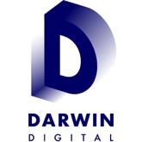Darwin Digital • designer 12.97 - 11.99  
A Saatchi & Saatchi Vision Company

* website design
* moderate programming, including html and light javascript
* moderate flash work
* light 3d modeling & rendering

clients include: Albertsons, Allied Domecq, Darwin Digital, Enterprise, General Mills, Geocities, Hewlett-Packard,   
Procter & Gamble, Reynolds Metals, Smarterkids, TeaQ, Tel-Save, Time Inc. New Media

EDUCATION



Columbia University, School of Engineering and Applied Science

Degree: Bachelor of Science

Major: Mechanical Engineering

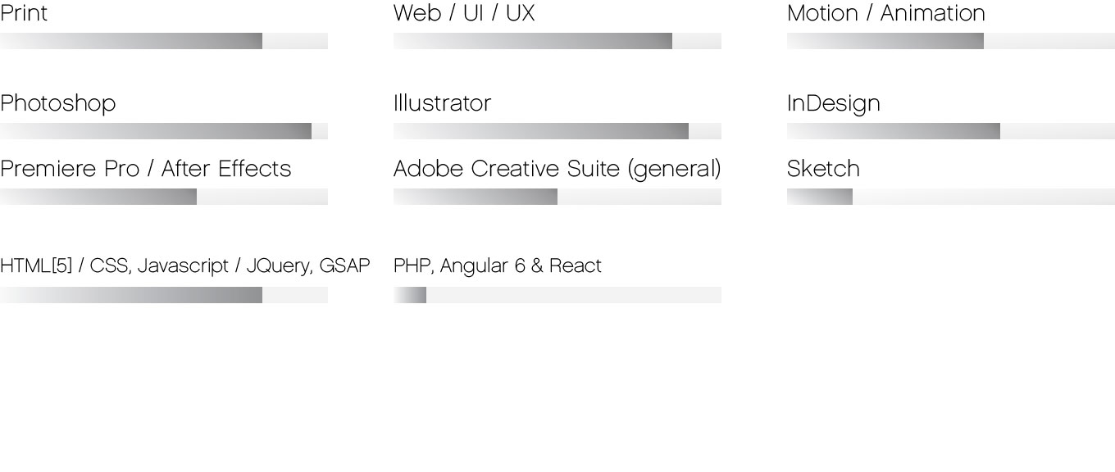SKILLS