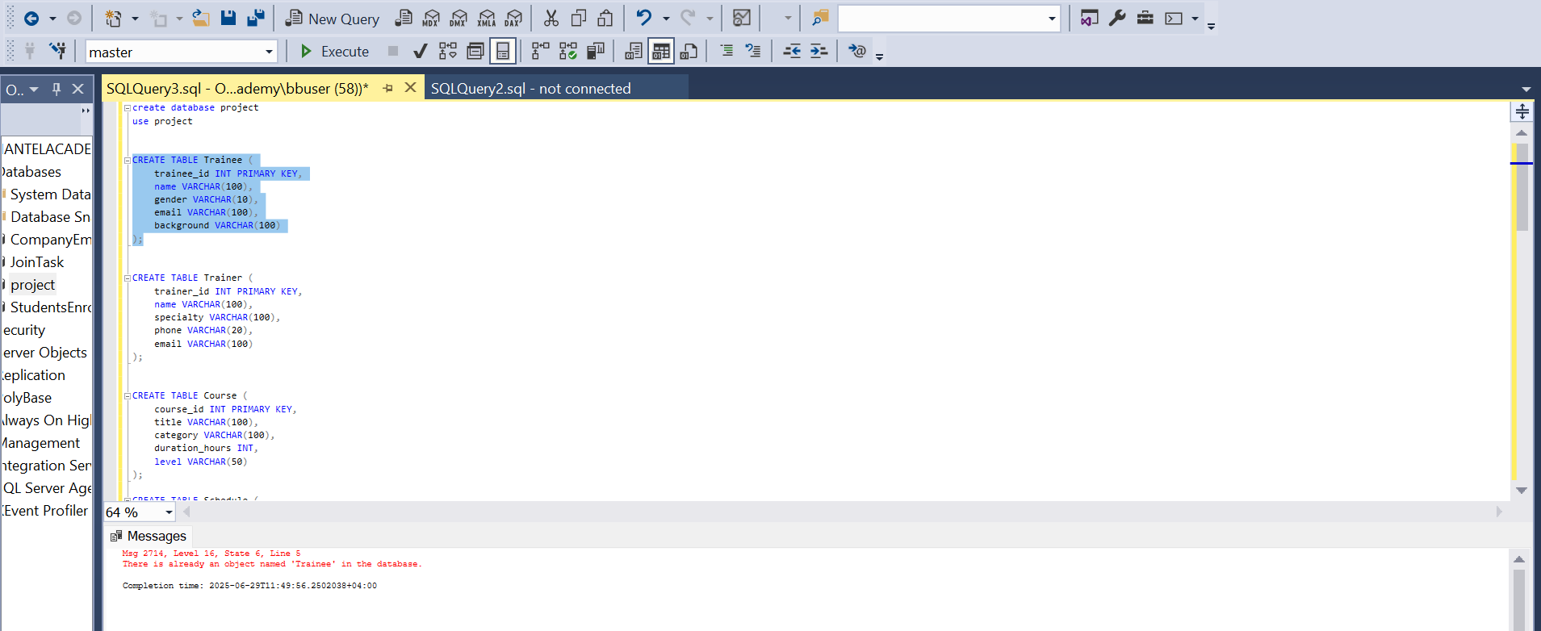

I didn't notice that I was working in the master database and after executing, the error appeared to me. Then I changed from the master database to the project database.

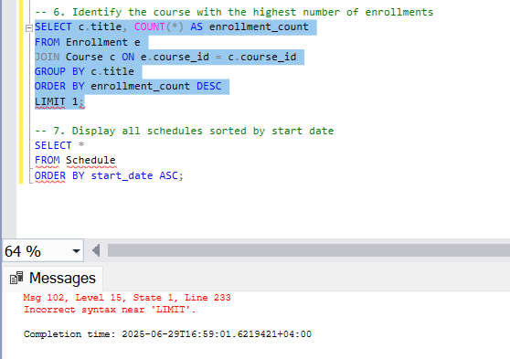

I was trying to find a query that helps me restrict the number of results in my query and I used the LIMIT clause, which caused an error because it is not valid in SQL Server. I learned that LIMIT is used in MySQL to control the number of rows returned, but SQL Server uses a different syntax. The correct way in SQL Server is to use TOP within the SELECT statement. After understanding that, I replaced LIMIT with TOP, and the query worked correctly.

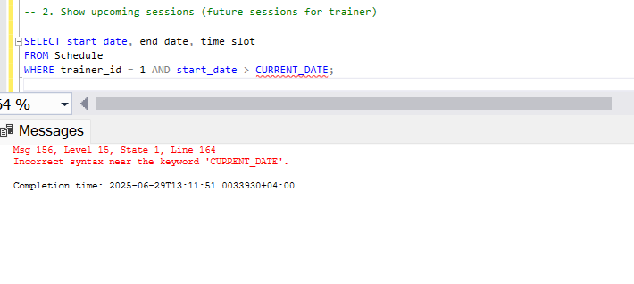

The issue I faced was due to using CURRENT_DATE in my SQL query, which isn't supported in SQL Server. I found out that CURRENT_DATE works in databases like MySQL or PostgreSQL, but SQL Server uses GETDATE() or CAST(GETDATE() AS DATE) instead to get the current date. Once I understood this difference in syntax between database systems, I corrected the query using the appropriate SQL Server function.