Commands:

**TASK A**

shihab@shihab-VirtualBox:~/cse321ass1$ mkdir shihab1

shihab@shihab-VirtualBox:~/cse321ass1$ mkdir shihab2

shihab@shihab-VirtualBox:~/cse321ass1$ touch 21301610_1.txt

shihab@shihab-VirtualBox:~/cse321ass1$ touch 21301610_2.txt

shihab@shihab-VirtualBox:~/cse321ass1$ touch 21301610_3.txt

shihab@shihab-VirtualBox:~/cse321ass1$ touch 21301610_4.txt

shihab@shihab-VirtualBox:~/cse321ass1$ mv 21301610_1.txt shihab1

shihab@shihab-VirtualBox:~/cse321ass1$ mv 21301610_2.txt shihab1

shihab@shihab-VirtualBox:~/cse321ass1$ mv 21301610_3.txt shihab1

shihab@shihab-VirtualBox:~/cse321ass1/shihab1$ cp 21301610_1.txt 21301610_2.txt ~/cse321ass1/shihab2

shihab@shihab-VirtualBox:~/cse321ass1$ mkdir shihab3

shihab@shihab-VirtualBox:~/cse321ass1$ cp -r shihab1 shihab3

shihab@shihab-VirtualBox:~/cse321ass1/shihab3$ ls -l

shihab@shihab-VirtualBox:~/cse321ass1/shihab3$ chmod -R 755 shihab1

shihab@shihab-VirtualBox:~/cse321ass1$ ls

21301610_4.txt shihab1 shihab2 shihab3

shihab@shihab-VirtualBox:~/cse321ass1$ mv ~/cse321ass1/shihab3 ~/

shihab@shihab-VirtualBox:~/cse321ass1$ cd ..

shihab@shihab-VirtualBox:~$ rm -r cse321ass1

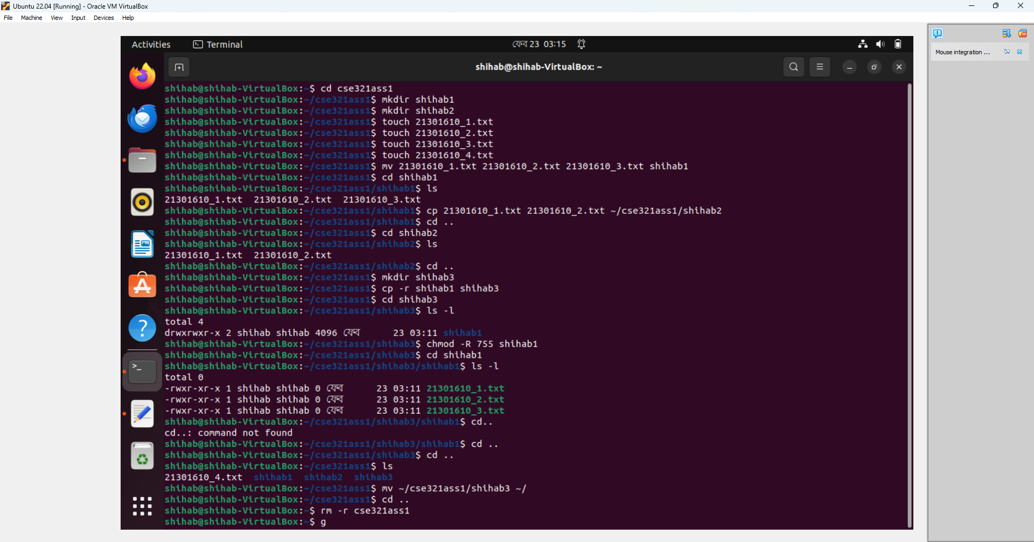

**TASK B**

shihab@shihab-VirtualBox:~$ mkdir taskb

shihab@shihab-VirtualBox:~$ cd taskb

shihab@shihab-VirtualBox:~/taskb$ cat>course.txt

course ID: CSE461, CSE321, CSE340, CSE421, HUM101

Course names: Introduction to Robotics, Operating Systems, Computer Architechture, Computer Networks, World Civilization

Sections: 4,8.8.2.2

shihab@shihab-VirtualBox:~/taskb$ grep "CSE" course.txt

course ID: CSE461, CSE321, CSE340, CSE421, HUM101

shihab@shihab-VirtualBox:~/taskb$ grep -c "CSE" course.txt

1

**TASKC**

shihab@shihab-VirtualBox:~$ ls -a

. .config Downloads .pki .sudo_as_admin_successful

.. cse321 .gnupg .profile taskb

.bash_history cse421 hi Public Templates

.bash_logout Desktop .local shihab3 Videos

.bashrc Documents Music snap .vscode

.cache .dotnet Pictures .ssh

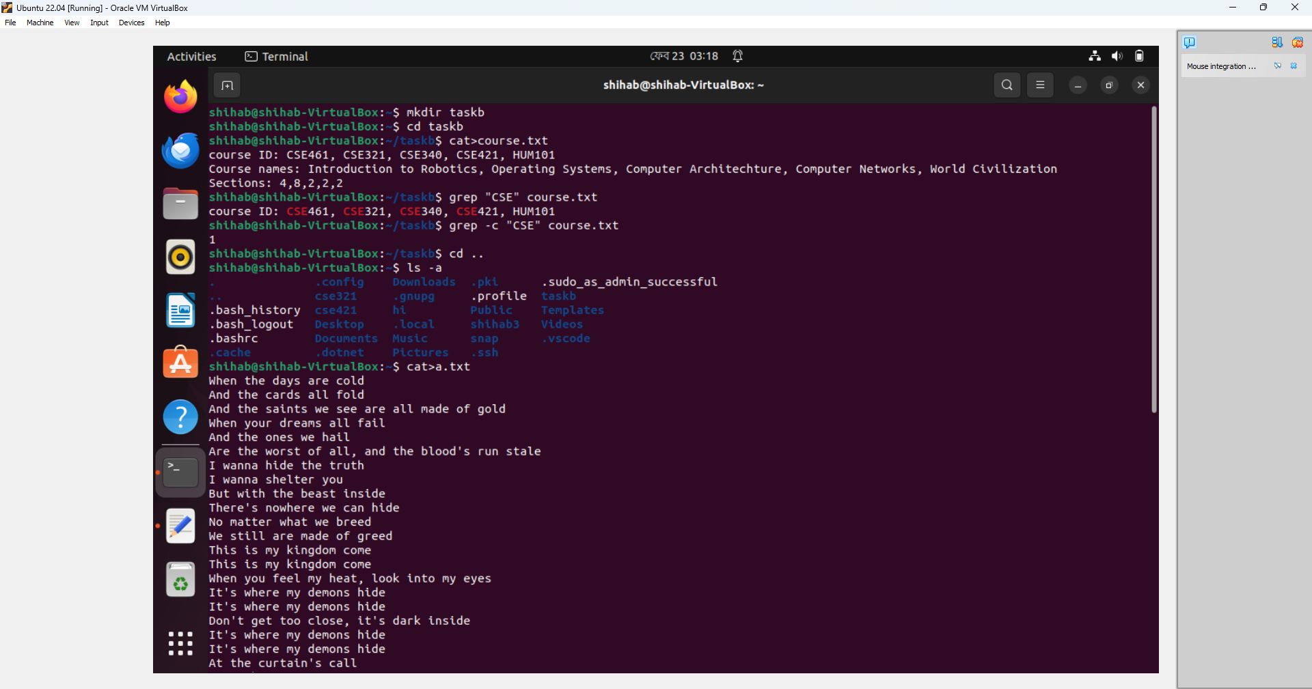

**TASK D**

shihab@shihab-VirtualBox:~/taskd$ cat>a.txt

When the days are cold

And the cards all fold

And the saints we see are all made of gold

When your dreams all fail

And the ones we hail

Are the worst of all, and the blood's run stale

I wanna hide the truth

I wanna shelter you

But with the beast inside

There's nowhere we can hide

No matter what we breed

We still are made of greed

This is my kingdom come

This is my kingdom come

When you feel my heat, look into my eyes

It's where my demons hide

It's where my demons hide

Don't get too close, it's dark inside

It's where my demons hide

It's where my demons hide

At the curtain's call

It's the last of all

When the lights fade out, all the sinners crawl

So they dug your grave

And the masquerade

Will come calling out at the mess you've made

Don't wanna let you down

But I am hell-bound

Though this is all for you

Don't wanna hide the truth

No matter what we breed

We still are made of greed

This is my kingdom come

This is my kingdom come

When you feel my heat, look into my eyes

It's where my demons hide

It's where my demons hide

Don't get too close, it's dark inside

It's where my demons hide

shihab@shihab-VirtualBox:~/taskd$ sed -n '5,17p' a.txt

And the ones we hail

Are the worst of all, and the blood's run stale

I wanna hide the truth

I wanna shelter you

But with the beast inside

There's nowhere we can hide

No matter what we breed

We still are made of greed

This is my kingdom come

This is my kingdom come

When you feel my heat, look into my eyes

It's where my demons hide

It's where my demons hide

