

American International University-Bangladesh (AIUB)  
**Department of Computer Science  
Faculty of Science &Technology (FST)  
Summer 20_21  
CSC 2210 Object-Oriented Analysis and Design (OOAD)**

**Section: B  
Group No: 7**

**Online Shopping System**

An Object-Oriented Analysis and Design (OOAD) project submitted

By

|  |  |  |  |
| --- | --- | --- | --- |
| Serial No. | Student Name | Student ID | Contribution |
| 23 | AFTAB, RAKIN SAD | 20-41991-1 | 20% |
| 24 | JANNAT, SHIHABUN SAKIBA | 20-41992-1 | 20% |
| 25 | AHMED, MIR MARUF | 20-42082-1 | 20% |
| 39 | ISLAM, SADIA | 20-43395-1 | 20% |
| 41 | BARDHAN, DURJOY | 20-43347-1 | 20% |

The project will be evaluated for the following Course Outcomes.

|  |  |
| --- | --- |
| **Project Marks Distribution** | Total Marks |
|  |
| Sequence Diagram and Class Diagram [5Marks] |  |
| Activity Diagram [5Marks] |  |
| State Diagram [5Marks] |  |
| Submission, Completeness, Spelling, Grammar, and Organization [5Marks] |  |

**Class Diagram**

The first step is, the user must log in to the system. If the user is new, he must give his name, mobile number, email, and password. Registered user will enter name and password. Even if the user forgets the password, the user can recover it via email with the forgotten password. Then the user will be able to see the products, search their desired products and add them to the cart if they wish. The system will list chosen products and create a browsing catalogue accordingly. If the user wants to buy something, he can see his item in the checkout option. The user has to pay to purchase the product of his choice. In payment class, he can pay cash if he wants. There are some more methods for that, such as Mobile Banking, PayPal and Cash & Delivery. If the user chooses a way of paying the product's price, the product's delivery process will start. As soon as the product is delivered, the user will receive a mail. If the user wants, he can also know where his product is now. Every class here has a one-to-one relationship with each other.

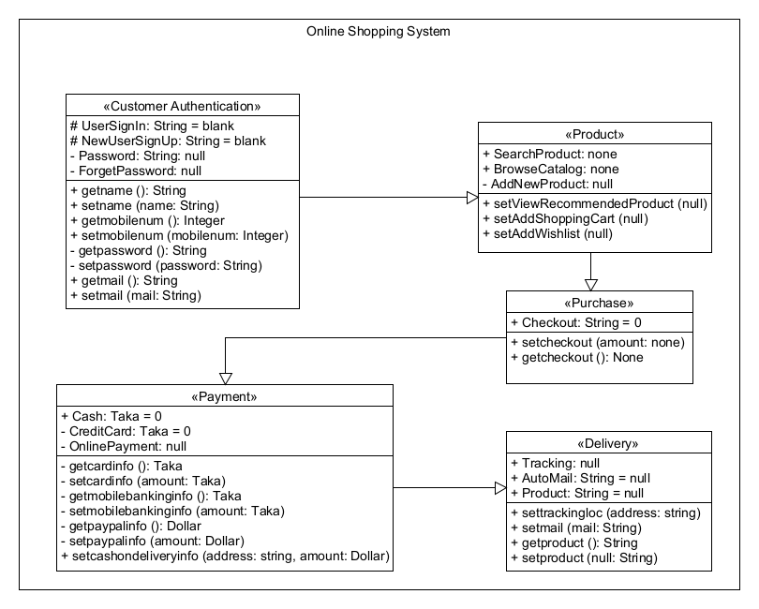

**Sequence Diagram**

Customers browse the products. If the customer is already registered, the customer can see the items, and the system will send query products from browser interface to product interface. If the customer does not log in, the system will ask for a login. The customer will choose the product. When the customer selects the product, they could add it to the shopping cart and purchase it. The browser interface gets the desired item and confirms that to get the product details. The purchase interface ensures that customers can see the selected product and product details, and at the same time, the system will send a message for authorizing. If the customer does not fill in the address information, the system will ask for it. If the address info is submitted, then a confirmation mail is sent to the customer. The delivery man shipped the product and handed it to the customer. The customer will receive the product and give payment.

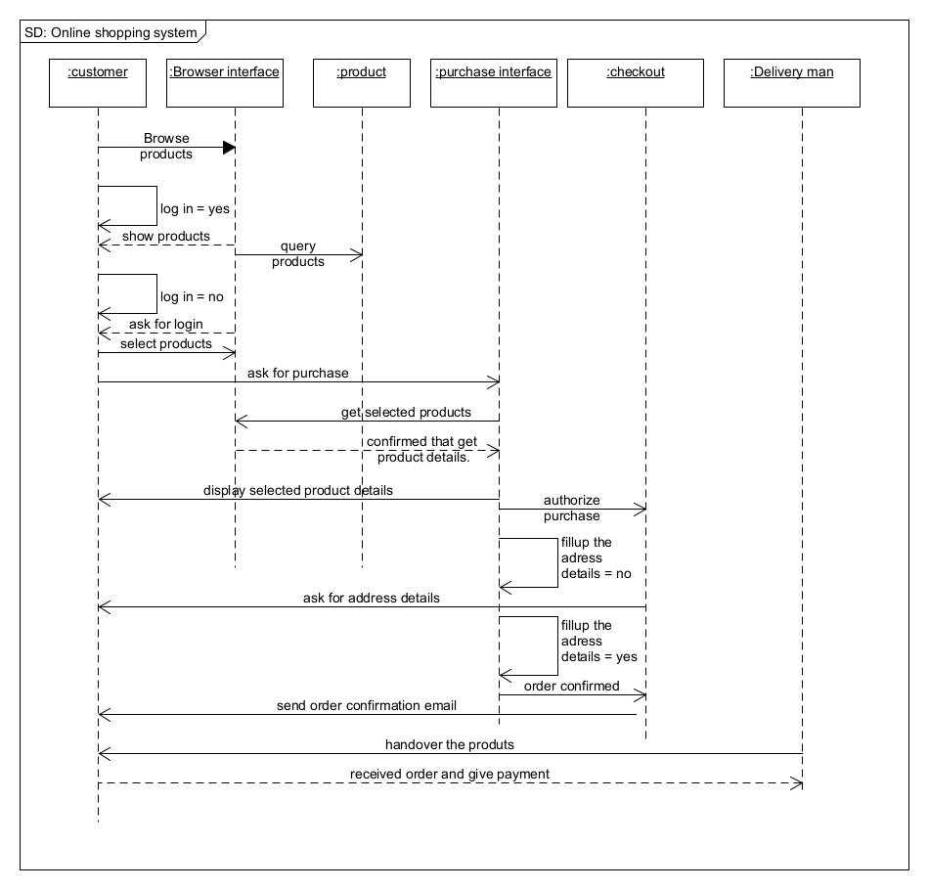

**Activity Diagram**

An online shopping system is when a customer visits a website, the system asks for a login. Registered customers log in, view, and search products. New customers will register first, then view and search products from the home page. If the product is not available, the system will ask for a search again. If the product is available, customers can view the product and add it to the shopping cart. After adding into the cart, a payment section will appear. Customers can select Online payment, Credit card, Cash on delivery simultaneously, and Mobile – banking, Bkash, Rocket under online payment. After confirming the order, the selected product will be hand over to the delivery man. Customers also can dismiss the plan and search again for better outcomes. The delivery man will depart the order to the customer using the Google Maps tracking system. After reaching the destination, the customer will receive the product.

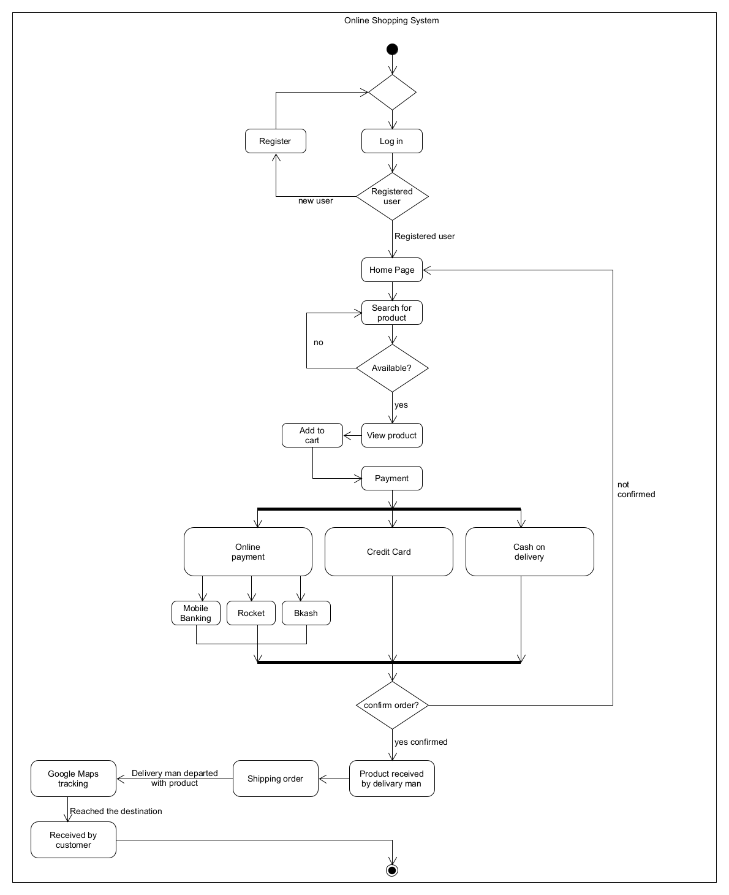

**State Diagram**

Customers visit the website. The system will ask to log in or register (for new users). The customers search for products from the home page. If the product isn't found, then the customer can repeat the process. When the product is found, the customer can view the product and search again. If the customer liked the product customer can add it to the shopping cart and search again, but can't edit the cart. Once everything is added, customers can view the shopping cart. Final confirmation will appear that customers can discard the process and remove the product from the cart if the customers want. If the customer agrees to discard and remove the product, the system will automatically bring the customer to the home page or log out. Customers can view the shopping cart from the home page.

