**Outline Design of Website**

**Group member Student number of BUPT**

**Shi Hang 2013213341**

**Yan Yibo 2013213331**

**Zhao Ziqiao 2013213356**

**Wang Danynag 2013213350**

**Yao Guangnan 2013213337**

1. **Entity-Relationship Diagrams**
2. Whole Relationships:

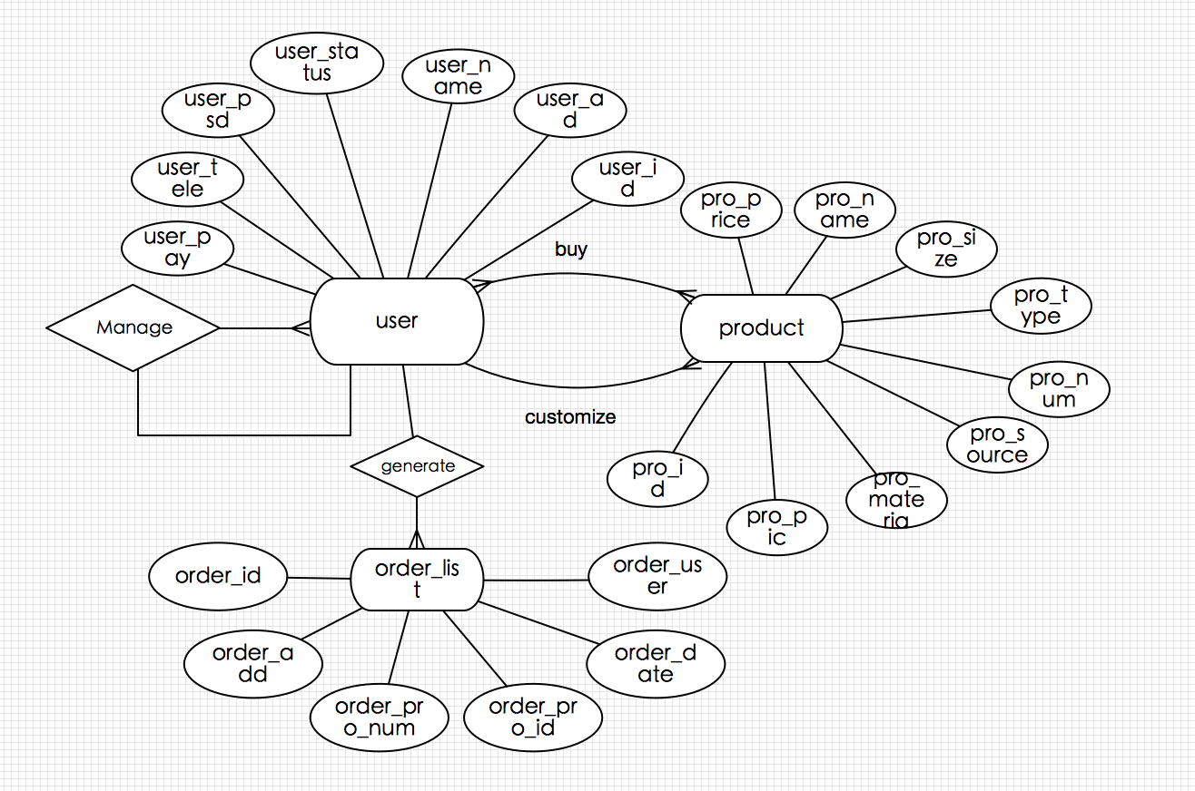

Including:

3 main entities:

User: contain all customer and admin-person account.

Product: contain all prefabricate products and new adding products

Order _list: the order list of the customer and the feedback paper of customer.

1. Main Relationships:

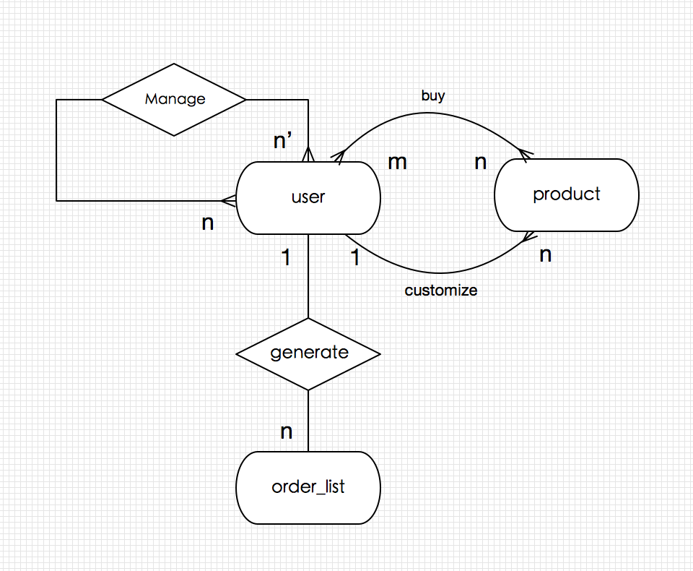

Products can be customized by Users. (Products : Users= n : 1);

Users can buy deferent kinds of products. (User : Products = n : m)

User(admin) can manage the account of other User ( User(ad) : User =n’ : n)

User can generate many kinds of order *lists . (User : order* _lists = 1 : n)

1. User:

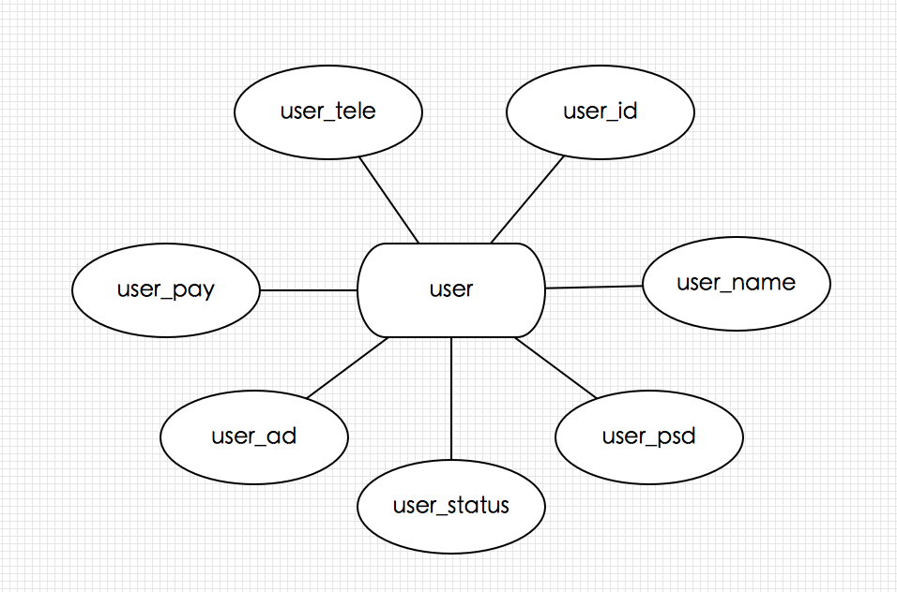

Including 7 main attributes: (user _id is primary key)

1. Order:

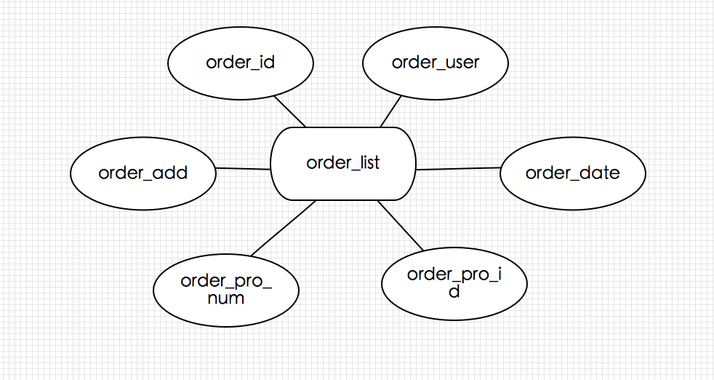

Including 6 main attributes: (order _id is primary key)

1. Product:

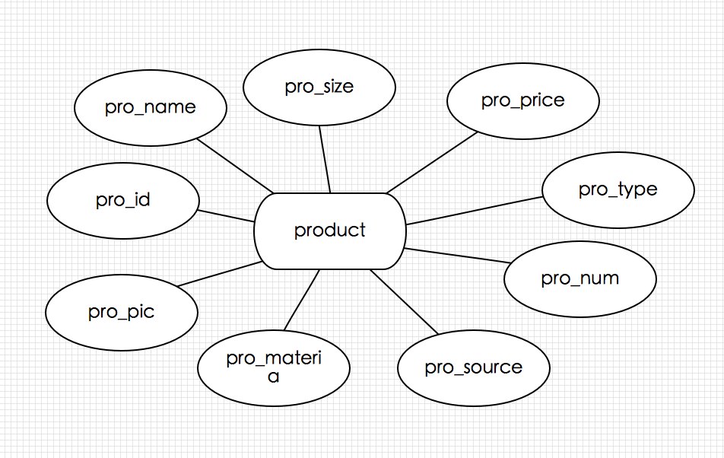

Including 9 main attributes: (pro _id is primary key)

1. **SQL Statements for basic Requirements**

2.1 Basic Tables

1. Product

CREATE TABLE product(

* pro_id int NOT NULL AUTO_INCREMENT,
* pro_name varchar(50) NOT NULL,
* pro_size varchar(50) NOT NULL,
* pro_type varchar(50) NOT NULL,
* pro_num int NOT NULL,
* pro_price int NOT NULL,
* pro_source varchar(50) NOT NULL,
* pro_material varchar(50) NOT NULL,
* pro_pic varchar(50) default NULL,
* PRIMARY KEY(pro_id)
* );

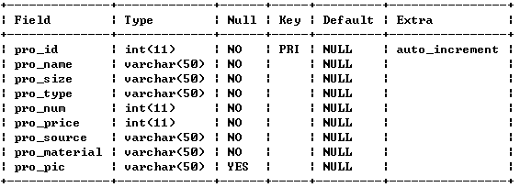

1. User

CREATE TABLE user(

* user_id int NOT NULL AUTO_INCREMENT,
* user_ad varchar(50) NOT NULL,
* user_name varchar(50) NOT NULL,
* user_psd varchar(50) NOT NULL,
* user_tele int NOT NULL,
* user_pay int NOT NULL,
* user_status varchar(50) NOT NULL,
* PRIMARY KEY(user_id)
* );

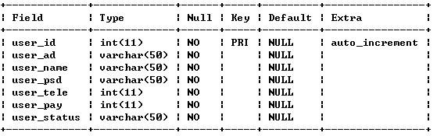

1. Order List

CREATE TABLE order_list(

* order_id int NOT NULL AUTO_INCREMENT,
* order_user varchar(50) NOT NULL,
* order_date varchar(50) NOT NULL,
* order_pro_num varchar(50) NOT NULL,
* order_add varchar(50) NOT NULL,
* order_pro_id varchar(50) NOT NULL,
* PRIMARY KEY(order_id)
* );

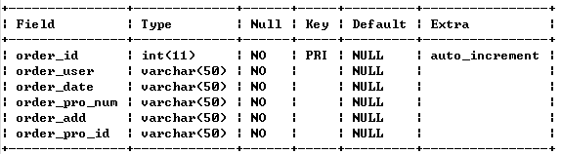

2.2 User and Administrator Operations

2.2.1 User Operations

(1)Register

INSERT INTO user(

* user_name,user_psd,user_ad,user_tele,user_pay,
* user_status)
* VALUES
* (’Ming’,’123456’,’XXSTREET’,12345678912,654321,
* ’0’);

(2)Customize

INSERT INTO product(

* pro_name,pro_size,pro_type,pro_num,pro_price,
* pro_source,pro_material,pro_pic)
* VALUES
* (’Craft’,’11cm*11cm’,’Toy’,100,100,’user_id’,
* ’cloth’,’picture_path’);

(3)Generate Order

INSERT INTO order

* (order_user,order_date,order_pro_num,
* order_pro_id,order_add)
* VALUES
* (user_id,’date’,’12/45’,’pro_id/pro_id’,’Hello’);

(4)Delete Order

DELETE FROM order_list

* WHERE user_id='user_id' and order_id='order_id';

(5) Delete Product Customized

DELETE FROM product

* WHERE user_id='user_id' and pro_id='pro_id';

1. Search Products

SELECT * FROM product;

1. Check Orders

SELECT FROM order_list WHERE user_id='user_id';

2.2.2 Administrator (special user) Operations

(1)Register

INSERT INTO user(

* user_name,user_psd,user_ad,user_tele,user_pay,
* user_status)
* VALUES
* (’Ming’,’123456’,’XXSTREET’,12345678912,654321,
* ’1’);

(2) Modify Information of Users

UPDATE user SET user_name='user_name'

* where user_id='user_id';

(3) Delete users' orders

DELETE FROM order_list

* WHERE order_id='order_id';

1. Delete users' Products Customized

DELETE FROM product

* WHERE pro_id='pro_id';

1. **Web page navigation diagram**
2. Web Page Design & Relationship

***Login:***

Users input their own username and password then he can do all options in the website.

***Register:***

Users can set the username and password to found a new account. And complete other individual information (address, telephone number)

***Product:***

Product page lists the product information (product name, product type, product amount, product master’s information, product material)

***My account***：

Customers can check the product information they have already bought including the products they have customized before or their own shopping cart. They can modify the order they have already paid like cancel order and change product.

***Customization：***

In this page customer can customize their products by providing products type, size, quantity, material and other specific demand)

***Administrator***：

Administrator page can check the user information, order information and product information.

1. Pages Jumping Trace Routine

