Environmentally Friendly Solar Air Collector Based on Foam Copper-Enhanced Phase Change Materials

Shihan Zhangª, Ruixue Li*^{b}
ª American Heritage School of Plantation, 12200 W Broward Blvd, Plantation, FL 33325; ^{b} Sinopec Cangzhou Company, Cangzhou 061000, Hebei, China

Abstract
To reduce the consumption of fossil fuels for building heating and address the problems of insufficient heat storage density and low heat transfer efficiency existing in traditional solar air collectors. This paper presents a novel evacuated cube-structured solar air collector integrated with copper foam-enhanced PCM. A Monte Carlo-based MATLAB simulation was conducted to determine the optimal operating parameters. The simulation results reveal that the optimal air mass flow rate ranges from 0.05 kg/s to 0.08 kg/s, increasing with PCM melting temperature up to 40 °C and then stabilizing. The heat absorption efficiency (0.4–0.6) and heat release efficiency (0.5–0.7) reach an optimal balance at a PCM temperature of 40 °C with minimal fluctuation. The recommended operating window (PCM temperature: 35–45 °C; air flow rate: 0.05–0.08 kg/s) exhibits strong robustness against ±5% parameter errors. A prototype composite collector and a reference non-composite collector were fabricated and tested under the optimized conditions. The heat absorption experiment lasted 2 hours, and the heat release experiment exceeded 7 hours. Experimental results show that the composite collector improves heat absorption efficiency by 11% and heat release efficiency by 21.39% compared with the non-composite design. This work provides a high-performance, low-cost, and environmentally friendly solar air collector for building heating and agricultural greenhouse applications.

Keywords: Solar air collector; phase change material; copper foam; thermal performance; Monte Carlo simulation

INTRODUCTION
According to the report released by the United Nations' climate change agency, building energy consumption accounts for more than 30% of the global total energy consumption, and it is projected that its carbon emissions will account for approximately 30% of global carbon emissions by 2030 [1]. Currently, solar energy, as a clean and renewable energy source, has been widely applied in building heating systems. Solar collectors use solar energy to heat water or high specific heat capacity materials such as kerosene, which not only reduces reliance on traditional energy sources but also significantly reduces carbon emissions, providing a clean and sustainable solution for heating needs in cold climate regions.
The main components of a solar air collector include a transparent glass cover, a solar absorber plate, a thermal insulation layer, and a metal shell [1]. Among them, the solar absorber plate is the core component that collects solar energy and converts it into thermal energy [2], transferring heat indoors with air as the medium. It features a simple structure, high heat collection efficiency, and strong antifreeze capability [3]. However, the intermittency of solar radiation greatly limits the application of solar air collectors in building heating. When sunlight is sufficient, users’ heating demand is low while the collector can provide efficient heat output. In contrast, when the temperature drops at night, heating demand increases significantly, but the collector stops operating due to insufficient solar energy supply, resulting in a serious mismatch between the instability of solar energy and users’ heating demand. Therefore, traditional solar air collectors are difficult to promote and develop [4].
Phase change materials (PCMs) have the advantages of high energy storage density and low corrosiveness [5], and are widely used in building energy conservation, solar energy utilization, agricultural production, and other fields [6]. Researchers have attempted to combine PCMs with solar collectors to resolve the conflict between solar intermittency and heating demand. Nevertheless, the low thermal conductivity of PCMs reduces the heat storage efficiency of the thermal storage layer [7]. Copper foam has high porosity, low weight, and excellent thermal conductivity; when combined with the PCMs, it can significantly improve thermal conductivity, heat storage capacity, heat release efficiency,
*13120059811@163.com, phone +86 13120059811
thermal peak migration ability, and heat collection efficiency [9]. In summary, solar collectors based on a copper foam–PCM composite exhibit stronger heat release efficiency than traditional solar collectors and can be widely used in regions with large diurnal temperature differences [10–11].
Although scientists have conducted extensive research on solar collectors integrated with phase change materials (PCMs), the existing designs still have significant limitations. For example, Enibe proposed a single-layer glass plate solar collector combined with a phase change material and a thermal storage system. This design was successfully applied to crop drying, but the system efficiency was low and the environmental adaptability was insufficient [12]. Abuşka et al. improved the heat transfer efficiency by combining phase-change materials with aluminum honeycomb cores, but they lacked exploration of high-performance porous media (such as copper foam) and failed to evaluate a wide range of material combinations [13]. The dual-channel collector developed by Assadeg et al. achieved relatively high efficiency through numerical simulation but did not fully investigate the effects of different fin configurations on collector performance and lacked research on the optimal melting point and type of PCM [14].
Overall, state-of-the-art solar air collectors are plagued by low thermal conductivity of PCMs, insufficient heat storage–release efficiency, poor structural stability, and high implementation costs, which restrict large-scale application. To overcome these drawbacks, this paper proposes an environmentally friendly solar air collector using copper foam–enhanced PCMs with an optimized evacuated cubic structure, achieving comprehensive improvements in efficiency, stability, cost, and environmental adaptability.

METHODS

Structural Design
The internal structure of the first-generation non-contact solar collector consists of a heat collection section and an outer shell. As shown in Figure 1a, the core component is an acrylic tube (inner diameter 56 mm, outer diameter 60 mm, length 150 mm) wrapped with thermal insulation cotton, integrating three copper foam–PCM composite modules. Liquid PCM is uniformly infused into copper foam (diameter 50 mm, thickness 25 mm) using a rotating motor and then solidified. A 10 mm central through-hole is drilled in the copper foam to improve air permeability, and a customized tray is used to prevent liquid PCM leakage. The acrylic tube is connected to the top heat-absorbing copper plate through a square conical connector. The sealed outer shell is made of acrylic plates and a wooden base reserved for a ducted motor. The collector includes three functional layers: heat absorption, thermal storage, and insulation.
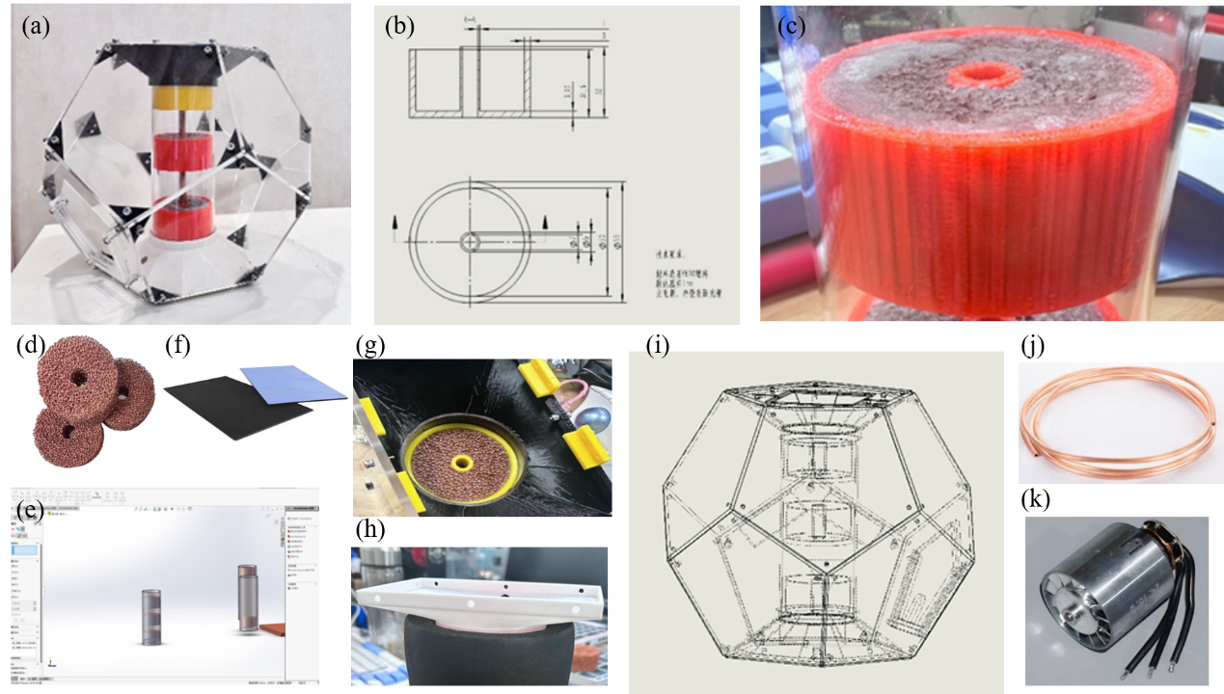
Figure 1. (a) Actual image of non-contact solar collector (b) Tray-like structure design (c) Phase change material and copper foam composite uniformly mixed by motor (d) Copper Foam (e) Integrated component modeling (f) Copper plate coated with carbon fiber nano-heat-absorbing material (g) Actual installation effect diagram of the tray component (h) Bottom hollow cavity structure (i) Modeling diagram of the outer shell and conical connector (j) Flexible Copper Tube (k) Ducted Motor
The heat storage layer is composed of a lipid-based solid–liquid phase change material (melting point 40°C, latent heat 220 J/g) and foam copper (diameter 50 mm, thickness 25 mm). A 10 mm central hole is drilled in the foam copper to improve ventilation (Figure 1b–e), and a custom tray structure is designed to prevent leakage of the liquid PCM. The heat absorption layer consists of copper plates coated with carbon fiber nanomaterials, which efficiently convert solar radiation into thermal energy. These plates are fixed by 3D-printed slots to ensure a stable connection with the PCM module (Figure 1f–g). The insulation layer uses wood boards and insulation cotton to reduce heat loss, while a hollow wooden base simulates the indoor heating environment (Figure 1h). As shown in Figure 1i, the shell consists of five acrylic plates and a wooden baseplate forming a sealed structure. To realize air circulation, a 150 W pulley-type motor (7.4 V) drives the airflow, which passes through a 12 mm rigid tube into a 10 mm flexible copper tube to increase air pressure and enhance convective heat transfer, replacing the less efficient fan used initially (Figure 1j–k).

MATLAB Simulation for Optimal Performance
A MATLAB-based thermal simulation model was established, and the operating parameters were optimized. The collector area was set at 2 m², the solar radiation intensity was set at 800 W/m², and the simulation duration was set at 9 hours (32400 s). Key parameters included the properties of the phase change material (density 900 kg/m³, specific heat 2000 J/kg·K, latent heat 200 kJ/kg, melting temperature 25–50°C) as well as the air mass flow rate (0.01–0.1 kg/s). Monte Carlo sampling (20 iterations with ±5% parameter variability) was used to evaluate the uncertainty of indicators such as heat absorption/release efficiency and outlet air temperature, while an adaptive time step was adopted to ensure accuracy during the phase change process.
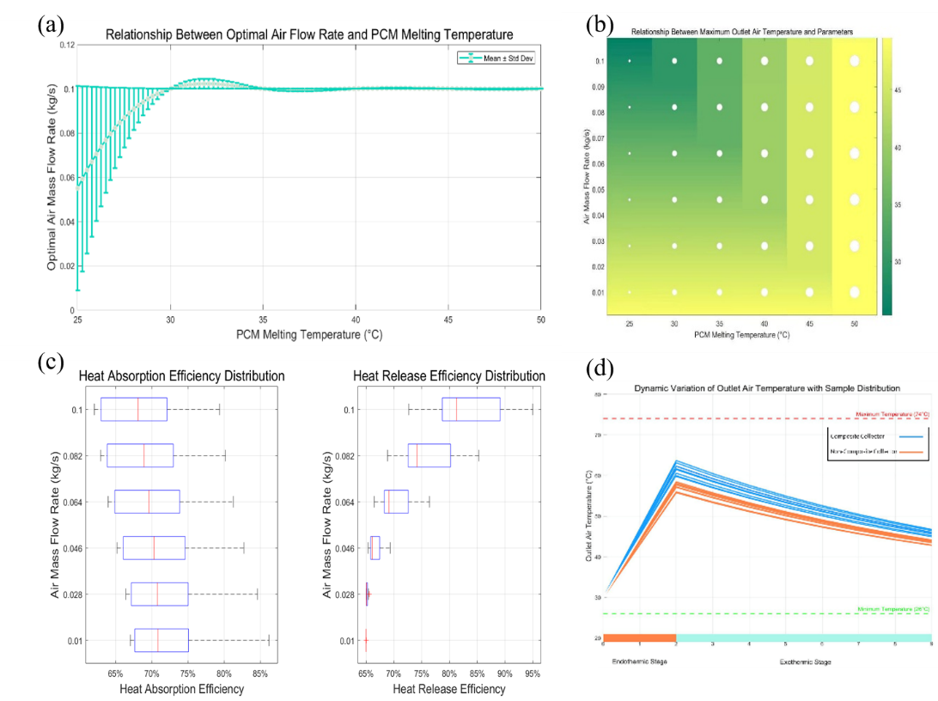
Figure 2 (a) Relationship between Optimal Air Flow Rate and PCM Melting Temperature (b) Relationship between Heat Absorption and Heat Release Efficiencies and Air Mass Flow Rate (c) Relationship between Optimal Air Flow Rate and PCM Melting Temperature (d) Dynamic Variations of Outlet Air Temperature with Sample Distribution
The simulation results illustrate the key performance trends: the optimal air flow rate is shown in Figure 2a, increasing as the melting temperature of the phase change material rises, ranging from 0.04 to 0.08 kg/s; the heat absorption efficiency is shown in Figure 2b. It reaches its peak (with a median value of 65%) at a flow rate of 0.05 kg/s, and the heat release efficiency remains stable at higher flow rates. Figure 2c shows that the melting temperature of PCM is 40-45℃, and the air flow rate of 0.06-0.08 kg/s is the "optimal point", which can achieve the highest outlet temperature (65-75℃). The time series analysis in Figure 2d confirmed that the system maintained stable heat release (56 - 78°C) within 7 hours after sunset, verifying the role of the PCM in buffering intermittent solar energy.

Experimental Setup and Results
This experimental system uses an ESP32 Lite control board (which has been improved over three generations to enhance stability and integration) to read data from eight DS18B20 temperature sensors, display the real-time values on an OLED screen, and wirelessly transmit the data (Figure 3). The sensors are used to measure the temperature of the heat absorption layer, the PCM-copper foam composite material, and the simulated user environment and environmental conditions. Buttons controlled a ducted motor for adjustable airflow, with sensor pins assigned specifically for reliable data collection.
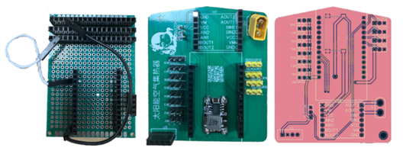
Figure 3 Actual circuit board diagram, from left to right: first generation, second generation, third generation circuit board
Under the same conditions, a comparison was made between the foam copper-PCM composite collector and the traditional PCM single collector. During the 2-hour outdoor heat absorption test (from 10:15 to 12:00), the heat absorption efficiency of the composite collector increased by 11%. The temperature sensor near the pcm - copper foam composite material rose more rapidly, and the temperature difference between the two collectors decreased from the initial 2.5°C to 1°C after heat absorption, indicating more effective heat capture and storage (Figure 4a-b). In the subsequent indoor heat release test, the composite collector maintained stable heating for over 7 hours, with the heat release efficiency increasing by 21.39%. The temperature curve of the simulated user environment confirmed that, compared with the traditional design, the thermal output of the composite collector decreased at a steeper rate (with a higher slope), reflecting a faster and more continuous heat transfer, which kept the user-side temperature near the 40°C phase transition temperature of the PCM for a longer period of time (Figure 4c-d).
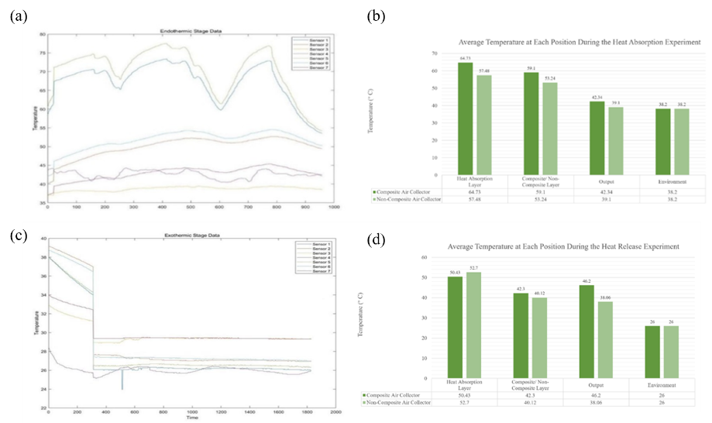
Figure 4 (a) Temperature changes at each position during the heat absorption experiment (b) Average temperature at each position during the heat absorption experiment (c) Temperature changes at each position during the heat release experiment (d) Average temperature at each position during the heat release experiment

Results and Discussion
The experimental and simulation results jointly demonstrate that the foam copper-enhanced PCM solar air collector has significant performance advantages. The results are shown in Figure 5. In the heating experiment, by measuring the temperature difference near the PCM layer, the heating efficiency of the composite collector was 11% higher than that of the pure PCM collector. This improvement stems from the high thermal conductivity of the foam copper, which accelerates the transfer of heat to the phase change material, thereby achieving more efficient solar energy capture. In the cooling experiment, the cooling efficiency of the composite collector was 21.39% higher than that of the pure PCM design; the foam copper matrix facilitates faster and more uniform heat release, maintaining stable heating for over 7 hours, with the outlet temperature remaining above 25℃.
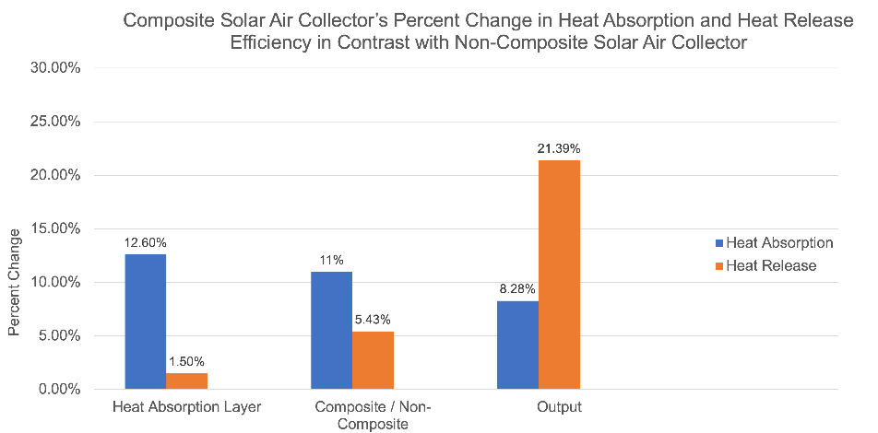
Figure 5 Composite Solar Air Collector’s Percent Change in Heat Absorption and Heat release efficiency in Contrast with Non-Composite Solar Air Collector
The simulation results further determined the optimal operating parameters: the air mass flow rate is 0.05-0.08 kg/s, increasing as the PCM melting temperature reaches 40°C, and then stabilizing thereafter. The heat absorption (0.4-0.6) and release (0.5-0.7) efficiencies reach the minimum fluctuation balance at 40°C. The recommended operating window (PCM temperature 35-45°C, air flow rate 0.05-0.08 kg/s) has good stability under a parameter error of ±5%, ensuring reliable performance in practical applications. These findings are consistent with previous research on metal matrix reinforced PCM systems, confirming that the foam copper resolves the low thermal conductivity bottleneck of pure PCM and enhances the thermal charging and discharging processes.
Table 1. Optimal operating parameters of foam copper reinforced PCM solar air collector
Parameters | Values
Optimal Air Flow Rate | 0.06kg/s–0.08kg/s
PCM Phase Change Temperature | 40°C
Parametric Errors | ±-5%
Heat Absorption Efficiency | 64%–75%
Heat Release Efficiency | 64%–88%
Percent Increase in Heat Release Efficiency for Composite Solar Air Collectors | 11%
Percent Increase in Heat Absorption Efficiency for Composite Solar Air Collectors | 21.39%

CONCLUSION
This study demonstrates that the combination of foam copper and phase change material (PCM) can significantly enhance the thermal performance of solar air collectors. Specifically, compared with the traditional pure PCM system, the heat absorption efficiency of the composite collector has increased by 11%, the heat release efficiency has increased by 21.39%, and its heat absorption rate has been improved. The continuous delivery of thermal energy to users has also become more effective. The optimal operating parameters are determined as follows: the melting temperature range of the PCM is 35-45°C (with balanced heat absorption and release efficiency at 40°C), and the air flow rate is 0.05-0.08 kg/s. This parameter combination shows good stability within a ±5% parameter uncertainty range, enabling the system to maintain an outlet temperature of over 25°C during heat release and operate continuously for more than 7 hours, thus ensuring reliable and efficient utilization of solar energy in practical applications.

References
- National Solar Energy Standardization Technical Committee. 2009, GB/T 20083249-T-469.
- Fudholi, A., & Sopian, K. (2019). A review of solar air flat plate collector for drying application. Renewable and Sustainable Energy Reviews, 102, 333-345.
- Shen, J., Zhang, X., Yang, T., Tang, L., Cheshmehzangi, A., Wu, Y., ... & Liu, S. (2016). Characteristic study of a novel compact Solar Thermal Facade (STF) with internally extruded pin–fin flow channel for building integration. Applied Energy, 168, 48-64.
- Hassan, A., Nikbahkt, A. M., Welsh, Z., Yarlagadda, P., Fawzia, S., & Karim, A. (2022). Experimental and thermodynamic analysis of solar air dryer equipped with V-groove double pass collector: Techno-economic and exergetic measures. Energy Conversion and Management: X, 16, 100296.
- Liu, C., Ma, Z., Jiang, R., Qu, J., & Rao, Z. (2020). Experimental study on heat transfer enhancement of phase change material using embedded oscillating heat pipe for thermal energy storage. ISIJ International, 60(10), 2157-2164.
- Hu, W., Nickolaevich, A. V., Huang, Y., & Hou, C. (2023). Design and thermal performance evaluation of a new solar air collector with comprehensive consideration of five factors of phase-change materials and copper foam combination. Applied Energy, 344, 121268.
- Charvát, P., Klimeš, L., Pech, O., & Hejčík, J. (2019). Solar air collector with the solar absorber plate containing a PCM–Environmental chamber experiments and computer simulations. Renewable Energy, 143, 731-740.
- Sharma, A., Chauhan, R., Kallioğlu, M. A., Chinnasamy, V., & Singh, T. (2021). A review of phase change materials (PCMs) for thermal storage in solar air heating systems. Materials Today: Proceedings, 44, 4357-4363.
- Esakkimuthu, S., Hassabou, A. H., Palaniappan, C., Spinnler, M., Blumenberg, J., & Velraj, R. (2013). Experimental investigation on phase change material based thermal storage system for solar air heating applications. Solar Energy, 88, 144-153.
- Waqas, A., & Kumar, S. (2013). Phase change material (PCM)-based solar air heating system for residential space heating in winter. International journal of green energy, 10(4), 402-426.
- Li, Y., Liang, J., Chen, W., Wu, Z., & Yin, H. (2025). Optimal design of a solar-assisted heat pump system with PCM tank for swimming pool utilization. Renewable Energy, 240, 122272.
- Enibe, S. O. (2002). Performance of a natural circulation solar air heating system with phase change material energy storage. Renewable Energy, 27(1), 69-86.
- Abuşka, M., Şevik, S., & Kayapunar, A. (2019). Experimental analysis of solar air collector with PCM-honeycomb combination under the natural convection. Solar Energy Materials and Solar Cells, 195, 299-308.
- Assadeg, J., Al-Waeli, A. H., Fudholi, A., & Sopian, K. (2021). Energetic and exergetic analysis of a new double pass solar air collector with fins and phase change material. Solar Energy, 226, 260-271.

