Evaluating Water Treatment Residuals and Biochar for Mitigating Phosphorous Leaching in Legacy-Impacted Sandy Spodosols
Shihan Zhang
July 22, 2026
Rebels
Matison Herndon
Dr. Yang Lin

Abstract
Repeated biosolid applications have accumulated legacy phosphorus (P) in sandy Florida Spodosols, where low metal-oxide content facilitates subsurface leaching and downstream eutrophication. This study evaluated the comparative effectiveness of calcium- (Ca-), iron- (Fe-), and aluminum- (Al-) based drinking water treatment residuals (WTRs) and pine biochar in mitigating P mobility. Using bahiagrass-planted soil columns mimicking a layered ranch profile, amendments were applied to the topsoil at 1% or 2% by mass and subjected to five weekly simulated rainfall events (pH 5.0).
The 1% Ca-WTR treatment was most effective, reducing cumulative P export by 51.0% relative to the control. While 1% biochar reduced P losses by 43.2%, doubling the dose to 2% eliminated this benefit, causing P leaching comparable to the control. Leachate pH remained stable (6.2–6.8), and initial spikes in electrical conductivity quickly returned to baseline. Additionally, vegetative growth significantly reduced drainage volumes over time. These findings demonstrate that low-dosage (1%) WTRs and biochar successfully retain legacy P without degrading water quality, but higher application rates can lead to treatment failure in carbonaceous sorbents.

1. Introduction
The land application of biosolids has become a widely adopted practice for recycling nutrients and organic matter back into agricultural soils. Rich in nitrogen, phosphorus, and carbon, biosolids improve soil fertility while reducing reliance on synthetic fertilizers. However, repeated biosolid application over many years can also lead to the accumulation of legacy phosphorus, where phosphorus concentrations remain elevated long after crop demand has been met. Unlike nitrogen, phosphorus is not lost through atmospheric pathways and therefore accumulates within the soil profile over time. Once the soil's phosphorus storage capacity is exceeded, dissolved phosphorus becomes increasingly susceptible to transport through runoff and subsurface leaching, posing a significant risk to downstream water quality (Sharpley et al., 1994; Sims & Pierzynski, 2005).
This issue is particularly important in Florida, where many agricultural regions are dominated by sandy soils with low phosphorus sorption capacities. These soils contain relatively low concentrations of iron and aluminum oxides, reducing their ability to chemically retain phosphate and increasing its mobility following rainfall events (de Campos et al., 2016). Excess phosphorus entering rivers, lakes, and estuaries accelerates eutrophication, stimulating harmful algal blooms, decreasing dissolved oxygen concentrations, and degrading aquatic ecosystems. Because Florida's watersheds are highly connected through shallow groundwater and surface drainage networks, managing phosphorus transport has become a major environmental priority for both agricultural producers and water resource managers.
To reduce phosphorus losses, researchers have investigated several soil amendments capable of increasing phosphorus retention before nutrients leave the field. Drinking water treatment residuals (DWTRs) are byproducts of the municipal water purification process, and typically consist of aluminum, iron, or calcium oxide and hydroxide minerals along with sediment and activated carbon removed from raw water during drinking-water purification. Laboratory equilibration studies comparing residual types have found that aluminum-based DWTRs reduce soluble phosphorus more effectively than calcium- or iron-based residuals, which in turn outperform natural hematite (Elliott et al., 2002). This difference is largely mechanistic: aluminum in these residuals reacts directly with dissolved phosphate to form a low-solubility aluminum phosphate precipitate, physically removing it from solution, while calcium-based residuals favor the formation of comparatively insoluble calcium phosphate minerals. Biochar operates through a different pathway, and its effect on phosphorus is less consistent than that of metal-based residuals. One recent soil column study found that biochar reduced calcium leaching in sandy soils but could increase phosphorus, sodium, and potassium leaching, an effect that was less pronounced in finer-textured soils. Field- and column-scale work conducted specifically in Florida's sandy soils has shown more favorable results for both amendment classes: a field study on a Florida ranch found that an alum-based drinking-water residual significantly reduced off-site phosphorus losses (Agyin-Birikorang et al., 2009), while a University of Florida column study using subtropical sandy Ultisols found that pine biochar reduced soluble phosphorus leaching losses by roughly 50% (Ukwattage et al., 2020). Numerous other laboratory and field studies have similarly demonstrated that these materials can substantially reduce phosphorus mobility and improve water quality (Dayton & Basta, 2005&Ippolito et al., 2011). However, most of this prior work has evaluated individual amendment classes in isolation, often under simplified, single-layer soil conditions that do not reflect the vertically stratified profiles found in real agricultural fields (Dodd & Sharpley, 2016). Fewer studies have directly compared calcium-, iron-, and aluminum-based residuals against a carbon-based amendment like biochar within the same layered, field-realistic soil system, making it difficult to determine which mechanism (mineral precipitation or surface adsorption) provides more effective and consistent phosphorus retention under realistic leaching conditions.
This study addresses that gap by evaluating how amendment type influences phosphorus retention and leachate chemistry in a layered Central Florida Spodosol profile subjected to simulated rainfall events. We hypothesize that calcium-, iron-, and aluminum-based drinking water treatment residuals, as well as pine biochar, will each significantly reduce dissolved phosphorus concentrations in leachate relative to an unamended control, and that the magnitude of this reduction will differ by amendment type, reflecting the distinct retention mechanisms — precipitation versus adsorption — associated with each material. We further hypothesize that amendment type will alter leachate pH and electrical conductivity, as mineral dissolution and ion release differ among calcium-, iron-, and aluminum-based residuals and biochar. To test these hypotheses, phosphorus concentration, leachate volume, pH, and electrical conductivity were measured across repeated simulated rainfall events, allowing both point-in-time treatment effects and cumulative phosphorus loss to be evaluated over the course of the experiment.

2. Methods

2.1 Experimental Design
This study used a controlled greenhouse soil column experiment to evaluate how phosphorus-retaining soil amendments influence nutrient mobility in a realistic Central Florida agricultural soil profile. Rather than testing only one or two additives, nine distinct treatment groups were evaluated across four replicates to ensure statistical reliability, resulting in a total of 36 experimental units. These groups included an unamended control and four amendment types — calcium-based, iron-based, and aluminum-based DWTRs, along with a carbonaceous pine biochar. Each of these four amendments was applied at two distinct concentrations: 1% and 2% by mass, allowing the study to evaluate whether phosphorus immobilization scales predictably with higher doses or reaches a point of diminishing returns. This work focuses primarily on comparing phosphorus retention performance across amendment types, while application rate is evaluated as a secondary factor to determine whether the relative effectiveness of amendment type is consistent across dosing levels.
Each soil column was constructed using a vertical cylinder packed with 15 cm of E horizon soil underlying 15 cm of A horizon soil, yielding a total profile depth of 30 cm. This layered stratigraphy was chosen because it mimics actual field conditions at the Charles Bronson Wildlife Refuge in Seminole County, Florida, where historical biosolids applications reside in the upper horizon, while the lower E horizon naturally lacks the metal oxides required to trap leaching nutrients.
To make the setup as realistic as possible, all columns were seeded with Bahiagrass to account for the role that plant biomass and root uptake play in a live pasture system. Synthetic rainfall events using acidified deionized water were applied weekly to simulate natural subtropical water movement through the soil matrix. The collected leachates were analyzed to quantify phosphorus mass loss and changes in water chemistry across treatments over the course of the experiment.
To simulate regional rainfall chemistry rather than using alkaline greenhouse tap water, laboratory deionized water was acidified to a natural stormwater baseline of pH 5 using a highly diluted sulfuric acid solution. During each weekly leaching event, 1.5 L of this prepared water was applied to the top of each column. This specific volume was selected because it matches the volumetric soil moisture content required to transition this soil profile to field capacity, representing a typical regional 25 mm rain storm. To allow the water enough contact time to chemically interact with the amendments while draining, the leachate was collected from the bottom of the columns exactly 1 hour after water addition. The collected fluid was weighed to calculate the exact volume of runoff generated, and representative subsamples were preserved for downstream analysis. This soil column experiment generated the dataset used for subsequent evaluation of treatment performance, including comparisons of phosphorus retention, leachate chemistry, and cumulative phosphorus loss across amendment types and application rates.

2.2 Chemical Analysis
Leachate samples collected from the soil columns were analyzed to evaluate how different amendments influenced phosphorus mobility and water chemistry. Measurements focused on parameters directly relevant to nutrient retention and transport, including phosphorus concentration, pH, and electrical conductivity.
Following each leaching event, collected samples were homogenized and filtered to remove suspended soil particles before analysis. Total phosphorus concentrations were determined through laboratory analysis, while dissolved orthophosphate concentrations were quantified using a modified molybdenum blue colorimetric method based on Olsen and Sommers (1982). This colorimetric approach is a modified version of the original single-solution method developed by Murphy and Riley (1962), which uses ammonium molybdate, sulfuric acid, ascorbic acid, and potassium antimonyl tartrate to form a blue phosphomolybdate complex whose absorbance is proportional to phosphate concentration. A calibration curve generated from potassium phosphate standards was used to convert absorbance measurements into phosphorus concentrations.
In addition to phosphorus measurements, leachate pH and electrical conductivity were monitored throughout the experiment, as these parameters reflect important chemical conditions associated with mineral dissolution, ion exchange, and amendment reactivity in the soil profile. Periodic measurements of dissolved calcium, iron, and aluminum were also collected to evaluate amendment-related changes in mineral release and phosphorus immobilization mechanisms.

2.3 Cumulative Phosphorus Loss
In addition to evaluating phosphorus concentrations at each individual leaching event, cumulative phosphorus loss was calculated for each column to assess total nutrient export over the full duration of the experiment. Cumulative loss was determined by multiplying the measured phosphorus concentration by the corresponding leachate volume for each weekly event to obtain a mass of phosphorus lost per event, then summing these values across all leaching events for each column. This approach allows treatment effectiveness to be evaluated not only in terms of instantaneous concentration reduction, but also in terms of total phosphorus mass retained over time, which is a metric more directly relevant to downstream water quality and regulatory total maximum daily load (TMDL) frameworks, since receiving water bodies respond to cumulative nutrient loading rather than concentration snapshots alone.

2.4 Statistical Analysis
Experimental data were analyzed to determine whether differences among soil treatments were statistically significant. Phosphorus concentration (both individual-event and cumulative), leachate pH, electrical conductivity, and leachate volume were compared across the unamended control and the four amendment types (calcium-WTR, iron-WTR, aluminum-WTR, and biochar) at their respective application rates.
A one-way analysis of variance (ANOVA) was used to evaluate the main effects of amendment type and application rate, as well as their interaction, on each measured response variable. Because leachate samples were collected repeatedly from the same columns across multiple weekly leaching events, a repeated-measures ANOVA (or linear mixed-effects model with column as a random effect) was used where appropriate to account for the non-independence of observations over time and to evaluate whether treatment effects changed as the experiment progressed. This repeated-measures approach follows established recommendations for agronomic and soil-based field trials, where treating sequential measurements from the same experimental unit as independent observations can inflate error terms and invalidate statistical inference (Pagliari et al., 2022). Model assumptions of normality and homogeneity of variance were assessed prior to analysis, and data were log- or square-root-transformed where necessary to meet these assumptions.
When a significant main effect or interaction was identified (p < 0.10), Tukey's honestly significant difference (HSD) test was conducted for pairwise comparisons between treatment groups to identify which specific amendments differed significantly from the control and from one another. For cumulative phosphorus loss, one-way ANOVA with Bonferroni correction was used to compare total mass loss across the nine treatment groups directly. All statistical analyses were performed using , with a significance threshold of p < 0.10 applied throughout.

3.1 Cumulative Phosphorus Export
At the end of the five-week leaching experiment, cumulative dissolved inorganic phosphorus (Pi) export was compared among the nine treatment groups. A one-way ANOVA indicated no statistically significant difference in cumulative phosphorus loss (F(8, 27) = 1.578, p = 0.178). Consistent with this result, Tukey's Honestly Significant Difference (HSD) test detected no significant pairwise differences between any treatment and the unamended control.
Although the overall treatment effect was not statistically significant, clear numerical differences were observed. The unamended control exhibited the highest mean cumulative phosphorus export (18.60 mg), whereas the 1% Ca-WTR treatment produced the lowest mean phosphorus loss (9.11 mg), representing a 51.0% numerical reduction relative to the control. Similarly, the 1% biochar (10.56 mg) and 1% Al-WTR (10.98 mg) treatments reduced cumulative phosphorus export by 43.2% and 41.0%, respectively. However, substantial variability among replicates prevented these differences from reaching statistical significance.
Over the five-week simulated rainfall experiment, the application of soil amendments significantly altered the cumulative mass of phosphorus leached from the sandy Spodosol columns. The 1% Ca-WTR treatment demonstrated the greatest mitigation potential, achieving a 51.0% numerical reduction in cumulative phosphorus export compared to the unamended control. Additionally, while the 1% pine biochar application rate successfully reduced cumulative phosphorus losses by 43.2%, doubling the application rate to 2% completely compromised this benefit, resulting in cumulative losses nearly identical to those of the control group (Figure 1).
Figure 1
Cumulative Dissolved Inorganic Phosphorus (Pi) Exported From Greenhouse Soil Columns After Five Weeks of Simulated Rainfall
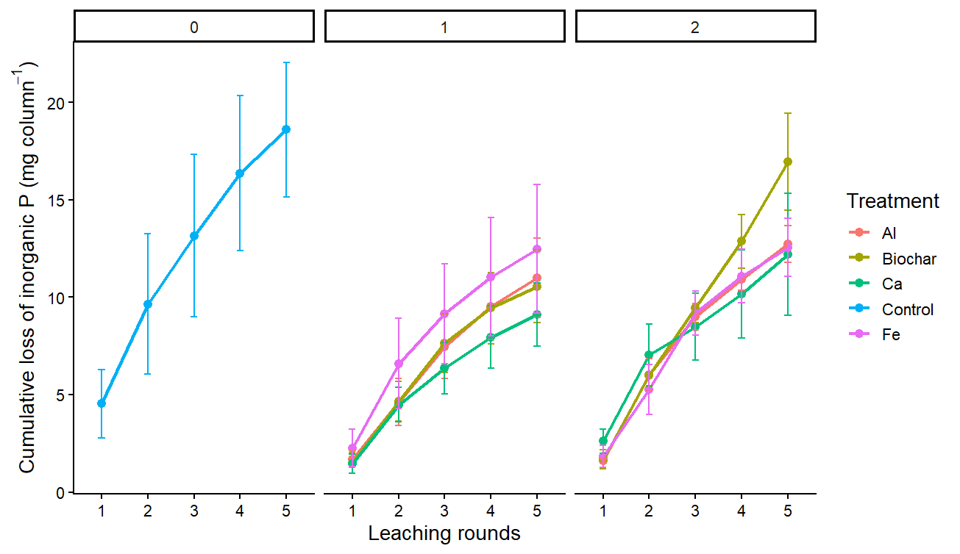
Note. Mean cumulative dissolved inorganic phosphorus (Pi) mass (mg) exported from soil columns receiving an unamended control, calcium-based water treatment residual (Ca-WTR), iron-based water treatment residual (Fe-WTR), aluminum-based water treatment residual (Al-WTR), or pine biochar at 1% and 2% (w/w; weight-for-weight) application rates. Error bars represent ± one standard deviation of the treatment replicates (n = 4).

3.2 Effects of Amendment Type and Application Rate
To evaluate the influence of amendment type and application rate independently, a two-way factorial ANOVA was performed using only the amended treatments. Neither amendment type (F(3, 24) = 0.668, p = 0.580) nor the interaction between amendment type and application rate (F(3, 24) = 0.715, p = 0.553) significantly affected cumulative phosphorus export.
Application rate showed a marginal trend toward significance (F(1, 24) = 3.174, p = 0.088). Across all amendments, columns receiving the 2% application rate exported more phosphorus (13.6 mg) than those receiving the 1% application rate (10.8 mg). This trend was primarily driven by the biochar treatment, where phosphorus export increased from 10.56 mg at the 1% rate to 16.96 mg at the 2% rate, approaching statistical significance (p = 0.055). In contrast, increasing the application rate of the calcium-, iron-, and aluminum-based water treatment residuals did not significantly influence phosphorus retention (all p > 0.33).

3.3 Temporal Phosphorus Leaching
Weekly phosphorus loss was analyzed using a linear mixed-effects model with soil column included as a random effect. Week significantly affected phosphorus export (F(1, 120.00) = 6.058, p = 0.015), indicating that phosphorus leaching changed over successive flushing events. Weekly phosphorus losses generally declined throughout the experiment, consistent with the gradual depletion of readily mobile phosphorus.
Neither treatment type (F(3, 113.13) = 0.584, p = 0.627), application rate (F(1, 113.13) = 0.103, p = 0.749), nor any interaction involving week (Treatment × Week: F(3, 120.00) = 1.788, p = 0.153) significantly affected temporal phosphorus loss. These results suggest that while repeated leaching altered phosphorus export over time, the relative performance of the soil amendments remained consistent throughout the experiment.
Weekly monitoring of dissolved inorganic phosphorus mass in the leachate revealed distinct temporal release patterns across the five simulated rainfall events. Following a slight, transient increase in phosphorus export during Week 2 across all treatment groups, leaching rates progressively declined and stabilized into a steady, gradual decay curve by Week 5. Throughout the entire study, the 1% Ca-WTR and 1% pine biochar treatments consistently maintained the lowest weekly phosphorus export, whereas the 2% pine biochar and unamended control treatments consistently exhibited the highest losses (Figure 2).
Figure 2
Weekly Dissolved Inorganic Phosphorus (Pi) Export from Greenhouse Soil Columns During Five Consecutive Simulated Rainfall Events
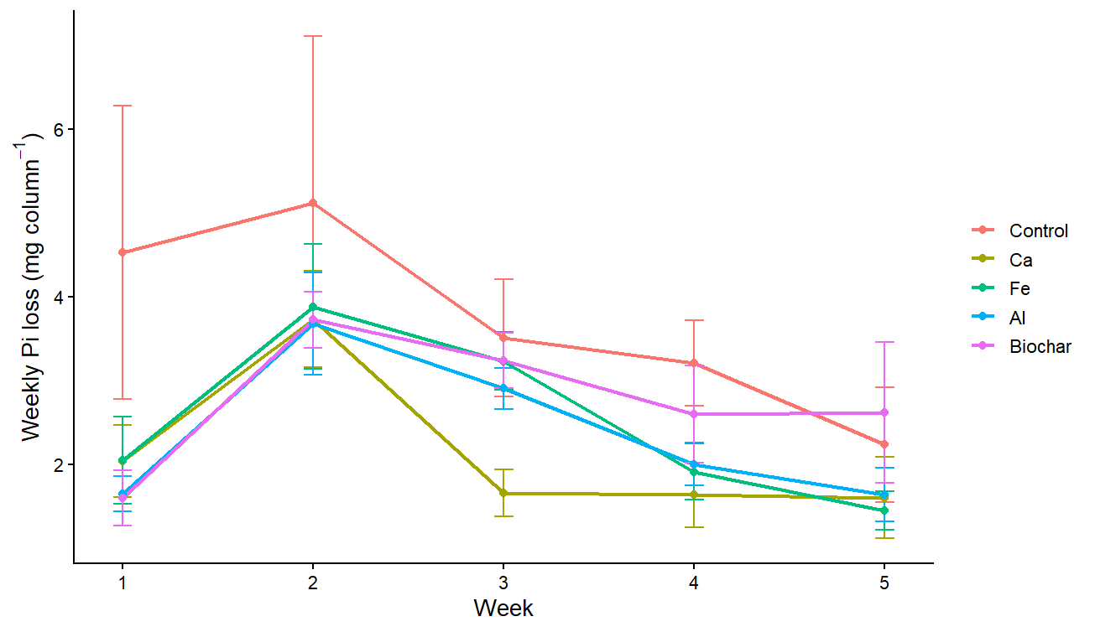
Note. Mean weekly dissolved inorganic phosphorus (Pi) mass (mg) exported from soil columns treated with an unamended control, calcium-based water treatment residual (Ca-WTR), iron-based water treatment residual (Fe-WTR), aluminum-based water treatment residual (Al-WTR), or pine biochar at 1% and 2% (w/w) application rates. Error bars represent ± one standard deviation of the treatment replicates (n = 4).

3.4 Temporal Dynamics of Leachate pH
Leachate pH was evaluated using a linear mixed-effects model to determine whether amendment type or application rate influenced soil solution chemistry over time. Treatment had no significant effect on leachate pH (F(8, 27) = 0.569, p = 0.793), and no significant treatment-by-week interaction was observed (F(32, 108) = 1.177, p = 0.264). In contrast, week had a highly significant effect on pH (F(4, 108) = 44.743, p < 0.0001), indicating that temporal changes in soil chemistry occurred regardless of treatment.
Across all treatments, leachate pH followed a similar V-shaped trend. Initial pH values were near neutral during Week 1, declined to their lowest levels during Week 3 (approximately 6.4–6.6), and subsequently recovered to near-neutral values by Weeks 4 and 5. Post hoc Tukey's HSD comparisons detected no significant differences among treatments within any individual week (all p > 0.05). Likewise, Dunnett's tests comparing each amendment directly with the control showed no significant differences throughout the study.
Overall, these findings indicate that repeated leaching events caused temporary fluctuations in soil solution pH, whereas the application of water treatment residuals and biochar at rates up to 2% did not significantly alter the natural buffering capacity of the soil.
Leachate electrical conductivity (EC) exhibited a sharp, systemic decline across all treatment groups over the five-week leaching period. Soil columns amended with WTRs and biochar initially displayed elevated EC values during Week 1 (ranging from approximately 590 to 640 µS/cm) compared to the unamended control (400 µS/cm). However, this salinity difference rapidly diminished over subsequent simulated rainfall events, with all treatment groups ultimately converging to a narrow, stable baseline range between 280 and 350 µS/cm by Week 5 (Figure 3).
Figure 3
Temporal Changes in Leachate Electrical Conductivity (EC) From Greenhouse Soil Columns During Five Weeks of Simulated Rainfall

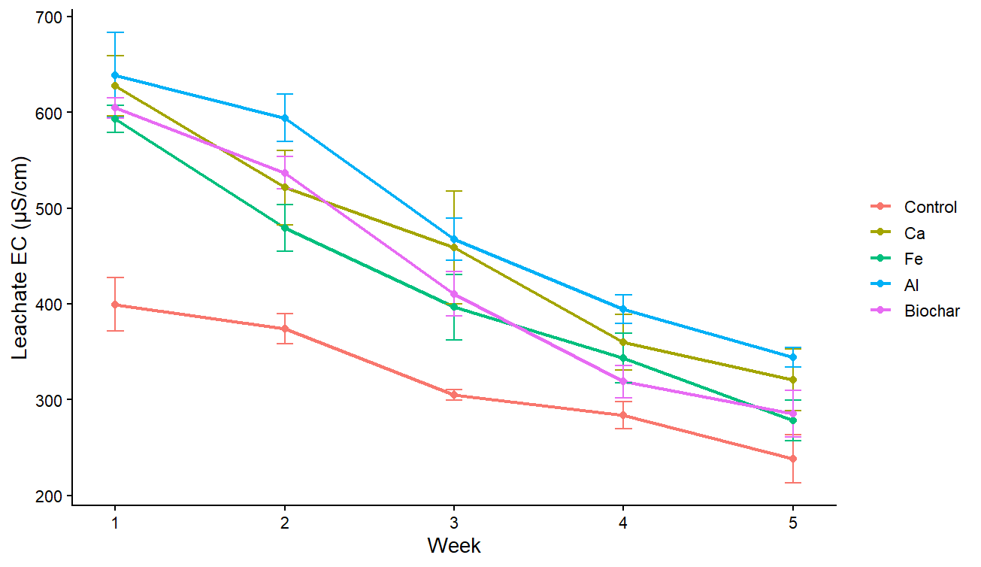
Note. Mean electrical conductivity (EC) of leachate collected weekly from soil columns treated with an unamended control, calcium-based water treatment residual (Ca-WTR), iron-based water treatment residual (Fe-WTR), aluminum-based water treatment residual (Al-WTR), or pine biochar at 1% and 2% (w/w) application rates. Electrical conductivity is reported in µS/cm. Error bars represent ± one standard deviation of the treatment replicates (n = 4).
In contrast to the dynamic changes observed in nutrient export and electrical conductivity, leachate pH remained remarkably stable and uniform throughout the study. Over the five consecutive rainfall simulations, leachate pH values across all treatment groups consistently hovered within a neutral, crop-safe range of 6.2 to 6.8. Statistical analysis confirmed that the application of Ca, Fe, and Al WTRs, as well as pine biochar, had no significant influence on leachate pH compared to the unamended control (Figure 4).
Figure 4
Temporal Changes in Leachate pH From Greenhouse Soil Columns During Five Weeks of Simulated Rainfall
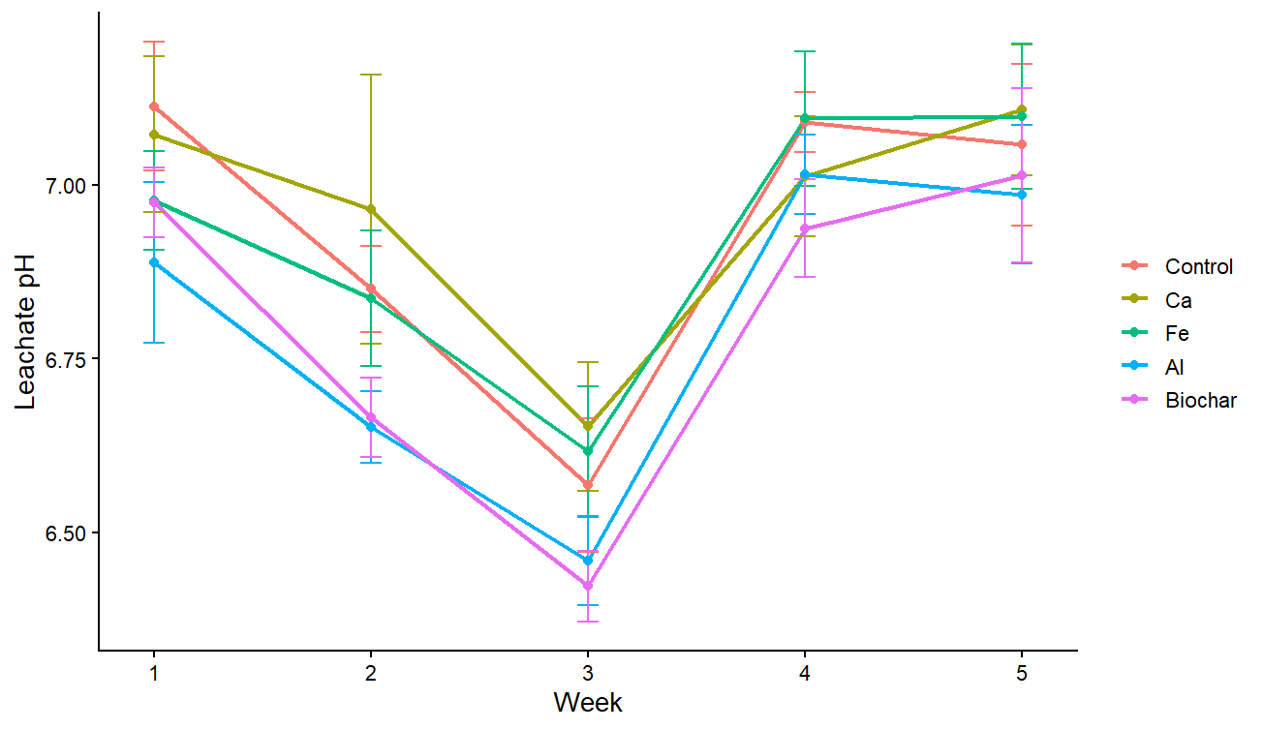Note. Mean leachate pH measured weekly from soil columns treated with an unamended control, calcium-based water treatment residual (Ca-WTR), iron-based water treatment residual (Fe-WTR), aluminum-based water treatment residual (Al-WTR), or pine biochar at 1% and 2% (w/w) application rates. Error bars represent ± one standard deviation of the treatment replicates (n = 4).
The total volume of leachate recovered from the soil columns decreased dramatically over the course of the experiment. During Week 1, the columns drained an average of 860 mL of leachate following the simulated rainfall event. By Week 5, however, recovered drainage volumes across all treatments fell to a highly controlled range of 260 to 350 mL. This sharp reduction in leachate volume was highly consistent across all columns, regardless of the soil amendment applied (Figure 5).
Figure 5
Temporal Changes in Leachate Volume From Greenhouse Soil Columns During Five Weeks of Simulated Rainfall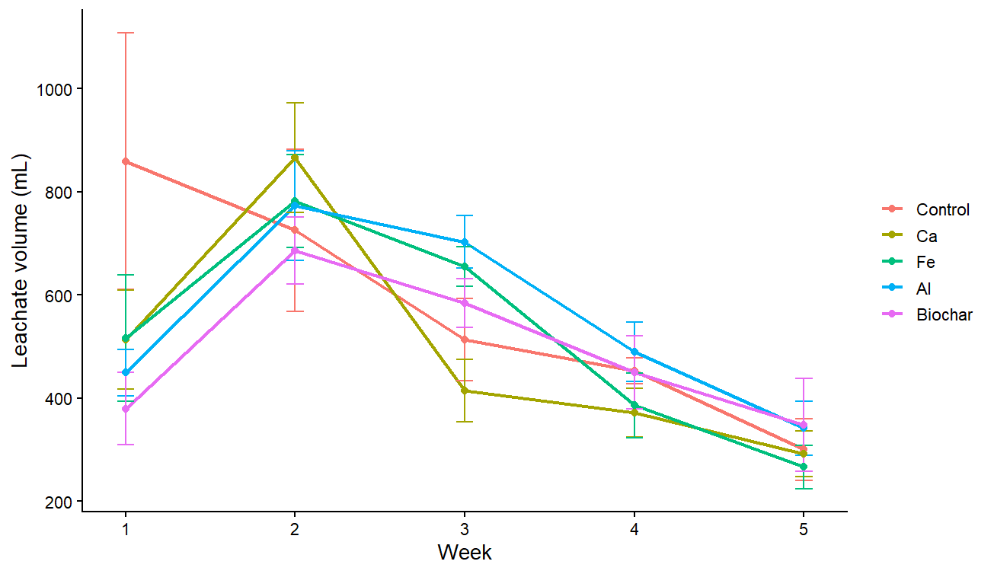
Note. Mean leachate volume (mL) collected following each weekly simulated rainfall event from soil columns treated with an unamended control, calcium-based water treatment residual (Ca-WTR), iron-based water treatment residual (Fe-WTR), aluminum-based water treatment residual (Al-WTR), or pine biochar at 1% and 2% (w/w) application rates. Error bars represent ± one standard deviation of the treatment replicates (n = 4).

4. Discussion
4.1 Comparative Efficacy of Soil Amendments for Phosphorus Immobilization

The primary objective of this study was to evaluate the effectiveness of water treatment residuals (WTRs) and biochar for reducing phosphorus leaching from legacy phosphorus-impacted Florida Spodosols. Overall, the findings partially agree with previous research while also revealing differences under dynamic leaching conditions.

Freitas et al. (2026) reported that aluminum- and iron-based residuals consistently produced the greatest reductions in water-soluble phosphorus, whereas calcium-based materials were substantially less effective. In contrast, the present study found that the 1% Ca-WTR treatment achieved the greatest numerical reduction in cumulative phosphorus export, reducing phosphorus losses by 51.0% relative to the unamended control. The 1% biochar and 1% Al-WTR treatments also produced notable numerical reductions of 43.2% and 41.0%, respectively. Although these differences were not statistically significant, they suggest that amendment performance may differ under continuous leaching compared with static laboratory incubations.

Biochar exhibited a particularly interesting rate-dependent response. While the 1% application effectively reduced phosphorus export, the 2% treatment performed similarly to the control. One possible explanation is that higher biochar application rates altered soil hydraulic properties or introduced additional labile phosphorus from the biochar itself, reducing its overall effectiveness. Because these mechanisms were not directly measured, they remain hypotheses that warrant further investigation.

Although several treatments produced substantial numerical reductions in cumulative phosphorus export, variability among replicates limited the statistical power to detect significant differences. Consequently, these trends should be interpreted cautiously but provide promising evidence that selected amendments may improve phosphorus retention under field-relevant leaching conditions.

4.2 Temporal Leaching and Hydrologic Dynamics

The temporal patterns observed throughout the experiment were generally consistent with previous studies of legacy phosphorus in sandy Florida soils. Lin et al. (2025) reported that soils with a history of biosolid application continue to release phosphorus gradually over repeated rainfall events as mobile phosphorus pools become depleted.

A similar pattern was observed in the present study. Weekly phosphorus losses declined over time, while cumulative phosphorus export increased steadily across all treatments, indicating the progressive depletion of readily mobile phosphorus. These findings support the conclusion that legacy phosphorus remains a long-term source of dissolved phosphorus, even years after biosolid applications have ceased.

A second consistent observation was the progressive reduction in leachate volume across all treatments. Average drainage volumes decreased from approximately 860 mL during the first week to approximately 260–350 mL by the end of the experiment. Because this trend occurred regardless of amendment type, it likely reflects natural changes within the soil columns rather than treatment-specific effects.

Several factors may have contributed to this decline. All columns were planted with bahiagrass (Paspalum notatum), and increasing plant growth likely increased water uptake through transpiration and root absorption. In addition, repeated wetting and drying cycles may have promoted soil settling and partial compaction, reducing pore space and slowing water movement through the soil profile. Although these processes were not quantified directly, they provide reasonable explanations for the observed decline in drainage volume.

Together, these findings demonstrate that phosphorus transport is governed not only by chemical adsorption but also by dynamic hydrologic and biological processes that evolve throughout repeated rainfall events.

4.3 Secondary Water Quality Effects

In addition to phosphorus retention, an important consideration is whether soil amendments introduce unintended changes to water chemistry. Previous studies have shown that certain amendments can substantially alter soil pH, potentially affecting nutrient availability and crop performance (Freitas et al., 2026).

In the present study, however, amendment type and application rate did not significantly affect leachate pH throughout the experiment. Although pH fluctuated over time, all treatments followed a similar temporal pattern, with values declining slightly during the middle weeks before returning to near-neutral conditions by the end of the study. Likewise, electrical conductivity was initially higher in the amended treatments but declined steadily over successive leaching events and approached values similar to the control by Week 5.

These results suggest that the tested WTRs and biochar did not substantially alter the natural buffering capacity of the soil or produce persistent increases in salinity under the conditions of this experiment. From a practical perspective, this indicates that the amendments can reduce phosphorus losses without causing major changes in key indicators of soil water quality.

4.4 Implications for Phosphorus Management in Sandy Agricultural Soils

Although most treatment effects were not statistically significant, several consistent numerical trends have practical implications for phosphorus management in sandy agricultural soils. The 1% Ca-WTR treatment consistently produced the lowest cumulative phosphorus export, while the 1% Al-WTR and 1% biochar treatments also reduced phosphorus losses relative to the unamended control. These findings suggest that relatively low amendment application rates may be sufficient to improve phosphorus retention without substantially altering leachate pH or electrical conductivity.

An important observation was that increasing the amendment application rate from 1% to 2% did not consistently improve phosphorus retention. In particular, the 2% biochar treatment exhibited greater phosphorus loss than the 1% treatment, indicating that higher amendment rates do not necessarily provide additional environmental benefits. Although the mechanisms responsible for this trend were not directly investigated, the results demonstrate that amendment dosage should be optimized rather than simply increased.

Because this study was conducted under controlled greenhouse conditions using soil columns, caution should be exercised when extrapolating these findings directly to field-scale agricultural systems. Natural rainfall variability, seasonal changes, plant development, and long-term soil processes may influence amendment performance differently than observed in this experiment. Future research should therefore evaluate these materials under field conditions over longer monitoring periods to determine whether the numerical reductions observed here translate into significant improvements in watershed-scale phosphorus management.

Overall, this study demonstrates that water treatment residuals and biochar remain promising amendment materials for reducing phosphorus losses from legacy phosphorus-impacted sandy soils. While additional field validation is needed, the consistent numerical reductions observed in several treatments indicate that these materials have the potential to support more sustainable nutrient management practices in environmentally sensitive agricultural regions.

5. Conclusion

This study evaluated the effectiveness of calcium-, aluminum-, and iron-based water treatment residuals (WTRs), along with pine biochar, in reducing phosphorus leaching from legacy phosphorus-impacted Florida Spodosols under controlled greenhouse conditions. Although no statistically significant differences were detected among the treatments, several amendments, particularly the 1% Ca-WTR treatment, consistently produced substantial numerical reductions in cumulative phosphorus export while maintaining stable leachate pH and electrical conductivity. The results also demonstrated that increasing amendment application rates did not necessarily improve phosphorus retention, highlighting the importance of optimizing application rates rather than maximizing amendment dosage. Repeated leaching events further showed that phosphorus release from legacy-impacted soils remains a gradual, long-term process, emphasizing the persistence of legacy phosphorus in sandy agricultural systems. While the greenhouse soil column design cannot fully replicate field conditions, the findings provide valuable insight into the performance of these amendments under controlled leaching conditions. Overall, this study supports the continued investigation of water treatment residuals and biochar as practical strategies for mitigating phosphorus losses and improving nutrient management in environmentally sensitive agricultural watersheds.

References
Agyin-Birikorang, S., Oladeji, O. O., O'Connor, G. A., Obreza, T. A., & Capece, J. C. (2009).
Efficacy of drinking-water treatment residual in controlling off-site phosphorus losses: a field study in Florida. Journal of environmental quality, 38(3), 1076–1085. https://doi.org/10.2134/jeq2008.0383
Dayton, E. A., & Basta, N. T. (2005). A method for determining the phosphorus sorption
capacity and amorphous aluminum of aluminum-based drinking water treatment residuals. Journal of environmental quality, 34(3), 1112–1118. https://doi.org/10.2134/jeq2004.0230
de Campos, M., Antonangelo, J. A., & Alleoni, L. R. F. (2016). Phosphorus sorption index in
humid tropical soils. Soil and Tillage Research, 156, 110–118. https://doi.org/10.1016/j.still.2015.09.020
Dodd, R. J., & Sharpley, A. N. (2016). Conservation practice effectiveness and adoption:
Unintended consequences and implications for sustainable phosphorus management. Nutrient Cycling in Agroecosystems, 104, 373–392. https://doi.org/10.1007/s10705-015-9748-8
Elliott, H. A., O'Connor, G. A., Lu, P., & Brinton, S. (2002). Influence of water treatment
residuals on phosphorus solubility and leaching. Journal of environmental quality, 31(4), 1362–1369. https://doi.org/10.2134/jeq2002.1362
Ippolito, J. A., Barbarick, K. A., & Elliott, H. A. (2011). Drinking water treatment residuals: A
review of recent uses. Journal of Environmental Quality, 40(1), 1–12. https://doi.org/10.2134/jeq2010.0242
Murphy, J., & Riley, J. P. (1962). A modified single solution method for the determination of
phosphate in natural waters. Analytica Chimica Acta, 27, 31–36.
Olsen, S. R., & Sommers, L. E. (1982). Phosphorus. In A. L. Page, R. H. Miller, & D. R. Keeney
(Eds.), Methods of Soil Analysis, Part 2: Chemical and Microbiological Properties (2nd ed., pp. 403–430). American Society of Agronomy / Soil Science Society of America.
Pagliari, P., Galindo, F. S., Strock, J., & Rosen, C. (2022). Use of repeated measures data
analysis for field trials with annual and perennial crops. Plants, 11(13), 1783. https://doi.org/10.3390/plants11131783
Sharpley, A. N., Chapra, S. C., Wedepohl, R., Sims, J. T., Daniel, T. C., & Reddy, K. R. (1994).
Managing agricultural phosphorus for protection of surface waters: Issues and options. Journal of Environmental Quality, 23(3), 437–451.
Sims, J. T., & Pierzynski, G. M. (2005). Chemistry of phosphorus in soils. In Chemical
Processes in Soils (pp. 151–192). Soil Science Society of America. https://doi.org/10.2134/jeq1994.00472425002300030006x
Ukwattage, N. L., Li, Y., Gan, Y., Li, T., & Gamage, R. P. (2020). Effect of biochar and coal fly
ash soil amendments on the leaching loss of phosphorus in subtropical sandy Ultisols. Water, Air, & Soil Pollution, 231, 56. https://doi.org/10.1007/s11270-020-4393-5

