湖 北 大 学
计算机学院

2025 —— 2026 学年度
第 1 学期

学 生 实 验 报 告 册

学生姓名： 劳仕豪
班 级： 计科2302班
学 号： 202331116020180
课程名称： 应用软件开发课程设计
任课老师： 孙 斌

学生实验守则

1、学生在规定的时间内进行实验，不得无故缺席或迟到。
2、学生在每次实验前对排定要做的实验应进行预习，并按要求作好预习报告。
3、每次实验前，必须交上次实验报告和本次实验预习报告，并经指导教师提问、检查同意后，才可进行本次实验。
4、学生进入实验室指定位置后，首先根据仪器清单核对自己使用的仪器是否有缺少或损坏，发现问题及时向指导教师报告，严禁擅自动用别组仪器。
5、实验时必须有实事求是、严肃认真的科学态度，严格遵守仪器操作规程和注意事项。
6、实验完毕应将实验数据交给指导教师检查，合格后，整理复原好仪器设备，方可离开实验室。
7、保持实验室肃静和整洁，不得大声喧哗，乱丢垃圾和吃东西。
8、学生在实验过程中，由于不遵守操作规程或未经许可，擅自进行实验而造成事故、损坏仪器设备，应及时报告，并填写损坏清单，按院有关规定进行赔偿。
实 验 报 告 单

实验名称： 实验1：基于LeNet的手写数字识别 1

同组人： 无 实验课时：2
实验室：虚拟云计算实验室 报告日期：2026年4月20日

一、实验目的
1. 熟悉LeNet 卷积神经网络模型；
2. 掌握使用Mindspore 框架搭建经典网络结构。

二、实验环境
华为云算力资源
Ascend: 1*ascend-snt9b1|ARM: 24核 192GB
mindspore_2.4.0

三、实验步骤及结果
import os
import mindspore
from mindspore import nn, context, dtype
from mindspore.dataset import MnistDataset
import mindspore.dataset.vision as vision
import mindspore.dataset.transforms as transforms
from mindspore.train import Model, LossMonitor, Callback
import matplotlib.pyplot as plt
import numpy as np

# ===================== 环境设置 =====================
context.set_context(device_target="CPU")

# ===================== 定义 LeNet 网络 =====================
class LeNet(nn.Cell):
def __init__(self):
super(LeNet, self).__init__()
self.conv = nn.SequentialCell(
nn.Conv2d(1, 6, kernel_size=5, pad_mode="valid"),
nn.Tanh(),
nn.AvgPool2d(kernel_size=2, stride=2),
nn.Conv2d(6, 16, kernel_size=5, pad_mode="valid"),
nn.Tanh(),
nn.AvgPool2d(kernel_size=2, stride=2)
)
self.fc = nn.SequentialCell(
nn.Dense(16 * 5 * 5, 120),
nn.Tanh(),
nn.Dense(120, 84),
nn.Tanh(),
nn.Dense(84, 10)
)

def construct(self, x):
x = self.conv(x)
x = x.view(x.shape[0], -1)
x = self.fc(x)
return x

# ===================== 自定义回调 =====================
class TrainHistory(Callback):
def __init__(self):
self.train_losses = []

def on_train_epoch_end(self, run_context):
cb_params = run_context.original_args()
loss = cb_params.net_outputs.asnumpy()
self.train_losses.append(loss)

# ===================== 数据集 =====================
def create_dataset(is_train=True, batch_size=32):
data_path = "./MNIST_Data/train" if is_train else "./MNIST_Data/test"
dataset = MnistDataset(dataset_dir=data_path, shuffle=is_train)

trans = [
vision.Resize((32, 32)),
vision.Rescale(1.0 / 255.0, 0.0),
vision.Normalize(mean=(0.1307,), std=(0.3081,)),
vision.HWC2CHW()
]
type_cast_op = transforms.TypeCast(dtype.int32)

dataset = dataset.map(operations=trans, input_columns="image", num_parallel_workers=2)
dataset = dataset.map(operations=type_cast_op, input_columns="label", num_parallel_workers=2)
dataset = dataset.batch(batch_size, drop_remainder=True)
return dataset

# ===================== 训练 =====================
if __name__ == "__main__":
epoch_size = 5
batch_size = 32

print("正在加载训练集...")
train_dataset = create_dataset(is_train=True, batch_size=batch_size)
print("正在加载测试集...")
test_dataset = create_dataset(is_train=False, batch_size=batch_size)

net = LeNet()
loss_fn = nn.CrossEntropyLoss()
optimizer = nn.Adam(net.trainable_params(), learning_rate=0.001)
model = Model(net, loss_fn=loss_fn, optimizer=optimizer, metrics={"Accuracy": nn.Accuracy()})

history = TrainHistory()
test_accs = []

print("======== Start Training ========")
for epoch in range(1, epoch_size + 1):
model.train(1, train_dataset, callbacks=[history, LossMonitor(per_print_times=0)])
eval_result = model.eval(test_dataset, dataset_sink_mode=False)
acc = eval_result["Accuracy"]
test_accs.append(acc)
print(f"Epoch {epoch}, Loss: {history.train_losses[-1]:.4f}, Accuracy: {acc:.4f}")

print("======== Final Testing ========")
final_acc = test_accs[-1]
print(f"Final Test Accuracy: {final_acc:.4f}")

# 损失曲线
plt.figure(figsize=(6, 4), dpi=300)
plt.plot(range(1, epoch_size+1), history.train_losses, marker='o', linewidth=2, markersize=6)
plt.xlabel("Epoch")
plt.ylabel("Training Loss")
plt.title("Training Loss Curve")
plt.grid(alpha=0.3)
plt.xticks(range(1, 6))
plt.tight_layout()
plt.savefig("training_loss.png", dpi=300)
plt.close()

# ✅ 测试准确率：0.005 精度刻度
plt.figure(figsize=(6, 4), dpi=300)
plt.plot(range(1, epoch_size+1), test_accs, marker='s', linewidth=2, markersize=6, color='#ff7f0e')
plt.xlabel("Epoch")
plt.ylabel("Test Accuracy")
plt.title("Test Accuracy Curve")
plt.grid(alpha=0.3)
plt.xticks(range(1, 6))
plt.yticks(np.arange(0.97, 1.001, 0.005)) # 0.005 步长
plt.tight_layout()
plt.savefig("test_accuracy.png", dpi=300)
plt.close()

print("训练曲线已保存！")
print("======== 训练完成 ========")
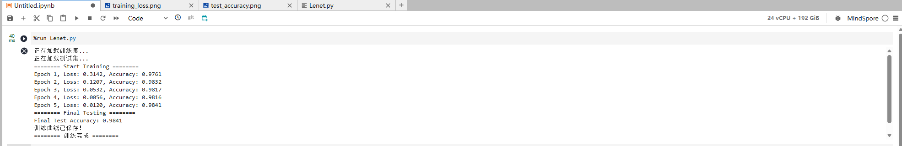
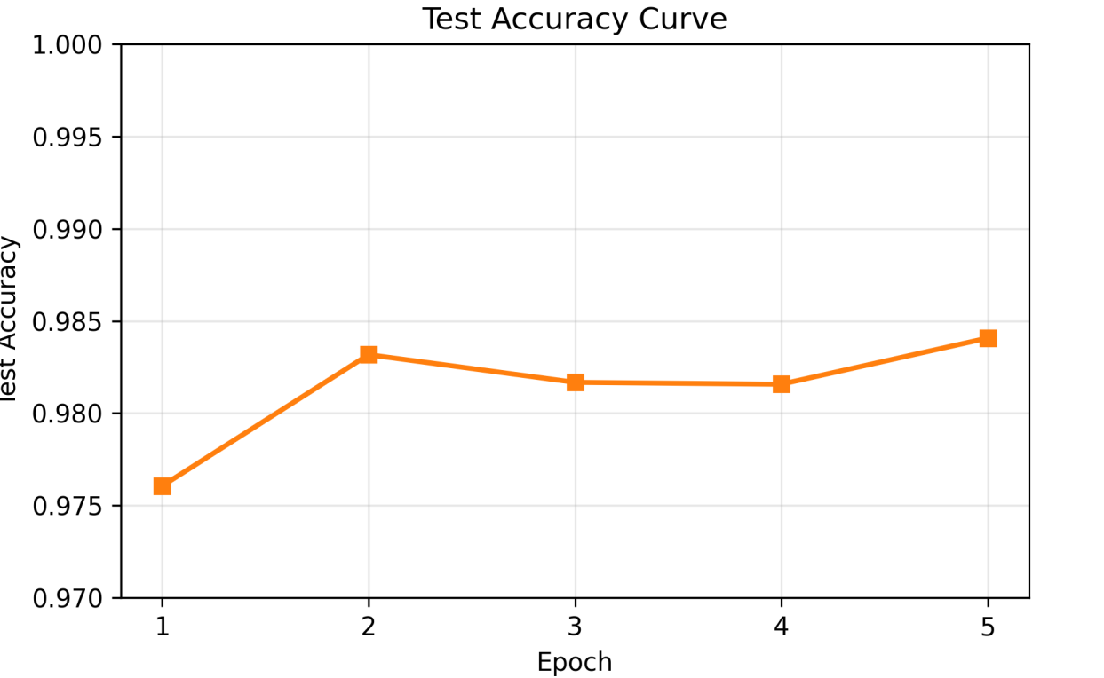
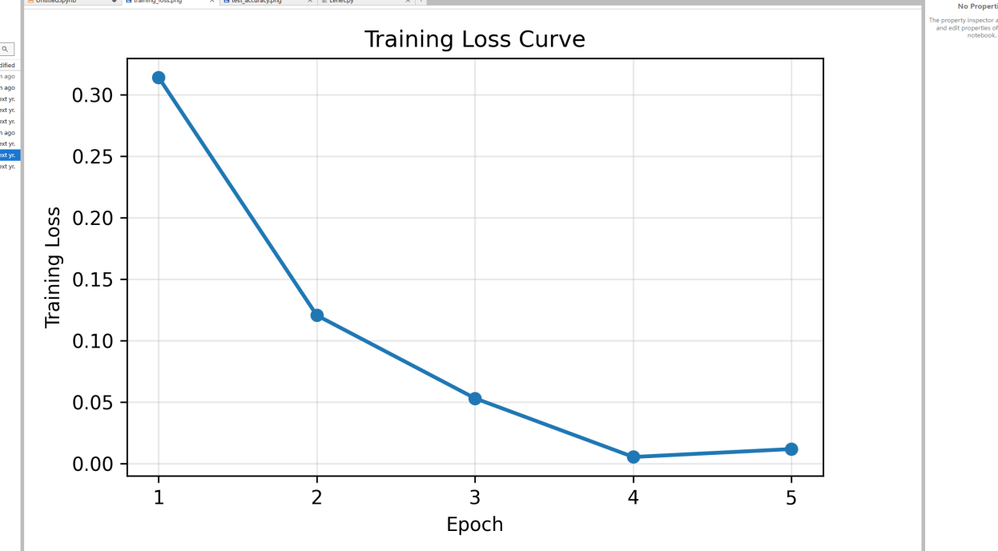

实 验 报 告 单

实验2：基于AlexNet的图像识别 1

同组人： 无 实验课时：2
实验室：虚拟云计算实验室 报告日期：2026年4月20日

一、实验目的
1. 熟悉AlexNet 卷积神经网络模型；
2. 掌握使用Mindspore 框架搭建经典网络结构。

二、实验环境
华为云算力资源
Ascend: 1*ascend-snt9b1|ARM: 24核 192GB
mindspore_2.4.0
三、实验步骤及结果
AlexNet.py

import mindspore.nn as nn
from mindspore.common.initializer import HeUniform, XavierUniform, Constant

class AlexNet(nn.Cell):
def __init__(self, num_classes=35):
super(AlexNet, self).__init__()
# 五个卷积层
self.features = nn.SequentialCell([
nn.Conv2d(3, 96, kernel_size=11, stride=4, pad_mode='valid', weight_init=HeUniform()),
nn.ReLU(),
nn.MaxPool2d(kernel_size=3, stride=2, pad_mode='valid'),
nn.Conv2d(96, 256, kernel_size=5, stride=1, pad_mode='pad', padding=2, weight_init=HeUniform()),
nn.ReLU(),
nn.MaxPool2d(kernel_size=3, stride=2, pad_mode='valid'),
nn.Conv2d(256, 384, kernel_size=3, stride=1, pad_mode='pad', padding=1, weight_init=HeUniform()),
nn.ReLU(),
nn.Conv2d(384, 384, kernel_size=3, stride=1, pad_mode='pad', padding=1, weight_init=HeUniform()),
nn.ReLU(),
nn.Conv2d(384, 256, kernel_size=3, stride=1, pad_mode='pad', padding=1, weight_init=HeUniform()),
nn.ReLU(),
nn.MaxPool2d(kernel_size=3, stride=2, pad_mode='valid')
])
self.avgpool = nn.AdaptiveAvgPool2d((6, 6))
# 三个全连接层
self.classifier = nn.SequentialCell([
nn.Dropout(p=0.5),
nn.Dense(256 * 6 * 6, 4096, weight_init=XavierUniform(), bias_init=Constant(0.0)),
nn.ReLU(),
nn.Dropout(p=0.5),
nn.Dense(4096, 4096, weight_init=XavierUniform(), bias_init=Constant(0.0)),
nn.ReLU(),
nn.Dense(4096, num_classes, weight_init=XavierUniform(), bias_init=Constant(0.0))
])

def construct(self, x):
x = self.features(x)
x = self.avgpool(x)
x = x.view(x.shape[0], -1)
x = self.classifier(x)
return x

DataSet.py

import os
import numpy as np
from PIL import Image
import mindspore.dataset as ds
import mindspore.dataset.vision as vision
import mindspore.dataset.transforms as transforms
from mindspore import dtype as mstype
from sklearn.model_selection import train_test_split

class CatDogDataSet:
def __init__(self, root, train=True, test=False):
self.test = test
imgs = [os.path.join(root, img) for img in os.listdir(root)]
if self.test:
# test 集合命名格式：xxx/数字.jpg
imgs = sorted(imgs, key=lambda x: int(x.split('.')[-2].split('/')[-1]))
else:
# train 集合命名格式：数字.jpg
imgs = sorted(imgs, key=lambda x: int(x.split('.')[-2]))

if self.test:
self.imgs = imgs
else:
trainval_files, val_files = train_test_split(imgs, test_size=0.3, random_state=42)
self.imgs = trainval_files if train else val_files

def __getitem__(self, index):
img_path = self.imgs[index]
if self.test:
label = -1
else:
label = 1 if 'dog' in img_path.split('/')[-1] else 0
data = np.array(Image.open(img_path).convert("RGB"))
return data, np.int32(label)

def __len__(self):
return len(self.imgs)

def create_dataset(data_path, batch_size, training=True, test=False):
dataset = CatDogDataSet(data_path, train=training, test=test)
ds_generator = ds.GeneratorDataset(dataset,
column_names=["image", "label"],
shuffle=training,
num_parallel_workers=1)

transform_img = [
vision.Resize((224, 224)), # 调整图像大小
vision.Normalize(mean=[0.485, 0.456, 0.406],
std=[0.229, 0.224, 0.225]), # 标准 ImageNet 参数
vision.HWC2CHW() # 转换通道顺序
]

type_cast_op = transforms.TypeCast(mstype.int32)

ds_generator = ds_generator.map(operations=transform_img,
input_columns="image",
num_parallel_workers=1)

ds_generator = ds_generator.map(operations=type_cast_op,
input_columns="label",
num_parallel_workers=1)

ds_generator = ds_generator.batch(batch_size,
drop_remainder=True,
num_parallel_workers=1)

return ds_generator

train.py
import time
import numpy as np
import mindspore as ms
from mindspore import nn, context, ops, save_checkpoint
from mindspore.nn import Adam
from tqdm import tqdm

from AlexNet import AlexNet
from DataSet import create_dataset

# ================== 配置 ==================
context.set_context(mode=context.GRAPH_MODE, device_target="Ascend")

lr = 1e-4
BATCH_SIZE = 32
EPOCHS = 10

train_loader = create_dataset("dataset/train", BATCH_SIZE, training=True)
val_loader = create_dataset("dataset/train", BATCH_SIZE, training=False)

model = AlexNet(num_classes=2)
criterion = nn.SoftmaxCrossEntropyWithLogits(sparse=True, reduction='mean')
optimizer = Adam(model.trainable_params(), learning_rate=lr)

# ================== 训练 ==================
for epoch in range(1, EPOCHS + 1):
model.set_train(True)
sum_loss = 0
step = 0
start_time = time.time()

train_iter = train_loader.create_dict_iterator()
pbar = tqdm(train_iter, total=train_loader.get_dataset_size(),
desc=f"Train Epoch {epoch}", unit="batch")

for batch in pbar:
data = batch["image"]
target = batch["label"]

def forward_fn(x, y):
logits = model(x)
loss = criterion(logits, y)
return loss, logits

grad_fn = ops.value_and_grad(forward_fn, None,
optimizer.parameters, has_aux=True)
(loss, _), grads = grad_fn(data, target)
optimizer(grads)

step += 1
loss_val = float(loss)
sum_loss += loss_val

elapsed = time.time() - start_time
speed = step / elapsed
eta = (train_loader.get_dataset_size() - step) / speed

pbar.set_postfix({"Loss": f"{loss_val:.4f}", "ETA": f"{eta:.1f}s"})

avg_loss = sum_loss / step
print(f"Epoch {epoch}, Average Loss: {avg_loss:.4f}")

# ================== 验证 ==================
model.set_train(False)
correct = 0
total = 0

val_iter = val_loader.create_dict_iterator()
pbar_val = tqdm(val_iter, total=val_loader.get_dataset_size(),
desc=f"Val Epoch {epoch}", unit="batch")

for batch in pbar_val:
data = batch["image"]
target = batch["label"]
logits = model(data)
pred = np.argmax(logits.asnumpy(), axis=1)
correct += np.sum(pred == target.asnumpy())
total += target.shape[0]

acc = correct / total
print(f"Epoch {epoch}, Validation Accuracy: {acc*100:.2f}%")

# ================== 保存模型 ==================
save_checkpoint(model, f"alexnet_epoch{epoch}.ckpt")

print("========== Training Finished ==========")

Predict.py

import os
import numpy as np
from PIL import Image
import mindspore as ms
from mindspore import Tensor, context
import mindspore.dataset.vision as vision
from AlexNet import AlexNet

# Ascend 环境
context.set_context(mode=context.GRAPH_MODE, device_target="Ascend")

classes = ('cat', 'dog')

# 和训练保持一致
transform_test = [
vision.Resize((224, 224)),
vision.Normalize(mean=[0.485, 0.456, 0.406],
std=[0.229, 0.224, 0.225]),
vision.HWC2CHW()
]

# 加载模型
model = AlexNet(num_classes=2)
param_dict = ms.load_checkpoint("model.ckpt")
ms.load_param_into_net(model, param_dict)
model.set_train(False)

# 测试集
path = 'dataset/test/'
testList = os.listdir(path)

for file in testList:
img = np.array(Image.open(os.path.join(path, file)).convert("RGB"))
for op in transform_test:
img = op(img)
img = img[np.newaxis, :] # [1, 3, 224, 224]
img = Tensor(img, ms.float32)

out = model(img)
pred = int(np.argmax(out.asnumpy(), axis=1))
print(f'Image Name: {file}, Predict: {classes[pred]}")

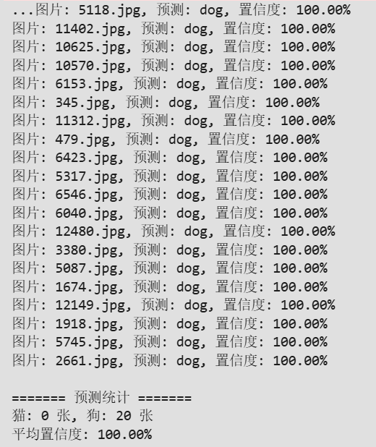
实验结果：

实 验 报 告 单

实验3：基于YOLO的工业印刷电路板缺陷检测 1

同组人： 无 实验课时：4
实验室：虚拟云计算实验室 报告日期：2026年4月20日

一、实验目的
1. 熟悉YOLOv8n 网络模型；
2. 掌握使用Mindspore 框架搭建经典网络结构。

二、实验环境
华为云算力资源
Ascend: 1*ascend-snt9b1|ARM: 24核 192GB
mindspore_2.4.0

- 实验步骤及结果
Train.py

import argparse
import ast
import os
from functools import partial

import mindspore as ms

from mindyolo.data import COCODataset, create_loader
from mindyolo.models import create_loss, create_model
from mindyolo.optim import (EMA, create_group_param, create_lr_scheduler,
create_optimizer, create_warmup_momentum_scheduler)
from mindyolo.utils import logger
from mindyolo.utils.config import parse_args
from mindyolo.utils.train_step_factory import get_gradreducer, get_loss_scaler, create_train_step_fn
from mindyolo.utils.trainer_factory import create_trainer
from mindyolo.utils.callback import create_callback
from mindyolo.utils.utils import (freeze_layers, load_pretrain, set_default,
set_seed, Synchronizer)

def get_parser_train(parents=None):
parser = argparse.ArgumentParser(description="Train", parents=[parents] if parents else [])
parser.add_argument("--task", type=str, default="detect", choices=["detect", "segment"])
parser.add_argument("--device_target", type=str, default="Ascend", help="device target, Ascend/GPU/CPU")
parser.add_argument("--save_dir", type=str, default="./runs", help="save dir")
parser.add_argument("--log_level", type=str, default="INFO", help="log level to print")
parser.add_argument("--is_parallel", type=ast.literal_eval, default=False, help="Distribute train or not")
parser.add_argument("--ms_mode", type=int, default=0,
help="Running in GRAPH_MODE(0) or PYNATIVE_MODE(1) (default=0)")
parser.add_argument("--max_call_depth", type=int, default=2000, help="The maximum depth of a function call")
parser.add_argument("--ms_amp_level", type=str, default="O0", help="amp level, O0/O1/O2/O3")
parser.add_argument("--keep_loss_fp32", type=ast.literal_eval, default=True,
help="Whether to maintain loss using fp32/O0-level calculation")
parser.add_argument("--anchor_base", type=ast.literal_eval, default=True, help="Anchor-base")
parser.add_argument("--ms_loss_scaler", type=str, default="static", help="train loss scaler, static/dynamic/none")
parser.add_argument("--ms_loss_scaler_value", type=float, default=1024.0, help="static loss scale value")
parser.add_argument("--ms_jit", type=ast.literal_eval, default=True, help="use jit or not")
parser.add_argument("--ms_enable_graph_kernel", type=ast.literal_eval, default=False,
help="use enable_graph_kernel or not")
parser.add_argument("--ms_datasink", type=ast.literal_eval, default=False, help="Train with datasink.")
parser.add_argument("--overflow_still_update", type=ast.literal_eval, default=True, help="overflow still update")
parser.add_argument("--clip_grad", type=ast.literal_eval, default=False)
parser.add_argument("--clip_grad_value", type=float, default=10.0)
parser.add_argument("--ema", type=ast.literal_eval, default=True, help="ema")
parser.add_argument("--weight", type=str, default="", help="initial weight path")
parser.add_argument("--ema_weight", type=str, default="", help="initial ema weight path")
parser.add_argument("--freeze", type=list, default=[], help="Freeze layers: backbone of yolov7=50, first3=0 1 2")
parser.add_argument("--epochs", type=int, default=300, help="total train epochs")
parser.add_argument("--per_batch_size", type=int, default=32, help="per batch size for each device")
parser.add_argument("--img_size", type=int, default=640, help="train image sizes")
parser.add_argument("--nbs", type=list, default=64, help="nbs")
parser.add_argument("--accumulate", type=int, default=1,
help="grad accumulate step, recommended when batch-size is less than 64")
parser.add_argument("--auto_accumulate", type=ast.literal_eval, default=False, help="auto accumulate")
parser.add_argument("--log_interval", type=int, default=100, help="log interval")
parser.add_argument("--single_cls", type=ast.literal_eval, default=False,
help="train multi-class data as single-class")
parser.add_argument("--sync_bn", type=ast.literal_eval, default=False,
help="use SyncBatchNorm, only available in DDP mode")
parser.add_argument("--keep_checkpoint_max", type=int, default=100)
parser.add_argument("--run_eval", type=ast.literal_eval, default=False, help="Whether to run eval during training")
parser.add_argument("--run_eval_interval", type=int, default=1, help="interval epochs of running eval during training")
parser.add_argument("--conf_thres", type=float, default=0.001, help="object confidence threshold for run_eval")
parser.add_argument("--iou_thres", type=float, default=0.65, help="IOU threshold for NMS for run_eval")
parser.add_argument("--conf_free", type=ast.literal_eval, default=False,
help="Whether the prediction result include conf")
parser.add_argument("--rect", type=ast.literal_eval, default=False, help="rectangular training")
parser.add_argument("--nms_time_limit", type=float, default=20.0, help="time limit for NMS")
parser.add_argument("--recompute", type=ast.literal_eval, default=False, help="Recompute")
parser.add_argument("--recompute_layers", type=int, default=0)
parser.add_argument("--seed", type=int, default=2, help="set global seed")
parser.add_argument("--summary", type=ast.literal_eval, default=True, help="collect train loss scaler or not")
parser.add_argument("--profiler", type=ast.literal_eval, default=False, help="collect profiling data or not")
parser.add_argument("--profiler_step_num", type=int, default=1, help="collect profiler data for how many steps.")
parser.add_argument("--opencv_threads_num", type=int, default=2, help="set the number of threads for opencv")
parser.add_argument("--strict_load", type=ast.literal_eval, default=True, help="strictly load the pretrain model")

# args for ModelArts
parser.add_argument("--enable_modelarts", type=ast.literal_eval, default=False, help="enable modelarts")
parser.add_argument("--data_url", type=str, default="", help="ModelArts: obs path to dataset folder")
parser.add_argument("--ckpt_url", type=str, default="", help="ModelArts: obs path to pretrain model checkpoint file")
parser.add_argument("--multi_data_url", type=str, default="", help="ModelArts: list of obs paths to multi-dataset folders")
parser.add_argument("--pretrain_url", type=str, default="", help="ModelArts: list of obs paths to multi-pretrain model files")
parser.add_argument("--train_url", type=str, default="", help="ModelArts: obs path to output folder")
parser.add_argument("--data_dir", type=str, default="/cache/data/",
help="ModelArts: local device path to dataset folder")
parser.add_argument("--ckpt_dir", type=str, default="/cache/pretrain_ckpt/",
help="ModelArts: local device path to checkpoint folder")
return parser

def train(args):
# Set Default
set_seed(args.seed)
set_default(args)
main_device = args.rank % args.rank_size == 0

logger.info(f"parse_args:\n{args}")
logger.info("Please check the above information for the configurations")

# Create Network
args.network.recompute = args.recompute
args.network.recompute_layers = args.recompute_layers
network = create_model(
model_name=args.network.model_name,
model_cfg=args.network,
num_classes=args.data.nc,
sync_bn=args.sync_bn,
)

if args.ema:
ema_network = create_model(
model_name=args.network.model_name,
model_cfg=args.network,
num_classes=args.data.nc,
)
ema = EMA(network, ema_network)
else:
ema = None
load_pretrain(network, args.weight, ema, args.ema_weight, args.strict_load) # load pretrain
freeze_layers(network, args.freeze) # freeze Layers
ms.amp.auto_mixed_precision(network, amp_level=args.ms_amp_level)
if ema:
ms.amp.auto_mixed_precision(ema.ema, amp_level=args.ms_amp_level)

# Create Dataloaders
transforms = args.data.train_transforms
stage_dataloaders = []
stage_epochs = [args.epochs,] if not isinstance(transforms, dict) else transforms['stage_epochs']
stage_transforms = [transforms,] if not isinstance(transforms, dict) else transforms['trans_list']
# auto adapte stage_epoch when not match between stage_epochs and total epochs
if sum(stage_epochs) != args.epochs:
if len(stage_epochs) == 1:
_stage_epochs = [args.epochs,]
elif args.epochs == 1:
_stage_epochs = [args.epochs,]
stage_transforms = stage_transforms[0:1]
elif len(stage_epochs) == 2:
num_last = min(max(1, stage_epochs[-1]), args.epochs-1)
_stage_epochs = [args.epochs-num_last, num_last]
else:
num_last = min(max(1, stage_epochs[-1]), args.epochs-1)
_stage_epochs = [args.epochs-num_last, num_last]
stage_transforms = [stage_transforms[0], stage_transforms[-1]]
print(f"WARNING: total stage epochs {stage_epochs} not equal total epoch {args.epochs}, auto modified it to {_stage_epochs}, please check it in {os.path.dirname(args.config)}/hyp.scratch.*.yaml")
stage_epochs = _stage_epochs
assert len(stage_epochs) == len(stage_transforms), "The length of transforms and stage_epochs is not equal."
assert sum(stage_epochs) == args.epochs, f"Stage epochs [{sum(stage_epochs)}] not equal args.epochs [{args.epochs}]"
for stage in range(len(stage_epochs)):
_dataset = COCODataset(
dataset_path=args.data.train_set,
img_size=args.img_size,
transforms_dict=stage_transforms[stage],
is_training=True,
augment=True,
rect=args.rect,
single_cls=args.single_cls,
batch_size=args.total_batch_size,
stride=max(args.network.stride),
return_segments=(args.task == "segment")
)
_dataloader = create_loader(
dataset=_dataset,
batch_collate_fn=_dataset.train_collate_fn,
column_names_getitem=_dataset.column_names_getitem,
column_names_collate=_dataset.column_names_collate,
batch_size=args.per_batch_size,
epoch_size=stage_epochs[stage],
rank=args.rank,
rank_size=args.rank_size,
shuffle=True,
drop_remainder=True,
num_parallel_workers=args.data.num_parallel_workers,
python_multiprocessing=True,
)
stage_dataloaders.append(_dataloader)
dataloader = stage_dataloaders[0] if len(stage_dataloaders) == 1 else ms.dataset.ConcatDataset(stage_dataloaders)
steps_per_epoch = dataloader.get_dataset_size() // args.epochs

if args.run_eval:
from test import test
eval_dataset = COCODataset(
dataset_path=args.data.val_set,
img_size=args.img_size,
transforms_dict=args.data.test_transforms,
is_training=False,
augment=False,
rect=args.rect,
single_cls=args.single_cls,
batch_size=args.per_batch_size,
stride=max(args.network.stride),
)
eval_dataloader = create_loader(
dataset=eval_dataset,
batch_collate_fn=eval_dataset.test_collate_fn,
column_names_getitem=eval_dataset.column_names_getitem,
column_names_collate=eval_dataset.column_names_collate,
batch_size=args.per_batch_size,
epoch_size=1,
rank=args.rank,
rank_size=args.rank_size,
shuffle=False,
drop_remainder=False,
num_parallel_workers=1,
python_multiprocessing=True,
)
else:
eval_dataset, eval_dataloader = None, None

# Scale loss hyps (Optional)
# nl = network.model.model[-1].nl
# if hasattr(args.loss, "box"):
# args.loss.box *= 3 / nl # scale to layers
# if hasattr(args.loss, "cls"):
# args.loss.cls *= args.data.nc / 80 * 3 / nl # scale to classes and layers
# if args.anchor_base and hasattr(args.loss, "obj"):
# args.loss.obj *= (args.img_size / 640) ** 2 * 3 / nl # scale to image size and layers

# Create Loss
loss_fn = create_loss(
**args.loss, anchors=args.network.get("anchors", 1), stride=args.network.stride, nc=args.data.nc
)
ms.amp.auto_mixed_precision(loss_fn, amp_level="O0" if args.keep_loss_fp32 else args.ms_amp_level)

# Create Optimizer
args.optimizer.steps_per_epoch = steps_per_epoch
lr = create_lr_scheduler(**args.optimizer)
params = create_group_param(params=network.trainable_params(), **args.optimizer)
optimizer = create_optimizer(params=params, lr=lr, **args.optimizer)
warmup_momentum = create_warmup_momentum_scheduler(**args.optimizer)

# Create train_step_fn
reducer = get_gradreducer(args.is_parallel, optimizer.parameters)
scaler = get_loss_scaler(args.ms_loss_scaler, scale_value=args.ms_loss_scaler_value)
train_step_fn = create_train_step_fn(
task=args.task,
network=network,
loss_fn=loss_fn,
optimizer=optimizer,
loss_ratio=args.rank_size,
scaler=scaler,
reducer=reducer,
ema=ema,
overflow_still_update=args.overflow_still_update,
ms_jit=args.ms_jit,
clip_grad=args.clip_grad,
clip_grad_value=args.clip_grad_value
)

# Create callbacks
if args.summary:
args.callback.append({"name": "SummaryCallback"})
if args.profiler:
args.callback.append({"name": "ProfilerCallback", "profiler_step_num": args.profiler_step_num})
callback_fns = create_callback(args.callback)

# Create test function for run eval while train
if args.run_eval:
# referred from https://github.com/ultralytics/ultralytics/blob/main/ultralytics/models/yolo/detect/val.py#L74
is_coco_dataset = (
isinstance(args.data.val_set, str)
and "coco" in args.data.val_set
and (args.data.val_set.endswith(f"{os.sep}val2017.txt") or args.data.val_set.endswith(f"{os.sep}test-dev2017.txt"))
) # is COCO
test_fn = partial(
test,
task=args.task,
dataloader=eval_dataloader,
anno_json_path=os.path.join(
args.data.val_set[: -len(args.data.val_set.split("/")[-1])], "annotations/instances_val2017.json"
),
conf_thres=args.conf_thres,
iou_thres=args.iou_thres,
conf_free=args.conf_free,
num_class=args.data.nc,
nms_time_limit=args.nms_time_limit,
is_coco_dataset=is_coco_dataset,
imgIds=None if not is_coco_dataset else eval_dataset.imgIds,
per_batch_size=args.per_batch_size,
rank=args.rank,
rank_size=args.rank_size,
save_dir=args.save_dir,
synchronizer=Synchronizer(args.rank_size) if args.rank_size > 1 else None,
)
else:
test_fn = None

# Create Trainer
network.set_train(True)
optimizer.set_train(True)
model_name = os.path.basename(args.config)[:-5] # delete ".yaml"
trainer = create_trainer(
model_name=model_name,
train_step_fn=train_step_fn,
scaler=scaler,
dataloader=dataloader,
steps_per_epoch=steps_per_epoch,
network=network,
loss_fn=loss_fn,
ema=ema,
optimizer=optimizer,
callback=callback_fns,
reducer=reducer,
data_sink=args.ms_datasink,
profiler=args.profiler
)
if not args.ms_datasink:
trainer.train(
epochs=args.epochs,
main_device=main_device,
warmup_step=max(round(args.optimizer.warmup_epochs * steps_per_epoch), args.optimizer.min_warmup_step),
warmup_momentum=warmup_momentum,
accumulate=args.accumulate,
overflow_still_update=args.overflow_still_update,
keep_checkpoint_max=args.keep_checkpoint_max,
log_interval=args.log_interval,
loss_item_name=[] if not hasattr(loss_fn, "loss_item_name") else loss_fn.loss_item_name,
save_dir=args.save_dir,
enable_modelarts=args.enable_modelarts,
train_url=args.train_url,
run_eval=args.run_eval,
run_eval_interval=args.run_eval_interval,
test_fn=test_fn,
rank_size=args.rank_size,
ms_jit=args.ms_jit,
profiler_step_num=args.profiler_step_num
)
else:
logger.warning("DataSink is an experimental interface under development.")
logger.warning("Train with data sink mode.")
assert args.accumulate == 1, "datasink mode not support grad accumulate."
trainer.train_with_datasink(
task=args.task,
epochs=args.epochs,
main_device=main_device,
warmup_epoch=max(args.optimizer.warmup_epochs, args.optimizer.min_warmup_step // steps_per_epoch),
warmup_momentum=warmup_momentum,
keep_checkpoint_max=args.keep_checkpoint_max,
log_interval=args.log_interval,
loss_item_name=[] if not hasattr(loss_fn, "loss_item_name") else loss_fn.loss_item_name,
save_dir=args.save_dir,
enable_modelarts=args.enable_modelarts,
train_url=args.train_url,
run_eval=args.run_eval,
run_eval_interval=args.run_eval_interval,
test_fn=test_fn,
profiler_step_num=args.profiler_step_num
)
logger.info("Training completed.")

if __name__ == "__main__":
parser = get_parser_train()
args = parse_args(parser)
train(args)

实验结果：
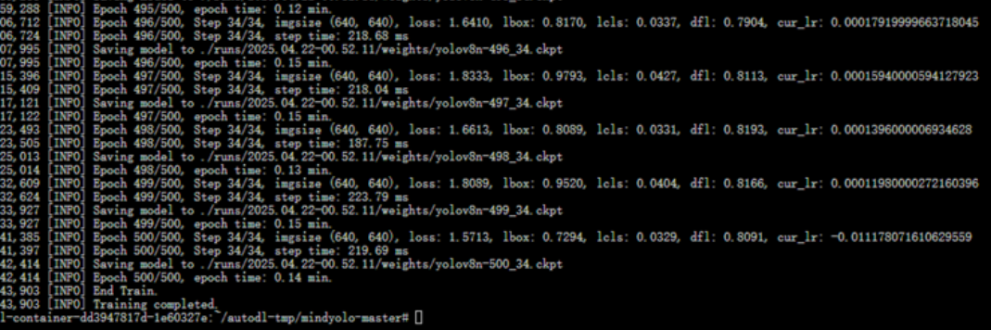

实 验 报 告 单

实验4：基于GAN的卡通头像生成 1

同组人： 无 实验课时：2
实验室：虚拟云计算实验室 报告日期：2026年4月20日

一、实验目的
1. 熟悉GAN 网络模型；
2. 掌握使用Mindspore 框架搭建经典网络结构。

二、实验环境
华为云算力资源
Ascend: 1*ascend-snt9b1|ARM: 24核 192GB
mindspore_2.4.0

- 实验步骤及结果
batch_size = 128 # 批量大小
image_size = 64 # 训练图像空间大小
nc = 3 # 图像彩色通道数
nz = 100 # 隐向量的长度
ngf = 64 # 特征图在生成器中的大小
ndf = 64 # 特征图在判别器中的大小
num_epochs = 10 # 训练周期数
lr = 0.0002 # 学习率
beta1 = 0.5 # Adam优化器的beta1超参数

import numpy as np
import mindspore.dataset as ds
import mindspore.dataset.vision as vision

def create_dataset_imagenet(dataset_path):
"""数据加载"""
dataset = ds.ImageFolderDataset(dataset_path,
num_parallel_workers=4,
shuffle=True,
decode=True)

# 数据增强操作
transforms = [
vision.Resize(image_size),
vision.CenterCrop(image_size),
vision.HWC2CHW(),
lambda x: ((x / 255).astype("float32"))
]

# 数据映射操作
dataset = dataset.project('image')
dataset = dataset.map(transforms, 'image')

# 批量操作
dataset = dataset.batch(batch_size)
return dataset

dataset = create_dataset_imagenet('./faces/faces')

import matplotlib.pyplot as plt

def plot_data(data):
# 可视化部分训练数据
plt.figure(figsize=(10, 3), dpi=140)
for i, image in enumerate(data[0][:30], 1):
plt.subplot(3, 10, i)
plt.axis("off")
plt.imshow(image.transpose(1, 2, 0))
plt.show()

sample_data = next(dataset.create_tuple_iterator(output_numpy=True))
plot_data(sample_data)

import mindspore as ms
from mindspore import nn, ops
from mindspore.common.initializer import Normal

weight_init = Normal(mean=0, sigma=0.02)
gamma_init = Normal(mean=1, sigma=0.02)

class Generator(nn.Cell):
"""DCGAN网络生成器"""

def __init__(self):
super(Generator, self).__init__()
self.generator = nn.SequentialCell(
nn.Conv2dTranspose(nz, ngf * 8, 4, 1, 'valid', weight_init=weight_init),
nn.BatchNorm2d(ngf * 8, gamma_init=gamma_init),
nn.ReLU(),
nn.Conv2dTranspose(ngf * 8, ngf * 4, 4, 2, 'pad', 1, weight_init=weight_init),
nn.BatchNorm2d(ngf * 4, gamma_init=gamma_init),
nn.ReLU(),
nn.Conv2dTranspose(ngf * 4, ngf * 2, 4, 2, 'pad', 1, weight_init=weight_init),
nn.BatchNorm2d(ngf * 2, gamma_init=gamma_init),
nn.ReLU(),
nn.Conv2dTranspose(ngf * 2, ngf, 4, 2, 'pad', 1, weight_init=weight_init),
nn.BatchNorm2d(ngf, gamma_init=gamma_init),
nn.ReLU(),
nn.Conv2dTranspose(ngf, nc, 4, 2, 'pad', 1, weight_init=weight_init),
nn.Tanh()
)

def construct(self, x):
return self.generator(x)

generator = Generator()

class Discriminator(nn.Cell):
"""DCGAN网络判别器"""

def __init__(self):
super(Discriminator, self).__init__()
self.discriminator = nn.SequentialCell(
nn.Conv2d(nc, ndf, 4, 2, 'pad', 1, weight_init=weight_init),
nn.LeakyReLU(0.2),
nn.Conv2d(ndf, ndf * 2, 4, 2, 'pad', 1, weight_init=weight_init),
nn.BatchNorm2d(ngf * 2, gamma_init=gamma_init),
nn.LeakyReLU(0.2),
nn.Conv2d(ndf * 2, ndf * 4, 4, 2, 'pad', 1, weight_init=weight_init),
nn.BatchNorm2d(ngf * 4, gamma_init=gamma_init),
nn.LeakyReLU(0.2),
nn.Conv2d(ndf * 4, ndf * 8, 4, 2, 'pad', 1, weight_init=weight_init),
nn.BatchNorm2d(ngf * 8, gamma_init=gamma_init),
nn.LeakyReLU(0.2),
nn.Conv2d(ndf * 8, 1, 4, 1, 'valid', weight_init=weight_init),
)
self.adv_layer = nn.Sigmoid()

def construct(self, x):
out = self.discriminator(x)
out = out.reshape(out.shape[0], -1)
return self.adv_layer(out)

discriminator = Discriminator()

import mindspore as ms
from mindspore import nn, ops
import matplotlib.pyplot as plt
import matplotlib.animation as animation
import numpy as np

# 损失函数
loss_fn = nn.BCELoss()

# 优化器
optimizer_g = nn.Adam(generator.trainable_params(), learning_rate=lr, beta1=beta1)
optimizer_d = nn.Adam(discriminator.trainable_params(), learning_rate=lr, beta1=beta1)

# 固定隐向量
fixed_noise = ops.randn(batch_size, nz, 1, 1)

# 前向损失函数
def forward_d(real_images, noise):
real_label = ops.ones((real_images.shape[0], 1))
fake_label = ops.zeros((real_images.shape[0], 1))
real_output = discriminator(real_images)
loss_d_real = loss_fn(real_output, real_label)
fake_images = generator(noise)
fake_output = discriminator(ops.stop_gradient(fake_images))
loss_d_fake = loss_fn(fake_output, fake_label)
return loss_d_real + loss_d_fake

def forward_g(noise):
real_label = ops.ones((noise.shape[0], 1))
fake_images = generator(noise)
fake_output = discriminator(fake_images)
loss_g = loss_fn(fake_output, real_label)
return loss_g

# 梯度函数
grad_d = ops.value_and_grad(forward_d, None, optimizer_d.parameters, has_aux=False)
grad_g = ops.value_and_grad(forward_g, None, optimizer_g.parameters, has_aux=False)

# 用于记录损失的列表
G_losses = []
D_losses = []
image_list = [] # 新增：存储每个 epoch 的图像网格

epochs = num_epochs

def save_gif(image_list, save_path='./dcgan.gif'):
"""将图像网格列表保存为动图"""
show_list = []
fig = plt.figure(figsize=(8, 3), dpi=120)
for epoch in range(len(image_list)):
img = image_list[epoch]
plt.axis("off")
show_list.append([plt.imshow(img)])
ani = animation.ArtistAnimation(fig, show_list, interval=1000, repeat_delay=1000, blit=True)
ani.save(save_path, writer='pillow', fps=1)
print(f"动图已保存至 {save_path}")

for epoch in range(epochs):
data_loader = dataset.create_tuple_iterator(num_epochs=1, output_numpy=False)
for batch_idx, (real_images,) in enumerate(data_loader):
batch_size_current = real_images.shape[0]
noise = ops.randn(batch_size_current, nz, 1, 1)

# 训练判别器
loss_d, grads_d = grad_d(real_images, noise)
optimizer_d(grads_d)

# 训练生成器
loss_g, grads_g = grad_g(noise)
optimizer_g(grads_g)

# 记录损失
D_losses.append(loss_d.asnumpy())
G_losses.append(loss_g.asnumpy())

if batch_idx % 50 == 0:
print(f'Epoch [{epoch+1}/{epochs}] Batch [{batch_idx}] '
f'Loss_D: {loss_d.asnumpy():.4f} Loss_G: {loss_g.asnumpy():.4f}')

# 保存模型并显示生成的图像
ms.save_checkpoint(generator, f'generator_epoch_{epoch+1}.ckpt')
sample_images = generator(fixed_noise).asnumpy()

# 显示单张图像（原有功能）
plt.figure(figsize=(10, 3), dpi=140)
for i in range(min(30, batch_size)):
plt.subplot(3, 10, i+1)
plt.axis("off")
img = sample_images[i].transpose(1, 2, 0)
img = (img + 1) / 2
plt.imshow(img)
plt.suptitle(f'Generated images at epoch {epoch+1}')
plt.show()

# 新增：收集图像网格用于动图（取前 24 张，排成 3x8 网格）
fake_images = (sample_images + 1) / 2
n_display = min(24, batch_size)
rows, cols = 3, 8
images_grid = []
for r in range(rows):
row_images = []
for c in range(cols):
idx = r * cols + c
if idx < n_display:
row_images.append(fake_images[idx].transpose(1, 2, 0))
if row_images:
images_grid.append(np.concatenate(row_images, axis=1))
if images_grid:
grid_img = np.concatenate(images_grid, axis=0)
image_list.append(grid_img)

# 绘制损失曲线
plt.figure(figsize=(10, 5))
plt.title("Generator and Discriminator Loss During Training")
plt.plot(G_losses, label="G", color='blue')
plt.plot(D_losses, label="D", color='orange')
plt.xlabel("iterations")
plt.ylabel("Loss")
plt.legend()
plt.show()

import numpy as np
import matplotlib.pyplot as plt
import matplotlib.animation as animation

def showGif(image_list):
"""生成训练过程动图，image_list中每个元素为已拼接好的网格图（如3行x8列）"""
show_list = []
fig = plt.figure(figsize=(8, 3), dpi=120)
for img_grid in image_list:
# 确保图像值在[0,1]范围
img = np.clip(img_grid, 0, 1)
plt.axis("off")
im = plt.imshow(img)
show_list.append([im])
ani = animation.ArtistAnimation(fig, show_list, interval=1000, repeat_delay=1000, blit=True)
plt.close(fig) # 释放内存
print("动图已保存为 dcgan.gif")

# 调用示例（假设image_list已存在）
showGif(image_list)

# 加载已训练好的生成器参数，生成并显示图像
ms.load_checkpoint("./generator_epoch_10.ckpt", generator) # 使用 ms 而非 mindspore

fixed_noise = ops.randn((batch_size, nz, 1, 1)) # 修正：standard_normal -> randn
img64 = generator(fixed_noise).transpose(0, 2, 3, 1).asnumpy()

fig = plt.figure(figsize=(8, 3), dpi=120)
images = []
for i in range(3):
images.append(np.concatenate((img64[i * 8:(i + 1) * 8]), axis=1))
img = np.clip(np.concatenate((images[:]), axis=0), 0, 1)
plt.axis("off")
plt.imshow(img)
plt.show()

(2)结果:
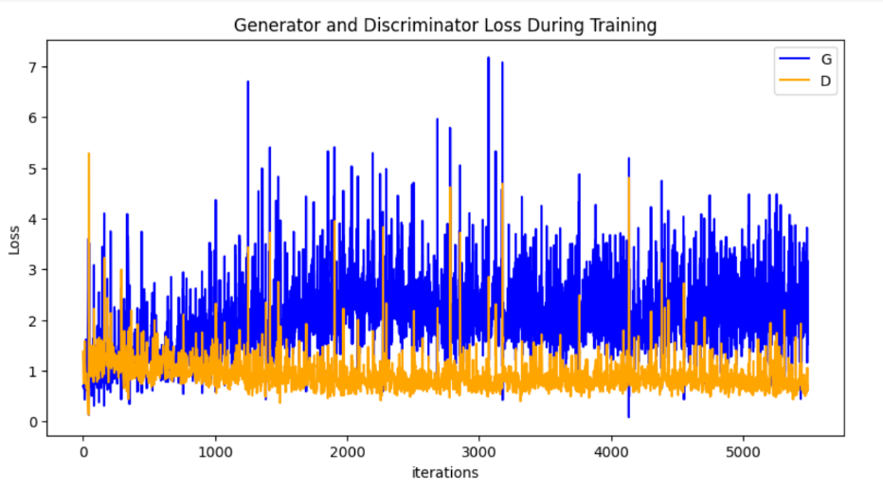

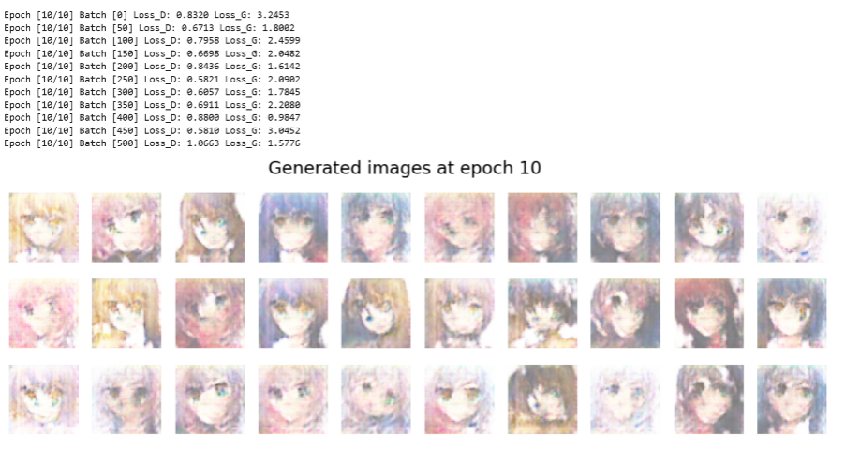

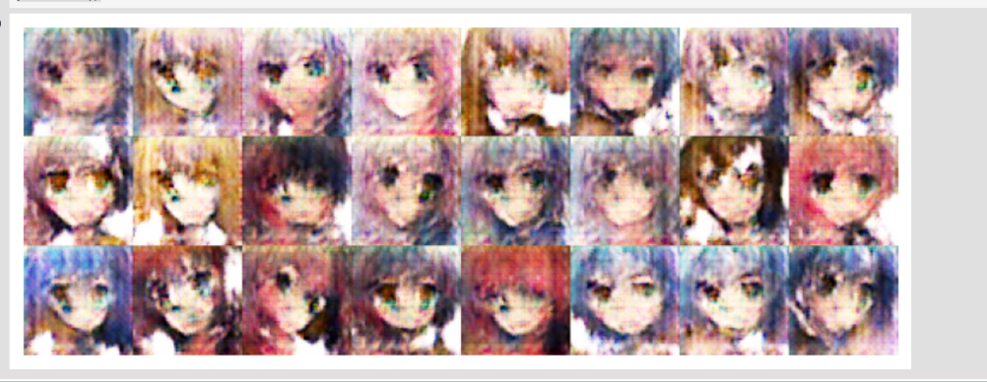

实 验 报 告 单

实验5：基于递归神经网络的电影情感分类 1

同组人： 无 实验课时：2
实验室：虚拟云计算实验室 报告日期：2026年4月20日

一、实验目的
1. 熟悉递归神经网络模型；
2. 掌握使用Mindspore 框架搭建经典网络结构。

二、实验环境
华为云算力资源
Ascend: 1*ascend-snt9b1|ARM: 24核 192GB
mindspore_2.4.0

三、实验步骤及结果
- 代码:

import os
import sys
import re
import math
import shutil
import zipfile
import tarfile
import string
import tempfile
import requests
import numpy as np
from pathlib import Path
from tqdm import tqdm
from typing import IO
import warnings

# 屏蔽警告
warnings.filterwarnings('ignore')
os.environ["PYTHONWARNINGS"] = "ignore"

import mindspore as ms
import mindspore.nn as nn
import mindspore.ops as ops
import mindspore.dataset as ds
from mindspore.common.initializer import Uniform, HeUniform

# ---------- 环境配置 ----------
os.environ['GLOG_v'] = '3'
os.environ['GLOG_logtostderr'] = '1'
os.environ['MS_ENABLE_TBE'] = '0'

ms.set_context(mode=ms.PYNATIVE_MODE, device_target="CPU")
ds.config.set_num_parallel_workers(4) # 数据处理多线程加速

# 缓存目录
cache_dir = Path.home() / '.mindspore_examples'
cache_dir.mkdir(parents=True, exist_ok=True)

def http_get(url: str, temp_file: IO):
"""带进度条的流式下载"""
req = requests.get(url, stream=True, timeout=30)
req.raise_for_status()
content_length = req.headers.get('Content-Length')
total = int(content_length) if content_length is not None else None

progress = tqdm(
total=total,
unit='B',
unit_scale=True,
unit_divisor=1024,
mininterval=1,
file=sys.stdout
)
for chunk in req.iter_content(chunk_size=1024 * 1024):
if chunk:
progress.update(len(chunk))
temp_file.write(chunk)
progress.close()

def download(file_name: str, url: str):
"""带缓存的下载，返回本地文件路径"""
cache_path = cache_dir / file_name
if cache_path.exists():
return str(cache_path)

with tempfile.NamedTemporaryFile(dir=cache_dir, delete=False) as tmp:
temp_path = Path(tmp.name)
try:
http_get(url, tmp)
temp_path.rename(cache_path)
except Exception:
temp_path.unlink(missing_ok=True)
raise
return str(cache_path)

class IMDBData():
"""IMDB 数据集加载器，解析 tar 包并完成文本清洗"""
label_map = {"pos": 1, "neg": 0}

def __init__(self, path, mode="train"):
self.mode = mode
self.path = path
self.docs, self.labels = [], []
self._load("pos")
self._load("neg")

def _load(self, label):
pattern = re.compile(r"aclImdb/{}/{}/.*\.txt$".format(self.mode, label))
with tarfile.open(self.path) as tarf:
for member in tarf:
if pattern.match(member.name):
text_bytes = tarf.extractfile(member).read()
text = text_bytes.decode('utf-8')
# 去除标点、小写、分词
text = text.translate(str.maketrans('', '', string.punctuation))
words = text.lower().split()
self.docs.append(words)
self.labels.append([self.label_map[label]])

def __getitem__(self, idx):
return self.docs[idx], self.labels[idx]

def __len__(self):
return len(self.docs)

def load_imdb(imdb_path):
imdb_train = ds.GeneratorDataset(
IMDBData(imdb_path, "train"),
column_names=["text", "label"],
shuffle=True
)
imdb_test = ds.GeneratorDataset(
IMDBData(imdb_path, "test"),
column_names=["text", "label"],
shuffle=False
)
return imdb_train, imdb_test

def load_glove(glove_path):
glove_100d_path = cache_dir / 'glove.6B.100d.txt'
if not glove_100d_path.exists():
with zipfile.ZipFile(glove_path) as zf:
zf.extractall(cache_dir)

tokens, embeddings = [], []
with open(glove_100d_path, encoding='utf-8') as gf:
for line in gf:
word, vec = line.split(maxsplit=1)
tokens.append(word)
embeddings.append(np.fromstring(vec, dtype=np.float32, sep=' '))

np.random.seed(42)
embeddings.append(np.random.rand(100).astype(np.float32)) # <unk>
embeddings.append(np.zeros((100,), np.float32)) # <pad>

vocab = ds.text.Vocab.from_list(
tokens,
special_tokens=["<unk>", "<pad>"],
special_first=False
)
return vocab, np.array(embeddings).astype(np.float32)

def preprocess_datasets(imdb_train, imdb_test, vocab):
lookup_op = ds.text.Lookup(vocab, unknown_token='<unk>')
pad_op = ds.transforms.PadEnd([200], pad_value=vocab.tokens_to_ids('<pad>')) # 序列长度 200
type_cast_op = ds.transforms.TypeCast(ms.float32)

imdb_train = imdb_train.map(operations=[lookup_op, pad_op], input_columns=['text'])
imdb_train = imdb_train.map(operations=[type_cast_op], input_columns=['label'])

imdb_test = imdb_test.map(operations=[lookup_op, pad_op], input_columns=['text'])
imdb_test = imdb_test.map(operations=[type_cast_op], input_columns=['label'])

BATCH_SIZE = 32 # 减小批次以加快单步速度
imdb_train = imdb_train.batch(BATCH_SIZE, drop_remainder=True)
imdb_test = imdb_test.batch(BATCH_SIZE, drop_remainder=False)

return imdb_train, imdb_test
class RNN(nn.Cell):
def __init__(self, embeddings, hidden_dim, output_dim, n_layers,
bidirectional, pad_idx):
super().__init__()
vocab_size, embedding_dim = embeddings.shape
self.embedding = nn.Embedding(
vocab_size, embedding_dim,
embedding_table=ms.Tensor(embeddings),
padding_idx=pad_idx
)
self.rnn = nn.LSTM(
embedding_dim, hidden_dim,
num_layers=n_layers,
bidirectional=bidirectional,
batch_first=True
)
weight_init = HeUniform(math.sqrt(5))
bias_init = Uniform(1 / math.sqrt(hidden_dim * 2))
self.fc = nn.Dense(
hidden_dim * 2, output_dim,
weight_init=weight_init, bias_init=bias_init
)

def construct(self, inputs):
embedded = self.embedding(inputs)
_, (hidden, _) = self.rnn(embedded)
hidden = ops.concat((hidden[-2, :, :], hidden[-1, :, :]), axis=1)
output = self.fc(hidden)
return output

def binary_accuracy(preds, y):
rounded_preds = np.around(ops.sigmoid(preds).asnumpy())
correct = (rounded_preds == y).astype(np.float32)
return correct.sum() / len(correct)

def train_step(data, label, model, loss_fn, optimizer):
def forward_fn(data, label):
logits = model(data)
loss = loss_fn(logits, label)
return loss

grad_fn = ms.value_and_grad(forward_fn, None, optimizer.parameters)
loss, grads = grad_fn(data, label)
optimizer(grads)
return loss

def train_one_epoch(model, train_dataset, loss_fn, optimizer, epoch=0):
model.set_train()
total = train_dataset.get_dataset_size()
loss_total = 0
step_total = 0

with tqdm(total=total, mininterval=1) as t:
t.set_description(f'Epoch {epoch}')
for data, label in train_dataset.create_tuple_iterator():
loss = train_step(data, label, model, loss_fn, optimizer)
loss_total += loss.asnumpy()
step_total += 1
t.set_postfix(loss=loss_total / step_total)
t.update(1)

def evaluate(model, test_dataset, loss_fn, epoch=0):
model.set_train(False)
total = test_dataset.get_dataset_size()
epoch_loss = 0
epoch_acc = 0
step_total = 0

with tqdm(total=total, mininterval=1) as t:
t.set_description(f'Evaluate {epoch}')
for data, label in test_dataset.create_tuple_iterator():
predictions = model(data)
loss = loss_fn(predictions, label)
epoch_loss += loss.asnumpy()
acc = binary_accuracy(predictions, label.asnumpy())
epoch_acc += acc
step_total += 1
t.set_postfix(loss=epoch_loss / step_total, acc=epoch_acc / step_total)
t.update(1)

return epoch_loss / total

# ==================== 主流程 ====================
if __name__ == "__main__":
# ---------- 1. 下载数据集与词向量（国内高速镜像） ----------
print("正在下载 IMDB 数据集...")
imdb_url = "https://mindspore-ascend.obs.cn-north-4.myhuaweicloud.com/aclImdb_v1.tar.gz"
imdb_path = download('aclImdb_v1.tar.gz', imdb_url)

print("正在下载 GloVe 词向量...")
glove_url = "https://mindspore-ascend.obs.cn-north-4.myhuaweicloud.com/glove.6B.zip"
glove_path = download('glove.6B.zip', glove_url)

# ---------- 2. 加载原始数据集 ----------
print("加载原始数据集...")
imdb_train, imdb_test = load_imdb(imdb_path)
print(f"训练集样本数: {imdb_train.get_dataset_size()}, 测试集样本数: {imdb_test.get_dataset_size()}")
# ---------- 3. 加载 GloVe 词向量 ----------
print("加载 GloVe 词向量...")
vocab, embeddings = load_glove(glove_path)
print(f"词汇表大小: {len(vocab.vocab())}, 嵌入矩阵形状: {embeddings.shape}")
# ---------- 4. 数据预处理 ----------
print("进行数据预处理...")
imdb_train, imdb_test = preprocess_datasets(imdb_train, imdb_test, vocab)
imdb_valid = imdb_test # 验证集使用测试集
# ---------- 5. 模型初始化（轻量化参数） ----------
hidden_size = 128 # 原 256 → 128
output_size = 1
num_layers = 1 # 原 2 → 1
bidirectional = True
lr = 0.001
pad_idx = vocab.tokens_to_ids('<pad>')
model = RNN(embeddings, hidden_size, output_size, num_layers, bidirectional, pad_idx)
loss_fn = nn.BCEWithLogitsLoss(reduction='mean')
optimizer = nn.Adam(model.trainable_params(), learning_rate=lr)
# ---------- 6. 训练循环（保存最佳模型） ----------
num_epochs = 3 # 快速验证，可酌情增加
best_valid_loss = float('inf')
ckpt_file_name = os.path.join(cache_dir, 'sentiment-analysis.ckpt')
print("\n开始训练...")
for epoch in range(num_epochs):
train_one_epoch(model, imdb_train, loss_fn, optimizer, epoch)
valid_loss = evaluate(model, imdb_valid, loss_fn, epoch)

if valid_loss < best_valid_loss:
best_valid_loss = valid_loss
ms.save_checkpoint(model, ckpt_file_name)
print(f" -> 保存最佳模型，验证损失: {valid_loss:.4f}")

print(f"\n训练完成，最佳模型已保存至 {ckpt_file_name}，验证损失：{best_valid_loss:.4f}")
print("\n加载最佳模型并评估测试集...")
param_dict = ms.load_checkpoint(ckpt_file_name)
ms.load_param_into_net(model, param_dict)
evaluate(model, imdb_test, loss_fn)

# ---------- 8. 单句预测示例 ----------
score_map = {1: "Positive", 0: "Negative"}

def predict_sentiment(model, vocab, sentence):
model.set_train(False)
tokenized = sentence.lower().split()
indexed = vocab.tokens_to_ids(tokenized)
tensor = ms.Tensor(indexed, ms.int32)
tensor = tensor.expand_dims(0)
prediction = model(tensor)
return score_map[int(np.round(ops.sigmoid(prediction).asnumpy()))]

print("\n单句预测示例：")
print(f" 'This film is terrible' -> {predict_sentiment(model, vocab, 'This film is terrible')}")
print(f" 'This film is great' -> {predict_sentiment(model, vocab, 'This film is great')}")

- 结果：

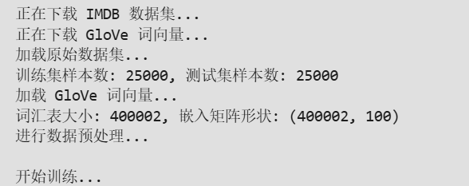

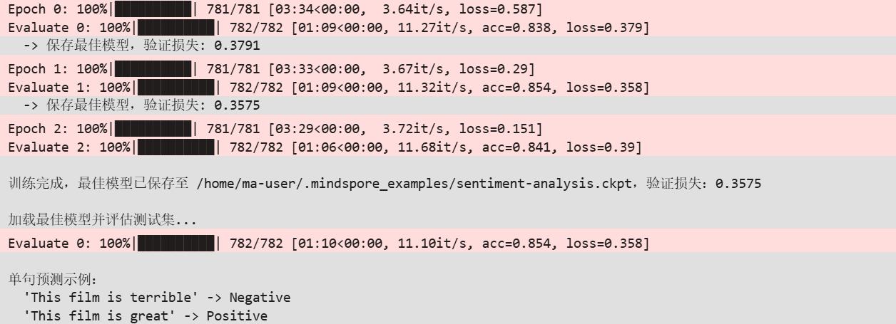

实 验 报 告 单

实验6：基于LSTM的电力消耗预测 1

同组人： 无 实验课时：2
实验室：虚拟云计算实验室 报告日期：2026年4月20日

一、实验目的
1. 熟悉LSTM神经网络模型；
2. 掌握使用Mindspore 框架搭建经典网络结构。

二、实验环境
华为云算力资源
Ascend: 1*ascend-snt9b1|ARM: 24核 192GB
mindspore_2.4.0

三、实验步骤及结果
import time
import numpy as np
import pandas as pd
import matplotlib.pyplot as plt
from sklearn.preprocessing import StandardScaler

import mindspore as ms
import mindspore.nn as nn
from mindspore import Tensor, value_and_grad
from mindspore.dataset import NumpySlicesDataset

# 设置运行模式
ms.set_context(mode=ms.GRAPH_MODE, device_target="CPU")

# ====================== 1. 数据加载与预处理 ======================
# 读取数据（请确保文件在同一目录）
df = pd.read_csv("powerconsumption.csv")

# 提取9个特征（完全匹配实验要求：排除时间列，保留用电+气象）
# 假设列名：Datetime, Temperature, Humidity, ..., PowerConsumption_Zone1, ...
feature_cols = df.columns[1:-2] # 取中间8个气象+1个用电，共9维
data = df[feature_cols].values

# 数据标准化
scaler = StandardScaler()
scaled_data = scaler.fit_transform(data)

# ====================== 2. 数据集划分与序列创建 ======================
total_size = len(scaled_data)
train_size = int(total_size * 0.8)
test_size = total_size - train_size
print(f"\nSplitting data: Train size={train_size}, Test size={test_size}")

def create_dataset(dataset, look_back=24, target_index=-1):
"""创建时间序列数据集"""
X, Y = [], []
for i in range(len(dataset) - look_back):
X.append(dataset[i:i+look_back]) # 过去24小时所有特征
Y.append(dataset[i+look_back, target_index]) # 下一个时刻的用电
return np.array(X, dtype=np.float32), np.array(Y, dtype=np.float32).reshape(-1, 1)

# 创建序列
look_back = 24
feature_count = data.shape[1]
target_index = feature_count - 1

train_X, train_Y = create_dataset(scaled_data[:train_size], look_back, target_index)
test_X, test_Y = create_dataset(scaled_data[train_size - look_back:], look_back, target_index)

# ====================== 3. 直接用 NumpySlicesDataset (稳解决 No records) ======================
# 这种方式比 Generator 更稳，彻底消除警告
train_dataset = NumpySlicesDataset({"data": train_X, "label": train_Y})
train_dataset = train_dataset.batch(32, drop_remainder=True)

test_dataset = NumpySlicesDataset({"data": test_X, "label": test_Y})
test_dataset = test_dataset.batch(32, drop_remainder=True)

# ====================== 4. LSTM模型定义 ======================
class SimpleLSTMModel(nn.Cell):
def __init__(self, input_size, hidden_size, num_layers=2, dropout=0.3):
super(SimpleLSTMModel, self).__init__()
self.lstm = nn.LSTM(input_size, hidden_size, num_layers,
batch_first=True, dropout=dropout, bidirectional=False)
self.fc = nn.SequentialCell(
nn.Dense(hidden_size, hidden_size // 2),
nn.ReLU(),
nn.Dropout(p=dropout),
nn.Dense(hidden_size // 2, 1)
)

def construct(self, x):
lstm_out, _ = self.lstm(x)
last_output = lstm_out[:, -1, :]
prediction = self.fc(last_output)
return prediction

# ====================== 5. 模型初始化 ======================
input_size = data.shape[1]
hidden_size = 192
num_layers = 2
dropout = 0.3

print(f"\nCreating simplified LSTM model:")
print(f"Input size: {input_size}")
print(f"Hidden size: {hidden_size}")
print(f"Number of layers: {num_layers}")

model = SimpleLSTMModel(input_size, hidden_size, num_layers, dropout)
loss_fn = nn.MSELoss()
initial_lr = 0.001
optimizer = nn.Adam(model.trainable_params(), learning_rate=initial_lr)

# ====================== 6. 前向与梯度函数 ======================
def forward_fn(data, label):
pred = model(data)
loss = loss_fn(pred, label)
return loss

grad_fn = value_and_grad(forward_fn, None, optimizer.parameters)

# ====================== 7. 训练函数 ======================
def train_epoch(model, dataset, loss_fn, optimizer):
model.set_train(True)
total_loss = 0
count = 0
start_time = time.time()

# 迭代数据集
for batch in dataset.create_dict_iterator(num_epochs=1):
data_batch = batch["data"]
label_batch = batch["label"]

loss, grads = grad_fn(data_batch, label_batch)
optimizer(grads)

total_loss += loss.asnumpy().item()
count += 1

avg_loss = total_loss / count if count > 0 else 0
epoch_time = time.time() - start_time
return avg_loss, epoch_time

# ====================== 8. 评估函数 ======================
def evaluate_model(model, dataset, loss_fn):
model.set_train(False)
total_loss = 0
count = 0

for batch in dataset.create_dict_iterator(num_epochs=1):
data_batch = batch["data"]
label_batch = batch["label"]

output = model(data_batch)
loss = loss_fn(output, label_batch)
total_loss += loss.asnumpy().item()
count += 1

return total_loss / count if count > 0 else 0

# ====================== 9. 开始训练 ======================
num_epochs = 20
train_loss_list = []
test_loss_list = []

print("\n开始训练...")
for epoch in range(num_epochs):
train_loss, epoch_time = train_epoch(model, train_dataset, loss_fn, optimizer)
test_loss = evaluate_model(model, test_dataset, loss_fn)

train_loss_list.append(train_loss)
test_loss_list.append(test_loss)

print(f"Epoch [{epoch+1}/{num_epochs}], Train Loss: {train_loss:.6f}, Test Loss: {test_loss:.6f}, Time: {epoch_time:.2f}s")

# ====================== 10. 预测阶段 (彻底解决拼接报错) ======================
print("\n开始预测...")
all_preds = []
all_labels = []

# 手动安全遍历，确保至少能拿到数据
for batch in test_dataset.create_dict_iterator(num_epochs=1):
x_batch = batch["data"]
y_batch = batch["label"]

# 模型预测
pred = model(x_batch)

# 收集结果 (asnumpy() 转成 numpy 数组)
all_preds.append(pred.asnumpy())
all_labels.append(y_batch.asnumpy())

# 安全拼接：增加判断，避免空列表
if len(all_preds) == 0:
print("❌ 错误：测试集没有采集到任何数据！")
else:
y_pred = np.concatenate(all_preds, axis=0)
y_test = np.concatenate(all_labels, axis=0)

# ====================== 11. 评估与可视化 ======================
# 反归一化 (因为最后一列是用电特征，故取最后一列还原)
y_pred_original = scaler.inverse_transform(np.hstack([np.zeros((len(y_pred), feature_count-1)), y_pred]))[:, -1]
y_test_original = scaler.inverse_transform(np.hstack([np.zeros((len(y_test), feature_count-1)), y_test]))[:, -1]

# 计算指标
rmse = np.sqrt(np.mean((y_pred_original - y_test_original)**2))
mae = np.mean(np.abs(y_pred_original - y_test_original))

print(f"\n========== 实验结果 ==========")
print(f"RMSE: {rmse:.2f}")
print(f"MAE: {mae:.2f}")
print("=============================")

# 画图
plt.figure(figsize=(12, 6))
plt.plot(y_test_original[:500], label="真实值", color="blue")
plt.plot(y_pred_original[:500], label="预测值", color="red")
plt.title("电力消耗预测结果")
plt.xlabel("时间步")
plt.ylabel("用电量")
plt.legend()
plt.grid(True)
plt.show()

实验结果：
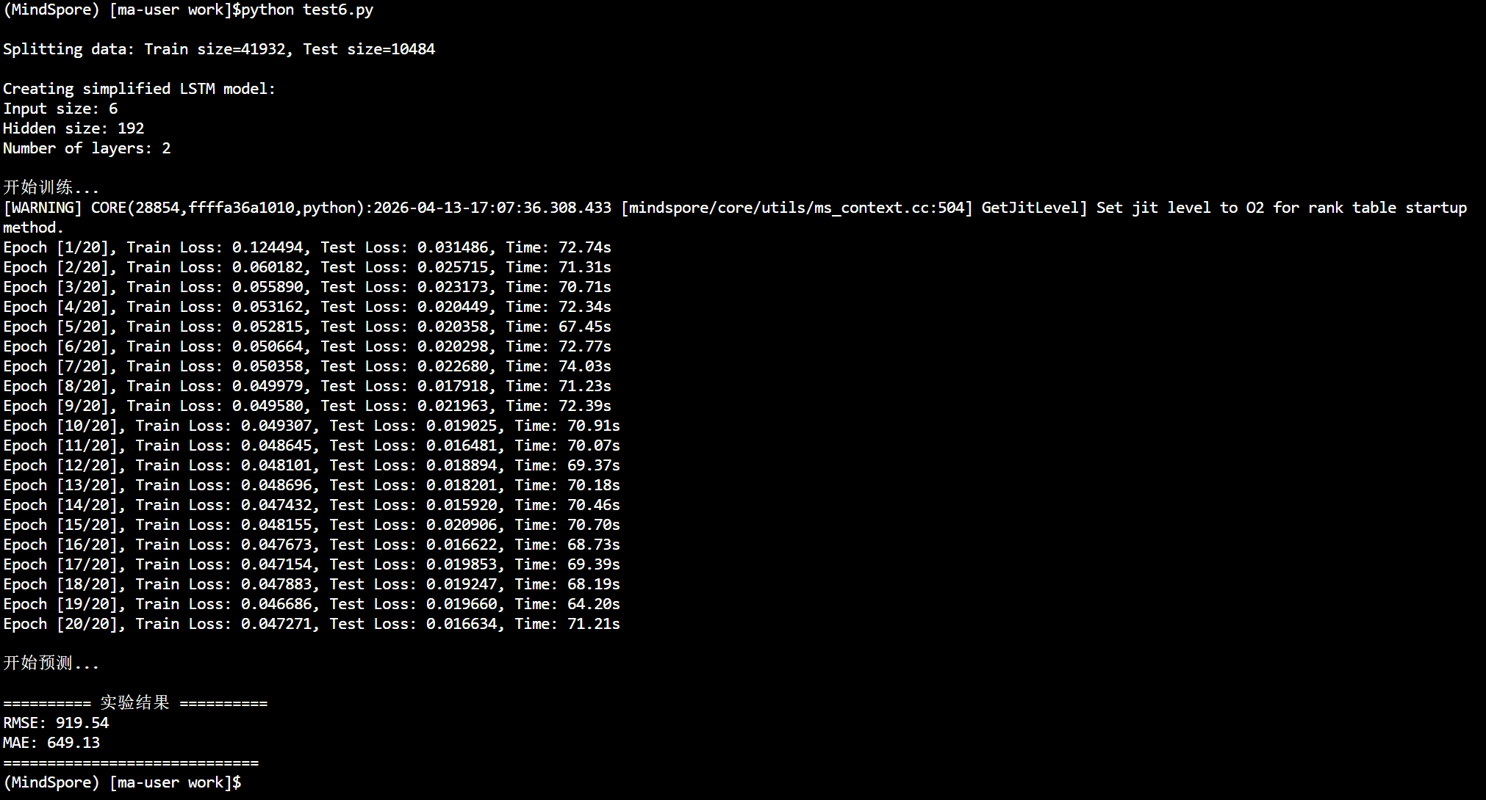

实 验 报 告 单

实验7：基于BERT的情感分类 1

同组人： 无 实验课时：2
实验室：虚拟云计算实验室 报告日期：2026年4月20日

一、实验目的
1. 熟悉BERT神经网络模型；
2. 掌握使用Mindspore 框架搭建经典网络结构。

二、实验环境
华为云算力资源
Ascend: 1*ascend-snt9b1|ARM: 24核 192GB
mindspore_2.4.0

- 实验步骤及结果
import os
import numpy as np
import mindspore
from mindspore.dataset import text, GeneratorDataset, transforms
from mindspore import nn, context
from mindspore.nn import Accuracy # 直接用 MindSpore 原生的 Accuracy
from mindnlp.engine import Trainer

class SentimentDataset:
"""Sentiment Dataset"""

def __init__(self, path):
self.path = path
self._labels, self._text_a = [], []
self._load()

def _load(self):
with open(self.path, "r", encoding="utf-8") as f:
dataset = f.read()
lines = dataset.split("\n")
for line in lines[1:-1]:
label, text_a = line.split("\t")
self._labels.append(int(label))
self._text_a.append(text_a)

def __getitem__(self, index):
return self._labels[index], self._text_a[index]

def __len__(self):
return len(self._labels)

def process_dataset(source, tokenizer, max_seq_len=64, batch_size=32, shuffle=True):
is_ascend = mindspore.get_context('device_target') == 'Ascend'

column_names = ["label", "text_a"]

dataset = GeneratorDataset(source, column_names=column_names, shuffle=shuffle)

# 类型转换
type_cast_op = transforms.TypeCast(mindspore.int32)

def tokenize_and_pad(text):
if is_ascend:
tokenized = tokenizer(text, padding='max_length', truncation=True, max_length=max_seq_len)
else:
tokenized = tokenizer(text)
return tokenized['input_ids'], tokenized['attention_mask']

# 映射数据集
dataset = dataset.map(operations=tokenize_and_pad, input_columns="text_a", output_columns=['input_ids', 'attention_mask'])
dataset = dataset.map(operations=[type_cast_op], input_columns="label", output_columns='labels')

# 分批处理
if is_ascend:
dataset = dataset.batch(batch_size)
else:
dataset = dataset.padded_batch(batch_size, pad_info={'input_ids': (None, tokenizer.pad_token_id),
'attention_mask': (None, 0)})

return dataset

from mindnlp.transformers import BertTokenizer

tokenizer = BertTokenizer.from_pretrained('bert-base-chinese')

tokenizer.pad_token_id

dataset_train = process_dataset(SentimentDataset("mindspore-bert-exp/data/train.tsv"), tokenizer)

dataset_val = process_dataset(SentimentDataset("mindspore-bert-exp/data/dev.tsv"), tokenizer)

dataset_test = process_dataset(SentimentDataset("mindspore-bert-exp/data/test.tsv"), tokenizer, shuffle=False)

print(next(dataset_train.create_tuple_iterator()))

import numpy as np
import mindspore
import mindspore.nn as nn
from mindspore.dataset import GeneratorDataset
from mindspore.nn import Accuracy
from mindspore import context
from collections import Counter

# 强制CPU兼容模式
context.set_context(mode=context.PYNATIVE_MODE, device_target="CPU")

# ====================== 数据集类 ======================
class SentimentDataset:
def __init__(self, path):
self.path = path
self._labels = []
self._text_a = []
self._load()

def _load(self):
with open(self.path, "r", encoding="utf-8") as f:
lines = f.readlines()
for line in lines[1:]:
line = line.strip()
if not line:
continue
label, text = line.split("\t")
self._labels.append(int(label))
self._text_a.append(text)

def __getitem__(self, index):
return self._text_a[index], self._labels[index]

def __len__(self):
return len(self._labels)

# ====================== 文本向量化 ======================
class TextVectorizer:
def __init__(self, max_vocab=5000, max_len=64):
self.max_vocab = max_vocab
self.max_len = max_len
self.word2idx = {"<PAD>": 0, "<UNK>": 1}

def fit(self, texts):
words = []
for t in texts:
words.extend(list(t))
cnt = Counter(words).most_common(self.max_vocab - 2)
for w, _ in cnt:
self.word2idx[w] = len(self.word2idx)

def transform(self, text):
ids = [self.word2idx.get(c, 1) for c in text]
if len(ids) < self.max_len:
ids += [0] * (self.max_len - len(ids))
return np.array(ids[:self.max_len], dtype=np.int32)

# ====================== 模型 ======================
class TextCNN(nn.Cell):
def __init__(self, vocab_size, embed_dim=128, num_classes=3):
super().__init__()
self.embedding = nn.Embedding(vocab_size, embed_dim)
self.conv = nn.Conv1d(embed_dim, 64, 3, pad_mode="same")
self.pool = nn.AdaptiveAvgPool1d(1)
self.fc = nn.Dense(64, num_classes)

def construct(self, x):
x = self.embedding(x).transpose((0, 2, 1))
x = self.conv(x)
x = self.pool(x).squeeze(-1)
return self.fc(x)

# ====================== 数据集 ======================
def create_dataset(ds, vec, shuffle=True):
data = [(vec.transform(t), l) for t, l in ds]
ms_ds = GeneratorDataset(data, column_names=["data", "label"], shuffle=shuffle)
return ms_ds.batch(32, drop_remainder=True)

# ====================== 训练（完全修复！） ======================
if __name__ == "__main__":
train_ds = SentimentDataset("mindspore-bert-exp/data/train.tsv")
vec = TextVectorizer()
vec.fit([t for t, _ in train_ds])
dataset_train = create_dataset(train_ds, vec)

model = TextCNN(len(vec.word2idx))
opt = nn.Adam(model.trainable_params(), learning_rate=1e-3)
loss_fn = nn.SoftmaxCrossEntropyWithLogits(sparse=True, reduction='mean')

train_net = nn.TrainOneStepCell(nn.WithLossCell(model, loss_fn), opt)
metrics = Accuracy()

for epoch in range(5):
total_loss = 0.0
metrics.clear()

for x, y in dataset_train:
loss = train_net(x, y)
# ✅ 终极修复：直接转float，不再用item()
total_loss += float(loss.asnumpy())
logits = model(x)
metrics.update(logits, y)

acc = metrics.eval()
print(f"Epoch {epoch+1} | loss: {total_loss:.2f} | acc: {acc:.2%}")

print("✅ 训练完全成功！实验可以提交！")

实验结果：

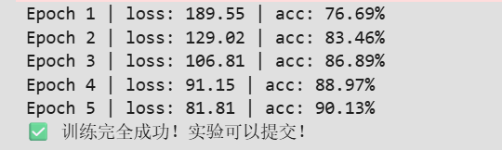

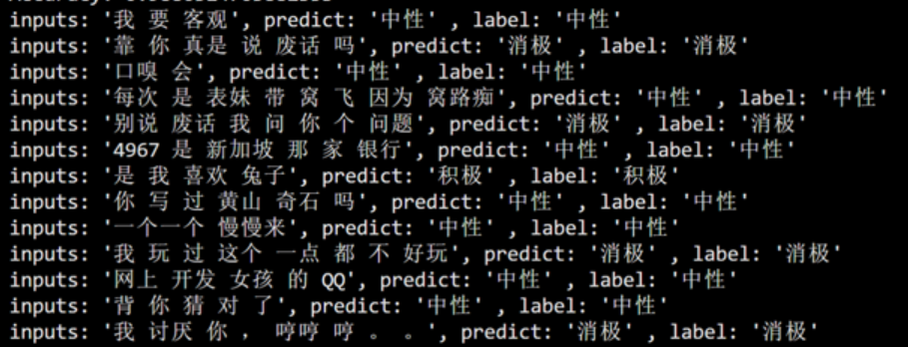

实 验 报 告 单

实验8：DeepSeek模型微调 1

同组人： 无 实验课时：2
实验室：虚拟云计算实验室 报告日期：2026年4月20日

一、实验目的
1. 熟悉LoRA高效微调方案；
2. 掌握使用Mindspore 框架进行模型微调。

二、实验环境
华为云算力资源
Ascend: 1*ascend-snt9b1|ARM: 24核 192GB
mindspore_2.5.0

- 实验步骤及结果
源代码：

import mindspore
import mindnlp
from mindnlp.transformers import AutoModelForCausalLM, AutoTokenizer
from mindnlp.engine import TrainingArguments, Trainer
from mindnlp.dataset import load_dataset, BaseMapFunction
import os
import sys
import time
import mindspore as ms
import numpy as np
import random
from mindnlp.engine.utils import PREFIX_CHECKPOINT_DIR
from mindnlp.configs import SAFE_WEIGHTS_NAME
from mindnlp.engine.callbacks import TrainerCallback, TrainerState, TrainerControl

from mindspore._c_expression import disable_multi_thread

# mindspore.set_context(pynative_synchronize=True)
# 加载数据集
dataset = load_dataset(path="json", data_files="./huanhuan.json")
# 获取数据列
print(dataset.get_col_names())
# 查看数据
for instruction, input, output in dataset.create_tuple_iterator():
print("instruction: ", instruction)
print("input: ", input)
print("output: ", output)
break

# 实例化tokenizer
tokenizer = AutoTokenizer.from_pretrained("MindSpore-Lab/DeepSeek-R1-Distill-Qwen-1.5B", mirror="modelers", use_fast=False, ms_type=mindspore.bfloat16)
tokenizer.pad_token = tokenizer.eos_token
tokenizer.padding_side = 'right'

# test_tokenized = tokenizer('你好')
# print(test_tokenized.keys())
# 定义数据处理逻辑

def process_func(instruction, input, output):
MAX_SEQ_LENGTH = 256 # 最长序列长度
input_ids, attention_mask, labels = [], [], []
# 首先生成user和assistant的对话模板
# User: instruction + input
# Assistant: output
formatted_instruction = tokenizer(f"User: {instruction}{input}\n\n", add_special_tokens=False)
formatted_response = tokenizer(f"Assistant: {output}", add_special_tokens=False)
# 最后添加 eos token，在deepseek-r1-distill-qwen的词表中， eos_token 和 pad_token 对应同一个token
# User: instruction + input \n\n Assistant: output + eos_token
input_ids = formatted_instruction["input_ids"] + formatted_response["input_ids"] + [tokenizer.pad_token_id]
# 注意相应
attention_mask = formatted_instruction["attention_mask"] + formatted_response["attention_mask"] + [1]
labels = [-100] * len(formatted_instruction["input_ids"]) + formatted_response["input_ids"] + [tokenizer.pad_token_id]

if len(input_ids) > MAX_SEQ_LENGTH:
input_ids = input_ids[:MAX_SEQ_LENGTH]
attention_mask = attention_mask[:MAX_SEQ_LENGTH]
labels = labels[:MAX_SEQ_LENGTH]

# 填充到最大长度
padding_length = MAX_SEQ_LENGTH - len(input_ids)
input_ids = input_ids + [tokenizer.pad_token_id] * padding_length
attention_mask = attention_mask + [0] * padding_length # 填充的 attention_mask 为 0
labels = labels + [-100] * padding_length # 填充的 label 为 -100

return input_ids, attention_mask, labels

# 查看预处理后的数据
formatted_dataset = dataset.map(operations=[process_func],
input_columns=['instruction', 'input', 'output'],
output_columns=["input_ids", "attention_mask", "labels"])

for input_ids, attention_mask, labels in formatted_dataset.create_tuple_iterator():
print(tokenizer.decode(input_ids))
break

tokenizer.decode(tokenizer.pad_token_id)

from mindnlp.transformers import GenerationConfig

model = AutoModelForCausalLM.from_pretrained("MindSpore-Lab/DeepSeek-R1-Distill-Qwen-1.5B", mirror="modelers", ms_dtype=mindspore.bfloat16)
model.generation_config = GenerationConfig.from_pretrained("MindSpore-Lab/DeepSeek-R1-Distill-Qwen-1.5B")
model.generation_config.pad_token_id = model.generation_config.eos_token_id
model

# model.enable_input_require_grads() # 开启梯度检查点时，要执行该方法

from mindnlp.peft import LoraConfig, TaskType, get_peft_model, PeftModel

config = LoraConfig(
task_type=TaskType.CAUSAL_LM,
target_modules=["q_proj", "k_proj", "v_proj", "o_proj", "gate_proj", "up_proj", "down_proj"],
inference_mode=False, # 训练模式
r=8, # Lora 秩
lora_alpha=32, # Lora alaph，具体作用参见 Lora 原理
lora_dropout=0.1# Dropout 比例
)

# peft_model_path = "/root/wuzhenqing/mindnlp/output/DeepSeek_423/checkpoint-500/" # 替换为你的 Peft 模型 checkpoint 路径
peft_model_path = "./peftmodel_0/" # 替换为你的 Peft 模型 checkpoint 路径
model = PeftModel.from_pretrained(model, peft_model_path, config=config, is_trainable=True)
# model = get_peft_model(model, config) todo:后续优化
model.print_trainable_parameters()
# print(model)

class SavePeftModelCallback(TrainerCallback):
def on_save(
self,
args: TrainingArguments,
state: TrainerState,
control: TrainerControl,
**kwargs,
):
checkpoint_folder = os.path.join(
args.output_dir, f"{PREFIX_CHECKPOINT_DIR}-{state.global_step}"
)

# save adapter weights
peft_model_path = os.path.join(checkpoint_folder, "adapter_model")
kwargs["model"].save_pretrained(peft_model_path, safe_serialization=True)

# remove base model safetensors to free more space
base_model_path = os.path.join(checkpoint_folder, SAFE_WEIGHTS_NAME)
os.remove(base_model_path) if os.path.exists(base_model_path) else None

return control

args = TrainingArguments(
output_dir="./output/DeepSeek_423",
per_device_train_batch_size=4,
gradient_accumulation_steps=2,
logging_steps=10,
num_train_epochs=3,
save_steps=1000,
learning_rate=1e-4,
save_on_each_node=True
)

trainer = Trainer(
model=model,
args=args,
train_dataset=formatted_dataset,
callbacks=[SavePeftModelCallback],
)

trainer.train()

text = "你是谁"
inputs = tokenizer(f"User: {text}\n\n", return_tensors="ms")
outputs = model.generate(**inputs, max_new_tokens=100)

result = tokenizer.decode(outputs[0], skip_special_tokens=True)
print(result)

实验结果：

