Cairo University  
Faculty of Computers and Information



**CS251**

**Software Engineering I**

**Social Network**

Software Design

Abdelrahman Bahig Mahmoud 20170143

Saeed Mohamed Saeed 20170114

Shehap Ahmed Mohamed 20170129

Seif Mostafa Abobaker 20170123

December 2019

Contents

Team 3

Document Purpose and Audience 3

System Models 3

I. System Decomposition 4

II. Class diagrams 5

Important Algorithm 6

III. Sequence diagrams 7

Class - Sequence Usage Table 16

Traceability Matrix 17

Ownership Report 18

References 18

Authors 18

# Team

|  |  |  |  |
| --- | --- | --- | --- |
| **ID** | **Name** | **Email** | **Mobile** |
| 20170143 | Abdelrahman Bahig Mahmoud | abdelrahmanbahig04@gmail.com | 01115675674 |
| 20170114 | Saeed Mohamed Saeed | saidmsaid2011@gmail.com | 01116908081 |
| 20170129 | Shehap Ahmed Mohamed | Shihap.amara@gmail.com | 01005674525 |
| 20170123 | Seif Mostafa Abobaker | se.seifzzzz@gmail.com | 01550448069 |

# Document Purpose and Audience

The Purpose of document: explaining the Function of The System as System Decomposition , class Diagram , sequence Diagram The Audiences are: Project Manager, Customer, System Designer and System Analyst.

# System Models

## I. System Decomposition

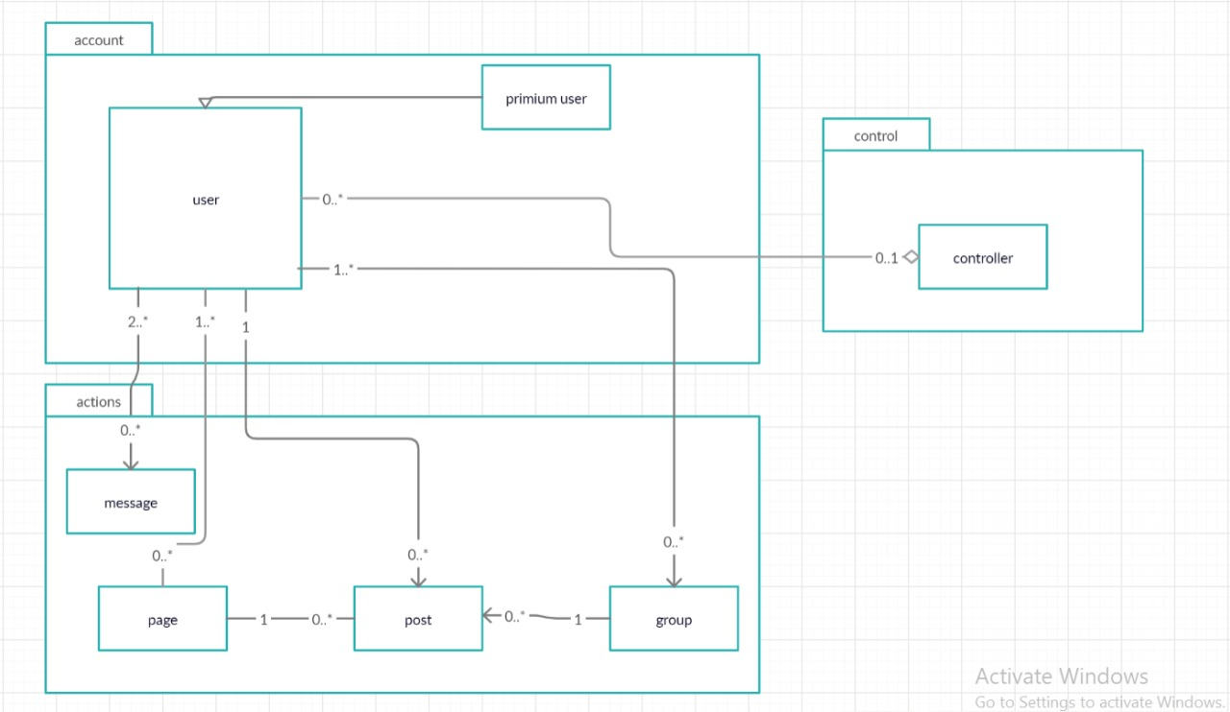

## II. Class diagrams

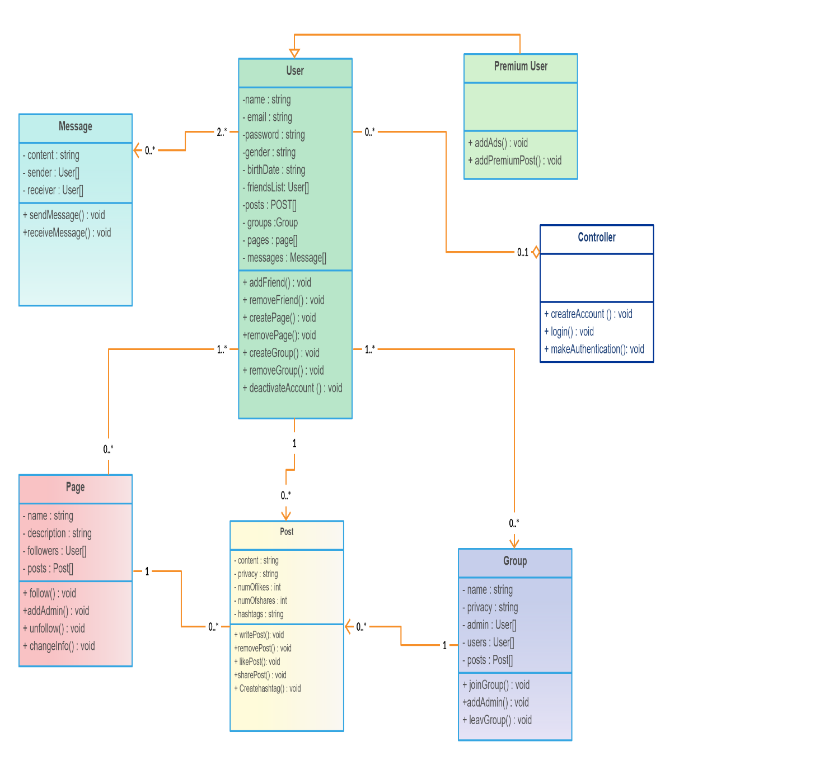

| **Class ID** | **Class Name** | **Subsystem ID** | **Description & Responsibility** |
| --- | --- | --- | --- |
| 1 | User | account | Save information of any user , |
| 2 | Premium User | account | Do special function from normal user such as add Advertisements |
| 3 | Page | Action | Save information of page and number of users who followed it and posts of this page |
| 4 | Post | action | Make functions related of post such as write , remove , like and share |
| 5 | Group | action | Save users numbers and posts of this Group Make functions related of Group such as create Group , leave Group , and join Group |
| 6 | Message | action | Send and receive Message between two users or many users like group chat |
| 7 | Controller | control | Make authentication of users who want to signup and login in this system |

### 

### Important Algorithm

## III. Sequence diagrams

## 1-Follow Page

**2-Join Group**

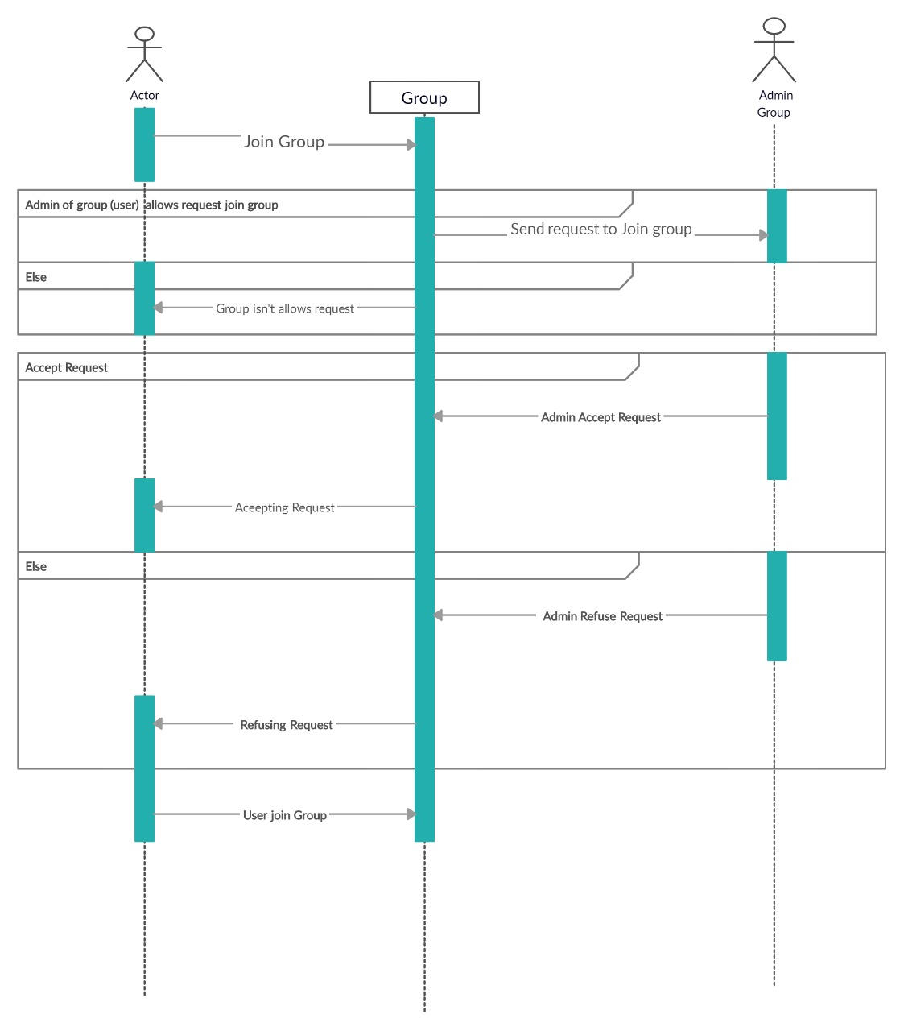

### 3-Login

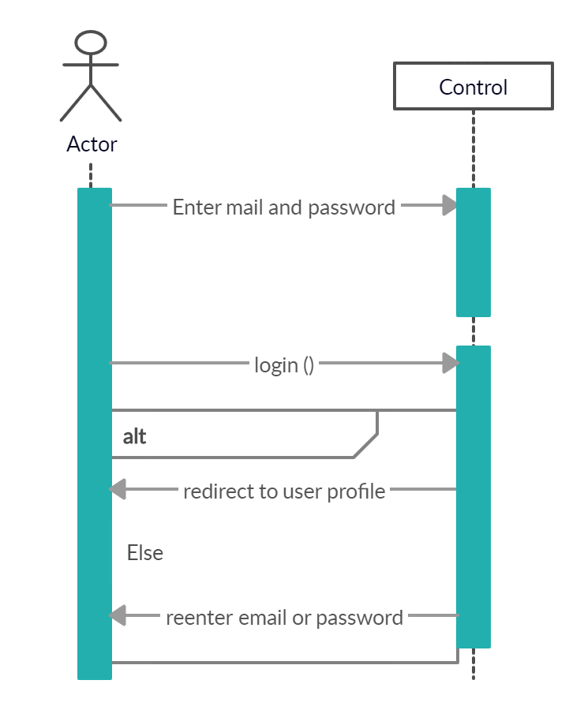

### 4-Send Message

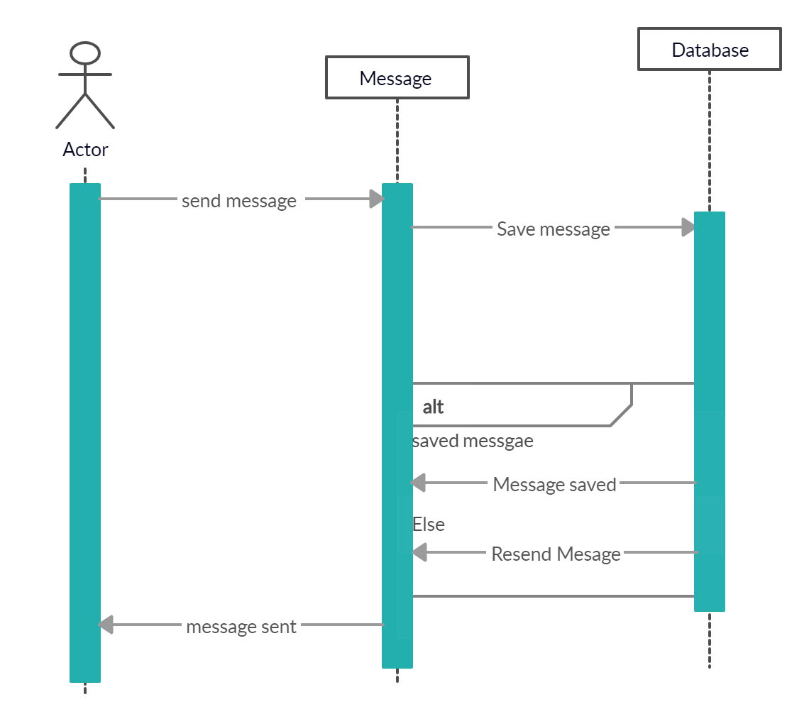

### 5-Deactivate Account

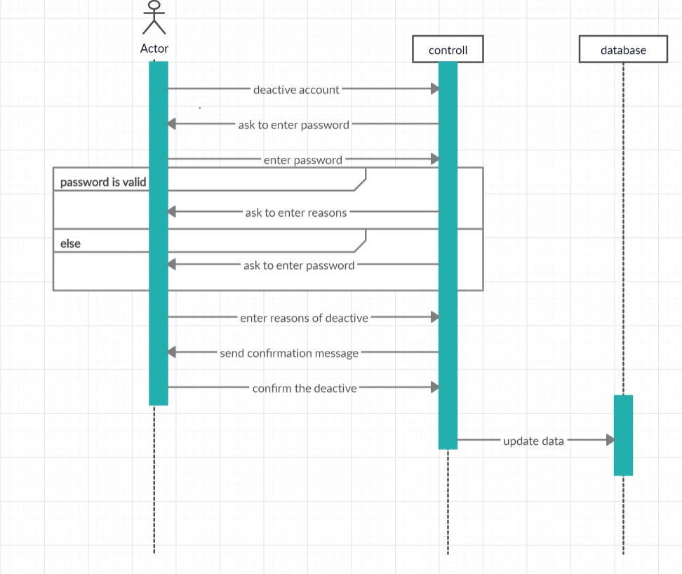

### 6-Delete Post

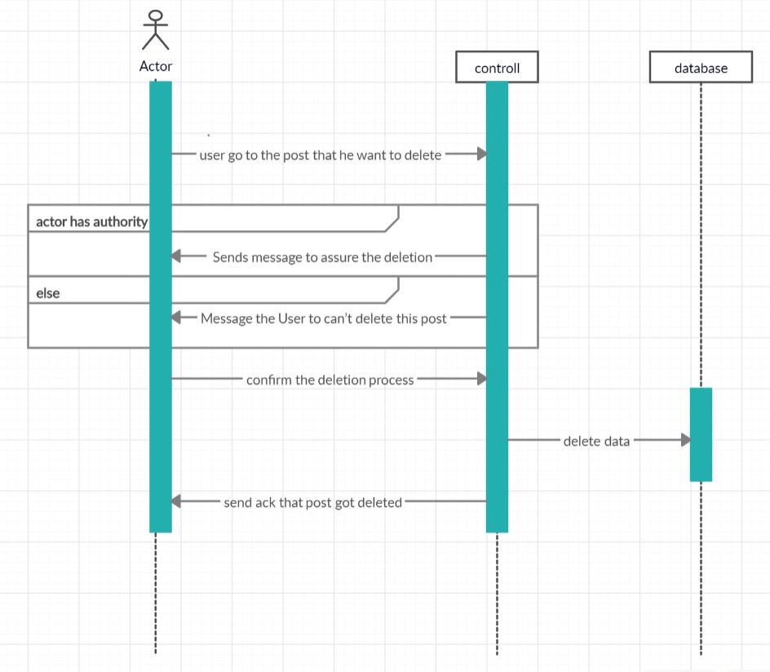

### 7-Create Group

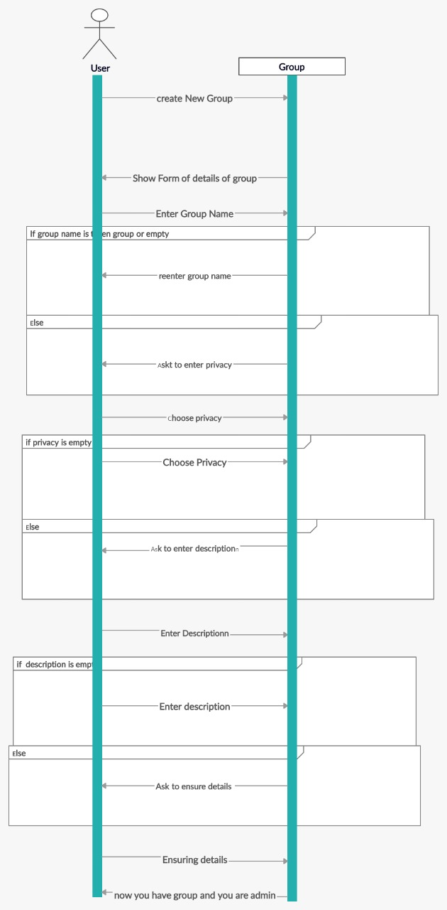

### 8-Create Account

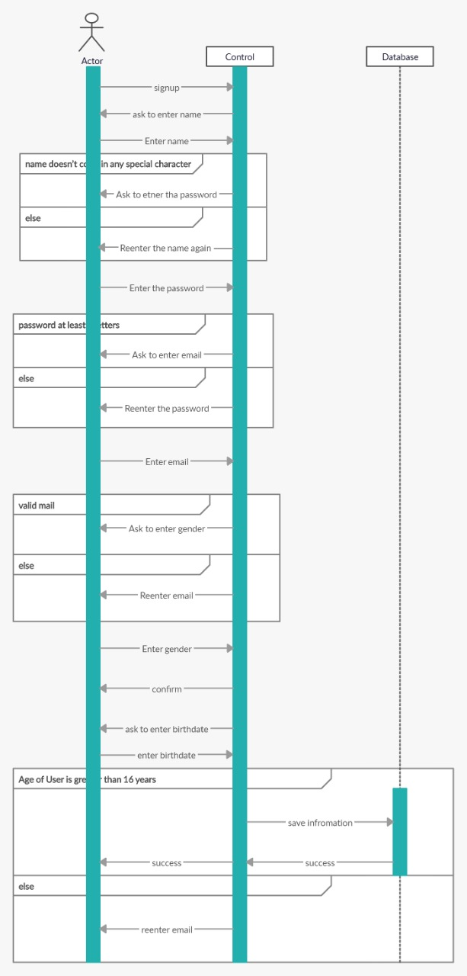

### 9- Add Friend

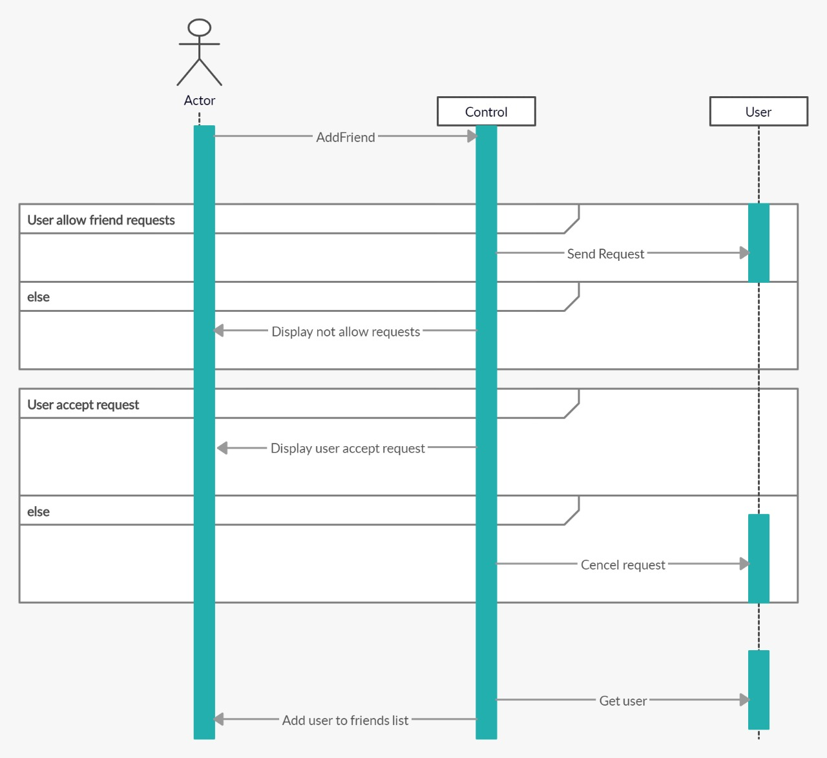

### Class - Sequence Usage Table

| **Class Name** | **Sequence Diagrams** | **Overall used methods** |
| --- | --- | --- |
| User | 5,7&9 | create Group () , add Friend () & Deactivate Account () |
| Controller | 3&8 | Login() & create Account () |
| Post | 6 | Delete Post () |
| Page | 1 | Follow Page() |
| Group | 2 | Join Group() |
| Message | 4 | Send Message() |

# 

# Traceability Matrix

|  |  |  |  |
| --- | --- | --- | --- |
| **BR#** | **Use Case ID** | **Class(es) Name(s)** | **component** |
| BR1 | Ca-1 | Controller | account |
| BR2 | Po-2 | Post | action |
| BR3 | Add-3 | User,Premium User | action |
| BR4 | Dact-4 | User,Premium User | action |
| BR5 | JPG-5 | Group | action |
| BR6 | Cre-6 | User,Premium User | account |
| BR7 | MSG-7 | Message | action |
| BR8 | Repo-8 | Post | action |
| BR9 | Re-F -9 | User, Premium User | account |
| BR10 | ReP/G-10 | User, Premium User | account |
| BR11 | Log-11 | Controller | control |
| BR12 | creHash-12 | Post | action |
| BR13 | Un/fol-P-13 | Page | action |
| BR14 | Ads-14 | Premium User | account |
| BR15 | Auth-15 | Controller | control |

# 

# Ownership Report

|  |  |
| --- | --- |
| **Item** | **Owners** |
| Purpose, UML Class Diagram ,  Login , follow page & send message sequence diagram | *20170143* |
| UML Class Diagram  Create account & add friend sequence diagram | *20170114* |
| Join Group & create Group sequence diagram & Traceability Matrix | *20170123* |
| Decomposition diagram  Deactivate account & delete post | *20170129* |

# References

[https://creately.com/app/?tempID=h165rwt81&login_type=demo#](https://creately.com/app/?tempID=h165rwt81&login_type=demo)

# Authors

* Abdelrahman Bahig , Saeed Mohamed , Seif Mostafa and Shehap Ahmed