**Matlab HW4 B09901081 施伯儒 電機二**

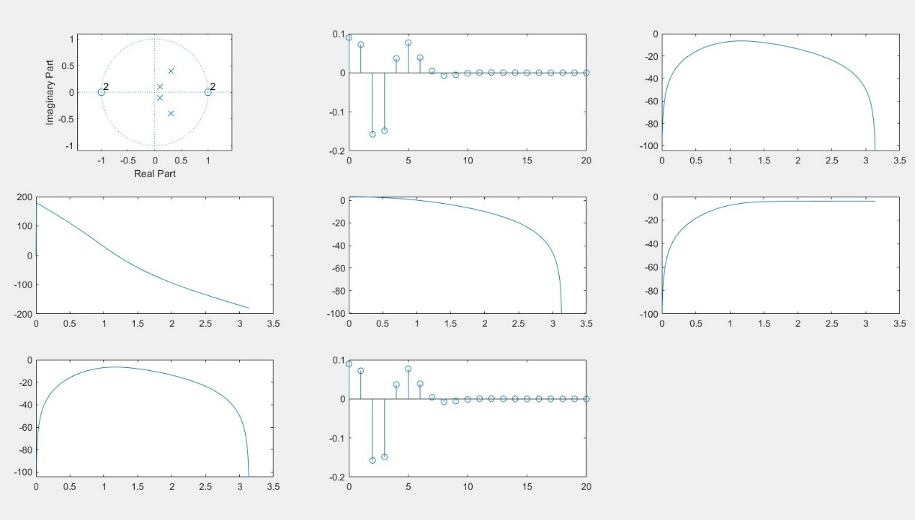

1. **ROC is |z| > 0.5 if right sided,**

**ROC is |z| < 0.1414 if left sided.**

1. 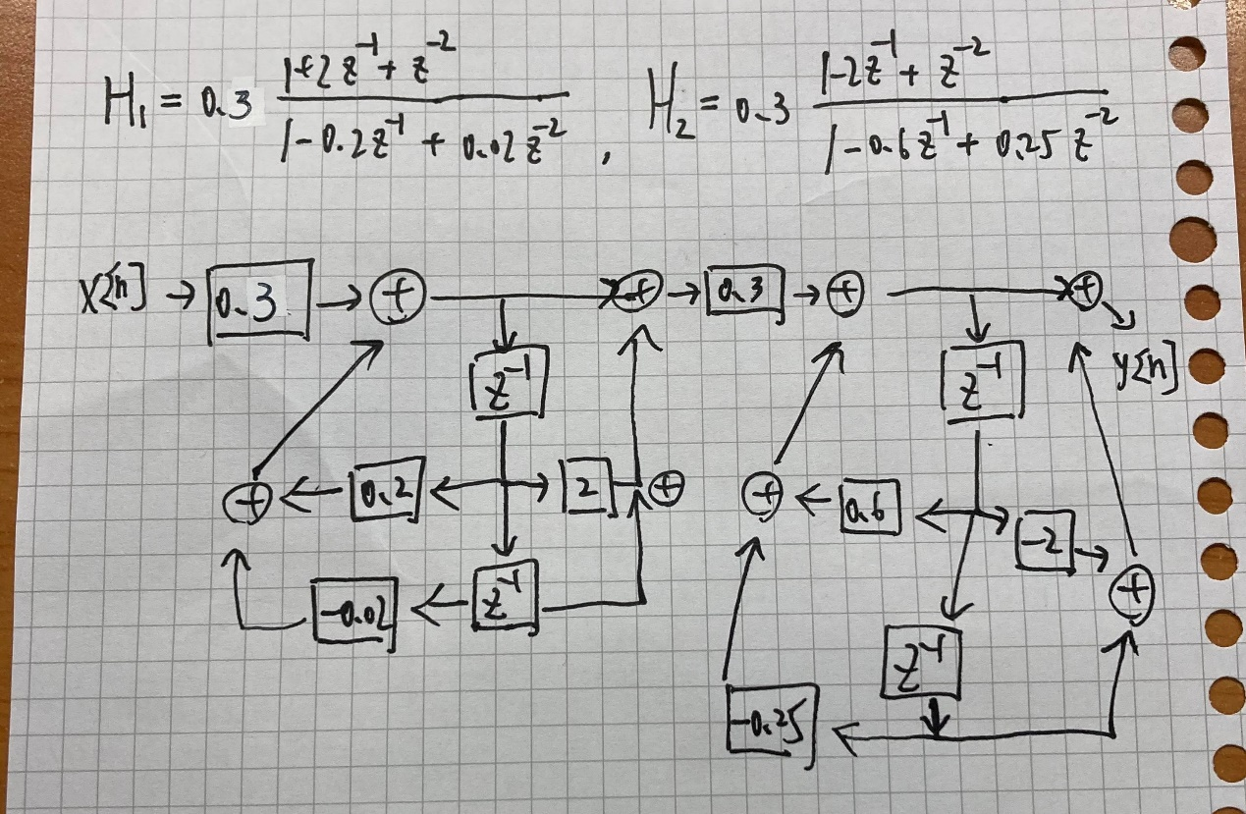
2. **The result is the same as (c)**
3. **The result is the same as (b)**