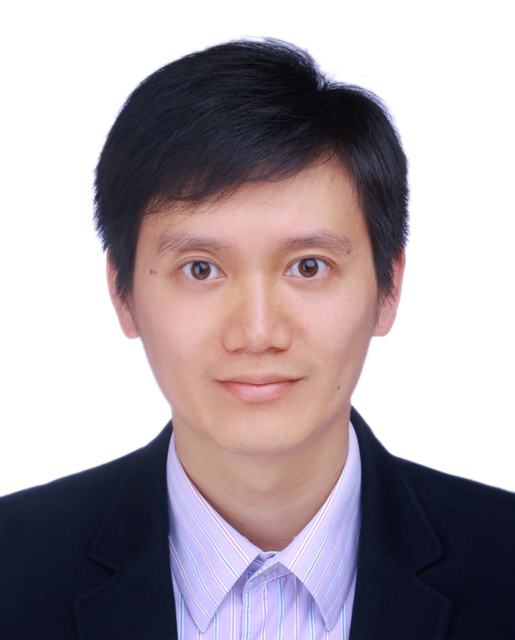
邵秉成
出生日期: 1986/02/22 性别: 男
联系地址: 上海市原平路1029弄10号401室
电子邮件: fallenblacktulip@126.com
手机: 13795282531
教育背景
2009/09-2012/03 | 上海大学 | 通信与信息工程学院 | 工学硕士
 | GPA: 3.7/4.0 电磁场与微波技术
2005/03—2009/03 | 上海大学 | 通信与信息工程学院 | 工学学士
 | GPA：3.4/4.0 通信工程
工作经历
2015/06-Now 思科系统 测试工程师
- 测试工程师，负责DAG（数据分析）部门的数据分析平台和行业解决方案产品(B/S架构)的测试。
- 作为测试小组的负责人，带领团队完成零售行业(CAR)和电信行业(CASP)两个解决方案产品的测试。
- CAR产品以WiFi数据和摄像头数据为数据源，以商场商品展区为用户场景，分析顾客的消费行为和商品的关注度。
- CASP产品以MPLS网络管理数和VPN客户CRM数据等为数据源，为网络运营商提供实时的服务影响分析，服务质量预览，网络运营效率分析和客户分析。
- 数据分析产品架构涵盖：可配置的数据处理接口（Data Handlers）、流式数据库引擎（Trucq）、数据仓库（Data Warehouse）、REST框架和UI/BI报表展示。
- 参与平台和解决方案的手工和自动化测试，设计测试计划，测试案例，执行测试脚本。熟悉整个项目的测试流程。为全球团队和客户做产品功能演示。
- 使用Python脚本设计并开发自动化测试框架。此框架结合了关键字驱动和数据驱动，使用数据配置文件传入测试数据，保证代码的重用性和扩展性。
- 做为Scrum Master参与了敏捷项目的开发和运作。
- 拥有DB (PostgreSQL), RESTful API 和GUI/BI的测试经验。
- 拥有功能测试和系统测试的经验。

2012/01-2015/06 科锐安（Coriant） 中级工程师
- 负责网管系统的功能测试。涵盖OTN, ASON, Metro WDM以及Packet光传输设备的网管系统，功能覆盖NMS和EMS。深刻理解光传输网络和数据网络的通信协议。熟知光传输网络产品的应用。
- 自动化测试。使用VBS和Java编写自动化测试脚本，调试脚本。使用自动化测试工具QTP/UFT和RFT执行自动化测试脚本。
- 参与软件系统需求文档的评审会议并提出修改建议。
- 分析软件系统的需求和功能，细分功能模块，设计相应的测试用例。整理和归档测试用例。
- 撰写测试报告。记录测试进度，生成测试结果报告。发现、分析并记录软件系统的缺陷。提交软件缺陷报告，跟踪并验证修复后的软件质量。
- 定期与位于美国的工程师召开项目会议，商议项目进度和项目输出。
- 2013年独自一人赴美国研发中心，将ASON的测试项目交接到上海，此项目业务之前多年在美国运作。仅在两周的时间里，学会新系统的框架、功能和测试流程。目前独自一人建立测试环境，运作整个测试项目，使上海研发中心具备该复杂功能的测试能力。

工具
- HP QTP/UFT, HP ALM, IBM RFT
- Jenkins

语言水平与计算机技能
- 英语:CET-6，流利的口语，良好的书写能力。
- 计算机：掌握C ,C++/VC++, Java, Linux, Python, VBS, PostgreSQL, javascript, MS office和Matlab。
- ISTQB认证。

自我评价
- 本人工作主动，拥有创新的思维。凡事乐观积极，诚实守信, 具有团队合作精神。
- 对数字敏感，框架化的思考方式，拥有较强的逻辑思维能力。具有较强的学习能力，分析能力和解决问题的能力，喜欢解决问题。
- 能够适应在不同文化和工作人员的背景下出色地工作
- 拥有较强的幻灯片制作能力和演讲能力。
- 能承受一定的工作压力，适应出差。

Vincent Shao
Gender: Male Date of Birth: 1986/02/22
Current Location：Shanghai E-mail: fallenblacktulip@126.com
Mobile Tele: 13795282531
Education
2009/09— 2012/03 | SHANGHAI UNIVERSITY  GPA：3.7/4.0（top5%） | Master in Electromagnetic field and Microwave Technology
2005/03—2009/03 | SHANGHAI UNIVERSITY | Bachelor in Communication Engineering
 | GPA：3.4/4.0（top5%）
Work Experience
2015/06-Now Cisco Engineer QA/testing
- QA in DAG (Data Analytics Group) for data analysis platform and solution products (B/S architecture).
- Lead a small QA team to execute the test tasks on two data analysis solutions which focus on Retails (CAR) and Telecom (CASP) industry.
- CAR data sources are WiFi data, digital camera data and video data. The scenarios of CAR is in the retails stores and exhibition zones. It analyzes the behavior of consumers and the of products popularity for a certain area.
- CASP data sources include MPLS network management data and VPN customers CRM data. It provides real-time service impacted analysis, service quality overview, operation efficiency and customer segment analysis.
- The architecture for Data analysis products consist of configurable data processing interface (Data Handlers), streaming database engine (Trucq), Data Warehouse, REST framework and UI/BI dashboard and report.
- Manual and automation testing for both data analytics platform and solutions. Design test plan and test cases, and execute test cases. Do product demo for global team and customers.
- Design and develop the automation test framework for all products using Python. This framework combines both keywords driven and data driven. Configuration file is introduced to import test source and data so that the framework can keep reusable and scalable.
- Scrum master in Agile team.
- Experience in testing DB (PostgreSQL), RESTful API and GUI/BI.
- Experience in functional and system testing.

2012/01-2015/06 Coriant Engineer II
- Responsible for the functional testing of network management system which manages OTN, ASON, Metro WDM and Optical Packet transport system. Functions cover NMS and EMS. Have deeply understanding of the protocols of Optical transport and Packet network technology. Familiar with the application of Optical transport system.
- Automation testing. Compose VBS and JAVA scripts for automation testing. Debug the testing script and executed the script by using test tool such as QTP/UFT and RFT.
- Join the review meeting of requirement documents. Give comments of the documents.
- Analyze the requirements and functions of the software systems. Clarify the function modules. Design the test cases or user cases based on the function modules. File the test cases and user cases.
- Make the testing report. Follow testing schedule and make the summary report for the testing project. Find, analyze and record the defects of the software system. Submit the defect report, trace the report and evaluated the fix of the defect.
- Have regular meeting with engineers located in U.S. Discuss the process and output of the projects.
- In 2013, I had a business trip to R&D center in U.S alone. Took over the testing project for ASON network management system which was developed in U.S. for many years to Shanghai. Studied the new system structure, function and testing within only 2 weeks. Now, I’m the only person who sets up the test environment and operates the whole test project. The test of this complicated function is able to be executed well in Shanghai R&D center.

Tools
- HP QTP/UFT, HP ALM, IBM RFT
- Jenkins

Language 、Skills and Certificate
- English:CET-6, fluent in oral English and good English writing
- IT skills: C, C++/VC++, Java, Linux, Python, VBS, PostgreSQL, javascript, MS office and Matlab.
- ISTQB Certificate.

Personality
- Initiative, innovation, positive attitude, commitment, honest and teamwork sense
- Be sensitive to figures. Think in structure and logic. Poised and articulate. Can Work well with a multi-cultural and diverse work force.
- Have strong learning ability, analytical ability and problem solving skills. Enjoy solving problems.
- Strong skills in making slides and speech.
- Can work under pressure. Adapt to business trip.

