ITU - Telecommunications Standardization Sector  STUDY GROUP 16 Question 6  Video Coding Experts Group (VCEG)  _________________  Thirteenth Meeting: Austin, Texas, USA, 2-4 April, 2001 | Document VCEG-M33  Filename: VCEG-M33.doc  Generated: 26 March ’01

Question: | Q.6/SG16 (VCEG)
Source: | Gisle Bjontegaard  Telenor Satellite Services  P.O.Box 6914 St.Olavs plass  N-0130 Oslo, Norway | Tel:  Fax:  Email: | +47 23 13 83 81  +47 22 77 79 80  gisle.bjontegaard@telenor.com
Title: | Calculation of average PSNR differences between RD-curves
Purpose: | Proposal
_____________________________

Introduction
VCEG-L38 defines "Recommended Simulation Conditions for H.26L". One of the outcomes is supposed to be RD-plots where PSNR and bitrate differences between two simulation conditions may be read. The present document describes a method for calculating the average difference between two such curves. The basic elements are:
- Fit a curve through 4 data points (PSNR/bitrate are assumed to be obtained for QP = 16,20,24,28)
- Based on this, find an expression for the integral of the curve
- The average difference is the difference between the integrals divided by the integration interval

IPR
“The contributor(s) are not aware of any issued, pending, or planned patents associated with the technical content of this proposal.”

Fitting a curve
A good interpolation curve through 4 data points of a "normal" RD-curve (see figure 1) can be obtained by:
SNR = (a + b*bit + c*bit²)/(bit + d)
where a,b,c,d are determined such that the curve passes through all 4 data points.
This type of curve is well suited to make interpolation in "normal" luma curves. However, the division may cause problems. For certain data (Jani pointed out some typical chroma data) the obtained function may have a singular point in the range of integration - and it fails.

Use of logarithmic scale of bitrate
When we look at figure 1, the difference between the curves is dominated by the high bitrates.
- The range (1500-2000) gets 4 times the weight of the range (375-500) even if they both represent a bitrate variation of 33%
Hence it was considered to be more appropriate to do the integration based on logarithmic scale of bitrate. Figure 2 shows a plot where "Logarithmic x-axes" is used in the graph function of Excel. However, this function has no flexibility and only allows factors of 10 as units.
In figure 3 I first took the logarithm of bitrates and the plot has units of "dB" along both axes. The factor between two vertical gridlines in the plot is: 10^{0.05} = 1.122 (or 12.2%). Could this be an alternative way of presenting RD-plots?

Interpolation with logarithmic bitrate scale
With logarithmic bitrate scale the interpolation can also be made more straight forward with a third order polynomial of the form:
SNR = a + b*bit + c*bit² + d*bit³
This result in good fit and there is no problems with singular points. This is therefore the function I have used for the calculations in VCEG-M34. However, for integration of luma curves the results are practically the same as with the first integration method which was used for the software distributed by Michael regarding the complexity experiment.
In the same way we can do the interpolation to find Bit as a function of SNR:
SNR = a + b*SNR + c*SNR² + d*SNR³
In this way we can find both:
- Average PSNR difference in dB over the whole range of bitrates
- Average bitrate difference in % over the whole range of PSNR
On request from Michael average differences are found over the whole simulation range (see integration limits in figure 3) as well as in the middle section - called mid range.
- As a result VCEG-M34 shows 4 separate data tables.

Conclusions
- It is proposed to include this method of finding numerical averages between RD-curves as part of the presentation of results. This is a more compact and in some sense more accurate way to present the data and comes in addition to the RD-plots.
- The distinction between "total range" and "mid range" does not seem to add much and it is therefore proposed to use "total range" only.
- From the data it is seen that relation between ΔSNR and Δbitrate is well represented by 0.5 dB = 10% or 0.05 dB = 1% It is therefore proposed to calculate either change in bitrate or change in PSNR.
- Should it be considered to present RD-plots as indicated in figure 3?
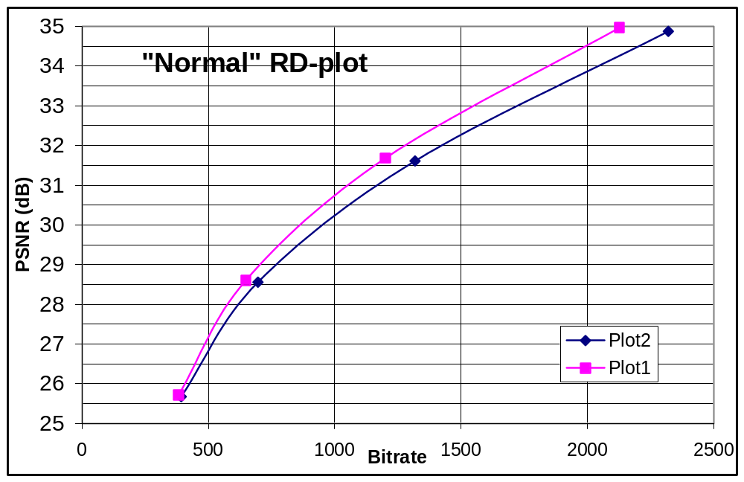
Figure 1

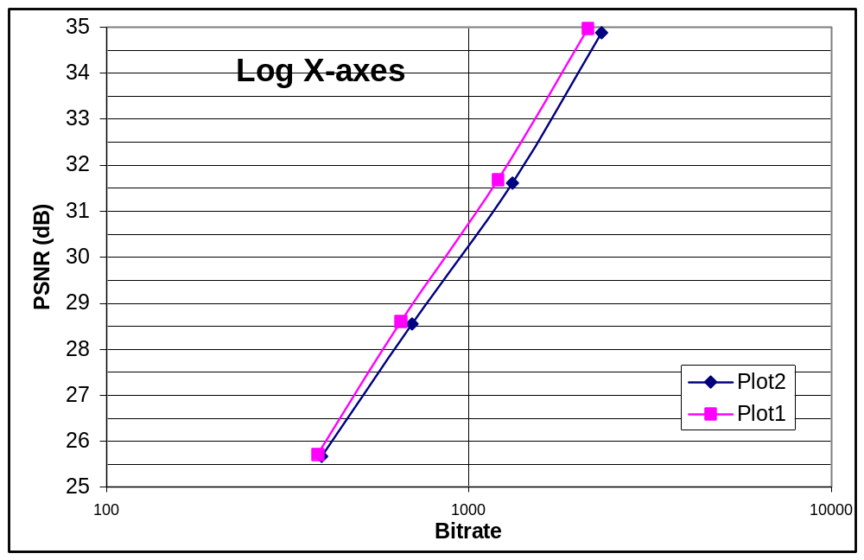
Figure 2
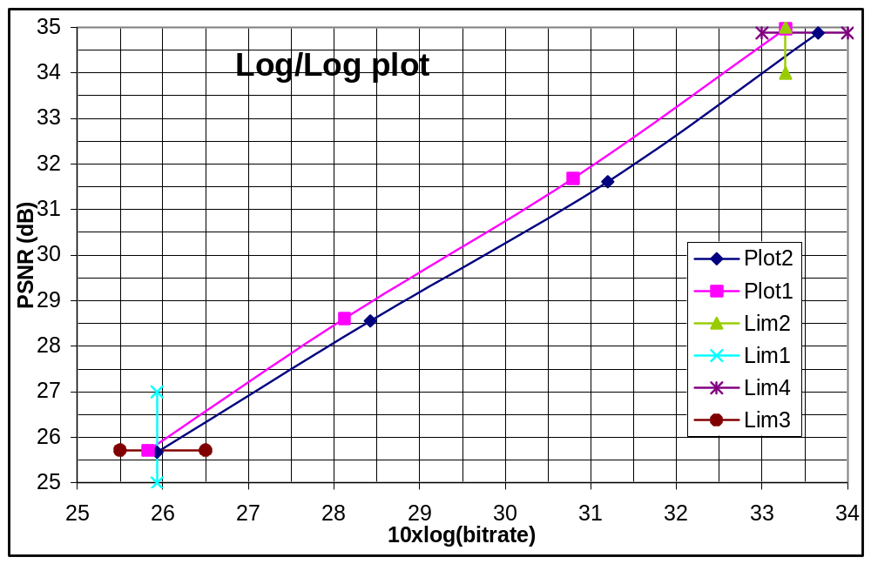
Figure 3

Here is a document about BD-PSNR which has been referenced by many Video Engineers. You can download it at http://wftp3.itu.int/av-arch/video-site/

The matlab code for computing BD-Bitrate and BD-PSNR is found in this link:
http://www.mathworks.com/matlabcentral/fileexchange/27798-bjontegaardmetric/content/bjontegaard.m

function avg_diff = bjontegaard(R1,PSNR1,R2,PSNR2,mode)

%BJONTEGAARD Bjontegaard metric calculation
% Bjontegaard's metric allows to compute the average gain in PSNR or the
% average per cent saving in bitrate between two rate-distortion
% curves [1].
% Differently from the avsnr software package or VCEG Excel [2] plugin this
% tool enables Bjontegaard's metric computation also with more than 4 RD
% points.
%
% R1,PSNR1 - RD points for curve 1
% R2,PSNR2 - RD points for curve 2
% mode -
% 'dsnr' - average PSNR difference
% 'rate' - percentage of bitrate saving between data set 1 and
% data set 2
%
% avg_diff - the calculated Bjontegaard metric ('dsnr' or 'rate')
%
% (c) 2010 Giuseppe Valenzise
%
% References:
%
% [1] G. Bjontegaard, Calculation of average PSNR differences between
% RD-curves (VCEG-M33)
% [2] S. Pateux, J. Jung, An excel add-in for computing Bjontegaard metric and
% its evolution

% convert rates in logarithmic units
lR1 = log(R1);
lR2 = log(R2);

switch lower(mode)
case 'dsnr'
% PSNR method
p1 = polyfit(lR1,PSNR1,3);
p2 = polyfit(lR2,PSNR2,3);

% integration interval
min_int = min([lR1; lR2]);
max_int = max([lR1; lR2]);

% find integral
p_int1 = polyint(p1);
p_int2 = polyint(p2);

int1 = polyval(p_int1, max_int) - polyval(p_int1, min_int);
int2 = polyval(p_int2, max_int) - polyval(p_int2, min_int);

% find avg diff
avg_diff = (int2-int1)/(max_int-min_int);

case 'rate'
% rate method
p1 = polyfit(PSNR1,lR1,3);
p2 = polyfit(PSNR2,lR2,3);

% integration interval
min_int = min([PSNR1; PSNR2]);
max_int = max([PSNR1; PSNR2]);

% find integral
p_int1 = polyint(p1);
p_int2 = polyint(p2);

int1 = polyval(p_int1, max_int) - polyval(p_int1, min_int);
int2 = polyval(p_int2, max_int) - polyval(p_int2, min_int);

% find avg diff
avg_exp_diff = (int2-int1)/(max_int-min_int);
avg_diff = (exp(avg_exp_diff)-1)*100;
end

