# 一账通Ionic插件返回给调用者的JSON格式

{

"result": "0000",

"data": {

"mobileNo": "18513855349",

"idType": "",

"idNo": "",

"sex": "",

"cnName": ""

}

}

## 人脸识别Ionice插件返回给调用者的JSON格式

{

"rotate": 2.02,

"yaw": -2.83,

"motion_blurness": 0.46785715,

"rect_w": 135,

"head_motion": 0,

"mouth_motion": 0,

"rect_x": 139,

"pitch": -9.72,

"rect_h": 148,

"imgurl": "/storage/emulated/0/paface/upload/2017-01-13-15-09-27_b",

"rect_y": 217,

"brightness": 145.68677,

"eye_hwratio": 0.3271361

}

# iOS Ionic人脸识别插件注意事项

1. cordova plugin remove cordova-plugin-pingan-face
2. cordova plugin add “插件地址”
3. 打开xcode

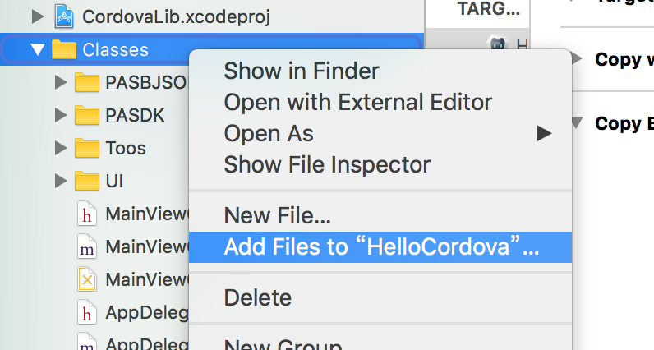

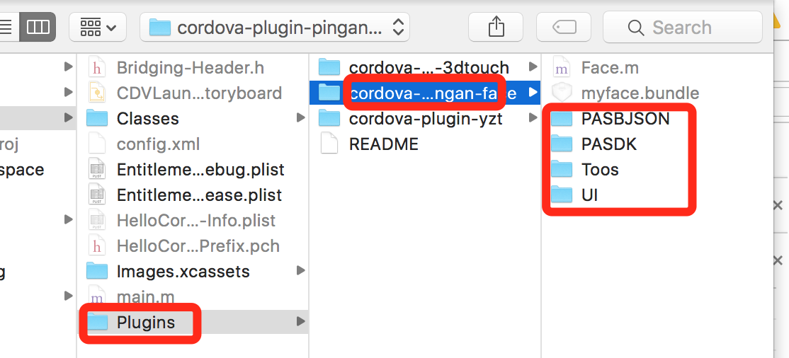

1. 最终的目录结果如图：

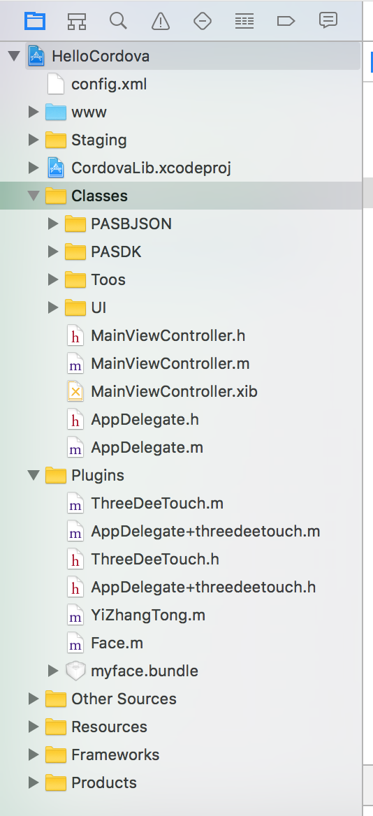

1. 添加myface.bundle

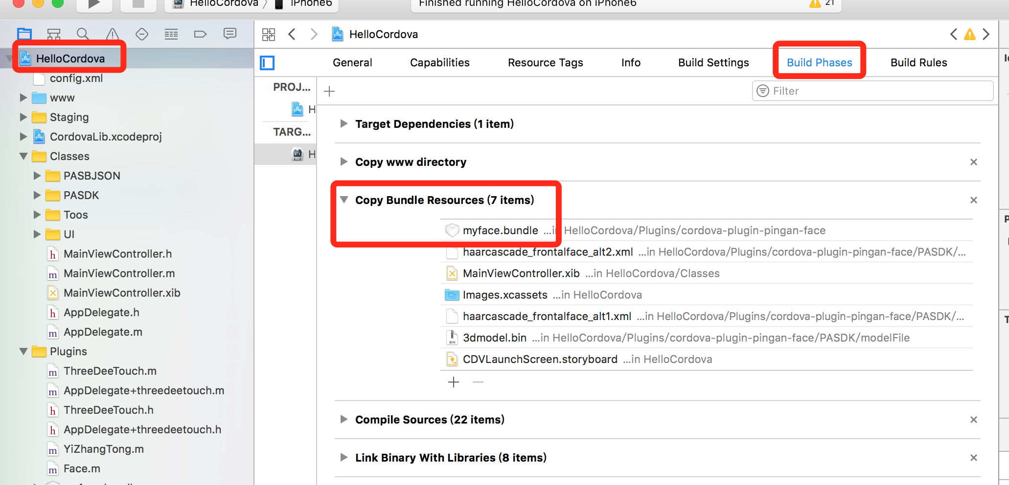

1. 解决SBJSON的问题

-fno-objc-arc

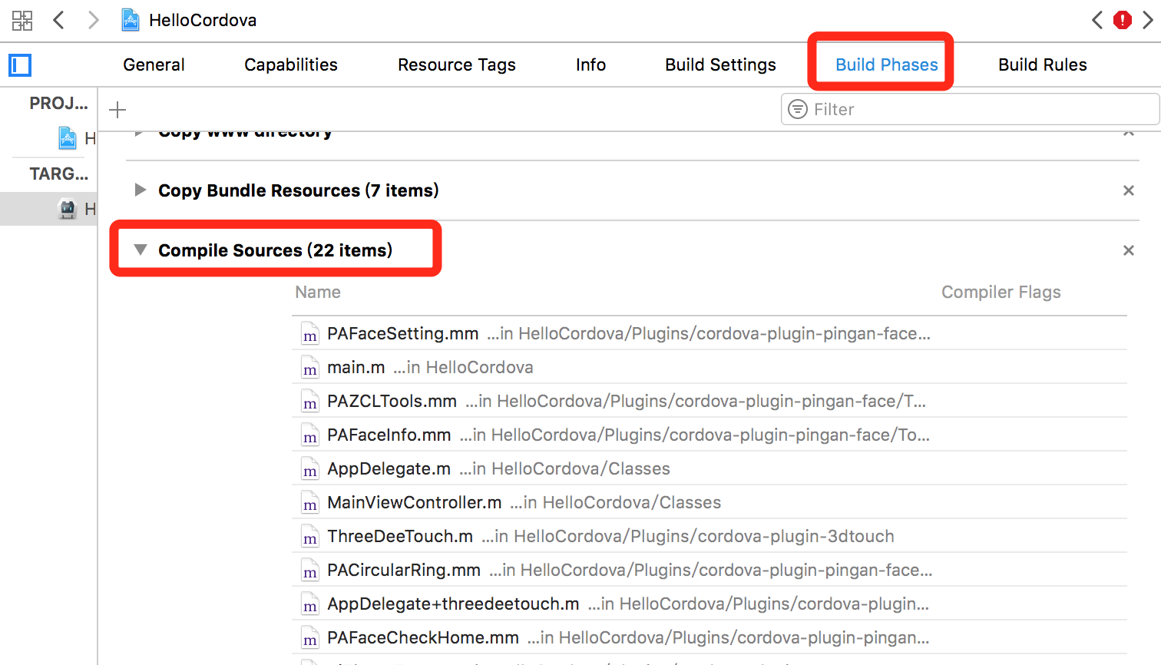

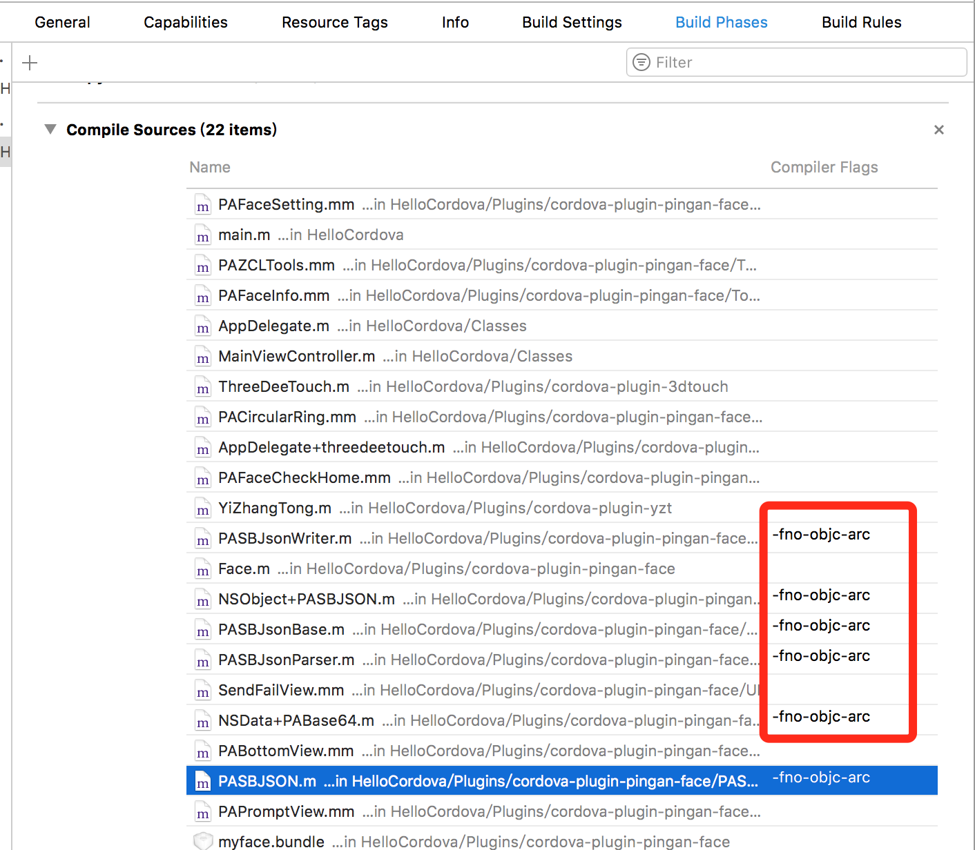

1. 编辑打包

# 一账通iOS Ionic插件注意事项

ios登录时提示**appId 不能为空**。需要在plist文件中配置SSOAppId 和SSOAppKey

SSOAppId :10885

SSOAppKey :**43C18306BB4F2B57E054000B5DE0B7FC**

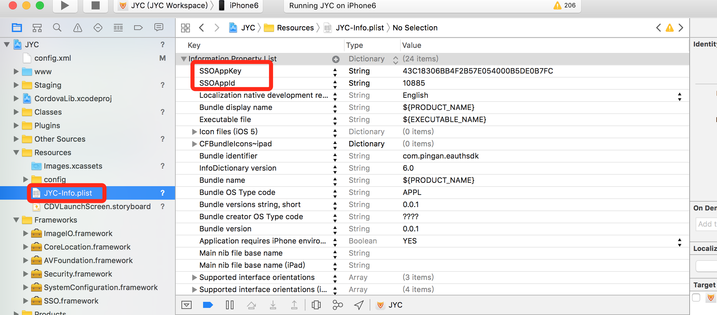

# 聚友财人脸识别功能附件上传注意事项

cordova plugin add <https://github.com/shihujiang/cordova-HTTP>

自定义的cordova－HTTP插件（ios） 修改了默认uploadFile

的实现，新增如下代码：[dictionary setObject:responseObject forKey:@"data"];

# 创建ionic 自定义插件

ionic插件是对cordova插件的进一步封装，所以在创建ionic插件前，必须有对应的cordova插件。

1. git clone <https://github.com/driftyco/ionic-native>
2. gulp plugin:create -n jyc-cashier
3. open src/plugins/jyc-cashier.ts

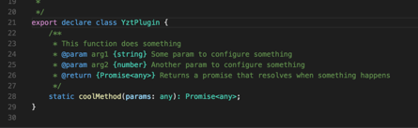

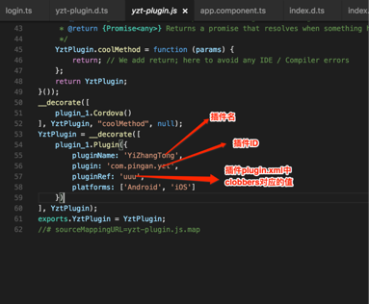

open /src/index.ts

import { JycCashier} from './plugins/jyc-cashier';

export * from './plugins/jyc-cashier';

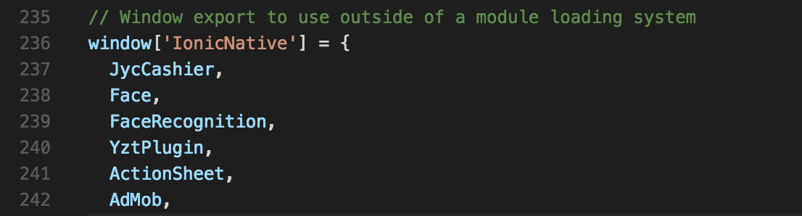

npm run build

# 创建cordova插件

#创建插件

plugman create --name jycCashierPlugin --plugin_id com.pingan.jyc.cashier --plugin_version 1.0.0

plugman platform add --platform_name android/ios

# ionic插件之iOS聚友财收银台SDK

ionic plugin add /Users/shihujiang/Documents/cordova/plugin-cust/jycCashierPlugin

微信支付配置

1.配置微信白名单LSApplicationQueriesSchemes

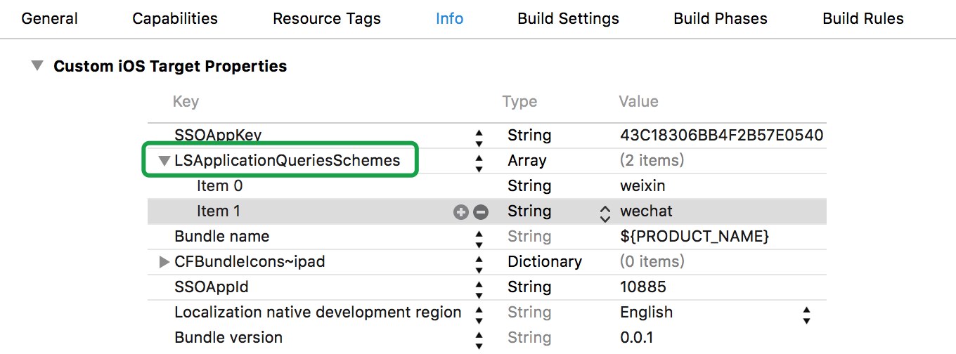

2.

wxd930ea5d5a258f4f

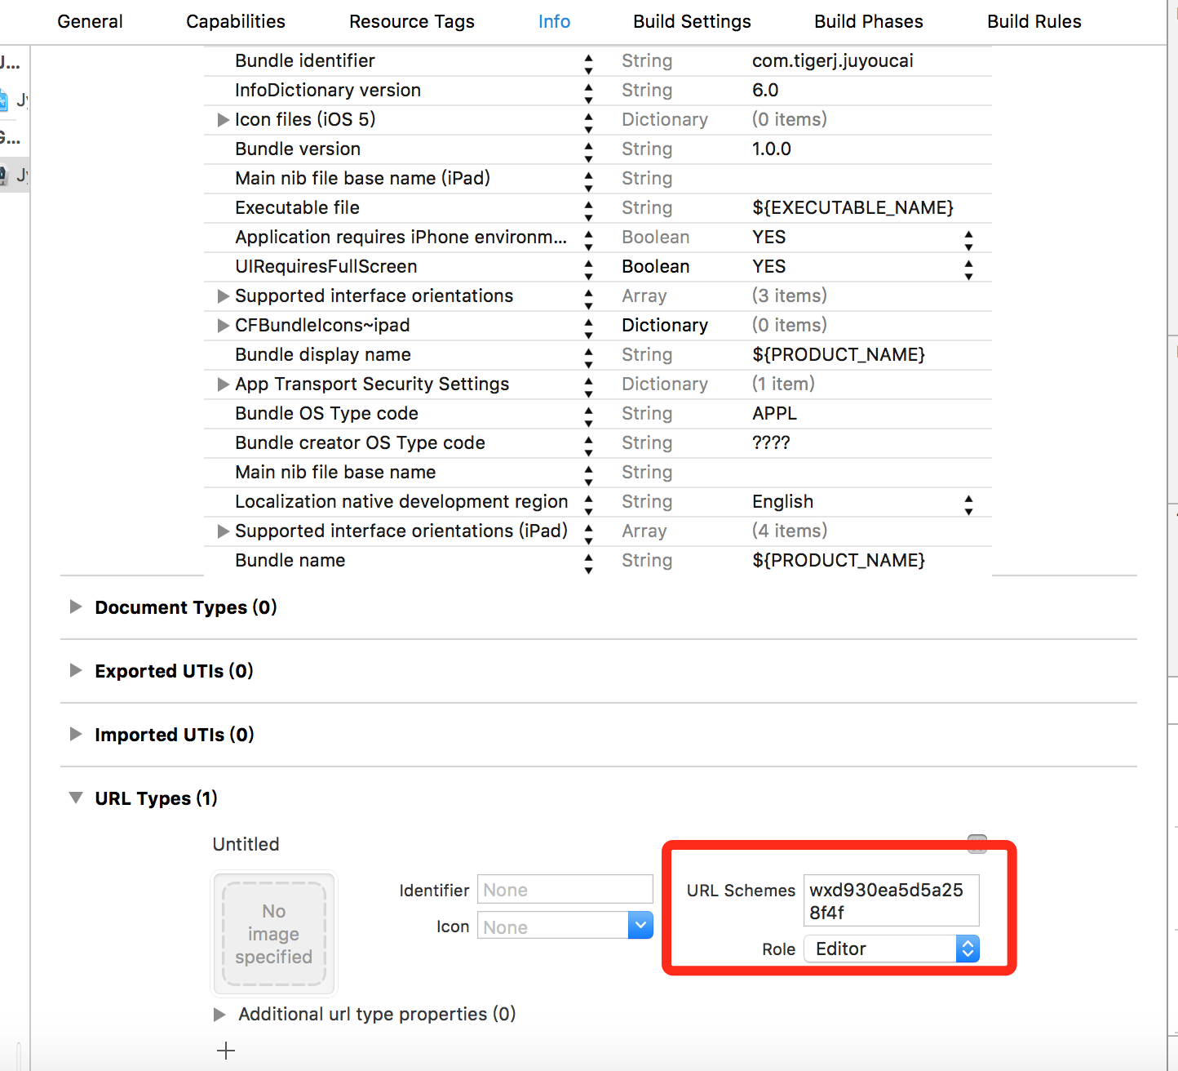

# ionic插件之Android聚友财收银台SDK

repositories {

flatDir {

dirs 'libs'

}

}

compile(name:' **pingan-pay-1.0.1**',ext:'aar')

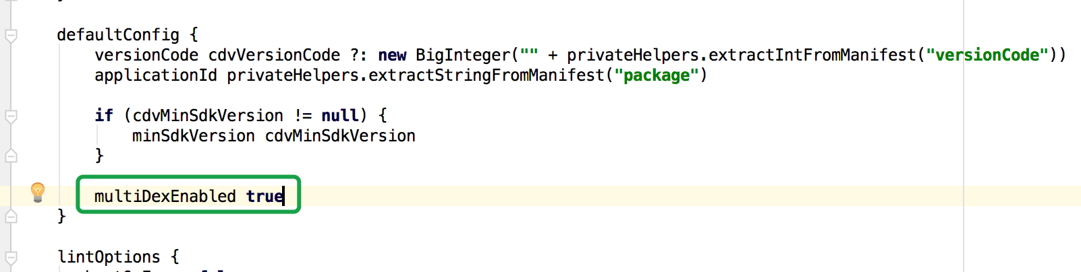

multiDexEnabled **true**

# iOS打包注意事项