需求時間軸為：

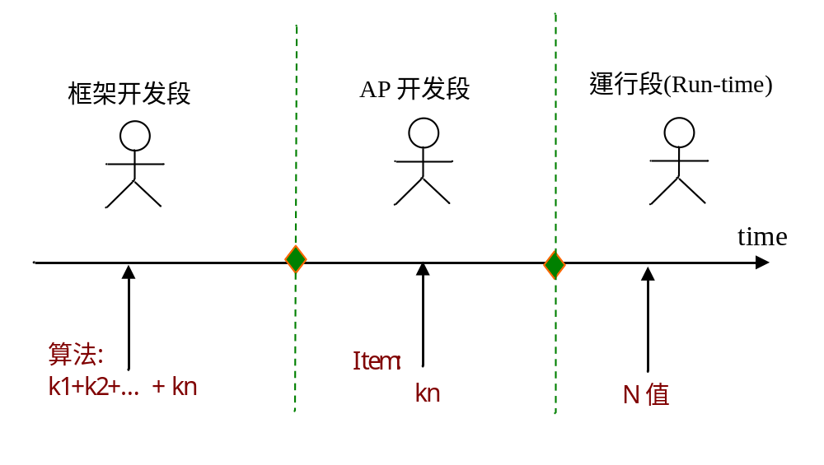
設計圖更改為：
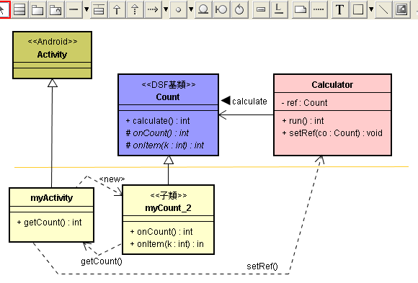

撰寫如下的Android項目的源碼：

// 框架部份
package Engine;
import Framework.Count;

public class Calculator {
private Count ref;
public int run() {
return ref.calculate();
}
public void setRef(Count co){
ref = co;
}
}

package Framework;
public abstract class Count {
public int calculate(){
int N = getCount();
int sum = 0;
for(int i=0; i<=N; i++) {
sum += onItem(i);
}
return sum;
}
public int getCount() {
return onCount();
}
protected abstract int onCount();
protected abstract int onItem(int k);
}

// AP部分
package com.misoo.ppxx;
import Framework.Count;

public class myCount extends Count{
protected int onCount(){
return myActivity.mN;
}

@Override
protected int onItem(int k) {
return k;
}
}

package com.misoo.ppxx;
import Engine.Calculator;
import Framework.Count;
import android.app.Activity;
import android.os.Bundle;
import android.view.View;
import android.view.View.OnClickListener;
import android.widget.Button;
import android.widget.EditText;
import android.widget.LinearLayout;

public class myActivity extends Activity implements OnClickListener {
/** Called when the activity is first created. */
private Button btn, btn2;
private EditText et;
public static int mN;

@Override
public void onCreate(Bundle savedInstanceState) {
super.onCreate(savedInstanceState);
setContentView(R.layout.main);
LinearLayout layout = new LinearLayout(this);
layout.setOrientation(LinearLayout.VERTICAL);
LinearLayout.LayoutParams param =
new LinearLayout.LayoutParams(100, 55);
param.leftMargin = 1;
param.topMargin = 3;

et = new EditText(this);
et.setId(100);
et.setOnClickListener(this);
layout.addView(et, param);

btn = new Button(this);
btn.setId(101);
btn.setText("Run");
btn.setOnClickListener(this);
btn.setBackgroundResource(R.drawable.x_jude);
layout.addView(btn, param);

btn2 = new Button(this);
btn2.setId(102);
btn2.setText("Exit");
btn2.setOnClickListener(this);
btn2.setBackgroundResource(R.drawable.x_sky);
layout.addView(btn2, param);
setContentView(layout);
}
public void onClick(View v) {
switch(v.getId()) {
case 100:
String ss = et.getText().toString();
mN = Integer.parseInt(ss);
setTitle(ss);
break;
case 101:
Calculator cal = new Calculator();
Count co = new myCount();
cal.setRef(co);
int result;
result = cal.run();
setTitle(String.valueOf(result));
break;
case 102:
finish();
break;
}
}
}

~~ END ~~

