2.3 a. interval data b. nominal data c. nominal data

2.7 a. interval b. nominal c. nominal d. interval e. interval f. ordinal

2.15(the following two charts)

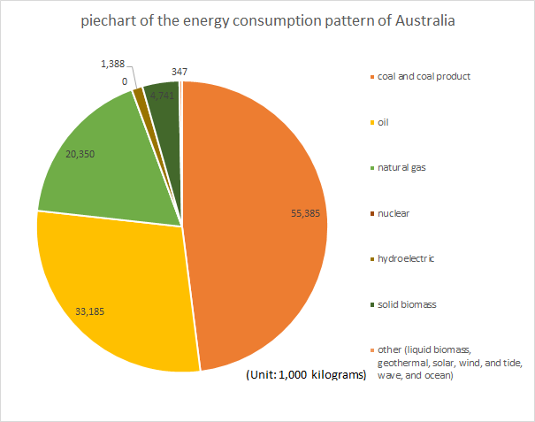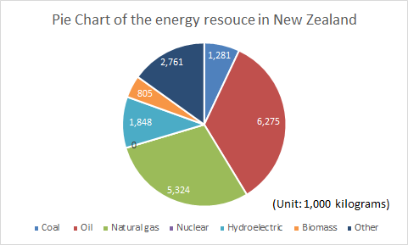

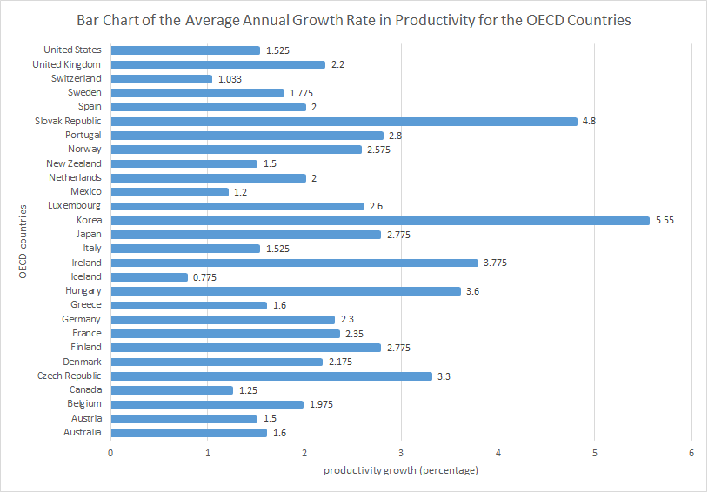2.23

2.43(the following two charts)

According to the data below, the most frequent places that robberies are taken is on streets or highways, and the least frequent one is in banks. The frequency of on street or highways is decreased over the years. In commercial house and in residence are similar but more frequent than in convenience store. Though it seems that the frequency in each places are decreasing year by year, the rank of the places doesn’t not change.

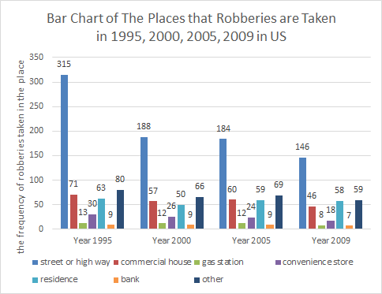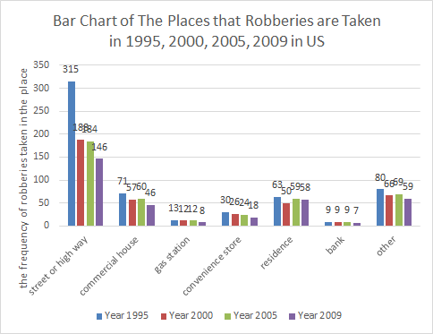

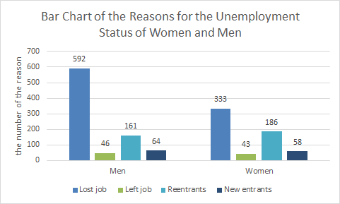

2.47(illustrated as the right chart)

The reason that is “lost job” is rank one, “reentrants” is rank 2, “new entrants” is rank 3, and “left job” is rank 4 to both men and women. However, the number for the reason “reentrants” of women is the only one that is more than men.

3.7 (a)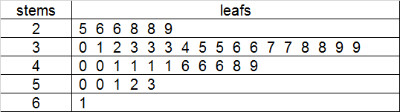(b)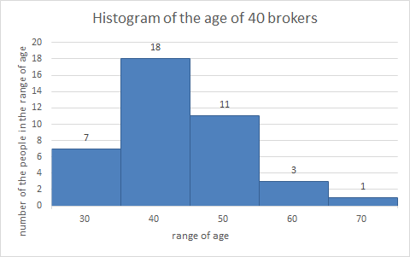

(c)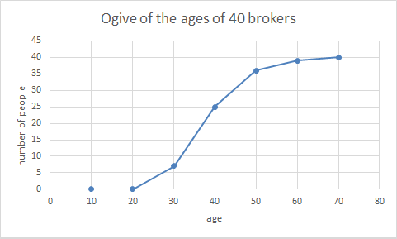

(d)Observing the above three displays, we can find that people in the age of 30~40 is the most frequent in the sample data.

3.11(the following figure)

Most of the fans are in the range of 5~10. This is a unimodal and positively skewed histagram

