3.31

a.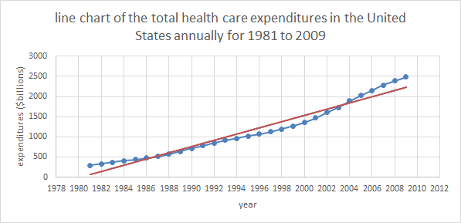b.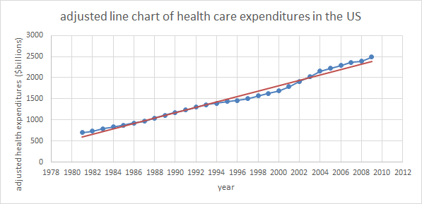

After adjusted, the values are more similar to the red line.

3.37

The new residential construction in the United States is the highest in 2006, and after that it’s decreasing dramatically.

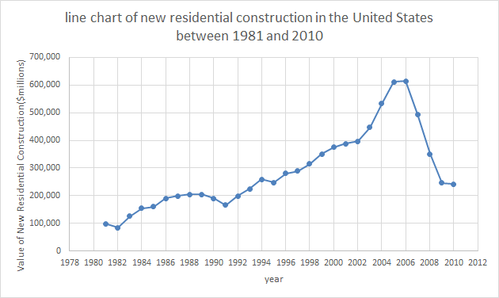

3.51

Two variables have positive linear relationship.

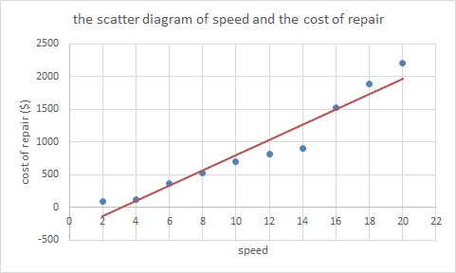

3.59

The relationship between two variables is very little and approach to zero. Thus, we can determine that the showing time of a movie doesn’t really influence the sales of concession.

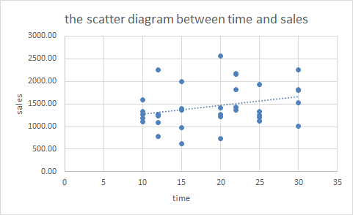

3.73

b. I don’t think that the crime rates is decreasing since there still exists other types of crimes.

c. I think other types of crimes should be included.

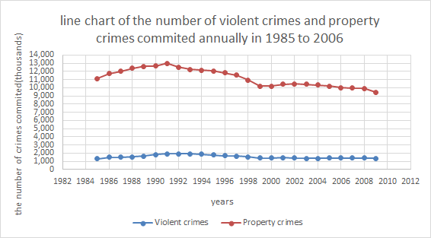

3.77

a. the values are shown in the following line chart.

c. Both the highest death rates and injury rates is in the ages of 85 or more.

d. The denominator of 3.77 is larger than the one in 3.9, so the statistic result in 3.77 may be more accurate than in 3.9.

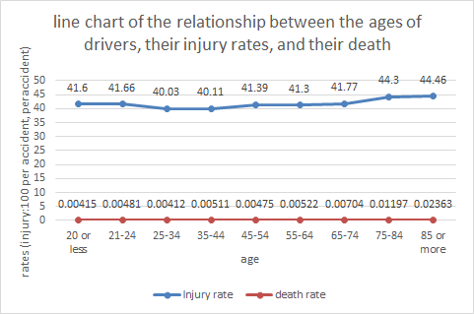

4.5

a. mean = 8.2, median = 8.5, mode = 4

b. From mean we can find the average number of days that the professors submits their exam, and from median we can know the average between the 10 and 11 rank of days, and mode can only tell us that the most frequent number of days in this statistics is 4.

4.15

a. mean = 26.95(精確至小數點後兩位), median = 27

b. mean = 31.77(精確至小數點後兩位), median = 32

c. The mean value and the median are very similar in the two places. Thus, maybe we can infer that they are symmetrical and unimodal.

4.27

a. 68%

b. 95%

c. 99.7%

4.31

Range : 25.85, variance : 29.45522, standard deviation : 5.400062

We can use these statistics to draw a picture of normal distribution, and will be a bell shape picture, which will meet the distribution in 4.27.