4.49 = a[340]\*0.15 + a[341]\*0.85 = 75mph

4.53

BBA has the highest starting salaries, and also has the largest variability. BA has the lowest starting salaries, but has the smallest variability. BSc and BA are symmetric and BBA and other are positively skewed.

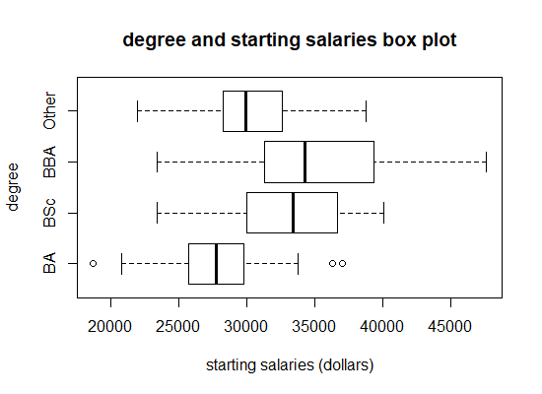

4.57

Since Q2 – Q1 > Q3 – Q2, it is negatively skewed.

Fisrt quartile = a[150.25] = 9836.973

Second quartile = a[300.5] = 18335.72

Third quartile = a[450.75] = 14597.99

4.69 (picture left below)

Covariance : 51.49

r : 0.254

* moderately weak positive linear relationship

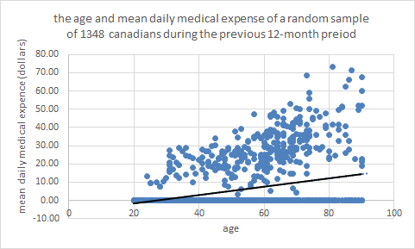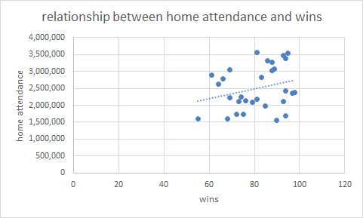

4.75(picture right above)

Covariance : 2103578

r : 0.274

* moderately weak positive linear relationship