CENTRALIZED ENTERPRISE SECURITY OPERATIONS CENTER (SOC) HOME LAB
Multi-OS Security Log Ingestion, Telemetry Forwarding, Noise Reduction, and Detection Engineering using Splunk Enterprise 10.4.2

Executive Summary
Modern cybersecurity operations require centralized visibility across diverse operating systems and network boundaries. Traditional, decentralized log management—where system logs reside isolated on individual endpoints—fails to provide timely threat visibility, hinders forensic investigation, and increases mean time to detect (MTTD).
This project details the design, deployment, configuration, and validation of a centralized Security Information and Event Management (SIEM) laboratory. Using Splunk Enterprise 10.4.2 hosted on a Windows 11 platform as the central receiving, indexing, search, and alerting engine, security telemetry is collected near real-time over TCP port 9997 from heterogeneous endpoints: a Windows 10 Virtual Machine and a Kali Linux Virtual Machine, alongside local Windows 11 Host logs.
The laboratory successfully establishes segregated index storage (windows11, windows10, sh-kali), implements custom Linux auditd noise reduction to prevent event flooding, enforces inbound host firewall restrictions, and validates end-to-end telemetry ingestion with over 9,435+ events processed. Furthermore, actionable Splunk Processing Language (SPL) detection rules were engineered to identify brute-force logons, unauthorized user creations, privilege escalation attempts, and sensitive file integrity breaches.

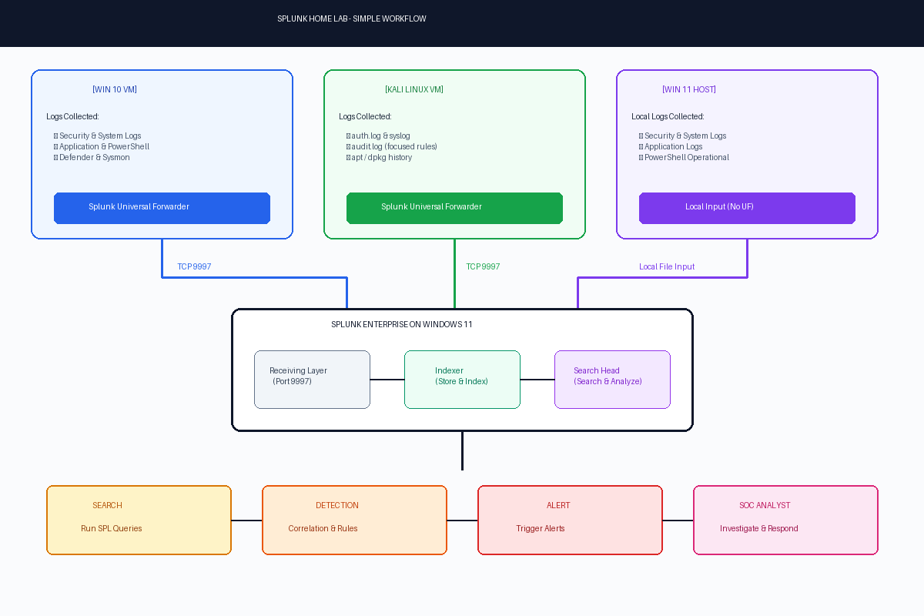
Figure 1: High-Level SOC Ingestion Workflow & Component Pipeline

1. Project Overview & Objectives

1.1 Project Background
In an enterprise environment, Security Operations Center (SOC) analysts must monitor thousands of endpoints. Without central aggregation, detecting lateral movement, privilege escalation, or multi-host attacks is nearly impossible. This project creates a fully functional, small-scale SOC telemetry pipeline to emulate enterprise SIEM operations within a virtualized home lab environment.

1.2 Core Objectives
• Central SIEM Deployment: Establish a single-instance Splunk Enterprise 10.4.2 server combining Indexer and Search Head capabilities on a Windows 11 host.
• Heterogeneous Data Collection: Ingest native Windows Event Logs (Security, System, Application, PowerShell, Defender) and Linux telemetry (auth.log, auditd, kern.log, apt/dpkg).
• Data Pipeline Segregation: Structure incoming data streams into logical indexes (windows11, windows10, sh-kali) for efficient querying and strict data hygiene.
• Linux Audit Noise Optimization: Fine-tune Linux kernel auditd rules to eliminate excessive system call logs while capturing high-value File Integrity Monitoring (FIM) and account database changes.
• Detection Engineering: Develop and test correlation rules using SPL to detect security anomalies and automate alerting workflows.

2. Comparative Analysis: Traditional vs. Centralized SIEM
Feature / Metric | Traditional Decentralized System | Centralized Splunk SIEM Lab | SOC Impact / Advantage
Log Storage | Dispersed locally across endpoints | Centralized Indexer database | Instant search access; prevents log tampering
Event Correlation | Manual log collection per machine | Automated cross-platform SPL rules | Correlates Windows & Linux events simultaneously
Search Speed | Hours/Days manually parsing files | Seconds using indexed SPL queries | Drastically reduces Mean Time to Detect (MTTD)
Alerting | None or local email/popups | Automated alerts & threshold triggers | Real-time notification of brute-force & privilege abuse
Visibility | No visual aggregation | Real-time graphical UI & dashboards | Executive & operational situational awareness
Noise Control | Raw un-filtered file logs | Filtered telemetry (auditd keys) | Prevents storage exhaustion and analyst burnout

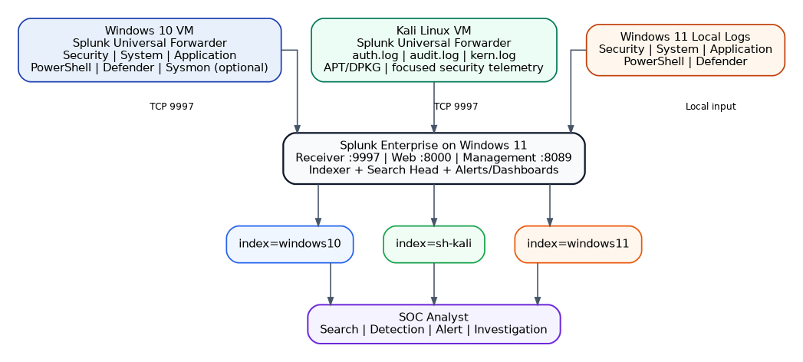
Figure 2: Multi-OS Network & Index Ingestion Architecture

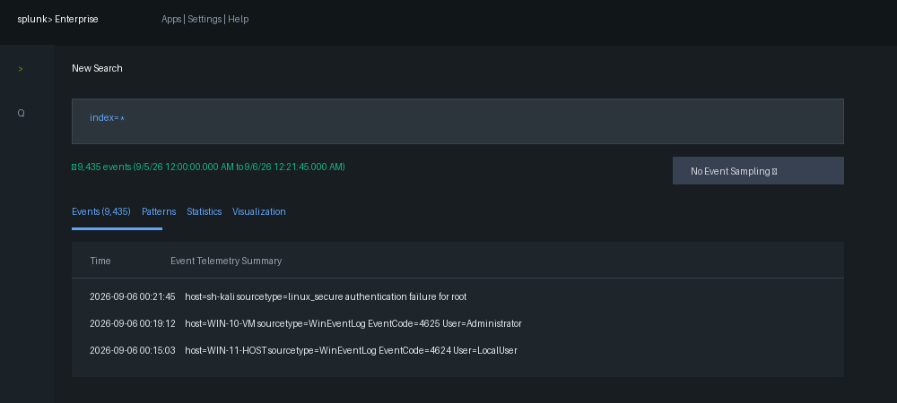
Figure 3: Live Ingestion Search Proof (9,435 Total Ingested Events)

