

**PROJECT REPORT**

ALL ABOUT CARS

The 24/7 Car Trading Platform

By,

Shivam Sharma

2018004547 2Nd Year B-Tech, CSE (IBM)

Aniket kulshreshta

2018008832 2Nd Year B-Tech, CSE (IBM)

JITIN KUMAR SINGH

2018010791 2Nd Year B-Tech, CSE (IBM)

Version 1.0

**ANCKNOWLEDGEMENT**

We owe our deep gratitude to our project guide, who took keen interest on our project work and guided us all along, till the completion of our project work by providing all the necessary information for developing a good project.

**ABOUT THE PROJECT**

"**AAC**" is an online car trading web site aimed at taking the trade to the fingertips of aspiring sellers and buyers there by opening up the doors of the online vehicle trading to a wider range of sellers & buyers. The site makes sure that the sellers get a fair deal and buyers get a genuine product.

PROBLEM DEFINITION

Car Buy/Sell & Value Calculator Project Explanation: A car comparison and second hand car value calculator system. Now a days a lot of classified websites allow people to post their used cars at their own price. A buyer at this time does not know the real value of the car and may get fooled. So, our system requires the seller to enter car details such as car manufacturing year, model, engine condition, accident/repairs, paint condition and many other factors. Based on these values our algorithm calculates the most accurate value for the car. These factors need to be verified at the time of buying the car. Thus, our system allows users to buy sell cars and also calculates the true value of a car.

1. It's accessible to everyone, at any time no matter where they are
2. Reliable user validation & checking.
3. Easy online settlement.

"AAC" is designed in such a way that it is as user friendly as possible. So any aspiring seller or buyer can visit the site and engage in trading with least effort.

**EXISTING SYSTEM**

The existing system is typical and complex and many times leads to different fraud activities. Those who uploads products many times add more or fake prices. This conventional method most of the times prevent aspiring buyers from getting vehicles at real and reasonable prices process. Another headache of the old system is to track each product process and to make it culminate in financial settlement. So the system has to keep records of both buyers and sellers until the end of settlement. The process is very cumbersome and time consuming.

**SOFTWARE & HARDWARE REQIREMENTS**

**Software Requirements:**

* **Xampp Server**
* **Browser**
* **MySql**

**Hardware Requirements:**

* **Personal Computer**
* **Laptop**

**TECHNOLOGIES USED**

**Languages Used:**

* **HTML**
* **CSS**
* **PHP**
* **Bootstrap**

**Server Used:**

* **Localhost (Xampp)**

**Software’s Used:**

* **Xampp**
* **Web Browser**
* **Visual Studio Code**
* **Notepad++**
* **Sublime Text**
* **Adobe Dreamweaver**

**SYSTEM DESIGN**

The system under consideration has been divided into several modules taking in consideration the above-mentioned criteria. The different modules are:

1. Main Module
2. Vehicle Selling Module
3. Trending Today Module
4. Vehicle Compare Module
5. Vehicle Evaluation Module

**DIFFERENT MODULES**

1. 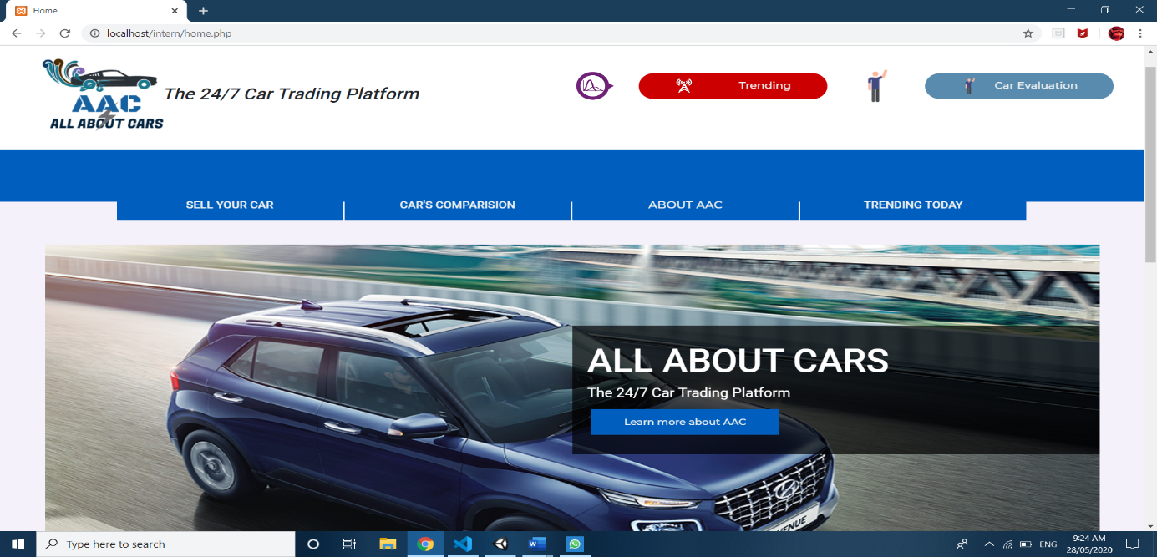**Home Page:**

**Home Page** - The site opens up door to aspiring web users through the Home page. The Home page is designed in such way that the layout is as user friendly as possible. There is a navigational menu at the top of the page which links to various inner pages. There is a category drop down on the left side for easy manipulation. The center area is for displaying latest products in the chorological order.

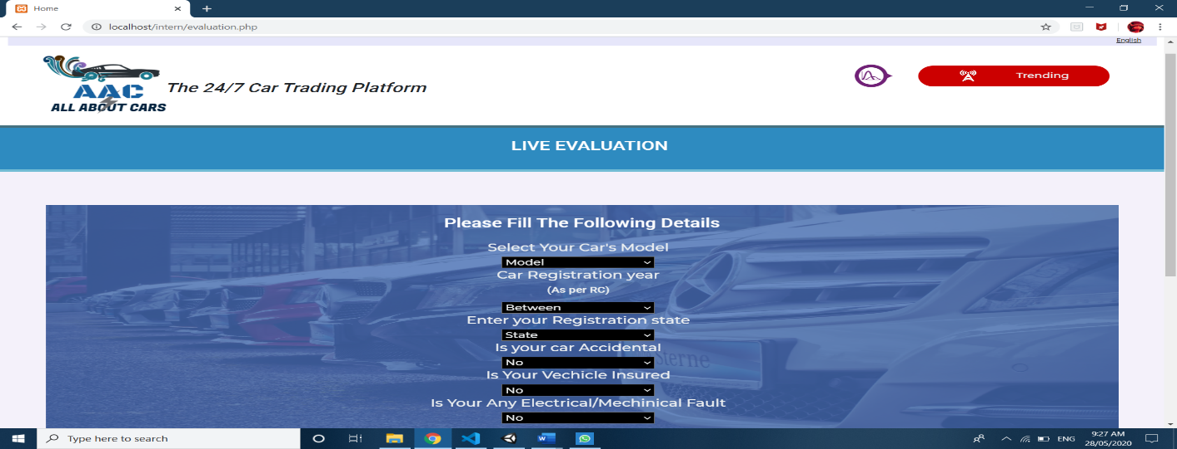**2.Vhicle Evaluation**

**Vehicle Evaluation** - Those who wish to check estimated resale value of their vehicle can easily check it with the help of this module. If they wish they can make an appointment to know the exact resale value. This module is prepared in such a way that user will always get a fair evaluation without any inconvenience.

**3.Trending Today**

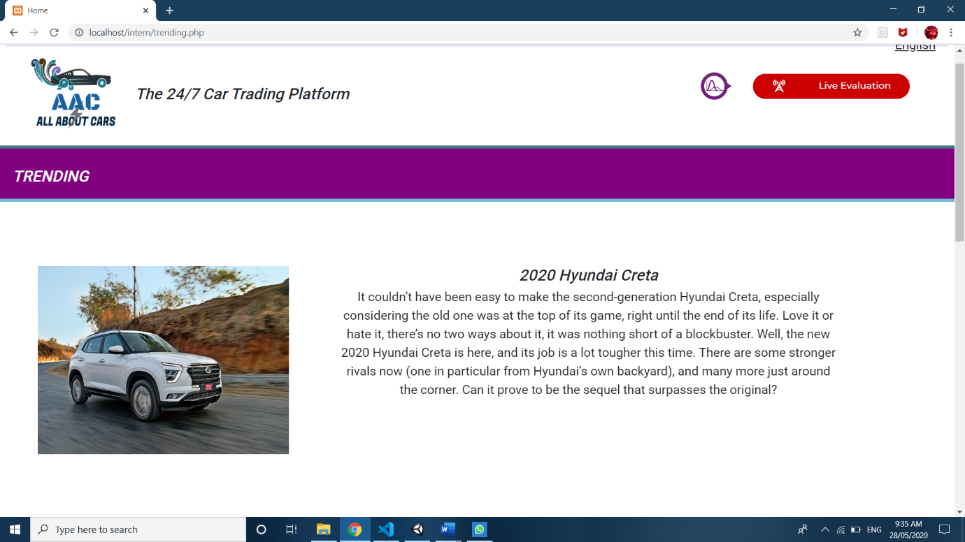

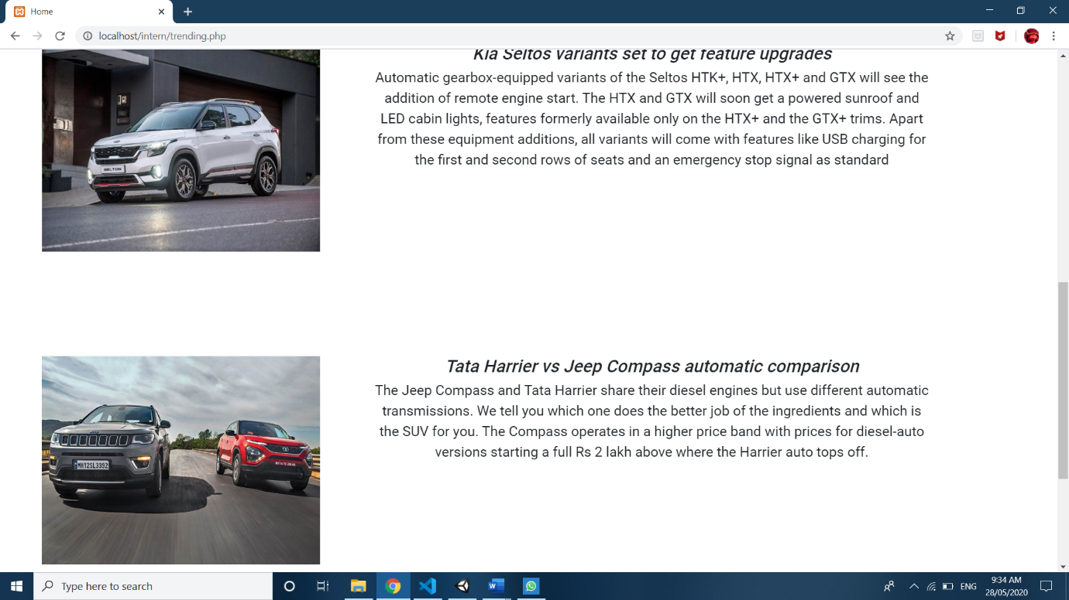**Trending Today-** With the help of this module the user gets daily updates on what is hot in the automobile market. They will get updates on new launches and performances of previous launched automotive.

**Compare**

**Vehicle Comparison-** User can easily compare different vehicles and get to know what is the best deal in the market. It will help users to get great package in minimal prices.

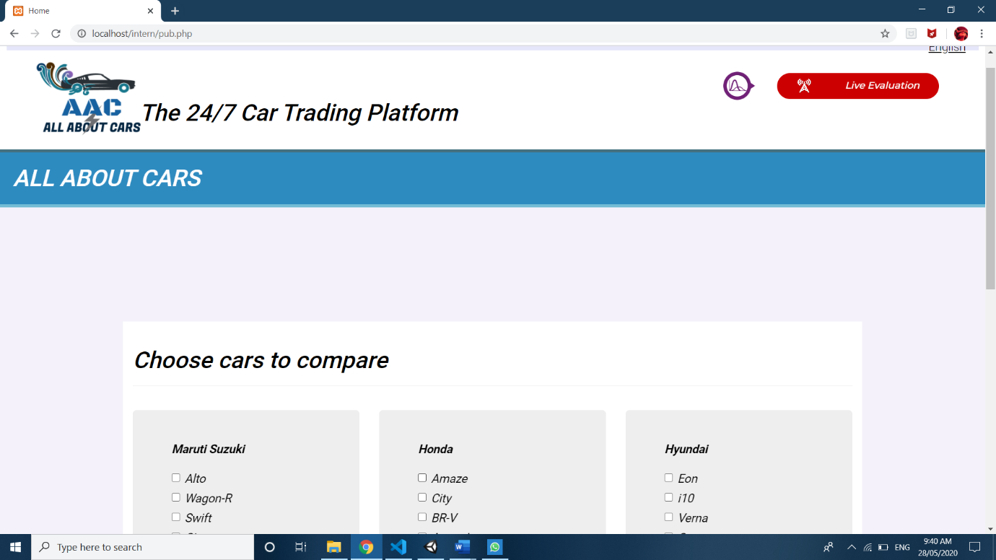

**CONCLUSION**

The project report entitled "ALL ABOUT CARS" has come to its conclusion. The new system has been developed with so much care that it is free of errors and at the same time efficient and less time consuming. System is robust. Also, provision is provided for future developments in the system. The developed system is flexible and changes can be made easily. The system is developed with an insight into the necessary modification that may be required in the future. Hence the system can be maintained successfully without much rework.