**50.012 Networks (2020 Term 6)**

**Homework 4**

Hand-out: 24 Nov

Due: 4 Dec 23:59

Name: _______________ Student ID: ________________

**1.** (Adapted from last year’s final exam) Consider the network in the Figure below (noticed that there is a direct link between node u and z), where the numbers show the symmetrical link costs. Assume a link state routing protocol is used. **Node x** applies Dijkstra’s algorithm to compute the best route to every other node. Step 0 of Dijkstra’s algorithm (i.e., immediately after initialization) is shown below. Write down **all** the rows after step 0 until the algorithm completes.

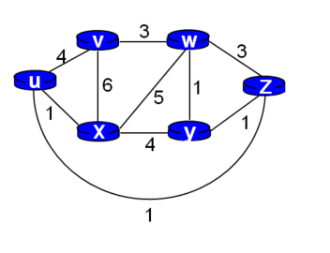

|  |  |  |  |  |  |  |
| --- | --- | --- | --- | --- | --- | --- |
| Step | N’ | D(u), p(u) | D(v), p(v) | D(w), p(w) | D(y), p(y) | D(z), p(z) |
| 0 | x | 1, x | 6, x | 5, x | 4, x | ∞ |
| 1 | x, u |  | 5, u | 5, x | 4, x | 2, u |
| 2 | x, u, z |  | 5, u | 5, x | 3, z |  |
| 3 | x, u, z, y |  | 5, u | 4, y |  |  |
| 4 | x, u, z, y, w |  | 5, u |  |  |  |
| 5 | x, u, z, y, w, v |  |  |  |  |  |

**2**. (textbook chapter 5, problem P11): Consider the network below and suppose that poisoned reverse is used in the distance-vector routing algorithm.

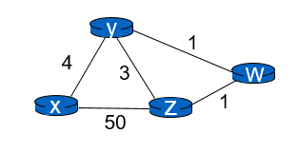

1. When the distance vector routing is stabilized, router w, y, and z inform their distances to x to each other. What distance values do they tell each other?
2. Now suppose that the link cost between x and y increases to 60. Will there be a count-to-infinity problem even if poisoned reverse is used? Why or why not? If there is a count-to-infinity problem, show the first three rounds of message exchanged among w, y, and z and how their DV change.

**Solution template:**

|  |  |
| --- | --- |
|  |  |
| Router z | Informs w, Dz(x)=___ |
|  | Informs y, Dz(x)= ___ |
| Router w | Informs y, Dw(x)= ___ |
|  | Informs z, Dw(x)= ___ |
| Router y | Informs w, Dy(x)= ___ |
|  | Informs z, Dy(x)= ___ |

2. Now suppose that the link cost between x and y increases to 60. Will there be a count-to-infinity problem even if poisoned reverse is used? Why or why not?

If there is a count-to-infinity problem, you can use the following table to fill in the first few iterations.

|  |  |  |  |  |
| --- | --- | --- | --- | --- |
| time | t0 | Round 1 | Round 2 | Round 3 |
| Z |  |  |  |  |
|  |  |  |  |  |
| W |  |  |  |  |
|  |  |  |  |  |
| Y |  |  |  |  |
|  |  |  |  |  |