**50.012 Networks (2020 Term 6)**

**Homework 5**

Hand-out: 4 Dec

Due: 10 Dec 23:59

Name: _______________ Student ID: ________________

**1.** (textbook chapter 5, adapted from problem P14 and P15): Consider the network shown below. Suppose all the four ASes are running **OSPF for their intra-AS routing protocol** and assume the cost for every link in the graph is 1. Suppose **eBGP and iBGP are used for the inter-AS routing protocol**. Initially suppose there is no physical link between AS2 and AS4.

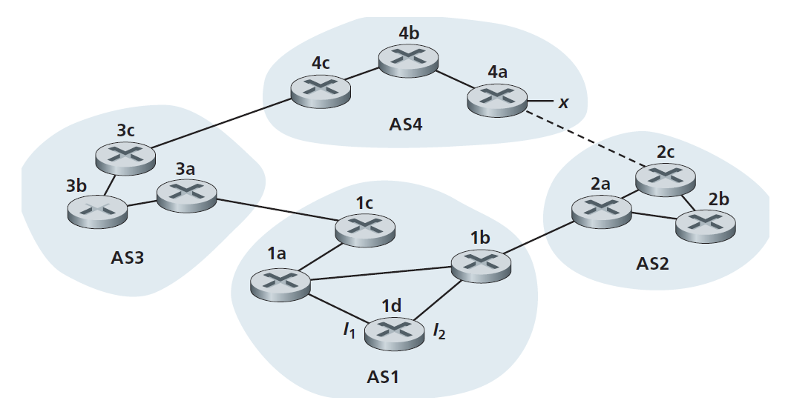

a. Router 3c learns about prefix x from which routing protocol: OSPF, eBGP, or iBGP?

eBGP

b. Router 3a learns about x from which routing protocol?

iBGP

c. Router 1c learns about x from which routing protocol?

eBGP

d. Router 1d learns about x from which routing protocol?

iBGP

e. Once router 1d learns about x it will put an entry (x, I) in its forwarding table. Will I be equal to I1 or I2 for this entry? Explain why in one sentence.

I1. It’s the interface with the shortest path to 1c

f. Now suppose that there is a physical link between AS2 and AS4, shown by the dotted line. Suppose router 1d learns that x is accessible via AS2 as well as via AS3. Will I be set to I1 or I2? Explain why in one sentence.

I2. It’s the interface that is closest to the NEXT-HOP router. (hot potato routing)

g. Now suppose there is another AS, called AS5, which lies on the path between AS2 and AS4 (not shown in diagram). Suppose router 1d learns that x is accessible via AS2 AS5 AS4 as well as via AS3 AS4. Will I be set to I1 or I2? Explain why in one sentence.

I1. Has the shortest AS-PATH

**2.** (textbook chapter 6, adapted from problem P15): Consider the following network:

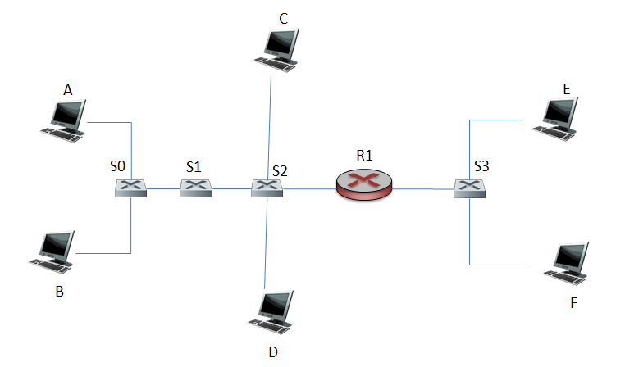

Where S0, S1, S2, and S3 are switches and R1 is a router. Note that the hosts at different side of R1 belong to different subnets.

a. Consider sending an IP datagram from Host E to Host F. Will Host E ask router R1 to help forward the datagram? Why? In the Ethernet frame containing the IP datagram, what are the source and destination IP and MAC addresses?

No. Because Host E and Host F are in the same subnet.  
Source IP and MAC address are E’s IP address and MAC address  
Destination IP and MAC address are F’s IP address and MAC address

b. Suppose host E would like to send an IP datagram to host B, and assume that E’s ARP cache does not contain B’s MAC address. Will E perform an ARP query to find B’s MAC address? Why? In the Ethernet frame (containing the IP datagram destined to B) that is delivered to router R1, what are the source and destination IP and MAC addresses?

No. Not in the same LAN.  
Source IP and MAC address are E’s IP address and MAC address  
Destination IP is B’s IP address, MAC address is R1’s interface connected to S3.

c. Suppose Host A would like to send an IP datagram to Host B, and neither A’s ARP cache contains B’s MAC address nor does B’s ARP cache contain A’s MAC address. Further suppose that the switch S1’s forwarding table contains entries for Host B and router R1 only. Thus, A will broadcast an ARP request message. What actions will switch S1 perform once it receives the ARP request message? Will router R1 also receive this ARP request message? If so, will R1 forward the message? Once Host B receives this ARP request message, it will send back to Host A an ARP response message. But will it send an ARP query message to ask for A’s MAC address? Why? Will switch S1 receive the ARP response message from Host B?

S1 will broadcast the ARP.  
Yes. No, it won’t.   
No, the broadcasted message will contain A’s MAC address.  
Yes.