1. 1s
2. Expected It to increase over time
3. Ping RTT kept increasing
4. Since it is parallel and streaming was taking up bandwidth, downloading was slower
5. 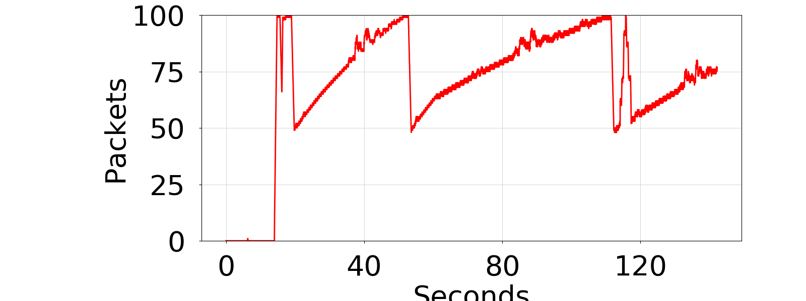   
   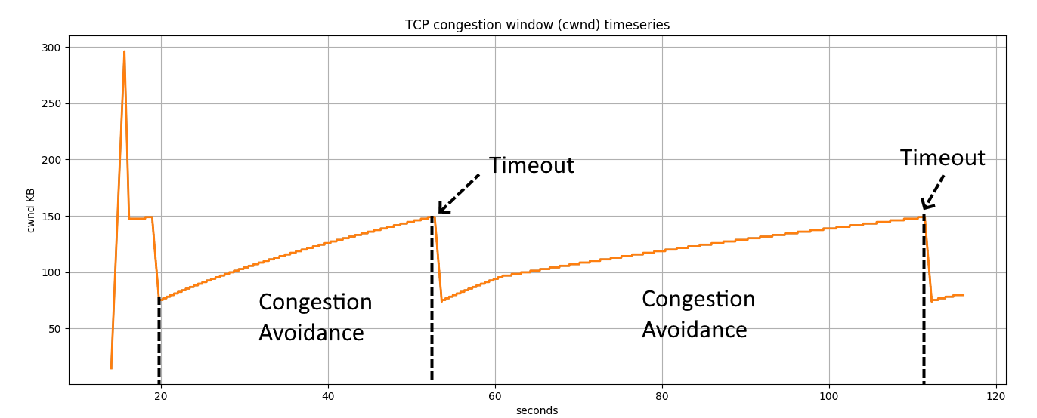  
   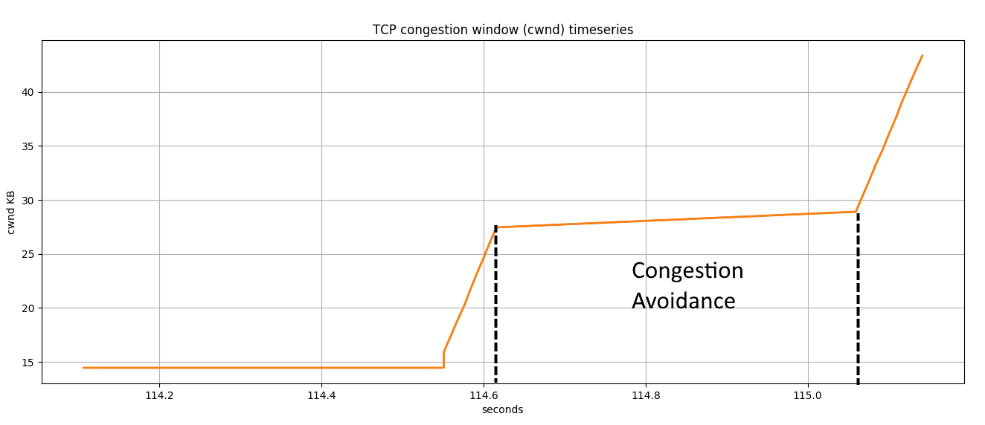  
   Started with slow-start, had some packet loss event and stuck to congestion avoidance after slow-start.

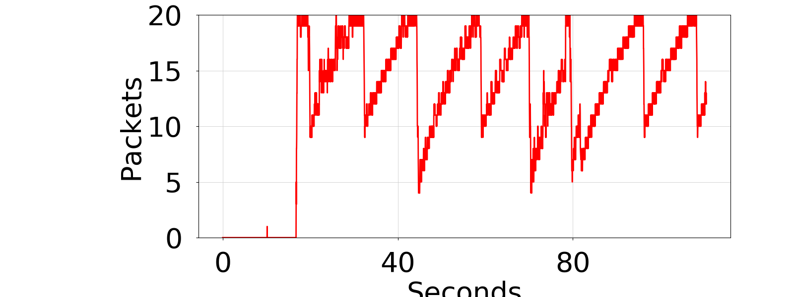

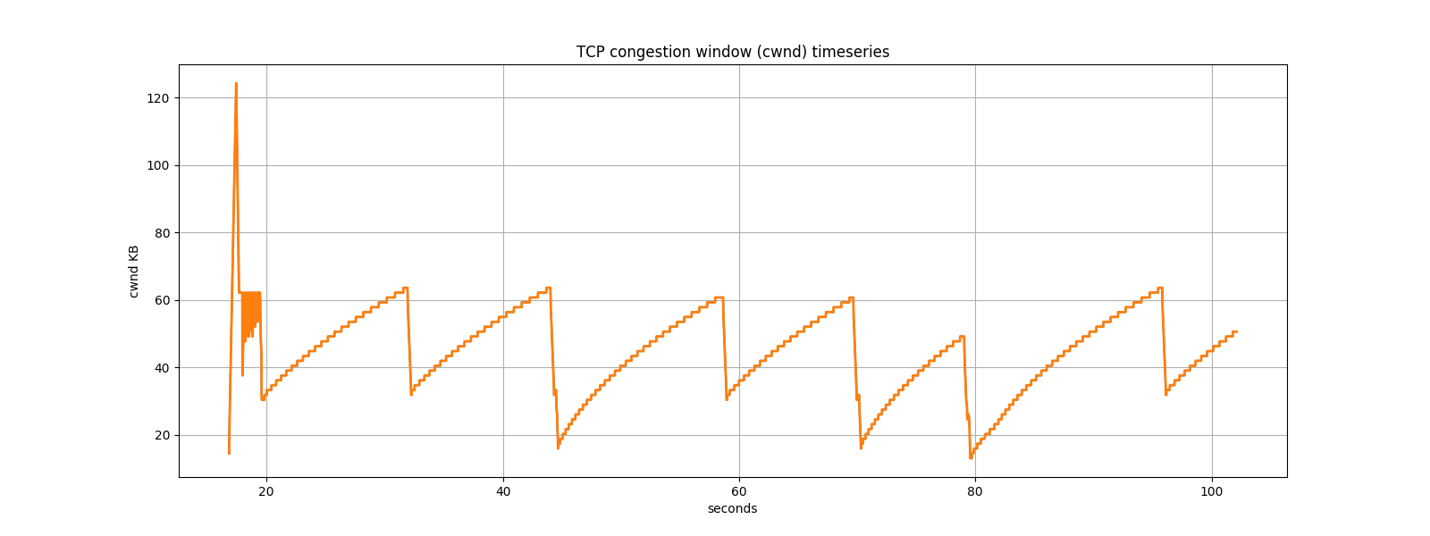

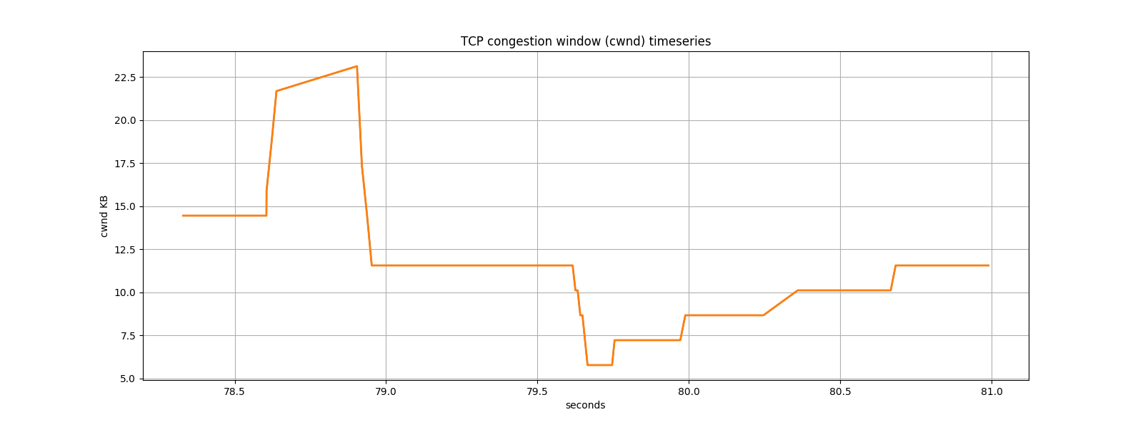

Same as previous, slow-start then congestion avoidance. Seems to have a lot more packet lost event compared to when queue length was larger. Most likely caused by packet overflow.