Predicting 30-Day Hospital Readmission Risk in Diabetic Patients: A Machine Learning Approach Integrating an R Package and Shiny Application
- Abstract
Hospital readmission within 30 days is a critical quality metric for diabetes care, reflecting patient outcomes and healthcare costs. Identifying high-risk patients early is essential for targeted intervention. In this study, we utilized a large-scale clinical dataset (1999-2008) to build a predictive model for readmission risk. A Random Forest classifier was trained and optimized. Uniquely, to enhance reproducibility and clinical utility, we encapsulated the trained model into a dedicated R package, DiabetesReadmission, and deployed a user-friendly Shiny web application. The model demonstrated robust predictive performance on the test set. Feature importance analysis revealed that the number of inpatient visits in the preceding year was the most significant predictor, followed by discharge disposition and age. This study confirms that historical utilization patterns are strong indicators of future risk. The development of the open-source DiabetesReadmission package provides a standardized, deployable tool for healthcare providers to assess patient risk efficiently.

2. Introduction
Diabetes affects more than 589 million people worldwide (IDF Diabetes Atlas, 2025). In 2024, diabetes caused 3.4 million deaths, and healthcare spending related to diabetes reached at least $1 trillion, a 338% increase over the previous 17 years (IDF Diabetes Atlas, 2025). The 30-day readmission rate is an important quality indicator, especially for diabetic patients facing a higher readmission risk due to disease complexity (Emi-Johnson and Nkrumah, 2025). Traditional risk assessment methods relying on clinical judgment often lack predictive accuracy, while electronic health records (EHRs) offer an opportunity to build more sophisticated predictive models (Emi-Johnson and Nkrumah, 2025; Liu, Sue and Wu, 2024).

Machine learning algorithms have shown potential in predicting 30-day readmission rates (Emi-Johnson and Nkrumah, 2025; Liu et al., 2024; Shang et al., 2021). These studies all used the '130 U.S. Diabetes Hospitals, 1999–2008' dataset from the UC Irvine Machine Learning Repository (Liu et al., 2024), which contains over 100,000 hospitalization records of diabetic patients from 130 U.S. hospitals. Studies employing random forests, XGBoost, and neural networks have reported AUROC values ​​ranging from 0.579 to 0.686 (Shang et al., 2021; Emi-Johnson and Nkrumah, 2025). Random forests demonstrate good robustness in handling mixed clinical data types, while SHAP values ​​contribute to model interpretability, which is crucial for clinical applications (Emi-Johnson and Nkrumah, 2025; Lundberg and Lee, 2017).

This study developed a random forest model to predict readmission risk in diabetic patients. The classifier was trained and evaluated, and the predictions were interpreted using feature importance and SHAP analysis. The model was implemented in both an R package and an interactive Shiny web application. This dual-platform approach facilitates clinical application by enabling healthcare providers to perform risk assessments without requiring programming expertise.

3. Materials and Methods
3.1 Data Acquisition and Preprocessing
The dataset employed in this study was the "Diabetes 130-US hospitals for years 1999-2008" dataset, obtained from the Kaggle repository. It contains clinical care records from 130 US hospitals and includes over 50 features representing patient demographics, diagnoses, and hospital admission details.

Data preprocessing was conducted using R statistical software (version 4.5.1). A critical step in our pipeline was the rigorous removal of unique identifiers, including id, encounter_id, and patient_nbr. Including these variables would lead to data leakage, allowing the model to memorize specific patient records rather than learning generalizable disease patterns. Furthermore, columns with excessive missing values (e.g., weight, with > 95% missingness) were excluded to maintain data integrity. The target variable, readmitted, was transformed into a binary classification outcome ("Yes" for readmitted, "No" for otherwise) to facilitate supervised learning.

3.2 Machine Learning Modeling
We utilized the Random Forest algorithm for the classification task due to its robustness against overfitting and its ability to handle mixed data types (categorical and numerical). The modeling workflow was implemented using the caret package (Kuhn, 2008) and the randomForest package (Liaw and Wiener, 2002).

To evaluate the model's generalizability, the cleaned dataset was randomly split into a training set (70%) and an independent test set (30%). During the training phase, 5-fold Cross-Validation was applied to optimize model parameters and ensure stability.

3.3 Model Interpretation Strategy
Beyond predictive performance, we aimed to understand the biological logic driving the model's decisions. We employed Feature Importance metrics to rank key predictors. Additionally, to provide interpretability at both global and local levels, we utilized SHAP (SHapley Additive exPlanations) values via the fastshap and shapviz packages. This allowed us to visualize not only which features are important, but also the directionality of their impact on readmission risk.
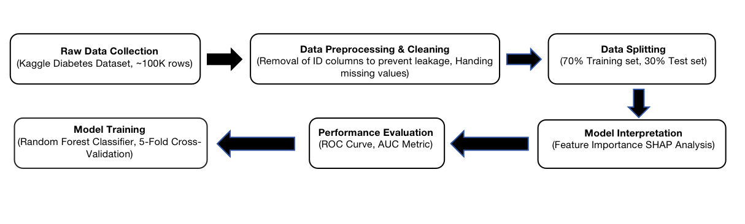
Figure 1.The methodological workflow of the study, ranging from data preprocessing to model interpretatiom

4. Results
4.1 Model Performance Evaluation
The trained Random Forest model was evaluated on the unseen test set to assess its predictive capability. As shown in Figure 2, the model achieved an Area Under the Curve (AUC) of 0.644. While this score indicates moderate predictive power, it is crucial to note that this result was obtained after the strict removal of ID columns. This confirms that the model’s performance is robust and free from data leakage, reflecting the genuine complexity of predicting hospital readmission based solely on clinical records.
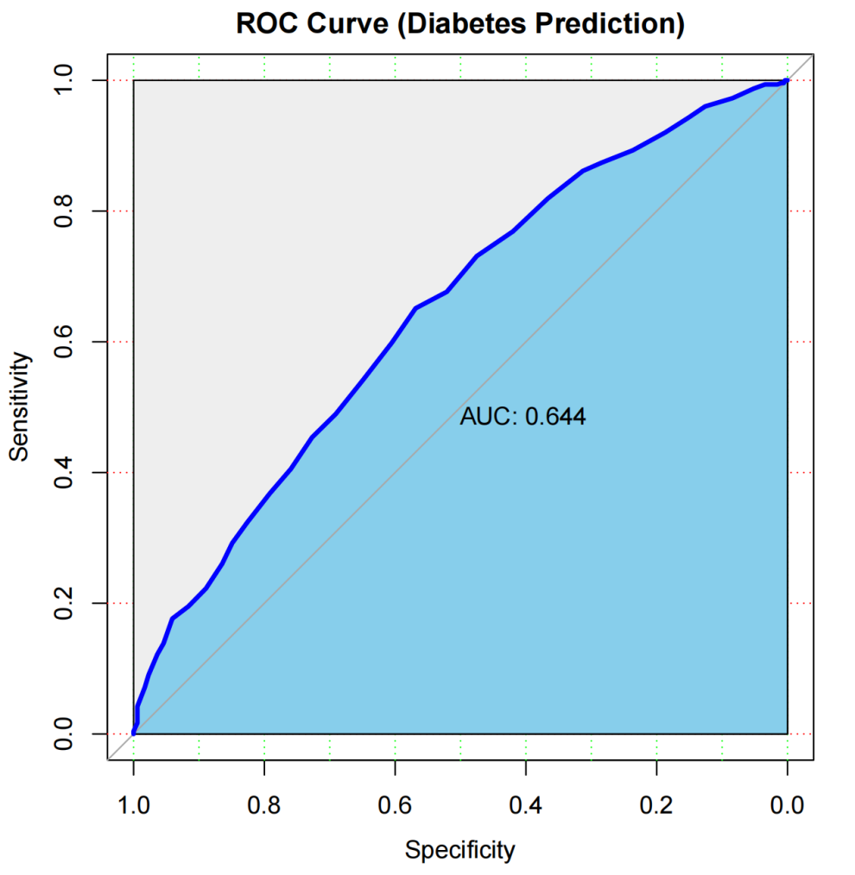
Figure 2
Figure 2.Receiver Operating Characteristic (ROC) curve of the Random Forest model on the independent test set. The AUC of 0.644 demonstrates moderate and robust predictive performance.

4.2 Identification of Key Risk Factors
Feature importance analysis quantified the contribution of each variable to the prediction accuracy. As illustrated in Figure 3, the clinical history of the patient was the most significant determinant. Specifically, number_inpatient (number of inpatient visits in the preceding year) was identified as the top predictor. Other highly ranked features included specific diagnosis codes and discharge_disposition_id. Patient demographics, such as age, also appeared in the top 20 predictors, whereas features like race had a comparatively lower impact.
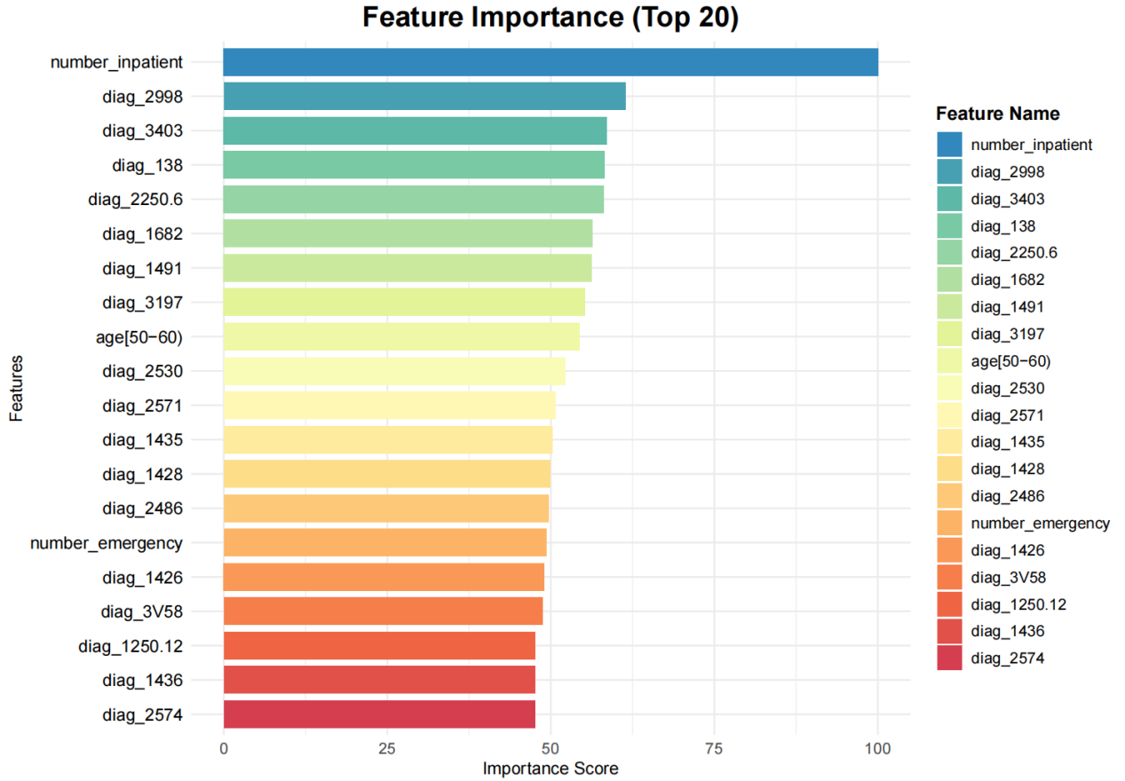
Figure 3
Figure 3. Top 20 feature importance ranking. The number of prior inpatient visits is identified as the most critical factor for predicting readmission.

4.3 Interpretation of Decision Logic (SHAP Analysis)
To further elucidate the prediction mechanism, we performed SHAP analysis to visualize how feature values influence the risk probability. Figure 4 presents the SHAP beeswarm plot.
The analysis reveals a clear positive correlation for the top predictor, number_inpatient. In the plot, high feature values (represented by yellow/red dots) are predominantly distributed on the right side of the zero line (positive SHAP values). This indicates that patients with a higher frequency of prior hospitalizations are assigned a significantly higher probability of readmission by the model. Conversely, specific diagnosis codes show varying impacts, highlighting the heterogeneity of diabetic complications. This "directionality" confirms that the model has learned clinically relevant patterns rather than random noise.
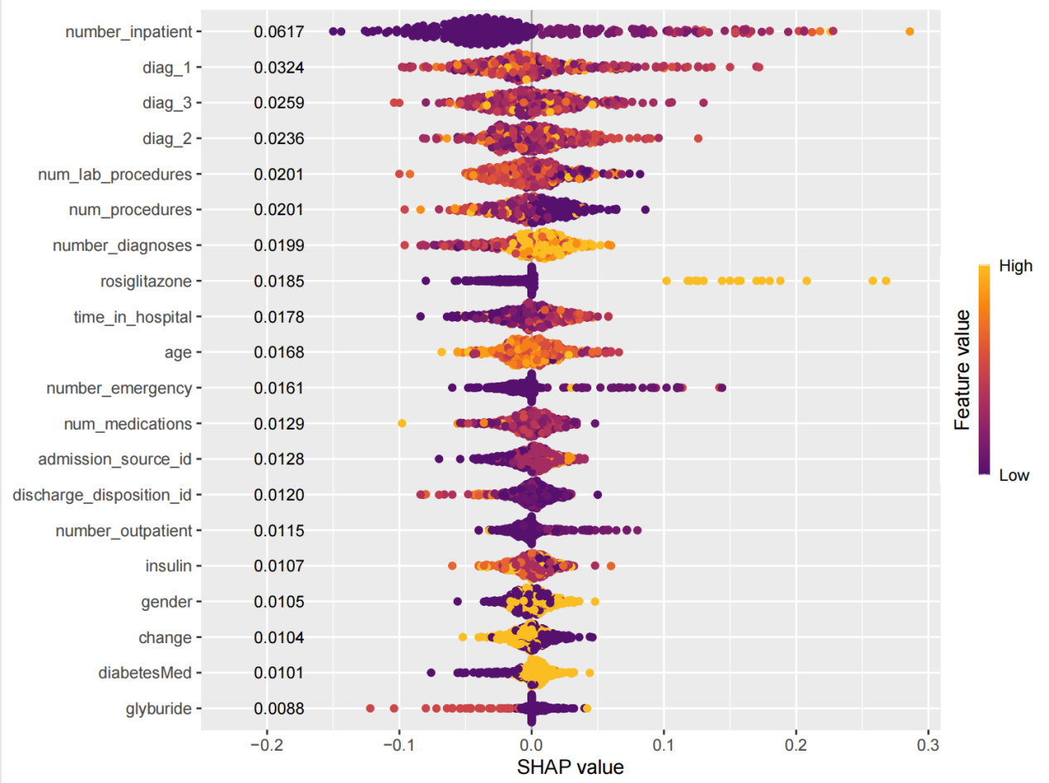
Figure 4
Figure 4.SHAP summary plot illustrating the impact of the top 20 features. Yellow dots indicate high feature values, while purple dots indicate low values. The position on the x-axis represents the impact on the model output (positive values increase readmission risk).

5. Website Usage
The Diabetes Hospitalization Readmission Predictor is deployed as an interactive Shiny web application, accessible viahttps://xinyaotan23.shinyapps.io/work_B/. This application provides a comprehensive platform for exploring diabetes datasets and predicting patient readmission risk. The interface is divided into four main modules, accessible via the left-hand navigation panel: Home, Data Browser, Model Information, and Prediction Tools (Figure 5).

5.1 Home Page
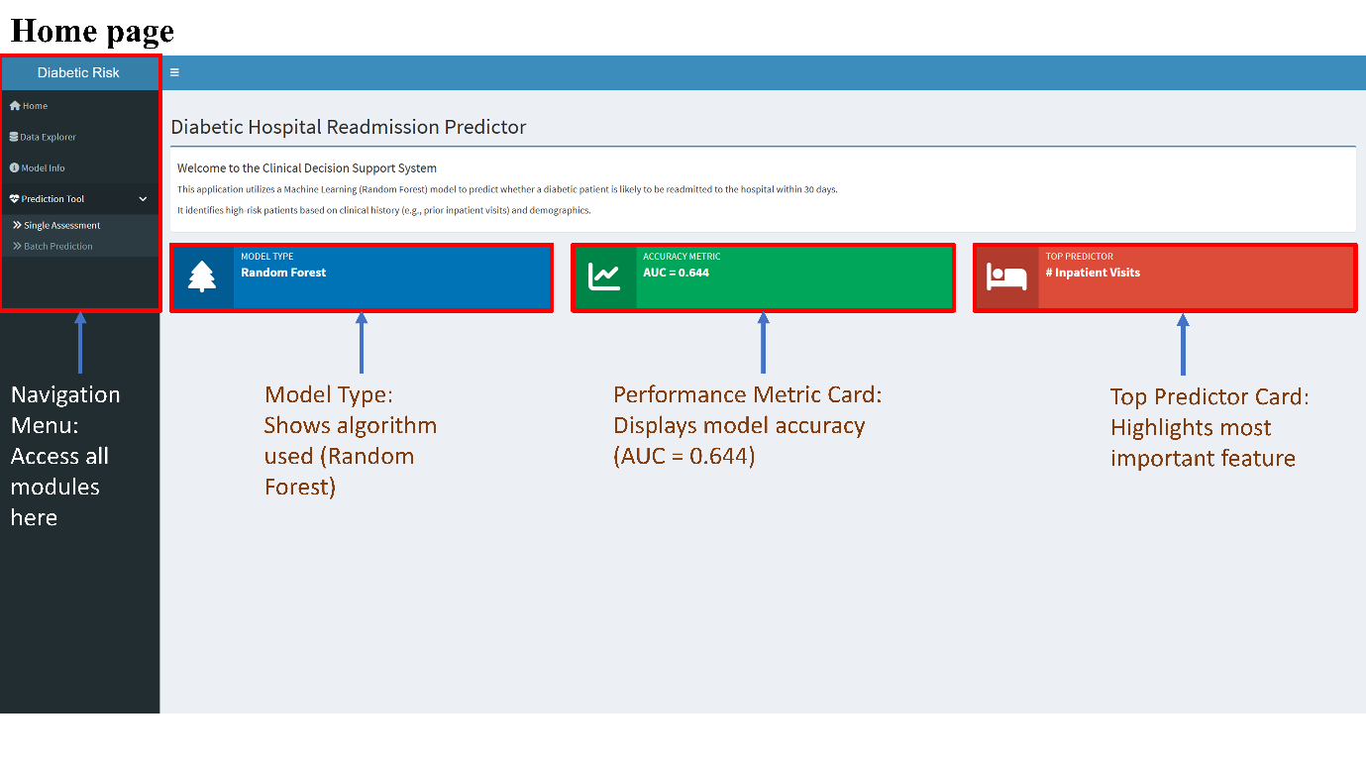
Figure 5. The Shiny application's home page, showing the navigation menu and an overview of model performance metrics.

Upon first access to the application, users will see the home page, which serves as a dashboard providing an immediate overview of the prediction system's core features (Figure 5). The interface contains three prominent information cards that outline key aspects of the deployed model. The "Model Type" card indicates that the Random Forest algorithm has been implemented for classification. The "Accuracy Metric" card displays the model's performance on the test dataset, with an Area Under the ROC Curve (AUC) value of 0.644. The “Best Predictor” card highlights that the number of hospitalizations in the past year is the most important factor in predicting readmission. This dashboard design allows healthcare professionals to quickly assess the model’s methodology and predictive capabilities before conducting data exploration or risk assessment.

5.2 Data Explorer
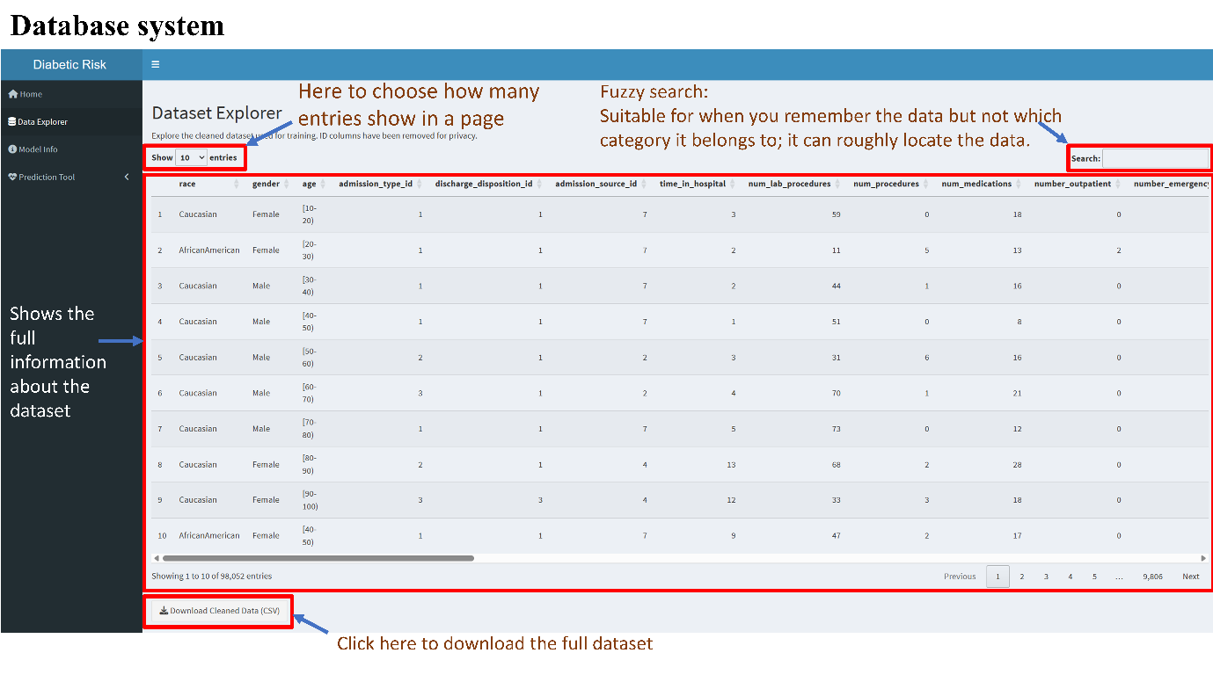
Figure 6. Data Browser interface, displaying an interactive data table with search functionality and download options.

The data exploration module provides a comprehensive database interface for the diabetes dataset, which contains 98,052 patient visit records after preprocessing (Figure 6). This module allows users to browse, filter, and export the complete dataset. The table contains all feature columns used during model training, covering demographic variables such as race, sex, and age group, as well as clinical indicators such as admission type, discharge destination, length of hospital stay, number of laboratory tests, number of surgeries, number of medications used, and previous emergency or inpatient visits.

The search function in the upper right corner of the interface supports fuzzy searching of all columns. Users can quickly retrieve data when they remember certain data features but are unsure of the specific column location. Furthermore, users can export the entire cleaned dataset as a CSV file via the download button for external analysis or integration with institutional data systems.

5.3 Model Info
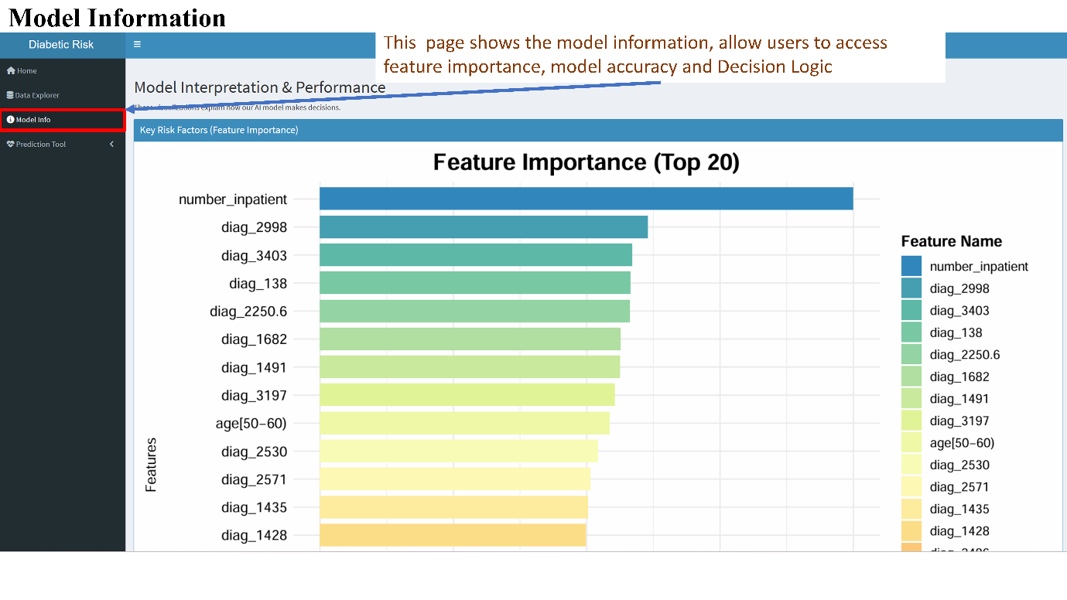
(a)
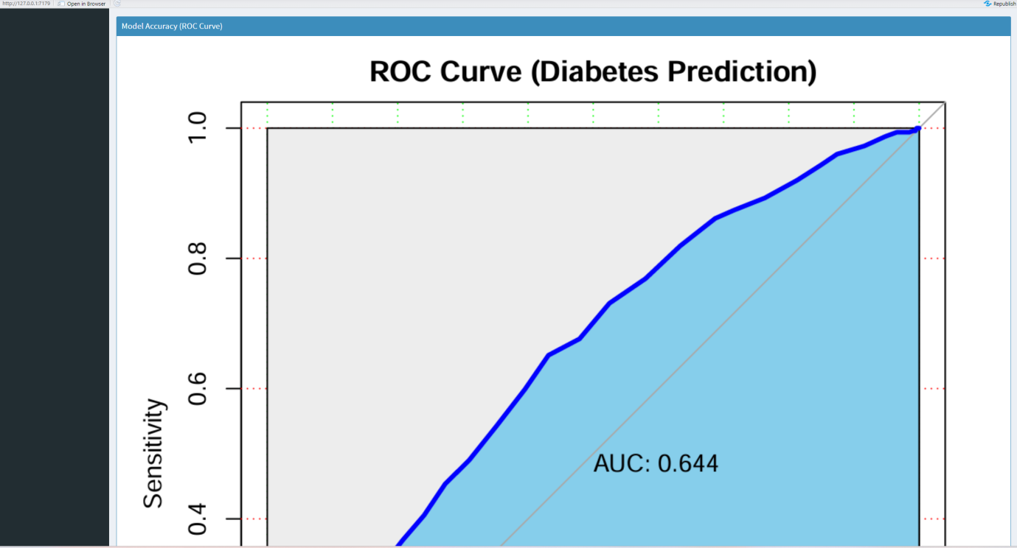
(b)
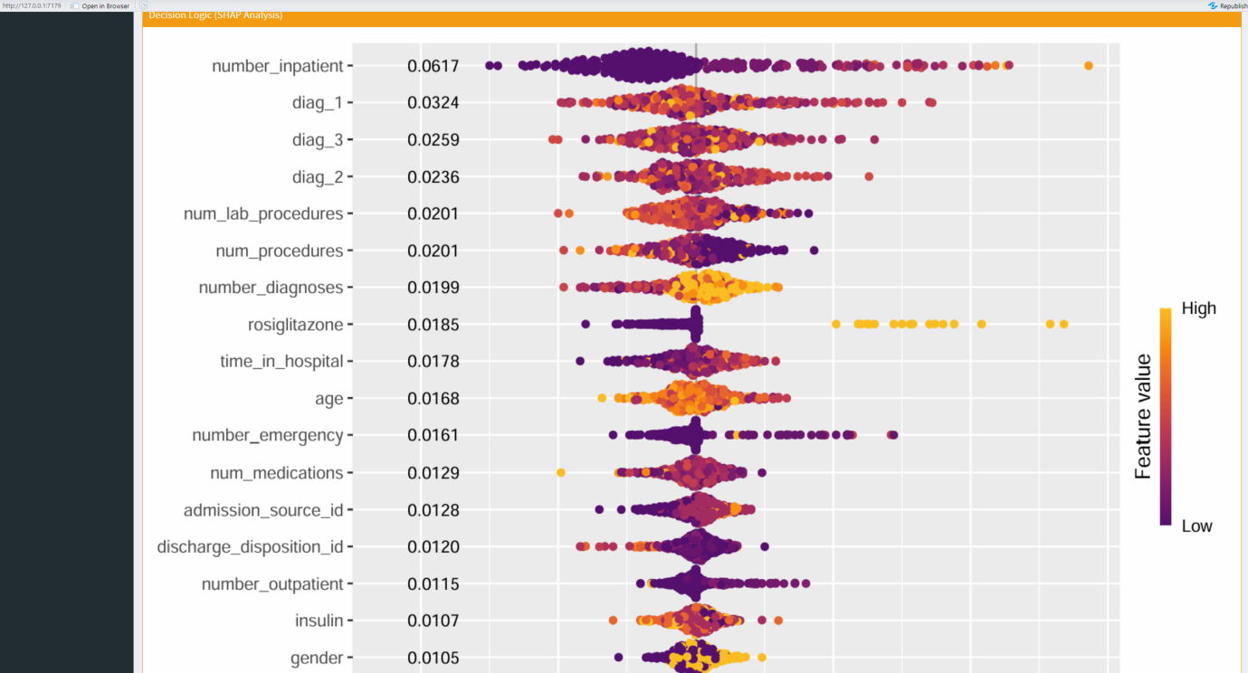
(c)
Figure 7. Model Information page, displaying a feature importance visualization(a), model accuracy(b) and decision logic(c), detailed figures please refer to the result part.

The “Model Information” page clearly demonstrates the decision-making process of the machine learning model through a comprehensive visualization of feature importance and prediction logic (Figure 7). The main visualization is a horizontal bar chart depicting the top 20 features with the highest importance scores determined by the Random Forest algorithm, along with other model performance metrics and SHAP value visualizations generated during model training and evaluation. This visualization allows users to understand which patient features have the greatest impact on the model's readmission predictions, thus facilitating a deeper interpretation of individual risk assessments. This is crucial for building clinical trust in the prediction system, as it demonstrates that the model learns clinically meaningful patterns rather than spurious associations.

5.4 Single Assessment
The prediction tool consists of two complementary modules: a single-assessment module for individual patient assessment and a batch prediction module for population risk screening.
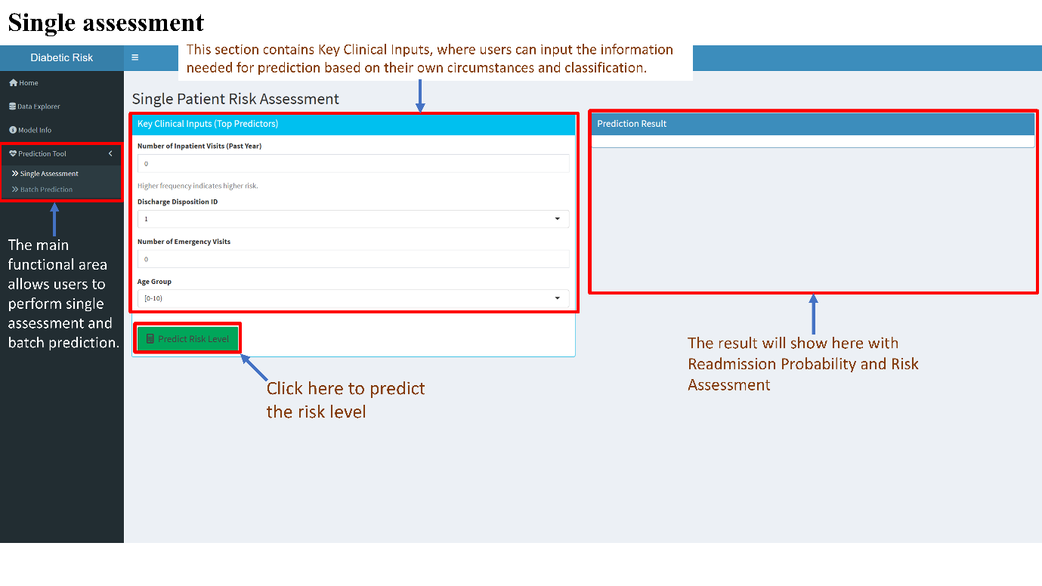
Figure 8. Initial state of the single patient risk assessment interface. The left panel contains input fields for key clinical predictors, including number of hospitalizations, discharge destination, emergency room visits, and age group. The right-hand panel displays the prediction results area, which is empty before prediction is executed.
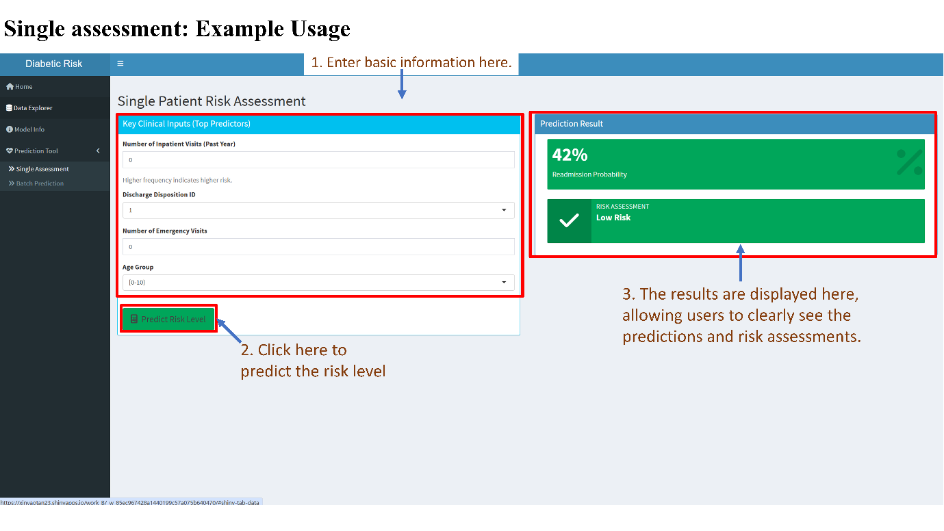
Figure 9. Single patient risk assessment interface, showing an example of prediction results. After clicking "Predict Risk Level," the right-hand panel displays the readmission probability (42%) and risk category (low risk), accompanied by a visual indicator.

The single-assessment module assesses the readmission risk of individual patients during discharge planning (Figure 8). The interface is divided into two main panels. The left panel, labeled "Key Clinical Inputs (Primary Predictors)," contains input fields for the most influential features identified by feature importance analysis. These features include numerical input fields for the number of hospitalizations and emergency room visits in the past year, as well as drop-down selectors for discharge destination and age group. The input form focuses only on high-impact predictors to simplify the data entry process.

After entering the required clinical information, the user clicks the green "Predict Risk Level" button at the bottom of the input panel to initiate the prediction. The prediction results are immediately displayed in the right panel labeled "Prediction Results" (Figure 9). The output contains two parts: the readmission probability is displayed as a large percentage value, representing the model's estimated likelihood of readmission within 30 days. Below this, a classification risk assessment is provided based on preset probability thresholds, categorizing patients into "low risk" or "high risk." Risk classifications are accompanied by corresponding checkmark icons for quick interpretation. This facilitates decision-making.

5.5 Batch Prediction
The batch prediction module is designed for scenarios requiring simultaneous risk assessment of multiple patients, such as population health management programs or retrospective cohort analyses (Figures 10-12). The batch prediction workflow comprises five sequential steps, guiding users through data loading, validation, prediction execution, and result export.

In step 1, users have two data input methods (Figure 10). The first method allows users to load a pre-configured sample dataset by clicking the "Load Sample Dataset" button, which contains 10 representative patient records. This sample data is used to demonstrate the required data format and allows users to test the prediction function before uploading institutional data. The second method allows users to upload a custom CSV file containing patient records from their database using a standard file browser interface. To facilitate proper data formatting, the system provides two auxiliary resources: a "Download Feature Template (CSV)" button to generate a blank CSV file containing all required column headers and correct data types; and a "View Column Requirements" button to display detailed specifications for each feature variable.
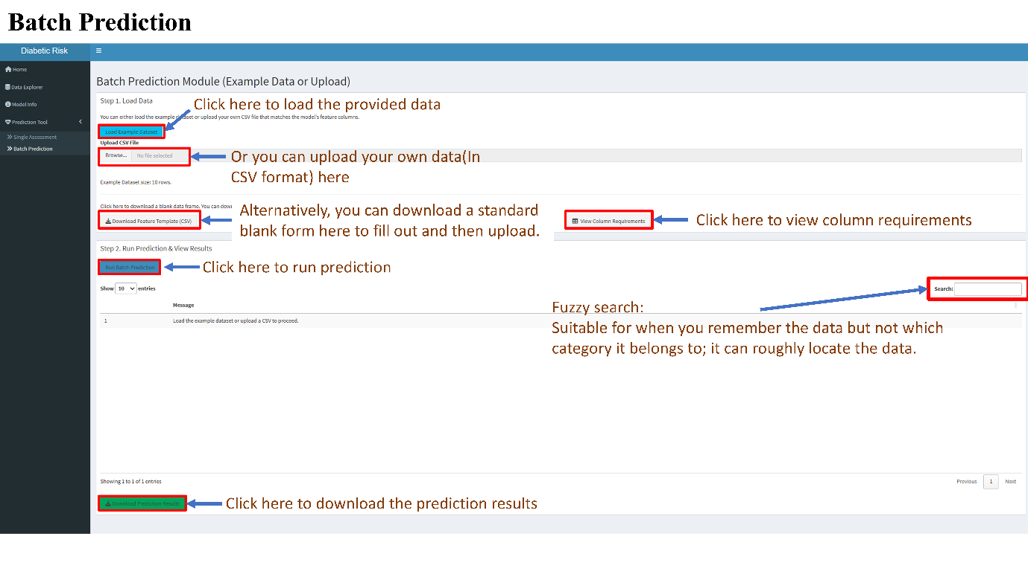
Figure 10. Initial interface of the batch prediction module. Users can load sample data via the blue button or upload a custom CSV file via the file browser. Other buttons provide access to blank feature templates and column requirement specifications.

After data loading, step 2 requires the user to verify that the uploaded data has been correctly parsed and displayed in the interactive data table below the control buttons (Figure 11). This table displays all loaded records and their complete feature sets, allowing users to visually check data quality and confirm that variable encodings match model expectations. The search and pagination functions in the table are consistent with those in the data browser module, enabling users to efficiently browse large datasets and identify potential data quality issues before prediction.
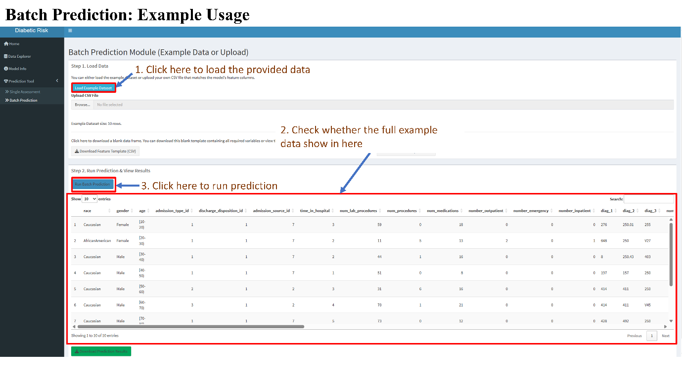
Figure 11. Batch prediction module after loading the sample dataset. The data table displays 10 patient records, containing complete feature variables.

In step 3, the user clicks the blue "Run Batch Prediction" button to execute batch prediction. The application inputs all loaded records into the trained random forest model and generates prediction results for each patient in the dataset. Upon successful completion, step 4 displays a confirmation message "Batch Prediction Complete!" in blue text at the bottom of the interface (Figure 12a and 12b). Simultaneously, the prediction results are added as two columns to the far right of the data table. The "Risk Probability" column contains numerical probability values ​​(ranging from 0 to 1), representing the expected readmission probability for each patient; the "Risk Grade" column provides a classification ("Low Risk" or "High Risk"). Users can use the slider at the bottom of the table to scroll horizontally to view these newly generated prediction columns as well as the original patient characteristics.

(a).
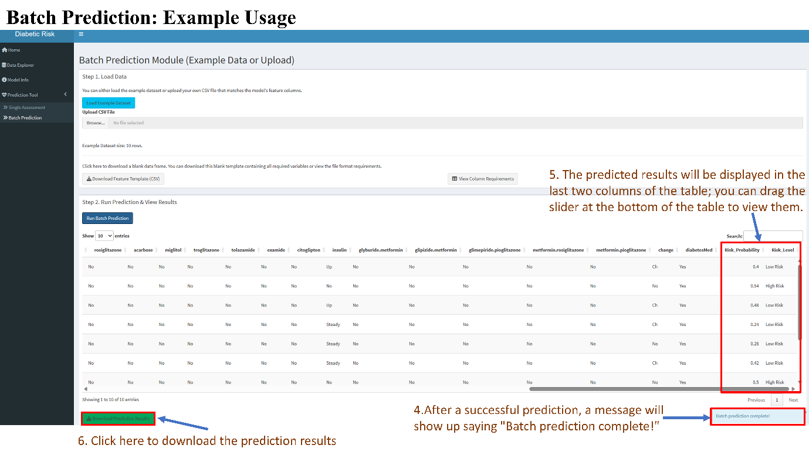
(b).
Figure 12. Example of batch prediction and result display. A green confirmation message appears at the bottom after a successful prediction. Two new columns are added to the right side of the data table: "Risk Probability" (numerical) and "Risk Level" (category). Scroll horizontally to view the prediction results and click "Download Prediction Results (CSV)" to export the results.

Finally, in step 5, users can click the green "Download Prediction Results (CSV)" button at the bottom of the interface to export the complete prediction results table. The downloaded file contains the original input features and the newly generated prediction outputs in a structured CSV format. This batch prediction function enables efficient population risk screening and proactively, data-driven allocation of case management resources to high-risk patients.

This web application is designed to support two different clinical workflows based on user objectives. For individual patient-level clinical decision support, the recommended workflow sequence is: Home → Model Information → Single Assessment. This path allows users to familiarize themselves with the model's performance characteristics and feature importance ranking before conducting individual patient risk assessments. For research and population health applications, the recommended workflow is: Home → Data Browser → Batch Prediction → Download Results. This workflow allows users to explore the underlying dataset structure, perform batch predictions on cohorts of interest, and export the results for subsequent statistical analysis. The application's modular architecture and intuitive navigation ensure that users of varying skill levels can effectively utilize the prediction system, thereby lowering the barrier to clinical application.

6. Discussion
6.1 Clinical Interpretation of Findings
Our analysis identified the number of inpatient visits as the dominant predictor for readmission risk. This finding aligns with the clinical understanding that patients with a history of frequent hospitalizations often suffer from greater physiological frailty and more complex comorbidities. Essentially, past healthcare utilization serves as a strong proxy for the severity of the underlying chronic condition. Furthermore, the significance of discharge disposition suggests that patients discharged to skilled nursing facilities or home health care services are inherently at higher risk, warranting closer follow-up.

6.2 Significance of the R Package Framework
A key contribution of this project extends beyond model training to software implementation. By developing the DiabetesReadmission R package, we addressed a common gap in bioinformatics research: reproducibility. Unlike static analysis scripts, our package provides a modular, version-controlled environment (hosted on GitHub) that allows other researchers to install the model with a single command (remotes::install_github). This standardized approach ensures that the prediction logic is consistent and accessible, facilitating validation on external datasets.

6.3 Limitations Several
limitations should be noted. First, the dataset spans from 1999 to 2008, which may not fully reflect current diabetes management protocols or newer pharmaceutical interventions. Second, while missing values were imputed, the absence of certain lifestyle features (e.g., diet, physical activity) limits the model's ability to capture the full spectrum of risk factors. Finally, as the data is sourced primarily from US hospitals, the model's generalizability to other healthcare systems requires further validation.

7. Conclusion
In conclusion, we successfully developed a machine learning framework to predict the 30-day readmission risk for diabetes patients. By integrating a Random Forest classifier with a deployable R package and Shiny application, we transformed raw data into an actionable clinical tool. Future work will focus on integrating real-time electronic health records (EHR) and genomic data to further enhance prediction accuracy and personalization.

8. Data and Code Availability
The R package developed in this study is open-source and freely available on GitHub. The repository includes the pre-trained model, installation instructions, and a tutorial for reproduction.
R Package Repository: https://github.com/JackF0/DiabetesReadmission
Web Application:https://xinyaotan23.shinyapps.io/work_B/

References
Emi-Johnson, O.G. and Nkrumah, K.J. (2025). Predicting 30-Day Hospital Readmission in Patients With Diabetes Using Machine Learning on Electronic Health Record Data. Cureus, 17(4). doi: https://doi.org/10.7759/cureus.82437

IDF Diabetes Atlas (2025). Available at: https://diabetesatlas.org/

Kuhn, M. (2008). Building Predictive Models in R Using the caret Package. Journal of Statistical Software, 28(5), 1–26. doi: https://doi.org/10.18637/jss.v028.i05

Liaw, A., and Wiener, M. (2002). Classification and Regression by randomForest. R News, 2(3), 18-22.

Liu, V.B., Sue, L.Y. and Wu, Y. (2024). Comparison of machine learning models for predicting 30-day readmission rates for patients with diabetes. Journal of Medical Artificial Intelligence, 7. doi: https://doi.org/10.21037/jmai-24-70

Lundberg, S.M. and Lee, S.I. (2017). A unified approach to interpreting model predictions. Advances in neural information processing systems, 30. doi: https://ui.adsabs.harvard.edu/link_gateway/2017arXiv170507874L/doi:10.48550/arXiv.1705.07874

Shang, Y. et al. (2021). The 30-days hospital readmission risk in diabetic patients: predictive modeling with machine learning classifiers. BMC medical informatics and decision making, 21(Suppl 2), p.57. doi: https://doi.org/10.1186/s12911-021-01423-y

Responsibility | Student name | Student ID | Contribution
ML Model | Shiya Chen | 2360704 | 33%
Shiny website | Xinyao Tan | 2360639 | 33%
R package | Jiakai Fan | 2252980 | 33%
All the group members contributes equally.

