**If you are connecting from off campus, please first establish an SSL connection via** [**https://ssl.binghamton.edu**](https://ssl.binghamton.edu/)

**Go to above link.**

1. **Login with your PODS username and password.**
2. **Download Pulse Secure for appropriate OS.**

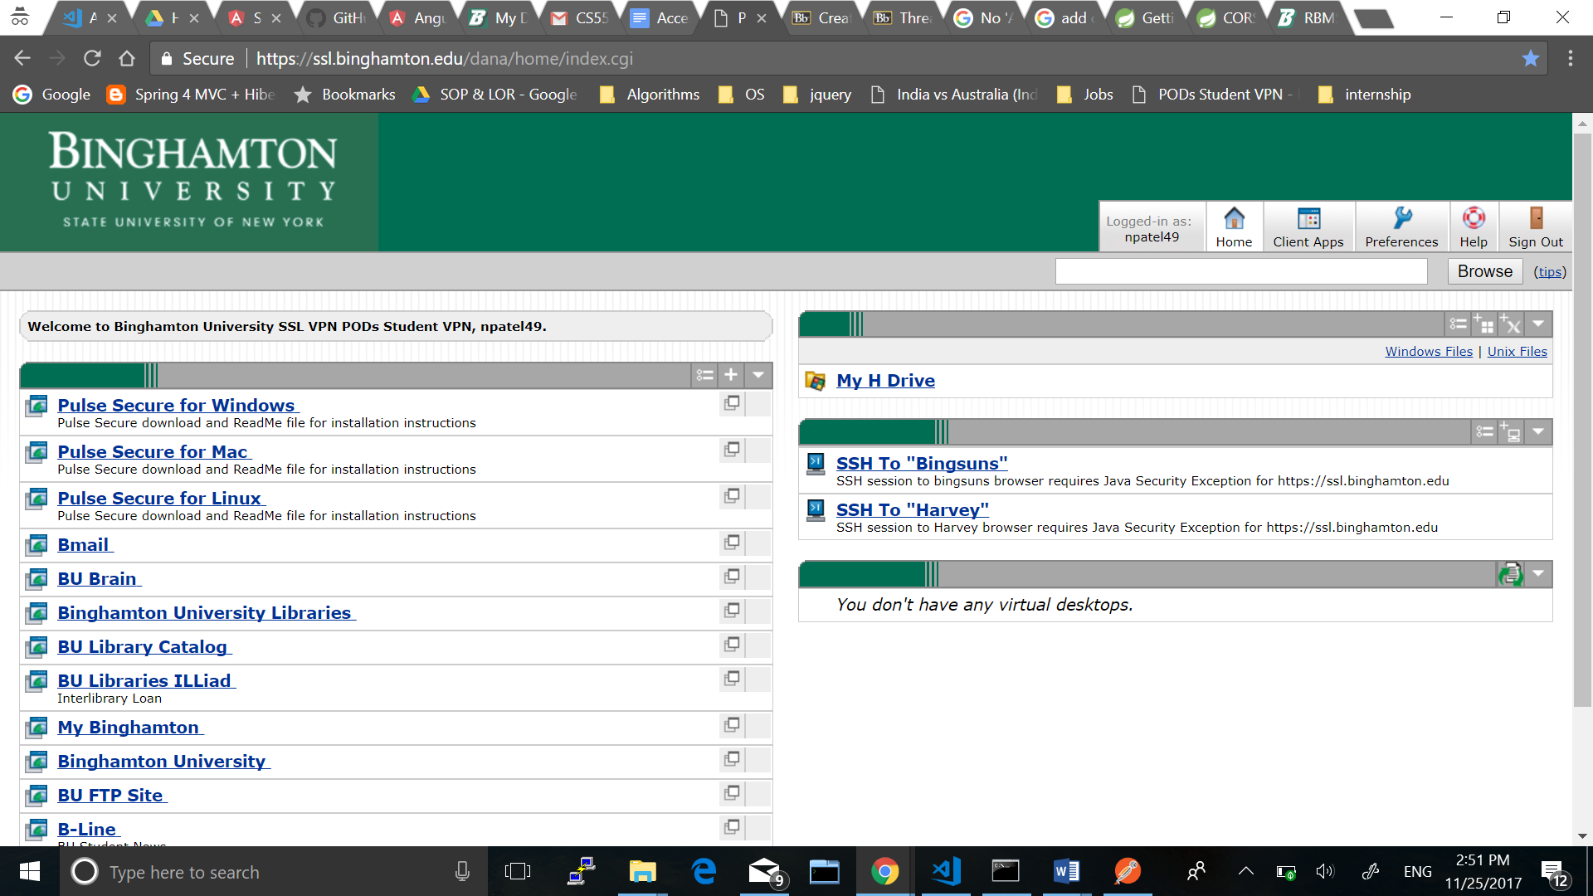

1. **Add a connection similar to below in Pulse Secure and connect to VPN.**

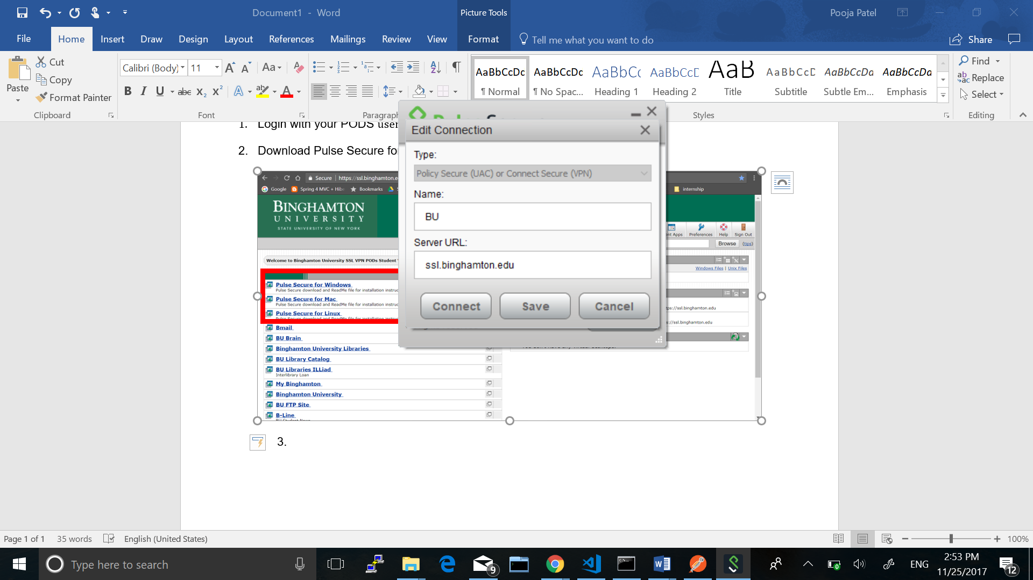

1. **Now you can connect to bingsuns oracle using eclipse or sql developer from your local machine off campus**