Top 50 ggplot2 Visualizations - The Master List
主旨在于使用ggplot2画出美观的图形
- Correlation
用于展示两个变量间关系的图形
  - Scatterplot 散点图
方法：geom_point() + geom_smooth()
用途：散点分布+曲线拟合
# load package and data
options(scipen=999) # turn-off scientific notation like 1e+48
library(ggplot2)
theme_set(theme_bw()) # pre-set the bw theme.
data("midwest", package = "ggplot2") ###使用的数据

# Scatterplot
gg <- ggplot(midwest, aes(x=area, y=poptotal)) +
geom_point(aes(col=state, size=popdensity)) +
geom_smooth(method="loess", se=F) +
xlim(c(0, 0.1)) +
ylim(c(0, 500000)) +
labs(subtitle="Area Vs Population",
y="Population",
x="Area",
title="Scatterplot",
caption = "Source: midwest")
plot(gg)
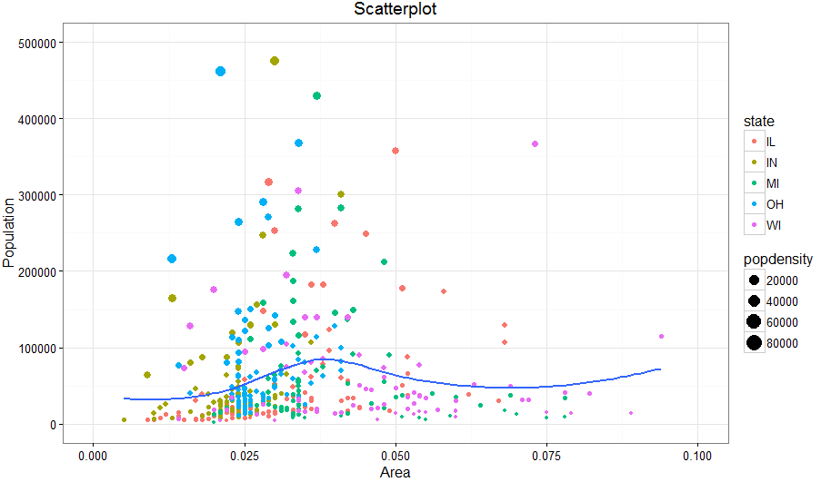
  - Scatterplot With Encircling
方法：使用ggalt 包中的geom_encircle() 函数。
备注：geom_encircle()函数适用的数据是感兴趣的一些点，即给出点的横坐标范围和纵坐标范围。
用途：当用散点图表示两个变量关系时，需要标记出重点分布区域，可以用该方法
options(scipen = 999)
library(ggplot2)
library(ggalt) ###这个R包需要R的版本在3.1.5以上
###筛选出需要标记的散点区域
midwest_select <- midwest[midwest$poptotal > 350000 &
midwest$poptotal <= 500000 &
midwest$area > 0.01 &
midwest$area < 0.1, ]

# Plot
gg <- ggplot(midwest, aes(x=area, y=poptotal)) +
geom_point(aes(col=state, size=popdensity)) + # draw points
geom_smooth(method="loess", se=F) +
xlim(c(0, 0.1)) +
ylim(c(0, 500000)) + # draw smoothing line
geom_encircle(aes(x=area, y=poptotal),
data=midwest_select,
color="red",
size=2,
expand=0.08) + # encircle
labs(subtitle="Area Vs Population",
y="Population",
x="Area",
title="Scatterplot + Encircle",
caption="Source: midwest")
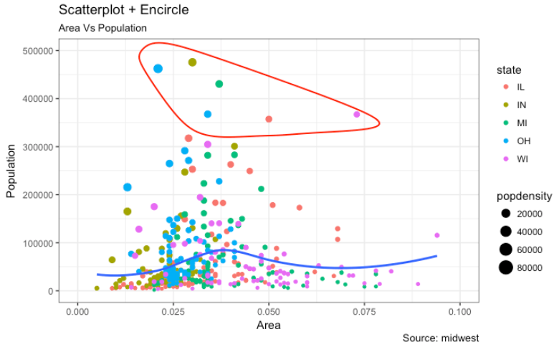
  - Jitter Plot 抖动图
方法：使用geom_jitter() 函数。
用途：数据中出现多个位置一样的点时，很多点就会被覆盖，这样不利于我们观察数据整体情况，不能了解数据全面信息。为了解决这个问题，提出一个策略，以原始点为核心，在其周围标记出与其重复的点。这种方法叫抖动图。
# load package and data
library(ggplot2)
data(mpg, package="ggplot2")
# mpg <- read.csv("http://goo.gl/uEeRGu")

# Scatterplot
theme_set(theme_bw()) # pre-set the bw theme.
g <- ggplot(mpg, aes(cty, hwy))
g + geom_jitter(width = .5, size=1) +
labs(subtitle="mpg: city vs highway mileage",
y="hwy",
x="cty",
title="Jittered Points")
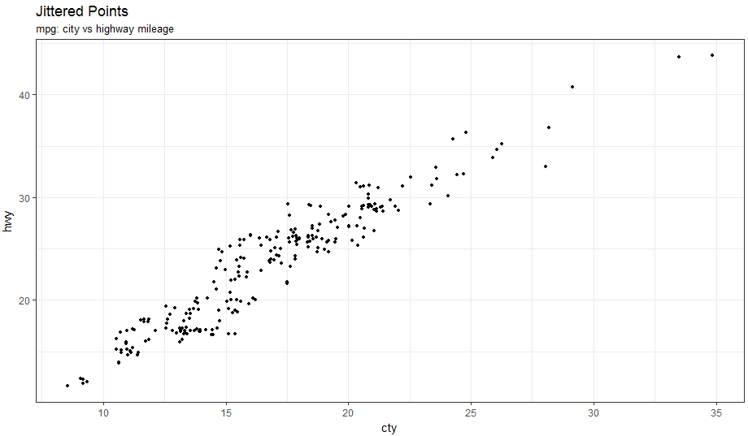
  - Counts Chart
方法：使用geom_count () 函数。
用途：当数据中出现多个位置一样的点的情况，解决方法：同一个点overlap的点数越多那么该点越大。
# load package and data
library(ggplot2)
data(mpg, package="ggplot2")
# mpg <- read.csv("http://goo.gl/uEeRGu")

# Scatterplot
theme_set(theme_bw()) # pre-set the bw theme.
g <- ggplot(mpg, aes(cty, hwy))
g + geom_count(col="tomato3", show.legend=F) +
labs(subtitle="mpg: city vs highway mileage",
y="hwy",
x="cty",
title="Counts Plot")
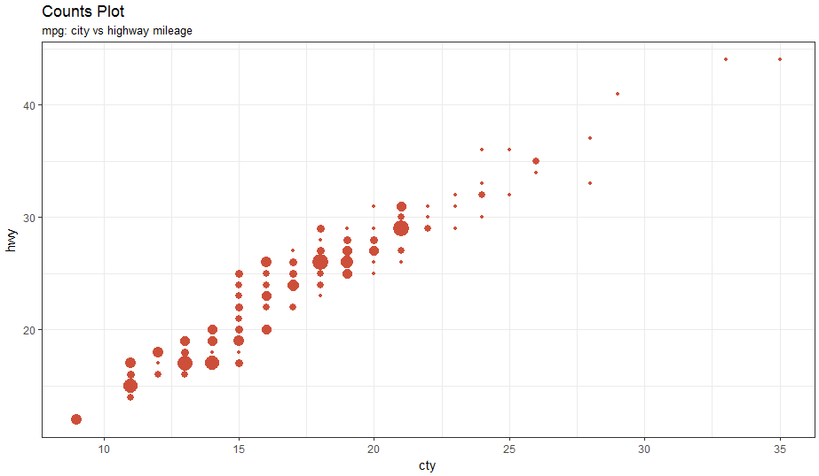
  - Bubble plot 泡泡图
方法：使用geom_jitter ()+geom_smooth() 函数。
用途：当一个数据中出现多个组别时，我们就需要单独分析每个组别内两个变量的关系，这时需要使用泡泡图
# load package and data
library(ggplot2)
data(mpg, package="ggplot2")

mpg_select <- mpg[mpg$manufacturer %in% c("audi", "ford", "honda", "hyundai"), ]

# Scatterplot
theme_set(theme_bw()) # pre-set the bw theme.
g <- ggplot(mpg_select, aes(displ, cty)) +
labs(subtitle="mpg: Displacement vs City Mileage",
title="Bubble chart")

g + geom_jitter(aes(col=manufacturer, size=hwy)) +
geom_smooth(aes(col=manufacturer), method="lm", se=F)
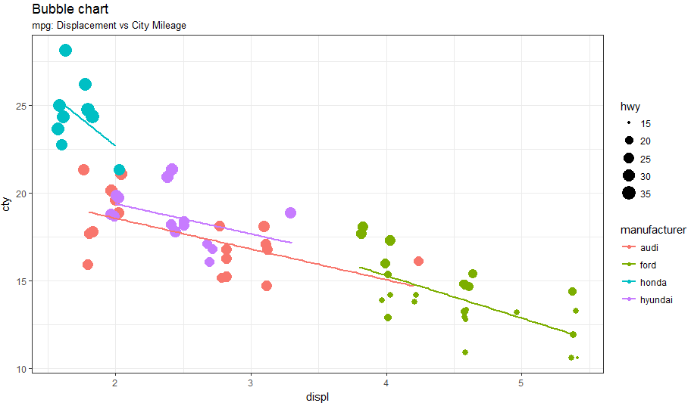
  - Animated Bubble chart 活动的泡泡图
用途：动态展示不同组别间两个变量关系。
方法：使用R包gganimate 中函数
library(ggplot2)
library(gganimate)
library(gapminder)
theme_set(theme_bw()) # pre-set the bw theme.

g <- ggplot(gapminder, aes(gdpPercap, lifeExp, size = pop, frame = year)) +
geom_point() +
geom_smooth(aes(group = year),
method = "lm",
show.legend = FALSE) +
facet_wrap(~continent, scales = "free") +
scale_x_log10() # convert to log scale

gganimate(g, interval=0.2)
  - Marginal Histogram / Boxplot
用途：当既想展示两者关系又想展示两个不同变量的分布情况。
方法：使用R包ggExtra 中的ggMarginal()函数
# load package and data
library(ggplot2)
library(ggExtra)
data(mpg, package="ggplot2")
# mpg <- read.csv("http://goo.gl/uEeRGu")

# Scatterplot
theme_set(theme_bw()) # pre-set the bw theme.
mpg_select <- mpg[mpg$hwy >= 35 & mpg$cty > 27, ]
g <- ggplot(mpg, aes(cty, hwy)) +
geom_count() +
geom_smooth(method="lm", se=F)

ggMarginal(g, type = "histogram", fill="transparent")
ggMarginal(g, type = "boxplot", fill="transparent")
# ggMarginal(g, type = "density", fill="transparent")
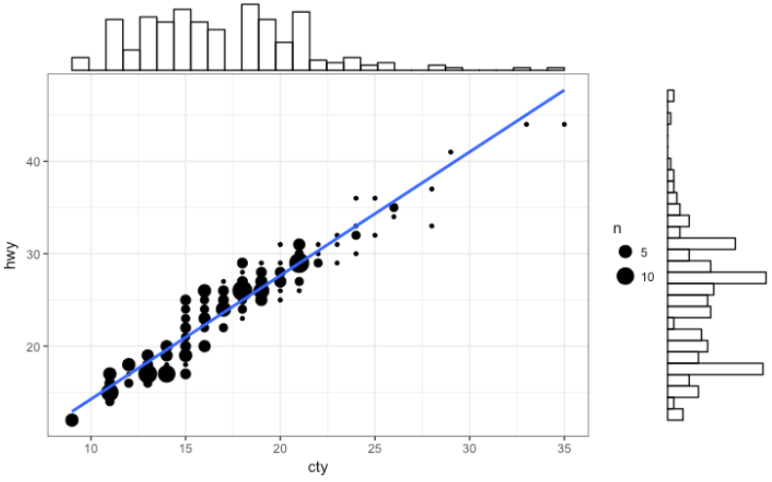
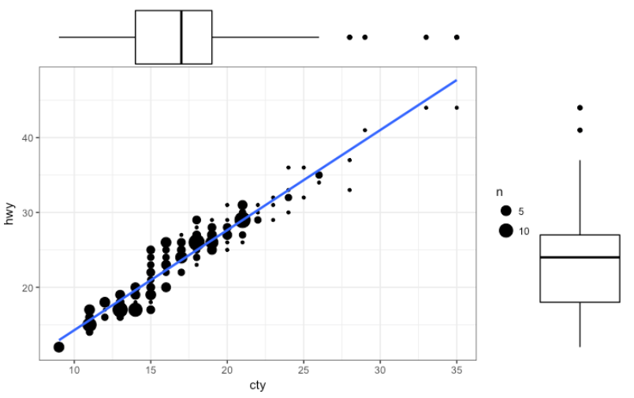
  - Correlogram
用途：上述都是两个变量之间的关系。本方法适用于一个数据框内多个变量间的关系比较，即展示变量间相关性
方法：使用R包ggcorrplot 中的ggcorrplot ()函数
# devtools::install_github("kassambara/ggcorrplot")
library(ggplot2)
library(ggcorrplot)

# Correlation matrix
data(mtcars)
corr <- round(cor(mtcars), 1)

# Plot
ggcorrplot(corr, hc.order = TRUE,
type = "lower",
lab = TRUE,
lab_size = 3,
method="circle",
colors = c("tomato2", "white", "springgreen3"),
title="Correlogram of mtcars",
ggtheme=theme_bw)
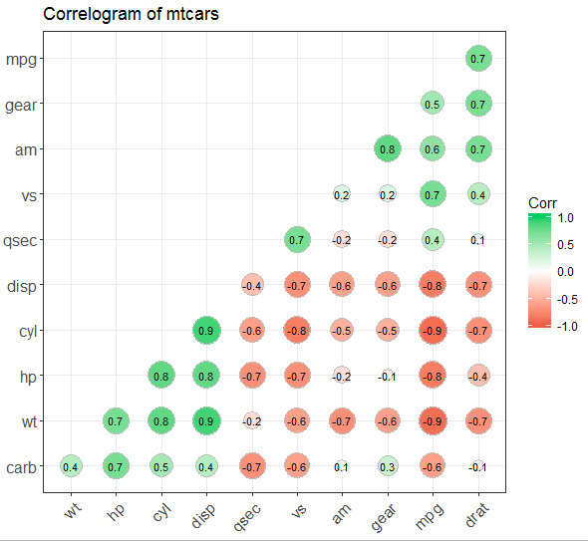
- Deviation
用于展示少量数据间差异
  - Diverging bars
用途：Diverging Bars 既可以展示正直又可以展示负值。这种方法数据需要前期处理成需要的格式
方法：geom_bar() + scale_fill_manual()
library(ggplot2)
theme_set(theme_bw())

# Data Prep
data("mtcars") # load data
mtcars$`car name` <- rownames(mtcars) # create new column for car names
mtcars$mpg_z <- round((mtcars$mpg - mean(mtcars$mpg))/sd(mtcars$mpg), 2) # compute normalized mpg
mtcars$mpg_type <- ifelse(mtcars$mpg_z < 0, "below", "above") # above / below avg flag
mtcars <- mtcars[order(mtcars$mpg_z), ] # sort
mtcars$`car name` <- factor(mtcars$`car name`, levels = mtcars$`car name`) # convert to factor to retain sorted order in plot.

# Diverging Barcharts
ggplot(mtcars, aes(x=`car name`, y=mpg_z, label=mpg_z)) +
geom_bar(stat='identity', aes(fill=mpg_type), width=.5) +
scale_fill_manual(name="Mileage",
labels = c("Above Average", "Below Average"),
values = c("above"="#00ba38", "below"="#f8766d")) +
labs(subtitle="Normalised mileage from 'mtcars'",
title= "Diverging Bars") +
coord_flip()
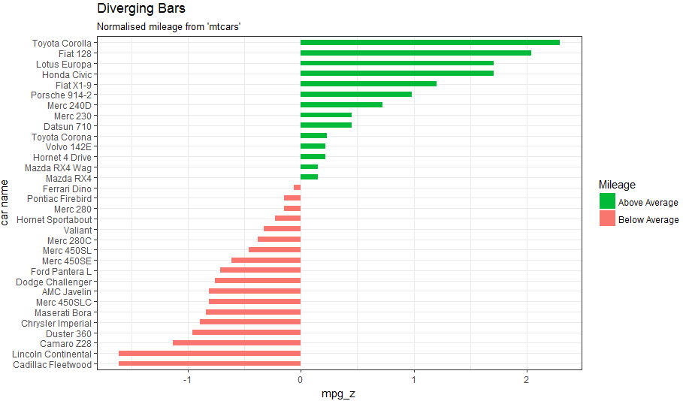
  - Diverging Lollipop Chart 棒棒糖图
用途: 展示整个数据与某个固定值的差异
方法：geom_point () + geom_segment()
library(ggplot2)
theme_set(theme_bw())

ggplot(mtcars, aes(x=`car name`, y=mpg_z, label=mpg_z)) +
geom_point(stat='identity', fill="black", size=6) +
geom_segment(aes(y = 0,
x = `car name`,
yend = mpg_z,
xend = `car name`),
color = "black") +
geom_text(color="white", size=2) +
labs(title="Diverging Lollipop Chart",
subtitle="Normalized mileage from 'mtcars': Lollipop") +
ylim(-2.5, 2.5) +
coord_flip()
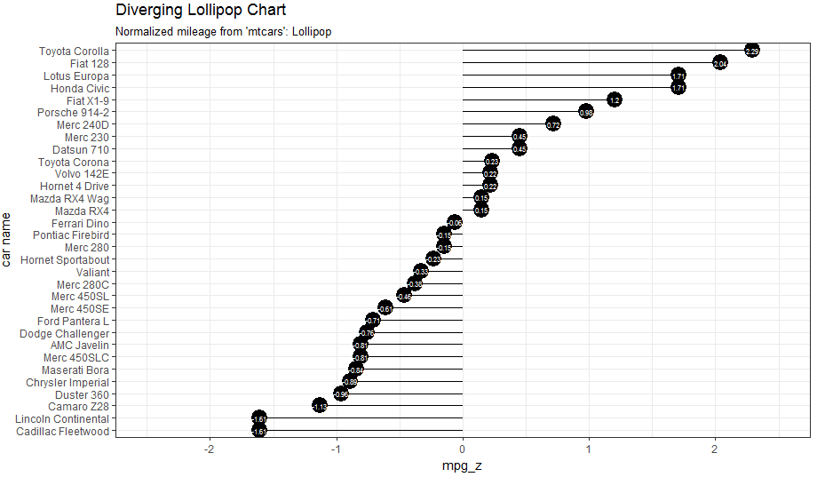
  - Diverging Dot Plot 点图
用途: 展示整个数据与某个固定值的差异，即棒棒糖图没有尾巴
方法：geom_point()
library(ggplot2)
theme_set(theme_bw())

# Plot
ggplot(mtcars, aes(x=`car name`, y=mpg_z, label=mpg_z)) +
geom_point(stat='identity', aes(col=mpg_type), size=6) +
scale_color_manual(name="Mileage",
labels = c("Above Average", "Below Average"),
values = c("above"="#00ba38", "below"="#f8766d")) +
geom_text(color="white", size=2) +
labs(title="Diverging Dot Plot",
subtitle="Normalized mileage from 'mtcars': Dotplot") +
ylim(-2.5, 2.5) +
coord_flip()
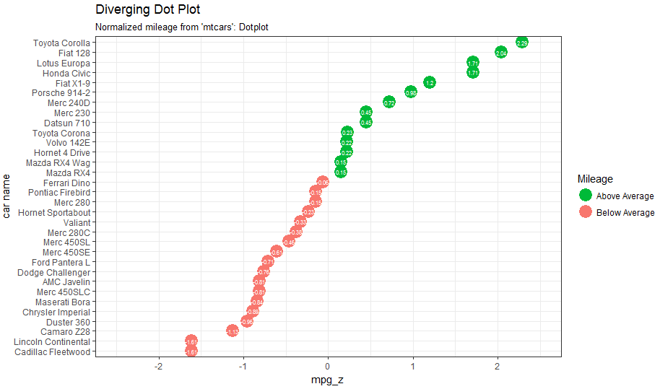
  - Area Chart
用途: 展示整个数据与某个固定值的差异，即区域展示
方法：R包quantmod中geom_area()函数
library(ggplot2)
library(quantmod)
data("economics", package = "ggplot2")

# Compute % Returns
economics$returns_perc <- c(0, diff(economics$psavert)/economics$psavert[-length(economics$psavert)])

# Create break points and labels for axis ticks
brks <- economics$date[seq(1, length(economics$date), 12)]
lbls <- lubridate::year(economics$date[seq(1, length(economics$date), 12)])

# Plot
ggplot(economics[1:100, ], aes(date, returns_perc)) +
geom_area() +
scale_x_date(breaks=brks, labels=lbls) +
theme(axis.text.x = element_text(angle=90)) +
labs(title="Area Chart",
subtitle = "Perc Returns for Personal Savings",
y="% Returns for Personal savings",
caption="Source: economics")

- Ranking
数据中多个不同条目的排秩比较
  - Ordered Bar Chart
用途：按Y变量将数据从小到大排序进行数据展示，同时要把X变量变成factor类型
方法：geom_bar()
# Prepare data: group mean city mileage by manufacturer.
cty_mpg <- aggregate(mpg$cty, by=list(mpg$manufacturer), FUN=mean) # aggregate
colnames(cty_mpg) <- c("make", "mileage") # change column names
cty_mpg <- cty_mpg[order(cty_mpg$mileage), ] # sort
cty_mpg$make <- factor(cty_mpg$make, levels = cty_mpg$make) # to retain the order in plot.

library(ggplot2)
theme_set(theme_bw())

# Draw plot
ggplot(cty_mpg, aes(x=make, y=mileage)) +
geom_bar(stat="identity", width=.5, fill="tomato3") +
labs(title="Ordered Bar Chart",
subtitle="Make Vs Avg. Mileage",
caption="source: mpg") +
theme(axis.text.x = element_text(angle=65, vjust=0.6))
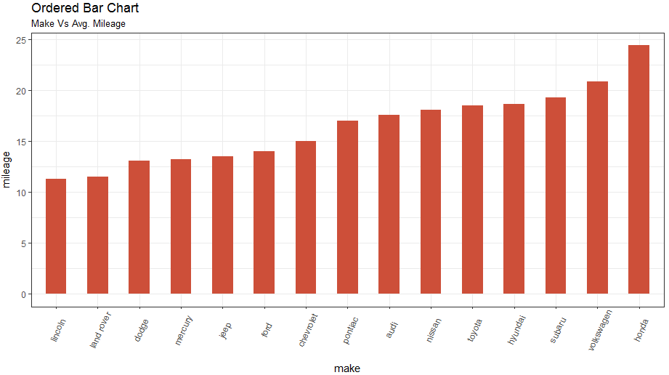
  - Lollipop Chart 棒棒糖
用途：将数据按从大到小排序进行数据展示与比较
方法：geom_point () + geom_segment()
library(ggplot2)
theme_set(theme_bw())

# Plot
ggplot(cty_mpg, aes(x=make, y=mileage)) +
geom_point(size=3) +
geom_segment(aes(x=make,
xend=make,
y=0,
yend=mileage)) +
labs(title="Lollipop Chart",
subtitle="Make Vs Avg. Mileage",
caption="source: mpg") +
theme(axis.text.x = element_text(angle=65, vjust=0.6))
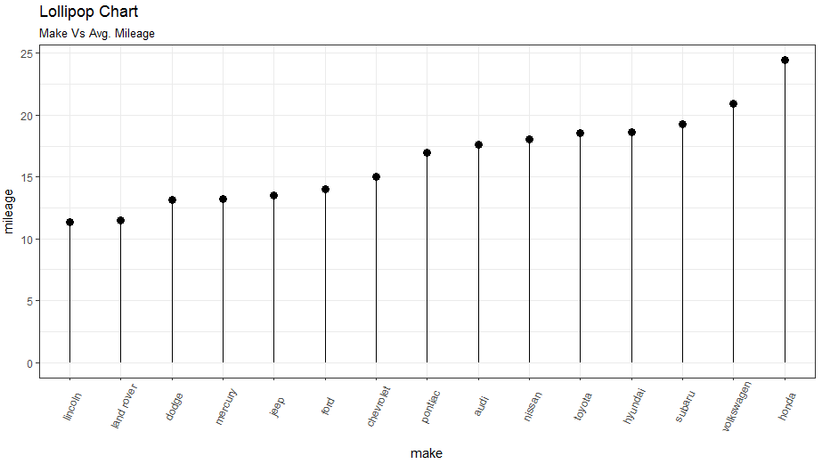
  - Dot Plot
用途：将数据按从大到小排序进行数据展示与比较
方法：geom_point ()
library(ggplot2)
library(scales)
theme_set(theme_classic())

# Plot
ggplot(cty_mpg, aes(x=make, y=mileage)) +
geom_point(col="tomato2", size=3) + # Draw points
geom_segment(aes(x=make,
xend=make,
y=min(mileage),
yend=max(mileage)),
linetype="dashed",
size=0.1) + # Draw dashed lines
labs(title="Dot Plot",
subtitle="Make Vs Avg. Mileage",
caption="source: mpg") +
coord_flip()
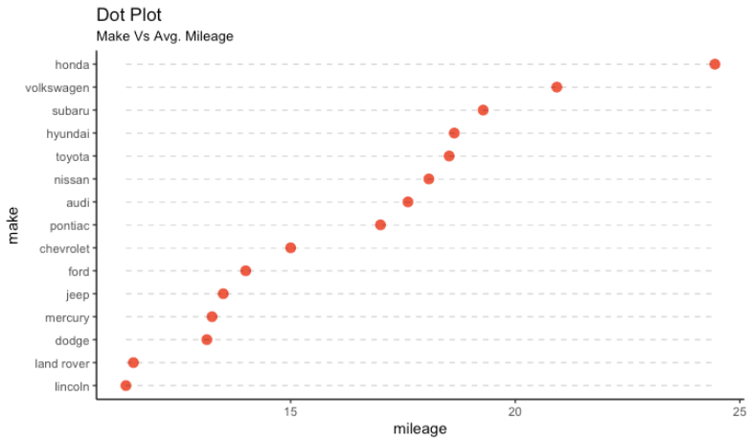
  - Slope Chart 倾斜图形
用途：在同一时间比较两个点差异
方法：使用R包 scales 中函数
library(ggplot2)
library(scales)
theme_set(theme_classic())

# prep data
df <- read.csv("https://raw.githubusercontent.com/selva86/datasets/master/gdppercap.csv")
colnames(df) <- c("continent", "1952", "1957")
left_label <- paste(df$continent, round(df$`1952`),sep=", ")
right_label <- paste(df$continent, round(df$`1957`),sep=", ")
df$class <- ifelse((df$`1957` - df$`1952`) < 0, "red", "green")

# Plot
p <- ggplot(df) + geom_segment(aes(x=1, xend=2, y=`1952`, yend=`1957`, col=class), size=.75, show.legend=F) +
geom_vline(xintercept=1, linetype="dashed", size=.1) +
geom_vline(xintercept=2, linetype="dashed", size=.1) +
scale_color_manual(labels = c("Up", "Down"),
values = c("green"="#00ba38", "red"="#f8766d")) + # color of lines
labs(x="", y="Mean GdpPerCap") + # Axis labels
xlim(.5, 2.5) + ylim(0,(1.1*(max(df$`1952`, df$`1957`)))) # X and Y axis limits

# Add texts
p <- p + geom_text(label=left_label, y=df$`1952`, x=rep(1, NROW(df)), hjust=1.1, size=3.5)
p <- p + geom_text(label=right_label, y=df$`1957`, x=rep(2, NROW(df)), hjust=-0.1, size=3.5)
p <- p + geom_text(label="Time 1", x=1, y=1.1*(max(df$`1952`, df$`1957`)), hjust=1.2, size=5) # title
p <- p + geom_text(label="Time 2", x=2, y=1.1*(max(df$`1952`, df$`1957`)), hjust=-0.1, size=5) # title

# Minify theme
p + theme(panel.background = element_blank(),
panel.grid = element_blank(),
axis.ticks = element_blank(),
axis.text.x = element_blank(),
panel.border = element_blank(),
plot.margin = unit(c(1,2,1,2), "cm"))
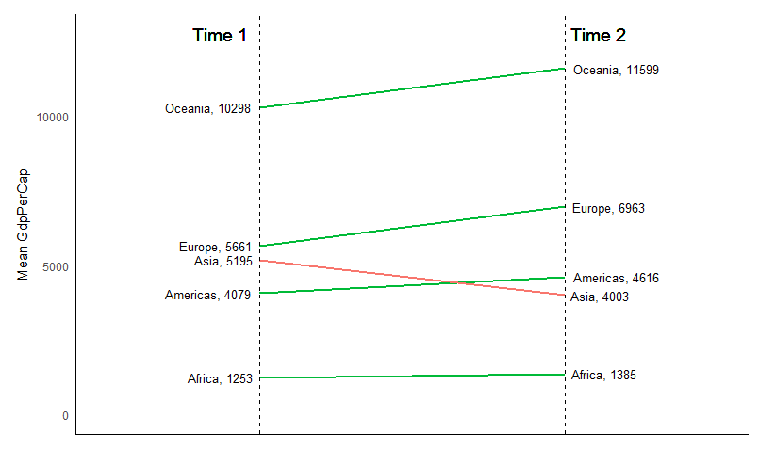
  - Dumbbell Plot 哑铃图
用途：1）在同一时间可视化两个点位置；2）比较两个点之间距离
方法：使用R包 ggalt 中函数
# devtools::install_github("hrbrmstr/ggalt")
library(ggplot2)
library(ggalt)
theme_set(theme_classic())

health <- read.csv("https://raw.githubusercontent.com/selva86/datasets/master/health.csv")
health$Area <- factor(health$Area, levels=as.character(health$Area)) # for right ordering of the dumbells

# health$Area <- factor(health$Area)
gg <- ggplot(health, aes(x=pct_2013, xend=pct_2014, y=Area, group=Area)) +
geom_dumbbell(color="#a3c4dc",
size=0.75,
point.colour.l="#0e668b") +
scale_x_continuous(label=percent) +
labs(x=NULL,
y=NULL,
title="Dumbbell Chart",
subtitle="Pct Change: 2013 vs 2014",
caption="Source: https://github.com/hrbrmstr/ggalt") +
theme(plot.title = element_text(hjust=0.5, face="bold"),
plot.background=element_rect(fill="#f7f7f7"),
panel.background=element_rect(fill="#f7f7f7"),
panel.grid.minor=element_blank(),
panel.grid.major.y=element_blank(),
panel.grid.major.x=element_line(),
axis.ticks=element_blank(),
legend.position="top",
panel.border=element_blank())
plot(gg)
- Distribution
研究大量数据点的分布情况
  - Histogram
用途：计算数据集中每个类别内不同组分的比例
方法：geom_histogram()
library(ggplot2)
theme_set(theme_classic())

# Histogram on a Continuous (Numeric) Variable
g <- ggplot(mpg, aes(displ)) + scale_fill_brewer(palette = "Spectral")

g + geom_histogram(aes(fill=class),
binwidth = .1,
col="black",
size=.1) + # change binwidth
labs(title="Histogram with Auto Binning",
subtitle="Engine Displacement across Vehicle Classes")

g + geom_histogram(aes(fill=class),
bins=5,
col="black",
size=.1) + # change number of bins
labs(title="Histogram with Fixed Bins",
subtitle="Engine Displacement across Vehicle Classes")
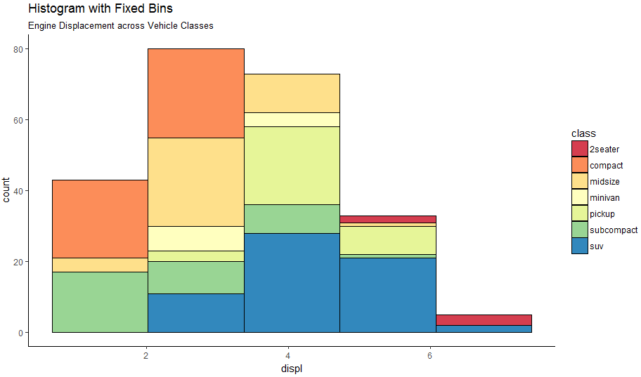
library(ggplot2)
theme_set(theme_classic())

# Histogram on a Categorical variable
g <- ggplot(mpg, aes(manufacturer))
g + geom_bar(aes(fill=class), width = 0.5) +
theme(axis.text.x = element_text(angle=65, vjust=0.6)) +
labs(title="Histogram on Categorical Variable",
subtitle="Manufacturer across Vehicle Classes")
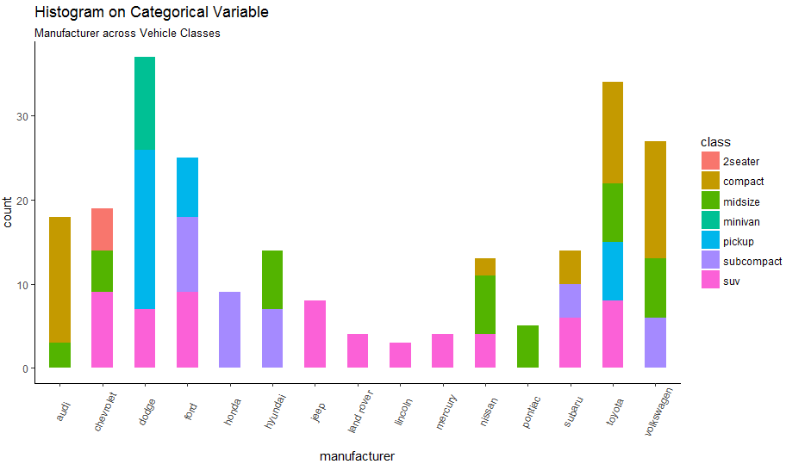
  - Density plot
方法：geom_density ()
library(ggplot2)
theme_set(theme_classic())

# Plot
g <- ggplot(mpg, aes(cty))
g + geom_density(aes(fill=factor(cyl)), alpha=0.8) +
labs(title="Density plot",
subtitle="City Mileage Grouped by Number of cylinders",
caption="Source: mpg",
x="City Mileage",
fill="# Cylinders")
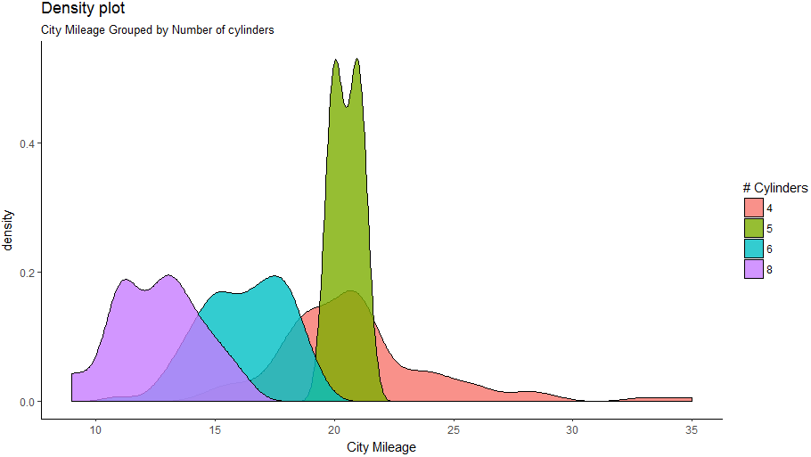
  - Box Plot
方法：geom_boxplot()
library(ggplot2)
theme_set(theme_classic())

# Plot
g <- ggplot(mpg, aes(class, cty))
g + geom_boxplot(varwidth=T, fill="plum") +
labs(title="Box plot",
subtitle="City Mileage grouped by Class of vehicle",
caption="Source: mpg",
x="Class of Vehicle",
y="City Mileage")
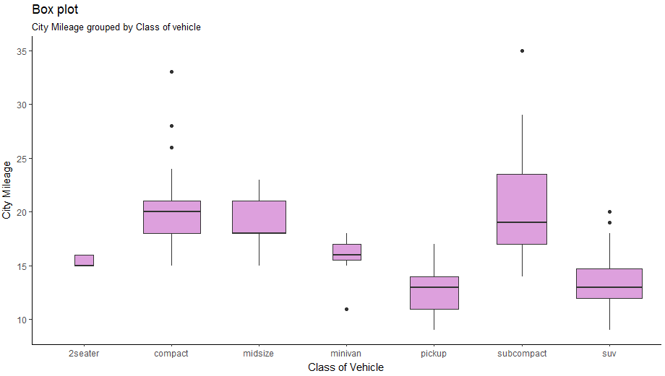
library(ggthemes)
g <- ggplot(mpg, aes(class, cty))
g + geom_boxplot(aes(fill=factor(cyl))) +
theme(axis.text.x = element_text(angle=65, vjust=0.6)) +
labs(title="Box plot",
subtitle="City Mileage grouped by Class of vehicle",
caption="Source: mpg",
x="Class of Vehicle",
y="City Mileage")
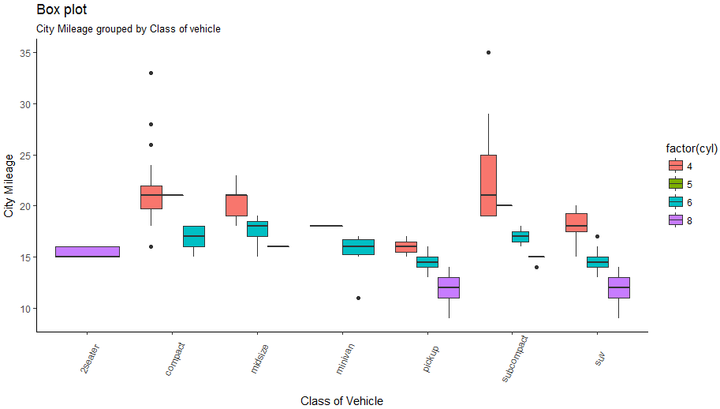
  - Dot + Box Plot
方法：geom_boxplot() + geom_dotplot()
library(ggplot2)
theme_set(theme_bw())

# plot
g <- ggplot(mpg, aes(manufacturer, cty))
g + geom_boxplot() +
geom_dotplot(binaxis='y',
stackdir='center',
dotsize = .5,
fill="red") +
theme(axis.text.x = element_text(angle=65, vjust=0.6)) +
labs(title="Box plot + Dot plot",
subtitle="City Mileage vs Class: Each dot represents 1 row in source data",
caption="Source: mpg",
x="Class of Vehicle",
y="City Mileage")
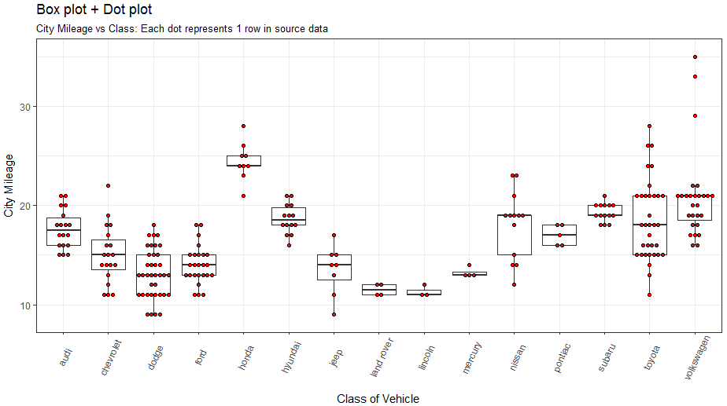
  - Tufte Boxplot
用途：box图变成成簇的展示
方法：geom_tufteboxplot()
library(ggthemes)
library(ggplot2)
theme_set(theme_tufte()) # from ggthemes

# plot
g <- ggplot(mpg, aes(manufacturer, cty))
g + geom_tufteboxplot() +
theme(axis.text.x = element_text(angle=65, vjust=0.6)) +
labs(title="Tufte Styled Boxplot",
subtitle="City Mileage grouped by Class of vehicle",
caption="Source: mpg",
x="Class of Vehicle",
y="City Mileage")
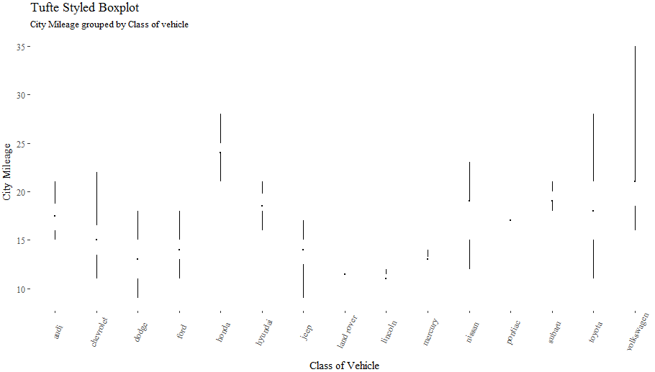
  - Violin Plot 小提琴图
library(ggplot2)
theme_set(theme_bw())

# plot
g <- ggplot(mpg, aes(class, cty))
g + geom_violin() +
labs(title="Violin plot",
subtitle="City Mileage vs Class of vehicle",
caption="Source: mpg",
x="Class of Vehicle",
y="City Mileage")
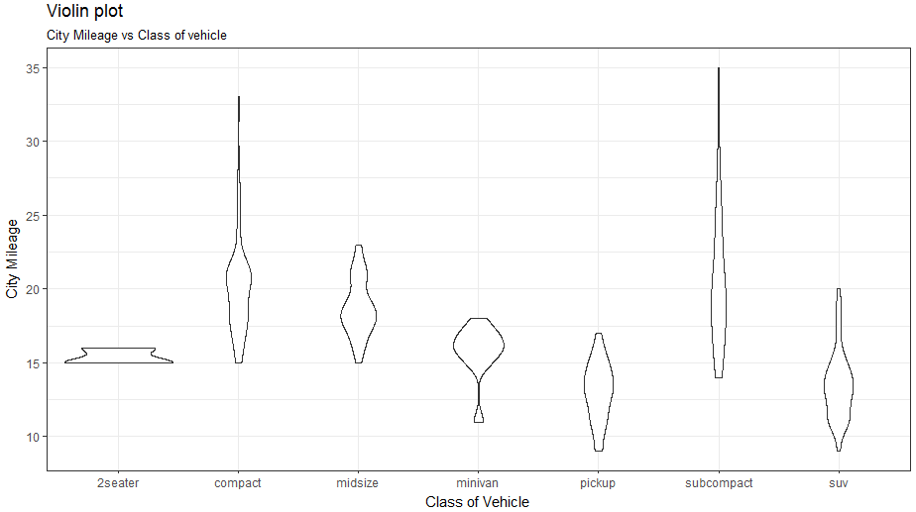
  - Population Pyramid 种族椎体
用途：1）可视化有多少population；2）在某个类别中population比例
方法：R包ggthemes中函数
library(ggplot2)
library(ggthemes)
options(scipen = 999) # turns of scientific notations like 1e+40

# Read data
email_campaign_funnel <- read.csv("https://raw.githubusercontent.com/selva86/datasets/master/email_campaign_funnel.csv")

# X Axis Breaks and Labels
brks <- seq(-15000000, 15000000, 5000000)
lbls = paste0(as.character(c(seq(15, 0, -5), seq(5, 15, 5))), "m")

# Plot
ggplot(email_campaign_funnel, aes(x = Stage, y = Users, fill = Gender)) + # Fill column
geom_bar(stat = "identity", width = .6) + # draw the bars
scale_y_continuous(breaks = brks, # Breaks
labels = lbls) + # Labels
coord_flip() + # Flip axes
labs(title="Email Campaign Funnel") +
theme_tufte() + # Tufte theme from ggfortify
theme(plot.title = element_text(hjust = .5),
axis.ticks = element_blank()) + # Centre plot title
scale_fill_brewer(palette = "Dark2") # Color palette
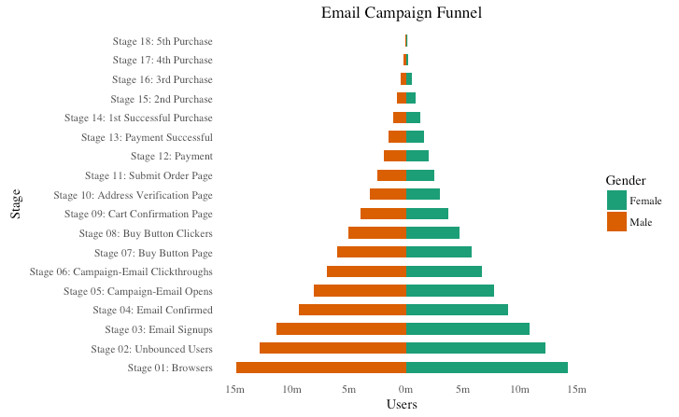
- Composition
数据集的组份展示
  - Waffle Chart 华夫格图
var <- mpg$class # the categorical data

## Prep data (nothing to change here)
nrows <- 10
df <- expand.grid(y = 1:nrows, x = 1:nrows)
categ_table <- round(table(var) * ((nrows*nrows)/(length(var))))

df$category <- factor(rep(names(categ_table), categ_table))
# NOTE: if sum(categ_table) is not 100 (i.e. nrows^2), it will need adjustment to make the sum to 100.

## Plot
ggplot(df, aes(x = x, y = y, fill = category)) +
geom_tile(color = "black", size = 0.5) +
scale_x_continuous(expand = c(0, 0)) +
scale_y_continuous(expand = c(0, 0), trans = 'reverse') +
scale_fill_brewer(palette = "Set3") +
labs(title="Waffle Chart", subtitle="'Class' of vehicles",
caption="Source: mpg") +
theme(panel.border = element_rect(size = 2),
plot.title = element_text(size = rel(1.2)),
axis.text = element_blank(),
axis.title = element_blank(),
axis.ticks = element_blank(),
legend.title = element_blank(),
legend.position = "right")
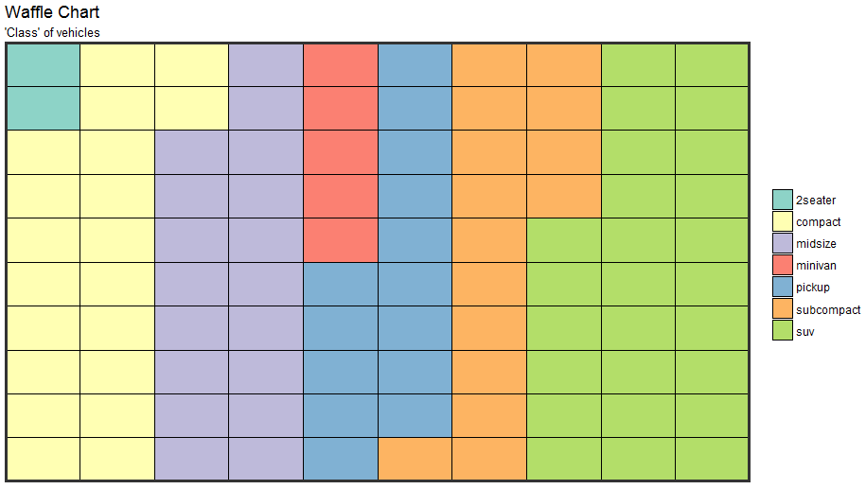
  - Pie Chart 饼图
library(ggplot2)
theme_set(theme_classic())

# Source: Frequency table
df <- as.data.frame(table(mpg$class))
colnames(df) <- c("class", "freq")
pie <- ggplot(df, aes(x = "", y=freq, fill = factor(class))) +
geom_bar(width = 1, stat = "identity") +
theme(axis.line = element_blank(),
plot.title = element_text(hjust=0.5)) +
labs(fill="class",
x=NULL,
y=NULL,
title="Pie Chart of class",
caption="Source: mpg")

pie + coord_polar(theta = "y", start=0)

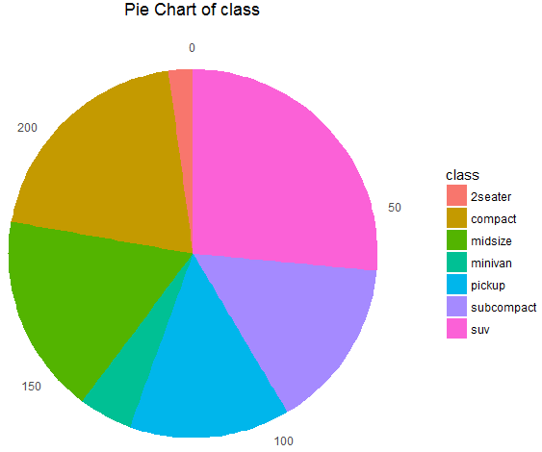
  - Treemap
方法：使用R包treemapify中函数ggplotify()
备注：在调用画图工具前要使用treemapify()将数据集转成ggplotify()需要的格式
library(ggplot2)
library(treemapify)
proglangs <- read.csv("https://raw.githubusercontent.com/selva86/datasets/master/proglanguages.csv")

# plot
treeMapCoordinates <- treemapify(proglangs,
area = "value",
fill = "parent",
label = "id",
group = "parent")

treeMapPlot <- ggplotify(treeMapCoordinates) +
scale_x_continuous(expand = c(0, 0)) +
scale_y_continuous(expand = c(0, 0)) +
scale_fill_brewer(palette = "Dark2")

print(treeMapPlot)
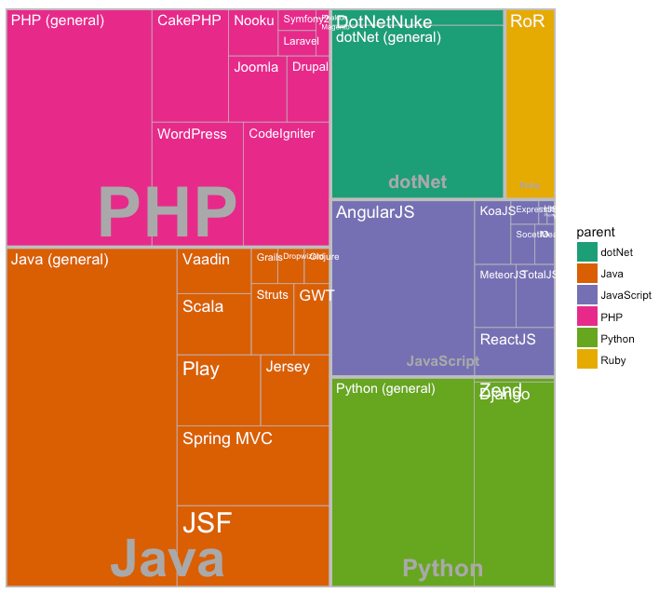
  - Bar Chart
# prep frequency table
freqtable <- table(mpg$manufacturer)
df <- as.data.frame.table(freqtable)

# plot
library(ggplot2)
theme_set(theme_classic())

# Plot
g <- ggplot(df, aes(Var1, Freq))
g + geom_bar(stat="identity", width = 0.5, fill="tomato2") +
labs(title="Bar Chart",
subtitle="Manufacturer of vehicles",
caption="Source: Frequency of Manufacturers from 'mpg' dataset") +
theme(axis.text.x = element_text(angle=65, vjust=0.6))
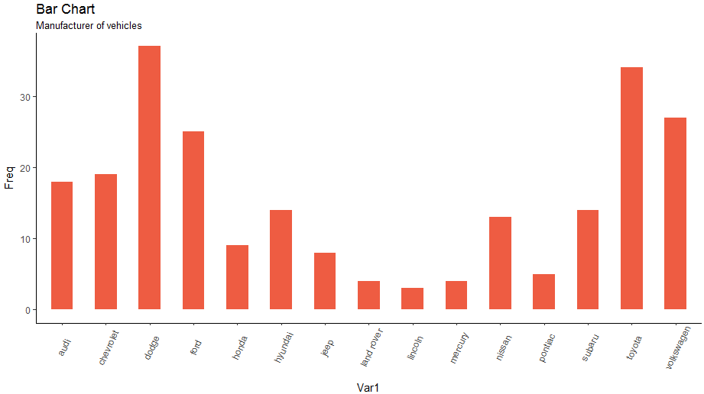

# From on a categorical column variable
g <- ggplot(mpg, aes(manufacturer))
g + geom_bar(aes(fill=class), width = 0.5) +
theme(axis.text.x = element_text(angle=65, vjust=0.6)) +
labs(title="Categorywise Bar Chart",
subtitle="Manufacturer of vehicles",
caption="Source: Manufacturers from 'mpg' dataset")
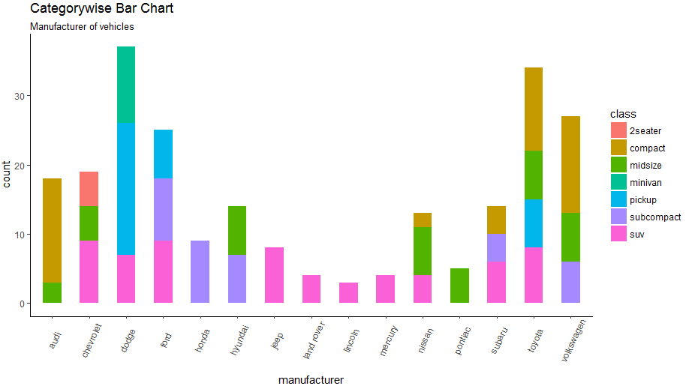
- Change
时序数据展示
  - Time Series Plot From a Time Series Object (ts)
用途：时序对象的时序图
方法：R包ggfortify中函数
## From Timeseries object (ts)
library(ggplot2)
library(ggfortify)
theme_set(theme_classic())

# Plot
autoplot(AirPassengers) +
labs(title="AirPassengers") +
theme(plot.title = element_text(hjust=0.5))
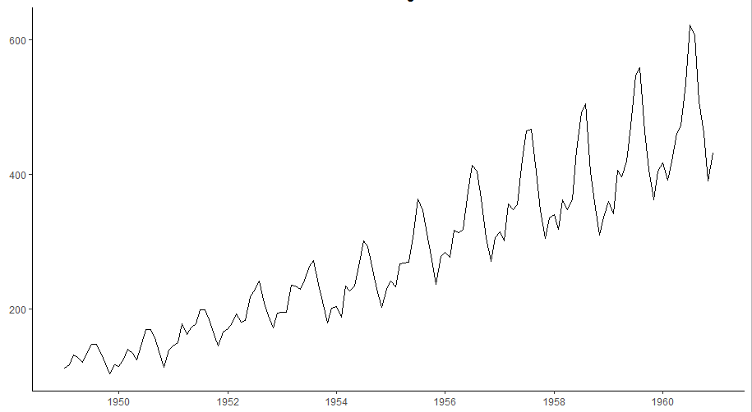
  - Time Series Plot From a Data Frame
用途：数据框对象的时序图
方法：geom_line()
library(ggplot2)
theme_set(theme_classic())

# Allow Default X Axis Labels
ggplot(economics, aes(x=date)) +
geom_line(aes(y=returns_perc)) +
labs(title="Time Series Chart",
subtitle="Returns Percentage from 'Economics' Dataset",
caption="Source: Economics",
y="Returns %")
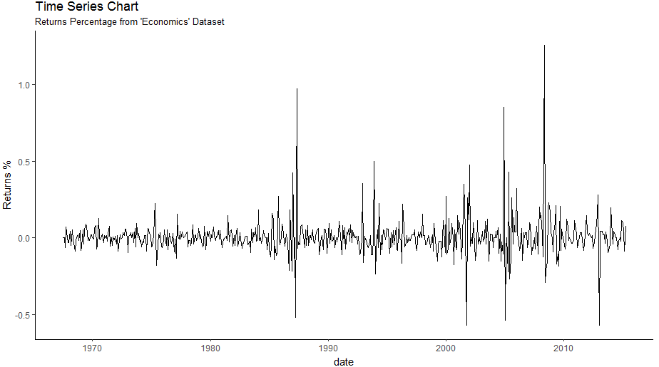
  - Time Series Plot For a Monthly Time Series
用途：月度时序数据的时序图
方法：使用R包lubridate中函数
library(ggplot2)
library(lubridate)
theme_set(theme_bw())

economics_m <- economics[1:24, ]

# labels and breaks for X axis text
lbls <- paste0(month.abb[month(economics_m$date)], " ", lubridate::year(economics_m$date))
brks <- economics_m$date

# plot
ggplot(economics_m, aes(x=date)) +
geom_line(aes(y=returns_perc)) +
labs(title="Monthly Time Series",
subtitle="Returns Percentage from Economics Dataset",
caption="Source: Economics",
y="Returns %") + # title and caption
scale_x_date(labels = lbls,
breaks = brks) + # change to monthly ticks and labels
theme(axis.text.x = element_text(angle = 90, vjust=0.5), # rotate x axis text
panel.grid.minor = element_blank()) # turn off minor grid
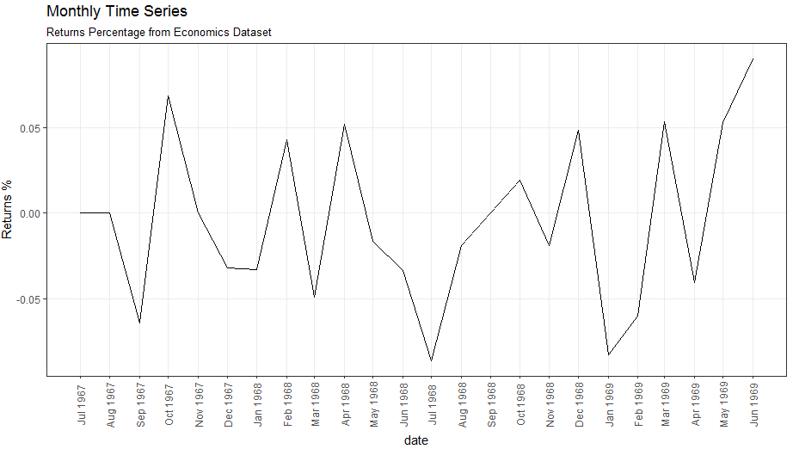
  - Time Series Plot For a Yearly Time Series
用途：数据框对象的时序图
方法：使用R包lubridate中函数
library(ggplot2)
library(lubridate)
theme_set(theme_bw())

economics_y <- economics[1:90, ]

# labels and breaks for X axis text
brks <- economics_y$date[seq(1, length(economics_y$date), 12)]
lbls <- lubridate::year(brks)

# plot
ggplot(economics_y, aes(x=date)) +
geom_line(aes(y=returns_perc)) +
labs(title="Yearly Time Series",
subtitle="Returns Percentage from Economics Dataset",
caption="Source: Economics",
y="Returns %") + # title and caption
scale_x_date(labels = lbls,
breaks = brks) + # change to monthly ticks and labels
theme(axis.text.x = element_text(angle = 90, vjust=0.5), # rotate x axis text
panel.grid.minor = element_blank()) # turn off minor grid
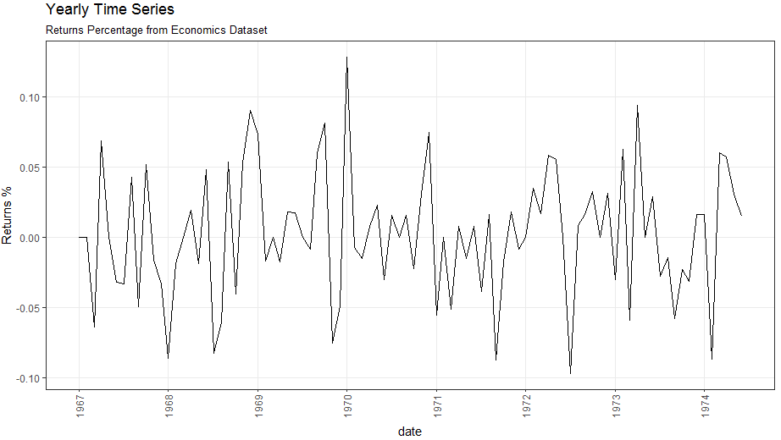
  - Time Series Plot From Long Data Format: Multiple Time Series in Same Dataframe Column
用途：展示数据集中，不同维度
方法：geom_line

data(economics_long, package = "ggplot2")
library(ggplot2)
library(lubridate)
theme_set(theme_bw())

df <- economics_long[economics_long$variable %in% c("psavert", "uempmed"), ]
df <- df[lubridate::year(df$date) %in% c(1967:1981), ]

# labels and breaks for X axis text
brks <- df$date[seq(1, length(df$date), 12)]
lbls <- lubridate::year(brks)

# plot
ggplot(df, aes(x=date)) +
geom_line(aes(y=value, col=variable)) +
labs(title="Time Series of Returns Percentage",
subtitle="Drawn from Long Data format",
caption="Source: Economics",
y="Returns %",
color=NULL) + # title and caption
scale_x_date(labels = lbls, breaks = brks) + # change to monthly ticks and labels
scale_color_manual(labels = c("psavert", "uempmed"),
values = c("psavert"="#00ba38", "uempmed"="#f8766d")) + # line color
theme(axis.text.x = element_text(angle = 90, vjust=0.5, size = 8), # rotate x axis text
panel.grid.minor = element_blank()) # turn off minor grid
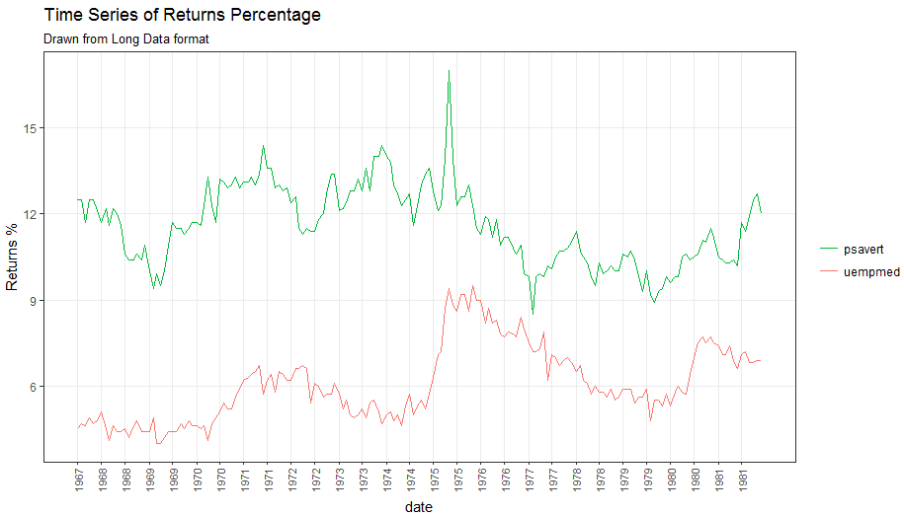
  - Time Series Plot From Wide Data Format: Data in Multiple Columns of Dataframe
library(ggplot2)
library(lubridate)
theme_set(theme_bw())

df <- economics[, c("date", "psavert", "uempmed")]
df <- df[lubridate::year(df$date) %in% c(1967:1981), ]

# labels and breaks for X axis text
brks <- df$date[seq(1, length(df$date), 12)]
lbls <- lubridate::year(brks)

# plot
ggplot(df, aes(x=date)) +
geom_line(aes(y=psavert, col="psavert")) +
geom_line(aes(y=uempmed, col="uempmed")) +
labs(title="Time Series of Returns Percentage",
subtitle="Drawn From Wide Data format",
caption="Source: Economics", y="Returns %") + # title and caption
scale_x_date(labels = lbls, breaks = brks) + # change to monthly ticks and labels
scale_color_manual(name="",
values = c("psavert"="#00ba38", "uempmed"="#f8766d")) + # line color
theme(panel.grid.minor = element_blank()) # turn off minor grid
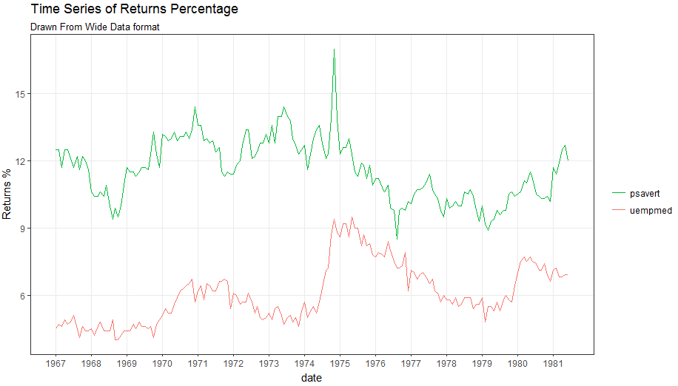
  - Stacked Area Chart 面积堆叠图
library(ggplot2)
library(lubridate)
theme_set(theme_bw())

df <- economics[, c("date", "psavert", "uempmed")]
df <- df[lubridate::year(df$date) %in% c(1967:1981), ]

# labels and breaks for X axis text
brks <- df$date[seq(1, length(df$date), 12)]
lbls <- lubridate::year(brks)

# plot
ggplot(df, aes(x=date)) +
geom_area(aes(y=psavert+uempmed, fill="psavert")) +
geom_area(aes(y=uempmed, fill="uempmed")) +
labs(title="Area Chart of Returns Percentage",
subtitle="From Wide Data format",
caption="Source: Economics",
y="Returns %") + # title and caption
scale_x_date(labels = lbls, breaks = brks) + # change to monthly ticks and labels
scale_fill_manual(name="",
values = c("psavert"="#00ba38", "uempmed"="#f8766d")) + # line color
theme(panel.grid.minor = element_blank()) # turn off minor grid
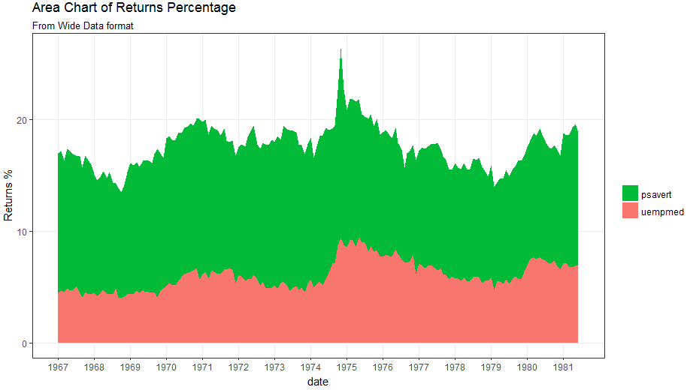
  - Calendar Heatmap 日历热图
# http://margintale.blogspot.in/2012/04/ggplot2-time-series-heatmaps.html
library(ggplot2)
library(plyr)
library(scales)
library(zoo)

df <- read.csv("https://raw.githubusercontent.com/selva86/datasets/master/yahoo.csv")
df$date <- as.Date(df$date) # format date
df <- df[df$year >= 2012, ] # filter reqd years

# Create Month Week
df$yearmonth <- as.yearmon(df$date)
df$yearmonthf <- factor(df$yearmonth)
df <- ddply(df,.(yearmonthf), transform, monthweek=1+week-min(week)) # compute week number of month
df <- df[, c("year", "yearmonthf", "monthf", "week", "monthweek", "weekdayf", "VIX.Close")]

# Plot
ggplot(df, aes(monthweek, weekdayf, fill = VIX.Close)) +
geom_tile(colour = "white") +
facet_grid(year~monthf) +
scale_fill_gradient(low="red", high="green") +
labs(x="Week of Month",
y="",
title = "Time-Series Calendar Heatmap",
subtitle="Yahoo Closing Price",
fill="Close")
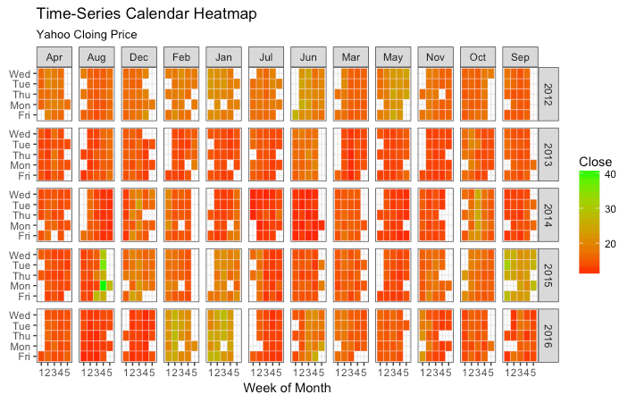
  - Slope Chart 斜坡图
library(dplyr)
theme_set(theme_classic())
source_df <- read.csv("https://raw.githubusercontent.com/jkeirstead/r-slopegraph/master/cancer_survival_rates.csv")

# Define functions. Source: https://github.com/jkeirstead/r-slopegraph
tufte_sort <- function(df, x="year", y="value", group="group", method="tufte", min.space=0.05) {
## First rename the columns for consistency
ids <- match(c(x, y, group), names(df))
df <- df[,ids]
names(df) <- c("x", "y", "group")

## Expand grid to ensure every combination has a defined value
tmp <- expand.grid(x=unique(df$x), group=unique(df$group))
tmp <- merge(df, tmp, all.y=TRUE)
df <- mutate(tmp, y=ifelse(is.na(y), 0, y))

## Cast into a matrix shape and arrange by first column
require(reshape2)
tmp <- dcast(df, group ~ x, value.var="y")
ord <- order(tmp[,2])
tmp <- tmp[ord,]

min.space <- min.space*diff(range(tmp[,-1]))
yshift <- numeric(nrow(tmp))
## Start at "bottom" row
## Repeat for rest of the rows until you hit the top
for (i in 2:nrow(tmp)) {
## Shift subsequent row up by equal space so gap between
## two entries is >= minimum
mat <- as.matrix(tmp[(i-1):i, -1])
d.min <- min(diff(mat))
yshift[i] <- ifelse(d.min < min.space, min.space - d.min, 0)
}

tmp <- cbind(tmp, yshift=cumsum(yshift))

scale <- 1
tmp <- melt(tmp, id=c("group", "yshift"), variable.name="x", value.name="y")
## Store these gaps in a separate variable so that they can be scaled ypos = a*yshift + y

tmp <- transform(tmp, ypos=y + scale*yshift)
return(tmp)
}

plot_slopegraph <- function(df) {
ylabs <- subset(df, x==head(x,1))$group
yvals <- subset(df, x==head(x,1))$ypos
fontSize <- 3
gg <- ggplot(df,aes(x=x,y=ypos)) +
geom_line(aes(group=group),colour="grey80") +
geom_point(colour="white",size=8) +
geom_text(aes(label=y), size=fontSize, family="American Typewriter") +
scale_y_continuous(name="", breaks=yvals, labels=ylabs)
return(gg)
}

## Prepare data
df <- tufte_sort(source_df,
x="year",
y="value",
group="group",
method="tufte",
min.space=0.05)

df <- transform(df,
x=factor(x, levels=c(5,10,15,20),
labels=c("5 years","10 years","15 years","20 years")),
y=round(y))

## Plot
plot_slopegraph(df) + labs(title="Estimates of % survival rates") +
theme(axis.title=element_blank(),
axis.ticks = element_blank(),
plot.title = element_text(hjust=0.5,
family = "American Typewriter",
face="bold"),
axis.text = element_text(family = "American Typewriter",face="bold"))
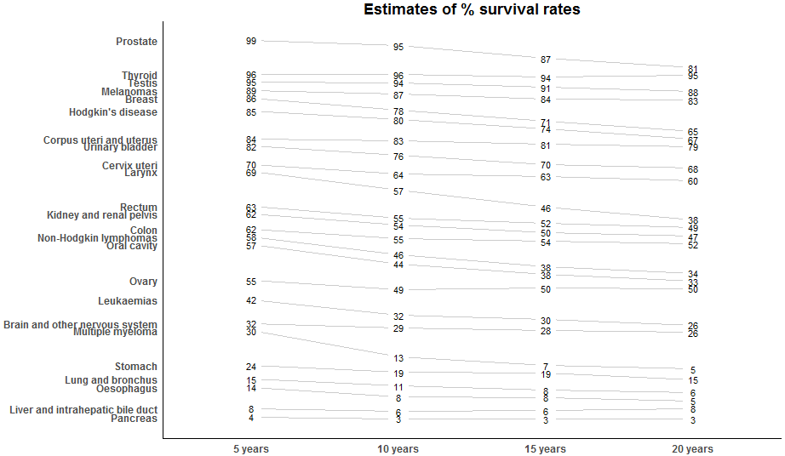
  - Seasonal Plot 季节性图
library(ggplot2)
library(forecast)
theme_set(theme_classic())

# Subset data
nottem_small <- window(nottem, start=c(1920, 1), end=c(1925, 12)) # subset a smaller timewindow
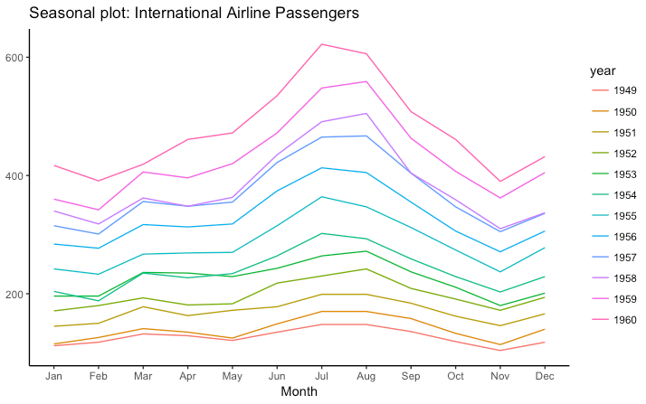
# Plot
ggseasonplot(AirPassengers) + labs(title="Seasonal plot: International Airline Passengers")
ggseasonplot(nottem_small) + labs(title="Seasonal plot: Air temperatures at Nottingham Castle")
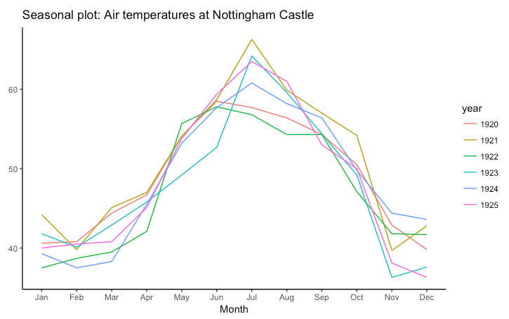
- Groups
数据聚类
  - Hierarchical Dendrogram分层系统树图
用途：使用树状图展示聚类结果
方法：使用R包ggdendro中hclust函数
# install.packages("ggdendro")
library(ggplot2)
library(ggdendro)
theme_set(theme_bw())

hc <- hclust(dist(USArrests), "ave") # hierarchical clustering

# plot
ggdendrogram(hc, rotate = TRUE, size = 2)
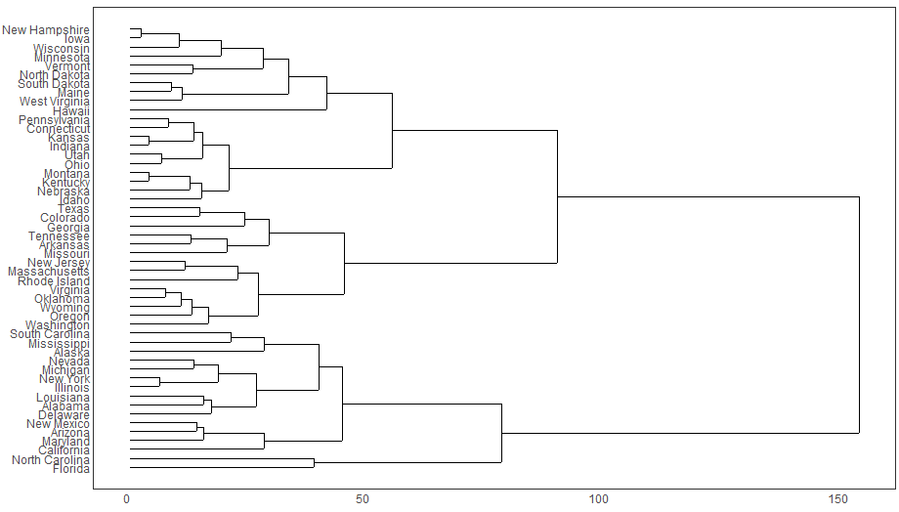
  - Clusters
用途：用区域图展示聚类结果
方法：使用R包ggfortify和R包ggalt中函数
# devtools::install_github("hrbrmstr/ggalt")
library(ggplot2)
library(ggalt)
library(ggfortify)
theme_set(theme_classic())

# Compute data with principal components ------------------
df <- iris[c(1, 2, 3, 4)]
pca_mod <- prcomp(df) # compute principal components

# Data frame of principal components ----------------------
df_pc <- data.frame(pca_mod$x, Species=iris$Species) # dataframe of principal components
df_pc_vir <- df_pc[df_pc$Species == "virginica", ] # df for 'virginica'
df_pc_set <- df_pc[df_pc$Species == "setosa", ] # df for 'setosa'
df_pc_ver <- df_pc[df_pc$Species == "versicolor", ] # df for 'versicolor'

# Plot ----------------------------------------------------
ggplot(df_pc, aes(PC1, PC2, col=Species)) +
geom_point(aes(shape=Species), size=2) + # draw points
labs(title="Iris Clustering",
subtitle="With principal components PC1 and PC2 as X and Y axis",
caption="Source: Iris") +
coord_cartesian(xlim = 1.2 * c(min(df_pc$PC1), max(df_pc$PC1)),
ylim = 1.2 * c(min(df_pc$PC2), max(df_pc$PC2))) + # change axis limits
geom_encircle(data = df_pc_vir, aes(x=PC1, y=PC2)) + # draw circles
geom_encircle(data = df_pc_set, aes(x=PC1, y=PC2)) +
geom_encircle(data = df_pc_ver, aes(x=PC1, y=PC2))
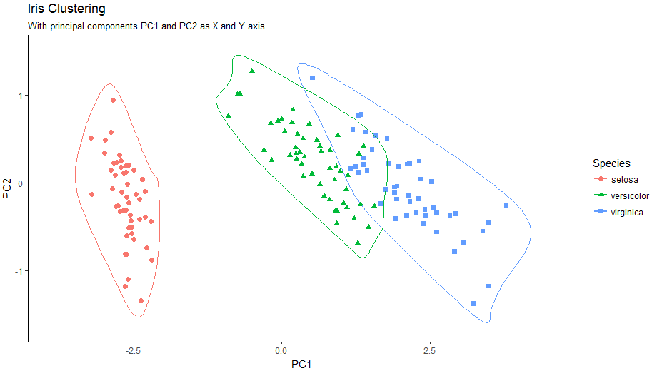
- Spatial
用途：展示google区域图
# Better install the dev versions ----------
# devtools::install_github("dkahle/ggmap")
# devtools::install_github("hrbrmstr/ggalt")

# load packages
library(ggplot2)
library(ggmap)
library(ggalt)

# Get Chennai's Coordinates --------------------------------
chennai <- geocode("Chennai") # get longitude and latitude

# Get the Map ----------------------------------------------
# Google Satellite Map
chennai_ggl_sat_map <- qmap("chennai", zoom=12, source = "google", maptype="satellite")

# Google Road Map
chennai_ggl_road_map <- qmap("chennai", zoom=12, source = "google", maptype="roadmap")

# Google Hybrid Map
chennai_ggl_hybrid_map <- qmap("chennai", zoom=12, source = "google", maptype="hybrid")

# Open Street Map
chennai_osm_map <- qmap("chennai", zoom=12, source = "osm")

# Get Coordinates for Chennai's Places ---------------------
chennai_places <- c("Kolathur",
"Washermanpet",
"Royapettah",
"Adyar",
"Guindy")

places_loc <- geocode(chennai_places) # get longitudes and latitudes

# Plot Open Street Map -------------------------------------
chennai_osm_map + geom_point(aes(x=lon, y=lat),
data = places_loc,
alpha = 0.7,
size = 7,
color = "tomato") +
geom_encircle(aes(x=lon, y=lat),
data = places_loc, size = 2, color = "blue")

# Plot Google Road Map -------------------------------------
chennai_ggl_road_map + geom_point(aes(x=lon, y=lat),
data = places_loc,
alpha = 0.7,
size = 7,
color = "tomato") +
geom_encircle(aes(x=lon, y=lat),
data = places_loc, size = 2, color = "blue")

# Google Hybrid Map ----------------------------------------
chennai_ggl_hybrid_map + geom_point(aes(x=lon, y=lat),
data = places_loc,
alpha = 0.7,
size = 7,
color = "tomato") +
geom_encircle(aes(x=lon, y=lat),
data = places_loc, size = 2, color = "blue")
