## Class Diagram

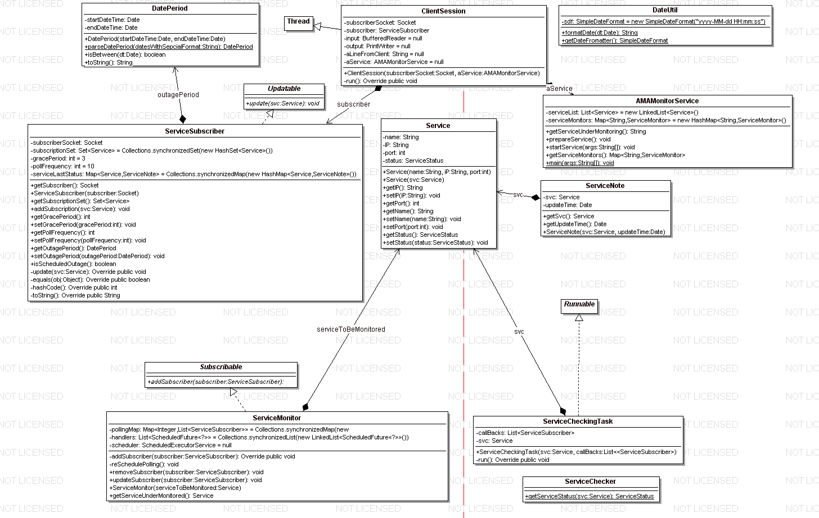The service includes mainly two parts. One is for client communication and another is for service monitoring. AMAMonitorService has a registry of services to be monitored. It start one ServiceMonitor for each service under monitoring. It also has a pool of service subscribers who are interested in receiving service update. A ServiceSubscriber can subscribe to ServiceMonitor, and ServiceMonitor can update service status back to ServiceSubscriber.

ServiceMonitor schedules service checking according to polling requests from subscribers and arrange them to run as ServiceCheckTask, which uses ServiceChecker to check service status.

ClientSession is an interpreter of network protocol which is used by AMAMonitorService to talk with client. ServiceSubscriber is server side client representative. It has caller’s properties such as polling frequency and service subscription, it communicates with caller via ClientSession.

## Conceptual sequence Diagram

Service status

Restricted Update based on polling, grace period and outage settings

Service status

Get service status

execute

schedule

create

create

create

Connect

ClientSession

ServiceSubscriber

ServiceMonitor

ServiceCheckingTask

ServiceChecker

AMAMonitorService

caller

## Network Protocol

Basic format is like this:

### Command

For command without parameter, it is defined as command suffixed with colon.

Command:

For example, shutdown: will shut down the monitoring service.

For command with parameters, it is defined as multiple line content. First line is command with same form as command without parameter. Followings lines are parameters. Each parameter uses one line. It is ended with a special terminator defined as “.end.”.

Command:  
 parameter1

Parameter 2

…

ParameterN

.end.

For example, the following commands subscribe two services.

subscribe:

gWeb

GRWeb

.end.

Responses to client are not well defined, but basically every response will be ended with “.end.”.

Implementation details are in ClientSession class.

Some examples are provided in SampleCommands.txt in docs folder.