Project: Commodity Price Intelligence Dashboard
The one-liner: A full-stack app that ingests live oil/commodity data, runs time-series forecasting and anomaly detection, and surfaces everything in a React dashboard — deployed as a cloud microservice.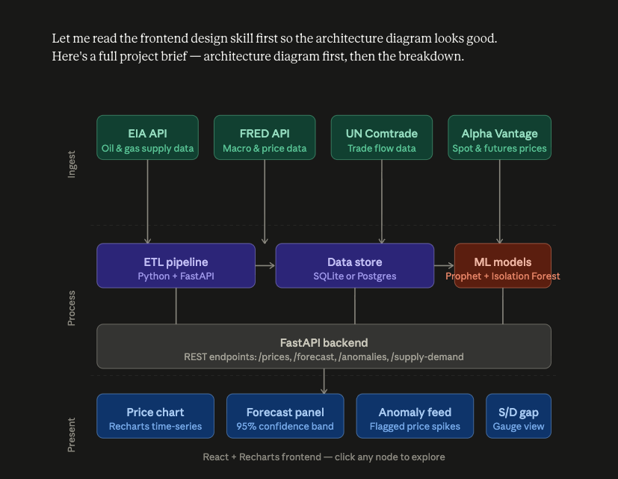

Phase 1 — Data ingestion (Week 1)
Build a Python ETL pipeline that pulls from EIA and FRED on a schedule (APScheduler or a simple cron). Normalize the data and store it in SQLite to start — you can migrate to Postgres later if you want Azure to feel more realistic. Write a few SQL views for common queries like weekly price rolling averages and YoY supply changes. This maps directly to the ETL and SQL requirements in the JD.
Phase 2 — ML layer (Week 2)
Two models, both straightforward to build and explain well in an interview:
- Prophet for weekly price forecasting (handles seasonality out of the box, produces nice confidence intervals)
- Isolation Forest for anomaly detection on price and volume data (flags unusual spikes — e.g. a 3-sigma move in Brent crude)
Wrap both in a FastAPI service with endpoints like /forecast?commodity=crude_oil&horizon=30 and /anomalies?start=2024-01-01. This is your "microservice on cloud" story.
Phase 3 — Frontend (Week 3)
React app with three main views: a price trend chart (Recharts), a forecast panel with confidence bands, and an anomaly feed that highlights flagged dates. Keep it clean — this is a trading analytics tool, not a marketing site. Dark mode looks good for this domain.
Phase 4 — Deployment (Week 4)
Deploy the FastAPI backend to Azure Container Apps (free tier is sufficient). Set up a GitHub Actions workflow to rebuild and redeploy on push. This gives you a real "maintained microservices on Azure with automated workflow" talking point.

Tech choices that match the JD exactly
JD requirement | What you build
Python, SQL | ETL pipeline + SQL views
REST API integration | EIA, FRED, Alpha Vantage clients
Azure microservices | FastAPI on Azure Container Apps
BI / dashboards | React + Recharts frontend
Time-series forecasting | Prophet model
ML anomaly detection | Isolation Forest
LLM/Agent (bonus) | Optional: NL query layer like SPARK

The optional SPARK layer
If you want to go beyond the baseline, bolt on a simple natural language query agent on top of the FastAPI — same architecture you already built at Shopee, just pointed at commodity data. "What was the biggest supply-demand gap last quarter?" becomes a solved problem. That alone sets you apart from anyone else applying with a generic ML project.
Want me to scaffold the project structure or write the ETL pipeline starter code?

