一、给有兴趣的同事看的，纯粹为了找现成例子的同事可以直接跳到下一节
echarts是常用的报表绘图工具之一，其他类似的绘图工具还有如：
fusionCharts：http://www.fusioncharts.com/javascript-chart-fiddles/
highcharts：http://www.hcharts.cn/
网上找的还有其他的：
http://www.cnblogs.com/lhb25/archive/2011/04/12/1964343.html
其他的几个我还不熟，这里主要介绍echart。
echarts的使用说明官网上有详细的文字参考，点击5 分钟上手 ECharts
有兴趣的同事可以通过点击上面给出的链接进行学习，一步一步看到一个丰富多彩的华丽报表世界：
特性说明
各种版本的echarts插件下载
API
配置项（这个是最常用的，通过搜索框搜索配置项关键字姐可以很容易获取到相应的配置项说明，不用去百度各种找，我下面写的“常用配置内容”都在这里面）
GL配置项（实现三维可视化）
官方实例
GL实例
社区（这个是我最喜欢的一个版块，展开筛选，例子全面，想要的效果基本都能找到些可参考的，平时开发的时候用的比较多）
重要：官方实例、GL实例、社区里的例子你点进去试试，看到没？能在线编辑，别怕把它改挫了，改挫了刷新就变回原来的样子了，这里就是给你练手的地方，使劲改。
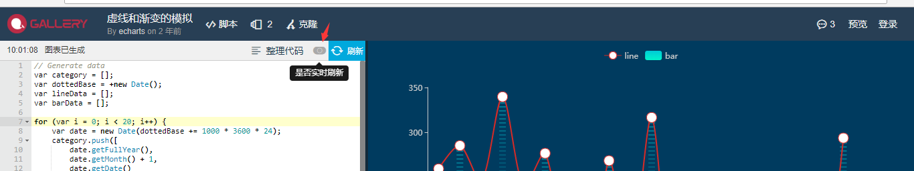
看到上面图片里的箭头没？点红它，你修改的效果就能实时在右侧展现。实际项目开发时在这里先调试好效果也是不错的选择。

好了，echarts海洋之门已经就此打开，尽情地在里面游泳吧。

二、关于配置项和相应配置项参数

要点
首先，我要告诉你要画出一个echarts你需要准备些什么，不用紧张，不用你长得帅，不用你有车有房，你只需要有一个jquery.js插件和一个echarts.js插件，echarts.js你可以点这里去下载到本地，也可以直接引用echarts的在线最新版本链接：
<script src="http://gallery.echartsjs.com/dep/echarts/latest/echarts.js"></script>
然后，你需要在你的dom结构中增加一个用来安放echarts的有宽高的容器，比如：
<div class="echarts-dome" style="height: 600px;width: 600px">
<div id="echarts-dome"></div>
</div>

然后，用js的方式写一个可执行的绘制脚本，比如：

(function() {
var mainContainer = document.getElementById('echarts-dome');
var echartsdome = document.getElementsByClassName('echarts-dome');
//用于使chart自适应高度和宽度,通过窗体高宽计算容器高宽
var resizeMainContainer = function () {
mainContainer.style.width = $(echartsdome[0]).width() + 'px';
mainContainer.style.height = $(echartsdome[0]).height() + 'px';
};
//设置div容器高宽
resizeMainContainer();
// 初始化图表
var mainChart = echarts.init(mainContainer);
$(echartsdome).on('resize', function () {
//屏幕大小自适应，重置容器高宽
resizeMainContainer();
mainChart.resize();
});

//重要：这里的option就是这个echarts的灵魂，我们下面叫做配置项及相应配置项说明
var option = {
xAxis: {
type: 'category',
data: ['Mon', 'Tue', 'Wed', 'Thu', 'Fri', 'Sat', 'Sun']
},
yAxis: {
type: 'value'
},
series: [{
data: [820, 932, 901, 934, 1290, 1330, 1320],
type: 'line'
}]//这里画了一条线，要画两条线，你就再往series里push一个type是'line'的
//json对象进去，要画什么type的图就push什么type的json对象进去。
};
mainChart.setOption(option);
})();

这样，你就能画出下面这个图了，不信你试试。

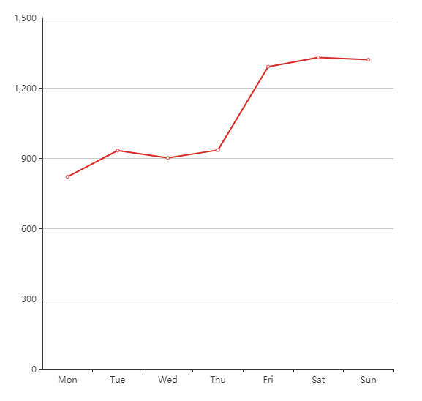

常用配置项说明
title -- 你要的标题
它长这样
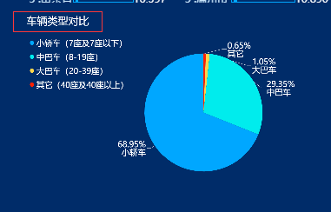
也可能长这样
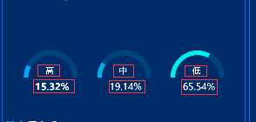
配置项相关的配置参数比如：
title.text-- 主标题文本，支持使用 \n 换行。
title.left-- title离容器左侧的距离
title.top-- title离容器上侧的距离
title.textStyle-- 主标题文本样式
title.textStyle.color-- 主标题文字的颜色
title.textStyle.fontStyle-- 主标题文字字体的风格
............实在太多无穷尽，不列举了，但是你得看到重点，都是什么点什么点什么，json格式的数据，其实整个echarts配置（option）就是基于json格式的数据，你所要知道的无非就是每个数据节点下面要放上些什么，都可以去这里找：
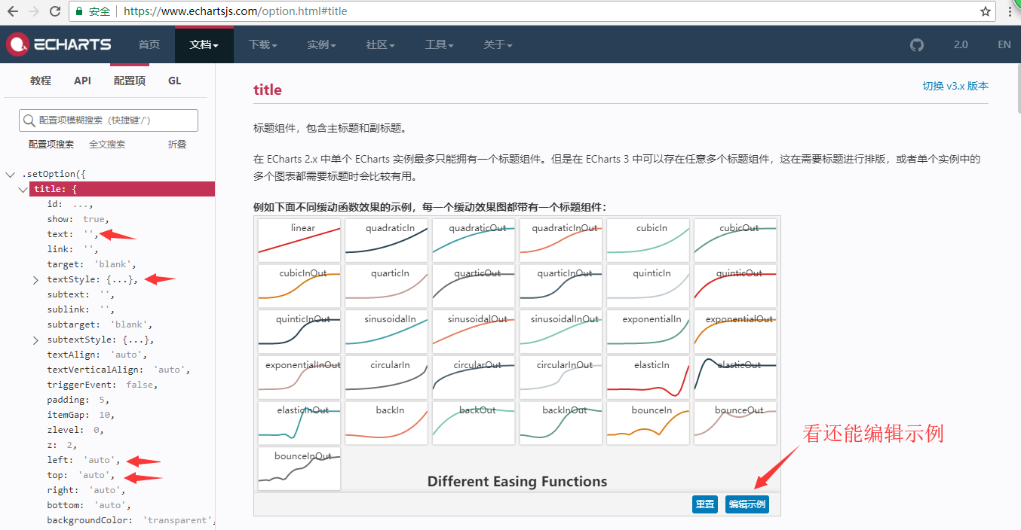

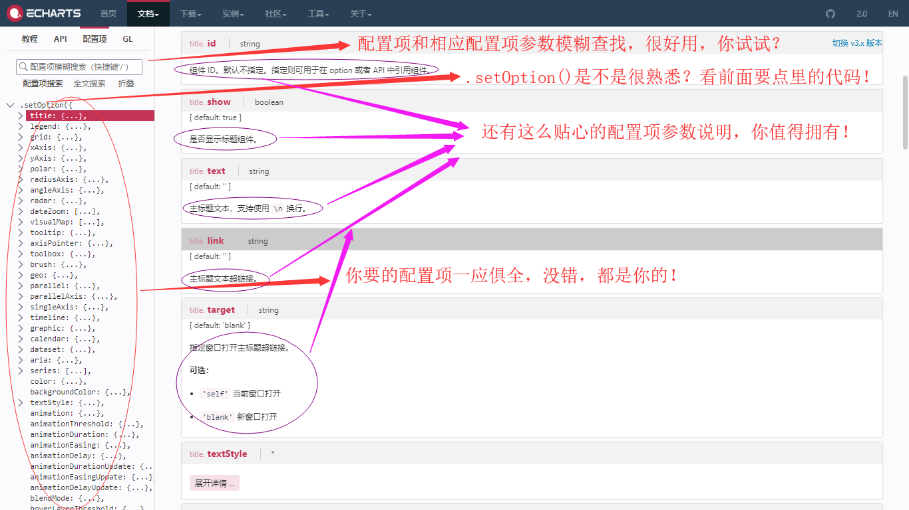

所以，更多的配置项和相应的配置项参数说明，去这里找，去这里找，去这里找，重要的事情说三遍。

那下面我就列举一些开发中常用的例子吧。

三、开发常用例子的option配置，都是之前做过的
认真点找，也许这才是你真正要的(Y_Y)，再说一句，配置项和相应的配置项参数说明，去这里找，不理解的请看上面的常用配置项说明。
以下列举的结构是：
echarts类型小标题 + 序号 + 效果图 + 实例option代码

饼图及其变形(type:'pie')

1.普通饼图
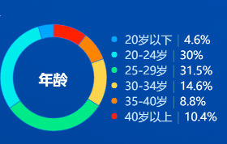

function showVisitorAgeChart(dataTemp) {
var mainContainer = document.getElementById('echarts-dome-visitorAge');
var echartsdome = document.getElementsByClassName('echarts-dome-visitorAge');
//用于使chart自适应高度和宽度,通过窗体高宽计算容器高宽
var resizeMainContainer = function () {
mainContainer.style.width = echartsdome[0].style.width + 'px';
mainContainer.style.height = 400 + 'px';
};
//设置div容器高宽
resizeMainContainer();
// 初始化图表
var mainChart = echarts.init(mainContainer);
$(echartsdome).on('resize', function () {
//屏幕大小自适应，重置容器高宽
resizeMainContainer();
mainChart.resize();
});

var legendDataPercent = [];
var legendData = [];

for (var i = 0; i < dataTemp.length; i++) {
legendDataPercent[dataTemp[i].attribute] = dataTemp[i].percent;
legendData.push(dataTemp[i].attribute);
}

var option = {
dataset: {
source: dataTemp.reverse(),
dimensions: ['attribute', 'percent']
},
title: {text: '年龄', textStyle: {color: '#fff', fontSize: 36}, x: '18%', y: '45%'},
tooltip: {
trigger: 'item',
formatter: "{b}({d}%)",
textStyle: {color: '#fff', fontSize: 28}
},
legend: {
top: 'middle',
orient: 'vertical',
x: '48%',
y: '0',
icon: 'circle',
data: legendData,
textStyle: {
rich: {
a: {
color: '#D0E4F9',
fontSize: 28
},
b: {
color: '#537BA5',
fontSize: 28
},
c: {
color: '#FFFFFF',
fontSize: 28
}
}
},
formatter: function (param) {
var arr = [
'{a| ' + param + '}',
'{b|' + ' | ' + '}',
'{c|' + legendDataPercent[param] + '%}'
]
return arr;
}
},
series: [{
type: 'pie',
center: ['25%', '50%'],
radius: ['50%', '66%'],
labelLine: {
show: false
},
label: {
show: false
},
itemStyle: {
borderColor: 'rgba(25,103,224,0.6)',
borderWidth: 2,
}
}],

color: ['#FF3B30', '#F78C26', '#FFD74C', '#3DE67F', '#29E8E9 ', '#00A5FF ']

};

mainChart.setOption(option);
}

2.四分之三饼图
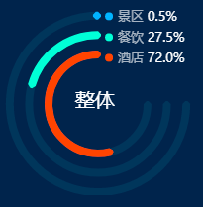

function consumptionClassificationAllDraw(data_arr) {
var mainContainer = document.getElementById('consume1');
var echartsdome = document.getElementsByClassName('con_bot');
//用于使chart自适应高度和宽度,通过窗体高宽计算容器高宽
var resizeMainContainer = function () {
mainContainer.style.width = ($(echartsdome[0]).width() / 2) + 'px';
mainContainer.style.height = $(echartsdome[0]).height() + 'px';
};
//设置div容器高宽
resizeMainContainer();
// 初始化图表
var mainChart = echarts.init(mainContainer);
$(echartsdome).on('resize', function () {
//屏幕大小自适应，重置容器高宽
resizeMainContainer();
mainChart.resize();
});

var color1 = 'rgba(0, 178, 255, 1)';
var color2 = 'rgba(0, 255, 209, 1)';
var color3 = 'rgba(255, 84, 43, 1)';
var color_bottom = 'rgba(0, 49, 91, 1)';
if ($.isEmptyObject(data_arr)) {
data_arr['景区'] = 0;
data_arr['餐饮'] = 0;
data_arr['酒店'] = 0;
}

var data_total = data_arr['景区'] + data_arr['餐饮'] + data_arr['酒店'];
var jqd = 75 * data_arr['景区'] / data_total;
var jqd_r = 100 - jqd;

var cyd = 75 * data_arr['餐饮'] / data_total;
var cyd_r = 100 - cyd;

var jdd = 75 * data_arr['酒店'] / data_total;
var jdd_r = 100 - jdd;

var radius1 = ['90%', '92%'];
var radius2 = ['70%', '72%'];
var radius3 = ['50%', '52%'];

var linear_color1 = {
type: 'linear',
x: 0,
y: 0,
x2: 0,
y2: 1,
colorStops: [{
offset: 0,
color: color1
}, {
offset: 1,
color: color1
}]
};

var linear_color2 = {
type: 'linear',
x: 0,
y: 0,
x2: 0,
y2: 1,
colorStops: [{
offset: 0,
color: color2
}, {
offset: 1,
color: color2
}]
};

var linear_color3 = {
type: 'linear',
x: 0,
y: 0,
x2: 0,
y2: 1,
colorStops: [{
offset: 0,
color: color3
}, {
offset: 1,
color: color3
}]
};

var linear_color_bottom = {
type: 'linear',
x: 0,
y: 0,
x2: 0,
y2: 1,
colorStops: [{
offset: 0,
color: color_bottom
}, {
offset: 1,
color: color_bottom
}]
};

var circle1 = [{
name: '背景',
type: 'pie',
clockWise: false, //顺时加载
radius: radius1,
center: ['50%', '53%'],
silent: true,
label: {
show: false,
},
labelLine: {
show: false,
},
data: [{
value: 75,
itemStyle: {
normal: {
color: linear_color_bottom,
borderWidth: 6,
borderColor: linear_color_bottom,
},
emphasis: {

color: linear_color_bottom,
borderWidth: 6,
borderColor: linear_color_bottom,
}
}
},
{
value: 25,
itemStyle: {
normal: {
color: 'rgba(0,0,0,0)'
}
}
}]
}, {
name: '景区',
type: 'pie',
hoverAnimation: false,
clockWise: false, //顺时加载
radius: radius1,
center: ['50%', '53%'],
color: [color1],
label: {
show: false,
},
labelLine: {
show: false,
},
data: [{
value: jqd,
itemStyle: {
normal: {
color: linear_color1,
borderWidth: 6,
borderColor: linear_color1,
},
emphasis: {
color: linear_color1,
borderWidth: 6,
borderColor: linear_color1,
}
}
}, {
value: jqd_r,
itemStyle: {
normal: {
color: 'rgba(0,0,0,0)'
}
}
}]

}];

var circle2 = [{
name: '背景',
type: 'pie',
clockWise: false, //顺时加载
radius: radius2,
center: ['50%', '53%'],
silent: true,
label: {
show: false,
},
labelLine: {
show: false,
},
data: [{
value: 75,
itemStyle: {
normal: {
color: linear_color_bottom,
borderWidth: 6,
borderColor: linear_color_bottom,
},
emphasis: {

color: linear_color_bottom,
borderWidth: 6,
borderColor: linear_color_bottom,
}
}
},
{
value: 25,
itemStyle: {
normal: {
color: 'rgba(0,0,0,0)'
}
}
}]
}, {
name: '餐饮',
type: 'pie',
hoverAnimation: false,
clockWise: false, //顺时加载
radius: radius2,
center: ['50%', '53%'],
color: [color2],
label: {
show: false,
},
labelLine: {
show: false,
},
data: [{
value: cyd,
itemStyle: {
normal: {
color: linear_color2,
borderWidth: 6,
borderColor: linear_color2,
},
emphasis: {
color: linear_color2,
borderWidth: 6,
borderColor: linear_color2,
}
}
}, {
value: cyd_r,
itemStyle: {
normal: {
color: 'rgba(0,0,0,0)'
}
}
}]

}];

var circle3 = [{
name: '背景',
type: 'pie',
silent: true,
clockWise: false, //顺时加载
radius: radius3,
center: ['50%', '53%'],
hoverAnimation: false,
label: {
show: false,
},
labelLine: {
show: false,
},
data: [{
value: 75,
itemStyle: {
normal: {
color: linear_color_bottom,
borderWidth: 6,
borderColor: linear_color_bottom,
},
emphasis: {

color: linear_color_bottom,
borderWidth: 6,
borderColor: linear_color_bottom,
}
}
},
{
value: 25,
itemStyle: {
normal: {
color: 'rgba(0,0,0,0)'
}
}
}]

}, {
name: '酒店',
type: 'pie',
hoverAnimation: false,
clockWise: false, //顺时加载
radius: radius3,
center: ['50%', '53%'],
color: [color3],
label: {
show: false,
},
labelLine: {
show: false,
},
data: [{
value: jdd,
itemStyle: {
normal: {
color: linear_color3,
borderWidth: 6,
borderColor: linear_color3,
},
emphasis: {

color: linear_color3,
borderWidth: 6,
borderColor: linear_color3,
}
}
}, {
value: jdd_r,
itemStyle: {
normal: {
color: 'rgba(0,0,0,0)'
}
}
}]

}];

var option = {
title: {
text: '整体',
left: '46%',
top: '43%',
textAlign: 'center',
textStyle: {
color: '#fff',
fontWeight: 'normal',
fontSize: '20',
textAlign: 'center',
},
},
backgroundColor: 'rgba(0, 0, 0, 0)',
colors: ['yellow', 'red', 'blue'],
legend: {
orient: 'vertical',
x: '51%',
y: '2%',
icon: 'circle',
itemGap: 8,
itemWidth: 8,
itemHeight: 8,
data: ['景区', '餐饮', '酒店'],
selectedMode: false,
formatter: function (legendName) {
return '{a|' + legendName + '}' + '{b|' + ((data_total == 0) ? " " + 0 :
" " + (((data_arr[legendName] / data_total) * 100).toFixed(1))) + '%}';
},
textStyle: {
rich: {
a: {
color: 'rgba(255,255,255,0.65)',
fontSize: 13,
fontFamily: 'Microsoft YaHei'
},
b: {
color: '#FFFFFF',
fontSize: 13,
fontFamily: 'Microsoft YaHei'
},
c: {
color: '#FFFFFF',
fontSize: 13,
fontFamily: 'Microsoft YaHei'
},
d: {
color: 'rgba(255,255,255,0.65)',
fontSize: 13,
fontFamily: 'Microsoft YaHei'
},
}
},
},
series: circle1.concat(circle2).concat(circle3)
};

mainChart.setOption(option);

}

3.模拟仪表盘1
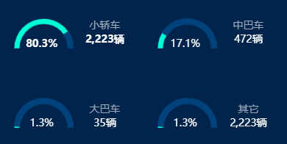

function carTypePointDataDraw(data, data_percent) {
var mainContainer = document.getElementById('cartTypeChar');
var echartsdome = document.getElementsByClassName('cartTypeChar');
//用于使chart自适应高度和宽度,通过窗体高宽计算容器高宽
var resizeMainContainer = function () {
mainContainer.style.width = $(echartsdome[0]).width() + 'px';
mainContainer.style.height = $(echartsdome[0]).height() + 'px';
};
//设置div容器高宽
resizeMainContainer();
// 初始化图表
var mainChart = echarts.init(mainContainer);
$(echartsdome).on('resize', function () {
//屏幕大小自适应，重置容器高宽
resizeMainContainer();
mainChart.resize();
});

var radius1 = ['35%', '42%'];
var radius2 = ['34%', '43%'];

//小轿车、大巴车
var left3_title = '35%';
//中巴车、其它
var left4_title = '85%';
//小轿车、中巴车
var top3_title = '10%';
//大巴车、其它
var top4_title = '70%';

//小轿车、大巴车
var left3_title_num = '35%';
//中巴车、其它
var left4_title_num = '85%';
//小轿车、中巴车
var top3_title_num = '20%';
//大巴车、其它
var top4_title_num = '80%';

//小轿车、大巴车
var left3_title_percent = '13%';
//中巴车、其它
var left4_title_percent = '63%';
//小轿车、中巴车
var top3_title_percent = '23%';
//大巴车、其它
var top4_title_percent = '80%';

var left1 = '15%';
var left2 = '65%';
var top1 = '33%';
var top2 = '90%';

var placeHolderStyle = {
normal: {
label: {
show: false
},
labelLine: {
show: false
},
color: "rgba(0,0,0,0)",
borderWidth: 0
},
emphasis: {
color: "rgba(0,0,0,0)",
borderWidth: 0
}
};

var dataStyle = {
normal: {
formatter: '{c}%',
position: 'center',
show: false,
textStyle: {
fontSize: '14',
fontWeight: 'normal',
color: '#fff'
}
}
};

var option = {

title: [
{
text: '小轿车',
left: left3_title,
top: top3_title,
textAlign: 'center',
textStyle: {
fontWeight: 'normal',
fontSize: '14',
color: '#A0AABB',
textAlign: 'center',
},
}, {
text: '中巴车',
left: left4_title,
top: top3_title,
textAlign: 'center',
textStyle: {
color: '#A0AABB',
fontWeight: 'normal',
fontSize: '14',
textAlign: 'center',
},
},
{
text: '大巴车',
left: left3_title,
top: top4_title,
textAlign: 'center',
textStyle: {
color: '#A0AABB',
fontWeight: 'normal',
fontSize: '14',
textAlign: 'center',
},
},
{
text: '其它',
left: left4_title,
top: top4_title,
textAlign: 'center',
textStyle: {
color: '#A0AABB',
fontWeight: 'normal',
fontSize: '14',
textAlign: 'center',
},
},
{
text: data_percent['小轿车'] + '%',
left: left3_title_percent,
top: top3_title_percent,
textAlign: 'center',
textStyle: {
fontWeight: 'bold',
fontSize: '14',
color: '#fff',
textAlign: 'center',
},
}, {
text: data_percent['中巴车'] + '%',
left: left4_title_percent,
top: top3_title_percent,
textAlign: 'center',
textStyle: {
color: '#fff',
fontWeight: 'normal',
fontSize: '14',
textAlign: 'center',
},
},
{
text: data_percent['大巴车'] + '%',
left: left3_title_percent,
top: top4_title_percent,
textAlign: 'center',
textStyle: {
color: '#fff',
fontWeight: 'normal',
fontSize: '14',
textAlign: 'center',
},
},
{
text: data_percent['其它'] + '%',
left: left4_title_percent,
top: top4_title_percent,
textAlign: 'center',
textStyle: {
color: '#fff',
fontWeight: 'normal',
fontSize: '14',
textAlign: 'center',
},
},
{
text: formatDataNumber(data['小轿车']) + '辆',
left: left3_title_num,
top: top3_title_num,
textAlign: 'center',
textStyle: {
fontWeight: 'bold',
fontSize: '14',
color: '#fff',
textAlign: 'center',
},
}, {
text: formatDataNumber(data['中巴车']) + '辆',
left: left4_title_num,
top: top3_title_num,
textAlign: 'center',
textStyle: {
color: '#fff',
fontWeight: 'normal',
fontSize: '14',
textAlign: 'center',
},
},
{
text: formatDataNumber(data['大巴车']) + '辆',
left: left3_title_num,
top: top4_title_num,
textAlign: 'center',
textStyle: {
color: '#fff',
fontWeight: 'normal',
fontSize: '14',
textAlign: 'center',
},
},
{
text: formatDataNumber(data['小轿车']) + '辆',
left: left4_title_num,
top: top4_title_num,
textAlign: 'center',
textStyle: {
color: '#fff',
fontWeight: 'normal',
fontSize: '14',
textAlign: 'center',
},
}
],
grid: {
bottom: 50,
},
series: [{
type: 'pie',
hoverAnimation: false, //鼠标经过的特效
radius: radius1,
center: [left1, top1],
startAngle: 180,
labelLine: {
normal: {
show: false
}
},
z: 2,
label: {
normal: {
position: 'center'
}
},
data: [
{
value: data_percent['小轿车'] / 2,
itemStyle: {
normal: {
color: '#00FECB',
}
},
label: dataStyle,
}, {
value: 100 - data_percent['小轿车'] / 2,
itemStyle: placeHolderStyle,
},
]
},
{
type: 'pie',
hoverAnimation: false,
radius: radius1,
center: [left2, top1],
startAngle: 180,
labelLine: {
normal: {
show: false
}
},
label: {
normal: {
position: 'center'
}
},
z: 2,
data: [{
value: data_percent['中巴车'] / 2,
itemStyle: {
normal: {
color: '#00FECB',
}
},
label: dataStyle,
}, {
value: 100 - data_percent['中巴车'] / 2,
itemStyle: placeHolderStyle,
},

]
},
{
type: 'pie',
hoverAnimation: false,
radius: radius1,
center: [left1, top2],
startAngle: 180,
labelLine: {
normal: {
show: false
}
},
label: {
normal: {
position: 'center'
}
},
z: 2,
data: [{
value: data_percent['大巴车'] / 2,
itemStyle: {
normal: {
color: '#00FECB',
}
},
label: dataStyle,
}, {
value: 100 - data_percent['大巴车'] / 2,
itemStyle: placeHolderStyle,
},

]
},
{
type: 'pie',
hoverAnimation: false,
radius: radius1,
center: [left2, top2],
startAngle: 180,
labelLine: {
normal: {
show: false
}
},
label: {
normal: {
position: 'center'
}
},
z: 2,
data: [{
value: data_percent['其它'] / 2,
itemStyle: {
normal: {
color: '#00FECB',
}
},
label: dataStyle,
}, {
value: 100 - data_percent['其它'] / 2,
itemStyle: placeHolderStyle,
},

]
},

//外圈的边框
{
// name: '总人数',
type: 'pie',
hoverAnimation: false, //鼠标经过的特效
radius: radius2,
center: [left1, top1],
startAngle: 180,
labelLine: {
normal: {
show: false
}
},
label: {
normal: {
position: 'center'
}
},
z: 1,
data: [{
value: 50,
itemStyle: {
normal: {
color: '#083F7D'
}
},
}, {
value: 50,
itemStyle: placeHolderStyle,
},

]
},
{
type: 'pie',
hoverAnimation: false,
radius: radius2,
center: [left2, top1],
startAngle: 180,
labelLine: {
normal: {
show: false
}
},
label: {
normal: {
position: 'center'
}
},
z: 1,
data: [{
value: 50,
itemStyle: {
normal: {
color: '#083F7D'
}
},
}, {
value: 50,
itemStyle: placeHolderStyle,
},

]
},
{
type: 'pie',
hoverAnimation: false,
radius: radius2,
center: [left1, top2],
startAngle: 180,
labelLine: {
normal: {
show: false
}
},
label: {
normal: {
position: 'center'
}
},
z: 1,
data: [{
value: 50,
itemStyle: {
normal: {
color: '#083F7D'
}
},
}, {
value: 50,
itemStyle: placeHolderStyle,
},

]
},
{
type: 'pie',
hoverAnimation: false,
radius: radius2,
center: [left2, top2],
startAngle: 180,
labelLine: {
normal: {
show: false
}
},
label: {
normal: {
position: 'center'
}
},
z: 1,
data: [{
value: 50,
itemStyle: {
normal: {
color: '#083F7D'
}
},
}, {
value: 50,
itemStyle: placeHolderStyle,
},

]
},
]
};

mainChart.setOption(option);
}

4.模拟仪表盘2
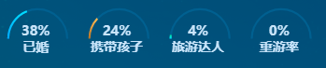

function setFourCharts() {
var mainContainer = document.getElementById('visitor-echart');
var echartsdome = document.getElementsByClassName('visitor-echart');
//用于使chart自适应高度和宽度,通过窗体高宽计算容器高宽
var resizeMainContainer = function () {
mainContainer.style.width = $(echartsdome[0]).width() + 'px';
mainContainer.style.height = $(echartsdome[0]).height() + 'px';
};
//设置div容器高宽
resizeMainContainer();
// 初始化图表
var mainChart = echarts.init(mainContainer);
$(echartsdome).on('resize', function () {
//屏幕大小自适应，重置容器高宽
resizeMainContainer();
mainChart.resize();
});

var radius = ['86%', '92%'];

var left1 = '12%';
var left2 = '36%';
var left3 = '60%';
var left4 = '84%';

var left_percent_title1 = '10%';
var left_percent_title2 = '34%';
var left_percent_title3 = '58%';
var left_percent_title4 = '82%';

var top = '50%';
var top_percent = '21%';
var top_title = '45%';

var data = [];
data['已婚'] = 0;
data['旅游达人'] = 0;
data['携带孩子'] = 0;
data['重游率'] = 0;
var data_percent = [];
data_percent['已婚'] = 0;
data_percent['旅游达人'] = 0;
data_percent['携带孩子'] = 0;
data_percent['重游率'] = 0;
var total_num = 0;
if (marriedData.length > 0) {
data_percent['已婚'] = marriedData[0].percent;
}

if (withChildData.length > 0) {
data_percent['携带孩子'] = withChildData[0].percent;
}

if (expertData.length > 0) {
data_percent['旅游达人'] = expertData[0].percent;
}

if (revisitRatioData.length > 0) {
data_percent['重游率'] = revisitRatioData[0].percent;
}

var placeHolderStyle = {
normal: {
label: {
show: false
},
labelLine: {
show: false
},
color: "rgba(0,0,0,0)",
borderWidth: 0
},
emphasis: {
color: "rgba(0,0,0,0)",
borderWidth: 0
}
};

var dataStyle = {
normal: {
formatter: '{c}%',
position: 'center',
show: false,
textStyle: {
fontSize: '14',
fontWeight: 'normal',
color: '#fff'
}
}
};

var option = {

title: [
{
text: '已婚',
left: left_percent_title1,
top: top_title,
textAlign: 'center',
textStyle: {
fontSize: '14',
color: '#D0E4F9',
textAlign: 'center',
fontFamily: 'Microsoft YaHei'
},
}, {
text: '携带孩子',
left: left_percent_title2,
top: top_title,
textAlign: 'center',
textStyle: {
fontSize: '14',
color: '#D0E4F9',
textAlign: 'center',
fontFamily: 'Microsoft YaHei'
},
},
{
text: '旅游达人',
left: left_percent_title3,
top: top_title,
textAlign: 'center',
textStyle: {
fontSize: '14',
color: '#D0E4F9',
textAlign: 'center',
fontFamily: 'Microsoft YaHei'
},
},
{
text: '重游率',
left: left_percent_title4,
top: top_title,
textAlign: 'center',
textStyle: {
fontSize: '14',
color: '#D0E4F9',
textAlign: 'center',
fontFamily: 'Microsoft YaHei'
},
},
{
text: data_percent['已婚'] + '%',
left: left_percent_title1,
top: top_percent,
textAlign: 'center',
textStyle: {
fontSize: '14',
color: '#D0E4F9',
textAlign: 'center',
fontFamily: 'Microsoft YaHei'
},
}, {
text: data_percent['携带孩子'] + '%',
left: left_percent_title2,
top: top_percent,
textAlign: 'center',
textStyle: {
fontSize: '14',
color: '#D0E4F9',
textAlign: 'center',
fontFamily: 'Microsoft YaHei'
},
},
{
text: data_percent['旅游达人'] + '%',
left: left_percent_title3,
top: top_percent,
textAlign: 'center',
textStyle: {
fontSize: '14',
color: '#D0E4F9',
textAlign: 'center',
fontFamily: 'Microsoft YaHei'
},
},
{
text: data_percent['重游率'] + '%',
left: left_percent_title4,
top: top_percent,
textAlign: 'center',
textStyle: {
fontSize: '14',
color: '#D0E4F9',
textAlign: 'center',
fontFamily: 'Microsoft YaHei'
},
}
],
grid: {
bottom: 50,
},
series: [{
type: 'pie',
hoverAnimation: false, //鼠标经过的特效
radius: radius,
center: [left1, top],
startAngle: 180,
labelLine: {
normal: {
show: false
}
},
z: 2,
label: {
normal: {
position: 'center'
}
},
data: [{
value: data_percent['已婚'] / 2,
itemStyle: {
normal: {
color: new echarts.graphic.LinearGradient(0, 0, 0, 1, [{
offset: 0, color: '#00DDFF'
}, {
offset: 1, color: '#00A5FF'
}], false),
}
},
label: dataStyle,
}, {
value: 100 - data_percent['已婚'] / 2,
itemStyle: placeHolderStyle,
},

]
},
{
type: 'pie',
hoverAnimation: false,
radius: radius,
center: [left2, top],
startAngle: 180,
labelLine: {
normal: {
show: false
}
},
label: {
normal: {
position: 'center'
}
},
z: 2,
data: [{
value: data_percent['携带孩子'] / 2,
itemStyle: {
normal: {
color: new echarts.graphic.LinearGradient(0, 0, 0, 1, [{
offset: 0, color: '#F8BF56'
}, {
offset: 1, color: '#AE7625'
}], false),
}
},
label: dataStyle,
}, {
value: 100 - data_percent['携带孩子'] / 2,
itemStyle: placeHolderStyle,
},

]
},
{
type: 'pie',
hoverAnimation: false,
radius: radius,
center: [left3, top],
startAngle: 180,
labelLine: {
normal: {
show: false
}
},
label: {
normal: {
position: 'center'
}
},
z: 2,
data: [{
value: data_percent['旅游达人'] / 2,
itemStyle: {
normal: {
color: new echarts.graphic.LinearGradient(0, 0, 0, 1, [{
offset: 0, color: '#32E594'
}, {
offset: 1, color: '#00DCFF'
}], false),
}
},
label: dataStyle,
}, {
value: 100 - data_percent['旅游达人'] / 2,
itemStyle: placeHolderStyle,
},

]
},
{
type: 'pie',
hoverAnimation: false,
radius: radius,
center: [left4, top],
startAngle: 180,
labelLine: {
normal: {
show: false
}
},
label: {
normal: {
position: 'center'
}
},
z: 2,
data: [{
value: data_percent['重游率'] / 2,
itemStyle: {
normal: {
color: new echarts.graphic.LinearGradient(0, 0, 0, 1, [{
offset: 0, color: '#00A5FF'
}, {
offset: 1, color: '#C86DD7'
}], false),
}
},
label: dataStyle,
}, {
value: 100 - data_percent['重游率'] / 2,
itemStyle: placeHolderStyle,
},

]
},

//外圈的边框
{
// name: '总人数',
type: 'pie',
hoverAnimation: false, //鼠标经过的特效
radius: radius,
center: [left1, top],
startAngle: 180,
labelLine: {
normal: {
show: false
}
},
label: {
normal: {
position: 'center'
}
},
z: 1,
data: [{
value: 50,
itemStyle: {
normal: {
color: 'rgba(0, 95, 145, 1)'
}
},
}, {
value: 50,
itemStyle: placeHolderStyle,
},

]
},
{
type: 'pie',
hoverAnimation: false,
radius: radius,
center: [left2, top],
startAngle: 180,
labelLine: {
normal: {
show: false
}
},
label: {
normal: {
position: 'center'
}
},
z: 1,
data: [{
value: 50,
itemStyle: {
normal: {
color: 'rgba(0, 95, 145, 1)'
}
},
}, {
value: 50,
itemStyle: placeHolderStyle,
},

]
},
{
type: 'pie',
hoverAnimation: false,
radius: radius,
center: [left3, top],
startAngle: 180,
labelLine: {
normal: {
show: false
}
},
label: {
normal: {
position: 'center'
}
},
z: 1,
data: [{
value: 50,
itemStyle: {
normal: {
color: 'rgba(0, 95, 145, 1)'
}
},
}, {
value: 50,
itemStyle: placeHolderStyle,
},

]
},
{
type: 'pie',
hoverAnimation: false,
radius: radius,
center: [left4, top],
startAngle: 180,
labelLine: {
normal: {
show: false
}
},
label: {
normal: {
position: 'center'
}
},
z: 1,
data: [{
value: 50,
itemStyle: {
normal: {
color: 'rgba(0, 95, 145, 1)'
}
},
}, {
value: 50,
itemStyle: placeHolderStyle,
},

]
},
]
};

mainChart.setOption(option);
}

5.多个模拟仪表盘（摘自鸿图）
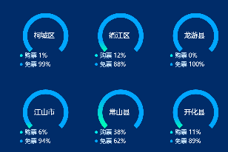

var series=[];
var titles=
[{text:'入园游客类型占比',x:20,y:'4%',textStyle:{color:'#fff',fontSize:36,fontWeight:400}}]

for(var i =0;i<chartData.xfData.length;i++){
if(i<3){
var x = i*30+20+'%'
var y = '33%'
var br =false
}else{
var x = (i-3)*30+20+'%'
var y = '75%'
var br =true
};
series.push({
name: chartData.xfData[i].AREA_NAME,
type: 'pie',
startAngle: 225,
color: [new echarts.graphic.LinearGradient(0, 0, 0, 1, [{
offset: 0,
color: '#00a2ff'
}, {
offset: 1,
color: '#70ffac'
}]), "transparent"],
z: 10,
center:[x,y],
radius: ['20%', '25%'],
labelLine: {
normal: {
show: false
}
},
data: [{
value: chartData.xfData[i].BUY_RATE*75/100
}, {
value: 100-chartData.xfData[i].BUY_RATE*75/100
}]
});
series.push({
name: chartData.xfData[i].AREA_NAME,
type: 'pie',
startAngle: 225,
center:[x,y],
color: ["#00A5FF", "transparent"],
radius: ['20%', '25%'],
labelLine: {
normal: {
show: false
}
},
data: [{
value: 75
}, {
value: 25
}]

});
if(!br){
titles.push({
text: chartData.xfData[i].AREA_NAME,
left: i*30+19+'%',
top: '30%',textAlign: 'center',
textStyle: {
fontWeight: 'normal',
fontSize: '28',
color: '#fff',
textAlign: 'center',
},
})
titles.push({
subtext: '{a|● }'+'{b|购票 }'+'{c|'+parseInt(chartData.xfData[i].BUY_RATE)+'%}'+'\n'+'\n'+ '{d|● }'+'{b|免票 }'+'{c|'+parseInt(chartData.xfData[i].FREE_RATE)+'%}',
left: i*30+9+'%',
top: '40%',
subtextStyle:{rich: {a:{color: '#29E8E9',fontSize: 24},b:{color:'#D0E4F9',fontSize:24},c:{color: '#FFF',fontSize: 24},d:{color: '#00A5FF',fontSize: 24}}}
})
}else{
titles.push({
text: chartData.xfData[i].AREA_NAME,
left: (i-3)*30+19+'%',
top: '72%',textAlign: 'center',
textStyle: {
fontWeight: 'normal',
fontSize: '28',
color: '#fff',
textAlign: 'center',
},
})
titles.push({
subtext: '{a|● }'+'{b|购票 }'+'{c|'+parseInt(chartData.xfData[i].BUY_RATE)+'%}'+'\n'+'\n'+ '{d|● }'+'{b|免票 }'+'{c|'+parseInt(chartData.xfData[i].FREE_RATE)+'%}',
left: (i-3)*30+9+'%',
top: '82%',
subtextStyle:{rich: {a:{color: '#29E8E9',fontSize: 24},b:{color:'#D0E4F9',fontSize:24},c:{color: '#FFF',fontSize: 24},d:{color: '#00A5FF',fontSize: 24}}}
})

}
}
option = {
title: titles,
series: series
};

6.多个饼图系列1（摘自鸿图）
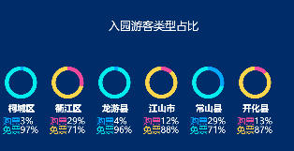

var place = ['柯城区','衢江区','龙游县','江山市','常山县','开化县']

var series= []
var titles=
[{text:'入园游客类型占比',textStyle:{color:'#fff',fontSize:36,fontWeight:400},x:'center',y:'10%'}]

for(var j=0;j<place.length;j++){
for(var i=0;i<chartData.rylx.length;i++){
if(place[j]==chartData.rylx[i].AREA_NAME){
var subtextStyle={}
if(j%2==0){
subtextStyle={rich: {a:{color: 'rgba(0,165,255,1)',fontSize: 28},b:{color:'#fff',fontSize:28},c:{color: '#29E8E9',fontSize: 28}}}
}else{
subtextStyle={rich: {a:{color: '#DD53A2',fontSize:28},b:{color:'#fff',fontSize:28},c:{color: '#FFD74C',fontSize: 28}}}
}
titles.push({
text:chartData.rylx[i].AREA_NAME,
textStyle:{color:'#fff',fontSize:28},
x:150*j+37,
y:'62%',
});
titles.push({
x:150*j+19,
y:'68%',
subtext:'{a|购票}'+'{b|'+parseInt(chartData.rylx[i].BUY_RATE)+'%}'+'\n'+'{c|免票}'+'{b|'+parseInt(chartData.rylx[i].FREE_RATE)+'%}',
subtextStyle: subtextStyle,})
series.push({
type:'pie',
radius: ['15%', '20%'],
center: [150*j+82,'50%'],
label: {
normal: {
show: false,
position: 'center'
},
},
labelLine: {
normal: {
show: false
}
},
data:[chartData.rylx[i].BUY_RATE,chartData.rylx[i].FREE_RATE]
})
}
}
}
console.log(titles);

option = {
title:titles,
color:['#00A5FF','#29E8E9','#DD53A2','#FFD74C'],
series: series,
};

7.多个饼图系列2（摘自鸿图）
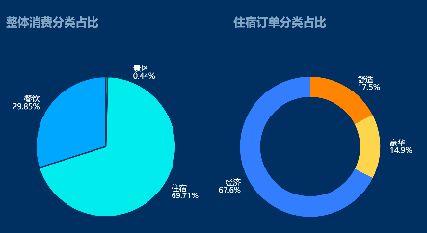

var colors = [];
var stayOrderDatas = [0,0,0];
for(var i = 0;i<chartData.stayOrderPercent.length;i++){
if(chartData.stayOrderPercent[i].attribute.indexOf('经济') >= 0){
stayOrderDatas[0] =chartData.stayOrderPercent[i].percent;
}else if(chartData.stayOrderPercent[i].attribute.indexOf('舒适') >= 0){
stayOrderDatas[1] =chartData.stayOrderPercent[i].percent;
}else if(chartData.stayOrderPercent[i].attribute.indexOf('豪华') >= 0){
stayOrderDatas[2] =chartData.stayOrderPercent[i].percent;
}
}

var scenic_percent = 0;
var hotel_percent = 0;
var catering_percent = 0;
var wholePayTypeNumber = chartData.wholePayTypeNumber;
var total_number = 0;
if(wholePayTypeNumber && wholePayTypeNumber != null && wholePayTypeNumber != ''){
for(var i = 0;i<wholePayTypeNumber.length;i++){
total_number += (wholePayTypeNumber[i].num - 0);
}

if(total_number>0){
for(var i = 0;i<wholePayTypeNumber.length;i++){
if(wholePayTypeNumber[i].name.trim() == 'catering'){
catering_percent = ((wholePayTypeNumber[i].num - 0)/total_number).toFixed(4);
}
if(wholePayTypeNumber[i].name.trim() == 'hotel'){
hotel_percent = ((wholePayTypeNumber[i].num - 0)/total_number).toFixed(4);
}
if(wholePayTypeNumber[i].name.trim() == 'scenic'){
scenic_percent = ((wholePayTypeNumber[i].num - 0)/total_number).toFixed(4);
}
}
}
}

option = {
backgroundColor: 'rgba(0, 0, 0, 0)',

title: [{
text: '整体消费分类占比',
left: '23',
top: 150,
textStyle: {
color: 'rgba(208,228,249,0.65)',
fontSize:36
}
},{
text: '住宿订单分类占比',
left: 731,
top: 150,
textStyle: {
color: 'rgba(208,228,249,0.65)',
fontSize:36
}
}],

/* tooltip : {
trigger: 'item',
formatter: "{a} <br/>{b} : {c} ({d}%)",
textStyle: {
fontSize:24
}
},*/
series : [
{
name:'整体消费订单分类占比',
type:'pie',
radius : '45%',
center: ['25%', '58%'],
color: ['rgba(61,230,127,1)', 'rgba(41,232,233,1)','rgba(0,165,255,1)'],
data:[
{value:scenic_percent, name:'景区'},
{value:hotel_percent, name:'住宿'},
{value:catering_percent, name:'餐饮'}
],
label: {
formatter: function(a){
console.log(a)
return '{b|'+a.name +'}'+'\n{c|' + a.percent + '%}';
},
rich:{
b:{
color:'#fff',
fontSize:24
},
c:{
color:'#fff',
fontSize:24
}
}
},
labelLine: {
show:false
},
itemStyle: {
normal: {
shadowBlur: 200,
shadowColor: 'rgba(0, 0, 0, 0)',
borderWidth: 4,
borderColor: 'rgba(5, 43, 98, 1)',
}
}
},
{
name:'住宿订单分类占比',
type:'pie',
radius : ['32%', '45%'],
center: ['72%', '58%'],
color: ['rgba(247,140,38,1)','rgba(255,215,76,1)','rgba(78,124,255,1)', ],
data:[
{value:stayOrderDatas[1], name:'舒适'},
{value:stayOrderDatas[2], name:'豪华'},
{value:stayOrderDatas[0], name:'经济'},
],
label: {
formatter: function(a){
console.log(a)
return '{b|'+a.name +'}'+'\n{c|' + a.percent + '%}';
},
rich:{
b:{
color:'#fff',
fontSize:24
},
c:{
color:'#fff',
fontSize:24
}
}
},
labelLine: {
show:false
},
itemStyle: {
normal: {
shadowBlur: 200,
shadowColor: 'rgba(0, 0, 0, 0)'
}
}
}
]
};

8.label线的设置（摘自鸿图）
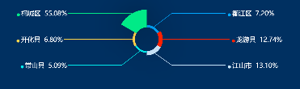

var colors = [];
colors['柯城区'] = 'rgba(61,230,127,1)';
colors['衢江区'] = 'rgba(0,165,255,1)';
colors['龙游县'] = 'rgba(255,59,48,1)';
colors['江山市'] = 'rgba(208,228,249,1)';
colors['常山县'] = 'rgba(41,232,233,1)';
colors['开化县'] = 'rgba(255,215,76,1)';

var percents = [];
percents['柯城区'] =0;
percents['衢江区'] =0;
percents['龙游县'] =0;
percents['江山市'] =0;
percents['常山县'] =0;
percents['开化县'] =0;

if(chartData.areaPayPercent){
for(var i = 0; i<chartData.areaPayPercent.length;i++){
percents[chartData.areaPayPercent[i].attribute] = chartData.areaPayPercent[i].percent;
}
}

option = {
backgroundColor: 'rgba(0, 0, 0, 0)',

title: {
text: '区县消费占比',
left: 23,
top: 20,
textStyle: {
color: '#fff',
fontSize:36
}
},
/*
tooltip : {
trigger: 'item',
formatter: "{a} <br/>{b} : {c} ({d}%)",
textStyle: {
fontSize:24
}
},*/
series : [
{
name:'消费情况',
type:'pie',
radius : ['20%', '50%'],
minAngle:60,
center: ['50%', '50%'],
color: [ 'rgba(0,165,255,1)', 'rgba(255,59,48,1)', 'rgba(208,228,249,1)', 'rgba(41,232,233,1)','rgba(255,215,76,1)','rgba(61,230,127,1)'],
data:[
{value:percents['衢江区'] , name:'衢江区'},
{value:percents['龙游县'] , name:'龙游县'},
{value:percents['江山市'] , name:'江山市'},
{value:percents['常山县'] , name:'常山县'},
{value:percents['开化县'] , name:'开化县'},
{value:percents['柯城区'] , name:'柯城区'},
],
roseType: 'radius',
label: {
formatter: function(a){
return '{a|·}'+'{b|'+a.name +' }'+'{c|' + a.value + '%}';
},
rich:{
a:{
fontSize:88
},
b:{
color:'#fff',
fontSize:24
},
c:{
color:'#fff',
fontSize:24
}
}
},
labelLine: {
smooth: false,
length: 1,
length2: 200,
lineStyle:{
width:2
}
},
itemStyle: {
normal: {
shadowBlur: 200,
shadowColor: 'rgba(0, 0, 0, 0.5)'
}
}
}
]
};

9.环形图（摘自鸿图）
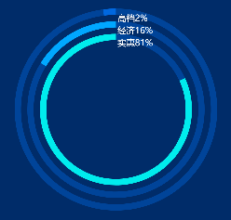

var bgColor = '#1967E0';
var data = {};
var dd=0;
$.each(chartData.jdflxdData,function(index,item){
//data[item.ATTRIBUTE] = parseFloat(item.PERCENT);
if (item.ATTRIBUTE =='实惠') {
dd+=parseFloat(item.PERCENT);
} else if (item.ATTRIBUTE =='经济') {
data[item.ATTRIBUTE] = parseFloat(item.PERCENT);
} else if (item.ATTRIBUTE =='高档') {
data[item.ATTRIBUTE] = parseFloat(item.PERCENT);
}

console.log(dd)

})
console.log("实惠" + dd);
data['实惠']=dd;

var radiuss = [['75%','80%'],['65%','70%'],['55%','60%']];

var sum = data['经济']+ data['实惠']+ data['高档'];

var placeHolderStyle = {
normal: {
label: {
show: false
},
labelLine: {
show: false
},
color: "rgba(0,0,0,0)",
borderWidth: 0
},
emphasis: {
color: "rgba(0,0,0,0)",
borderWidth: 0
}
};

option = {
tooltip:{
formatter:function(){
return "高档 "+ data['高档'] +"%<br><br>" +
"经济 "+ data['经济'] +"%<br><br>" +
"实惠 "+ data['实惠'] +"%<br><br>";

},
textStyle:{
fontSize:28
}
},
title:{
subtext:'{a|高档}'+'{b|'+data['高档']+'%}'+'\n\n'+'{a|经济}'+'{b|'+data['经济']+'%}'+'\n\n'+'{a|实惠}'+'{b|'+data['实惠']+'%}',
subtextStyle:{rich: {a:{color:'#fff',fontSize:28},b:{color:'#fff',fontSize:28}}},
x:'50%',y:'10%'
},

series:[

{

type:'pie',

data:[{
value: sum-data['高档'],
itemStyle:{color:'rgba(25,103,224,0.4)'}

},{
value:data['高档'],
itemStyle:{color:'rgba(25,103,224,1)'}
}],

labelLine:{show:false},
radius:radiuss[0]
},
{
type:'pie',
data:[{
value: sum-data['经济'],
itemStyle:{color:'rgba(25,103,224,0.4)'}

},{value:data['经济'],
itemStyle:{color:'#00A5FF'}

}],

labelLine:{show:false},
radius:radiuss[1]

},
{
type:'pie',
data:[{
value: sum-data['实惠'],
itemStyle:{color:'rgba(25,103,224,0.4)'}

},{value:data['实惠'],itemStyle:{color:'#29E8E9'}}],

labelLine:{show:false},
radius:radiuss[2]

}

]

}

10.多个简化的环形图1（摘自鸿图）
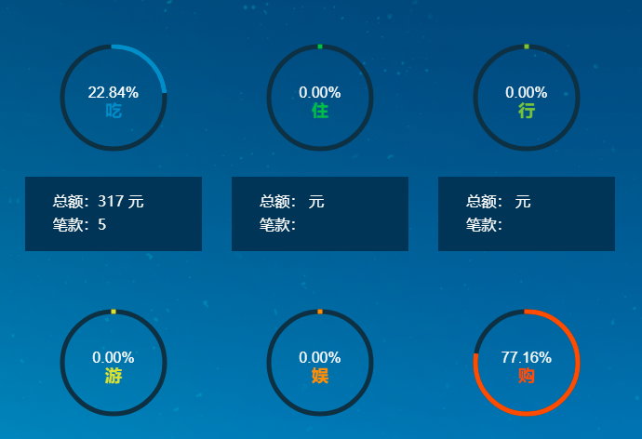

var canyinMoneyPre=document.getElementById('canyinMoneyPre').innerText;
var zhusuMoneyPre=document.getElementById('zhusuMoneyPre').innerText;
var jiaotongMoneyPre=document.getElementById('jiaotongMoneyPre').innerText;
var lvyouMoneyPre=document.getElementById('lvyouMoneyPre').innerText;
var wenhuaMoneyPre=document.getElementById('wenhuaMoneyPre').innerText;
var lingshouMoneyPre=document.getElementById('lingshouMoneyPre').innerText;

if(canyinMoneyPre == '' && zhusuMoneyPre =='' && jiaotongMoneyPre == '' && lvyouMoneyPre == '' && wenhuaMoneyPre == '' && lingshouMoneyPre == ''){
var divBox = document.getElementById("divBox");
divBox.style.display= "none";
}else{
drawCircle({
id: 'one',
angle:'canyinMoneyPre',
lineWidth: 5,
title:'吃',
color: '#008DCB'
});

drawCircle({
id: 'two',
color: '#00BD34',
angle: 'zhusuMoneyPre',
title:'住',
lineWidth: 5
});

drawCircle({
id: 'three',
angle:'jiaotongMoneyPre',
color: '#8BC327',
title:'行',
lineWidth: 5
});

drawCircle({
id: 'four',
angle: 'lvyouMoneyPre',
lineWidth: 5,
title:'游',
color: '#DCE224'
});

drawCircle({
id: 'five',
color: '#FF9600',
angle:'wenhuaMoneyPre',
title:'娱',
lineWidth: 5
});

drawCircle({
id: 'six',
angle: 'lingshouMoneyPre',
color: '#FF5A00',
title:'购',
lineWidth: 5
});
};
function drawCircle(_options){

console.log("chartData.month="+chartData.month);
if(chartData.month.length<=0){
return;
}
var options = _options || {}; //获取或定义options对象;
options.angle = options.angle || 1; //定义默认角度1为360度(角度范围 0-1);
options.color = options.color || '#fff'; //定义默认颜色（包括字体和边框颜色）;
options.lineWidth = options.lineWidth || 10; //定义默认圆描边的宽度;
options.lineCap = options.lineCap || 'square'; //定义描边的样式，默认为直角边，round 为圆角

var oBoxOne = document.getElementById(options.id);
var sCenter = oBoxOne.width / 2; //获取canvas元素的中心点;
var ctx = oBoxOne.getContext('2d');
var nBegin = Math.PI / 2; //定义起始角度;
var nEnd = Math.PI * 2; //定义结束角度;

var pre= document.getElementById(options.angle).innerText;
//console.log("pre="+pre);

ctx.textAlign = 'center'; //定义字体居中;
ctx.font = 'normal normal normal 16px Arial'; //定义字体加粗大小字体样式;
ctx.fillStyle = '#FFF'; //判断文字填充样式为颜色，还是渐变色;
ctx.fillText( (pre*100).toFixed(2)+'%', sCenter, sCenter); //设置填充文字;

ctx.font = 'normal normal bold 18px Arial'; //定义字体加粗大小字体样式;
ctx.fillStyle = options.color; //判断文字填充样式为颜色，还是渐变色;
ctx.fillText( options.title, sCenter, sCenter+20); //设置填充文字;
/*ctx.strokeStyle = grd; //设置描边样式为渐变色;
ctx.strokeText((options.angle * 100) + '%', sCenter, sCenter); //设置描边文字(即镂空文字);*/
ctx.lineCap = options.lineCap;
ctx.strokeStyle = options.color;
ctx.lineWidth = options.lineWidth;

ctx.beginPath(); //设置起始路径，这段绘制360度背景;
ctx.strokeStyle = '#162B40';
ctx.arc(sCenter, sCenter, (sCenter - options.lineWidth), -nBegin, nEnd, false);
ctx.stroke();

var imd = ctx.getImageData(0, 0, 240, 240);
function draw(current) { //该函数实现角度绘制;
ctx.putImageData(imd, 0, 0);
ctx.beginPath();
ctx.strokeStyle = options.color;
ctx.arc(sCenter, sCenter, (sCenter - options.lineWidth), -nBegin, (nEnd * current) - nBegin, false);
ctx.stroke();
}

var t = 0;
var timer = null;
function loadCanvas(angle) { //该函数循环绘制指定角度，实现加载动画;
timer = setInterval(function(){
if (t > angle) {
draw(angle);
clearInterval(timer);
}else{
draw(t);
t += 0.02;
}
}, 20);
}
loadCanvas(pre); //载入百度比角度 0-1 范围;
timer = null;
}

11.多个简化的环形图2
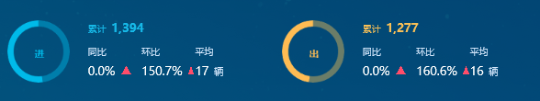

(function(){
setInOutCircle('in_card_circle_scenic', '进', totalNumberArr[2], totalNumberArr[1]);
setInOutCircle('out_card_circle_scenic', '出', totalNumberArr[1], totalNumberArr[2]);
})();

function setInOutCircle(domId, title, number_, number) {

var mainContainer = document.getElementById(domId);
var echartsdome = document.getElementsByClassName(domId);
//用于使chart自适应高度和宽度,通过窗体高宽计算容器高宽
var resizeMainContainer = function () {
mainContainer.style.width = $(echartsdome[0]).width() + 'px';
mainContainer.style.height = $(echartsdome[0]).height() + 'px';
};
//设置div容器高宽
resizeMainContainer();
// 初始化图表
var mainChart = echarts.init(mainContainer);
$(echartsdome).on('resize', function () {
//屏幕大小自适应，重置容器高宽
resizeMainContainer();
mainChart.resize();
});

let titleArr = ['进', '出'];

let colorsArr = [['rgba(0, 126, 171, 1)', 'rgba(0, 186, 233, 1)'],
['rgba(107, 125, 104, 1)', 'rgba(255, 188, 83, 1)']];
let colors = colorsArr[titleArr.indexOf(title)];
var option = {
backgroundColor: 'rgba(0, 0, 0, 0)',

title: [{
text: title, x: '38%', y: '40%',
textStyle: {
color: colors[1],
fontSize: 14
}
}],
series: [
{
type: 'pie',
animation: false,
radius: ['80%', '100%'],
center: ['50%', '50%'],
color: colors,
data: [
{value: number_, name: '出_'},
{value: number, name: '进'},
],
label: {
show: false
},
labelLine: {
show: false
},
itemStyle: {
normal: {
shadowBlur: 200,
shadowColor: 'rgba(0, 0, 0, 0)'
}
}
}
]
};

mainChart.setOption(option);

}

和仪表盘组合（type: 'gauge'）
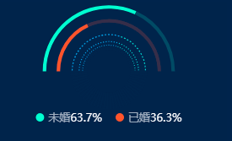

function tourismConsumeCharacterMarrDraw(datas){

var mainContainer = document.getElementById('marryEcharts');
var echartsdome = document.getElementsByClassName('marryEcharts');
//用于使chart自适应高度和宽度,通过窗体高宽计算容器高宽
var resizeMainContainer = function () {
mainContainer.style.width = ($(echartsdome[0]).width()/2) + 'px';
mainContainer.style.height = $(echartsdome[0]).height() + 'px';
};
//设置div容器高宽
resizeMainContainer();
// 初始化图表
var mainChart = echarts.init(mainContainer);
$(echartsdome).on('resize', function () {
//屏幕大小自适应，重置容器高宽
resizeMainContainer();
mainChart.resize();
});

var option = {
backgroundColor: '#011B4A',
color: ["#00FECB", "#EF5F3B"],
legend: {
orient: 'horizontal',
icon: 'circle',
bottom: '10%',
data: ['未婚', '已婚'],
itemWidth: 10, // 设置宽度
itemHeight: 10, //
textStyle: {
rich: {
a: {
color: 'rgba(255,255,255,0.65)',
fontSize: 13,
fontFamily: 'Microsoft YaHei'
},
b: {
color: '#FFFFFF',
fontSize: 13,
fontFamily: 'Microsoft YaHei'
}
}
},
formatter: function (name) {
return '{a|' + name + '}' + '{b|' + datas[name].toFixed(1) + '%}';
},
itemWidth: 10,
itemHeight: 10,
itemGap: 16
},
series: [{
name: '未婚',
type: 'pie',
radius: ['90%', '95%'],
label: false,
startAngle: 180,
endAngle: 0,
clockWise: true, //顺时加载
hoverAnimation: true,
hoverOffset: 3,
data: [{
value: datas['未婚'],
name: '未婚',
itemStyle: {
color: '#00FECB',
}
},
{
value: datas['已婚'],
hoverAnimation: false,
itemStyle: {
normal: {
color: '#014965'
}
}
},{
// 下半部分
value: 100,
itemStyle: {
normal: {
color: 'rgba(0,0,0,0)',
label: {
show: true
},
labelLine: {
show: true
}
},
emphasis: {
color: 'rgba(0,0,0,0)'
}
},
name: 'hide'
}
]
},

{
name: '已婚',
type: 'pie',
radius: ['70%', '75%'],
label: false,
startAngle: 180,
endAngle: 0,
clockWise: true,
hoverAnimation: true,
hoverOffset: 3,
data: [{
value: datas['已婚'],
name: '已婚',
itemStyle: {
color: "#EF5F3B",
}
},
{
value: datas['未婚'],
hoverAnimation: false,
itemStyle: {
normal: {
color: '#312948'
}
}
},
{
value: 100,
hoverAnimation: false,
itemStyle: {
color: 'rgba(0,0,0,0)'
}
}
]
},

{
name: "",
type: "gauge",
radius: "55%",
center:['50%','50%'],
startAngle: 0,
endAngle: 359.9,
splitNumber: 70,
hoverAnimation: true,
axisTick: {
show: false
},
splitLine: {
length: 20,
lineStyle: {
width: 2,
color: "#021C4B"
}
},
axisLabel: {
show: false
},
pointer: {
show: false
},
axisLine: {
lineStyle: {
opacity: 0
}
},
detail: {
show: false
},
data: [{
value: 0,
name: ""
}]
},
{
name: "",
type: "pie",
radius: ["52%","53.5%"],
center:['50%','50%'],
silent: true,
startAngle: 180,
endAngle: 0,
z: 0,
zlevel: 0,
label: {
normal: {
show: false,
position: "center"
}
},
data: [{
value: 60,
name: "",
label: {
normal: {
show: false
}
},
itemStyle: {
normal: {
color: "#08A0E2"
}
}
},
{
value: 40,
name: "",
label: {
normal: {
show: false
}
},
itemStyle: {
normal: {
color: "#05D3CB"
}
}
},
{
value: 100,
name: "",
label: {
normal: {
show: false
}
},
itemStyle: {
normal: {
color: "rgba(0,0,0,0)"
}
}
}
]
},
{
name: "",
type: "pie",
radius: ["42%","43.5%"],
center:['50%','50%'],
silent: true,
startAngle: 180,
endAngle: 0,
z: 0,
zlevel: 0,
label: {
normal: {
show: false,
position: "center"
}
},
data: [{
value: 60,
name: "",
label: {
normal: {
show: false
}
},
itemStyle: {
normal: {
color: "#08A0E2"
}
}
},
{
value: 40,
name: "",
label: {
normal: {
show: false
}
},
itemStyle: {
normal: {
color: "#05D3CB"
}
}
},
{
value: 100,
name: "",
label: {
normal: {
show: false
}
},
itemStyle: {
normal: {
color: "rgba(0,0,0,0)"
}
}
}
]
},
{
name: "",
type: "pie",
radius: ["37%","38.5%"],
center:['50%','50%'],
silent: true,
startAngle: 180,
endAngle: 0,
z: 0,
zlevel: 0,
label: {
normal: {
show: false,
position: "center"
}
},
data: [{
value: 60,
name: "",
label: {
normal: {
show: false
}
},
itemStyle: {
normal: {
color: "#08A0E2"
}
}
},
{
value: 40,
name: "",
label: {
normal: {
show: false
}
},
itemStyle: {
normal: {
color: "#05D3CB"
}
}
},
{
value: 100,
name: "",
label: {
normal: {
show: false
}
},
itemStyle: {
normal: {
color: "rgba(0,0,0,0)"
}
}
}
]
}

]
};
mainChart.setOption(option);
}

线图及其变形(type: 'line')

1.普通线图
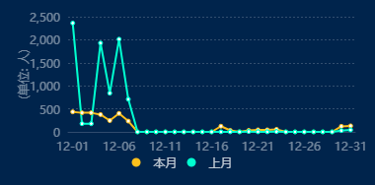

function allScenicTouristReporCurrentMonthDraw(data_list, datanumber, datapoint) {

var mainContainer = document.getElementById('flowEchart');
var echartsdome = document.getElementsByClassName('flowEchart');

//用于使chart自适应高度和宽度,通过窗体高宽计算容器高宽
var resizeMainContainer = function () {
mainContainer.style.width = $(echartsdome[0]).width() + 'px';
mainContainer.style.height = $(echartsdome[0]).height() + 'px';
};
//设置div容器高宽
resizeMainContainer();
// 初始化图表
var mainChart = echarts.init(mainContainer);
$(echartsdome).on('resize', function () {
//屏幕大小自适应，重置容器高宽
resizeMainContainer();
mainChart.resize();
});
var option = {
title: {},
tooltip: {
trigger: 'axis',
backgroundColor: 'rgba(0,0,0,0.75)',
},
legend: {
data: ['本月', '上月'],
textStyle: {
color: 'rgba(255,255,255,0.75)',
fontFamily: 'MicrosoftYaHei',
fontSize: 12,
},
bottom: 0,
itemHeight: 9,
icon: 'circle',
},
grid: {
top: '15',
bottom: '42',
left: '70',
right: '10'
},
xAxis: {
data: data_list,
axisLabel: {
show: true,
textStyle: {
fontFamily: 'MicrosoftYaHei',
fontSize: 12,
color: 'rgba(255,255,255,0.45)',
textAlign: 'right',
}
},
splitLine: {
show: false,
},
axisTick: {
show: false
},
axisLine: {
show: true,
lineStyle: {
color: '#354A6F',
}
},
},
yAxis: {
name: "(单位: 人)",
nameLocation: "center",
nameGap: 40,
nameTextStyle: {
color: "rgba(255,255,255,0.45)",
fontFamily: 'MicrosoftYaHei',
},
splitLine: {
lineStyle: {
color: 'rgba(250,250,250,0.2)',
type: 'sort',
}
},
axisLabel: {
show: true,
textStyle: {
fontFamily: 'MicrosoftYaHei',
fontSize: 12,
color: 'rgba(255,255,255,0.45)',
textAlign: 'right',
}
},
axisLine: {
show: false
},
axisTick: {
show: false
},
},
series: [
{
show: true,
type: 'line',
name: '本月',
itemStyle: {
normal: {color: '#F1C31B'}
},
// symbol:'none', //去掉点的
// smooth:true, //让曲线变平滑的
// barGap:'-100%',
// barCategoryGap:'40%',
data: datanumber,
animation: false
},
{
type: 'line',
name: '上月',
barWidth: 25,//固定柱子宽度
itemStyle: {
normal: {color: '#00FECB'}
},
data: datapoint,
animation: false
}
]
};
mainChart.setOption(option);
}

2.带阴影块的线图
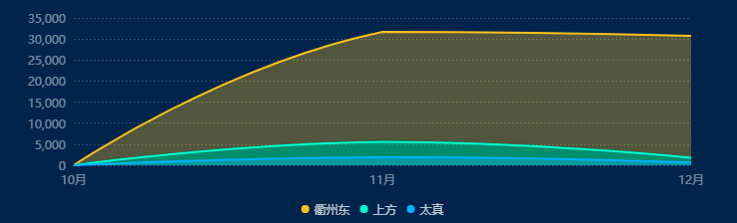

function setInOutChart(data_list) {
var mainContainer = document.getElementById('en_out_chart');
var echartsdome = document.getElementsByClassName('en_out_chart');
//用于使chart自适应高度和宽度,通过窗体高宽计算容器高宽
var resizeMainContainer = function () {
mainContainer.style.width = $(echartsdome[0]).width() + 'px';
mainContainer.style.height = $(echartsdome[0]).height() + 'px';
};
//设置div容器高宽
resizeMainContainer();
// 初始化图表
var mainChart = echarts.init(mainContainer);
$(echartsdome).on('resize', function () {
//屏幕大小自适应，重置容器高宽
resizeMainContainer();
mainChart.resize();
});

var timeArr = ['暂无数据'];
var numArr_qzd = [0];
var numArr_tz = [0];
var numArr_sf = [0];
var showDataList = data_list;

if (showDataList && showDataList != null) {

for (var i = 0; i < showDataList.length; i++) {
if (i == 0) {
timeArr = [];
numArr_qzd = [];
numArr_tz = [];
numArr_sf = [];
}
var timeShow = '暂无数据';
if (timeFlag == 1) {
timeShow = showDataList[i].time.split('-')[1] - 0 + '月';
} else if (timeFlag == 2) {
timeShow = showDataList[i].time.split('-')[2] - 0 + '日';
} else if (timeFlag == 3) {
timeShow = showDataList[i].time + '点';
}
timeArr.push(timeShow);
numArr_qzd.push(showDataList[i].qzd_num - 0);
numArr_tz.push(showDataList[i].tz_num - 0);
numArr_sf.push(showDataList[i].sf_num - 0);
}

}

var option = {
backgroundColor: 'rgba(0,0,0,0)',
grid: {top: 20, bottom: 80, left: 100},
color: ['#F1C31B', '#00FECB', '#02B0FE'],
tooltip: {
trigger: 'axis',
backgroundColor: 'rgba(0,0,0,0.75)',
axisPointer: {type: false},
formatter: function (param) {
return '<div style="font-size: 12px;">' +
'<span style="font-size: 12px;color: #FFFFFF;letter-spacing: 0;">'
+ param[0].name + '</span><br>' +
'<span style="font-size: 12px;color: #FFFFFF;letter-spacing: 0;">合计：'
+ formatNumber1(param[0].data + param[1].data + param[2].data) + '辆</span><br>' +
'<span style="font-size: 12px;color: #F1C31B;letter-spacing: 0;">●</span> ' +
'<span style="font-size: 12px;color: rgba(108, 132, 132, 1);letter-spacing: 0;">'
+ '衢州东' + '</span><span style="color:#FFFFFF;"> ' +
formatNumber1(param[0].data) + '辆</span><br>' +
'<span style="font-size: 12px;color: #00FECB;letter-spacing: 0;">●</span> ' +
'<span style="font-size: 12px;color: rgba(108, 132, 132, 1);letter-spacing: 0;">'
+ '上方' + '</span><span style="color:#FFFFFF;"> ' +
formatNumber1(param[1].data) + '辆</span><br>' +
'<span style="font-size: 12px;color: #02B0FE;letter-spacing: 0;">●</span> ' +
'<span style="font-size: 12px;color: rgba(108, 132, 132, 1);letter-spacing: 0;">'
+ '太真' + '</span><span style="color:#FFFFFF;"> ' +
formatNumber1(param[2].data) + '辆</span>'
+ '</div>'
},
},
xAxis: {
type: 'category',
boundaryGap: false,
data: timeArr,
axisLine: {show: false},
axisTick: {show: false},
axisLabel: {
color: "rgba(255,255,255,0.45)",
fontFamily: 'MicrosoftYaHei',
fontSize: 12
},
splitLine: {
show: false
},

},
yAxis: {
type: 'value',
axisLine: {show: false},
axisTick: {show: false},
axisLabel: {
color: "rgba(255,255,255,0.45)",
fontFamily: 'MicrosoftYaHei',
fontSize: 12
},
splitLine: {
lineStyle: {
color: 'rgba(250,250,250,0.2)',
type: 'sort',
}
},
},
series: [{
name: '衢州东',
data: numArr_qzd,
type: 'line',
smooth: true,
showSymbol: false,
lineStyle: {
color: '#F1C31B',
},
areaStyle: {
normal: {
color: 'rgba(241,195,27,0.45)'
}
},
},
{
name: '上方',
data: numArr_sf,
type: 'line',
smooth: true,
showSymbol: false,
lineStyle: {
color: '#00FECB',
},
areaStyle: {
normal: {
color: 'rgba(0,254,203,0.45)'
}
},
},
{
name: '太真',
data: numArr_tz,
type: 'line',
smooth: true,
showSymbol: false,
lineStyle: {
color: '#02B0FE',
},
areaStyle: {
normal: {
color: 'rgba(2,176,254,0.45)'
}
},
}],
legend: {
data: ['衢州东', '上方', '太真'],
icon: 'circle',
itemWidth: 8,
itemHeight: 8,
bottom: 25,
textStyle: {
fontSize: 12,
color: 'rgba(255,255,255,0.75)'
}
}
};
mainChart.setOption(option);
}

和柱状图组合（type: 'bar'）（摘自鸿图）
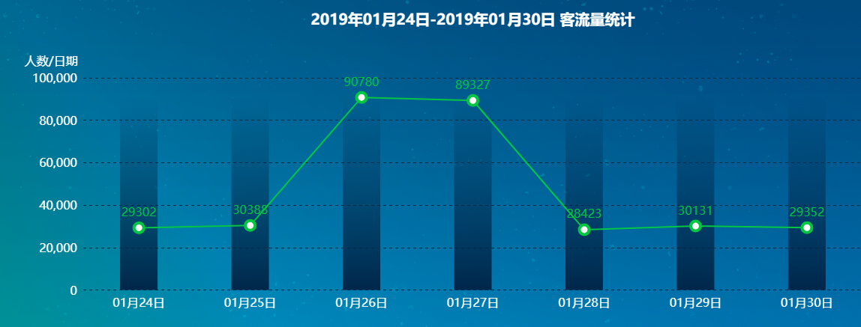

var xData=[];
var sData=[];
var backData=[];
var maxData=0;
$.each(chartData.getVisitorNumber,function(index,data){
xData.push(data.rdateShow);
sData.push({"value":data.number});
if(data.number>maxData){
maxData=data.number;
}
});

$.each(sData,function(){
console.log("maxData="+maxData);
backData.push(maxData);
});

var getTitle=function(){
if(sData.length > 0){
return chartData.chartTitle+' 客流量统计';
}else{
return '暂无数据';
}
};
var getYShow=function(){
if(sData.length > 0){
return true;
}else{
return false;
}
};

option = {
title: {
text: getTitle(),
x: "center",
y: 5,
textStyle:{
color:"#FFFFFF",
fontSize:20
//fontWeight:'bold',
// fontFamily:"微软雅黑"
}

},
grid: {
borderWidth: 0,
x: "10%",
y: "22%",
x2: "10%",
y2: "15%"
},
xAxis: {
type: 'category',
boundaryGap: ['25%', '25%'],
axisLabel:{
textStyle:{
color:"#FFFFFF",
fontSize:16
}
},
axisLine:{
show:false
},
axisTick:{
show:false
},
data: xData
},
yAxis: [{
type: 'value',
show: getYShow() ,
axisLabel: {
formatter: '{value}',
textStyle:{
color:"#FFFFFF",
fontSize:16
}
},
name:'人数/日期 ',
nameTextStyle:{
color:"#FFFFFF",
align:'left',
fontSize:16
},
left:"left",
axisLine:{
show:false
},
axisTick:{
show:false
},
splitLine:{
interval:0,
lineStyle:{
color:"#002740",
type:'dashed'
}
},
splitArea: {
show: false
}
}, {
type: 'value',
axisLine: {
show: false
},
axisTick: {
show: false
},
axisLabel:{
show: false
},
splitLine: {
show: false
},
splitArea: {
show: false
},
position: 'right'
}],
series: [{
type:'line',
smooth:false,
symbolSize:13,
data:sData,
label:{
normal: {
show: true,
textStyle:{
fontSize:16
}
}
},
itemStyle:{
normal:{
color:"#41C430",
borderType:"solid",
borderWidth:4
}
}
}, {
type: 'bar',
yAxisIndex: 1,
barWidth:50,
itemStyle:{
normal:{
color: new echarts.graphic.LinearGradient(0, 0, 0, 1, [{
offset: 0,
color: 'rgba(2, 31,73, 0)'
}, {
offset: 1,
color: 'rgba(2, 31,73, 1)'
}])
}
},
data: backData
}
]};

4.带日期范围滚动条的（摘自鸿图）
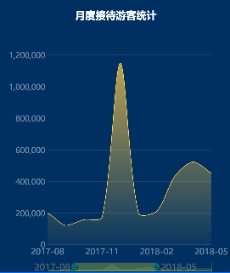

var date = [];
var data = [];
var monthTourData = chartData.monthTourData;

for (var i = 0; i < monthTourData.length; i++) {
date.push(monthTourData[i].MONTH);
data.push(monthTourData[i].GUEST_NUM);
}

option = {
tooltip: {
trigger: 'axis',
textStyle:{
fontSize:26
}
},
title: {
left: 'center',
top:36,
text: '月度接待游客统计',
textStyle: {
fontFamily:'MicrosoftYaHei',
fontSize: 36,
color: '#FFFFFF'
}
},
xAxis: {
type: 'category',
boundaryGap: false,
axisLabel:{color:'rgba(255,255,255,0.45)',fontSize:30},
data: date
},
yAxis: {
type: 'value',
axisLabel:{color:'rgba(255,255,255,0.45)',fontSize:28},
splitLine:{
show:true,
lineStyle:{
color:'#FFFFFF',
opacity:0.1,
width:2
}
}

},
dataZoom: [{
type: 'slider',
start: 50,
end: 100,
textStyle: {
fontSize: 32,
color: 'rgba(125,125,125,0.85)'
}
}, {
start: 50,
end: 100,
handleIcon: 'M10.7,11.9v-1.3H9.3v1.3c-4.9,0.3-8.8,4.4-8.8,9.4c0,5,3.9,9.1,8.8,9.4v1.3h1.3v-1.3c4.9-0.3,8.8-4.4,8.8-9.4C19.5,16.3,15.6,12.2,10.7,11.9z M13.3,24.4H6.7V23h6.6V24.4z M13.3,19.6H6.7v-1.4h6.6V19.6z',
handleSize: '80%',
handleStyle: {
color: '#fff',
shadowBlur: 3,
shadowColor: 'rgba(0, 0, 0, 0.6)',
shadowOffsetX: 2,
shadowOffsetY: 2
},
textStyle: {
fontSize: 32,
color: 'rgba(125,125,125,0.85)'
}
}],
series: [
{
name:'接待游客数',
type:'line',
smooth:true,
symbol: 'none',
sampling: 'average',
itemStyle: {
normal: {
color: 'rgb(255,215,76)'
}
},
areaStyle: {
normal: {
color: new echarts.graphic.LinearGradient(0, 0, 0, 1, [{
offset: 0,
color: 'rgba(255,215,76,1)'
}, {
offset: 1,
color: 'rgba(255,215,76,0.05)'
}])
}
},
data: data
}
],
grid:{
x:180,
y:200,
y2:100
}
};

5.带峰值显示的
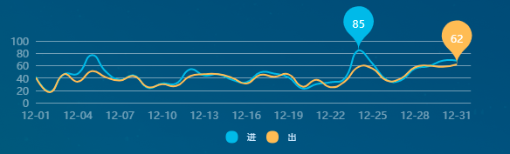

function setScenicDayCarNumChart() {

var mainContainer = document.getElementById('list_content_echart_scenic');
var echartsdome = document.getElementsByClassName('list_content_echart_scenic');
//用于使chart自适应高度和宽度,通过窗体高宽计算容器高宽
var resizeMainContainer = function () {
mainContainer.style.width = $(echartsdome[0]).width() + 'px';
mainContainer.style.height = $(echartsdome[0]).height() + 'px';
};
//设置div容器高宽
resizeMainContainer();
// 初始化图表
var mainChart = echarts.init(mainContainer);
$(echartsdome).on('resize', function () {
//屏幕大小自适应，重置容器高宽
resizeMainContainer();
mainChart.resize();
});

let days = [];
let dayCarNumIn = [];
let dayCarNumOut = [];

let year = selectTime.split('-')[0] - 0;
let month = selectTime.split('-')[1] - 0;

if (thisMonthDayCarNum != null && thisMonthDayCarNum.length > 0) {
year = thisMonthDayCarNum[0].month.split('-')[0];
month = thisMonthDayCarNum[0].month.split('-')[1] - 0;
}

//计算上月天数
var curMonthDays = new Date(year, month, 0).getDate();

for (let i = 1; i <= (curMonthDays + 1); i++) {
days.push((month < 10 ? ('0' + month) : month) + '-' + (i < 10 ? ('0' + i) : i));
}

for (let i = 0; i < new Date().getDate(); i++) {
dayCarNumIn.push(0);
dayCarNumOut.push(0);
}

if (thisMonthDayCarNum != null) {

for (let i = 0; i < thisMonthDayCarNum.length; i++) {
let month = thisMonthDayCarNum[i].month.split('-')[1] + '-' + thisMonthDayCarNum[i].month.split('-')[2];

if (thisMonthDayCarNum[i].enOrEx == 1) {
dayCarNumIn[days.indexOf(month)] = thisMonthDayCarNum[i].carNumber - 0;
} else {
dayCarNumOut[days.indexOf(month)] = thisMonthDayCarNum[i].carNumber - 0;
}
}

}

var option = {
legend: {
show: true,
icon: 'circle',
data: ['进', '出'],
bottom: '5%',
textStyle: {
fontSize: 10, color: '#D0E4F9'
}
},
color: ['#16B8E7', '#F8BF56'],
tooltip: {
trigger: 'axis',
axisPointer: {type: false},
formatter: function (param) {
let colorArr = ['#16B8E7', '#F8BF56'];
return '<div style="font-size: 12px;">' +
'<span style="font-size: 12px;color: #FFFFFF;letter-spacing: 0;">'
+ param[0].name + '</span><br>' +
'<span style="font-size: 12px;color: #16B8E7;letter-spacing: 0;">●</span> ' +
'<span style="font-size: 12px;color: #D0E4F9;letter-spacing: 0;">'
+ param[0].seriesName + '</span><span style="color:#D0E4F9;"> ' +
formatNumber1(param[0].data) + '辆</span><br>' +
'<span style="font-size: 12px;color: #F8BF56;letter-spacing: 0;">●</span> ' +
'<span style="font-size: 12px;color: #D0E4F9;letter-spacing: 0;">'
+ param[1].seriesName + '</span><span style="color:#D0E4F9;"> ' +
formatNumber1(param[1].data) + '辆</span>'
+ '</div>'
},
},
xAxis: {
type: 'category',
boundaryGap: false,
data: days,
axisLine: {show: false},
axisTick: {show: false},
axisLabel: {color: 'rgba(255,255,255,0.45)', fontSize: 12},
splitLine: {
show: false
},

},
grid: {
x: 40,
y: 40
},
yAxis: {
type: 'value',
axisLine: {show: false},
axisTick: {show: false},
axisLabel: {color: 'rgba(255,255,255,0.45)', fontSize: 12},
splitLine: {
lineStyle: {
opacity: 0.45,
color: '#FAFAFA'
}
},
},
series: [{
name: '进',
data: dayCarNumIn,
smooth: true,
type: 'line',
showSymbol: false,
lineStyle: {
color: '#16B8E7',
},
markPoint: {
symbolSize: 58,
data: [
{type: 'max', name: '最大值'}
]
},
},
{
name: '出',
data: dayCarNumOut,
smooth: true,
type: 'line',
showSymbol: false,
lineStyle: {
color: '#F8BF56',
},
markPoint: {
symbolSize: 58,
data: [
{type: 'max', name: '最大值'}
]
},
}]
};

mainChart.setOption(option);

}

柱状图及其变形(type: 'bar')

和线图(type: 'line')组合
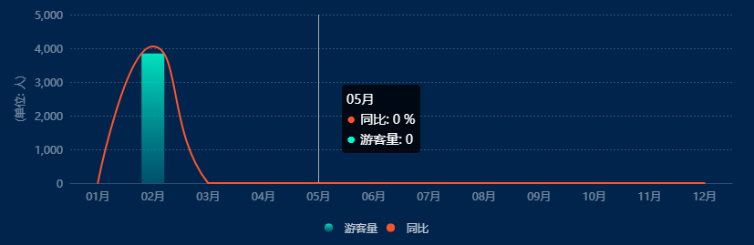

function allScenicTouristCount(type, date, datas) {
// 获取全区游客量统计数据
// X轴
let dataAxis = [];
// 游客量统计数据
var touristNumbers = [];
// 同比去年数据
var datapoint = [];

let flags = true;
let type2 = "bar";

if (type == 1) {
// (柱状图显示今年，拆线图显示去年同比) 年 (定制X轴)
dataAxis = dataAxisYear;
touristNumbers = new Array(12);
datapoint = new Array(12);
for (let index = 0; index < touristNumbers.length; index++) {
if (touristNumbers[index] == null) {
touristNumbers[index] = 0;
}
}
for (let index = 0; index < datapoint.length; index++) {
if (datapoint[index] == null) {
datapoint[index] = 0;
}
}
if (datas != null) {
$.each(datas, function (i, n) {
let flag = $.inArray(n.MONTH.split("-")[1] + "月", dataAxis);
if (flag != -1) {
touristNumbers[flag] = n.NUM;
datapoint[flag] = (n.YOY / 100) * n.NUM;
}
})
}
} else if (type == 2) {
// （拆线图显示每天游客） 月 (定制X轴)
dataAxis = dataAxisMonth;
var newdate = new Date(date);
let monthDays = new Date(newdate.getFullYear(), newdate.getMonth() + 1, 0).getDate()
if (monthDays == 30) {
dataAxis.splice(30, 1);
} else {
dataAxis[30] = "31";
}
touristNumbers = new Array(monthDays);
datapoint = new Array(monthDays);
for (let index = 0; index < touristNumbers.length; index++) {
if (touristNumbers[index] == null) {
touristNumbers[index] = 0;
}
}
for (let index = 0; index < datapoint.length; index++) {
if (datapoint[index] == null) {
datapoint[index] = 0;
}
}
if (datas != null) {
$.each(datas, function (i, n) {
let flag = $.inArray(n.RDATE.split("-")[2], dataAxis);
if (flag != -1) {
touristNumbers[flag] = n.NUM;
datapoint[flag] = (n.YOY / 100) * n.NUM;
flags = false;
type2 = "line";
}
})
}
} else if (type == 3) {
// （拆线图显示今天昨天游客量） 日 (定制X轴)
dataAxis = dataAxisDay;
touristNumbers = new Array(24);
datapoint = new Array(24);
for (let index = 0; index < touristNumbers.length; index++) {
if (touristNumbers[index] == null) {
touristNumbers[index] = 0;
}
}
for (let index = 0; index < datapoint.length; index++) {
if (datapoint[index] == null) {
datapoint[index] = 0;
}
}

if (datas != null) {
$.each(datas, function (i, n) {
let flag = $.inArray(n.TIME + '', dataAxis);
if (flag != -1) {
touristNumbers[flag] = n.TODAY_NUM;
datapoint[flag] = n.YESTERDAY_NUM;
type2 = "line";
}
})
}
}

allScenicTouristCountDraw(dataAxis, type2, touristNumbers, datapoint, flags);
}

function allScenicTouristCountDraw(data_list, type2, datanumber, datapoint, flag) {
var historyTop = echarts.init(document.getElementById("history_top"));

var option = {
title: {},
tooltip: {
trigger: 'axis',
backgroundColor: 'rgba(0,0,0,0.75)',
formatter: function (params) {
let htmlFormat = '<span>' + params[0].name + '</span><br />';
for (let index = 0; index < params.length; index++) {
if ("同比" == params[index].seriesName) {
htmlFormat += '<span style="font-size: 16px;color: ' + params[index].color + ';letter-spacing: 0;">● </span><span>' + params[index].seriesName + '</span>: <span>' + formatNumber1(params[index].value / params[index + 1].value * 100) + ' %</span>';
} else {
htmlFormat += '<br/><span style="font-size: 16px;color: #00FECB;letter-spacing: 0;">● </span><span>' + params[index].seriesName + '</span>: <span>' + formatNumber1(params[index].value) + '</span>';
}
}
return htmlFormat;
}
},
legend: {
data: ['游客量', '同比'],
textStyle: {
color: 'rgba(255,255,255,0.75)',
fontFamily: 'MicrosoftYaHei',
fontSize: 12,
},
bottom: 0,
itemHeight: 9,
icon: 'circle',
},
grid: {
top: '5',
bottom: '60',
left: '64',
right: '10'
},
xAxis: {
data: data_list,
axisLabel: {
show: true,
textStyle: {
fontFamily: 'MicrosoftYaHei',
fontSize: 12,
color: 'rgba(255,255,255,0.45)',
textAlign: 'right',
}
},
splitLine: {
show: false,
},
axisTick: {
show: false
},
axisLine: {
show: true,
lineStyle: {
color: '#354A6F',
}
},
},
yAxis: {
name: "(单位: 人)",
nameLocation: "center",
nameGap: 50,
nameTextStyle: {
color: "rgba(255,255,255,0.45)",
fontFamily: 'MicrosoftYaHei',
},
splitLine: {
lineStyle: {
color: 'rgba(250,250,250,0.2)',
type: 'sort',
}
},
axisLabel: {
show: true,
textStyle: {
fontFamily: 'MicrosoftYaHei',
fontSize: 12,
color: 'rgba(255,255,255,0.45)',
textAlign: 'right',
}
},
axisLine: {
show: false
},
axisTick: {
show: false
},
},
series: [
{
show: flag,
type: 'line',
name: '同比',
itemStyle: {
normal: {color: '#EF5F3B'}
},
symbol: 'none', //这句就是去掉点的
smooth: true, //这句就是让曲线变平滑的
barGap: '-100%',
barCategoryGap: '40%',
data: datapoint,
animation: false
},
{
type: type2,
name: '游客量',
barWidth: 25,//固定柱子宽度
itemStyle: {
normal: {
color: new echarts.graphic.LinearGradient(
0, 0, 0, 1,
[
{offset: 0, color: 'rgba(0,254,203,0.85)'},
{offset: 1, color: 'rgba(1,207,199,0.25)'}
]
)
},
},
data: datanumber
}
]
};
historyTop.setOption(option);
}

2.叠加的柱状图
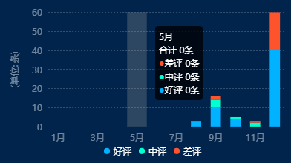

function setScenicOrHotelCommentTrendChart(dom_id, scenicOrHotelCommentTrend) {

var mainContainer = document.getElementById(dom_id + '_comment_trend_chart');
var echartsdome = document.getElementsByClassName(dom_id + '_comment_trend_chart');
//用于使chart自适应高度和宽度,通过窗体高宽计算容器高宽
var resizeMainContainer = function () {
mainContainer.style.width = $(echartsdome[0]).width() + 'px';
mainContainer.style.height = $(echartsdome[0]).height() + 'px';
};
//设置div容器高宽
resizeMainContainer();
// 初始化图表
var mainChart = echarts.init(mainContainer);
$(echartsdome).on('resize', function () {
//屏幕大小自适应，重置容器高宽
resizeMainContainer();
mainChart.resize();
});

var months = ['1月', '2月', '3月', '4月', '5月', '6月', '7月', '8月', '9月', '10月', '11月', '12月'];
var goodList = [0, 0, 0, 0, 0, 0, 0, 0, 0, 0, 0, 0];
var normalList = [0, 0, 0, 0, 0, 0, 0, 0, 0, 0, 0, 0];
var badList = [0, 0, 0, 0, 0, 0, 0, 0, 0, 0, 0, 0];

if (scenicOrHotelCommentTrend && scenicOrHotelCommentTrend != null && scenicOrHotelCommentTrend.length > 0) {
for (var i = 0; i < scenicOrHotelCommentTrend.length; i++) {
var month_index = scenicOrHotelCommentTrend[i].month.split('-')[1] - 1;
goodList[month_index] = scenicOrHotelCommentTrend[i].hp_num - 0;
normalList[month_index] = scenicOrHotelCommentTrend[i].zp_num - 0;
badList[month_index] = scenicOrHotelCommentTrend[i].cp_num - 0;
}
}

var option = {
legend: {
data: ['好评', '中评', '差评'],
icon: 'circle',
itemWidth: 8,
itemHeight: 8,
bottom: '1%',
textStyle: {
fontSize: 12,
color: '#FFFFFF'
}
},
tooltip: {
trigger: 'axis',
backgroundColor: 'rgba(0,0,0,0.75)',
axisPointer: {
type: 'shadow'
},
textStyle: {
fontSize: 12
},
formatter: function (data) {
var totalNumber = (data[0].value - 0) + (data[1].value - 0) + (data[2].value - 0);

return '<div style="font-size:12px"><span style="font-size: 12px;color: #fff;letter-spacing: 0;">'
+ data[0].name + '</div>' +
'<div style="font-size:12px"><span style="font-size: 12px;color: #fff;letter-spacing: 0;">合计 '
+ totalNumber + '条</div>' +
'<div style="font-size:12px"><span style="font-size: 12px;color: #EF5F3B;letter-spacing: 0;">' +
'●</span><span style="font-size: 12px;color: #fff;letter-spacing: 0;">'
+ data[2].seriesName + ' </span>' + data[2].value + '条</div>' +
'<div style="font-size:12px"><span style="font-size: 12px;color: #00FECB;letter-spacing: 0;">' +
'●</span><span style="font-size: 12px;color: #fff;letter-spacing: 0;">'
+ data[1].seriesName + ' </span>' + data[1].value + '条</div>' +
'<div style="font-size:12px"><span style="font-size: 12px;color: #02B0FE;letter-spacing: 0;">'
+ '●</span><span style="font-size: 12px;color: #fff;letter-spacing: 0;">'
+ data[0].seriesName + ' </span>' + data[0].value + '条</div>'
}
},
grid: {
top: '8%',
left: '8%',
right: '4%',
bottom: '12%',
containLabel: true
},
yAxis: {
name: "(单位: 条)",
nameLocation: "center",
nameGap: 40,
nameTextStyle: {
color: "rgba(255,255,255,0.45)",
fontFamily: 'MicrosoftYaHei',
fontSize: 12
},
type: 'value',
axisLine: {show: false},
axisTick: {show: false},
axisLabel: {
color: "rgba(255,255,255,0.45)",
fontFamily: 'MicrosoftYaHei',
fontSize: 12
},
splitLine: {
show: true,
lineStyle: {
color: 'rgba(250,250,250,0.2)',
type: 'sort',
}
},
splitArea: {
show: false
},
},
xAxis: {
type: 'category',
axisLabel: {
textStyle: {
fontSize: 12,
}
},
axisLine: {show: false},
axisTick: {show: false},
axisLabel: {
color: "rgba(255,255,255,0.45)",
fontFamily: 'MicrosoftYaHei',
fontSize: 12
},
splitLine: {
show: false
},
splitArea: {
show: false
},
axisTick: {show: false},
data: months
},
series: [
{
name: '好评',
type: 'bar',
stack: '评论数',
barWidth: '52%',
label: {
normal: {
show: false

}
},
itemStyle: {
normal: {
color: '#02B0FE'
}
},
data: goodList
},
{
name: '中评',
type: 'bar',
stack: '评论数',
barWidth: '52%',
label: {
normal: {
show: false
}
},
itemStyle: {
normal: {
color: '#00FECB'
}
},
data: normalList
},
{
name: '差评',
type: 'bar',
stack: '评论数',
barWidth: '52%',
label: {
normal: {
show: false
}
},
itemStyle: {
normal: {
color: '#EF5F3B'
}
},
data: badList
},
]
};

mainChart.setOption(option);
}

3.有点击事件（轴标签和柱子）
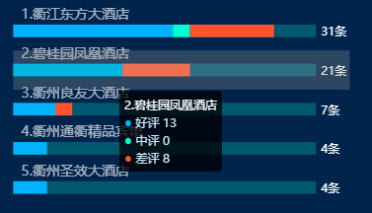

function setCommentTopFiveChart(dataList, dataListDetail) {

var mainContainer = document.getElementById('hotel_comment_info_chart');
var echartsdome = document.getElementsByClassName('hotel_comment_info_chart');
//用于使chart自适应高度和宽度,通过窗体高宽计算容器高宽
var resizeMainContainer = function () {
mainContainer.style.width = $(echartsdome[0]).width() + 'px';
mainContainer.style.height = $(echartsdome[0]).height() + 'px';
};
//设置div容器高宽
resizeMainContainer();
// 初始化图表
var mainChart = echarts.init(mainContainer);
$(echartsdome).on('resize', function () {
//屏幕大小自适应，重置容器高宽
resizeMainContainer();
mainChart.resize();
});

var commentNames = [];
var goods = [];
var goodCount = 0;
var mids = [];
var midCount = 0;
var bads = [];
var badCount = 0;
var totals = [0, 0, 0, 0, 0];
if (dataList && dataList != null) {
for (var i = dataList.length - 1; i >= 0; i--) {
commentNames.push(1 + i + '.' + dataList[i].commentName);
goodCount = 0;
badCount = 0;
midCount = 0;
for (var j = 0; j < dataListDetail.length; j++) {
if (dataList[i].commentName == dataListDetail[j].commentName) {
if (dataListDetail[j].isGood == '好评') {
goodCount += dataListDetail[j].totalCommentNumber - 0;
} else if (dataListDetail[j].isGood == '差评') {
badCount += dataListDetail[j].totalCommentNumber - 0;
} else if (dataListDetail[j].isGood == '中评') {
midCount += dataListDetail[j].totalCommentNumber - 0;
}
}
}
goods.push(goodCount);
bads.push(badCount);
mids.push(midCount);
totals[i] = (goodCount + badCount + midCount);
}
}

if (dataList.length == 0) {
commentNames = ['暂无数据'];
goods = [0];
mids = [0];
bads = [0];
totals = [0, 0, 0, 0, 0];
}

var backgroundNumber = totals.sort(function (a, b) {
return b - a
})[0] + 5;

var option = {
tooltip: {
trigger: 'axis',
backgroundColor: 'rgba(0,0,0,0.75)',
axisPointer: { // 坐标轴指示器，坐标轴触发有效
type: 'shadow' // 默认为直线，可选为：'line' | 'shadow'
},
textStyle: {
fontSize: 12
},
formatter: function (param) {
var colorArr = ['#16B8E7', '#F8BF56', '#32E594'];
return '<div style="font-size: 12px;">' +
'<span style="font-size: 12px;color: #FFFFFF;letter-spacing: 0;">'
+ param[0].name + '</span><br>' +
'<span style="font-size: 12px;color: #02B0FE;letter-spacing: 0;">●</span> ' +
'<span style="font-size: 12px;color: #D0E4F9;letter-spacing: 0;">'
+ param[0].seriesName + '</span><span style="color:#D0E4F9;"> ' +
param[0].data.toString().replace(/(\d)(?=(?:\d{3})+$)/g, '$1,') + '</span><br>' +
'<span style="font-size: 12px;color: #00FECB;letter-spacing: 0;">●</span> ' +
'<span style="font-size: 12px;color: #D0E4F9;letter-spacing: 0;">'
+ param[1].seriesName + '</span><span style="color:#D0E4F9;"> ' +
param[1].data.toString().replace(/(\d)(?=(?:\d{3})+$)/g, '$1,') + '</span><br>' +
'<span style="font-size: 12px;color: #EF5F3B;letter-spacing: 0;">●</span> ' +
'<span style="font-size: 12px;color: #D0E4F9;letter-spacing: 0;">'
+ param[2].seriesName + '</span><span style="color:#D0E4F9;"> ' +
param[2].data.toString().replace(/(\d)(?=(?:\d{3})+$)/g, '$1,') + '</span>'
+ '</div>'
}
},
grid: {
left: '3%',
right: '8%',
top: '5%',
bottom: '0%',
containLabel: true
},
xAxis: [
{
type: 'value',
nameTextStyle: {
fontSize: 12
},
axisLine: {show: false},
axisTick: {show: false},
axisLabel: {show: false},
splitLine: {
show: false
},
splitArea: {
show: false
},
}
],
yAxis: [
{
type: 'category',
triggerEvent: true,
axisLabel: {
textStyle: {
fontSize: 12,
}
},
axisLine: {show: false},
axisTick: {show: false},
axisLabel: {
color: 'rgba(255,255,255, 0.65)',
fontSize: 14,
fontFamily: 'Microsoft YaHei',
lineHeight: 16,
inside: true,
verticalAlign: 'bottom',
padding: [0, 0, 10, 0]
},
splitLine: {
show: false
},
splitArea: {
show: false
},
axisTick: {show: false},
data: commentNames
}
],
series: [
{
name: '好评',
type: 'bar',
stack: '基数',
barWidth: '32%',
barGap: '100%',
label: {
normal: {
show: false
}
},
itemStyle: {
normal: {
color: '#02B0FE'
}
},
data: goods
},
{
name: '中评',
type: 'bar',
stack: '基数',
barWidth: '32%',
barGap: '100%',
label: {
normal: {
show: false
}
},
itemStyle: {
normal: {
color: '#00FECB'
}
},
data: mids
},
{
name: '差评',
type: 'bar',
stack: '基数',
barWidth: '32%',
barGap: '100%',
itemStyle: {
normal: {
color: '#EF5F3B'
}
},
data: bads
},
{
name: '合计',
type: 'bar',
stack: '合计',
barWidth: '32%',
barGap: '-100%',
label: {
normal: {
show: true,
position: 'right',
color: '#FFFFFF',
formatter: function (data) {
var number = 0;
if (data.name != '暂无数据') {
number = totals[data.name.substr(0, 1) - 1]
}
return number + '条';
},
},
},
itemStyle: {
normal: {
color: 'rgba(39, 88, 113, 1)'
}
},
data: [backgroundNumber, backgroundNumber, backgroundNumber, backgroundNumber, backgroundNumber],
zlevel: -10
}
]
};
mainChart.setOption(option);
mainChart.on('click', function (params) {//点击轴标签或柱子后的处理});
}

柱子3D，双纵坐标
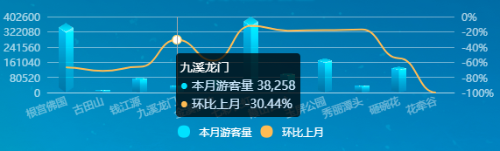

function drawMainChart() {

var num_data = [0];
var percent_data = [0];
var scenic_name_data = ['暂无'];

var maxValue = 1000;
var maxPercent = 100;

for (var i = 0; i < monthScenicVisitorNumber.length; i++) {
if (i == 0) {
num_data = [];
percent_data = [];
scenic_name_data = [];
$('#main_chart_title').html(monthScenicVisitorNumber[0].month.split('-')[1] - 0 + '月景区游客量');
}

if (maxValue < (monthScenicVisitorNumber[i].this_month_num - 0)) {
maxValue = (((monthScenicVisitorNumber[i].this_month_num - 0) / 100).toFixed(0) - 0) * 100;
}

if (maxPercent < Math.abs((monthScenicVisitorNumber[i].per - 0))) {
maxPercent = ((Math.abs((monthScenicVisitorNumber[i].per - 0)) / 100).toFixed(1) - 0) * 100;
}

scenic_name_data.push(monthScenicVisitorNumber[i].scenic_name);
num_data.push(monthScenicVisitorNumber[i].this_month_num);
percent_data.push(monthScenicVisitorNumber[i].per);
}
var option = {
backgroundColor: 'transparent',
grid: {
top: 20
},
tooltip: {
trigger: 'axis',
backgroundColor: 'rgba(0,0,0,0.75)',
formatter: function (param) {
let colorArr = ['#00DDFF', 'rgba(248,191,86,1)'];
return '<div style="font-size: 14px;">' +
'<span style="font-size: 14px;color: #FFFFFF;letter-spacing: 0;">'
+ param[0].name + '</span><br>' +
'<span style="font-size: 14px;color: #00DDFF;letter-spacing: 0;">●</span> ' +
'<span style="font-size: 14px;color: #D0E4F9;letter-spacing: 0;">'
+ param[0].seriesName + '</span><span style="color:#D0E4F9;"> ' +
formatNumber1(param[0].data) + '</span><br>' +
'<span style="font-size: 14px;color: rgba(248,191,86,1);letter-spacing: 0;">●</span> ' +
'<span style="font-size: 14px;color: #D0E4F9;letter-spacing: 0;">'
+ param[1].seriesName + '</span><span style="color:#D0E4F9;"> ' +
formatNumber1(param[1].data) + '%</span>'
+ '</div>'
},
},
legend: {
bottom: '2%',
icon: 'circle',
textStyle: {
color: '#fff'
},
data: ['本月游客量', '环比上月']
},
xAxis: [
{
type: 'category',
axisTick: {
alignWithLabel: false,
length: 0
},
axisLabel: {
fontSize: 12,
interval: 0,
rotate: 20,
showMinLabel: true,
showMaxLabel: true
},
axisLine: {
lineStyle: {
color: 'rgba(250,250,250, .45)',
},
color: '#fff',
type: 'dashed'
},
tooltip: {
backgroundColor: 'rgba(0,0,255,0.5)'
},
data: scenic_name_data
}
],
yAxis: [
{
type: 'value',
min: 0,
axisTick: {
alignWithLabel: false,
length: 0,
type: 'dashed'
},
position: 'left',
max: maxValue,
interval: Math.ceil(maxValue / 5),
axisLine: {
show: false
},
axisLabel: {
formatter: '{value}',
fontFamily: 'MicrosoftYaHei',
color: 'rgba(255,255,255,0.65)'
},
splitLine: {
show: false
}
},
{
type: 'value',
position: 'right',
axisTick: {
alignWithLabel: false,
length: 0,
type: 'dashed'
},
/* min: (0 - maxPercent),
max: (maxPercent - 0),*/
axisLine: {
show: false
},
axisLabel: {
formatter: '{value}%',
fontFamily: 'MicrosoftYaHei',
color: 'rgba(255,255,255,0.65)'
},
splitLine: {
lineStyle: {
color: 'rgba(250,250,250, .45)'
}
}
}
],
series: [
{
name: '本月游客量',
type: 'pictorialBar',
symbol: 'image://' + basePath + 'static/kh2_2/img/home_echart_zhuzi.png',
yAxisIndex: 0,
zIndex: 10,
symbolSize: ['50%', '100%'],
symbolPosition: 'bottom',
color: '#00DDFF',
data: num_data
},
{
name: '环比上月',
type: 'line',
yAxisIndex: 1,
color: 'rgba(248,191,86,1)',
smooth: true,
showSymbol: false,
smoothMonotone: 'x',
data: percent_data
}
]
};
let myChart = echarts.init(document.getElementById('mid_main_echart'))
myChart.clear()
myChart.setOption(option)
}

5.柱子变形，轮播tooltip（摘自鸿图）
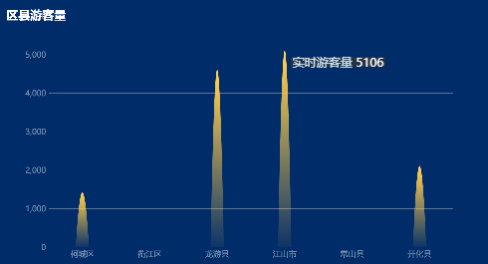

var visNum = 3920
var place = ['柯城区','衢江区','龙游县','江山市','常山县','开化县']

var number = ['','','','','','']
var qxykl = chartData.qxykl
for(var i=0;i<qxykl.length;i++){
if(qxykl[i].AREA_NAME=='柯城区'){number[0]=qxykl[i].TOTAL_NUM}
else if(qxykl[i].AREA_NAME=='衢江区'){number[1]=qxykl[i].TOTAL_NUM}
else if(qxykl[i].AREA_NAME=='龙游县'){number[2]=qxykl[i].TOTAL_NUM}
else if(qxykl[i].AREA_NAME=='江山市'){number[3]=qxykl[i].TOTAL_NUM}
else if(qxykl[i].AREA_NAME=='常山县'){number[4]=qxykl[i].TOTAL_NUM}
else if(qxykl[i].AREA_NAME=='开化县'){number[5]=qxykl[i].TOTAL_NUM}
}

option = {
title: {
text:'区县游客量',x:20,y:'4%',
textStyle:{color:'#fff',fontSize:36}
},
tooltip: {
trigger:'axis',
axisPointer:{type:false},
formatter:function(param){
return '<div style="font-size:24px"><span style="font-size: 24px;color: #D0E4F9;letter-spacing: 0;">实时游客量 </span>'+param[0].data+'</div>'
},
},
xAxis: {
type: 'category',
data: place,
boundaryGap: ['20%', '20%'],
axisLine:{show:false},
axisTick: {show:false},
axisLabel:{color:'rgba(255,255,255,0.45)',fontSize:24},
splitLine:{
show:false
},

},
yAxis: {
type: 'value',
axisLine:{show:false},
axisTick: {show:false},
axisLabel:{color:'rgba(255,255,255,0.45)',fontSize:24},
splitLine:{
lineStyle: {
opacity: 0.45
}
},
},
series: [{
data: number,
type: 'pictorialBar',
showSymbol:false,
barMaxWidth: 40,
symbol: 'path://M2,10 Q5,0 8,10',
itemStyle: {
normal: {
barBorderRadius: [85, 85, 0, 0] ,
color: new echarts.graphic.LinearGradient(
0, 0, 0, 1, [{
offset: 0,
color: 'rgba(255,215,76,1)'
},
{
offset: 1,
color: 'rgba(255,215,76,0.05)'
}
]
)
}
},
}]
};

6.轮播柱子（摘自鸿图）
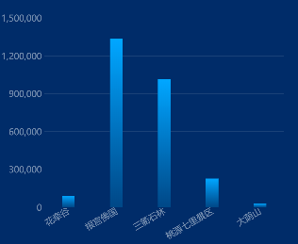

var jq = []
var jn = []

for(var i=0;i<chartData.jqykl.length;i++){
jq.push(chartData.jqykl[i].SCENIC_NAME);
jn.push(chartData.jqykl[i].NUM);
}

option = {
title: {
text:'景区游客量',x:20,y:'4%',
textStyle:{color:'#fff',fontSize:36,fontWeight:400},
},
color:['#00A5FF','#29E8E9'],
tooltip: {
trigger:'axis',
axisPointer:{type:false},
formatter:function(param){
var num = 0;
if(param[0].value && param[0].value != null){
num = splitNum(param[0].value);
}

return '<span style="font-size:36px;color:#00A5FF">●</span>'+
'<span style="font-size: 24px;color:rgba(208,228,249,0.85)">'+'今年累计 '+'</span>'+
'<span style="font-size: 24px;color:#fff">'+num+'</span><br/><br/>'
},
},
grid: {
x: 150,
y: 150,
bottom:138
},
xAxis: {
type: 'category',
boundaryGap: ['20%', '10%'],
data: jq,
axisLine:{show:false},
axisTick: {show:false},
axisLabel:{color:'rgba(255,255,255,0.45)',fontSize:28,rotate:30},
splitLine:{
show:false
},

},
yAxis: {
type: 'value',
axisLine:{show:false},
axisTick: {show:false},
axisLabel:{color:'rgba(255,255,255,0.45)',fontSize:28},
splitLine:{
show:true,
lineStyle: {
color:'#FFFFFF',
width:2,
opacity: 0.1
}
},
},
legend:{data:['今年累计'],icon:'circle',right:'3%', itemWidth:16,top:'4%',textStyle:{color:'#fff',fontSize:28}},
series: [{
name:'今年累计',
data: jn,
type: 'bar',
itemStyle:{
normal: {
color: new echarts.graphic.LinearGradient(0, 0, 0, 1, [{
offset: 0,
color: '#00A5FF'
}, {
offset: 1,
color: '#094588'
}])
}
},
barWidth:40,
lineStyle: {
fontSize:28
},
}
],
dataZoom: {
show: false,
y: 36,
height: 20,
type: 'slider', // 这个 dataZoom 组件是 slider 型 dataZoom 组件
startValue: 0, // 从头开始。
endValue: 4 // 一次性展示五个。
}
};

function splitNum(num){
var j = 0;
var num2 = '';
for(var i = 1; i<= num.length ; i++){
if(j == 3){
num2 = num.charAt(num.length - i) + ','+ num2;
j = 1;
}else{
num2 = num.charAt(num.length - i) + num2;
j += 1;
}
}
return num2;
}
setInterval(function() {
// 每次向后滚动一个，最后一个从头开始。
if(option.dataZoom.endValue == chartData.jqykl.length - 1){
option.dataZoom.endValue = 4;
option.dataZoom.startValue = 0;
}else{
option.dataZoom.endValue = option.dataZoom.endValue + 1;
option.dataZoom.startValue = option.dataZoom.startValue + 1;
}
chars['widget4'].setOption(option);

}, 3000);

7.带按钮（graphic（type: 'text';graphic.elements[i]-text.onclick Function））（摘自鸿图）
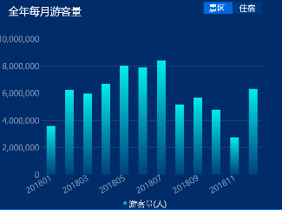

var place = []
var people = []
var percent = []
for(var i=0;i<chartData.myykl.length;i++){
place.push(chartData.myykl[i].MONTH)
people.push(chartData.myykl[i].CAR_NUM)
if(chartData.myykl[i].YOY==null){
percent.push(0)
}else{
percent.push(chartData.myykl[i].YOY)}
}

var place1 = []
var people1 = []
var percent1 = []
for(var i=0;i<chartData.stayDetailsYear.length;i++){
place1.push(chartData.stayDetailsYear[i].MONTH)
people1.push(chartData.stayDetailsYear[i].CAR_NUM)
if(chartData.stayDetailsYear[i].YOY==null){
percent1.push(0)
}else{
percent1.push(chartData.stayDetailsYear[i].YOY)}
}

option = {
title: {
text:'全年每月游客量',x:"3%",y:'4%',
textStyle:{color:'#fff',fontSize:36,fontWeight:400},
},
legend: {
data:['游客量(人)'],
icon: 'circle',
top:'bottom',
left:'center',
itemWidth:16,
textStyle:{
color:'rgba(255,255,255,0.85)',
fontSize:28
}
},
graphic: [{
type: 'group',
id: 'textGroup1',
left: '70%',
top: '3%',
bounding: 'all',
children: [
{
type: 'rect',
z: 100,
top: 'middle',
shape: {
width:100,
height: 40
},
style: {
fill:'#1967E0',
shadowColor: '#00A5FF',
lineWidth: 1,
}
},
{
type: 'text',
z: 100,
top: 'middle',
left: '18',
style: {
text: '景区',
fill:'#FFFFFF',
font: '28px "MicrosoftYaHei", sans-serif',
textAlign: 'center'
},
onclick:function () {
chars['widget1'].setOption(option)
}
},
]
},
{
type: 'group',
id: 'textGroup2',
left: '80%',
top: '3%',
bounding: 'all',
children: [
{
type: 'rect',
z: 100,
top: 'center',
left: 'center',
shape: {
width: 100,
height: 40
},
style: {
fill:'rgba(25,103,224,0.20)',
shadowColor: '#00A5FF',
lineWidth: 1,
}
},
{
type: 'text',
z: 100,
top: 'center',
left: 'center',
style: {
text: '住宿',
fill:'#FFFFFF',
font: '28px "MicrosoftYaHei", sans-serif'
},
onclick:function () {
chars['widget1'].setOption(option1)
}
}
]
}
],
tooltip: {
trigger:'axis',
axisPointer: {
type:'shadow'
},
formatter:function(param){
var num2_ = 0;
if(param[0].value && param[0].value != null){
num2_ = splitNum(param[0].value);
}
return '<div style="font-size:24px">'+param[0].name+'<br/><br/>'+'<span style="color:#00A5FF;line-height:2px">●</span>'+'<span style="color:rgba(208,228,249,0.85);font-size:24px;line-height:2px">'+param[0].seriesName+'</span>'+' '+num2_+'</div>'
}
},
grid: {
x: 150,
y: 150,
bottom:120
},
xAxis: {
type: 'category',
boundaryGap: ['20%', '20%'],
data: place,
axisLine:{show:false},
axisTick:{show:false},
axisLabel:{color:'rgba(255,255,255,0.45)',fontSize:28,rotate:30},
splitLine:{
show:false
},
},
yAxis: [{
type: 'value',
axisLine:{show:false},
axisTick: {show:false},
axisLabel:{color:'rgba(255,255,255,0.45)',fontSize:28},
splitLine:{
show:true,
lineStyle: {
color:'#FFFFFF',
width:2,
opacity: 0.1
}
},
},
{
type: 'value',
axisLine:{show:false},
axisTick: {show:false},
axisLabel:{color:'rgba(255,255,255,0.45)', formatter: '{value}%',fontSize:28},
splitLine:{
show:false
},
}],
series: [{
name:"游客量(人)",
data: people,
type: 'bar',
barWidth:30,
showSymbol:false,
itemStyle:{
normal: {
color: new echarts.graphic.LinearGradient(0, 0, 0, 1, [{
offset: 0,
color: '#29E8E9'
}, {
offset: 1,
color: '#0A3F7F'
}])
}
},
},]
};

option1 = {
title: {
text:'全年每月游客量',x:"3%",y:'4%',
textStyle:{color:'#fff',fontSize:36,fontWeight:400},
},
legend: {
data:['游客量(人)'],
icon: 'circle',
top:'bottom',
left:'center',
itemWidth:16,
textStyle:{
color:'rgba(255,255,255,0.85)',
fontSize:28
}
},
graphic: [{
type: 'group',
id: 'textGroup1',
left: '70%',
top: '3%',
bounding: 'all',
children: [
{
type: 'rect',
z: 100,
top: 'middle',
shape: {
width: 100,
height: 40
},
style: {
fill:'rgba(25,103,224,0.20)',
shadowColor: '#00A5FF',
lineWidth: 1,
}
},
{
type: 'text',
z: 100,
top: 'middle',
left: '18',
style: {
text: '景区',
fill:'#FFFFFF',
font: '28px "MicrosoftYaHei", sans-serif',
textAlign: 'center'
},
onclick:function () {
chars['widget1'].setOption(option)
}
},
]
},
{
type: 'group',
id: 'textGroup2',
left: '80%',
top: '3%',
bounding: 'all',
children: [
{
type: 'rect',
z: 100,
top: 'center',
left: 'center',
shape: {
width: 100,
height: 40
},
style: {
fill:'#1967E0',
shadowColor: '#00A5FF',
lineWidth: 1,
}
},
{
type: 'text',
z: 100,
top: 'center',
left: 'center',
style: {
text: '住宿',
fill:'#D0E4F9',
font: '28px "MicrosoftYaHei", sans-serif'
},
onclick:function () {
chars['widget1'].setOption(option1)
}
}
]
}
],
tooltip: {
trigger:'axis',
axisPointer: {
type:'shadow'
},
formatter:function(param){
var num2_ = 0;
if(param[0].value && param[0].value != null){
num2_ = splitNum(param[0].value);
}
return '<div style="font-size:24px">'+param[0].name+'<br/><br/>'+'<span style="color:#00A5FF;line-height:2px">●</span>'+'<span style="color:rgba(208,228,249,0.85);font-size:24px;line-height:2px">'+param[0].seriesName+'</span>'+' '+num2_+'</div>'
}
},
grid: {
x: 150,
y: 150,
bottom:120
},
xAxis: {
type: 'category',
boundaryGap: ['20%', '20%'],
data: place1,
axisLine:{show:false},
axisTick:{show:false},
axisLabel:{color:'rgba(255,255,255,0.45)',fontSize:28,rotate:30},
splitLine:{
show:false
},
},
yAxis: [{
type: 'value',
axisLine:{show:false},
axisTick: {show:false},
axisLabel:{color:'rgba(255,255,255,0.45)',fontSize:28},
splitLine:{
show:true,
lineStyle: {
color:'#FFFFFF',
width:2,
opacity: 0.1
}
},
},
{
type: 'value',
axisLine:{show:false},
axisTick: {show:false},
axisLabel:{color:'rgba(255,255,255,0.45)', formatter: '{value}%',fontSize:28},
splitLine:{
show:false
},
}],
series: [{
name:"游客量(人)",
data: people1,
type: 'bar',
barWidth:30,
showSymbol:false,
itemStyle:{
normal: {
color: new echarts.graphic.LinearGradient(0, 0, 0, 1, [{
offset: 0,
color: '#29E8E9'
}, {
offset: 1,
color: '#0A3F7F'
}])
}
},
},]
};
function splitNum(num){
var j = 0;
var num2 = '';
for(var i = 1; i<= num.length ; i++){
if(j == 3){
num2 = num.charAt(num.length - i) + ','+ num2;
j = 1;
}else{
num2 = num.charAt(num.length - i) + num2;
j += 1;
}
}
return num2;
}

8.多系列柱状图（摘自鸿图）
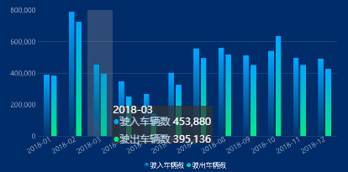

var carNum = '';
if(chartData.newlj[0].CAR_NUM && chartData.newlj[0].CAR_NUM != null){
carNum = splitNum(chartData.newlj[0].CAR_NUM + '');
}
var carNum1 = '';
if(chartData.newlc[0].CAR_NUM && chartData.newlc[0].CAR_NUM != null){
carNum1 = splitNum(chartData.newlc[0].CAR_NUM + '');
}
var month = []
var month1 = []
var monthCarNum = []
var percent = []
var monthCarNum1 = []
var percent1 = []
for(var j=0;j<chartData.newyj.length;j++){
if(j==0){
month = [];
monthCarNum = [];
percent = [];
}
var monthTemp = chartData.newyj[j].MONTH;
month.push(monthTemp.replace(monthTemp.substr(0,4),monthTemp.substr(0,4)+'-'));
monthCarNum.push(chartData.newyj[j].CAR_NUM);
if(chartData.newyj[j].YOY && chartData.newyj[j].YOY != null){
percent.push(chartData.newyj[j].YOY);
}else{
percent.push(0);
}
}
for(var j=0;j<chartData.newyc.length;j++){
if(j==0){
month1 = [];
monthCarNum1 = [];
percent1 = [];
}
var monthTemp = chartData.newyc[j].MONTH;
month1.push(monthTemp.replace(monthTemp.substr(0,4),monthTemp.substr(0,4)+'-'));
monthCarNum1.push(chartData.newyc[j].CAR_NUM);
if(chartData.newyc[j].YOY && chartData.newyc[j].YOY != null){
percent1.push(chartData.newyc[j].YOY);
}else{
percent1.push(0);
}
}
option = {
title: [{
text:'全市车流量',x:'2%',y:'2%',
textStyle:{color:'#fff',fontSize:36,fontWeight:400},
subtext:'{a|/进/}'+'{c| 累计车辆 }'+'{b|'+ carNum +'}',
subtextStyle: {
rich: {
a:{
color: 'rgba(255,215,76,1)',
fontSize: 32
},
b:{
color:'#fff',
fontSize:32
},
c:{
color:'#fff',
fontSize:32
}
},
fontSize:32
}
},
{
text:' ',x:'38%',y:'2%',
textStyle:{color:'#fff',fontSize:36,fontWeight:400},
subtext:'{a|/出/}'+'{c| 累计车辆 }'+'{b|'+ carNum1 +'}',
subtextStyle: {
rich: {
a:{
color: '#3DE67F',
fontSize: 32,
},
b:{
color:'#fff',
fontSize:32
},
c:{
color:'#fff',
fontSize:32
}
}
}
}],
legend: {
data:['驶入车辆数','驶出车辆数'],
icon: 'circle',
bottom:20,
itemWidth:16,
textStyle:{
color:'rgba(255,255,255,0.85)',
fontSize:24
}
},
tooltip: {
trigger:'axis',
axisPointer: {
type:'shadow'
},
formatter:function(param){
var num2 = 0;
var num22 = 0;
if(param[0].value && param[0].value != null){
num2 = splitNum(param[0].value);
}
if(param[1].value && param[1].value != null){
num22 = splitNum(param[1].value);
}
return '<div style="font-size:24px">'+param[0].name+'<br/><br/>'+'<span style="color:#00A5FF;line-height:1px">●</span>'+'<span style="color:rgba(208,228,249,0.85);font-size:24px;line-height:1px">'+param[0].seriesName+'</span>'+' '+num2
+'</div><br/><br/>'+'<span style="color:#3DE67F;line-height:1px">●</span>'+'<span style="color:rgba(208,228,249,0.85);font-size:24px;line-height:1px">'+param[1].seriesName+'</span>'+' '+num22
+'</div>'
}
},
grid: {
x: 150,
y: 150,
bottom:140
},
xAxis: {
type: 'category',
boundaryGap: ['20%', '20%'],
data: month,
axisLine:{show:false},
axisTick:{show:false},
axisLabel:{color:'rgba(255,255,255,0.45)',rotate:30,fontSize:24},
splitLine:{
show:false
},
},
yAxis: [{
type: 'value',
axisLine:{show:false},
axisTick: {show:false},
axisLabel:{color:'rgba(255,255,255,0.45)',fontSize:24},
splitLine:{
show:true,
lineStyle: {
color:'#FFFFFF',
width:2,
opacity: 0.1
}
},
}],
series: [{
name:"驶入车辆数",
data: monthCarNum,
type: 'bar',
showSymbol:false,
barWidth:20,
itemStyle:{
normal: {
color: new echarts.graphic.LinearGradient(0, 0, 0, 1, [{
offset: 0,
color: '#00A5FF'
}, {
offset: 1,
color: '#083170'
}])
}
}
},
{
name:"驶出车辆数",
data: monthCarNum1,
type: 'bar',
showSymbol:false,
barWidth:20,
itemStyle:{
normal: {
color: new echarts.graphic.LinearGradient(0, 0, 0, 1, [{
offset: 0,
color: '#00A5FE'
}, {
offset: 1,
color: '#3DE67F'
}])
}
},
}]
};
function splitNum(num){
var j = 0;
var num2 = '';
for(var i = 1; i<= num.length ; i++){
if(j == 3){
num2 = num.charAt(num.length - i) + ','+ num2;
j = 1;
}else{
num2 = num.charAt(num.length - i) + num2;
j += 1;
}
}
return num2;
}

雷达图（type: 'radar'）

1.普通雷达图（摘自鸿图）
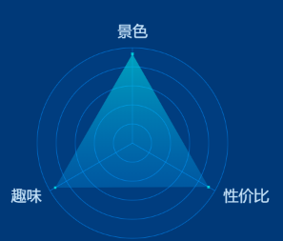
var a =
(parseFloat(chartData.jqzhdf[0].FIRST_SCORE)+parseFloat(chartData.jqzhdf[0].SECOND_SCORE)+parseFloat(chartData.jqzhdf[0].THIRD_SCORE))/3
a=(a+'').substring(0,3)
var data =[]
data.push(chartData.jqzhdf[0].FIRST_SCORE)
data.push(chartData.jqzhdf[0].SECOND_SCORE)
data.push(chartData.jqzhdf[0].THIRD_SCORE)
option = {
title:{
text:'{a|综合打分}{b|'+a+'}{a|分}',
left:'center',
top:'10%',
textStyle:{
rich: {
a: {
color: '#D0E4F9',
fontSize: 28,
fontFamily: 'Microsoft YaHei'
},
b: {
color: '#29E8E9',
fontSize: 48,
fontFamily: 'Microsoft YaHei-Bold'
},
}
}
},
backgroundColor:'rgba(0,165,255,0.1)',
color: ['rgba(41,232,233,0.81)'], // 调色盘颜色列表。
radar: [{
indicator: [{
text: '景色',color:' #D0E4F9',fontSize: 28,max:5
}, {
text: '趣味',color:' #D0E4F9',fontSize: 28,max:5
}, {
text: '性价比',color:' #D0E4F9',fontSize: 28,max:5
},
],
center: ['50%', '55%'],
radius: 150,
startAngle: 90,
splitNumber: 5,
shape: 'circle',
name: {
formatter: '{value}',fontSize:24,
textStyle: {
color: '#fff',
fontSize: 28
}
},
splitArea: {
areaStyle: {
color: ['rgba(0,141,255,0.05)',
'rgba(0,141,255,0.05)', 'rgba(0,141,255,0.05)',
'rgba(0,141,255,0.05)', 'rgba(0,141,255,0.05)'
],
shadowColor: 'rgba(0, 0, 0, 0.3)',
shadowBlur: 0
}
},
axisLine: {
lineStyle: {
color: 'rgba(0,141,255,0.60)'
}
},
splitLine: {
lineStyle: {
color: 'rgba(0,141,255,0.60)'
}
}
}],
series: [{
name: '雷达图',
type: 'radar',
itemStyle: {
emphasis: {
lineStyle: {
width: 1,
color:'rgba(0,0,0,0)'
}
}
},
data: [{
value: data,
symbol: 'rect',
symbolSize: 4,
areaStyle: {
normal: {
color: new echarts.graphic.LinearGradient(
0, 0, 0, 1, [{
offset: 0,
color: 'rgba(41,232,233,0.81)',
fontSize: 28
},
{
offset: 1,
color: 'rgba(0,165,255,0.36)',
fontSize: 28
}
]
)
}
},
lineStyle: {
normal: {
type: 'solid',
width: 0
}
}
}]
}]
}

2.轴标签可点击，tooltip自定义
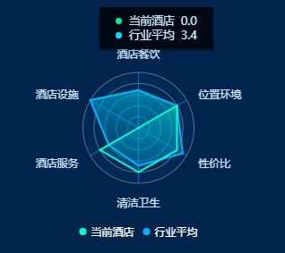

/*自定义tooltip html*/
<style>
.flow_wind_mid {
min-width: 1.36rem;
height: auto;
position: absolute;
font-size: .12rem;
background: rgba(0, 0, 0, 0.75);
box-shadow: 0 .01rem .02rem 0 rgba(0, 0, 0, 0.50);
border-radius: .03rem;
letter-spacing: 0;
display: flex;
flex-direction: column;
justify-content: space-between;
padding: .08rem .2rem;
}

.flow_wind_label {
display: flex;
align-items: center;
}

.flow_wind_name {
font-size: .14rem;
color: #D0E4F9;
padding-left: .08rem;
}

.flow_wind_number {
font-size: .14rem;
color: #D0E4F9;
padding-left: .08rem;
}

.flow_wind_yuan1 {
width: .08rem;
height: .08rem;
border-radius: .04rem;
background-color: #32E594;
}

.flow_wind_yuan2 {
width: .08rem;
height: .08rem;
border-radius: .04rem;
background-color: #00DDFF;
}

.flow_wind_yuan3 {
width: .08rem;
height: .08rem;
border-radius: .04rem;
background-color: #F8BF56;
}

.flow_wind_right {
min-width: 1.36rem;
height: .58rem;
position: absolute;
font-size: .12rem;
background: rgba(0, 0, 0, 0.75);
box-shadow: 0 .01rem .02rem 0 rgba(0, 0, 0, 0.50);
border-radius: .03rem;
letter-spacing: 0;
display: flex;
flex-direction: column;
justify-content: space-between;
padding: .08rem .2rem;
}
</style>

<div class="flow_wind_mid" style="display: none">
<div class="flow_wind_label">
<div class="flow_wind_yuan1"></div>
<div class="flow_wind_name" id="thisSeries_name">当前景区</div>
<div class="flow_wind_number" id="thisSeries_number">0</div>
</div>
<div class="flow_wind_label">
<div class="flow_wind_yuan2"></div>
<div class="flow_wind_name">行业平均</div>
<div class="flow_wind_number" id="total_avg_number">0</div>
</div>
</div>
/*自定义tooltip html*/

//渲染评分维度图表echarts js
function setCommentDimensionChart
(thisSeriesName, domClass, totalScoreList, thisCommentObjScoreList) {

$('#' + domClass).parent('div').html('<div id="' + domClass + '"></div>');

var mainContainer = document.getElementById(domClass);
var echartsdome = document.getElementsByClassName(domClass);
//用于使chart自适应高度和宽度,通过窗体高宽计算容器高宽
var resizeMainContainer = function () {
mainContainer.style.width = $(echartsdome[0]).width() + 'px';
mainContainer.style.height = $(echartsdome[0]).height() + 'px';
};
//设置div容器高宽
resizeMainContainer();
// 初始化图表
var mainChart = echarts.init(mainContainer);
$(echartsdome).on('resize', function () {
//屏幕大小自适应，重置容器高宽
resizeMainContainer();
mainChart.resize();
});

var indicatorData = [{text: '暂无数据', color: ' #D0E4F9', fontSize: 14, max: 5}];
var indicatorDataNames = ['暂无数据'];
var data_total = [0];
var data = [];

for (var i = 0; i < totalScoreList.length; i++) {

if (i == 0) {
indicatorData = [];
indicatorDataNames = [];
data_total = [];
}

var obj = {};
obj.text = totalScoreList[i].dimension;
obj.color = '#D0E4F9';
obj.fontSize = 14;
obj.max = 5;

indicatorData.push(obj);
indicatorDataNames.push(totalScoreList[i].dimension);
data_total.push(totalScoreList[i].score);
//初始化针对行业的各维度分数为0
data.push(0);
}

var seriesData = [
{
value: data_total,
name: '行业平均',
areaStyle: {
normal: {
color: new echarts.graphic.LinearGradient(0, 0, 0, 1, [{
offset: 0, color: 'rgba(0,221,255,0.65)'
}, {
offset: 1, color: 'rgba(25,151,224,0.25)'
}], false),
}
},
lineStyle: {
normal: {
color: '#02B0FE',
type: 'solid',
width: 2
}
}
}
];

var thisSeriesColors = [];
var thisSeriesColors_border = [];
var thisSeriesColors_border = [];
thisSeriesColors['当前景区'] = new echarts.graphic.LinearGradient(0, 0, 0, 1, [{
offset: 0, color: 'rgba(248,191,86,0.45)'
}, {
offset: 1, color: 'rgba(248,191,86,0.25)'
}], false);
thisSeriesColors['当前酒店'] = new echarts.graphic.LinearGradient(0, 0, 0, 1, [{
offset: 0, color: 'rgba(0,254,203,0.45)'
}, {
offset: 1, color: 'rgba(0,178,254,0.25)'
}], false);

thisSeriesColors_border['当前景区'] = '#F1C31B';
thisSeriesColors_border['当前酒店'] = '#00FECB';

if (thisCommentObjScoreList != null) {

for (var i = 0; i < thisCommentObjScoreList.length; i++) {

for (var j = 0; j < indicatorData.length; j++) {
if (indicatorData[j].text.trim() == thisCommentObjScoreList[i].dimension.trim()) {
data[j] = thisCommentObjScoreList[i].score;
}
}
}

seriesData.push(
{
value: data,
name: thisSeriesName,
areaStyle: {
normal: {
color: thisSeriesColors[thisSeriesName]
}
},
lineStyle: {
normal: {
color: thisSeriesColors_border[thisSeriesName],
type: 'solid',
width: 2
}
}
}
);

}
var option = {
backgroundColor: 'rgba(0,0,0,0)',
color: ['#02B0FE', thisSeriesColors_border[thisSeriesName]],
radar: [{
indicator: indicatorData,
triggerEvent: true,
center: ['50%', '50%'],
radius: 62,
startAngle: 90,
splitNumber: 5,
shape: 'circle',
name: {
formatter: '{value}', fontSize: 12,
textStyle: {
color: '#D0E4F9',
fontSize: 12
}
},
splitArea: {
areaStyle: {
color: ['rgba(0,141,255,0.05)',
'rgba(0,141,255,0.05)', 'rgba(0,141,255,0.05)',
'rgba(0,141,255,0.05)', 'rgba(0,141,255,0.05)'
],
shadowColor: 'rgba(0, 0, 0, 0.3)',
shadowBlur: 0
}
},
axisLine: {
lineStyle: {
color: 'rgba(0,141,255,0.60)'
}
},
splitLine: {
lineStyle: {
opacity: 0.45
}
}
}],
series: [
{
name: '雷达图',
type: 'radar',
symbol: 'none',
itemStyle: {
emphasis: {
lineStyle: {
width: 1,
color: 'rgba(0,0,0,0)'
}
}
},
data: seriesData
}
],
legend: {
data: [thisSeriesName, '行业平均'],
icon: 'circle',
itemWidth: 8,
itemHeight: 8,
bottom: 5,
textStyle: {
fontSize: 12,
color: '#FFFFFF'
}
},
}

mainChart.setOption(option);
mainChart.on('click', function (params) {//触发雷达图轴标签点击事件后的处理});

mainChart.on('mouseover', function (params) {

var domId = $(params.event.event.srcElement).parent('div').parent('div').attr('id');

if (params.name == '行业平均' || params.name == '当前景区' || params.name == '当前酒店') {
$('#' + domId + ' > div:nth-child(1)')
.addClass('dimension_chart');
return;
} else {
$('#' + domId + ' > div:nth-child(1)')
.removeClass('dimension_chart');
}

var domIds = ['', 'scenic_comment_dimension_chart', '', 'hotel_comment_dimension_chart'];
var thisSeries_name = ['', '当前景区', '', '当前酒店'];

$('#total_avg_number').html(data_total[indicatorDataNames.indexOf(params.name)].toFixed(1));

if (thisCommentObjScoreList != null) {
$('#thisSeries_name').html(thisSeries_name[domIds.indexOf(domId)]);
$('#thisSeries_number').html(data[indicatorDataNames.indexOf(params.name)].toFixed(1));
$('#thisSeries_name').parent('div').show();
if (domId == 'scenic_comment_dimension_chart') {
$('#thisSeries_name').prev('div').removeClass('flow_wind_yuan1').addClass('flow_wind_yuan3');
} else if (domId == 'hotel_comment_dimension_chart') {
$('#thisSeries_name').prev('div').removeClass('flow_wind_yuan3').addClass('flow_wind_yuan1');
}
} else {
$('#thisSeries_name').parent('div').hide();
}

var height = $('.flow_wind_mid').height();
$('.flow_wind_mid').show().css({
"top": params.event.event.pageY - height - 20,
"left": params.event.event.pageX - 20
})

});

mainChart.on('mouseout', function (params) {
$('.flow_wind_mid').hide();
});
}
//渲染评分维度图表echarts js

词云图（type: 'wordCloud'）

需要引用echarts-wordcloud.min.js
<script type="text/javascript" src="**/echarts-wordcloud.min.js?_=1.1"></script>
function setCloudWord(domId, dataList) {
var listArr = [];
for (var i = 0; i < dataList.length; i++) {
var obj = {};
obj.name = dataList[i].word;
obj.value = dataList[i].times - 0;
listArr.push(obj);
}
var dom = document.getElementById(domId);
var myChart = echarts.init(dom);
var app = {};
option = null;
option = {
tooltip: {
backgroundColor: 'rgba(0,0,0,0.75)',
formatter: function (data) {
return data.value + '次';
}
},
series: [{
type: 'wordCloud',
gridSize: 0,
sizeRange: [10, 25],
rotationRange: [0, 0],
shape: 'oval',
textStyle: {
normal: {
color: function () {
return 'rgb(' + [
Math.round(Math.random() * 128 + 127),
Math.round(Math.random() * 128 + 127),
Math.round(Math.random() * 128 + 127)
].join(',') + ')';
}
},
emphasis: {
shadowBlur: 10,
shadowColor: '#333'
}
},
data: listArr
}]
};
if (option && typeof option === "object") {
myChart.setOption(option, true);
}
myChart.on("click", function (params) {
//词云图单词点击事件触发后
})
}

水球图（type: 'liquidFill）

需要引用echarts-liquidfill.min.js
<script type="text/javascript" src="**/echarts-liquidfill.min.js?_=1.1"></script>

function tourismConsumeCharacterData(datas1, datas2){
let color = ['#00BDA6']; // 水滴球颜色
let outlineborderColor = "#00FECB"; // 外部边框颜色
let outlineBackColor = "rgba(0,254,203,0.15)"; // 外部背景色
let backgroundColor = "rgba(0,254,203,0.15)"; // 内部背景色
if (!$.isEmptyObject(datas1)) {
let data1 = [];
data1.push(datas1[0].percent / 100);
var mainContainer = document.getElementById('revisedEcharts');
var echartsdome = document.getElementsByClassName('revisedEcharts');
//用于使chart自适应高度和宽度,通过窗体高宽计算容器高宽
var resizeMainContainer = function () {
mainContainer.style.width = ($(echartsdome[0]).width()/2) + 'px';
mainContainer.style.height = $(echartsdome[0]).height() + 'px';
};
//设置div容器高宽
resizeMainContainer();
// 初始化图表
var mainChart = echarts.init(mainContainer);
$(echartsdome).on('resize', function () {
//屏幕大小自适应，重置容器高宽
resizeMainContainer();
mainChart.resize();
});
tourismConsumeCharacterDataDraw(mainChart, color,outlineborderColor,outlineBackColor,backgroundColor, data1);
}
if (!$.isEmptyObject(datas2)) {
let data2 = [];
data2.push(datas2[0].percent / 100);
color = ["#AD4C3D"];
outlineborderColor = "#EF5F3B";
outlineBackColor = "rgba(239,95,59,0.15)";
backgroundColor = "rgba(239,95,59,0.15)";
var mainContainer = document.getElementById('talentEcharts');
var echartsdome = document.getElementsByClassName('talentEcharts');
//用于使chart自适应高度和宽度,通过窗体高宽计算容器高宽
var resizeMainContainer = function () {
mainContainer.style.width = ($(echartsdome[0]).width()/2) + 'px';
mainContainer.style.height = $(echartsdome[0]).height() + 'px';
};
//设置div容器高宽
resizeMainContainer();
// 初始化图表
var mainChart = echarts.init(mainContainer);
$(echartsdome).on('resize', function () {
//屏幕大小自适应，重置容器高宽
resizeMainContainer();
mainChart.resize();
});
tourismConsumeCharacterDataDraw(mainChart, color,outlineborderColor,outlineBackColor,backgroundColor, data2);
}
}
function tourismConsumeCharacterDataDraw(dom, color,outlineborderColor,outlineBackColor,backgroundColor, data){
var option = {
backgroundColor:'#021C4B',
series: [{
type: 'liquidFill',
radius: '80%',
data: data,
amplitude: '8%',
waveLength: '80%',
phase: 'auto',
period: 'auto',
direction: 'right',
color: color,
outline: {
show: true,
backgroundColor: '#013D5D',
borderDistance: 3,
itemStyle: {
color: outlineBackColor,
borderColor: outlineborderColor,
borderWidth: 1,
shadowBlur: 0,
shadowColor: color
}
},
backgroundStyle: {
borderColor: color,
borderWidth: 0,
shadowColor: color,
shadowBlur: 0,
color: backgroundColor
},
itemStyle: {
opacity: 0.95,
shadowBlur: 50,
shadowColor: 'rgba(0, 0, 0, 0.4)'
},
label: {
show: true,
color: color,
insideColor: '#fff',
fontSize: 20,
fontWeight: 'bold',

align: 'center',
baseline: 'middle',
position: 'inside',
},
emphasis: {
itemStyle: {
opacity: 0.8
}
}
}]
};
dom.setOption(option);
}

geo+飞线图（type: 'lines'）+散点图（type: 'scatter';type: 'effectScatter'）
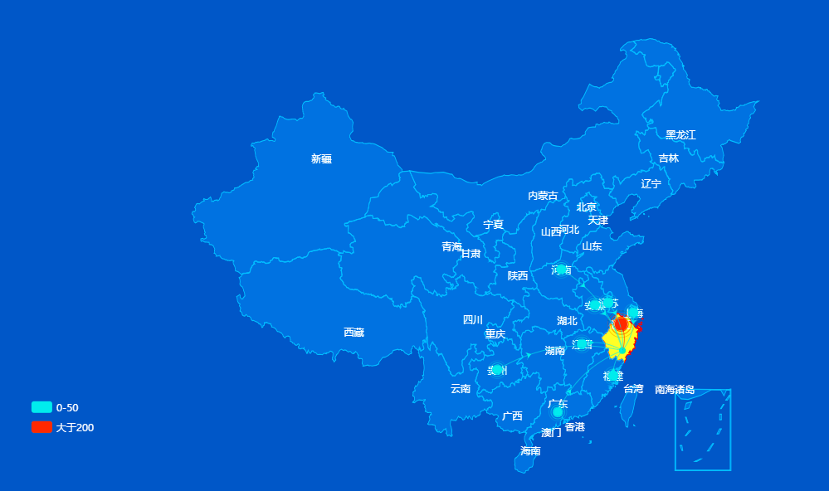
画世界地图需要引入world.js
画中国地图需要引入 china.js
画省地图需要引入各省的地图js
<script src='**/china.js'></script>
<script src='**/zhejiang.js'></script>
<script src='**/world.js'></script>

<!-- 例子的html -->
<html lang="en">
<head>
<meta charset="utf-8">
<title>超绚丽的HTML5地图分布动画DEMO演示</title>
</head>

<body style="height:100%;width: 100%">

<div class="mainMap" style="height:100%;width: 100%;padding:10px;">
<div id="mainMap"></div>
</div>

<script type="text/javascript" src="js/jquery-1.8.0.js"></script>
<script type="text/javascript" src="http://gallery.echartsjs.com/dep/echarts/latest/echarts.js"></script>
<script src='js/map/china.js'></script>
<script src='js/map/province/zhejiang.js'></script>
<script src='js/map/world.js'></script>
<script type="text/javascript">
$('#document').ready(function(){
getEcharts();
});
</script>

<script type="text/javascript">

function getEcharts(){
var mainContainer = document.getElementById('mainMap');
var echartsdome = document.getElementsByClassName('mainMap');
//用于使chart自适应高度和宽度,通过窗体高宽计算容器高宽
var resizeMainContainer = function () {
mainContainer.style.width = $(echartsdome[0]).width() + 'px';
mainContainer.style.height = $(echartsdome[0]).height() + 'px';
};
//设置div容器高宽
resizeMainContainer();
// 初始化图表
var mainChart = echarts.init(mainContainer);
$(echartsdome).on('resize', function () {
//屏幕大小自适应，重置容器高宽
resizeMainContainer();
mainChart.resize();
});

//1国内，2省内，3国际
var isProvince = 1;
//显示第几页
var toPageNumber = 1;

var geoCoordMap = {};
var BGData = [];
var geoCoordMapZhejiang = {
'杭州': [120.153576, 30.287459],
'建德': [119.279089, 29.472284],
'富阳': [119.949869, 30.049871],
'临安': [119.715101, 30.231153],
'宁波': [121.549792, 29.868388],
'余姚': [121.156294, 30.045404],
'慈溪': [121.248052, 30.177142],
'奉化': [121.41089, 29.662348],
'温州': [120.672111, 28.000575],
'瑞安': [120.646171, 27.779321],
'乐清': [120.967147, 28.116083],
'嘉兴': [120.750865, 30.762653],
'海宁': [120.688821, 30.525544],
'平湖': [121.014666, 30.698921],
'桐乡': [120.551085, 30.629065],
'湖州': [120.102398, 30.867198],
'绍兴': [120.582112, 29.997117],
'诸暨': [120.244326, 29.713662],
'上虞': [120.874185, 30.016769],
'嵊州': [120.82888, 29.586606],
'金华': [119.649506, 29.089524],
'兰溪': [119.460521, 29.210065],
'义乌': [120.074911, 29.306863],
'东阳': [120.23334, 29.262546],
'永康': [120.036328, 28.895293],
'衢州': [118.87263, 28.941708],
'江山': [118.627879, 28.734674],
'衢州市内': [118.37263, 29.181708],
'舟山': [122.106863, 30.016028],
'台州': [121.428599, 28.661378],
'温岭': [121.373611, 28.368781],
'临海': [121.131229, 28.845441],
'丽水': [119.921786, 28.451993],
'龙泉': [119.132319, 28.069177],
'青田': [120.291939, 28.135247]
};
var geoCoordMapWorld = {
'美国': [-77.02,39.91],
'中国': [116.20,39.55],
'中国香港': [114.173355, 22.320048],
'中国台湾': [121.509062, 25.044332],
'日本': [139.46, 35.42],
'德国': [13.25,52.30],
'英国': [-0.05,51.36],
'印度': [77.13,28.37],
'法国': [2.20,48.50],
'巴西': [-47.55,-15.47],
'意大利': [12.29,41.54],
'加拿大': [-75.42,45.27],
'俄罗斯': [37.35,55.45],
'韩国': [126.58,37.31],
'澳大利亚': [149.08,-35.15],
'西班牙': [-3.45,40.25],
'墨西哥': [-99.10,19.20],
'印度尼西亚': [106.49,-6.09],
'土耳其': [32.54,39.57],
'荷兰': [4.54,52.23],
'沙特阿拉伯': [46.42,24.41],
'瑞士': [7.28,46.57],
'阿根廷': [-60.00,-36.30],
'瑞典': [18.03,59.20],
'波兰': [21.00,52.13],
'比利时': [4.21,50.51],
'泰国': [100.35,13.45],
'伊朗': [51.30,35.44],
'奥地利': [16.22,48.12],
'挪威': [10.45,59.55],
'阿联酋': [54.22,24.28],
'尼日利亚': [7.32,9.05],
'以色列': [35.12,31.47],
'南非': [28.11,25.43],
'爱尔兰': [-6.15,53.21],
'丹麦': [12.34,55.41],
'新加坡': [103.51,1.17],
'马来西亚': [101.41,3.09],
'菲律宾': [121.03,14.40],
'哥伦比亚': [-74.00,4.34],
'巴基斯坦': [73.10,33.40],
'智利': [-70.40,-33.24],
'芬兰': [25.03,60.15],
'孟加拉国': [90.26,23.43],
'埃及': [31.14,30.01],
'越南': [105.55,21.05],
'葡萄牙': [-9.10,38.42],
'捷克': [14.22,50.05],
'罗马尼亚': [26.10,44.27],
'秘鲁': [-77.00,-12.00],
'新西兰': [174.46,-41.19],
'希腊': [23.46,37.58],
'青田': [120.291939, 28.135247]
};

var geoCoordMapChina = {
'北京': [116.405285, 39.904989],
'天津': [117.190182, 39.125596],
'上海': [121.472644, 31.231706],
'重庆': [106.504962, 29.533155],
'河北': [114.502461, 38.045474],
'山西': [112.549248, 37.857014],
'辽宁': [123.429096, 41.796767],
'吉林': [125.3245, 43.886841],
'黑龙江': [126.642464, 45.756967],
'江苏': [118.767413, 32.041544],
'浙江': [120.153576, 30.287459],
'衢州': [118.87263, 28.941708],
'安徽': [117.283042, 31.86119],
'福建': [119.306239, 26.075302],
'江西': [115.892151, 28.676493],
'山东': [117.000923, 36.675807],
'河南': [113.665412, 34.757975],
'湖北': [114.298572, 30.584355],
'湖南': [112.982279, 28.19409],
'广东': [113.280637, 23.125178],
'海南': [110.33119, 20.031971],
'四川': [104.065735, 30.659462],
'贵州': [106.713478, 26.578343],
'云南': [102.712251, 25.040609],
'陕西': [108.948024, 34.263161],
'甘肃': [103.823557, 36.058039],
'青海': [101.778916, 36.623178],
'台湾': [121.509062, 25.044332],
'内蒙古': [111.670801, 40.818311],
'广西': [108.320004, 22.82402],
'西藏': [91.132212, 29.660361],
'宁夏': [106.278179, 38.46637],
'新疆': [87.617733, 43.792818],
'香港': [114.173355, 22.320048],
'澳门': [113.54909, 22.198951],
'青田': [120.291939, 28.135247]
};

var showEmphasisLable = false;
var showNormalLabel = false;
var mapTitle = '国内热门';

//设置坐标
if(isProvince == 1) {
geoCoordMap = geoCoordMapChina;
showEmphasisLable = false;
showNormalLabel = true;
mapTitle = '国内热门';
}else if(isProvince == 2){
geoCoordMap = geoCoordMapZhejiang;
showEmphasisLable = false;
showNormalLabel = true;
mapTitle = '省内热门';
}else if(isProvince == 3){
geoCoordMap = geoCoordMapWorld;
showEmphasisLable = true;
showNormalLabel = false;
mapTitle = '国际热门';
}

//数据处理
var sourcePlacesDatasList = [];
var limitCount = 0;
var sourcePlacesDatasTemp = [];
var markLineDataBig = [];
var sourcePlacesJsonString1 = '[{"source_place":"浙江","number":"4499"},{"source_place":"江苏","number":"40"},{"source_place":"安徽","number":"25"},{"source_place":"河南","number":"25"},{"source_place":"贵州","number":"24"},{"source_place":"福建","number":"24"},{"source_place":"江西","number":"22"},{"source_place":"上海","number":"21"},{"source_place":"广东","number":"18"},{"source_place":"四川","number":"15"},{"source_place":"北京","number":"13"},{"source_place":"广西","number":"12"},{"source_place":"云南","number":"12"},{"source_place":"湖南","number":"10"},{"source_place":"湖北","number":"7"},{"source_place":"山东","number":"6"},{"source_place":"河北","number":"6"},{"source_place":"重庆","number":"6"},{"source_place":"陕西","number":"4"},{"source_place":"青海","number":"4"},{"source_place":"新疆","number":"3"},{"source_place":"辽宁","number":"3"},{"source_place":"甘肃","number":"3"},{"source_place":"山西","number":"3"},{"source_place":"内蒙古","number":"1"},{"source_place":"天津","number":"1"},{"source_place":"吉林","number":"1"},{"source_place":"海南","number":"0"},{"source_place":"西藏","number":"0"},{"source_place":"黑龙江","number":"0"}]';
var sourcePlacesJsonString2 = '[{"source_place":"丽水","number":"3849"},{"source_place":"温州","number":"397"},{"source_place":"杭州","number":"87"},{"source_place":"金华","number":"64"},{"source_place":"台州","number":"34"},{"source_place":"宁波","number":"22"},{"source_place":"绍兴","number":"16"},{"source_place":"衢州","number":"10"},{"source_place":"嘉兴","number":"9"},{"source_place":"湖州","number":"7"},{"source_place":"舟山","number":"1"}]';
var sourcePlacesJsonString3 = '[{"source_place":"中国（中华人民共和国","number":"4882"},{"source_place":"西班牙","number":"1"},{"source_place":"美国","number":"1"},{"source_place":"马来西亚","number":"0"}]';
var sourcePlacesJsonStringArr = ['',sourcePlacesJsonString1,sourcePlacesJsonString2,sourcePlacesJsonString3];
var sourcePlaces = JSON.parse(sourcePlacesJsonStringArr[isProvince]);
var regionsName = ['','浙江','丽水市','China'];

//每页9条，分页分组
if(sourcePlaces){
for(let i = 0; i < sourcePlaces.length; i++) {
var sourcePlace = sourcePlaces[i];
let obj = {};
obj.source_place = sourcePlace.source_place;
obj.number = sourcePlace.number;
sourcePlacesDatasTemp.push(obj);
limitCount = limitCount + 1;
if(limitCount == 9 || i == sourcePlaces.length - 1 ){
var objTemp = {};
objTemp.data = sourcePlacesDatasTemp;
sourcePlacesDatasList.push(objTemp);
sourcePlacesDatasTemp = [];
limitCount = 0;
}
}
}

var sourcePlacesDatas = [];
if(sourcePlacesDatasList[toPageNumber - 1]){
sourcePlacesDatas = sourcePlacesDatasList[toPageNumber - 1].data;
}

//飞线数据处理
if(sourcePlacesDatas) {
for (let i = 0; i < sourcePlacesDatas.length; i++) {
var sourcePlaceData = sourcePlacesDatas[i];
var markLineDataObj1 = {};
var markLineDataObj2 = {};
var markLineDataSmall = [];
let sourcePlace = sourcePlaceData.source_place;
sourcePlace = (sourcePlace.indexOf('(') >= 0)?(sourcePlace.substr(0,sourcePlace.indexOf('('))):sourcePlace;
sourcePlace = (sourcePlace.indexOf('（') >= 0)?(sourcePlace.substr(0,sourcePlace.indexOf('（'))):sourcePlace;
markLineDataObj1.name = sourcePlace.replace('省', '').replace('市', '').replace('自治区', '')
.replace('壮族', '').replace('回族', '').replace('维吾尔', '').replace('特别行政区', '').replace('共和国', '');
if (markLineDataObj1.name == '青田') {
markLineDataObj1.name = '青田县内';
}
markLineDataObj2.name = '青田';
markLineDataObj2.value = sourcePlaceData.number;
markLineDataSmall.push(markLineDataObj1);
markLineDataSmall.push(markLineDataObj2);
BGData.push(markLineDataSmall);
}
}

var convertLineData = function (data) {
var res = [];
var fromCoord = geoCoordMap[data[0].name];
var toCoord = geoCoordMap[data[1].name];
if (fromCoord && toCoord) {
res.push({
fromName: data[0].name,
toName: data[1].name,
coords: [fromCoord, toCoord]
});
}
return res;
};

var convertMarkPointData = function (data) {
var res = [];
var geoCoord = geoCoordMap[data[0].name];
if (geoCoord) {
res.push({
name: data[0].name,
value: geoCoord.concat(data[1].value - 0)
});
}
return res;
};

var maptype = ['', 'china','浙江', 'world'];
var maptypeName = maptype[isProvince];
if(!isProvince){
maptypeName= 'china';
}

var color = ['#29E8E9', '#7EEC8C','#EDF313', '#FFA700', '#FF3F00'];
var level = ['0-50','50-100','100-150','150-200','大于200'];
var series = [];
BGData.forEach(function (item, i) {
var levelIndex = ((Math.floor(item[1].value/50) > 4)?4:Math.floor(item[1].value/50));
series.push(
{
name: level[levelIndex],
type: 'lines',
zlevel: 1,
effect: {
show: false,
period: 6,
trailLength: 0.7,
color: '#fff',
symbolSize: 3
},
lineStyle: {
normal: {
color: color[levelIndex],
width: 0,
curveness: 0.2
}
},
data: convertLineData(item)
},
{
name: level[levelIndex],
type: 'lines',
zlevel: 2,
//symbol: ['none', 'arrow'],
symbolSize: 10,
effect: {
show: true,
period: 6,
trailLength: 0,
symbol: 'arrow',
symbolSize: 6
},
lineStyle: {
normal: {
color: color[levelIndex],
width: 1,
opacity: 0.6,
curveness: 0.2
}
},
data: convertLineData(item)
},
{
name: level[levelIndex],
type: 'effectScatter',
symbolSize: function (val) {
var size = val[2] / 20;
return size>15?15:(size<10?10:size);
},
coordinateSystem: 'geo',
data: convertMarkPointData(item),
rippleEffect:{
period:4,
scale:2.5,
brushType:'stroke'
},
label: {
normal: {
formatter: '{b}',
position: 'bottom',
show: false
},
emphasis: {
show: false
}
},
itemStyle: {
normal: {
color: color[levelIndex]
},
label: {
show: false
}
}
});
});

var markTargetPoint = {
name: '青田',
type: 'scatter',
symbolSize:8,
coordinateSystem: 'geo',
data: [{name:'青田',value:geoCoordMap['青田']}],
rippleEffect:{
period:4,
scale:2.5,
brushType:'stroke'
},
label: {
normal: {
formatter: '{b}',
position: 'bottom',
show: false
},
emphasis: {
show: false
}
},
itemStyle: {
normal: {
color: '#29E8E9'
},
label: {
show: false
}
}
};

series.push(markTargetPoint);

var option = {
tooltip: {
trigger: 'item',
formatter: function (params) {
if(params.seriesType == "lines"){
for(var i=0;i<BGData.length;i++){
var o= BGData[i];
if(o[0].name==params.data.fromName){
return params.data.fromName+" → "+params.data.toName+"<br/>人数:"+o[1].value+"人";
}
}
}
}
},
legend: {
orient: 'vertical',
top: '76%',
left: '10%',
data:level,
textStyle: {
color: '#fff'
},
selectedMode: 'multiple'
},
backgroundColor: '#1755c9',
geo: {
map:maptypeName,
label: {
emphasis: {
show: showEmphasisLable,
textStyle: {
color: '#fff'
},
},
normal: {
show: showNormalLabel,
textStyle: {
color: '#fff'
},
}
},
roam: false,//是否开启鼠标缩放和平移漫游。默认不开启。
itemStyle: {
normal: {
areaColor: 'rgba(16,147,255,0.45)',
borderColor: '#4EBDFF',
borderWidth:1,
},
emphasis: {
areaColor: 'rgba(16,147,255,0.45)'
}
},
//在地图中对特定的区域配置样式。
regions: [{
name: regionsName[isProvince],
itemStyle: {
normal: {
areaColor: 'yellow',
borderColor: 'red',
borderWidth: 1
},
emphasis: {
areaColor: 'yellow'
}
}
}]
},
series: series
};

mainChart.setOption(option);
}
</script>
</body>
</html>
<!-- 例子的html -->

echarts象形图pictorialBar（异型柱状图）（type: 'pictorialBar'）
象形图echarts官方解释为
象形柱图是可以设置各种具象图形元素（如图片、SVG PathData 等）的柱状图。往往用在信息图中。用于有至少一个类目轴或时间轴的直角坐标系上。
在网上有一种我认为更加贴切的名字异型组柱状图，这个图形的配置信息与柱状图的配置信息十分相似，只是将柱状图的‘柱子’进行了改变。
参考链接

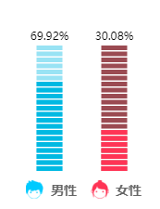

//性别统计
function drawEchartSex(male_data, female_data) {
var man = 'image://' + base + "/report/img/visitor_boy.png"
var women = 'image://' + base + "/report/img/visitor_girl.png"
var option = {
tooltip: {
show: false
},
title: [
{
text: '男性',
left: '28%',
top: '80%',
textStyle: {
color: '#666666',
fontSize: '14'
},
},
{
text: '女性',
left: '68%',
top: '80%',
textStyle: {
color: '#666666',
fontSize: '14'
},
}
],
xAxis: {
data: ['男性', '女性'],
offset: 15,
axisTick: {
show: false
},
axisLine: {
show: false
},
axisLabel: {
color: '#fff',
fontSize: 14
}
},
yAxis: {
min: 0,
max: 100,
splitLine: {
show: false
},
axisTick: {
show: false
},
axisLine: {
show: false
},
axisLabel: {
show: false
}
},
series: [{
label: {
show: true,
position: 'top',
color: '#000',
formatter: function (item) {
if (item.dataIndex === 0) {
return male_data + "%"
} else if (item.dataIndex === 1) {
return female_data + "%"
}
},
position: 'top'
},
type: 'pictorialBar',
barGap: '-100%',
symbol: 'rect',
itemStyle: {
normal: {
barBorderRadius: 5,
color: function (param) {
var colorList = ['rgba(25,183,224, .4)', '#904E55']
return colorList[param.dataIndex]
}
}
},
symbolRepeat: true,
symbolSize: [28, 5],
data: [100, 100],
z: 5
}, {
type: 'pictorialBar',
barGap: '-100%',
symbol: 'rect',
itemStyle: {
normal: {
barBorderRadius: 5,
color: function (param) {
var colorList = ['rgba(25,183,224, 1)', 'rgba(243,69,97, 1)']
return colorList[param.dataIndex]
}
}
},
symbolRepeat: true,
symbolSize: [28, 5],
data: [male_data, female_data],
z: 10
}, {
name: 'glyph',
type: 'pictorialBar',
barGap: '-100%',
symbolPosition: 'start',
symbolSize: 20,
symbolOffset: [0, '140%'],
data: [{
value: 100,
symbol: man,
symbolOffset: ['-80%', '148%']
}, {
value: 100,
symbol: women,
symbolOffset: ['-80%', '148%']
}],
z: 5
}],
backgroundColor: 'transparent'
}
var myChart = echarts.init(document.getElementById('echart_sex'))
myChart.clear()
myChart.setOption(option)
}

