Load Balancer URL

http://resou-WebAp-1S7TURTB3MZ2J-1588741839.us-west-2.elb.amazonaws.com

Load Balancer Target Group

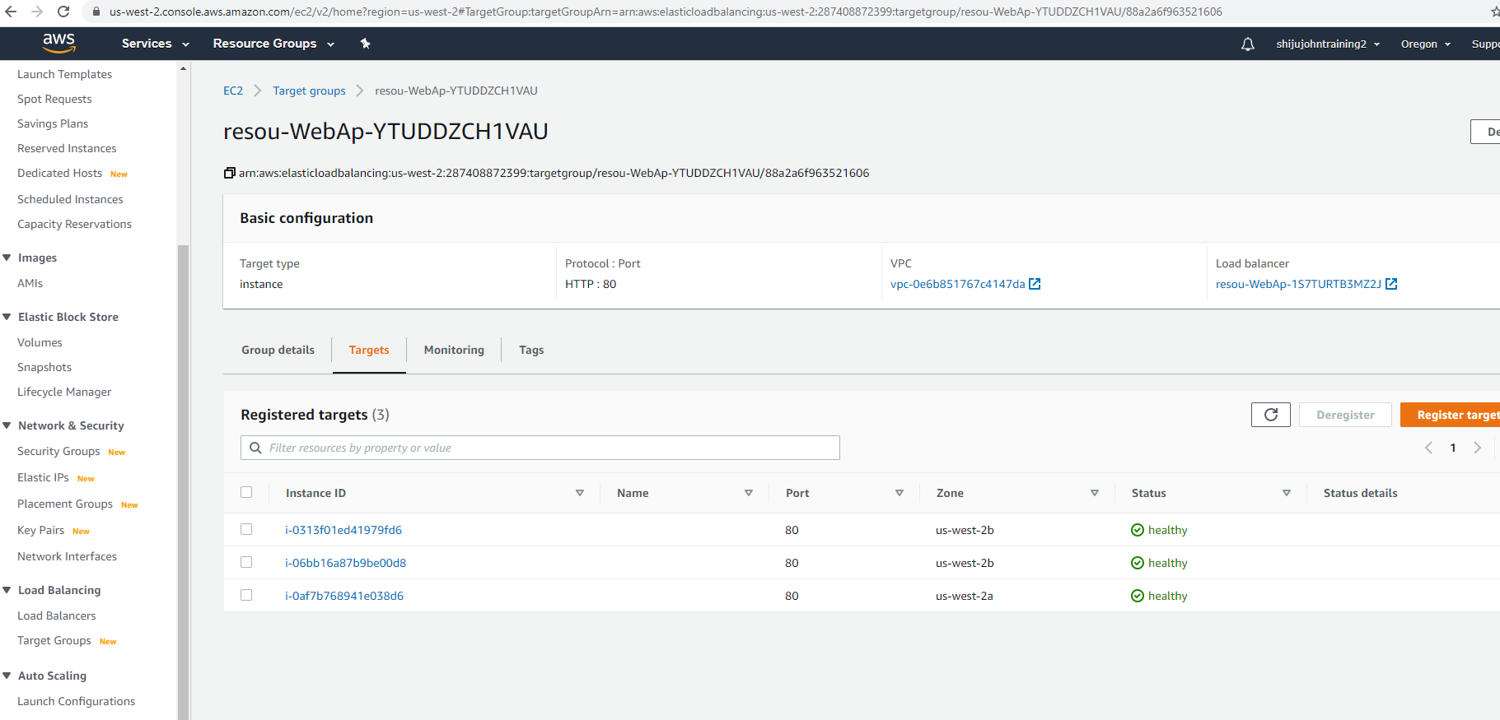

EC2 instance

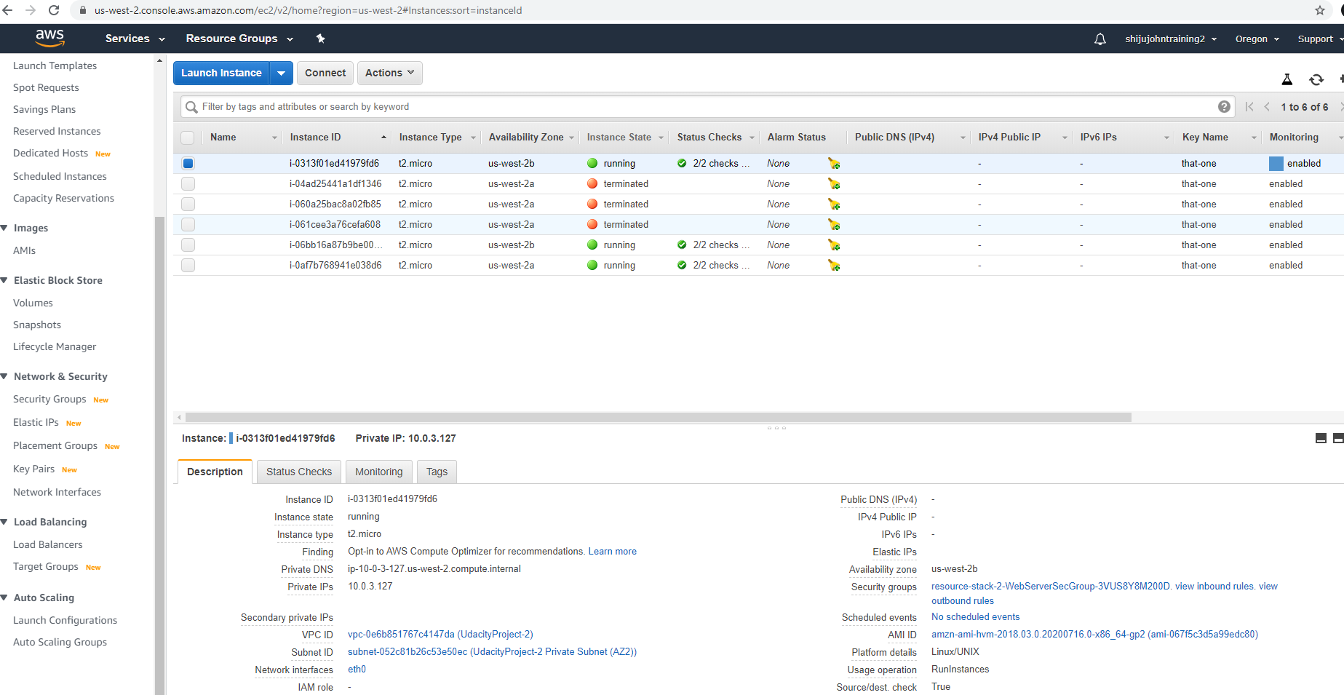

Cloud Formation

