Load Balancer URL

<http://resou-webap-1590ba2a1y2bv-1747557991.us-west-2.elb.amazonaws.com/>

Load Balancer Target Group

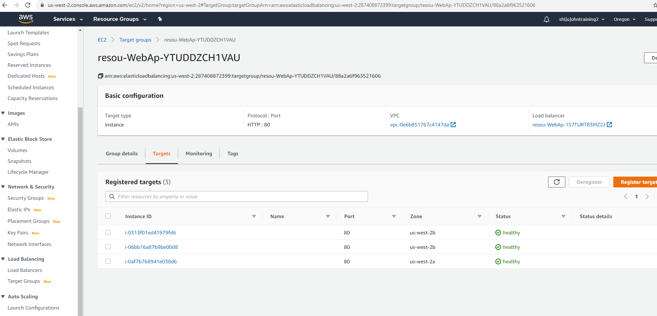

EC2 instance

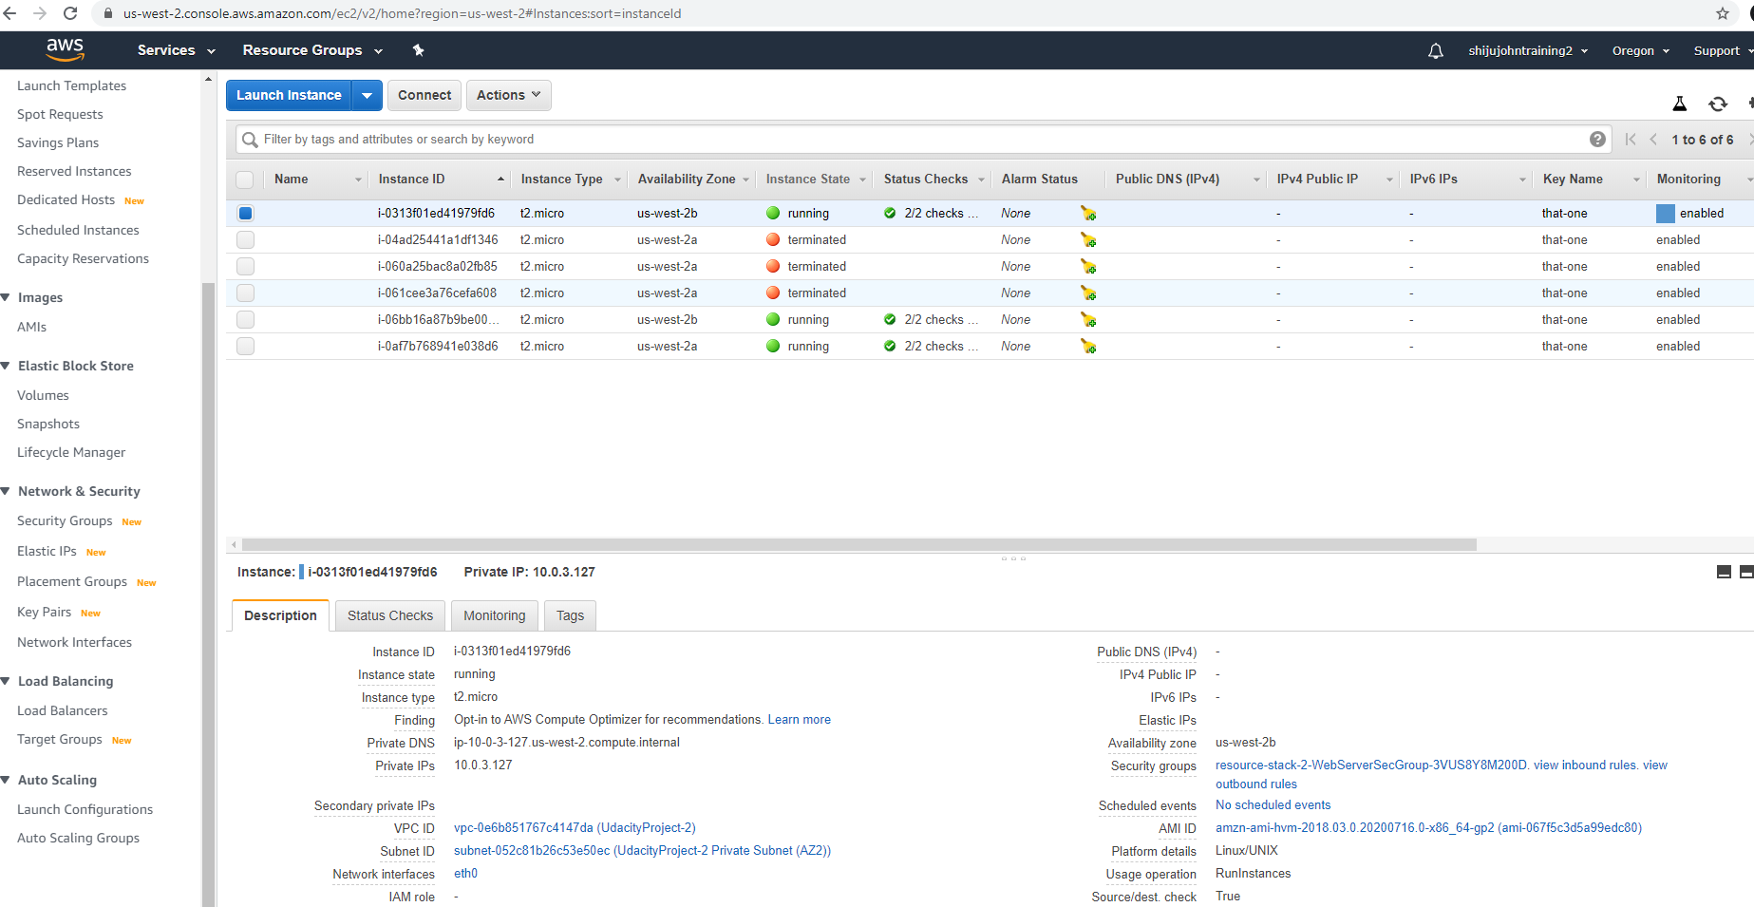

Cloud Formation

