# 3 Bucket and website files

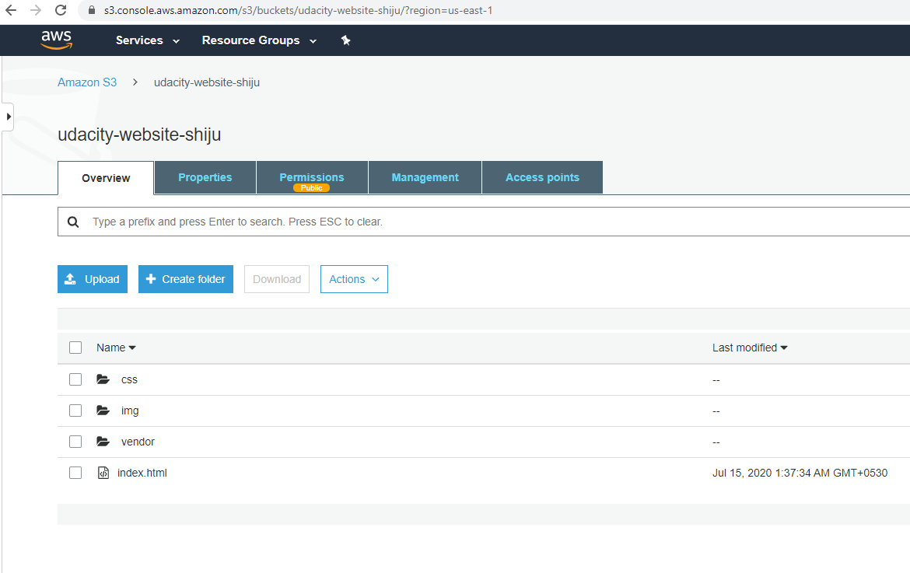

# Bucket Policy

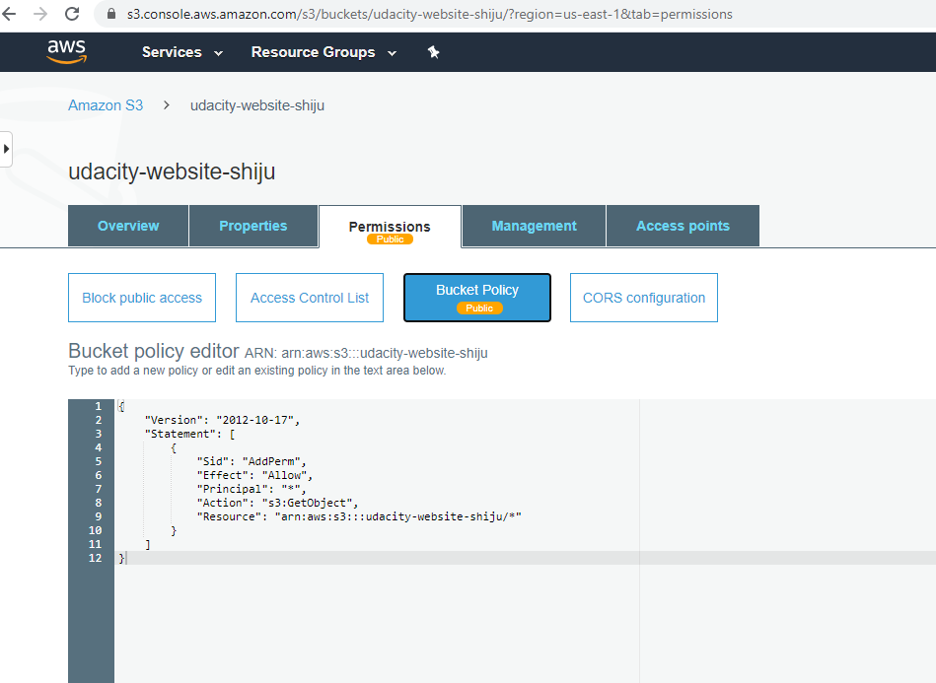

# S3 config for static website

<http://udacity-website-shiju.s3-website-us-east-1.amazonaws.com/>

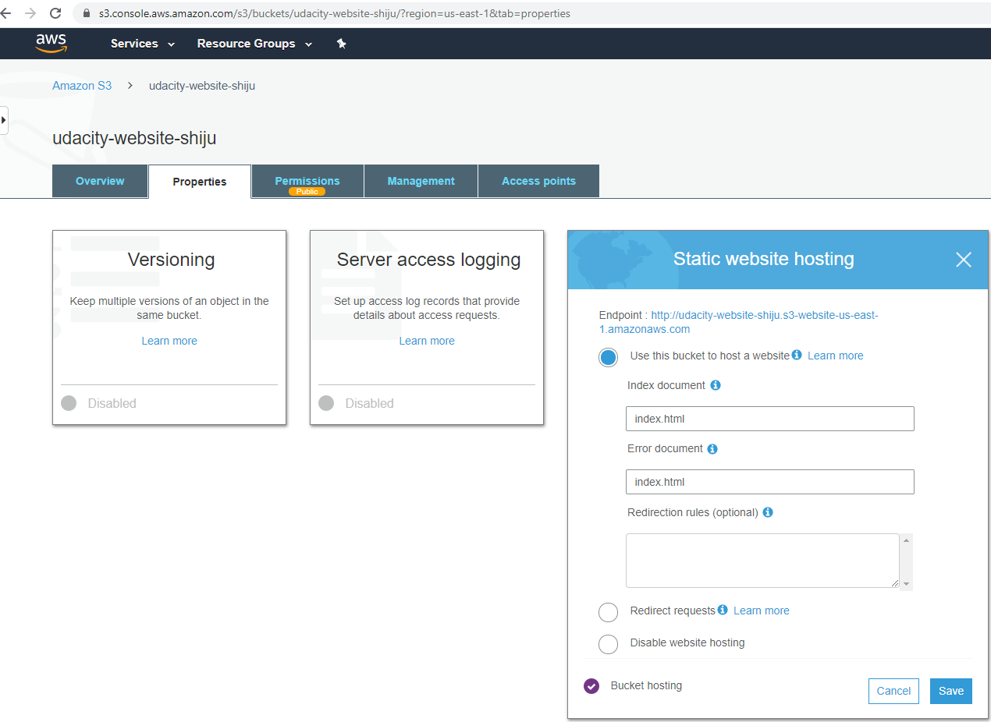

# Website Distribution

<http://d70maiziqpp23.cloudfront.net/index.html>

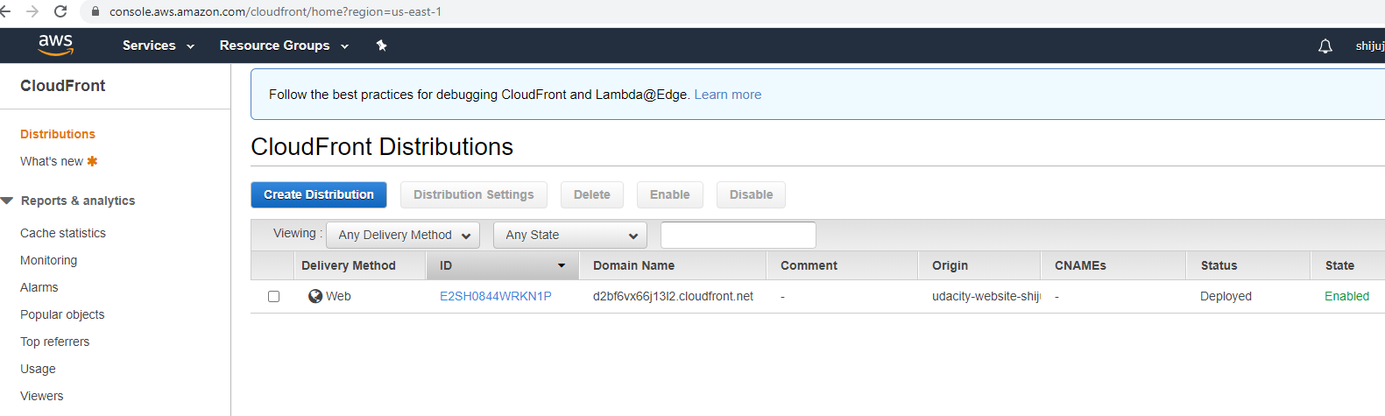

# URL to access portal

<http://d70maiziqpp23.cloudfront.net/index.html>

<http://udacity-website-shiju.s3-website-us-east-1.amazonaws.com/>