1.An Alternate Solution for Smartphone-based urinalysis

Abstract:
Image pre-processing steps and an artificeial nueral network mapping model to analyze the color pixels fo the urine test strip. Accurate results are claimed.
Conclusion:
Novel system for Smartphone-based urinalysis. Several computer vision methods such as homomorphic filter, Gaussian blur, Otsu, SOM, mean square error methods are applied to build a workable system and their experimental results are shown, claimed to be accurate without any additional physical tool.

Methodology.
The photograph is taken in natural lighting condition using smartphone camera.
The image is uploaded to cloud storage where their system will work with the image.

The following are the summarised steps of the methodology:
- The image pre processing unit filters and crops the image of the strip from black background.
- The processed image is sample image in artificial nueral network(ANN) mapping model.
- The ANN clusters and plots a map of the color pixels from the strip image.
- A similarity algorithm as mean square error(MSE) determines the final reading of the strip by matching each clustered color pixels with the reference color dataset.

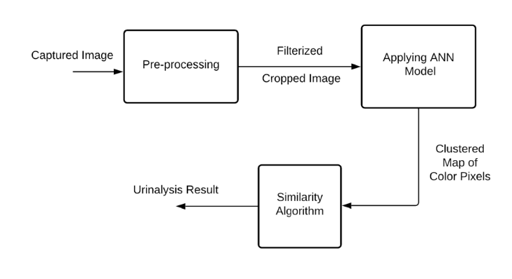

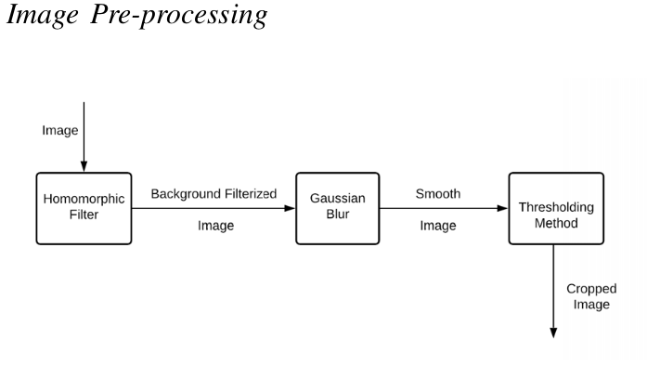

Homomorphic filter involves nonlinear mapping to a special domain, followed by a mapping back to the first domain using linear filter techniques. After applying, it frequently normalizes the brighntness of an image and increases the contrast and removes multiplicative noise.
The high frequency components are assumed to present more the reflectance in the image of the strip, and lower frequency components are assumed to mostly represent the illumination in the scene, high-frequency components are increased and low-frequency components are decreased to make illuminaiton of the image more equal.

Then we use Guassian blur, a blurring technique that is used on an image is equivalent to mathematically converting the image with the guassian function. This produces the blur which preserves the edges and boundries.

At the end we use Otsu’s thersholding method to minimize intra-class intensity variance. With this maximum contour of the image is selected and system can finally crop the image from the background image.

B.
After cropping the image ANN based colorimetric mapping model is used. SOM(self-organizing map). Thsi ANN trained using unsupervised learnig to genarate a low-dimensional(typically 2D), discritized representation of the input space of the training samples, referred to as map, and is thus a dimensionality reduction technique
C.
Similarity algorithms are neede to match the features with the urinalysis refrence color chart. Here mean square error(MSE)is used it gives the difference between the mapped pixel and refrence color pixels which satisfies the base purpose.

PythonIDE with i7

Results

A. Dataset Description
The only dataset that is used for this research is the universal urinalysis reference color chart by Multistix “Urinalysis test strip color chart — learn.parallax.com,”
https://learn.parallax.com/support/reference/urinalysis-test-strip-color-chart
Segmented in 10 folders by labelling them with primary identities.
The data can be called by pythonIDE and then flattened into matrices.
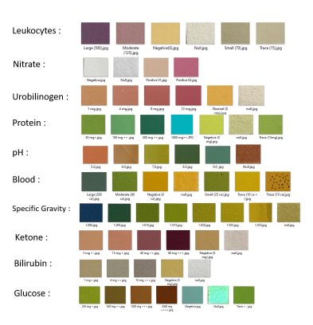

B. Evaluation of each step
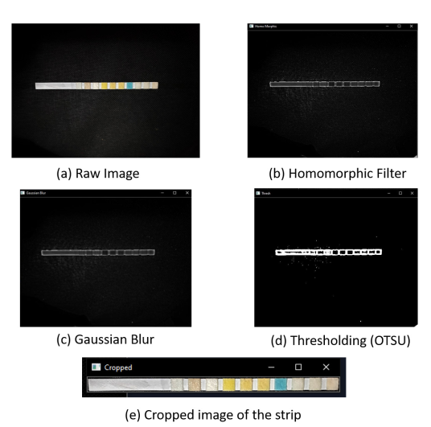

Maximum accuracy of cropping the srip from the backgroung image can be seen from black background in any lighting condition.

After pre-processing SOM approach on cropped image by Numpy library in python IDE is experimented.

Using CPU takes more time so GPU is used for that Tensor flow library is used

After obtaining the colorimetric map ofsample strip, the dataset ﬁle in Python IDE and
used the mean square error (MSE) method to determine the similarities between the acquired map’s color pixels and the dataset in order to ﬁnalize our urinalysis result.
The minimum mean square error deﬁnes the maximum similarity between the color pixels.
------------------------------------------------------------------------------------------------------------------------

2.
A smartphone based calibratiio free portable urinalysis device
Abstract:
Smartphone-based portable urinalysis sytem has been developed and applied for the colorimetric analysis of routine urine examination indices using an Android app.
Integrating test paper sensor in the portable device for urinalysis, significantally improving the instability of the conventional dipstick-based manual colorimetry, and the smartphone application used for color discrimination enhances the accuracy of visual assessment of sample strips.

Conclusion:
Smartphone-based calibration free urinalysis system with a unique test paper designed and colorimetric detection algorithm has been given.
Differences in camera’s hardware problem have been solved.

Design and algorithms

Design of detection device
Two point-of interest are here:
First, for device, a favorable environment with a stabilized light is needed. When the light source is unstable, the illumination will vary on the test paper, which will affect the RGB value of the sample and is prone to error in color measuring .
Second, the scattering of the internal housing surface should be minimized during the measurement process .

The detection box is composed of 54 mm×54 mm×76.5 mm(width×length×height) 3D printed box, two pieces of LED (light-emitting diode), light bars (3 diodes in 1 part), a GP 12 V A23 battery, a 12 V battery holder, and a push-button switch

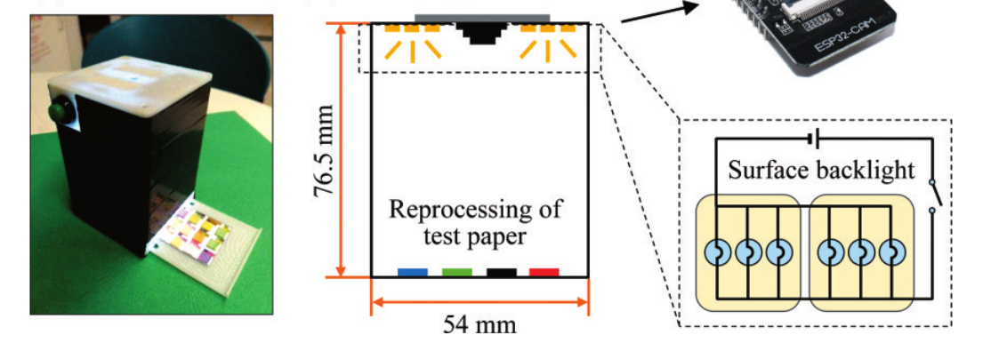
Test paper
Traditional strips are long strips increasing the difficultyof imaging with high quality in single shoot
so they minimized the strip size. Selected Medi-test Combi 11 and redesigned a new square test paper.

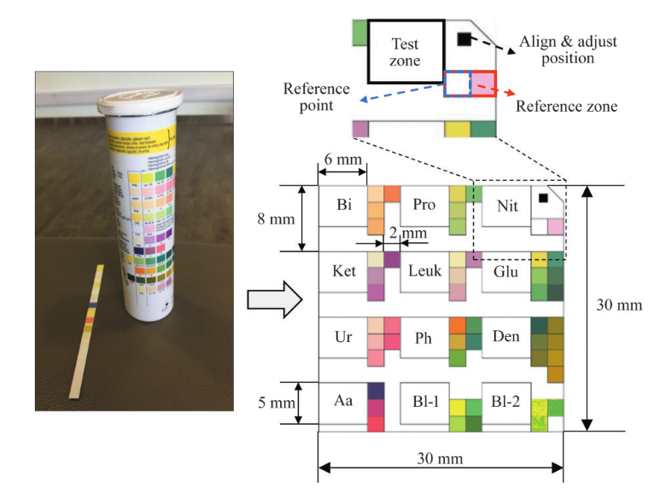
The black square spot has a fixed length of the side and helps to align the position of the test paper in the camera. Thus, the number of black pixels at this spot is related to the actual size of the black spot. They carefully arrange our reference zone and test zone so that the locating of each zone can be calculated by the number of pixels

Recognition algorithm
Platform is Eclipse(IDE for java). MacBook Pro
1.Database with the coordinate of the test zone and refrence points is built, which is used to match the recognized RGB values.
It includes co-ordinate of the test zone and reference points on the test strip.
Corresponding meaning of RGB values is listed in the datasbase.
getRGB(x,y). it is used to extract the pixel value of the specified coordinate of the image.
“(p>>16)& 0xff” ,”(p>>8)&0xff” and “p &oxff” are used to seperate the pixel value to get R/G/B value respectively.

Here half cut method is used to match the recognized data of the test zone
It adopts the concept of round-off in this method, and the cutoff interval is determined by the mean of the RGB values of two adjacent refrence points

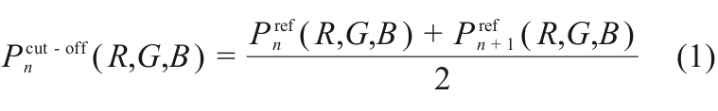
After we get the cutoff we can set the range of RGB value for each
concentration
The range would be determined by the RGB value of previous point and next point
For 1st ref. Point:

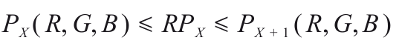

For last ref. Point:

