Urine Test Strip Analysis using Image Processing for Mobile Application

**Full paper**

**Jurnal**

**Teknologi**

1Ira C. Valenzuela\*, 1Timothy M. Amado, 1,2John William F. Orillo

1Electronics Engineering Department, Technological University of the Philippines, Ayala Blvd., Ermita, Manila Philippines 1000

3Electronics Engineering Department, De La Salle University, Taft Avenue, Manila Philippines 1000

\*Corresponding Author: valenzuela.ira12@gmail.com

|  |  |  |
| --- | --- | --- |
| **Article history**  Received :  Received in revised form :  Accepted :  **Graphical abstract**  C:\Users\jovanica\AppData\Local\Microsoft\Windows\Temporary Internet Files\Content.Word\20150128_042658.jpg | **Abstract**  In attaining vital information for diagnostic purposes in medicine, analysis of the urine sample or urinalysis is a powerful tool. Urine test strip is commonly used in this kind of assessment. In this study, a mobile application has been developed for urine test strip analysis using image processing. Glucose, pH, specific gravity and protein levels are determined and analyzed by the system. The urine test strip is captured using an Android phone, then the image captured is analyzed using the algorithm employed in OpenCV. Harris detection and RANSAC algorithms are utilzed to provide an accurate homography estimation. A portable document format report has been generated to provide the summary of analysis. One-hundred seventy-one (171) urine test strips images are stored in the SQLite database of the mobile phone. And 54 urine samples are tested for the accuracy of the system. The study showed that the overall accuracy is 91.7%.  *Keywords*: Urine analysis, Glucose, pH, Specific Gravity, Protein, Harris Algorithm, Eigenvector Calculation, Normalized Cross Correlation (NCC), Homography, Random Sampling Consensus (RANSAC) Algorithm  © 2015 Penerbit UTM Press. All rights reserved. |  |

**■**

**1.0 INTRODUCTION**

Urinalysis is the basic test done on a patient to determine various diseases. Levels of glucose, pH, specific gravity, protein and other parameters can be determined during the evaluation of urine. Figure 1 shows the urinalysis using reagent strip. Urine analysis has three types of examination namely: visual, chemical and microscopic [1]. Visual inspection involves observing the color, clarity and concentration of the urine. In chemical examination, a reagent strip is used. The color-coded strip as shown in Figure 2 is dipped in the urine sample and wait for seconds to minutes in order for the chemical reaction to take place. And then, it will be compared in the color chart. Cells, crystals and other substances are counted under microscope. This is done if there is an abnormalities in the readings during the chemical examination.

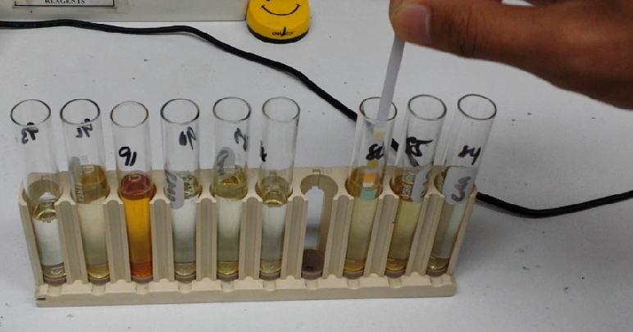

**Figure 1** Urinalysis using reagent strip

The use of color chart in urinalysis suffers from various limitations. Visual perception of the reader and the lighting condition during reading are some of the factors that greatly affects the accuracy of the reading [2]. Today, there are numerous automated test strip readers available. The higher the resolution of reading, the expensive the machine is. Mostly, these types of machines are present in exclusive hospitals. One example is the Clinitek 500 being used in National Kidney Transplant Institute in the Philippines. However, small laboratory clinics do not have this type of equipment.

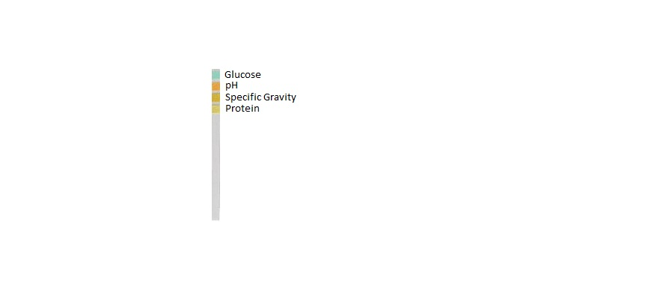

**Figure 2** Urine Test Strip

Portable, easy to operate urine tester is attracting concerns with the emerging home healthcare market. Automatic analysis of urine test strips using automated urine test strip analyzers is a well-established practice in modern day urinalysis. Available devices have the dimensions of 11 inches in width, 13 inches in depth, and 5 inches in height and approximately weighs 2 kilograms. The available analyzers develop the conventional way of testing that deals with the color intensity or color matching. Currently, most of the commercial urine analyzers adopt moving mechanisms with single photometry module for the reading of multiple pad urine dipsticks [3]. Recent development of economic color light emitting diodes (LEDs) and stable photo sensors have changed the situation.

In one study, a method made provides users with an automated test which receives an image of the patient’s urine test strip taken using a camera phone as an input and automatically processes the image to get the levels which are sent to the patient via SMS [4]. Another researchers proposed the function of multiple colorimetric units to be used for the measurement of multi-pad urinalysis reagent strips. Moving mechanism has been replaced by recently developed colored LEDs for multiple photometry method due to its simplicity and reliability [5]. Also, an iPhone-compatible urine analyzer has been developed which is based on reflectance photometry [6]. Advancement in urine test strip readers have given answer to increase the accuracy of visual reading.

For this study, Android has been used because it is a freeware and most of the consumers are using Android phones. Also, the software was specifically design for Biostix test strip as it is compatible to Clinitek 500.

This study generally aims to develop an android-based urine test strip analysis for the four parameters of test strip namely: pH, protein, glucose, and specific gravity using image processing. An algorithm has been developed to analyze the color change in the urine test strip. Homography estimation is employed in this study to match two images in mathematical approach. This is in contrast with reflectance photometry that quantifies light and compare it the data stored in the database. Also, feature matching, edge detection and test point location are utilized to increase the strength of homography estimation. Structures Query Lite is used for database of the system.

Moreover, this study will make laboratory testing accessible and easier to the people living in remote areas and in disaster-affected areas.

**■2.0 DESIGN OF SET-TOP BOX**

In capturing the dipstick image, a set top box was used to attain the ambient light required for the better quality of image. It was consisted of a box, android phone, and lightning structure installed. Figure 3 shows the actual image of the box that was formed small to become portable enough to carry.

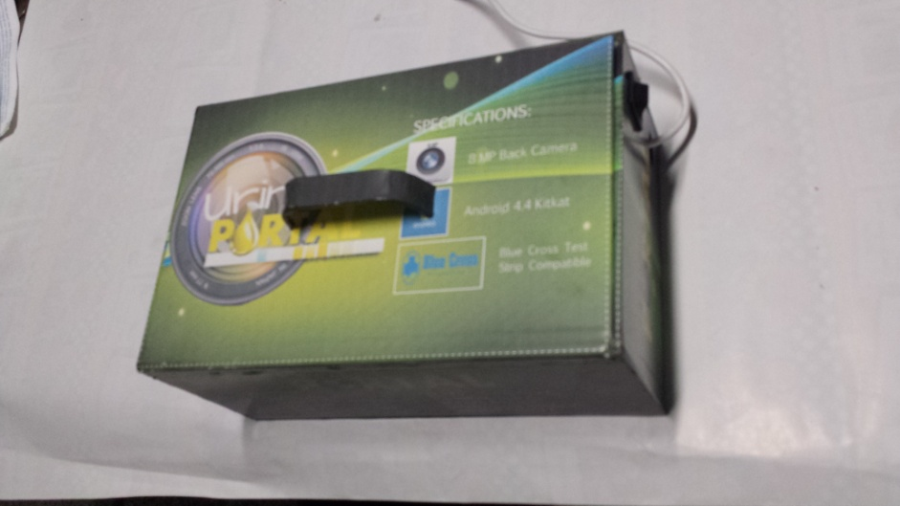

**Figure 3** Actual Image of Light-Controlled Set-top Box

The dimensions of light-controlled set-top box are shown in Figure 4. An intensive experiment was performed after coming-up to the said measurements. The elevation of the box was properly measured to obtain wanted space from the mobile device camera lens to the test strip image using the auto-focus function. The width of the box was measured to accommodate the size of the mobile phone, lighting distance covering the whole enclosure and the space for the power source. Proper position of the input test strip was also examined to provide alignment between the camera, the light source and the test pad.

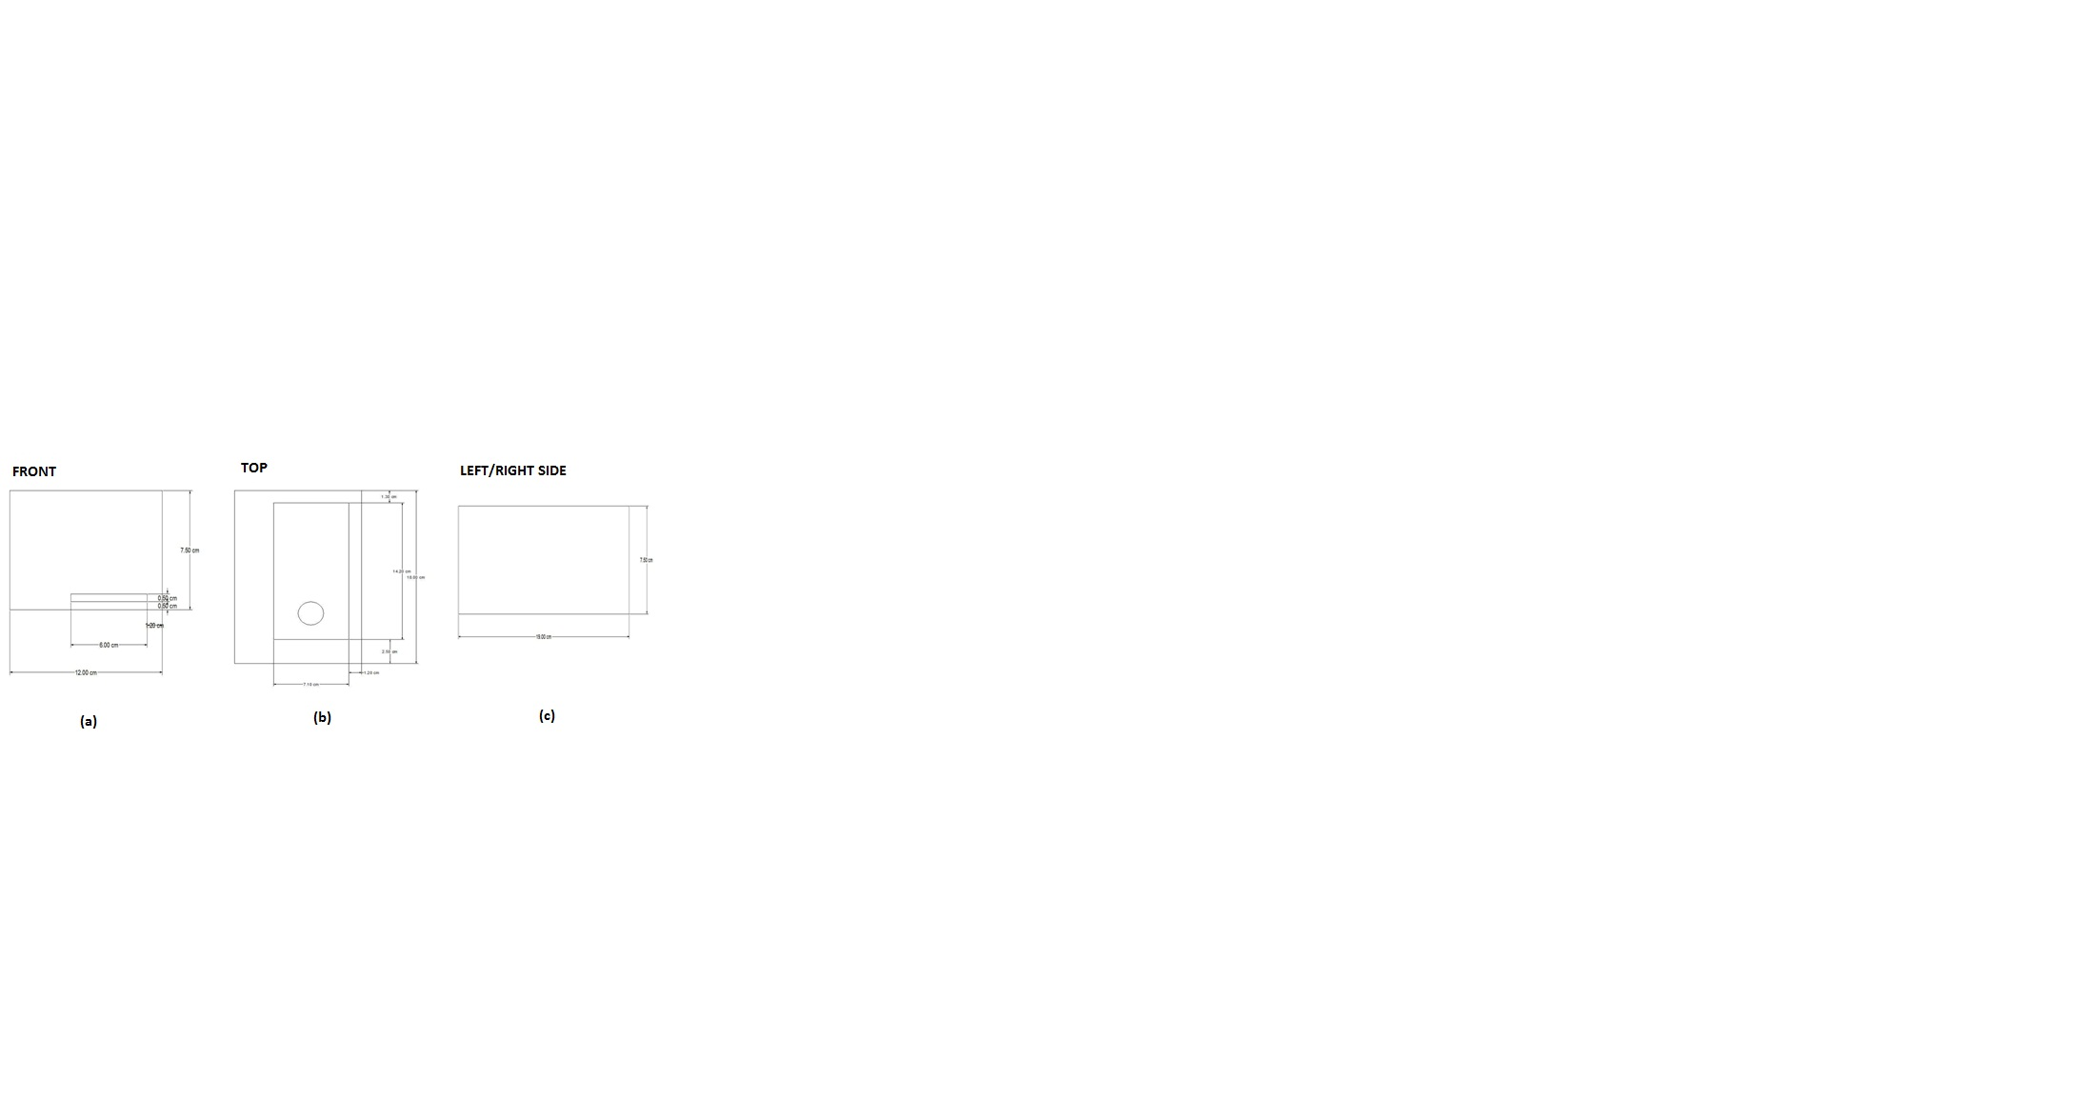

**Figure 4** Orthographic Views for Light-Controlled Set-Top Box

LEDs were installed inside the box with light-absorbent foam board for good and consistent quality of lighting inside the box as well as good image quality. For portability purposes, a power bank was used as the supply of the lights. Ten (10) LEDs were connected in parallel, five (5) placed on left and five (5) placed on right walls inside the box to produce equal illumination. The whole structure was enclosed using white acrylic panel.

**Table 1** System Compatibility of Three Android Phones [6]

|  |  |  |  |
| --- | --- | --- | --- |
| **System Requirement** | **HTC One M8** | **Samsung S4** | **Cherry Mobile Flare 3** |
| **OpenCV Manager 2.4.2** | With bug issues | With bug issues | Compatible |

Table 1 shows the system compatibility of the software used to the mobile platforms. Flare 3 became the main portal used in the application due to its general system compatibility on the software packages.

To ensure good image quality, the android phone should have at least five megapixels of camera paired dependently along with the module box having proper lighting system. In order to process the data in high speed behaviour and for system compatibility, at least 1 gigabit (GB) of Random Access Memory (RAM), 1.3 gigahertz (GHz) of microprocessor and an Android 4.4 version of operating system are required.

**■3.0 SOFTWARE DESIGN**

**3.1 System Design**

The block diagram of the system is shown in Figure 5. The system is comprised of five sections namely the Graphical User Interface (GUI), image acquisition, image recognition and data extraction, data comparison, and displaying the result.

|  |  |
| --- | --- |
| Graphical User Interface | |
|  |  |
| Test Strip Images using Set Top Box | |
|  |  |
| Image Recognition and Data Matching | |
|  |  |
| Database | |
|  |  |
| Display Results | |

**Figure 5** Block diagram of the System

Initially, the GUI installed on the android phone acquired patient’s basic information before starting the test. The mobile phone together with a set-top box was used to capture image. In the first part, the captured image was being acknowledged by the device. For the data matching section, the exact location of the reagents was identified as well as its unique color. The database organized records that would be used to keep track of information, like the color combination, the probable interpretation of the results based on the color combination of the four parameters. After these processes, the application displayed the results that would show the levels of pH, glucose, specific gravity and protein, and the patient’s possible health conditions that were related in the said parameters.

**3.2 Program Algorithm**

The patient’s information will be inputted first. An image of the urine test strip will be captured. The program will identify if the captured image is clear or not. If the captured image is not clear, it will recapture the image. If it is clear, it will proceed to the analysis of the image using OpenCV. Once the analysis is done, it will display the levels of pH, protein, glucose and specific gravity in a portable document format. This procedure is simplified in Figure 6.

Open Source Computer Vision (OpenCV) is an open source software that can learn on its own. It accelerates the use of a machine perception. Also, the program codes for OpenCV is easy to modify for different applications [7].

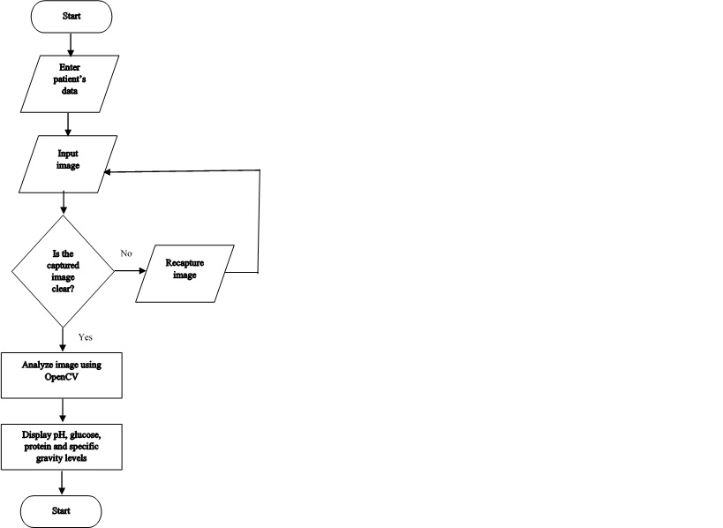

**Figure 6** Program Process Flowchart

In this study, homography estimation is used in image matching. This is a mathematical approach of relating two images. It is an invertible mapping of points and lines on the projective plane [8]. It is also an invertible mapping from plane to itself when three points line on the same line and the mapped points are collinear [9]. The interest points are obtained and determined putative correspondence. To estimate the entries of the image matrix using known matches, epipolar constraint should be used as shown in (1). An equation is directed to single match.

(1)

Where p is the corresponding point and F is the fundamental image matrix. The matrix can be fully estimated by solving the resulting set of linear equation. An example of obtaining test points in a test strip is shown in Figure 7.

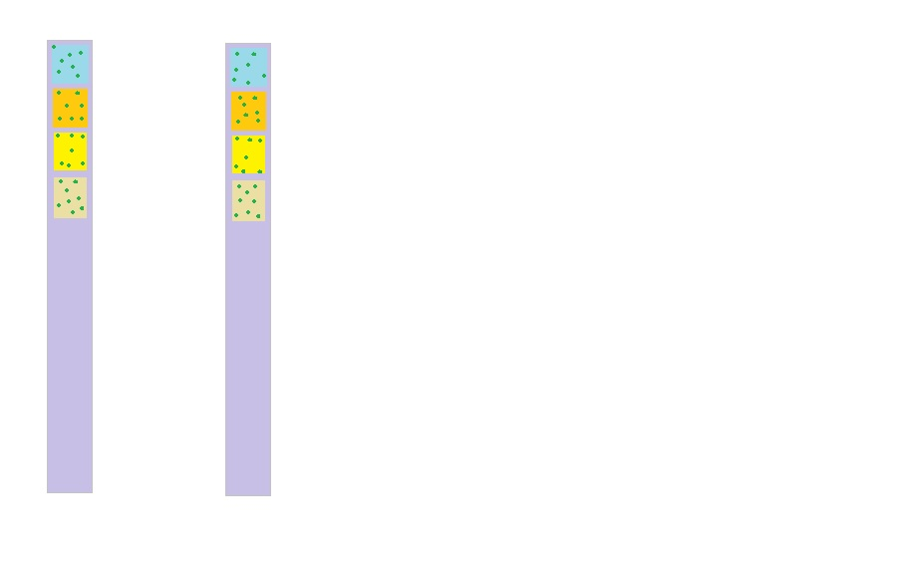

**Figure 7** Obtaining test points

The corner points of the image are detected using the Harris-corner detection or small eigenvalue factor [10]. Fixed window sized is set based on the size of the urine test pad of the strip. The pixel is defined by equation (2). And the response *R* of the detector is computed using equation (2).

(2)

(3)

Then, the smallest eigenvalue method is determined by the condition: if the smallest singular value min(σi(G)), i = (1, 2) is greater than T, the pixel (x, y) is regarded as a corner point candidate. To check the uniqueness, the condition is if the pixel (x, y) has greatest min(σi(G)) in a neighborhood, mark (x, y) as a corner point and eliminate the other false alarmed candidate in the neighborhood.

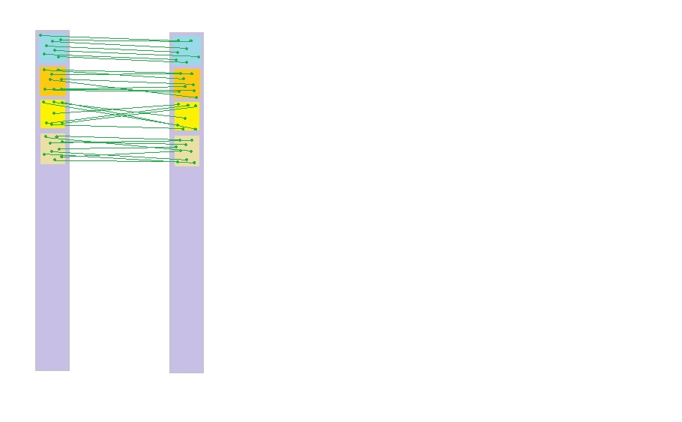

**Figure 8** Matching test points

And these are matched using Normalized Cross Correlation (NCC) criterion [11]. The NCC value is computed using equation (4). Figure 8 shows the image matching based on the test points.

(4)

where and are the mean intensities of all the pixels within the window and N is the total number of these pixels. The matched point is determined using (5) and if there is another correspondence determined before, will be chosen as the matched point for by using equation (6).

(5)

(6)

However, putative correspondence measured by NCC are not perfectly matched always. To further increase the robustness of image matching, RANSAC algorithm is also used. RANSAC is a random sample consensus that uses minimum interest points in estimating the underlying model parameters [12]. The model parameters are determined after obtaining the interest points for the urine test pads. The tolerance has been set and fitted the number of points. When the fraction of inliers are above the threshold , the model parameters are re-estimated. This is repeated until there is atleast one of the sets of the random samples does not include an outlier. The number of iterations can be computed using equation (8) and the probability *p*  is usually set to 0.99. The *u* represents the probability that any selected point is an inlier and *v* represents the probability of outlier.

(7)

(8)

After image matching, the level of glucose, pH, specific gravity and protein will be displayed in the screen of the Android phone. The user will be asked if a portable document format report is needed.

**■4.0 RESULTS AND DISCUSSION**

Figure 9 shows the urine test strip analysis using the devised prototype. All the images gathered were saved in SQLite. This relational database management system was contained in a C programming library. Contrasting with client–server database managing systems, the SQLite engine has no separate processes with which the application program communicates [13]. Instead, the SQLite collections were linked in and thus became an important part of the application program.

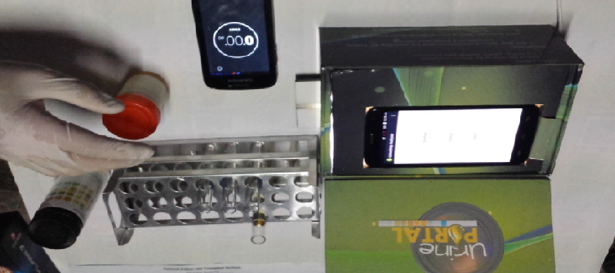

**Figure 9** Urinalysis using Urine Portal Prototype

A total of one hundred seventy one (171) sample images were put on the data bank. And, fifty-four (54) urine samples were simultaneously tested using the device and the Clinitek 500. Proper medical procedures are observed during data gathering. Similarly, freshness of urine samples is needed to provide accurate measurement. The urine sample is good until two (2) hours. This sample is mixed first before the test strip is dipped. The strip is dried for 60 seconds enough for color change to take place. Then it is placed in a strip slide. Once the image is captured, the system will analyze and match the color to its database. The levels of pH, glucose, protein and specific gravity is displayed on the screen of the smartphone. This measurement is supervised and validated by the skilled medical doctors and medical technologist of National Kidney Transplant Institute.

Figure 10 shows Glucose levels for NKTI’s Clinitek 500 versus Urine Portal. Assessment chart indicates the linearity pattern of both devices. The points were almost lying on the same y-axis and suggest correlation between two variables. The linear equation of the graph is y = 0.0005x – 0.97788R2 for Urine Portal and y = 0.0086x – 1.1495R2 for Clinitek 500.

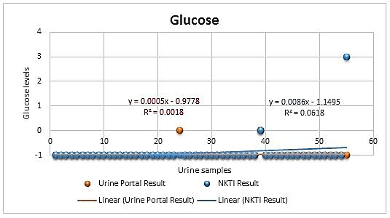

**Figure 10** Glucose Level Assessment Chart

Figure 11 shows pH levels for NKTI’s Clinitek 500 versus Urine Portal. The independent variable which is located on the horizontal axis indicates the samples gathered. The line of best fit was drawn and has the linearity formula of y = -0.0063x + 6.3131R2 and y = -0.0105x + 6.404R2 for Clinitek 500.

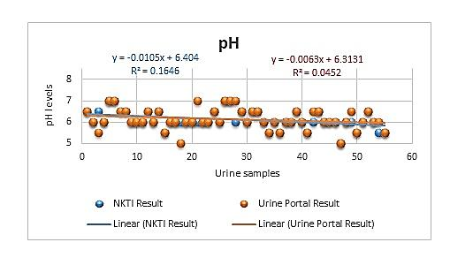

**Figure 11** pH Level Assessment Chart

Figure 12 shows Protein levels for NKTI’s Clinitek 500 versus Urine Portal. The data were displayed as a collection of points for variables determined on the position of two axes. The scatter diagram has the equation y = 0.0411x + 0.4323R2 for Urine Portal and y = 0.0101x – 0.0199R2 for Clinitek 500.

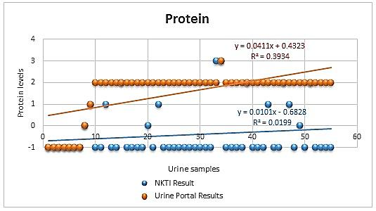

**Figure 12** Protein Level Assessment Chart

Specific Gravity levels for NKTI’s Clinitek 500 versus Urine Portal is shown on Figure 13. The data plotted on the chart shows association between variables. The equation of linearity is given by y = 1.829x – 31.763R2 for Urine Portal and y = 0.0001x + 1.0096R2 for Clinitek 500.

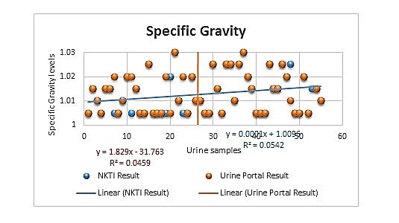

**Figure 13** Specific Gravity Level Assessment Chart

A pdf report has been generated to show the user whether the levels of the pH, glucose, protein and specific gravity are within normal reference range or not. Table 2 shows the values of these parameters in normal level while Table 3 shows the values in abnormal level.

**Table 2** Normal Level for Four Parameters [14][15][16]

|  |  |  |
| --- | --- | --- |
| **Parameters** | **Levels** | **Results** |
| **Protein** | Negative | Normal |
| **pH** | 5-8 | Acidic and Alkaline Urine |
| **Specific Gravity** | 1.005-1.025 | Normal |
| **Glucose** | Negative | Normal |

**Table 3** Abnormal Level for Four Parameters [14][15][16]

|  |  |  |
| --- | --- | --- |
| **Parameters** | **Levels** | **Results** |
| **Protein** | Trace, 1+, 2+, 3+ | Positive |
| **pH** | <5 and >8 | Abnormal |
| **Specific Gravity** | 1.000 and 1.030 | Abnormal |
| **Glucose** | Trace, 1+, 2+, 3+ | Positive |

Moreover, an example of generated pdf report is shown in Figure 14. This presents the name of the Android phone application which is Urine Portal, the normal reference range, the causes of the abnormal level of the parameter, and the necessary action to perform. The results and interpretations are all based on medical references. Results and interpretations may vary per patient based on his/her health condition. For more of the health information, patients are recommended to seek a doctor for further advice and supplemental clinical test. The outcomes are used for first screening only, additional laboratory tests may require if necessary.

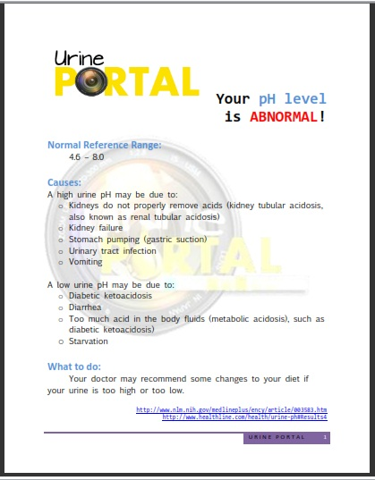

**Figure 14** Generated PDF Report for pH, Glucose, Specific Gravity and Protein Normal Levels

The accuracy of the system has been tested with 54 urine samples. The urine test strips for Urine Portal and for Clinitek 500 are simultaneously dipped into the fresh urine samples and simultaneously measured. Table 4 shows the accuracy of the Urine Portal at different parameters. The specific gravity acquired 49 accurate results out of 54 samples having a percentage of 90.74. On the other hand, pH got 47 accurate results out of 54 samples leading to an 87.04% accuracy. Having a 92.59% accuracy, protein came up to 50 out of 54 samples. Achieving the most accurate results among the four parameters, glucose had 52 accurate results out of 54 samples accumulating a 96.3%. The overall accuracy of the device is 91.7%.

**Table 4** Accuracy of Urine Portal

|  |  |  |  |  |
| --- | --- | --- | --- | --- |
| **Assessment of the device** | **Specific Gravity** | **pH** | **Protein** | **Glucose** |
| **Comparison of Results (Program vs. Clinitek 500)** | 49/54 | 47/54 | 50/54 | 52/54 |
| **Accuracy** | 90.74% | 87.04% | 92.59% | 96.3% |

**■5.0 CONCLUSION**

In this study, an image processing system has been effectively incorporated for the urine analysis with the aid of urine test strip and an Android phone application. The urine samples were properly collected and tested under the supervision of Dr. Juanario Veloso. Based on the data collected and evaluated, the system gave an accuracy of 92.59% for specific gravity, pH and protein level measurements and 88.89% accuracy for glucose level measurements. The overall accuracy of the system is 91.665% which is higher than the conventional machines used for urinalysis. Therefore, the program implemented and set-top box designed enhanced the urine test strip analysis.

**Acknowledgement**

The authors would like to thank for the contribution given to this research by Melanie Areta, Renz Esequel Cabrera, Jovanica Custodio, Gregorio III Damicog, Ronn Francis Maranan, Leynard King Nunez, Jeric Palomera, Phoebe Serrano, Cris Vincent Sedanto and Raul IV Rejuso. Also, the authors would like to acknowledge Dr. Januario Veloso, Mr. Buenaventura Sta. Maria, Mr. Rupert Patrick Aguda and all the medical staffs of National Kidney and Transplant Institute for their cooperation and unwavering support in developing this study.

**References**

1. American Association of Clinical Chemistry, Urine Analysis, [Online]. From:https://labtestsonline.org/understanding/analytes/urinalysis/ui-exams/start/2. [Accessed on 27 June 2015].
2. Bazin, et al., 2010. Rapid Visual Tests: Fast and Reliable Detection of Ochratoxin A. *Toxin*. 2:2230-2241
3. Lippincott, Williams & Wilkins. 2008. Diagnostic Test, Nurse’s 5-minute Clinical Consult*. Philadelphia: Lippincott Williams & Wilkins*.
4. Hapal et al., 2009. Patient-centric Medical Database with Remote Urinalysis Test, Ateneo de Manila University, Philippines
5. Joong Hun Ro et. al., 2007. Development of a Plural Colorimeter Module for Urinalysis Strip Readers.
6. Ingawale, M. Uchek: Mobile Urine Lab. 2013. [Online]. From: http://www.wired.com/2013/02/smartphone-becomes-smart-lab/ [Accessed 15 September 2015].
7. OpenCV DevZone. (2014). OpenCV Tutorial 1 - Camera Preview sample crash on Android 4.4.2 (HTC One M8) (Bug #3842). [Online]. From: http://code.opencv.org/issues/3842
8. OpenCV Developers Team. About OpenCV. [Online]. From: http://opencv.org/about/html. [Accessed on 25 July 2015].
9. Elan Dubfrosky. Homography Estimation, [Online]. From: https://www.cs.ubc.ca/grads/resources/thesis/May09/Dubrofsky\_Elan.pdf. [Accessed on 28 January 2015]
10. Hartley, R. and Zisserman, A. 2003*. Multiple View Geomerty in Computer Vision*. Cambridge University Press, second edition.
11. Collins, Robert. Harris Corner Detector. [Online]. From: http://www.cse.psu.edu/~rtc12/CSE486/lecture06.pdf.
12. Feng Zhao, Qingming Huang and Wen Gao. 2006. Image Matching by Normalized Cross-Correlation. IEEE International Conference on Acoustic, Speech and Signal Processing. 2:729-732
13. M.A. Fischler and R.C. Bolles. Random sample consensus: A paradigm for model fitting with applications to image analysis and automated cartography. Communications of the ACM, 24(6):381–395, 1981.
14. SQLite. [Online]. From: https://www.sqlite.org/about.html. [Accessed on 28 January 2015]
15. McPherson, R., & Pincus M. 2011. *Henry’s Clinical Diagnosis and Management by Laboratory Methods.* 22nd Edition. Philadelphia: Elsevier Saunders.
16. Strasinger, S. K., & Di Lorenzo, M. S. 2008. *Urinalysis and Body Fluids.* 5th Edition. Philadelphia: F. A. Davis Company.
17. Davidson, I., & Henry J. B. 1974. *Clinical Diagnosis by Laboratory Methods.* 15th Edition. Philadelphia: Elsevier Saunders.