I have created the blog application as requested.

Database: SQL Server 2019

Backend: C# .NET Core, Entity Framework

Frontend: Angular11

PS: please follow instructions provided here for project setup

<https://github.com/shikha2082/BlogApp/tree/main/BlogFront#readme>

Please see the screen shots for reference:

Backend Jason by visual studio (.Net core):

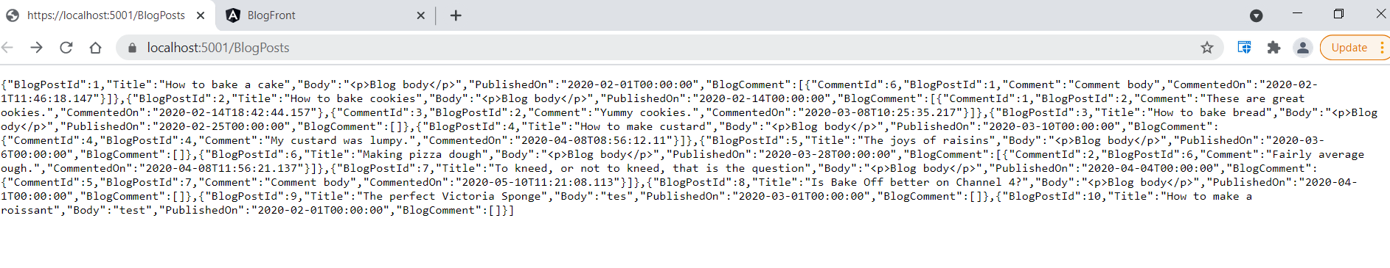

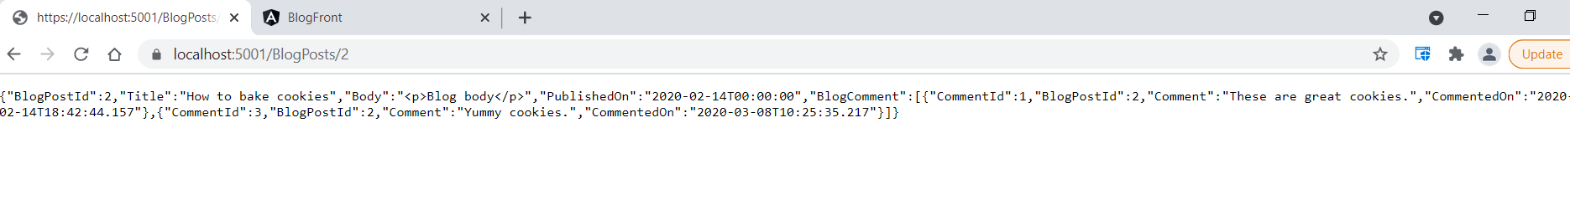

Angular UI pages:

