**Prerequisites:**

C#, .NET Core 5.0

Visual studio 2019

**Required packages:**

**Mandatory –**

Newtonsoft.Json

**Optional (to check unit test)-**

Microsoft.VisualStudio.TestPlatform

Moq

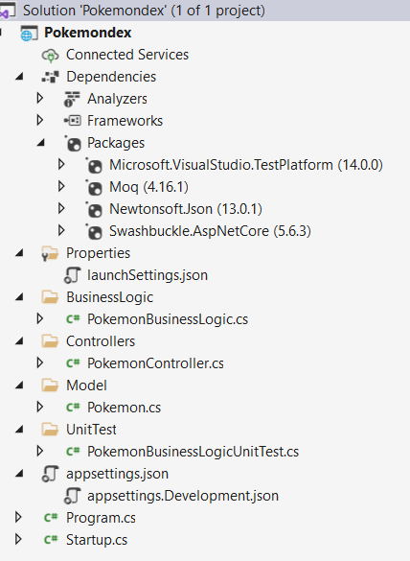

**Endpoint will look like:**

<https://localhost:5001/api/pokemon/ditto>

Test screenshot:

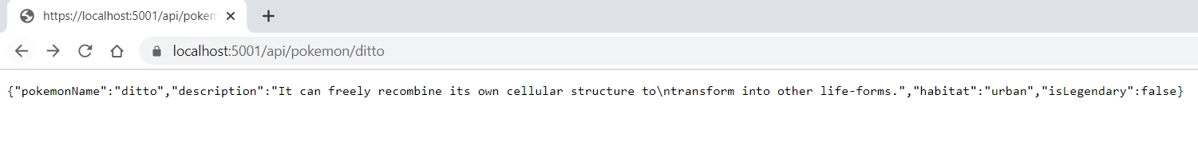

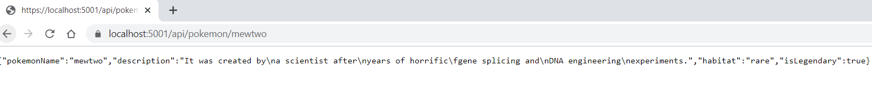

<https://localhost:5001/api/pokemon/translated/ditto>

Test screenshot:

