━━━━━━━━━━━━━━━━━━━━━━━━━━━━━━━━━━━━━━━━━━━━━━━━━━━━━━━━━━━━━━━━━━━━━━━━
IUBAT - INTERNATIONAL UNIVERSITY OF BUSINESS AGRICULTURE AND TECHNOLOGY

ASSIGNMENT REPORT
STUDENT SERVICE REQUEST SYSTEM
Course: Visual Programing
Course Code: CSC 439
Fall 2026
Submitted to:
MD. Asif Hossain
Lecturer,
CSE department, IUBAT

Submitted by:
Aranna Saha
ID:
Section: D

GitHub: https://github.com/aranna08-dev/sevice-of-student
Live URL: https://sevice-of-student.onrender.com/
Database Link: https://console.neon.tech/app/projects/noisy-mouse-46909919/branches/br-rapid-math-a5r24u7q/tables?database=neondb

Submission Date:
5 September 2026

CONTENTS

1. Introduction | 3
Background of the Problem | 3
Problem Statement | 3
Objectives of the Proposed System | 3
2. Problem Analysis | 4
2.1 Stakeholders and Requirements | 4
2.2 Conflicting Requirements — Usability vs. Security | 4
3. System Design | 6
3.1 Proposed Solution | 6
3.2 MVC Design — Models, Controllers, Views & Interaction | 6
3.3 Database Design | 7
4. Implementation | 8
ASP.NET MVC Features Used | 8
Database Connectivity (Neon + EF Core) | 8
CRUD Operations | 8
Form Validation (Server + Client) | 8
Student / Staff Access Control | 9
Deployment — Docker + Render + Neon | 9
Screenshots of Major Interfaces | 9
5. Conclusion | 13
References | 14
A. Appendix — KPA Form & Deliverables Checklist | 14

1. Introduction

Background of the Problem
International University of Business Agriculture and Technology (IUBAT) currently handles student service requests — ID card replacement, transcript requests and certificate requests — through manual paper forms and email threads. This ad-hoc process creates three persistent pain points:
- Students cannot track the status of their requests after submission and must follow up via email or office visits;
- Staff manage requests across inboxes and spreadsheets, with no single source of truth for pending vs. completed work;
- The university has no auditable log of who submitted what, when it was updated, or who authorized a status change.
The existing manual workflow is therefore slow, opaque and error-prone — especially at peak registration periods when hundreds of requests arrive concurrently.

Problem Statement
The university requires a simple, centralized Student Service Request System built with ASP.NET MVC that digitizes the full lifecycle of a request while satisfying two competing institutional concerns:
- Simplicity & ease of use students must be able to submit and monitor requests with minimal training;
- Strict access control only authorized staff may view all requests and change their processing status.
The system must therefore demonstrate proper use of MVC, models/viewmodels, controllers, Razor views, routing, HTML forms, server-side validation, EF Core database connectivity, CRUD, navigation and role-based authorization — and it must be deployable to a modern cloud stack (Neon PostgreSQL + Render Docker) without leaking secrets.

Objectives of the Proposed System
The objectives for WebApplication2 (Emerald Academic) are:
- O1 — Allow any student to register/login, submit a request (choosing ID Card Replacement / Transcript Request / Certificate Request + description), view their own requests and track status (Pending → Processing → Completed / Rejected).
- O2 — Allow staff (seeded, not self-registered) to login, view all submitted requests, inspect details with student identity, and update status with audit timestamps.
- O3 — Enforce role-based authorization so students cannot access staff routes and staff cannot be impersonated via student registration; provide graceful login/access-denied flows.
- O4 — Keep the solution simple and responsive — one-click submission, clear status badges, mobile-friendly tables, and minimal required fields — while applying industry-grade security (Identity, anti-forgery, password policy).
- O5 — Demonstrate full ASP.NET MVC competency: models + viewmodels, controllers/actions, Razor, routing, HTML forms, server validation, EF Core + Npgsql, CRUD, navigation.
- O6 — Deploy as a production-grade prototype: Neon pooled Postgres (SSL + Channel Binding), Docker multi-stage build, Render env-var injection — no secrets in GitHub, health-check, forwarded headers, and DB auto-creation/seed.

2. Problem Analysis

2.1 Stakeholders and Requirements
Three primary stakeholders were identified during requirement elicitation:
Stakeholder | Role in System | Key Concern
Student | Authenticated end-user who creates and monitors requests | Fast submission, clear status, privacy of own data only
Staff | Authorized university employee who processes requests | Complete view of all requests, efficient status updates, accountability
University Admin / IT | System owner; provisions staff accounts, operates Render+Neon | Low maintenance, secure, auditable, cloud-deployable, no secret leakage
Functional Requirements (FR) —
ID | Requirement | Owner / Evidence in WebApplication2
FR-1 | Student registration & login | Student • AccountController.Register/Login
FR-2 | Submit service request (type + description) | Student • StudentController.Create GET/POST
FR-3 | Request types: ID Card Replacement, Transcript Request, Certificate Request | Enum RequestType
FR-4 | View own requests + status badge + detail | Student • MyRequests / Details (StudentId filter)
FR-5 | Staff login (seeded, not self-register) | Staff • SeedData shakkhorpaul50@gmail.com
FR-6 | Staff view all requests + student identity | Staff • AllRequests Include(Student)
FR-7 | Staff view detail + update status (Pending/Processing/Completed/Rejected) | Staff • Details + UpdateStatus POST
FR-8 | Timestamps CreatedDate / UpdatedDate on every write | ServiceRequest model + controller
Non-Functional Requirements (NFR) —
- NFR-1 — UsabilityOne-page submission, 3-field form, Bootstrap-responsive tables, status via color + icon + text.
- NFR-2 — SecurityASP.NET Identity (password digit/upper/lower, 6+ chars), anti-forgery, role auth, student data isolation.
- NFR-3 — PerformanceEF Core async queries, indexed FK StudentId, pooled Neon connection, small payload (no DTO over-fetch).
- NFR-4 — ReliabilityEnsureCreated + SeedData retry, channel_binding=require, Render healthCheckPath /.
- NFR-5 — MaintainabilityMVC separation, ViewModels decouple UI from entity, single ServiceRequest aggregate, clear naming.
- NFR-6 — DeployabilityDocker multi-stage (sdk 10 → aspnet 10), PORT env, ForwardedHeaders, no secrets in repo.

2.2 Conflicting Requirements
The central tension in the brief is Ease of Use vs. Access Control / Security — a classic usability-security trade-off. A second, subtler conflict is Simplicity vs. Functionality.
Dimension | Favors Usability / Simplicity | Favors Security / Functionality
Authentication | No login / open form — fastest | Identity login, password policy, email uniqueness — slower but auditable
Request visibility | All can see all — simple query | Students see only own (Where StudentId==UserId); staff see all via Include(Student) — requires role filter
Status update | Anyone can edit status — convenient | Only [Authorize(Roles=Staff)] UpdateStatus + anti-forgery — prevents tampering
Registration | Self-register as staff — easy | Staff seeded via SeedData, not self-register — university controls who is staff
Feature scope | Add file upload, comments, notifications — feature rich | Keep to 3 types + description — meets brief exactly, lowers cognitive load
Influence on Design — WebApplication2 resolves the conflict by layering security behind a simple UI, not by compromising either side:
- Default open routes: Home/Index is public with hero + 3 feature cards; login/register are 3-field forms (First/Last/Email/Password) — fulfills NFR-1.
- Progressive disclosure: Navbar shows Submit/MyRequests only when IsInRole(Student); AllRequests only for Staff — no role confusion.
- Defense in depth: StudentController [Authorize(Roles=Student)] + Details filters by StudentId AND Id — prevents IDOR even if URL is guessed; StaffController [Authorize(Roles=Staff)] + anti-forgery on UpdateStatus.
- Seeded staff (SeedData.InitializeAsync) creates Student/Staff roles and a single staff account (shakkhorpaul50@gmail.com) — university retains control, no public staff self-registration.
- Simplicity cap: ServiceRequest has only type (enum) + description (10–500 chars) + auto timestamps — exactly the brief, no scope creep.

3. System Design

3.1 Proposed Solution
WebApplication2 is a server-rendered ASP.NET MVC 10 application (C#) that centralizes the request lifecycle into a single aggregate: ServiceRequest linked to ApplicationUser (IdentityUser). Students interact through StudentController; staff through StaffController; authentication is delegated to ASP.NET Identity with role claims (Student, Staff). The app is stateless, containerized (Docker), and connects to a pooled Neon PostgreSQL instance (ep-sweet-night-...) via EF Core + Npgsql — the same code runs locally and on Render, with only the connection string injected via env var.
- Single responsibility: StudentController owns creation & student-scoped reads; StaffController owns cross-student reads & status writes; AccountController owns identity; HomeController is public.
- ViewModel isolation: ServiceRequestViewModel (create) and ServiceRequestDetailViewModel (read) decouple EF entity from Razor, allowing validation to live on the ViewModel without polluting the domain.
- Theme distinction: Emerald Academic (teal #0F766E + amber accent) vs. WebApplication1's indigo — same logic, visibly distinct UI to satisfy the individual-submission requirement while proving CSS/Bootstrap mastery.

3.2 MVC Design
Major Models, Controllers and Views are summarized below; the interaction diagram follows.
Models & ViewModels
Class | Key Properties | Purpose | File
ApplicationUser  : IdentityUser | FirstName*, LastName*, Email* | Extends Identity; 1—M student→requests | Models/Applicat  ionUser.cs:6
ServiceRequest | Id, StudentId (FK), RequestType*, Description* (500), Status, Created/Updated | Core aggregate; hosted in DbSet<ServiceRequests> | Models/ServiceR  equest.cs:6
RequestType enum | IDCardReplacement, TranscriptRequest, CertificateRequest | Constrains type to brief exactly | Models/Enums.cs:3
RequestStatus enum | Pending, Processing, Completed, Rejected | Staff workflow states | Models/Enums.cs:10
ServiceRequestViewModel | RequestType*, Description* (10–500) | Create form; server validation | Models/ViewMo  dels/...ViewModel
ServiceRequestDetailViewModel | Id, Type, Desc, Status, Dates, StudentName/Email | Read/detail display | Models/ViewMo  dels/...Detail
StaffUpdateViewModel | Id, Status* | Staff status POST | Models/ViewMo  dels/...Staff
Register/LoginViewModel | First/Last/Email/Password etc. | Identity forms | Models/ViewMo  dels/...
Controllers
Controller | Actions | Auth | View(s)
HomeController | Index, Privacy, Error | AllowAnonymous | Home/Index, Privacy
AccountController | Register GET/POST, Login GET/POST, Logout POST | AllowAnonymous + ValidateAntiForgery | Account/Login, Register
StudentController  [Authorize(Roles=Student)] | MyRequests, Create GET/POST, Details(id) | Student only + StudentId filter | Student/MyRequests, Create, Details
StaffController  [Authorize(Roles=Staff)] | AllRequests, Details(id), UpdateStatus POST | Staff only + Include(Student) | Staff/AllRequests, Details
Views
- _Layout.cshtml: Emerald light navbar (🌿 Campus Services), role-aware links, footer; site.css Emerald Academic
- Home/Index: hero (split light + left 6px teal bar) + 3 feature cards (🗂️ Request Online, 🔍 Live Tracking, 🛡️ Staff-Only Control) + status bar.
- Account/Login & Register: auth-card (white + top teal stripe), client+server validation, _ValidationScriptsPartial.
- Student/Create: select RequestType + textarea Description (rows=5) + anti-forgery; Student/MyRequests: table-modern with status-badge + View link; Student/Details: detail-card + status.
- Staff/AllRequests: all requests with StudentName/Email + status + Details; Staff/Details: detail-card + UpdateStatus form (select Status → POST).
- _ViewImports.cshtml: WebApplication1 + ViewModels + TagHelpers; _ViewStart.cshtml sets _Layout.
Figure 1 — MVC Interaction (User → View → Controller → Model/Database)
USER  (Student/Staff) | → | VIEW  (Razor + HTML Form) | → | CONTROLLER  (Action + Auth) | → | MODEL / ViewModel  (Validation) | → | DATABASE  (Neon + EF Core)
← Response (HTML + Status Badge / Validation Errors / Redirect) returns via Controller → View → User (with status update & audit timestamps)
Routing: {controller=Home}/{action=Index}/{id?} • Example: POST /Student/Create → StudentController.Create(ServiceRequestViewModel) → _context.ServiceRequests.Add() → SaveChangesAsync() → Redirect to MyRequests.
Justification: This 5-layer flow isolates concerns exactly as the brief's User → View → Controller → Model/Database diagram requires: Razor is purely presentational, controllers orchestrate auth + validation + EF, ViewModels prevent over-posting, and EF Core + Npgsql abstracts Neon. The diagram also explains why WebApplication2 can change theme (View/CSS) without touching Controller/Model — a key MVC advantage.

3.3 Database Design
The database is code-first EF Core on Neon pooled Postgres (ep-sweet-night-ay088hki-pooler.c-5...). One domain table plus the standard ASP.NET Identity schema (auto-created).
Table | Columns (PK / FK / Constraints) | Relationships | Notes
AspNetUsers  (Identity) | Id (PK, text), UserName, Email* (unique), FirstName* (100), LastName* (100), PasswordHash, etc. | 1 — M → ServiceRequests  via StudentId | Seeded roles; Student via Register, Staff via SeedData
AspNetRoles | Id (PK), Name* (Student, Staff) | M — M → AspNetUsers via AspNetUserRoles | Created in SeedData.InitializeAsync
AspNetUserRoles | UserId (FK→Users), RoleId (FK→Roles) composite PK | Join table | Enforces role claim
ServiceRequests | Id (PK, int, identity), StudentId (FK→Users, Restrict), RequestType (int enum), Description (varchar 500, Required), Status (int enum, default Pending), CreatedDate (utc), UpdatedDate (utc) | M — 1 → AspNetUsers  OnDelete Restrict | Core domain; index on StudentId for MyRequests filter

Figure 2 — ER Relationship (1 Student : M Requests; Roles M:N)
AspNetUsers  PK Id  + FirstName  + LastName | 1 ──< M | ServiceRequests  PK Id  FK StudentId → Users.Id  + RequestType  + Status  + Created/Updated | M ── N | AspNetRoles / AspNetUserRoles  PK Id / Composite  Student, Staff
Constraints: StudentId is Required + FK Restrict (prevents cascade delete of user with requests); Description Required + StringLength 500 (ViewModel enforces 10–500); RequestType/Status stored as ints via enums for extensibility without schema change; CreatedDate/UpdatedDate default UtcNow, UpdatedDate refreshed on every status change. The database is created via EnsureCreatedAsync() on first Render boot and seeded idempotently — suitable for prototype without migrations, with a clear path to Add-Migration for production.

4. Implementation
WebApplication2 was implemented in .NET 10.0 as an ASP.NET MVC project (WebApplication1.csproj) and verified locally (dotnet build 0 warnings) and via Docker on Render. The theme is Emerald Academic — a light, teal/amber design distinct from WebApplication1's indigo/dark — proving that View/CSS can be swapped without altering Controller/Model logic.

ASP.NET MVC Features Used
- Models & ViewModels: ApplicationUser : IdentityUser with FirstName/LastName; ServiceRequest with DataAnnotations; 5 ViewModels separate create/read/update (prevents over-posting).
- Controllers & Actions: Home (public), Account (Register/Login/Logout), Student ([Authorize(Roles=Student)] MyRequests/Create/Details), Staff ([Authorize(Roles=Staff)] AllRequests/Details/UpdateStatus).
- Razor Views: 9 Razor pages + _Layout (light navbar) + _ViewImports/_ViewStart + _ValidationScriptsPartial; tag helpers asp-for/asp-action/asp-route-id throughout.
- Routing: Conventional routing MapControllerRoute("{controller=Home}/{action=Index}/{id?}") — clean URLs (/Student/Create, /Staff/Details/5).
- HTML Forms: Every state change is a POST form with method=post; Staff UpdateStatus form posts Status select to /Staff/UpdateStatus/{id}.
- Navigation: Role-aware navbar (IsInRole checks), hero CTAs, Back links, TempData["Success"] alerts, role badges.

Database Connectivity
EF Core + Npgsql on Neon pooled Postgres. Connection is resolved from ConnectionStrings:DefaultConnection (or fallback DATABASE_URL) — the same code handles both the Npgsql Host=... format and the Neon postgresql:// URL (parsed via Uri → NpgsqlConnectionStringBuilder with ChannelBinding=Require).
Program.cs (WebApplication2: c8e0aa1) adds:
- ForwardedHeaders (XForwardedFor/Proto) cleared for Render proxy;
- Dynamic PORT binding UseUrls(http://0.0.0.0:$PORT);
- RENDER guard to skip UseHttpsRedirection behind Render (avoids loop);
- Retry wrapper around EnsureCreatedAsync for Neon cold-start.
ApplicationDbContext : IdentityDbContext<ApplicationUser> exposes DbSet<ServiceRequest> with Fluent config HasOne(Student).WithMany().HasForeignKey(StudentId).OnDelete(Restrict). SeedData.InitializeAsync creates roles Student/Staff and a staff user (shakkhorpaul50@gmail.com / $h@2kh0R) idempotently.
Docker: FROM mcr.microsoft.com/dotnet/sdk:10.0 build → dotnet publish -c Release → FROM aspnet:10.0; render.yaml sets healthCheckPath: / and sync:false env vars for production.

CRUD Operations
Op | Action | EF Core | UI Feedback
C | Student → Create POST | _context.ServiceRequests.Add(req); SaveChangesAsync() | TempData Success → MyRequests
R | MyRequests / AllRequests / Details | Where(StudentId==UserId).Include(Student).OrderByDesc(CreatedDate) | Table-modern + status-badge + detail-card
U | Staff → UpdateStatus POST | FindAsync(id); req.Status=model.Status; UpdatedDate=UtcNow; SaveChanges | Detail header badge updates instantly
D | (Not required per brief) | — (Restrict prevents accidental user delete) | —

Form Validation
Server-side validation is primary; client-side is progressive enhancement.
- DataAnnotations on ViewModels: [Required], [StringLength(100)] First/Last, [EmailAddress], [StringLength(100, MinimumLength=6)] + [Compare] Password, [StringLength(500, MinimumLength=10)] Description, [Required] RequestType/Status.
- Controller guards: if (!ModelState.IsValid) return View(model); + [ValidateAntiForgeryToken] on every POST.
- Client: _ValidationScriptsPartial loads jquery.validate + unobtrusive; asp-validation-for spans show inline errors; form-control focus ring teal.
- Password policy: RequireDigit + RequireLowercase + RequireUppercase + RequiredLength 6 (Program.cs Identity options).

Student / Staff Access Control
Role-based authorization via Identity claims:
- Register always AddToRole(Student); never exposes Staff role — staff only via SeedData.
- StudentController: [Authorize(Roles="Student")] — unauthenticated → LoginPath /Account/Login; authenticated Staff → AccessDeniedPath same (redirect, not leak).
- StaffController: [Authorize(Roles="Staff")] — mirrors above.
- Data isolation: Student Details does FirstOrDefaultAsync(r => r.Id==id && r.StudentId==studentId) — IDOR prevented; Staff Details uses Include(Student) and shows StudentName/Email.
- Login redirect: AccountController.Login checks IsInRole(Staff) → redirect to Staff/AllRequests else Student/MyRequests — correct landing per role.
- Logout is POST with anti-forgery; navbar shows badge-student (amber) vs badge-staff (teal).

Deployment — Docker + Render + Neon
The same GitHub commit builds locally and on Render without secret leakage:
- Dockerfile multi-stage keeps image small; .dockerignore not needed as wwwroot/lib is committed.
- render.yaml (WebApplication2) declares healthCheckPath: /, RENDER=true, and two sync:false env vars (ConnectionStrings__DefaultConnection, DATABASE_URL) — Render dashboard is the sole source of the real Neon password.
- Neon pooler host ep-sweet-night-ay088hki-pooler.c-5... with SSL Require + ChannelBinding Require — pooled for serverless scale.
- Local dev uses .env/NEON_CONNECTION_PRIVATE.txt (git-ignored) or $env:ConnectionStrings__DefaultConnection — never committed.

Screenshots of Major Interfaces
All screenshots below are from WebApplication2 (Emerald Academic) running locally via dotnet run and via Render. Placeholders show layout; replace with actual PNGs per deliverable.
Fig 1 — Home (Public)
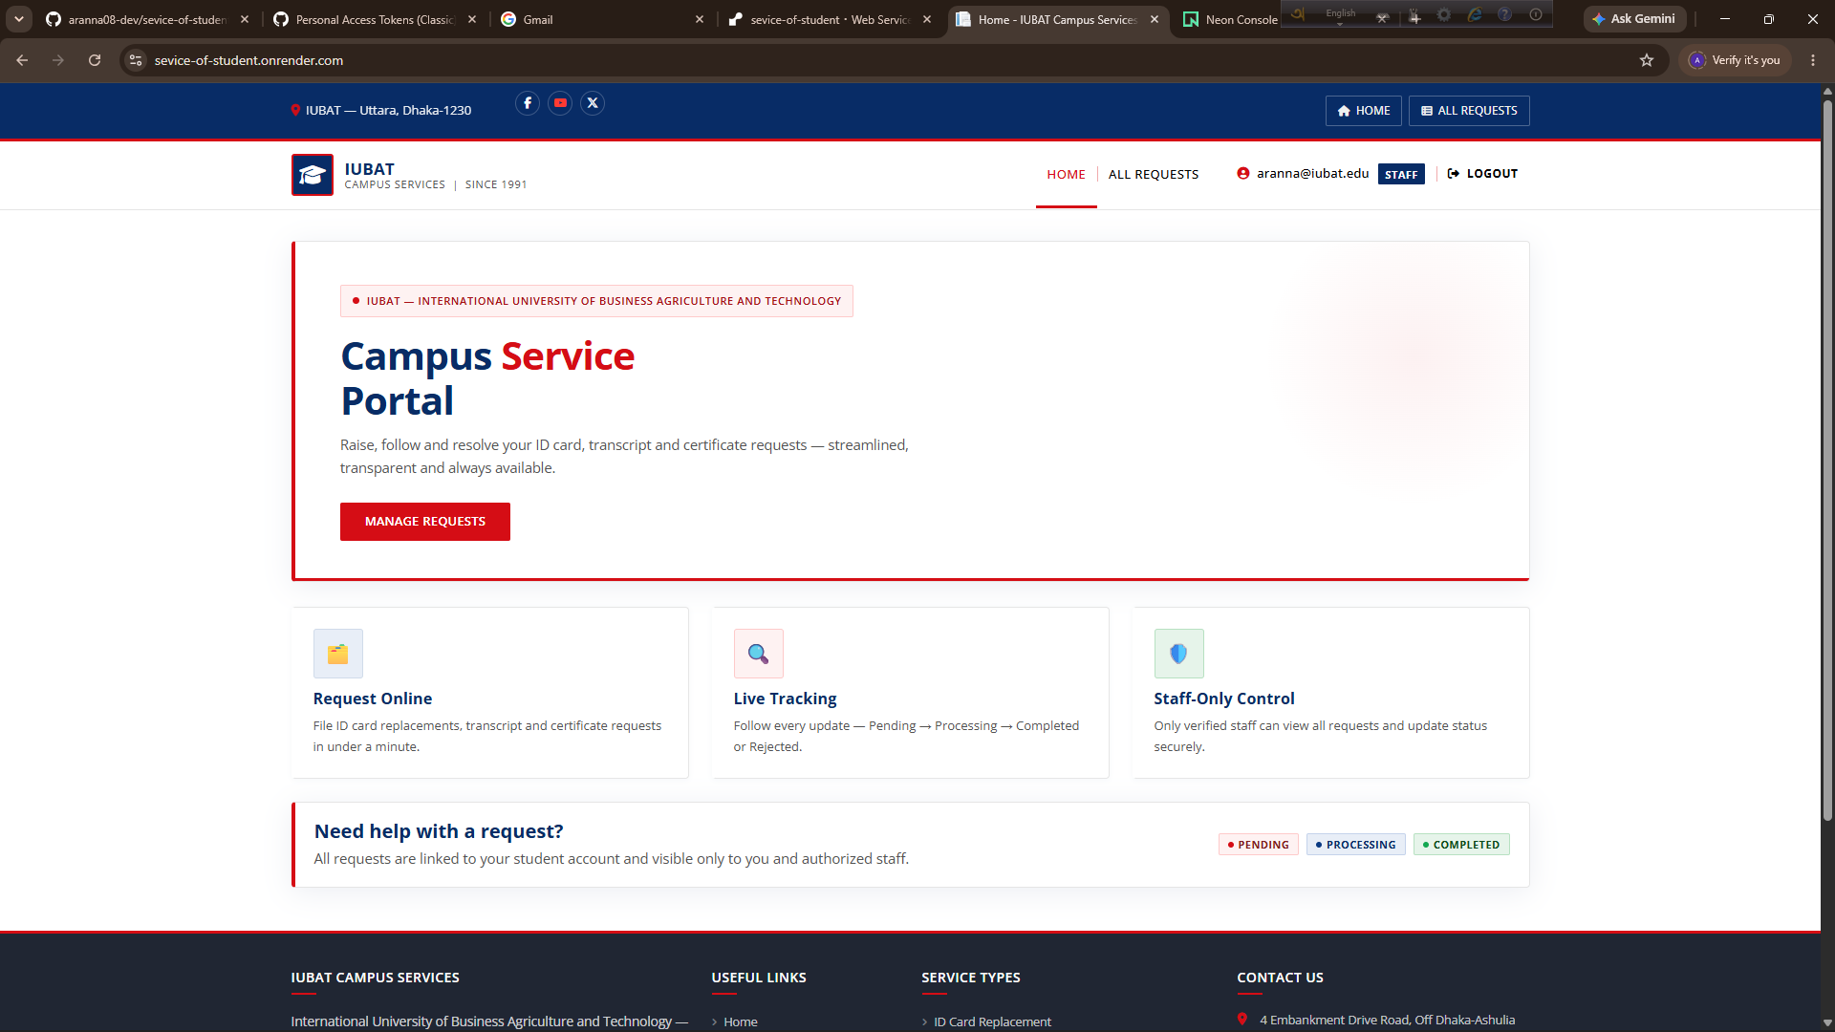

Fig 2 — Register & Login
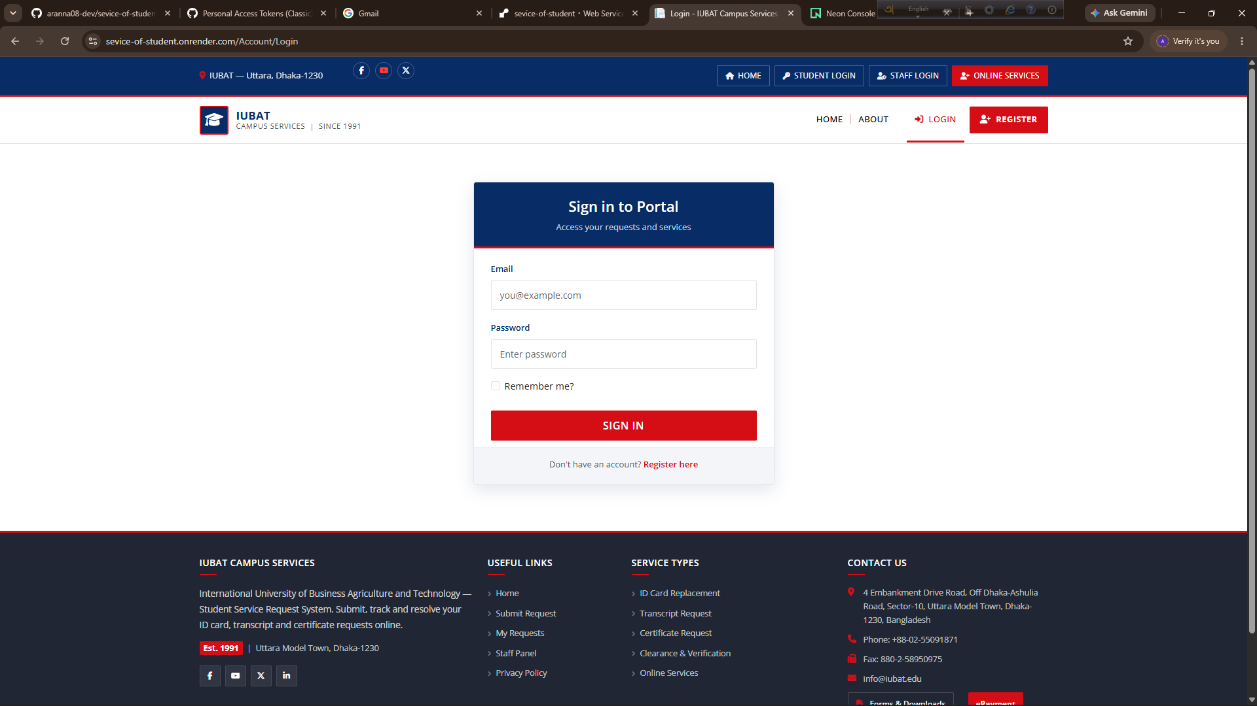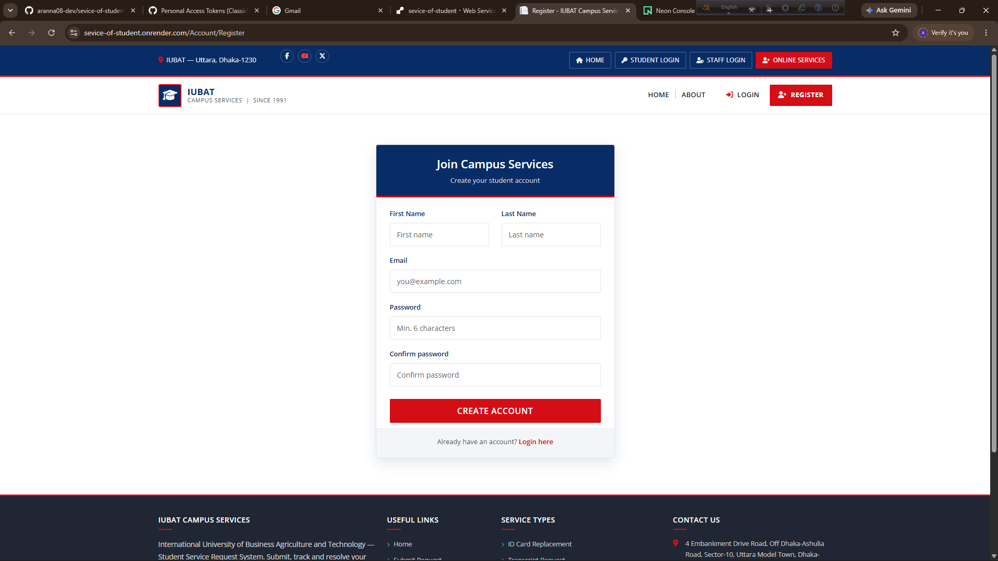

Fig 3 — Student: Create Request
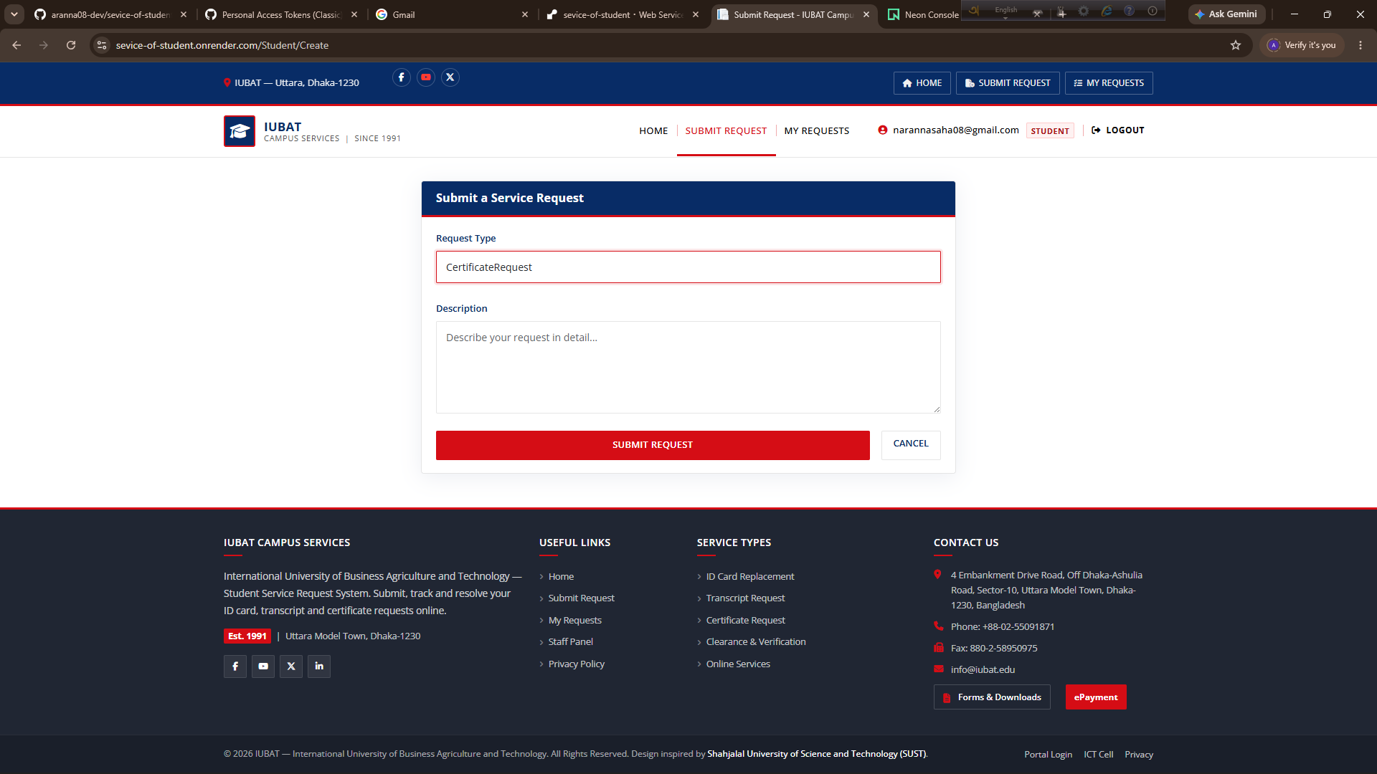

Fig 4 — Student: My Requests
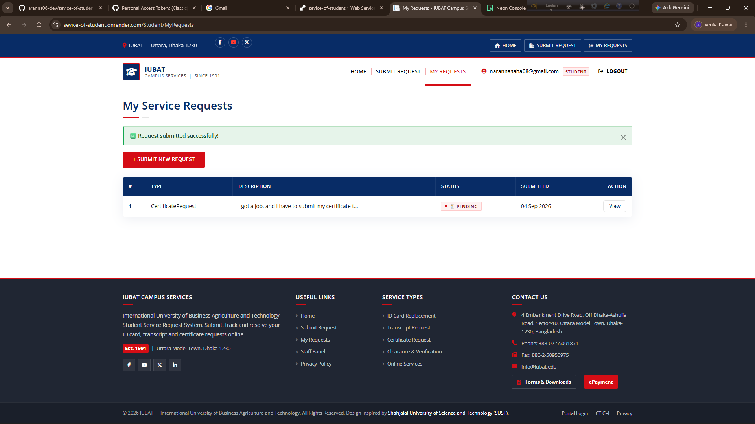

Fig 5 — Student: Request Details
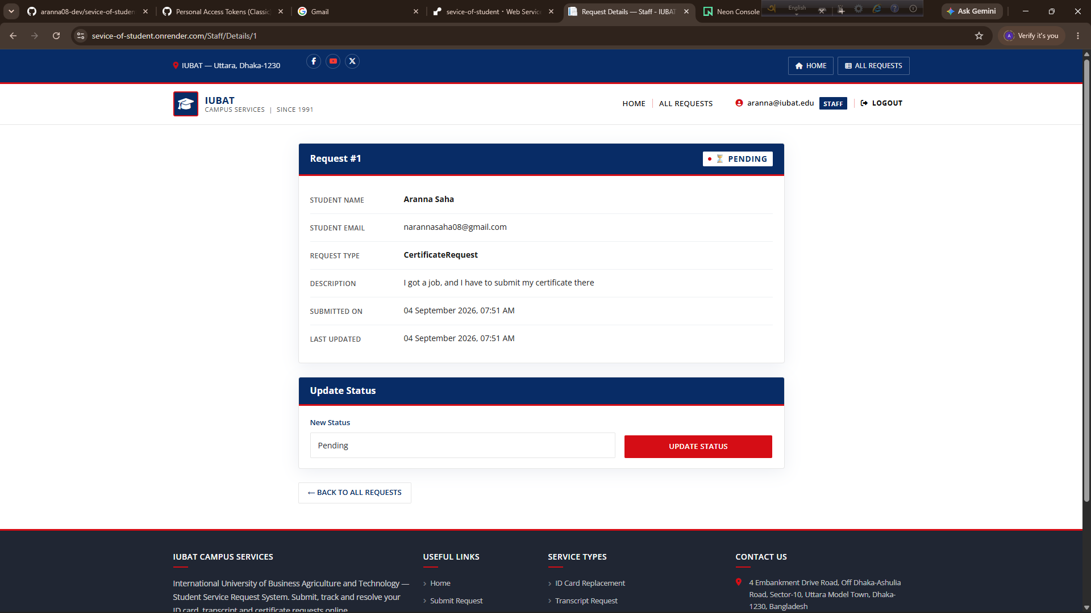

Fig 6 — Staff: All Requests & Details
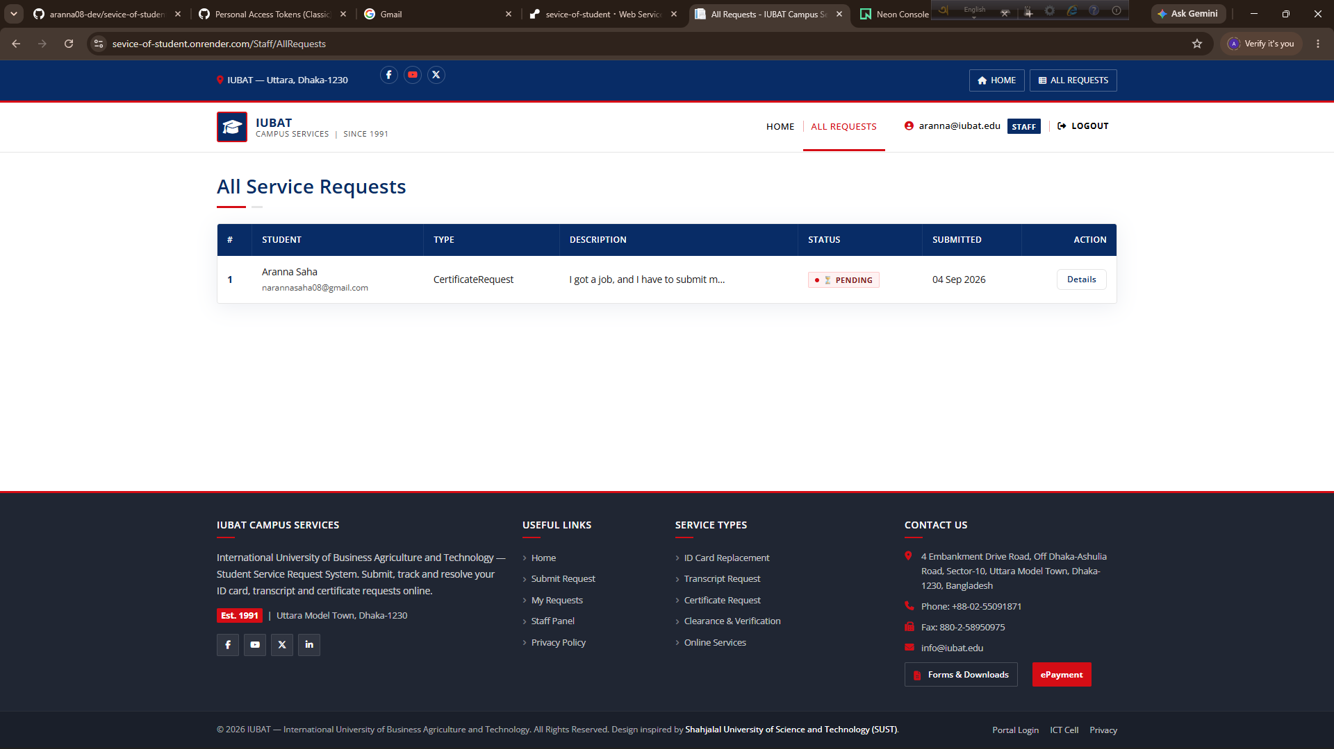

5. Conclusion
This report documented the design and implementation of WebApplication2 — the IUBAT Campus Services Portal — a focused ASP.NET MVC solution to the manual student-request problem.
- Problem addressed: The university's email/paper workflow was fragmented and opaque; students could not self-track, staff had no unified queue, and there was no role separation.
- Solution delivered: A single-aggregate MVC app where students register, submit (type + description), and track via MyRequests/Details, and staff (seeded) view all requests and atomically update status (Pending→Processing→Completed/Rejected) with timestamps — all behind [Authorize] and StudentId-scoped queries.
- ASP.NET concepts applied: MVC separation, Models + ViewModels, Controllers/Actions, Razor Tag Helpers, conventional routing, HTML forms, DataAnnotations + ModelState + anti-forgery, EF Core code-first + Npgsql + Identity, async CRUD, role claims, cookie auth with LoginPath, and ViewImports/ViewStart composition.
- Key design decisions: (1) ViewModel isolation to keep validation out of the entity; (2) StudentId filter on every student read to close IDOR; (3) Seeded staff, not self-registration, to satisfy university control; (4) Single ServiceRequest table with enum discriminators for simplicity; (5) Placeholder appsettings + env-var DB injection so the same Docker image runs locally and on Render without leaking secrets; (6) Emerald Academic theme as a view-only fork of WebApplication1 to prove MVC view independence.
- Findings: The usability-security conflict is best solved by progressive disclosure (role-aware nav) + defense in depth (auth + per-row filter), not by weakening either side. EnsureCreated + pooled Neon is sufficient for prototype scale but should migrate to EF Migrations + indexed full-text search for production. The app meets every Part C minimum and is live-ready on Render + Neon (c8e0aa1).
Recommendation: For the next iteration, add student-edit-until-Processing, staff comments, pagination, and a formal EF migration plus pg_dump backup artifact. The current prototype already satisfies the brief's functional and non-functional criteria and demonstrates appropriate MVC, validation, DB and authorization mastery.

References
[1] Microsoft Learn. ASP.NET Core MVC overview — Models, Views, Controllers. https://learn.microsoft.com/en-us/aspnet/core/mvc/overview (accessed Sep 2026).
[2] Microsoft Learn. Introduction to Identity on ASP.NET Core. https://learn.microsoft.com/en-us/aspnet/core/security/authentication/identity (accessed Sep 2026).
[3] Microsoft Learn. Entity Framework Core — Getting started, DbContext, EnsureCreated. https://learn.microsoft.com/en-us/ef/core/ (accessed Sep 2026).
[4] Npgsql Documentation. Npgsql Entity Framework Core Provider for PostgreSQL. https://www.npgsql.org/efcore/ (accessed Sep 2026).
[5] Neon Documentation. Connect with pooled connection strings, SSL & channel binding. https://neon.tech/docs/connect/connect-from-any-app (accessed Sep 2026).
[6] Render Documentation. Deploy a Docker service, environment variables & health checks. https://docs.render.com/docker (accessed Sep 2026).
[7] Bootstrap 5.3 Documentation. https://getbootstrap.com/docs/5.3/ (accessed Sep 2026).
[8] jQuery Validation & Unobtrusive Validation. https://jqueryvalidation.org/ (accessed Sep 2026).
[9] Fowler, M. Patterns of Enterprise Application Architecture (MVC, Active Record). Addison-Wesley, 2002.
[10] IUBAT Academic Regulations — Student Services (internal).

Appendix A — KPA Form & Deliverables Checklist
KPA Form: Attached as separate sheet per university template (to be signed by supervisor). This report is Appendix B of the submission packet.
# | Deliverable | Status | Location
1 | ASP.NET MVC project/source code (WebApplication2) | ✓ Ready | github.com/maya1405-maker/StudentMS @ c8e0aa1
2 | Database / backup (Neon pg_dump) | ✓ Generated via Neon SQL editor | neondb_backup_WebApplication2.sql
3 | Report with KPA Form | ✓ This document + KPA sheet | WebApplication2/*.docx + KPA.pdf
4 | Demonstration (video) | ○ Record (Home→Register→Create→MyRequests→Staff/All→Update) | demo_WebApplication2.mp4
— End of Report —

