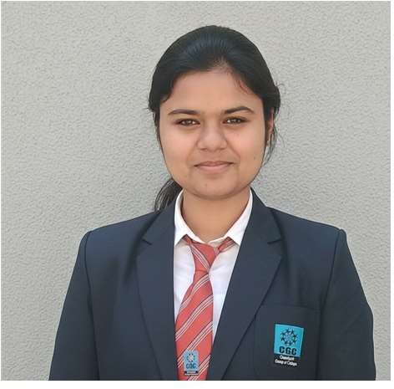

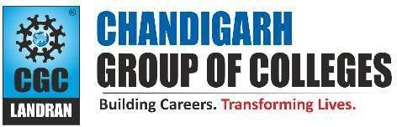
Shikha
Gangoh, Saharanpur Uttar Pradesh ,247341
+91 7505496877
shikha479saini@gmail.com linkedin.com/in/shikha479 github.com/shikha477

PROFESSIONAL SUMMARY

Frontend Developer and IT undergraduate with hands-on experience in building scalable and responsive web applications using React.js, JavaScript, HTML, CSS, and Firebase. Strong understanding of component-based architecture, REST APIs, authentication systems, and modern frontend development practices. Passionate about creating optimized and user-friendly interfaces..

TECHNICAL COMPETENCIES
- Programming Languages: C, C++, Java
- Web Technologies: HTML, CSS, JavaScript, React.js, Responsive Web Design
- Backend & Tools: Node.js, Express.js, Firebase, Git, GitHub
- Concepts: DSA, OOP, Operating Systems, Software Engineering

INTERPERSONAL SKILLS
Team Work | Leadership | Management & Coordination | Active Listening |Adaptability

INTERESTS & HOBBIES
ContinuousLearning| SkillDevelopment|
Technology Exploration

LANGUAGES KNOWN
English | Hindi

EDUCATION

Bachelor of Technology (B.Tech) – Information Technology
Chandigarh Group of Colleges, Landran
2023 – 2027 | CGPA: 8.03
Intermediate (CBSE)
Geetagyan Sanskar Academy, Gangoh
2022 – 2023 | Percentage: 74.2%
Matriculation (CBSE)
Geetagyan Sanskar Academy, Gangoh
2020 – 2021 | Percentage: 70.6%

PROJECTS EXPERIENCE

Starbucks Website Clone
Tech Stack: React.js, JavaScript, HTML, CSS
- Developed a responsive Starbucks website clone using React.js with a component-based architecture.
- Implemented client-side routing and state management using React Hooks and React Router.
- Optimized development workflow using Vite

Super Mall Web Application
Tech Stack: React.js, Firebase, JavaScript, CSS
- Developed a full-stack e-commerce web application using React.js and Firebase.
- Implemented user authentication and database management using Firebase.
- Developed an admin dashboard to manage product listings and shop details.
- Created a responsive user interface to ensure seamless user experience across devices.

ACADEMIC ACHIEVEMENTS
- Participated in Smart India Hackathon (SIH) 2025–26
- Completed React.js for Beginners certification from Simplilearn

CERTIFICATIONS
- Participant – Smart India Hackathon (SIH) 2024–25
- Participant – Zest-o-Fiesta 2024 (College-level Technical & Cultural Event)

EXTRA CURRICULAR & CO-CURRICULAR ACHIEVEMENTS
- Event Coordinator – Technical Club (Tech Roadies)
- Participant – College-level Coding Events and Hackathons

