**Product-Catalog Project**

Project files for the Product Catalog Project in the Udacity Full Stack Nanodegree.

This project contains a database of different sports.

**Set Up Instructions**

Follow these instructions to set up the Vagrant Linux Environment and the Product Catalog Project

**Prerequisite Resources**

You will need the following Python resources for it to run:

* Python 2.7 or above (<https://www.python.org/downloads/>).
* Git (<https://git-scm.com/downloads>).
* Vagrant (<https://www.vagrantup.com/>).
* VirtualBox (<https://www.virtualbox.org/wiki/Downloads>).
* Sqlalchemy (<https://www.sqlalchemy.org/download.html>).

You will need the following other resources for it to run:

* Flask (<http://flask.pocoo.org/>).
* Httplib2 (<https://pypi.python.org/pypi/httplib2/0.10.3>).
* Oauth2client (<https://pypi.python.org/pypi/oauth2client/>).
* Web browser i.e. Chrome (<https://www.google.com/chrome/>)

**Installation**

* Install Git (<https://git-scm.com/downloads>) on the local machine
* Install Python 2.7 or above (<https://www.python.org/downloads/>) on the local machine
* Install VirtualBox (<https://www.virtualbox.org/wiki/Downloads>) on the local machine
* Install Vagrant (<https://www.vagrantup.com/>) on the local machine

**Preparing the Virtual Machine**

1. Use git clone <https://github.com/shikhakhanna19/Product-Catalog.git>  to clone this repository.
2. Navigate to the cloned repository using Git i.e. cd desktop/local-machine/vagrant
3. Run the command 'vagrant up' to download and install the linux operating system.
4. Run the command 'vagrant ssh' to log in to the virtual machine.
5. Install Flask (<http://flask.pocoo.org/>) with pip install Flask, if it is not installed already.
6. Install Sqlalchemy, Httplib2 and Oauth2client with sudo apt-get install, if they are not installed already.

**Setup the Database**

After the initial setup you can load the project files while connected to vagrant.

Navigate to cd Product-Catalog:

1. Run python database_setup.py
2. Run python listofcatalog.py
3. Run your web browser.

**Contents of the Project**

It uses python to establish a simple Product Catalog database with an ability to add and edit new items.

The Product Catalog allows:

* The Product Catalog project consists of developing an application that provides a list of Games categories and list of Items required for that game, as well as provide a user registration and authentication system.
* Facebook or Google online login to edit ,add or delete content.

**Preparing the Project**

In order to run the project you must have:

1. Run pg_config.sh with the sudo ./ pg_config.sh command.
2. Run database_setup.py with the python database_setup.py command.
3. Run application.py with the python application.py command.
4. Prepared your web browser to navigate to <http://localhost:8080>/

**Run the Project**

1. Run the command python application.py in order to start the Product Catalog.
2. Navigate to http://localhost:8080 on your web browser for access.

**Useful Editors:**

* Atom (<https://atom.io/>)
* Notepad++ (<https://notepad-plus-plus.org/>)
* Sublime Text (<https://www.sublimetext.com/>)

**Screen shots of Product Catalog**

<http://localhost:8080>/

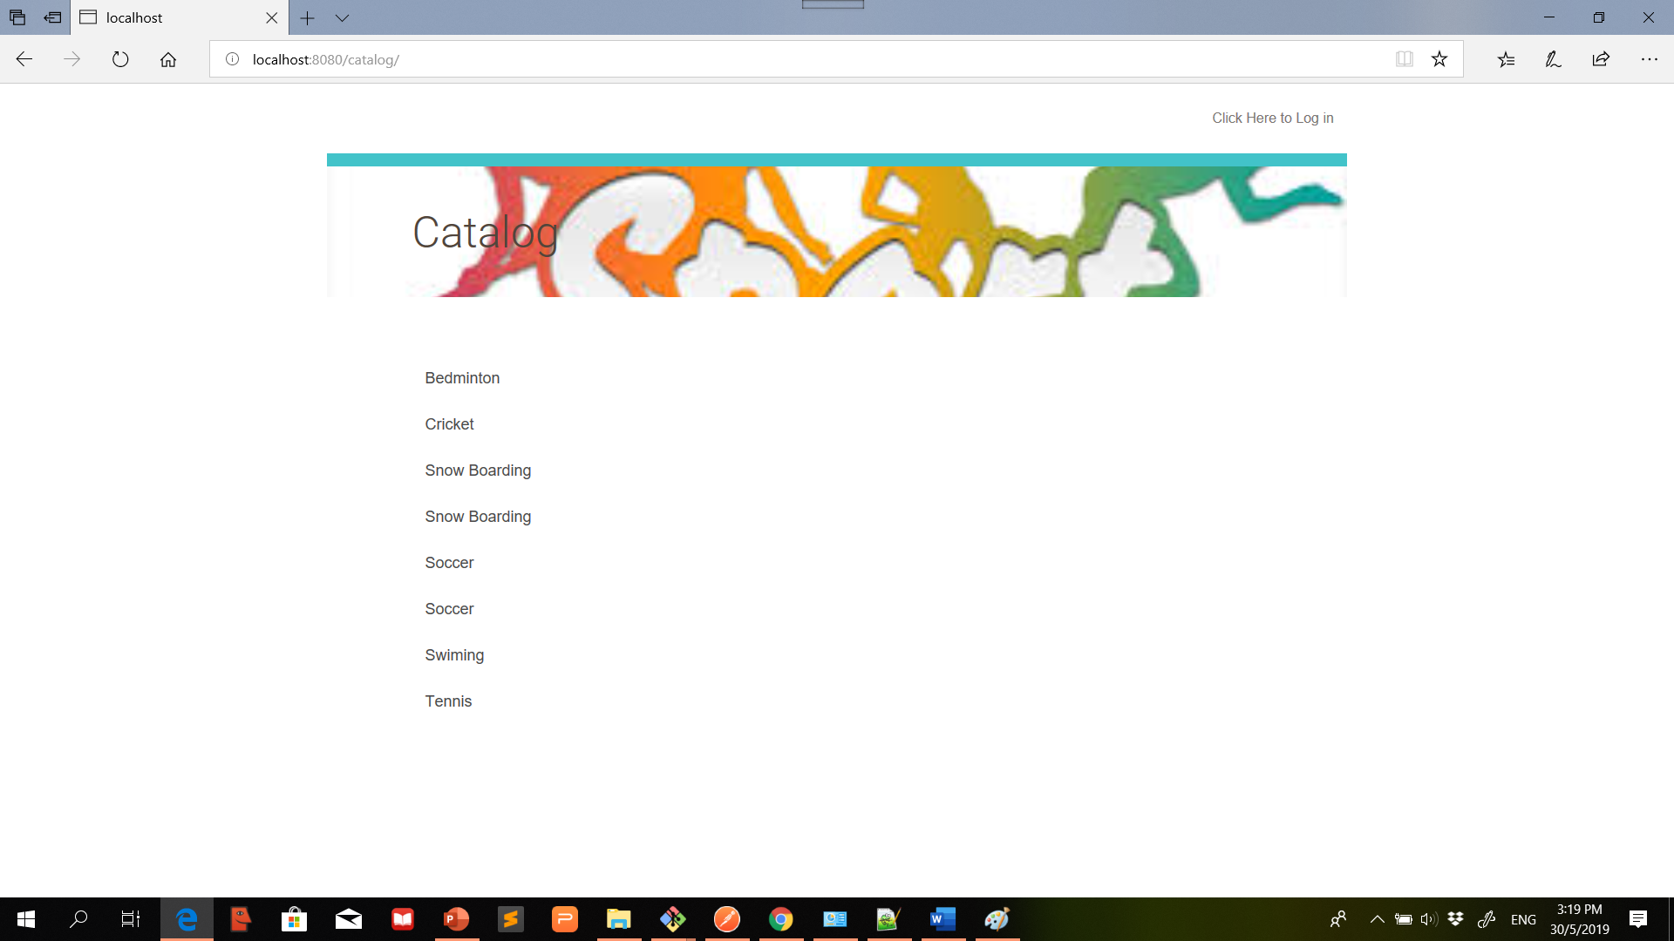

Click on : Click here to Log in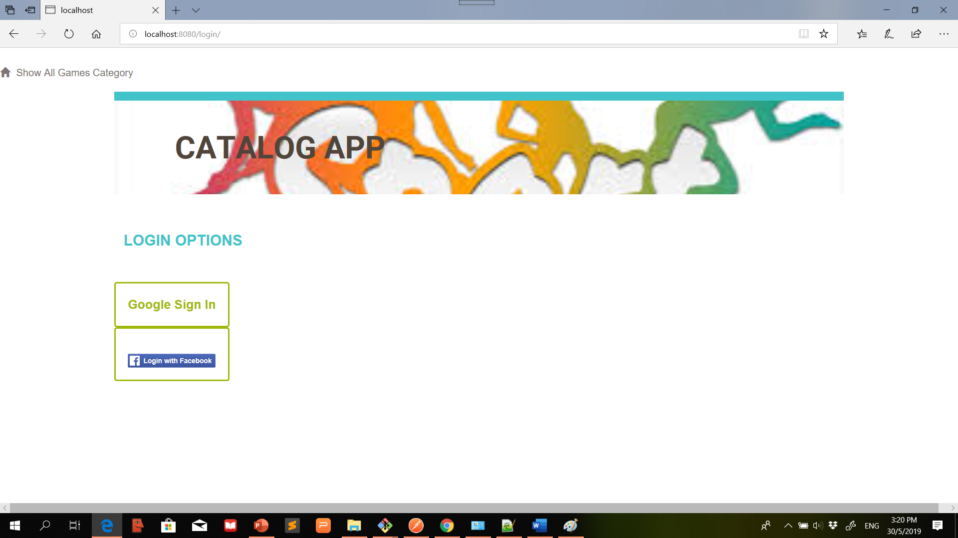

Select any option for Login as (Google/facebook) user

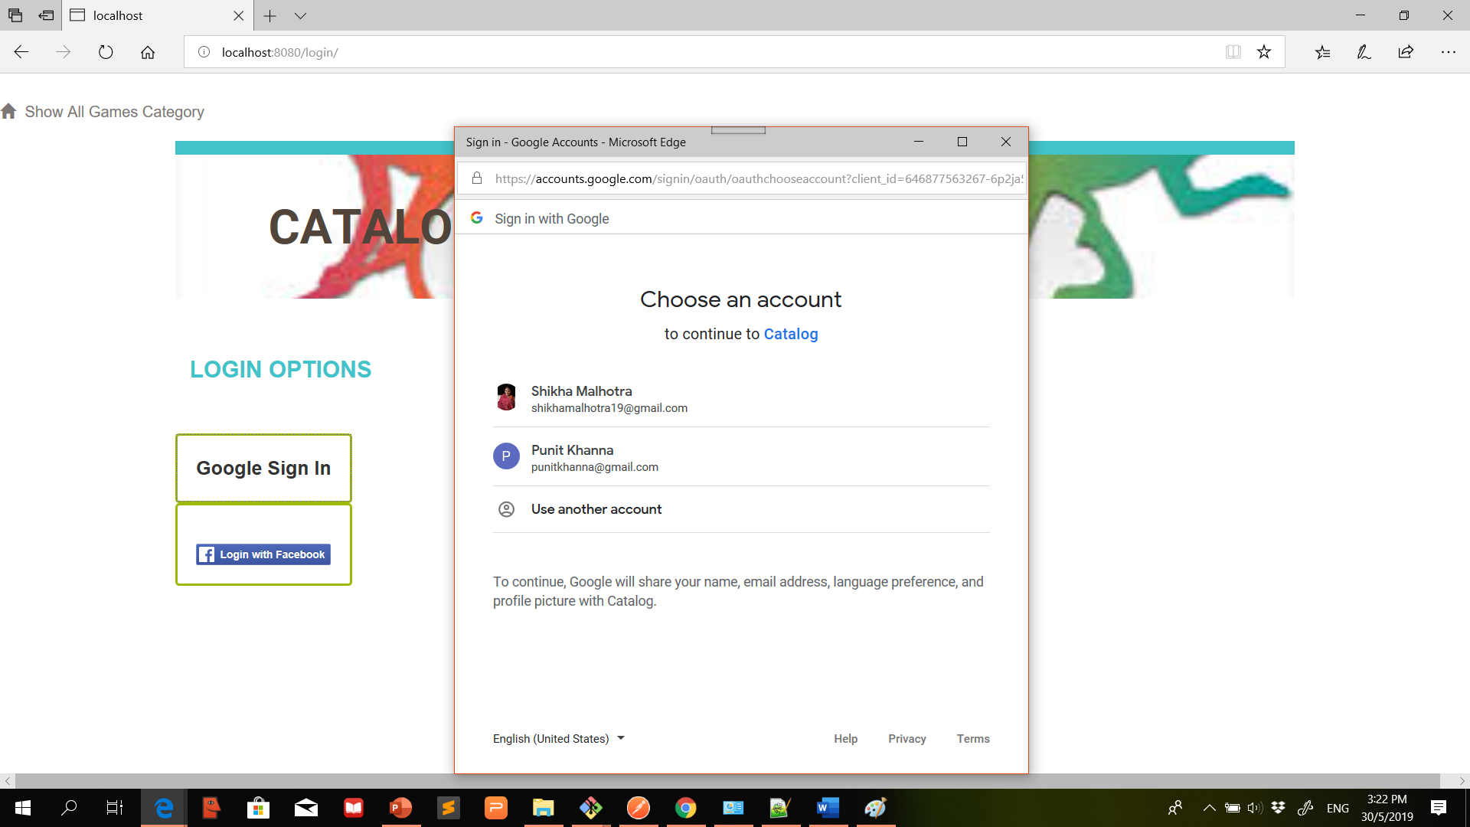

After successful login you can add/edit/delete Catalog new games categories and catalog Item list specific to login user.

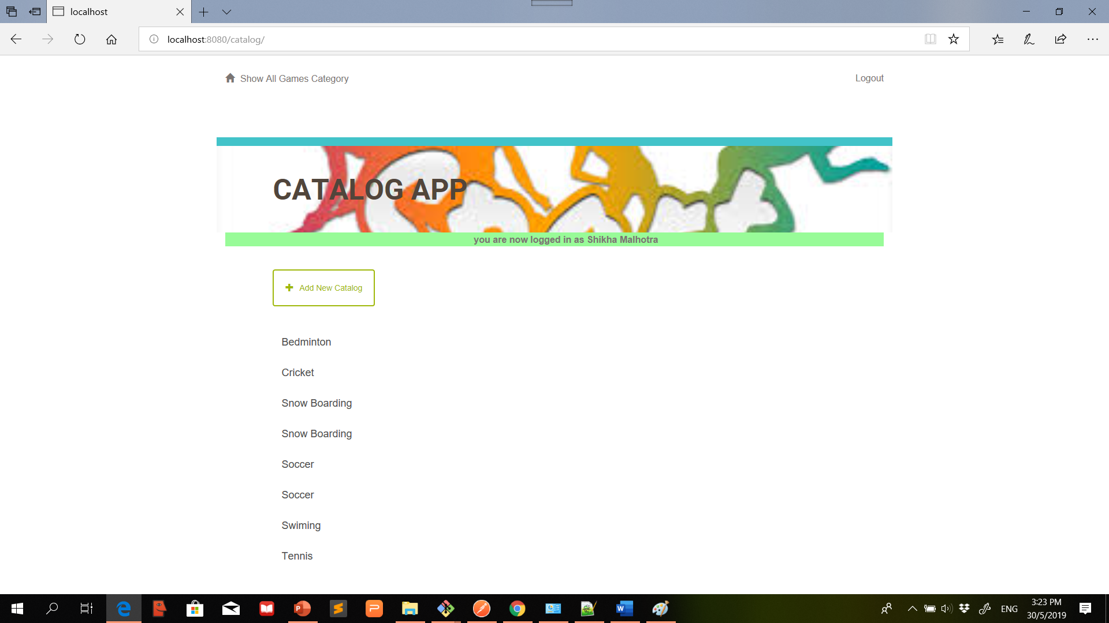

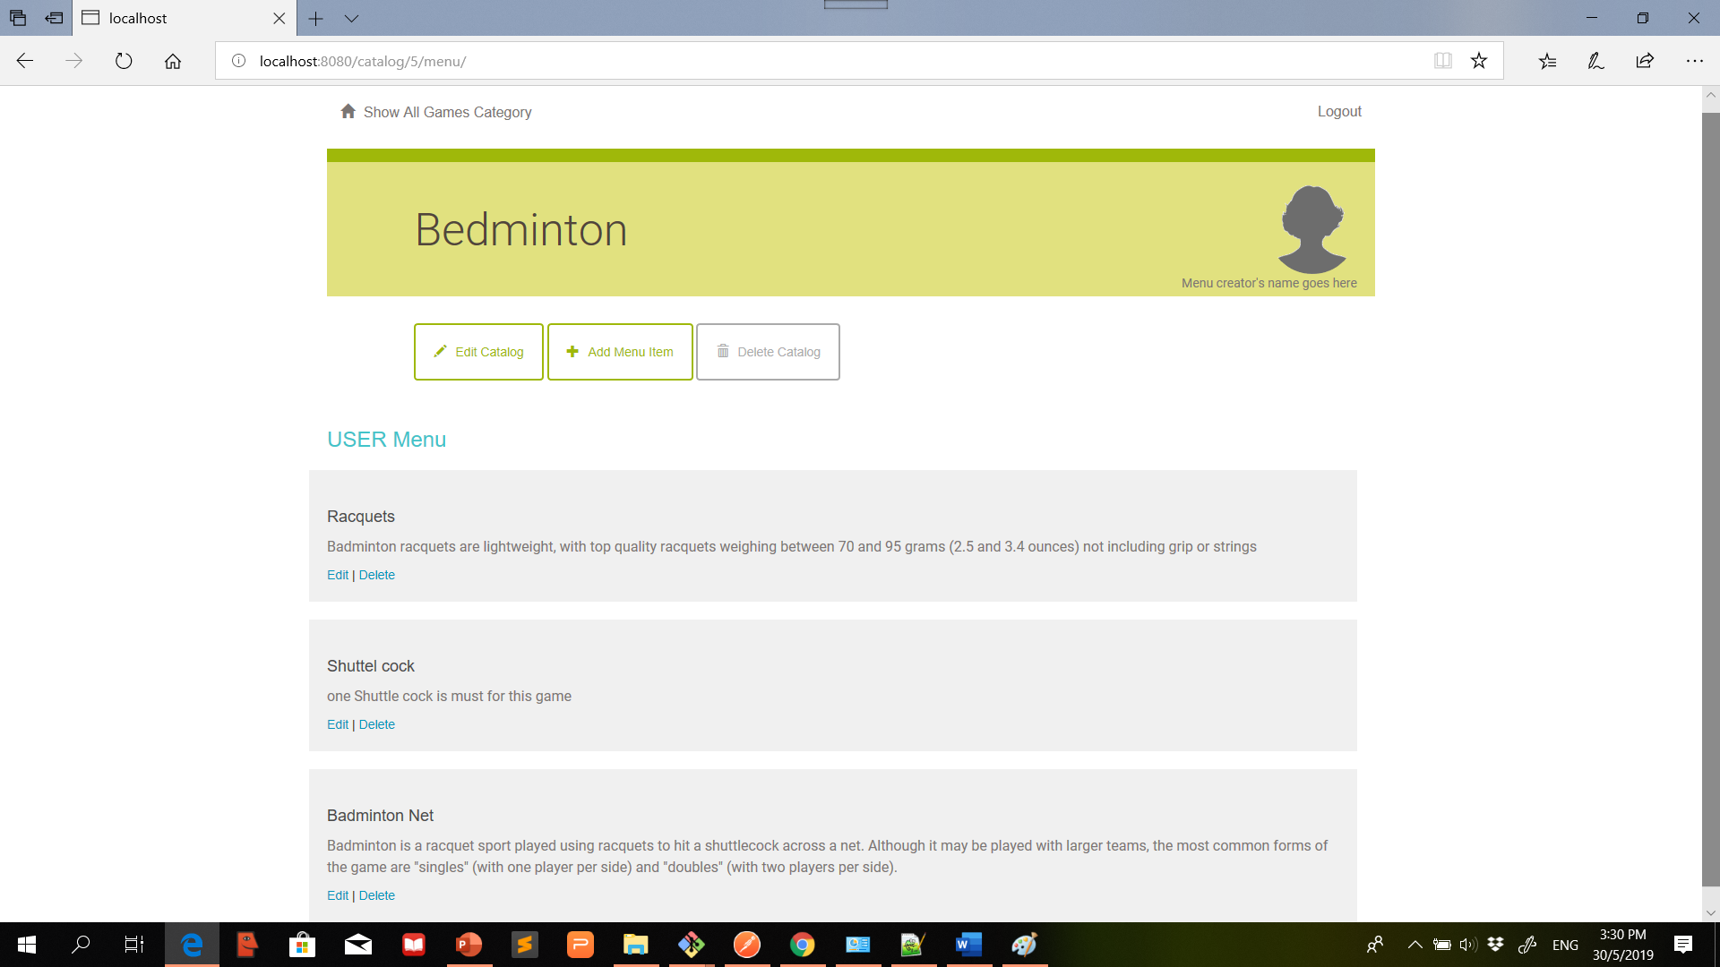

User can only view(not able to perform Add/edit/delete) all other categories i.e. previously added by other users.

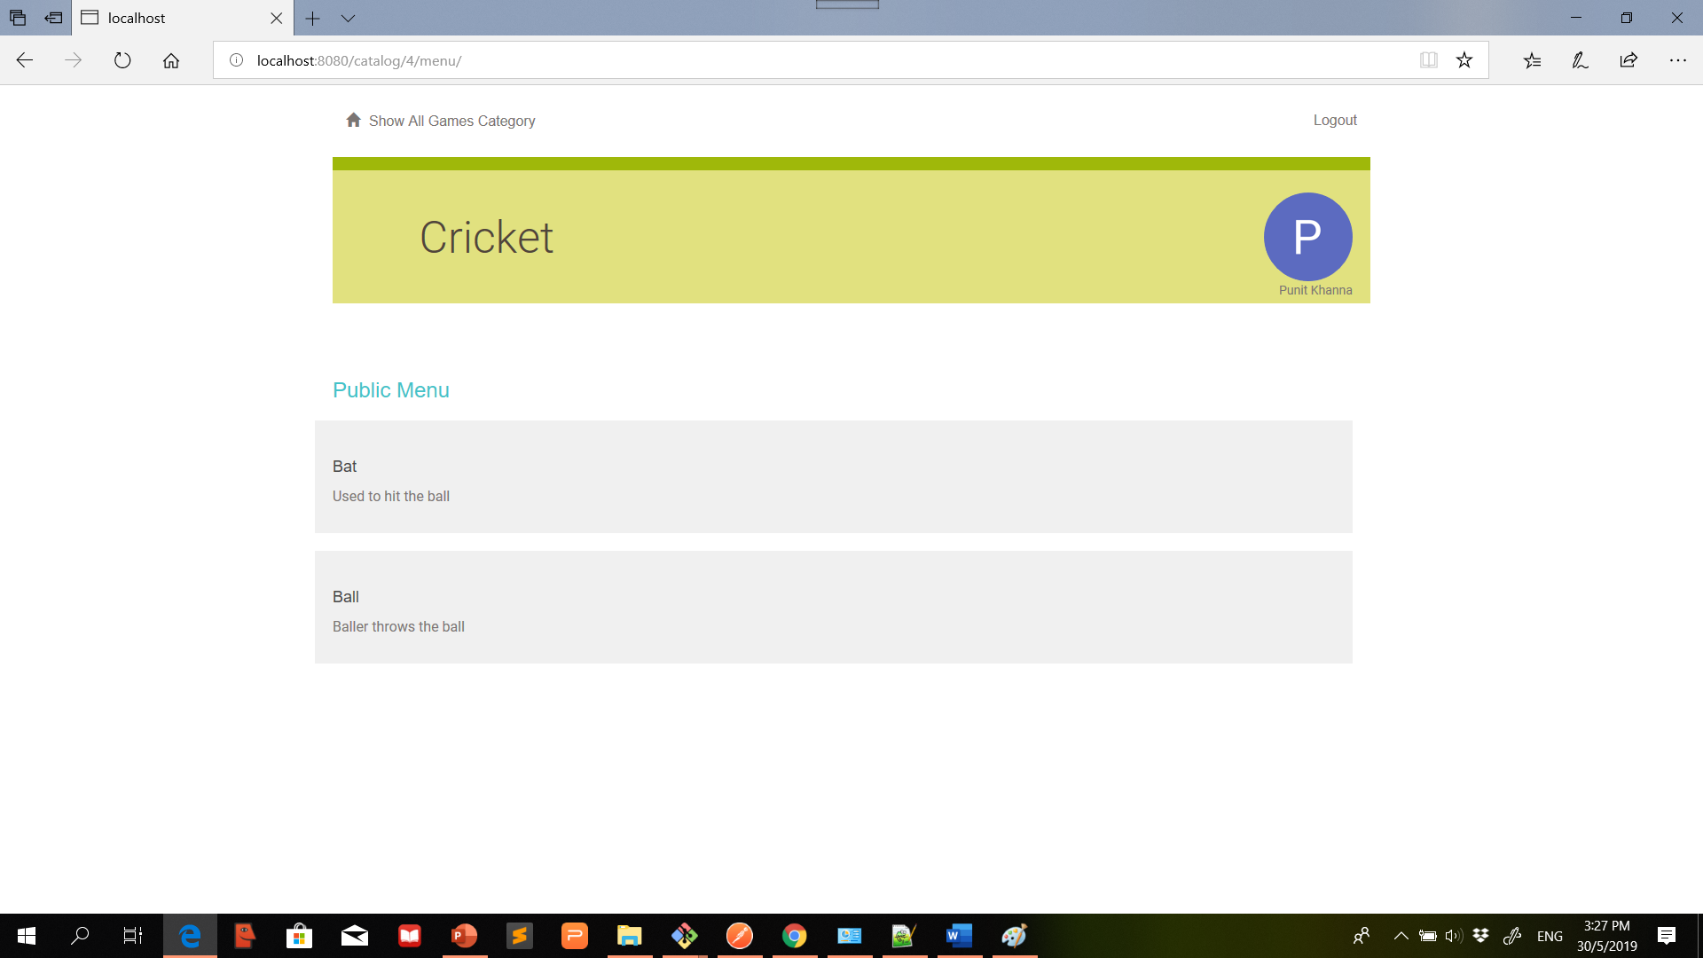

JSON Output:

