CONCURRENT SERVER REPORT

Documentation of Code :-

Procedure:-
At first run the server and then the client. The client side will ask for the file name. Enter the file name in the terminal.( Note:- Please do not enter any file which has spaces in its name. The filename has been parsed in that way.) The file can be of any type. I have tried with .txt, .ppt, .png, .mp4 . The server will send the acknowledgement stating the filename. After the file has been transferred, the server will send the MD5_checksum hash value and print “File <filename> received successfully”. If the hash values of the files match, the terminal will print “MD5 matched”, else “MD5 not matched”.
Please do not run the client and server code on the same directory, as it will cause a clash of the sent file name and received file name.

Compilation Procedure :-
(i) Server side :- make server
(ii) Client side :- make client

Running Procedure :-
(i) Server side :- ./server <port_no>
(ii) Client side :- ./client <server_address> <port_no> <filename>
Next page

Sample input/ouput :-

I sent five identical files(with different names) of 15MB each from my partners laptop to mine, concurrently through five different processes. Here is the output I got on the server side. It is interesting to note that the file sent from the client was not received in the same order at the server.

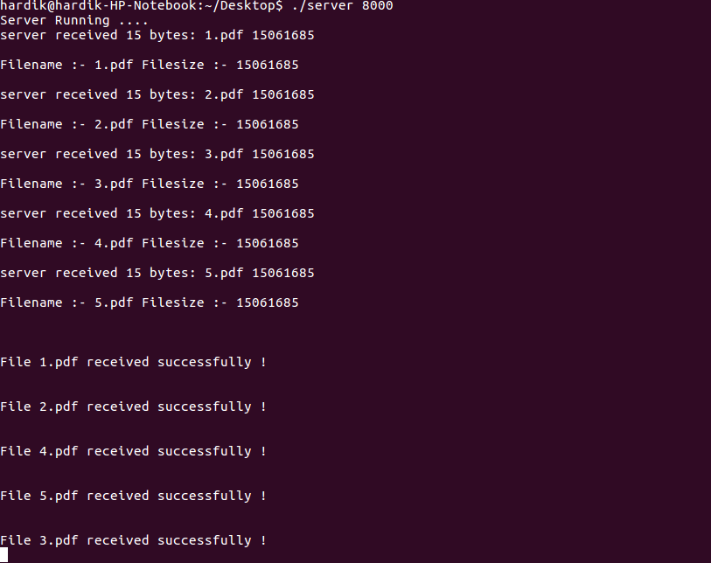

Next page

Observations:-

(i)
Packet Distribution :-

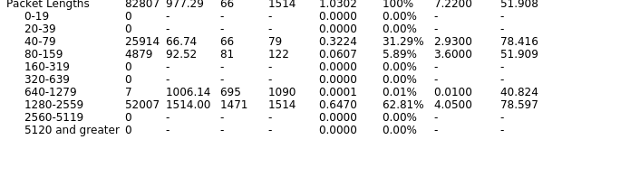

(ii) No of packets retransmitted :- 15235 (5.6 %)

Justifications:-

The order in which file was sent and received is not the same. This thing depends on the file size, OS scheduler of the receiver and sender. The OS scheduler gives different preference to different process and hence the result.

