Documentation of the code

The app process makes a connection request to the receiver. It initializes two threads afterwards, one to send data packets and other to receive acknowledgment packets. The receiver also creates two threads for this purpose. Semaphores have been used for syncronisation among threads and parent process.

Compilation and Running Procedure
Receiver Side:-

Compiling the code :- make server
Running the code as sender :- ./server <ip addr> <portno for the server>
Running the code as receiver :- ./server <port no>

Screenshots

Sender Side :-

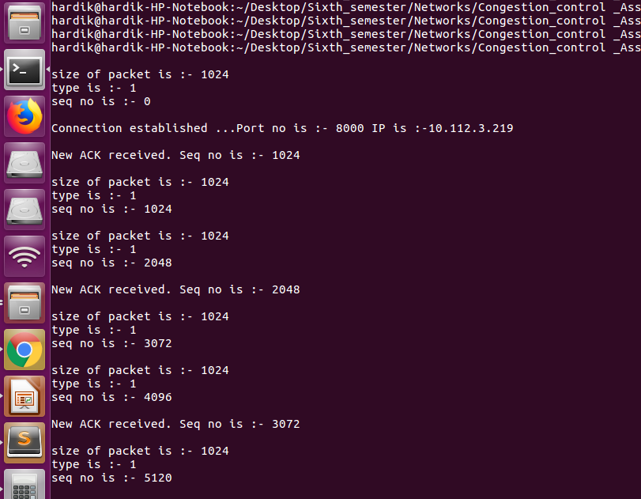

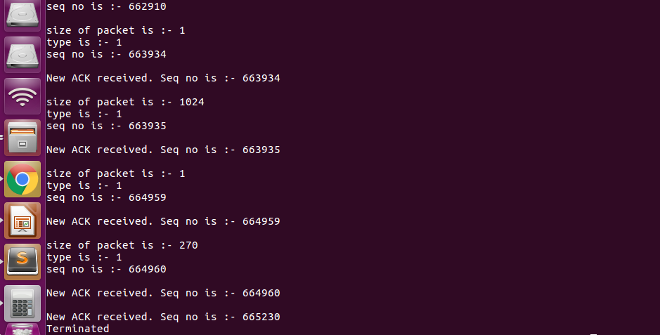

Receiver Side :-

