**Documentation of the code**

The app process makes a connection request to the receiver. It initializes two threads afterwards, one to send data packets and other to receive acknowledgment packets. The receiver also creates two threads for this purpose.

**Compilation and Running Procedure**

**Receiver Side:-**

**Compiling the code :-** make server

**Running the code as sender :-** ./server <ip addr> <portno for the server>

**Running the code as receiver :-** ./server <port no>

**Screenshots**

Sender Side :-

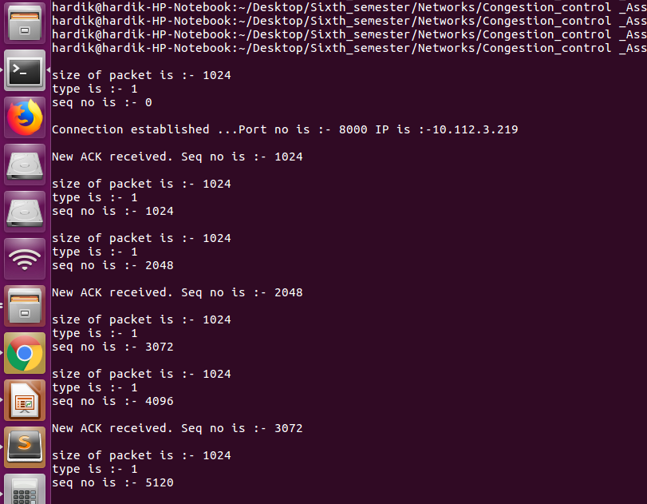

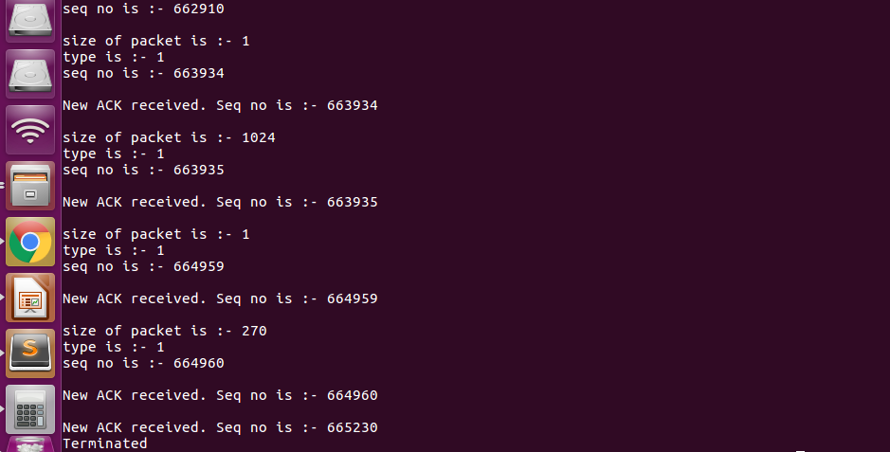

**Receiver Side :-**

