References

[1 ]FAO, IFAD, UNICEF, WFP, WHO, The State of Food Security and Nutrition in the World 2023. Geneva, Switzerland, Jul. 2023.

[2] "State of Agriculture in India," accessed Aug. https://prsindia.org/files/policy/policy_analytical_reports/State%20of%20Agriculture%20in%20India.pdf 9, 2023. [Online].

[3] C. Janiesch, P. Zschech, and K. Heinrich, "Machine learning and deep learning," Electron. Markets, vol. 31, no. 3, pp. 685–695, Apr. 2021, doi: 10.1007/s12525-021-00475-2.

[4] K. Kc, Z. Yin, D. Li, and Z. Wu, "Impacts of background removal on convolutional neural networks for plant disease classification in-situ," Agriculture, vol. 11, no. 9, p. 827, Aug. 2021, doi: 10.3390/agriculture11090827.

[5] J. Liu and X. Wang, "Plant diseases and pests detection based on deep learning: A review," Plant Methods, vol. 17, no. 1, pp. 1–18, Dec. 2021.

[6] Y. Zhang, C. Song, D. Zhang, Deep learning-based object detection improve- [ment for tomato disease, IEEE Access 8 (2020) 56607–56614, doi: 10.1109/AC- CESS.2020.2982456 .](https://doi.org/10.1109/ACCESS.2020.2982456)

[7] G. Sambasivam, G.D. Opiyo, A predictive machine learning application in agri- culture: Cassava disease detection and classification with imbalanced dataset using convolutional neural networks, Egypt. Inform. J. 22 (1) (2021) 27–34, doi: [10.1016/j.eij.2020.02.007 .](https://doi.org/10.1016/j.eij.2020.02.007)

[8] [I. Ahmed, P.K. Yadav, An automated system for early identification of diseases in plant through machine learning, in: Soft Computing: Theories and Applications: Pro- ceedings of SoCTA 2021, Springer Nature Singapore, 2022, pp. 803–814 .](http://refhub.elsevier.com/S2666-4127(23)00003-X/sbref0033)

[9] M.H. Saleem, J. Potgieter, K.M. Arif, Plant disease classification: A comparative eval- uation of convolutional neural networks and deep learning optimizers, Plants 9 (10) (2020) 1–17, doi: [10.3390/plants9101319 .](https://doi.org/10.3390/plants9101319)

[10] Tirkey D, Singh KK, Tripathi S. Performance analysis of AI-based solutions for crop disease identification detection, and classification. Smart Agric Technol. 2023.

[11] Jasim MA, Al-Tuwaijari JM. Plant leaf diseases detection and classification using image processing and deep learn ing techniques. Int Comput Sci Soft Eng Conf. 2020.

[12] V. K. Shrivastava, M. K. Pradhan, S. Minz, and M. P. Thakur, “Rice plant disease classification using transfer learning of deep convolution neural network,” The International Archives of the Photogrammetry, Remote Sensing and Spatial Information Sciences, vol. XLII-3/W6, pp. 631–635, 2019.

[13] K. Aderghal, A. Khvostikov, A. Krylov, J. Benois-Pineau, K. Afdel, and G. Catheline, “Classification of Alzheimer disease on imaging modalities with deep CNNs using cross modal transfer learning,” in 2018 IEEE 31st International Symposium on Computer-Based Medical Systems (CBMS), pp. 345–350, IEEE, Karlstad, Sweden, 2018.

[14] A. Abdalla, H. Cen, L. Wan et al., “Fine-tuning convolutional neural network with transfer learning for semantic segmenta tion of ground-level oilseed rape images in a field with high weed pressure,” Computers and Electronics in Agriculture, vol. 167, Article ID 105091, 2019.

[15] Kumar R, Chug A, Singh AP, Singh D. A systematic analysis of machine learning and deep learning based approaches for plant leaf disease classification: a Review. J Sensors. 2022

[16] Tiwari V, Joshi RC, Dutta MK. Dense convolutional neural networks based multiclass plant disease detection and classification using leaf images. Ecol Inform. 2021;63: 101289.

[17] Shoaib M, et al. An advanced deep learning models-based plant disease detection: a review of recent research. Front Plant Sci. 2023;14:1–22.

[18] Ahmed I, Yadav PK. A systematic analysis of machine learning and deep learning based approaches for identifying and diagnosing plant diseases. Sustain Oper Comput. 2023;4:96–104.

[19] Plant disease detection and classification techniques: a comparative study of the performances Wubetu Barud Demilie

[20] Liu J, Wang X. Plant diseases and pests detection based on deep learning: a review. Plant Methods. 2021;17(1):1 18

[21] Plant Leaf Disease Detection, Classification, and Diagnosis Using Computer Vision and Artificial Intelligence: A Review ANUJA BHARGAVA 1,AASHEESH SHUKLA1, OM PRAKASH GOSWAMI2, MOHAMMEDH.ALSHARIF 3,PEERAPONG UTHANSAKUL 4,(Member, IEEE), AND MONTHIPPA UTHANSAKUL 4,(Member, IEEE)

[22] V. K. Vishnoi, K. Kumar, and B. Kumar, ‘‘Plant disease detection using computational intelligence and image processing,’’ J. Plant Diseases Protection, vol. 128, no. 1, pp. 19–53, Aug. 2020,

[23] B. Liu, Y. Zhang, D. He, and Y. Li, ‘‘Identification of apple leaf diseases based on deep convolutional neural networks,’’ Symmetry, vol. 10, no. 1, p. 11, Dec. 2017.

[24] R. Chen, H. Qi, Y. Liang, and M. Yang, ‘‘Identification of plant leaf dis- eases by deep learning based on channel attention and channel pruning,’’ Frontiers Plant Sci., vol. 13, Nov. 2022.

[25] H. Nazki, S. Yoon, A. Fuentes, and D. S. Park, ‘‘Unsupervised image translation using adversarial networks for improved plant disease recog- nition,’’ Comput. Electron. Agricult., vol. 168, Jan. 2020, Art. no. 105117.

[26] Y. Tian, G. Yang, Z. Wang, E. Li, and Z. Liang, ‘‘Detection of apple lesions in orchards based on deep learning methods of CycleGAN and YOLOV3 dense,’’ J. Sensors, vol. 2019, pp. 1–13, Apr. 2019.

[27] Q. Wu, Y. Chen, and J. Meng, ‘‘DCGAN-based data augmenta- tion for tomato leaf disease identification,’’ IEEE Access, vol. 8, pp. 98716–98728, 2020.

[28] B. Liu, C. Tan, S. Li, J. He, and H. Wang, ‘‘A data augmentation method based on generative adversarial networks for grape leaf disease identifi- cation,’’ IEEE Access, vol. 8, pp. 102188–102198, 2020.

[29] Z. Lin, S. Mu, A. Shi, C. Pang, and X. Sun, ‘‘A novel method of maize leaf disease image identification based on a multichannel convolutional neural network,’’ Trans. ASABE, vol. 61, no. 5, pp. 1461–1474, 2018.

[30] J. G. Arnal Barbedo, "Plant disease identification from individual lesions and spots using deep learning," Biosyst. Eng., vol. 180, pp. 96–107, Apr. 2019.

[28]S. M. Kiran and D. N. Chandrappa, ‘‘Plant disease identification using discrete wavelet transforms and SVM,’’ J. Univ. Shanghai Sci. Technol., vol. 23, no. 6, pp. 108–114, 2021. [Online]. Available: https://jusst. org/wp-content/uploads/2021/06/Plant-Disease-Identification-Using-Discrete-Wavelet Transforms-and-SVM-1.pdf

[29] R. R. Patil and S. Kumar, ‘‘Rice-fusion: A multimodality data fusion framework for rice disease diagnosis,’’ IEEE Access, vol. 10, pp. 5207–5222, 2022.

[30] D. Zhang, X. Zhou, J. Zhang, Y. Lan, C. Xu, and D. Liang, ‘‘Detection of rice sheath blight using an unmanned aerial system with high-resolution color and multispectral imaging,’’ PLoS ONE, vol. 13, no. 5, May 2018, Art. no. e0187470.

[31] V. K. Shrivastava and M. K. Pradhan, ‘‘Rice plant disease classifi- cation using color features: A machine learning paradigm,’’ J. Plant Pathol., vol. 103, no. 1, pp. 17–26, Oct. 2020, doi: 10.1007/s42161-020- 00683-3.

[32] A. K. Rath and J. K. Meher, ‘‘Disease detection in infected plant leaf by computational method,’’ Arch. Phytopathol. Plant Protection, vol. 52, nos. 19 20, pp. 1348–1358, Dec. 2019.

[33] M. Azadbakht, D. Ashourloo, H. Aghighi, S. Radiom, and A. Alimohammadi, "Wheat leaf rust detection at canopy scale under different LAI levels using machine learning techniques," Comput. Electron. Agricult., vol. 156, pp. 119–128, Jan. 2019.

[34] B. S. Kusumo, A. Heryana, O. Mahendra, and H. F. Pardede, ‘‘Machine learning-based for automatic detection of corn-plant diseases using image processing,’’ in Proc. Int. Conf. Comput., Control, Informat. Appl. (IC3INA), Nov. 2018, pp. 93–97.

[35] A. Kaya, A. S. Keceli, C. Catal, H. Y. Yalic, H. Temucin, andB. Tekinerdogan, ‘‘Analysis of transfer learning for deep neural network based plant classification models,’’ Comput. Electron. Agricult., vol. 158, pp. 20–29, Mar. 2019.

**Etiology**

**Control & Management**

**Epidemiology**

**Pathogenesis**

**Phytopathology Objectives**

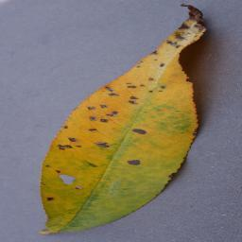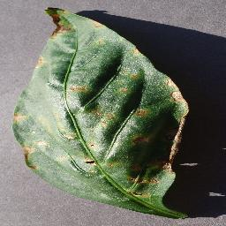

Peach - Bacterial Spot Bell Pepper - Bacterial Spot

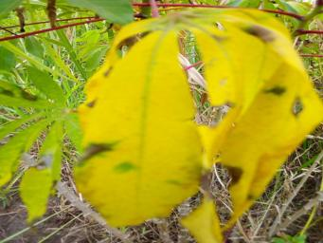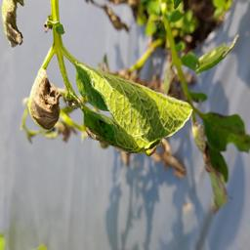

Cassava - Bacterial Blight Potato - Bacterial Wilt

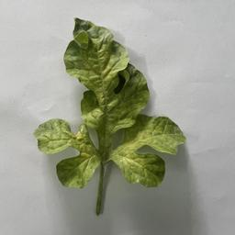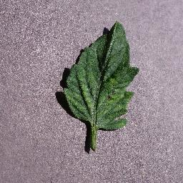

Watermelon - Mosaic Virus Tomato - Mosaic Virus

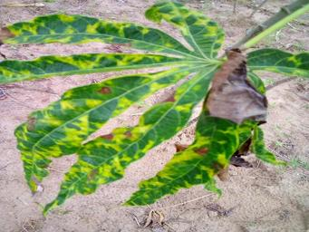

Cassava - Mosaic Disease

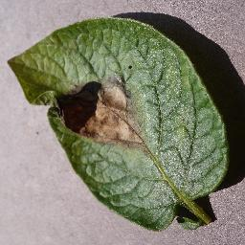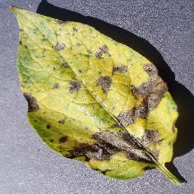

Potato - Late Blight (a) Potato - Early Blight (b)

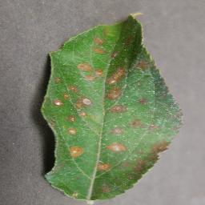

Apple – Rust

|  |  |  |  |
| --- | --- | --- | --- |
|  | Datasets | Techniques | Accuracy increased (%) |
| Bin et al. 2017 [23] | 1053 – 13689 | PCA | 4.00 |
| Srdjan et al. 2016 [24] | 4483 – 33469 | Rotation | 3.00 |
| Nazki et al. 2020 [25] | 2789 | ARGAN | 5.20 |
| Tain et al. 2019 [26] | TeaImage | CycleGAN | 28.00 |
| Wu et. al. 2020 [27] | GoogleNet | DCGAN | 94.33 |
| Liu et. al. 2020 [28] | Grape | LeafGAN | 94.02 |
| Lin et al. 2019 [29] | 10820 – 32460 | Radial Blur | 3.15 |
| Arnal Barbedo 2019 [30] | 1567 – 46409 | Segmentation | 12.00 |

Deployment

Model Evaluation

Model Training

Model Implementation

Model Selection

Data Preprocessing

Data Collection

|  |  |  |  |  |
| --- | --- | --- | --- | --- |
| **Class** | **Precision** | **Recall** | **F1-Score** | **Support** |
| Apple___alternaria_leaf_spot | 0.96 | 0.8 | 0.87 | 56 |
| Apple___black_rot | 0.77 | 0.91 | 0.83 | 124 |
| Apple___brown_spot | 0.78 | 0.84 | 0.81 | 43 |
| Apple___gray_spot | 0.8 | 0.52 | 0.63 | 79 |
| Apple___healthy | 0.81 | 0.65 | 0.72 | 514 |
| Apple___rust | 0.8 | 0.62 | 0.7 | 248 |
| Apple___scab | 0.56 | 0.45 | 0.5 | 244 |
| Cassava___bacterial_blight | 0.25 | 0.17 | 0.2 | 217 |
| Cassava___brown_streak_disease | 0.32 | 0.28 | 0.3 | 438 |
| Cassava___green_mottle | 0.22 | 0.13 | 0.16 | 477 |
| Cassava___healthy | 0.27 | 0.26 | 0.27 | 516 |
| Cassava___mosaic_disease | 0.73 | 0.84 | 0.78 | 2632 |
| Coffee___healthy | 0.67 | 0.63 | 0.65 | 158 |
| Coffee___red_spider_mite | 0.0 | 0.0 | 0.0 | 33 |
| Coffee___rust | 0.44 | 0.53 | 0.48 | 120 |
| Corn___common_rust | 0.98 | 0.89 | 0.93 | 238 |
| Corn___gray_leaf_spot | 0.78 | 0.64 | 0.7 | 103 |
| Corn___healthy | 0.87 | 0.97 | 0.92 | 232 |
| Corn___northern_leaf_blight | 0.86 | 0.9 | 0.88 | 197 |
| Grape___Leaf_blight | 0.98 | 0.98 | 0.98 | 295 |
| Grape___black_measles | 0.93 | 0.82 | 0.87 | 534 |
| Grape___black_rot | 0.97 | 0.93 | 0.95 | 316 |
| Grape___healthy | 0.93 | 0.92 | 0.93 | 341 |
| Potato___bacterial_wilt | 0.63 | 0.59 | 0.61 | 114 |
| Potato___early_blight | 0.88 | 0.88 | 0.88 | 526 |
| Potato___healthy | 0.75 | 0.69 | 0.72 | 455 |
| Potato___late_blight | 0.76 | 0.8 | 0.78 | 417 |
| Potato___leafroll_virus | 0.98 | 0.76 | 0.86 | 105 |
| Potato___mosaic_virus | 0.75 | 0.84 | 0.79 | 133 |
| Potato___nematode | 0.27 | 0.21 | 0.24 | 14 |
| Potato___pests | 0.36 | 0.35 | 0.36 | 122 |
| Potato___phytophthora | 0.51 | 0.61 | 0.56 | 69 |
| Potato___spindle_tuber_viroid | 0.81 | 1.0 | 0.89 | 17 |