**Plant Leaf Disease Detection and Classification Using AI and**

**Computer Vision Techniques**

Rati Goel1, Shikhar Sharma2, Ujjwal Singh3, Piyush Pandey4, Yash Srivastava5

[rati.python@gmail.com](mailto:rati.python@gmail.com), [2130154066@ipec.org.in](mailto:2130154066@ipec.org.in), [2130154074@ipec.org.in](mailto:2130154074@ipec.org.in), [2130154048@ipec.org.in](mailto:2130154048@ipec.org.in), [2130154081@ipec.org.in](mailto:2130154081@ipec.org.in)

Inderprastha Engineering College Ghaziabad

Abstract

Agriculture is essential for many nations' incomes. Diseases in plants caused by pathogens such as viruses, fungi, and bacteria cause global financial losses in agriculture. Effective disease management ensures crop quality and yield. Disease symptoms are often visible on various plant parts, with leaves being the most affected. Researchers have utilized computer vision, deep learning, few-shot learning, and soft computing techniques to automatically identify plant diseases using leaf images. These technologies help farmers act promptly to protect crops. By automating disease detection, these methods resolve limitations of traditional methods, enhancing both research speed and technology effectiveness. Additionally, molecular techniques have been developed to mitigate pathogenic threats. This review examines the use of machine learning, deep learning, and few-shot learning for automated plant disease detection, reviews diagnostic techniques and future advancements. The integration of these advanced techniques into agricultural practices not only aids in timely disease detection but also supports sustainable farming by reducing reliance on chemical treatments. By leveraging machine learning and molecular diagnostics, farmers can implement targeted interventions, minimizing environmental impact and improving resource efficiency. These innovations are vital in addressing the growing challenges of food security and climate change, ensuring the resilience of agricultural systems worldwide.

*Keywords: Deep learning, diagnosis, image processing, machine learning, and plant disease.*

**1. Introduction**

The United Nations' Food and Agriculture Organization has reported a consistent increase in global hunger since 2015. Current estimates suggest that approximately 680 million people are undernourished, accounting for less than 9% of the global population. This represents an annual increase of 10 million people and a rise of around 120 million over the last decade. Moreover, over 85% of the global population depends on agriculture for sustenance, underscoring the critical need for efficient farming mechanisms. Plants also play a vital role in maintaining environmental balance by producing oxygen through photosynthesis. However, plant diseases, particularly those affecting leaves, can severely impact plant health and disrupt food production. A historical example is the 1845 Irish Potato Famine, which caused 1.2 million deaths due to crop failure [1]. Laboratory techniques such as immunosorbent enzyme assays, isothermal amplification, and polymerase chain reaction (PCR) are commonly employed to detect plant diseases. Early detection, effective management, and prevention of plant diseases are

essential. However, diagnosing diseases in large agricultural fields is challenging, requiring skilled personnel and visual inspection of plant leaves [2]. Farmers typically rely on their experience to identify symptoms, a process that is time-intensive, laborious, and demands specialized skills. Automated disease detection systems aim to assist non-experts, including non-pathologists and non-botanists. This review explores automated techniques utilizing image processing, machine learning, deep learning, and few-shot learning for plant disease detection. Traditional machine learning approaches often lack robustness and are confined to controlled laboratory settings [3]. In contrast, deep learning has recently demonstrated remarkable success in classifying plant disease images. However, deep learning methods require extensive datasets, with images meticulously annotated by pathologists and botanists. These processes are resource-intensive and costly. Few-shot learning (FSL) offers an alternative by enabling models to learn from limited labeled datasets [4], where the number of samples depends on the experiment's objectives and complexity. Various pathogens contribute to plant diseases and can be identified using molecular techniques such as DNA analysis, PCR, MPG (Modified Panchayat Mixture), ELISA (Enzyme-Linked Immunosorbent Assay), FISH (Fluorescence in Situ Hybridization), and IF (Immunofluorescence) methods. This review paper provides a comparative analysis of machine learning, deep learning, and few-shot learning in plant disease detection. It also examines segmentation, feature extraction, and classification techniques alongside molecular diagnostic tools [5].

A typical symptom can be seen in (Fig. 1), which depicts an infected leaf.

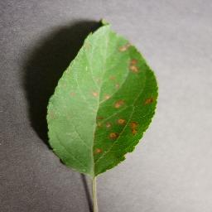

Fig. 1 Apple leaf infected with rust

The objective of the project "Plant Leaf Disease Detection and Classification Using AI and Computer Vision Techniques" is to develop an intelligent system capable of identifying and classifying plant leaf diseases accurately and efficiently. By leveraging advanced AI algorithms and computer vision, the system aims to assist farmers and agricultural professionals in detecting diseases at an early stage, reducing crop losses and improving productivity.

**2. Related Work**

This section provides a critical review of the existing literature on plant disease identification and classification. Research in this area can be broadly categorized into two approaches: machine learning (ML) and deep learning (DL) [6]. Early detection of crop health issues and diseases is crucial for effective management, including the use of fungicides, disease-specific treatments, and pesticide-based vector control. Beyond disease prevention, these measures can enhance agricultural productivity. Accurately distinguishing between healthy and diseased leaves is essential for reducing crop losses and increasing yield [7].

Machine learning techniques are increasingly being used for plant disease identification, as discussed in this section (Table 1). A comparison is presented between two widely adopted approaches—deep learning (DL) and machine learning (ML)—for plant disease detection using leaf image data [8]. Previously, many image-processing techniques relied on basic machine learning architectures [9]. However, deep learning networks are progressively becoming the industry standard for pattern recognition and image analysis. This comparison evaluates both approaches under standard conditions, considering three key factors: model design, processing capacity, and training data volume.

Table 1. Several recent research papers

|  |  |  |  |  |  |
| --- | --- | --- | --- | --- | --- |
| **Years** | **Literature Sources** | **Methodology for selecting features** | **Classification Approach** | **Datasets** | **Accuracy (%)** |
| 2022 | Aliyu M. Abdu et al. | SVM, DL | Supervised learning | Plantvillage dataset | 95.30% |
| 2022 | Savvas Dimitriadis | Naïve Bayes | Supervised learning | Kaggle dataset | 89.20% |
| 2022 | Asma Akhtar et al. | K-Mean, KNN, RNN | Unsupervised learning | Plant leaf dataset | 87.42% |
| 2021 | Kiran R. Gavhale et al | ANN, CNN | Supervised learning | Leaf images | 91.51% |
| 2021 | Jagadeh D. Pujari et al. | PNN, SVM, GLCM | Supervised learning/unsupervised | Image Data Set | 96.51% |
| 2021 | Sharada P.Mohanty | Neural Network | Supervised learning | Image Net | 83.13% |
| 2020 | Srdjan Sladojevic | SVM, Neural Network, Decision Tree | Supervised learning | Pictures of Plant  Pictures Potato  Village Tomato  Pictures Apple  Pictures Rice | 94.31% |
| 2020 | P.Ferntions | Neural Network | Supervised learning | Alex Net, Google  Net, Over-Feat, VGG | 97% |
| 2020 | S. Sannakkiet et al. | SVM | Supervised learning | Image Dataset | 85% |
| 2019 | TejalChandi waeetet al. | ANN SVM | Supervised learning | Manual Dataset | 82.34% |
| 2019 | Yan Guo et al. | ANN SVM | Supervised learning | Plant Village | 96.45% |
| 2019 | Yan Guo et al. | CNN | Supervised learning | Apple dataset | 93.81% |

Deep learning techniques are proving highly effective in agricultural image analysis. Study [10] demonstrated real-time insect detection and identification in soybean crops, achieving 98.75% accuracy and a processing speed of 53 frames per second using the YoloV5 model. This was accomplished with a custom dataset of crop insects, simplifying pest management for producers. Similarly, study [11] utilized a convolutional neural network (CNN) to classify plant leaf diseases from the PlantVillage dataset, achieving approximately 98% accuracy in both training and testing. This classification covered 15 categories, including healthy leaves and various diseases caused by bacteria and fungi. Shrivastava et al. [12] utilized transfer learning with deep convolutional neural networks (CNNs) to classify rice plant diseases. Their system identified four categories: rice blast, bacterial leaf blight, sheath blight, and healthy leaves. The classification process involved CNNs for feature extraction, followed by support vector machines (SVMs) for final classification. Aderghal et al. [13] employed cross-modal transfer learning with deep CNNs to classify Alzheimer’s disease using imaging modalities. Their approach aimed to enhance accuracy and was compared favorably to existing methods. The classification relied on CNNs. Abdalla et al. [14] focused on semantic segmentation of oilseed rape images in weed-heavy fields. They fine-tuned a CNN using transfer learning, specifically pre-trained VGG-19, achieving improved accuracy compared to VGG-16. Their image segmentation method operated as a single-step process.

**3. Phytopathology**

Phytopathology refers to the study of plant pathogens, the diseases they cause, their mechanisms, and methods to control and mitigate their impact on plants. It serves as a comprehensive framework for understanding and managing a plant's life cycle. Derived from Greek, "Phytopathology" combines "Phyto" (plant), "Patho" (disease), and "Logo" (knowledge) [6]. Its core objectives include investigating the origins and causes of plant diseases, whether biotic or abiotic (etiology), understanding the mechanisms behind disease development (pathogenesis), examining interactions between plant pathogens and diseases (epidemiology), and developing strategies to reduce damage and manage losses, as depicted in Fig. 2.

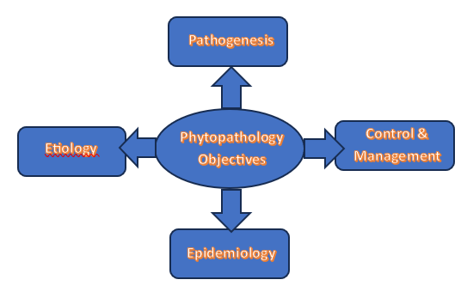

Fig 2. Phytopathology Objectives

Phytopathology is a specialized subfield within agricultural science that integrates foundational knowledge from diverse disciplines such as microbiology, physiology, nematology, virology, anatomy, bacteriology, mycology, genetic engineering, botany, meteorology, climatology, and molecular biology, as illustrated in Fig. 3.

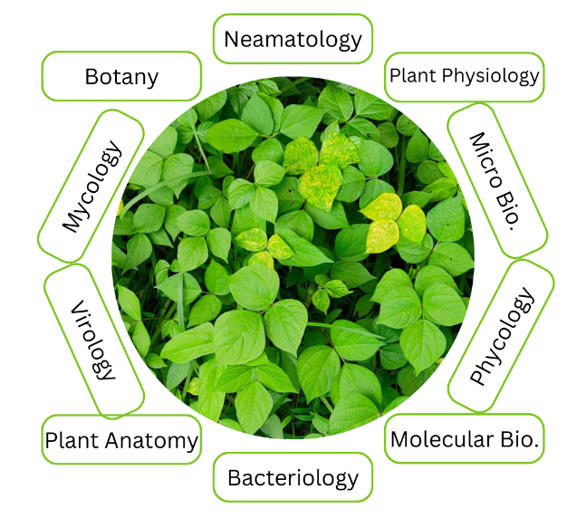

Fig 3. Subdomains of phytopathology [22]

Plant disease types & symptoms

*Bacterial Diseases:* Bacterial infections in plants typically begin as water-soaked lesions that develop into small green blemishes. Over time, these lesions expand and dry into dead spots, as illustrated in Fig. 4. For instance, foliage may display water-soaked black blemishes, brown leaf spots, or yellow halos of uniform size. Under dry conditions, the blemishes often appear dappled. Bacterial wilt, a common issue in brinjal crops, causes the entire plant to collapse [7, 21].

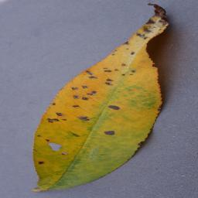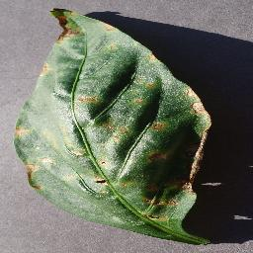

Peach - Bacterial Spot (a) Bell Pepper - Bacterial Spot (b)

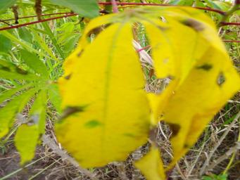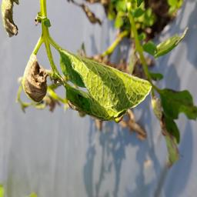

Cassava - Bacterial Blight (c) Potato - Bacterial Wilt (d)

Fig. 4 Bacterial Diseases

*Viral Diseases:* Viral infections in plants are among the most challenging to diagnose, as they may exhibit no visible symptoms or mimic signs of herbicide damage or nutrient deficiencies [7]. Commonly observed viral disease include those transmitted by beetles, leafhoppers, aphids, and whiteflies, such as mosaic viruses, which manifest as green or yellow streaks on foliage, as shown in Fig. 5.

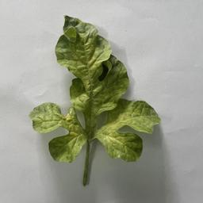

Watermelon – Mosaic Virus (a) Tomato – Mosaic Virus (b)

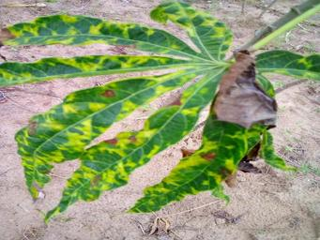

Cassava – Mosaic Disease (c)

Fig. 5 Viral Diseases

*Fungal Diseases:* Fungal infections affect various parts of plants, including stems, leaves, seeds, and roots. Examples include sclerotium wilt, stem rust, blight, ergot, and carnal bunt. Late blight caused by Phytophthora fungus initially appears as gray green waterlogged blemishes on older leaves, as shown in Fig. 6 (a). Over time, these lesions darken, and white fungal growth may appear due to fluctuating wet and dry conditions [8]. Early blight caused by Alternaria fungus produces small brown blemishes with a characteristic concentric ring pattern, as shown in Fig. 6 (b). Rust fungi form spots on mature leaves that turn black over time, as illustrated in Fig. 6.

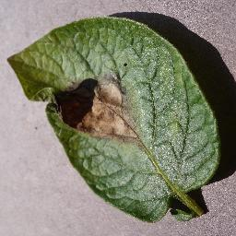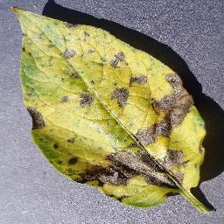

Potato - Late Blight (a) Potato - Early Blight (b)

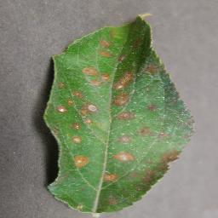

Apple – Rust (c)

Fig. 6 Fungal Diseases

Table 2. Distinct disease in different plants

|  |  |  |  |  |
| --- | --- | --- | --- | --- |
| **Author** | **Plant** | **Bacterial Disease** | **Viral Disease** | **Fungal Disease** |
| Kianat et al. 2021 [9]  Agarwal et al. 2021 [10] | Cucumber | Brown Blemnish, Angular Blemnish, Target  Blemnish | Mosaic, Yellow Blemnish | Black Blemish, Gray Mold |
| Shrivastava et al. 2019 [11]  Chen et al. 2021 [12] | Rice | Streak, Blight | Black Dwarfed Streaked | Smut False |
| Sun et al. 2021 [13] | Maize | Streak, Stalk | Crimson, Dwarf | Rust |
| Abbas et al. 2021 [14] | Tomato | Canker | Curl leaf yellow | Late/Early Blight |

Table 3. Distinct plants, their disease and responsible pathogen [22]

|  |  |  |  |
| --- | --- | --- | --- |
| **Plants** | **Diseases** | **Pathogens** | **Symptoms** |
| Apple | Scab  Rot  Rust | PomiSpilocal  MalorumSphaeropsis  Sporangium | Brown-Gray on leaf  Dark Brown on leaf  Yellow pale on leaf |
| Cherry | Mildew | Clandestina | Gray powder on leaf |
| Corn | Gray Spot  Rust  Light blight | Cercospora  Sorghipuccinia  Tutcicasetosphaeria | Rectangle lesions  Red pustules on leaf  Elliptical lesions |
| Grape | Rot  Measles  Isariopsis blight | Bidwelliiguignardia Aleophilum  Angulata brachypus | Red borders on leaf Necrotic stripping  Coalesce lesions |
| Peach | Spot | Arboricola Xanthomonas | Clustered lesions |
| Potato | Early blight  Late blight | Solani Alternaria  Infestans phytophthora | Brown lesion  Dark greeb spot |
| Tomato | Septoria spot  Mosaic | Lycopersici  Mosaic virus | Foliage  Mottle green leaf |
| Orange | Green Citrus | Bacteria Motile | Precipitate Demolition |
| Strawberry | Scorch Fungus | Diplocarpon | Brown edges |
| Squash | Mildew | Xanthiipodosphaers | White powder |

4. Plant Disease Detection & Classification

4.1 Machine learning (ML) Algorithms:

*A. Naïve Bayes:* The Naïve Bayes classifier is a probabilistic model based on Bayes' theorem. It assumes that the prior probabilities of patterns are known and assigns class labels based on posterior probabilities. Under this assumption, the maximum likelihood values for data belonging to a specific class are computed using the posterior probability. This is done by applying Bayes’ theorem to the product of each feature’s conditional probability. Despite its simplicity and the fact that its assumptions rarely hold in real-world scenarios, NB performs well in many classification tasks.

*B. k-Nearest Neighbors (kNN):* KNN is a nonparametric, supervised ML technique widely used for pattern recognition [15, 16]. It follows the nearest neighbor rule to classify data based on similarity. The classifier is trained using a dataset, and new test patterns are classified based on their resemblance to existing training patterns. The KNN algorithm assigns a class label based on a majority vote among the k-nearest neighbors. It functions as an instance-based learning model, using local approximations and performing distinct computations during the classification process.

*C. Decision Trees:* Decision Trees are supervised classification and regression models that split data into smaller groups (tree structure) based on attributes that create the greatest division. Common attribute selection metrics include the Gini index and entropy. One major advantage of DTs is their interpretability, making it easier for humans to understand classification results. If unrestricted in depth, a decision tree can achieve very low training error. Popular DT variants such as ID3, C4.5, and CART are frequently used in ML and data mining applications.

*D. Random Forest:* Random Forest is an ensemble learning method that builds multiple decision trees during training to improve classification accuracy. The final class label is determined based on the majority vote from all decision trees. By leveraging both bagging and feature randomness, RF creates an uncorrelated forest of trees, enhancing predictive performance compared to individual decision trees.

*E. Support Vector Machines:* SVM is a supervised ML classifier that defines an optimal separating hyperplane in high-dimensional space to maximize the margin between different class data points [15, 16, 18]. It is particularly effective for nonlinear classification due to kernel functions such as linear, polynomial, and radial basis functions, which transform features into higher-dimensional space. However, feature transformation can significantly increase the feature space’s dimensions, lengthening the training process. By computing dot products, SVM achieves higher-dimensional mapping without modifying the original feature set.

4.2 Deep Learning Techniques

*A. The CNN (Convolutional Neural Network) Technique:* CNNs are deep feed-forward neural networks designed to analyze multidimensional data. They learn feature representations by activating specific channels when detecting key spatial patterns in the input data [15, 17, 18]. The accuracy of CNN models depends on factors such as the number of training epochs and the implementation of convolution filters, typically with dimensions of 2 × 2 or 3 × 3. Several pre-trained architectures enhance CNN performance, including VGG16, VGG19, ResNet50, ResNet152, InceptionV3, InceptionNet, and DenseNet121.

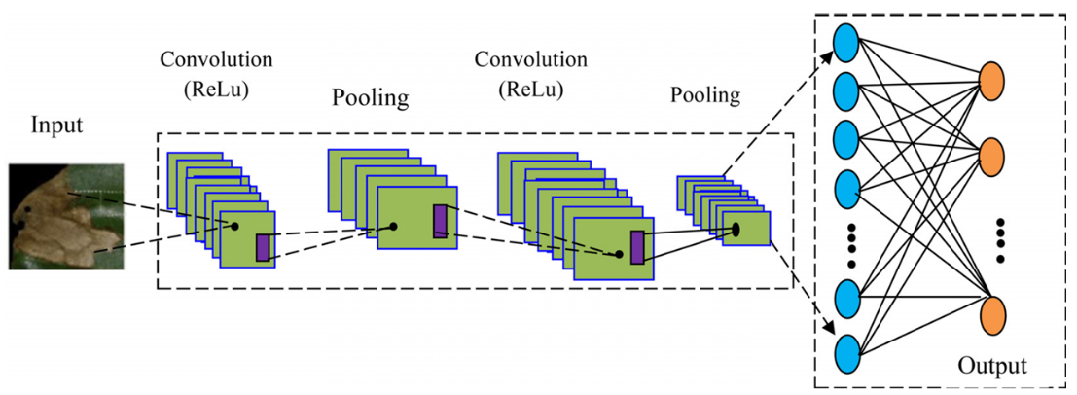

Fig. 8 CNN Image Processing Architecture

*B. The ANN (Artificial Neural Network) Technique:* ANNs are computational models that mimic the information-processing capabilities of biological neural systems, such as the human brain [15, 16]. These networks consist of artificial neurons, also known as processing elements (PEs), connected by weighted coefficients that define their structure. Instead of being explicitly programmed, ANNs learn patterns and relationships from experience, making them effective for identifying complex data patterns and extracting meaningful insights.

Fig. 7 Classification technique used by various researchers

**5. Methodology**

5.1 Data Collection & Preprocessing

*Dataset Selection*

For this study, we utilized the New Plant Disease dataset, which contain a diverse collection of plant leaf images categorized into multiple disease classes and healthy leaf samples. The dataset consists of over 100,000 images distributed across 72 plant disease classes.

*Data Augmentation*

To enhance model generalization and reduce overfitting, we applied various data augmentation techniques, including: Rotation (±20 degrees), Flipping (horizontal and vertical), Zooming (0.8x–1.2x scale), Brightness and contrast adjustments, Gaussian noise addition. These augmentations increase the variability of the dataset, ensuring robustness in real-world applications.

Fig. 8 Various data augmentation techniques

5.2 Model Selection & Implementation

We implemented the Convolutional Neural Network (CNN) to analyze their effectiveness in plant disease classification.

- Architecture: A multi-layer CNN with convolutional layers, batch normalization, ReLU activation, and fully connected layers.

- Pre-trained Models Used: VGG16, ResNet50, InceptionV3 for feature extraction.

- Optimization: Adam optimizer with categorical cross-entropy loss.

5.3 Model Training & Evaluation

The dataset was split into 80% training, 10% validation, and 10% testing. All models were trained using TensorFlow and PyTorch frameworks. Early stopping was applied to prevent overfitting. Models were assessed using the following performance metrics:

*- Accuracy*: The accuracy score of a model, often known as accuracy, is a classification statistic in DL and ML techniques that represents the proportion of correct predictions made by the model. [19]

- *Precision*: Precision is defined as the ability to identify only relevant objects. It is defined as the ratio of correctly classified positive outputs to total positive outputs.

- *Recall*: A model’s recall is defined as the model’s ability to correctly identify True Positives. It is defined as the ratio of correctly classified positive outputs to correctly classified outputs.

- *F1 – Score*: The f1 score is also introduced to assess the model’s accuracy. The f1-score considers both the model’s precision and recall [20]

$$F1-Score=\frac{2(Precision*Recall)}{Precision+Recall}$$

5.4 Deployment on Local Web Application

A Flask-based web application was developed to enable real-time plant disease detection using the trained models.

- Frontend: HTML, CSS, JavaScript.

- Backend: Python (Flask) for model inference.

- User Input: Users can upload leaf images for instant classification.

**6. Experiment**

We experimented with several machine learning algorithm, but confined to build the CNN model mainly due to computational limitations. Table n shows the classification report of the CNN model:

Table 4. Classification Report

|  |  |  |  |  |
| --- | --- | --- | --- | --- |
| **Class** | **Precision** | **Recall** | **F1-Score** | **Support** |
| Apple___alternaria_leaf_spot | 0.96 | 0.8 | 0.87 | 56 |
| Apple___black_rot | 0.77 | 0.91 | 0.83 | 124 |
| Apple___brown_spot | 0.78 | 0.84 | 0.81 | 43 |
| Apple___gray_spot | 0.8 | 0.52 | 0.63 | 79 |
| Apple___healthy | 0.81 | 0.65 | 0.72 | 514 |
| Apple___rust | 0.8 | 0.62 | 0.7 | 248 |
| Apple___scab | 0.56 | 0.45 | 0.5 | 244 |
| Bell_pepper___bacterial_spot | 0.85 | 0.76 | 0.81 | 199 |
| Bell_pepper___healthy | 0.84 | 0.88 | 0.86 | 296 |
| Blueberry___healthy | 0.91 | 0.98 | 0.94 | 300 |
| Cassava___bacterial_blight | 0.25 | 0.17 | 0.2 | 217 |
| Cassava___brown_streak_disease | 0.32 | 0.28 | 0.3 | 438 |
| Cassava___green_mottle | 0.22 | 0.13 | 0.16 | 477 |
| Cassava___healthy | 0.27 | 0.26 | 0.27 | 516 |
| Cassava___mosaic_disease | 0.73 | 0.84 | 0.78 | 2632 |
| Cherry___healthy | 0.89 | 0.97 | 0.93 | 171 |
| Cherry___powdery_mildew | 0.98 | 0.9 | 0.94 | 210 |
| Coffee___healthy | 0.67 | 0.63 | 0.65 | 158 |
| Coffee___red_spider_mite | 0.0 | 0.0 | 0.0 | 33 |
| Coffee___rust | 0.44 | 0.53 | 0.48 | 120 |
| Corn___common_rust | 0.98 | 0.89 | 0.93 | 238 |
| Corn___gray_leaf_spot | 0.78 | 0.64 | 0.7 | 103 |
| Corn___healthy | 0.87 | 0.97 | 0.92 | 232 |
| Corn___northern_leaf_blight | 0.86 | 0.9 | 0.88 | 197 |
| Grape___Leaf_blight | 0.98 | 0.98 | 0.98 | 295 |
| Grape___black_measles | 0.93 | 0.82 | 0.87 | 534 |
| Grape___black_rot | 0.97 | 0.93 | 0.95 | 316 |
| Grape___healthy | 0.93 | 0.92 | 0.93 | 341 |
| Orange___citrus_greening | 0.97 | 1.0 | 0.98 | 1102 |
| Peach___bacterial_spot | 0.85 | 0.92 | 0.88 | 460 |
| Peach___healthy | 0.92 | 0.67 | 0.77 | 72 |
| Potato___bacterial_wilt | 0.63 | 0.59 | 0.61 | 114 |
| Potato___early_blight | 0.88 | 0.88 | 0.88 | 526 |
| Potato___healthy | 0.75 | 0.69 | 0.72 | 455 |
| Potato___late_blight | 0.76 | 0.8 | 0.78 | 417 |
| Potato___leafroll_virus | 0.98 | 0.76 | 0.86 | 105 |
| Potato___mosaic_virus | 0.75 | 0.84 | 0.79 | 133 |
| Potato___nematode | 0.27 | 0.21 | 0.24 | 14 |
| Potato___pests | 0.36 | 0.35 | 0.36 | 122 |
| Potato___phytophthora | 0.51 | 0.61 | 0.56 | 69 |
| Potato___spindle_tuber_viroid | 0.81 | 1.0 | 0.89 | 17 |
| Raspberry___healthy | 0.87 | 0.91 | 0.89 | 74 |

The CNN model that we built achieves an accuracy of 81.83 %.

**Conclusion**

The emergence of plant pathogens poses a significant threat to global food security, ecosystems, and economies. Factors such as globalization, increased mobility, vectors, climate change, and pathogen evolution have accelerated the spread of invasive plant pathogens. To address agricultural losses, the development of automated approaches for plant disease detection and classification is urgently needed. This review explores the use of machine learning (ML), deep learning (DL), and few-shot learning (FSL) for automated plant disease recognition. It highlights key methodologies, including acquisition, preprocessing, segmentation, feature extraction, and classification. While many studies rely on RGB images, some have adopted hyperspectral imaging for plant leaves, which offers the advantage of detecting microscopic symptoms without requiring labeled datasets. These automated techniques have facilitated timely advancements in research. Additionally, the review examines molecular diagnostic tools and state-of-the-art techniques for plant disease detection. The methods discussed are highly sensitive, specific, and capable of rapid detection.

***Societal Benefits of the Project:***

1. Improved Crop Health and Yield - Early detection and accurate classification of plant leaf diseases enable timely intervention, reducing crop losses and ensuring higher yields. This contributes to food security and agricultural sustainability.

2. Empowering Farmers - By providing an accessible and cost-effective tool for disease diagnosis, the project empowers farmers, especially in rural and underdeveloped regions, to take proactive measures without relying solely on agricultural experts.

3. Reduction in Chemical Usage - Accurate disease identification minimizes the overuse or misuse of pesticides and fertilizers, reducing environmental pollution and promoting eco-friendly farming practices.

4. Economic Gains - Preventing large-scale crop damage reduces financial losses for farmers and boosts the agricultural economy. This is especially crucial for small-scale farmers who are more vulnerable to crop failures.

5. Scalable and Efficient Disease Management - AI-driven solutions can process large datasets quickly and provide insights on disease patterns and outbreaks, helping agricultural agencies and policymakers plan better resource allocation and disease management

**References**

[1] FAO, IFAD, UNICEF, WFP, WHO, The State of Food Security and Nutrition in the World 2023. Geneva, Switzerland, Jul. 2023.

[2] "State of Agriculture in India," accessed Aug. https://prsindia.org/files/policy/policy_analytical_reports 9, 2023.

[3] C. Janiesch, P. Zschech, and K. Heinrich, "Machine learning and deep learning," Electron. Markets, vol. 31, no. 3, pp. 685–695, Apr. 2021, doi: 10.1007/s12525-021-00475-2.

[4] K. Kc, Z. Yin, D. Li, and Z. Wu, "Impacts of background removal on convolutional neural networks for plant disease classification in-situ," Agriculture, vol. 11, no. 9, p. 827, Aug. 2021, doi: 10.3390/agriculture11090827.

[5] J. Liu and X. Wang, "Plant diseases and pests detection based on deep learning: A review," Plant Methods, vol. 17, no. 1, pp. 1–18, Dec. 2021.

[6] Y. Zhang, C. Song, D. Zhang, Deep learning-based object detection improve- [ment for tomato disease, IEEE Access 8 (2020) 56607–56614, doi: 10.1109/AC- CESS.2020.2982456 .](https://doi.org/10.1109/ACCESS.2020.2982456)

[7] G. Sambasivam, G.D. Opiyo, A predictive machine learning application in agri- culture: Cassava disease detection and classification with imbalanced dataset using convolutional neural networks, Egypt. Inform. J. 22 (1) (2021) 27–34, doi: [10.1016/j.eij.2020.02.007 .](https://doi.org/10.1016/j.eij.2020.02.007)

[8] [I. Ahmed, P.K. Yadav, An automated system for early identification of diseases in plant through machine learning, in: Soft Computing: Theories and Applications: Pro- ceedings of SoCTA 2021, Springer Nature Singapore, 2022, pp. 803–814 .](http://refhub.elsevier.com/S2666-4127(23)00003-X/sbref0033)

[9] M.H. Saleem, J. Potgieter, K.M. Arif, Plant disease classification: A comparative eval- uation of convolutional neural networks and deep learning optimizers, Plants 9 (10) (2020) 1–17, doi: [10.3390/plants9101319 .](https://doi.org/10.3390/plants9101319)

[10] Tirkey D, Singh KK, Tripathi S. Performance analysis of AI-based solutions for crop disease identification detection, and classification. Smart Agric Technol. 2023.

[11] Jasim MA, Al-Tuwaijari JM. Plant leaf diseases detection and classification using image processing and deep learn ing techniques. Int Comput Sci Soft Eng Conf. 2020.

[12] V. K. Shrivastava, M. K. Pradhan, S. Minz, and M. P. Thakur, “Rice plant disease classification using transfer learning of deep convolution neural network,” The International Archives of the Photogrammetry, Remote Sensing and Spatial Information Sciences, vol. XLII-3/W6, pp. 631–635, 2019.

[13] K. Aderghal, A. Khvostikov, A. Krylov, J. Benois-Pineau, K. Afdel, and G. Catheline, “Classification of Alzheimer disease on imaging modalities with deep CNNs using cross modal transfer learning,” in 2018 IEEE 31st International Symposium on Computer-Based Medical Systems (CBMS), pp. 345–350, IEEE, Karlstad, Sweden, 2018.

[14] A. Abdalla, H. Cen, L. Wan et al., “Fine-tuning convolutional neural network with transfer learning for semantic segmenta tion of ground-level oilseed rape images in a field with high weed pressure,” Computers and Electronics in Agriculture, vol. 167, Article ID 105091, 2019.

[15] Kumar R, Chug A, Singh AP, Singh D. A systematic analysis of machine learning and deep learning based approaches for plant leaf disease classification: a Review. J Sensors. 2022

[16] Tiwari V, Joshi RC, Dutta MK. Dense convolutional neural networks based multiclass plant disease detection and classification using leaf images. Ecol Inform. 2021;63: 101289.

[17] Shoaib M, et al. An advanced deep learning models-based plant disease detection: a review of recent research. Front Plant Sci. 2023;14:1–22.

[18] Ahmed I, Yadav PK. A systematic analysis of machine learning and deep learning based approaches for identifying and diagnosing plant diseases. Sustain Oper Comput. 2023;4:96–104.

[19] Plant disease detection and classification techniques: a comparative study of the performances Wubetu Barud Demilie

[20] Liu J, Wang X. Plant diseases and pests detection based on deep learning: a review. Plant Methods. 2021;17(1):1 18

[21] Plant Leaf Disease Detection, Classification, and Diagnosis Using Computer Vision and Artificial Intelligence: A Review ANUJA BHARGAVA 1,AASHEESH SHUKLA1, OM PRAKASH GOSWAMI2, MOHAMMEDH.ALSHARIF 3,PEERAPONG UTHANSAKUL 4,(Member, IEEE), AND MONTHIPPA UTHANSAKUL 4,(Member, IEEE)

[22] V. K. Vishnoi, K. Kumar, and B. Kumar, ‘‘Plant disease detection using computational intelligence and image processing,’’ J. Plant Diseases Protection, vol. 128, no. 1, pp. 19–53, Aug. 2020,

[23] B. Liu, Y. Zhang, D. He, and Y. Li, ‘‘Identification of apple leaf diseases based on deep convolutional neural networks,’’ Symmetry, vol. 10, no. 1, p. 11, Dec. 2017.

[24] R. Chen, H. Qi, Y. Liang, and M. Yang, ‘‘Identification of plant leaf dis- eases by deep learning based on channel attention and channel pruning,’’ Frontiers Plant Sci., vol. 13, Nov. 2022.

[25] H. Nazki, S. Yoon, A. Fuentes, and D. S. Park, ‘‘Unsupervised image translation using adversarial networks for improved plant disease recog- nition,’’ Comput. Electron. Agricult., vol. 168, Jan. 2020, Art. no. 105117.

[26] Y. Tian, G. Yang, Z. Wang, E. Li, and Z. Liang, ‘‘Detection of apple lesions in orchards based on deep learning methods of CycleGAN and YOLOV3 dense,’’ J. Sensors, vol. 2019, pp. 1–13, Apr. 2019.

[27] Q. Wu, Y. Chen, and J. Meng, ‘‘DCGAN-based data augmenta- tion for tomato leaf disease identification,’’ IEEE Access, vol. 8, pp. 98716–98728, 2020.

[28] B. Liu, C. Tan, S. Li, J. He, and H. Wang, ‘‘A data augmentation method based on generative adversarial networks for grape leaf disease identifi- cation,’’ IEEE Access, vol. 8, pp. 102188–102198, 2020.

[29] Z. Lin, S. Mu, A. Shi, C. Pang, and X. Sun, ‘‘A novel method of maize leaf disease image identification based on a multichannel convolutional neural network,’’ Trans. ASABE, vol. 61, no. 5, pp. 1461–1474, 2018.

[30] J. G. Arnal Barbedo, "Plant disease identification from individual lesions and spots using deep learning," Biosyst. Eng., vol. 180, pp. 96–107, Apr. 2019.

[28]S. M. Kiran and D. N. Chandrappa, ‘‘Plant disease identification using discrete wavelet transforms and SVM,’’ J. Univ. Shanghai Sci. Technol., vol. 23, no. 6, pp. 108–114, 2021. [Online]. Available: https://jusst. org/wp-content/uploads/2021/06/Plant-Disease-Identification-Using-Discrete-Wavelet Transforms-and-SVM-1.pdf

[29] R. R. Patil and S. Kumar, ‘‘Rice-fusion: A multimodality data fusion framework for rice disease diagnosis,’’ IEEE Access, vol. 10, pp. 5207–5222, 2022.

[30] D. Zhang, X. Zhou, J. Zhang, Y. Lan, C. Xu, and D. Liang, ‘‘Detection of rice sheath blight using an unmanned aerial system with high-resolution color and multispectral imaging,’’ PLoS ONE, vol. 13, no. 5, May 2018, Art. no. e0187470.

[31] V. K. Shrivastava and M. K. Pradhan, ‘‘Rice plant disease classifi- cation using color features: A machine learning paradigm,’’ J. Plant Pathol., vol. 103, no. 1, pp. 17–26, Oct. 2020, doi: 10.1007/s42161-020- 00683-3.

[32] A. K. Rath and J. K. Meher, ‘‘Disease detection in infected plant leaf by computational method,’’ Arch. Phytopathol. Plant Protection, vol. 52, nos. 19 20, pp. 1348–1358, Dec. 2019.

[33] M. Azadbakht, D. Ashourloo, H. Aghighi, S. Radiom, and A. Alimohammadi, "Wheat leaf rust detection at canopy scale under different LAI levels using machine learning techniques," Comput. Electron. Agricult., vol. 156, pp. 119–128, Jan. 2019.

[34] B. S. Kusumo, A. Heryana, O. Mahendra, and H. F. Pardede, ‘‘Machine learning-based for automatic detection of corn-plant diseases using image processing,’’ in Proc. Int. Conf. Comput., Control, Informat. Appl. (IC3INA), Nov. 2018, pp. 93–97.

[35] A. Kaya, A. S. Keceli, C. Catal, H. Y. Yalic, H. Temucin, andB. Tekinerdogan, ‘‘Analysis of transfer learning for deep neural network based plant classification models,’’ Comput. Electron. Agricult., vol. 158, pp. 20–29, Mar. 2019.