A Software Design Document:
Programming Club Server

Shikhar Gupta (B14132)
Tapesh Joham (B14136)
Mandala Rishik Reddy (B14322)
Sunil Kumar (B14135)
May 2017

Programming Club Server
Design Document
Revision History
Version | Date | Author(s) | Description
v1.0 | 01/05/17 | Shikhar, Rishik, Tapesh, Sunil | Initial version

Table of Contents
1Introduction 1
1.1Design Overview 1
1.2Intended Audience 2
1.3References 2
2Detailed Design 2
2.1Architecture 3
Components : Challenges and their solutions 3
Interfaces 3
2.2External Data 4
Applications’ Source Codes 4
2.3Performance 4
2.4Test Scripts 4
3Appendix A 4
3.1Alternate Approaches to Challenges 4

Introduction
The programming club wants to host several student projects. We want to create shared containers for shared components across projects using docker. If one of the projects that shares a container has a heavy load, it will affect others as well. Hence, we need mechanism to monitor application level requests and isolate the application from others in case its requests increase beyond a threshold. We can create a new container for that project with a cap on the resource usage using Nginx.

Design Overview
The Programming Club Server system is based on the Docker (Ref. [2]) and Nginx (Ref. [3]). Docker and Nginx have no license fee. Both are well documented and can be easily learnt and maintained. Any user can host his/her application on the docker container corresponding to the technology stack of the application. Nginx is used to forward the requests to appropriate containers and cap the number of requests and request rate for a particular application in the docker container.

Intended Audience
This document is intended for the administrators of the server and members of IIT Mandi who may use the server to host their applications.

References
[1] Programming Club Server System Requirements Document, IIT Mandi, 24/04/2017.
[2] What is Docker?, http://docker.com/what-docker/, accessed on 1/05/2017.
[3] What is Nginx?, http://nginx.com/, accessed on 1/05/2017.
[4] What is Flocker?, https://clusterhq.com/flocker/introduction/, accessed on 2/05/2017.

Detailed Design
Docker is chosen as the virtualization platform, keeping in mind its scalability support for future expansion and variety of options available.
Nginx is used as the HTTP server because of the vast amount of features it provides and support for graceful restart/reconfiguration.
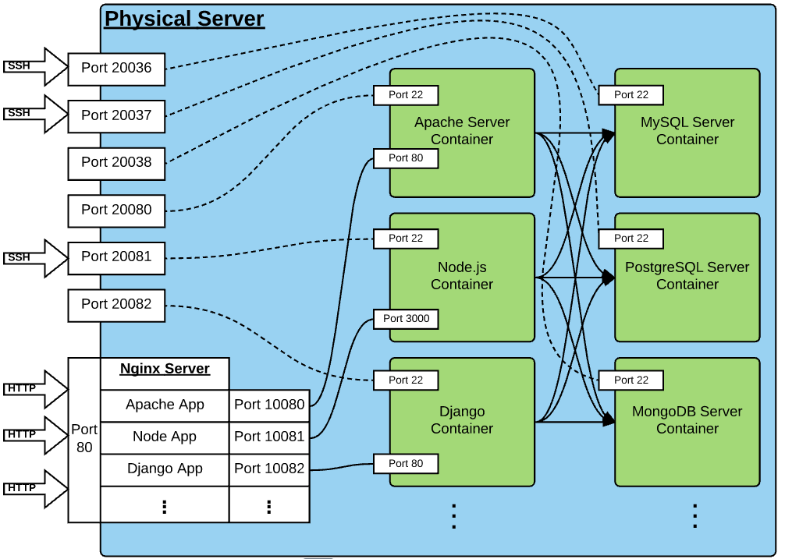
Fig. 1: Programming Club Server Architecture

Architecture
The Programming Club Server architecture (Fig. 1) consist of differents type of components. Blue block represents the physical server. Bottom-left block represents the Nginx server forwarding requests to the appropriate docker containers. Green blocks represents different docker containers.

Components : Challenges and their solutions
This section describes the challenges faced and the proposed solution for each of the components. The alternate solutions can be found in the Section 3.1
A) Docker Container
- Deploying the containers for each technology
The image for each technology will be fetched from the docker hub. The containers will be deployed using the latest image available.
- Preserving the stateful data of containers
Backup of each container will be taken to an image with period of 1 day. The number of backups can be limited to 7 for each container. This can be done using docker commit.
- Preserving the packages and dependencies installed for each app
The backup solution proposed above will also preserve the packages and dependencies.
- Communication between different docker containers
Rather than creating a user-defined network, the internal docker bridge network can be used to make legacy docker links between containers. This approach will set appropriate environment variables for connection between the containers. The apps can use these environment variables
B) Nginx Server
- HTTP Request Forwarding
Nginx will forward the requests received on the server to appropriate container-servers. The containers will be provided a static port and a fixed port forwarding rules which only.
- Balancing the requests received on the server
Using the nginx http_limit_req module, number of requests for each application will be capped.

Interfaces
All the HTTP requests will be recieved on default port 80 of the physical server. SSH request to each of the containers will be recieved through a particular port. The interfaces between the different containers are using TCP/IP protocol.

External Data

Applications’ Source Codes
Source Code of the applications to be hosted will be fetched from their github repositories.

Performance
The specified server should be sufficient to host about 50 different apps with average user load 100 users/sec and maximum response time less than 2 seconds.

Test Scripts
The following scripts will be used. All this scripts are to be used with Jmeter.
SingleRequest: Requests are made to a single webpage.
EqualNumber: Equal number of requests are made to all the apps.
BiasedRequest: High variance in number of request within apps.

Appendix A

Alternate Approaches to Challenges
The solutions discussed here are alternates to the approaches discussed in section 2.1. These approaches were rejected as they were either too time-consuming for the scope of the project or were lacking in some feature/support from the above-mentioned approaches.
Deploying the containers for each technology.
The applications are installed after fetching a basic Ubuntu image from the docker hub using a dockerfile to create a new image which is then used to deploy containers.
Preserving Stateful data of a container
The data can be stored in a directory on the physical host of the docker containers. This directory will be mounted to each of these containers.
Flocker (Ref. [4]) manages Docker containers and data volumes together. When you use Flocker to manage your stateful microservice, your volumes will follow your containers when they move between different hosts in your cluster.
Preserving the packages and dependencies installed for each app
User Namespace package installers like brew can be used to install the packages inside the home directory of the user. This will help keep the packages of different user seperate. However, the support of brew does not match support of apt.

Communication between different docker containers
A docker network will be created between the containers. A program within a container will have to make a request to another container using the corresponding static ip of the serving container if it wants to use the services of the other container.
Balancing the requests received on the server
Using the nginx module, number of requests for each application will be capped. The cap would be decided by monitoring the recent requests and setting the cap proportional to the amount of the requests received. This would require graceful reconfiguration of the nginx server which can be tedious task.

