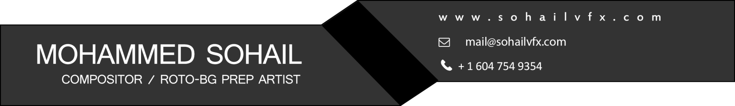

**Shots 1 - Invisible Effects**

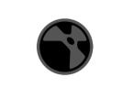

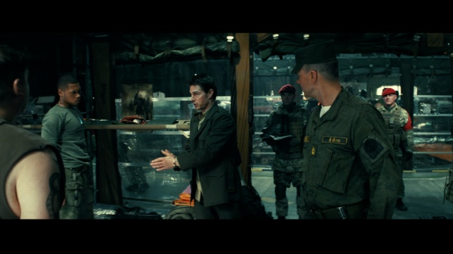 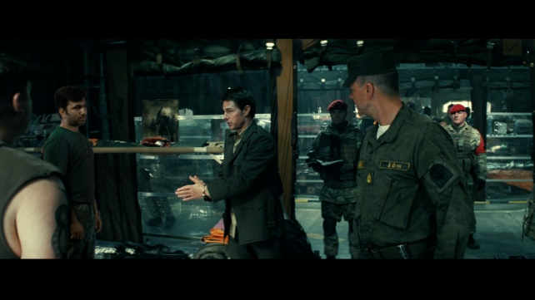

**Tasks-** 3D Camera tracking, creating clean patch, keying, color correcting, match moving, rotoscoping, 2D relighting, matching grain, adding motion blur and light wrap.

**Shots 2 - Wire removal**

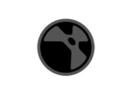

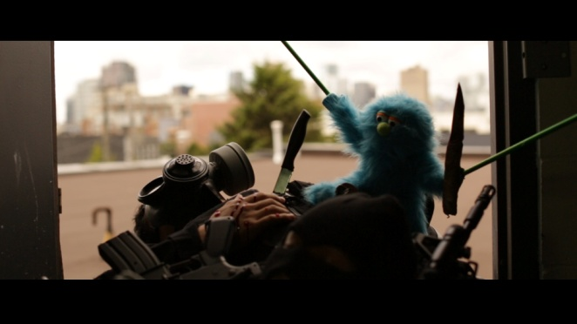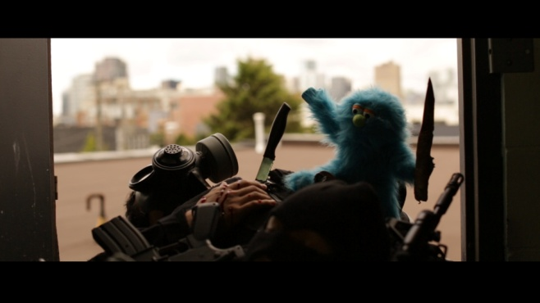

**Tasks-**Tracking, clean plate creation, rods paint out and rotoscoping

**Shots 3 – Reflection Paint out**

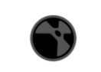

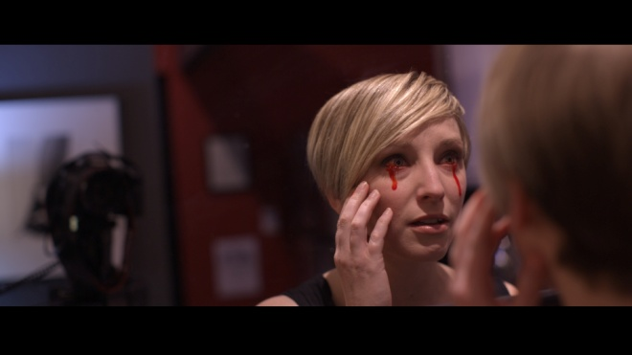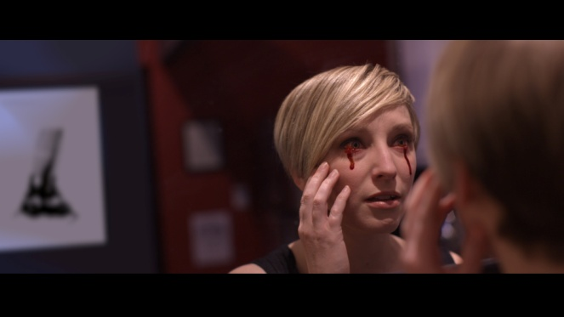

**Tasks-** Camera paint-out, add bruise, rotoscoping, color correction.

**Shots 4 - Muzzle Fire**

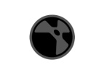

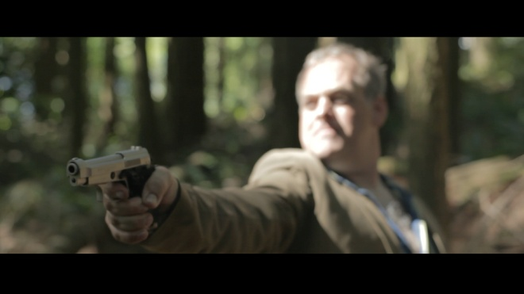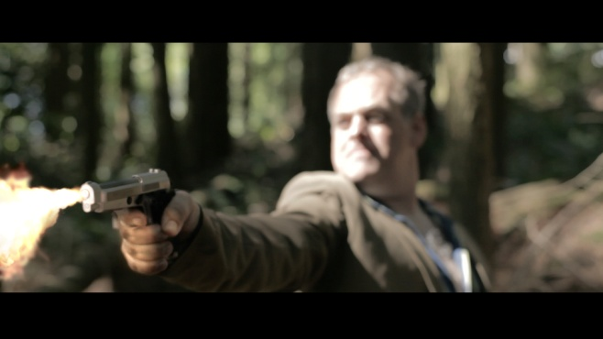

**Tasks-** Compositing muzzle fire elements with smoke, Interactive light and color correction.

**Shots 5 - Full Body Rotoscoping**



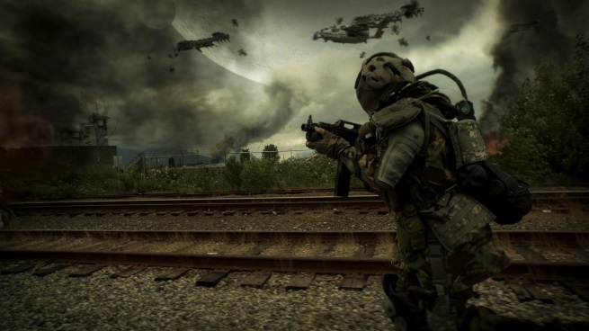 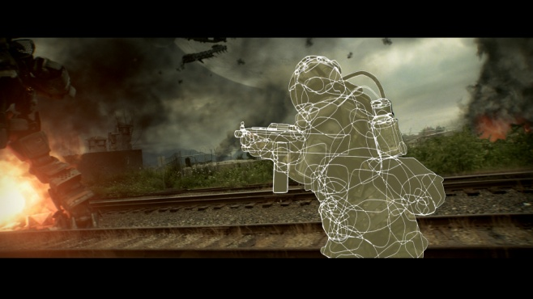

**Tasks-** Full body articulate Rotoscoping.

**Shots 6 - Sign Replacement**

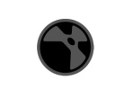

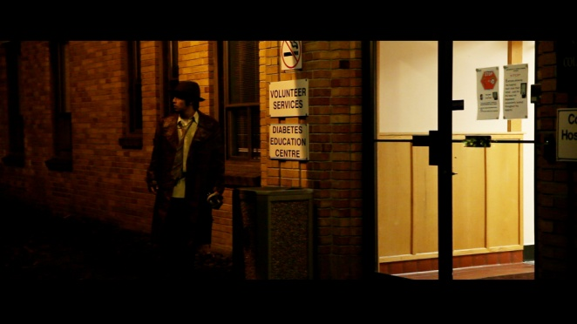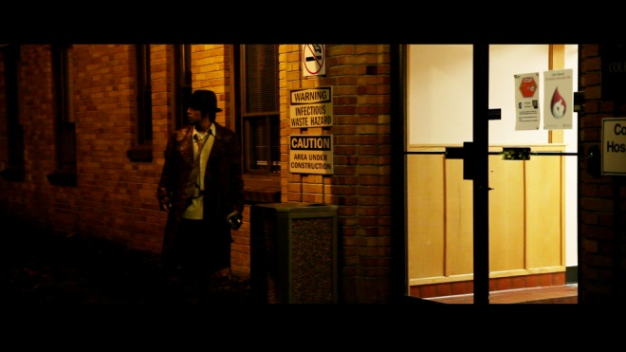

**Tasks-** 3D Tracking, sign replacement, match-moving, colour correction, rotoscoping, matching grain.

**Shots 7 - Title Project**

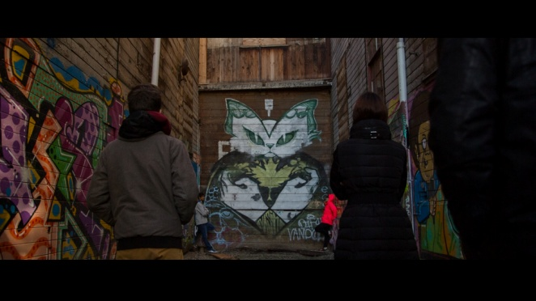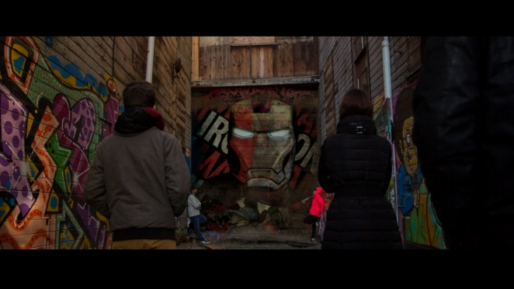

**Tasks-** 3D camera tracking, designing new wall, match moving, integrate shadows, color correcting, rotoscoping, and matching grain.

**Shots 8 - Logo Removal**

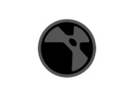

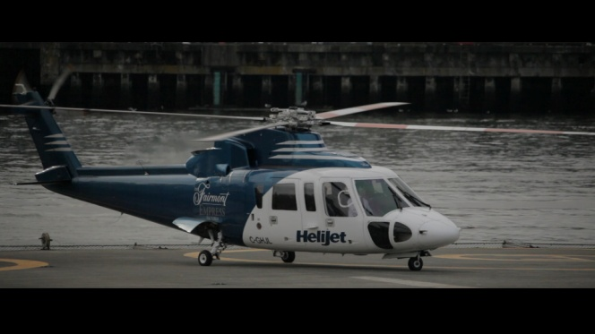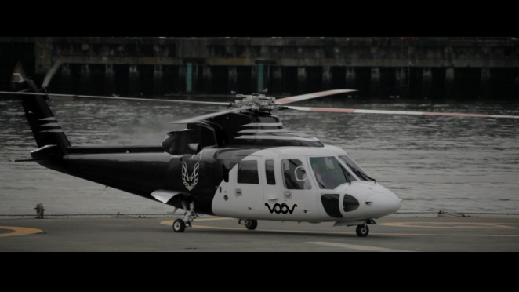

**Tasks-** 3D Tracking, logo paint out, creating clean plate and adding logo, changing helicopter colour, rotoscoping, match moving, matching motion blur.

**Shots 9 - Leg Paint Out**



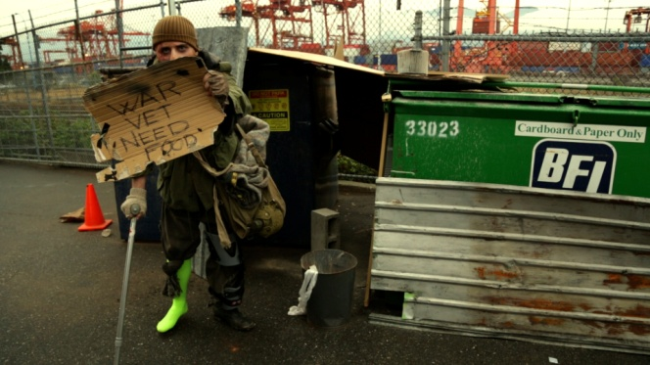 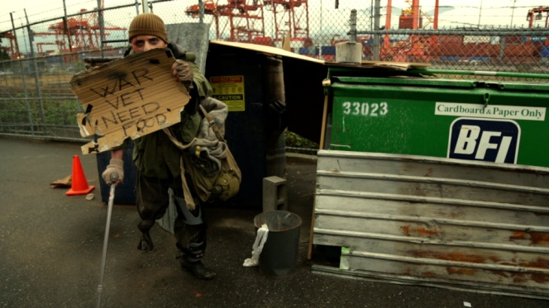

**Tasks-** 3D Tracking, leg paint out, creating clean plate and adding walking stick , metal sheet , rotoscoping, match moving.